INDOOR AIR QUALITY ASSESSMENT

Newman Elementary School
1155 Central Street
Needham, Massachusetts 02492

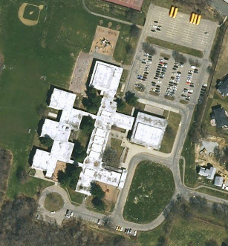

Prepared by:
Massachusetts Department of Public Health
Center for Environmental Health
Emergency Response/Indoor Air Quality Program
May 2007

Background/Introduction
At the request of the Needham School Department (NSD), the Massachusetts Department of Public Health (MDPH) Center for Environmental Health (CEH) conducted an indoor air quality assessment at the Newman Elementary School (NES), 1155 Central Avenue, Needham, Massachusetts. On March 1, 2007, Cory Holmes and Sharon Lee, Environmental Analysts for CEH’s Emergency Response/Indoor Air Quality (ER/IAQ) Program, visited the building to conduct an IAQ assessment. The assessment was prompted by concerns of potential mold growth in classroom 211.
The NES is a two-story red brick building constructed in the early 1960s. The building was reportedly renovated in 1993, 1995 and again from 1997 to1998. The school consists of upper and lower levels constructed around a central courtyard. The upper level consists of an amphitheatre, auditorium, media center, conference rooms, classrooms and office space. The lower level consists of the gym, preschool classrooms, art rooms and a storage area.
School officials reported that a steam leak had occurred in a mechanical room on December 4, 2006. The steam leak resulted in condensation generation in classroom 211. Upon discovering moisture accumulation in classroom 211, school personnel reportedly took actions to dry and clean the classroom and a dehumidifier was utilized to aid in removing moisture. On December 6, 2006, OccuHealth, Inc., an environmental consulting firm, was contracted by the NSD to conduct mold sampling. According to OccuHealth, no evidence of mold growth was observed; however water-damaged papers, books and other items located in the room could provide a source of mold growth. Air samples for mold spore analysis concluded that low levels of common environmental mold species were identified. OccuHealth recommended that any moisture damaged papers or materials in the room be discarded (OccuHealth, 2006).
OccuHealth returned to room 211 on January 15, 2007 to conduct further testing for mold and dust mite allergens. Airborne mold testing results concluded the classroom levels were well below outdoor/ambient levels. Dust mite allergens were determined to be considered low and within acceptable limits (OccuHealth, 2007). No further recommendations were provided.

Methods
CEH staff performed a visual inspection of building materials in classroom 211 to assess water damage and/or microbial growth. Moisture content of carpeting and materials prone to moistening (e.g., carpeting, wooden trim/shelving) was measured with a Delmhorst, BD-2000 Model, Moisture Detector equipped with a Delmhorst Standard Probe. Air tests for carbon dioxide, carbon monoxide, temperature and relative humidity were conducted with the TSI, Q-TRAK™ IAQ Monitor, Model 8551. Air tests for airborne particle matter with a diameter less than 2.5 micrometers were taken with the TSI, DUSTTRAK™ Aerosol Monitor Model 8520. Screening for total volatile organic compounds (TVOCs) was conducted using an Hnu, Model 102 Snap-on Photo Ionization Detector (PID).

Results
The school houses approximately 725 students in pre-K through grade 5 and approximately 60 staff members. Tests were taken during normal operations at the school and results appear in Table 1. Results of moisture testing in classroom 211 are listed in Table 2.

Discussion
Ventilation
It can be seen from Table 1 that carbon dioxide levels were above 800 parts per million (ppm) in of 19 of 59 areas surveyed, indicating adequate ventilation in two-thirds of areas surveyed during the assessment. Mechanical ventilation is provided by air-handling units (AHUs) located in mechanical rooms. Fresh air is drawn through air intakes on the exterior of the building (Picture 1) and distributed via wall-mounted air diffusers (Picture 2). Air is ducted back to AHUs via ceiling or wall-mounted return vents (Pictures 3 and 4). Both supply and return vents were obstructed by various items in a number of areas throughout the building.
In some cases, the efficiency of exhaust vents is limited by their location in the classrooms (Picture 3). In several classrooms, exhaust vents are located above hallway doors. When classroom doors are open, exhaust vents will tend to draw air from both the hallway and the classroom reducing the effectiveness of the exhaust vent to remove common environmental pollutants.
To maximize air exchange, the MDPH recommends that both supply and exhaust ventilation operate continuously during periods of school occupancy. In order to have proper ventilation with a mechanical supply and exhaust system, the systems must be balanced to provide an adequate amount of fresh air to the interior of a room while removing stale air from the room. It is recommended that HVAC systems be re-balanced every five years to ensure adequate air systems function (SMACNA, 1994). The mechanical ventilation systems were reportedly balanced in 1996-1997 following renovations.
The Massachusetts Building Code requires that each room have a minimum ventilation rate of 15 cubic feet per minute (cfm) per occupant of fresh outside air or openable windows (SBBRS, 1997; BOCA, 1993). The ventilation must be on at all times that the room is occupied. Providing adequate fresh air ventilation with open windows and maintaining the temperature in the comfort range during the cold weather season is impractical. Mechanical ventilation is usually required to provide adequate fresh air ventilation.
Carbon dioxide is not a problem in and of itself. It is used as an indicator of the adequacy of the fresh air ventilation. As carbon dioxide levels rise, it indicates that the ventilating system is malfunctioning or the design occupancy of the room is being exceeded. When this happens, a buildup of common indoor air pollutants can occur, leading to discomfort or health complaints. The Occupational Safety and Health Administration (OSHA) standard for carbon dioxide is 5,000 parts per million parts of air (ppm). Workers may be exposed to this level for 40 hours/week, based on a time-weighted average (OSHA, 1997).
The MDPH uses a guideline of 800 ppm for publicly occupied buildings. A guideline of 600 ppm or less is preferred in schools due to the fact that the majority of occupants are young and considered to be a more sensitive population in the evaluation of environmental health status. Inadequate ventilation and/or elevated temperatures are major causes of complaints such as respiratory, eye, nose and throat irritation, lethargy and headaches. For more information concerning carbon dioxide, consult Appendix A.
Temperature measurements the day of the assessment ranged from 70º F to 78º F, which were reflective of the MDPH recommended comfort range. The MDPH recommends that indoor air temperatures be maintained in a range of 70º F to 78º F in order to provide for the comfort of building occupants. Although temperatures were within the recommended comfort range, temperature control complaints were expressed by occupants to MDPH staff during the assessment. In many cases concerning indoor air quality, fluctuations of temperature in occupied spaces are typically experienced, even in a building with an adequate fresh air supply. CEH staff observed that insulation around ductwork in the lobby fan room was damaged/missing (Picture 5), which can make temperature control difficult.
The relative humidity measured in the building ranged from 7 to 20 percent, which was below the MDPH recommended comfort range in all areas the day of the assessment. The MDPH recommends a comfort range of 40 to 60 percent for indoor air relative humidity. Relative humidity levels in the building would be expected to drop during the winter months due to heating. The sensation of dryness and irritation is common in a low relative humidity environment. Low relative humidity is a very common problem during the heating season in the northeast part of the United States.

Microbial/Moisture Concerns
As previously mentioned, this assessment was prompted by concerns of possible mold growth from a steam leak in room 211. In order for building materials to support mold growth, a source of water exposure is necessary. Identification and elimination of the source of water moistening building materials is necessary to control mold growth, which in this case was the steam leak. Materials with increased moisture content over normal concentrations may indicate the possible presence of mold growth. All porous materials tested during the assessment were found to have low (i.e., normal) moisture content (Table 2), indicating that the drying of materials was successful. In addition, no visible mold and/or associated odors related to the steam leak were detected during the assessment. Please note that moisture content of materials measured is a real-time measurement of the conditions present at the time of the assessment.
The US Environmental Protection Agency (US EPA) and the American Conference of Governmental Industrial Hygienists (ACGIH) recommends that porous materials be dried with fans and heating within 24 to 48 hours of becoming wet (US EPA, 2001; ACGIH, 1989). If porous materials are not dried within this time frame, mold growth may occur. Cleaning cannot adequately remove mold growth from water-damaged porous materials. The application of a mildewcide to mold contaminated, porous materials is not recommended.
Several classrooms had a number of plants. Moistened plant soil and drip pans can be a source of mold growth. Plants should be equipped with drip pans; the lack of drip pans can lead to water pooling and mold growth on windowsills. Plants are also a source of pollen. Plants should be located away from the air stream of ventilation sources to prevent the aerosolization of mold, pollen or particulate matter throughout the classroom.
Breaches were observed between the counter and sink backsplashes in some classrooms (Table 1). If not watertight, water can penetrate through these seams. Water penetration and chronic exposure of porous and wood-based materials can cause these materials to swell and show signs of water damage, which can subsequently lead to mold growth.
CEH staff examined conditions on the exterior of the building for potential sources of water pooling/penetration. Several gutters and downspouts were observed as clogged with pine needles and other debris (Picture 6). To ensure proper drainage, school maintenance staff should inspect and clear debris periodically.

Other IAQ Evaluations
Indoor air quality can be negatively influenced by the presence of respiratory irritants, such as products of combustion. The process of combustion produces a number of pollutants. Common combustion emissions include carbon monoxide, carbon dioxide, water vapor and smoke (fine airborne particle material). Of these materials, exposure to carbon monoxide and particulate matter with a diameter of 2.5 micrometers (μm) or less (PM2.5) can produce immediate, acute health effects upon exposure. To determine whether combustion products were present in the school environment, CEH staff obtained measurements for carbon monoxide and PM2.5.
Carbon monoxide is a by-product of incomplete combustion of organic matter (e.g., gasoline, wood and tobacco). Exposure to carbon monoxide can produce immediate and acute health affects. Several air quality standards have been established to address carbon monoxide and prevent symptoms from exposure to these substances. The MDPH established a corrective action level concerning carbon monoxide in ice skating rinks that use fossil-fueled ice resurfacing equipment. If an operator of an indoor ice rink measures a carbon monoxide level over 30 ppm, taken 20 minutes after resurfacing within a rink, that operator must take actions to reduce carbon monoxide levels (MDPH, 1997).
The American Society of Heating Refrigeration and Air-Conditioning Engineers (ASHRAE) has adopted the National Ambient Air Quality Standards (NAAQS) as one set of criteria for assessing indoor air quality and monitoring of fresh air introduced by HVAC systems (ASHRAE, 1989). The NAAQS are standards established by the US EPA to protect the public health from six criteria pollutants, including carbon monoxide and particulate matter (US EPA, 2006). As recommended by ASHRAE, pollutant levels of fresh air introduced to a building should not exceed the NAAQS levels (ASHRAE, 1989). The NAAQS were adopted by reference in the Building Officials & Code Administrators (BOCA) National Mechanical Code of 1993 (BOCA, 1993), which is now an HVAC standard included in the Massachusetts State Building Code (SBBRS, 1997). According to the NAAQS, carbon monoxide levels in outdoor air should not exceed 9 ppm in an eight-hour average (US EPA, 2006).
Carbon monoxide should not be present in a typical, indoor environment. If it is present, indoor carbon monoxide levels should be less than or equal to outdoor levels. On the day of assessment, outdoor carbon monoxide concentrations were non-detect (ND) (Table 1). Carbon monoxide levels measured in the school were ND (Table 1).
The US EPA has established NAAQS limits for exposure to particulate matter. Particulate matter is airborne solids that can be irritating to the eyes, nose and throat. The NAAQS originally established exposure limits to particulate matter with a diameter of 10 μm or less (PM10). According to the NAAQS, PM10 levels should not exceed 150 microgram per cubic meter (μg/m³) in a 24-hour average (US EPA, 2006). These standards were adopted by both ASHRAE and BOCA. Since the issuance of the ASHRAE standard and BOCA Code, US EPA proposed a more protective standard for fine airborne particles. This more stringent PM2.5 standard requires outdoor air particle levels be maintained below 35 μg/m³ over a 24-hour average (US EPA, 2006). Although both the ASHRAE standard and BOCA Code adopted the PM10 standard for evaluating air quality, MDPH uses the more protective proposed PM2.5 standard for evaluating airborne particulate matter concentrations in the indoor environment.
Outdoor PM2.5 concentrations were measured at 8 μg/m³ (Table 1). PM2.5 levels within the school ranged from 1 to 15 μg/m³, which were below the NAAQS of 35 μg/m³ (Table 1). Frequently, indoor air levels of particulates can be at higher levels than those measured outdoors. A number of mechanical devices and/or activities that occur in schools can generate particulates during normal operation. Sources of indoor airborne particulate may include but are not limited to particles generated during the operation of fan belts in the HVAC system, cooking in the cafeteria stoves and microwave ovens; use of photocopiers, fax machines and computer printing devices, operating an ordinary vacuum cleaner and heavy foot traffic indoors.
Indoor air quality can also be negatively influenced by the presence of materials containing volatile organic compounds (VOCs). VOCs are carbon-containing substances that have the ability to evaporate at room temperature. Frequently, exposure to low levels of total VOCs (TVOCs) may produce eye, nose, throat and/or respiratory irritation in some sensitive individuals. For example, chemicals evaporating from a paint can stored at room temperature would most likely contain VOCs. In an effort to determine whether VOCs were present in the building, air monitoring for TVOCs was conducted during the assessment. An outdoor air sample was taken for comparison. Outdoor TVOC concentrations were ND (Table 1). Indoor TVOC concentrations were ND in all but one area surveyed (Table 1).
In an effort to identify materials that can potentially increase indoor TVOC concentrations, CEH staff examined classrooms for products containing these respiratory irritants. As mentioned, classrooms contained dry erase boards and dry erase board markers. Materials such as dry erase markers and dry erase board cleaners may contain VOCs, such as methyl isobutyl ketone, n-butyl acetate and butyl-cellusolve (Sanford, 1999), which can be irritating to the eyes, nose and throat. Cleaning products were found on countertops and in unlocked cabinets beneath sinks in some classrooms. Like dry erase materials, cleaning products contain VOCs and other chemicals that can be irritating to the eyes, nose and throat of sensitive individuals.
Other conditions that can affect indoor air quality were observed during the assessment. Filters for AHUs are reportedly changed by the Needham Department of Public Facilities once a year. CEH staff examined filters for the AHU in the lobby fan room from which the steam leak originated and observed the filters were occluded with dust and debris (Picture 7). Filters should be changed as per the manufacturer’s recommendations or more frequently if needed. Saturated filters can actually serve as a reservoir for dust and particulates to be distributed by the ventilation system.
Several personal fans and return/exhaust vents were occluded with dust and debris (Pictures 3 and 8). Dust can be a source for eye and respiratory irritation. If exhaust vents are not functioning, backdrafting can occur and aerosolize dust particles. Re-activated personal fans can serve to distribute dust.
Finally, occupants reported periodic sewer gas odors from the floor drain in the restroom of room 132. Drains are usually fitted with traps that prevent sewer odors/gases from penetrating into occupied spaces. When water enters a drain, the trap fills and forms a watertight seal. Without a periodic input of water (e.g., every other day), traps can dry, breaking the watertight seal. Without a watertight seal, odors or other material can travel up the drain and enter the occupied space.

Conclusions/Recommendations
It appears that the attempts to repair the moisture source (steam leak) and the prompt drying of water damaged materials were successful in preventing microbial growth. However, several other issues were identified that may affect indoor air quality. Many of the issues observed are typical of elementary school environments (presence of plants, dust control, building maintenance), particularly those built several decades ago. In view of the findings at the time of the assessment, the following recommendations are made to improve indoor air quality:
- Continue to operate all ventilation systems throughout the building (e.g., gym, auditorium, classrooms) continuously during periods of school occupancy to maximize air exchange.
- Work with HVAC vendor to examine methods of increasing fresh air intake.
- Remove all obstructions from supply and exhaust/return vents to facilitate airflow.
- Ensure classroom doors are closed to improve air exchange.
- Use openable windows in conjunction with mechanical ventilation to introduce fresh air. Care should be taken to ensure windows are properly closed at night and weekends during winter months to avoid the freezing of pipes and potential flooding.
- Consider adopting a balancing schedule for mechanical ventilation systems every 5 years, as recommended by ventilation industrial standards (SMACNA, 1994).
- Replace damaged ductwork insulation in lobby fan room shown in Picture 5.
- Change filters for HVAC equipment as per the manufacturer’s instructions or more frequently if needed.
- For buildings in New England, periods of low relative humidity during the winter are often unavoidable. Therefore, scrupulous cleaning practices should be adopted to minimize common indoor air contaminants whose irritant effects can be enhanced when the relative humidity is low. To control for dusts, a high efficiency particulate arrestance (HEPA) filter equipped vacuum cleaner in conjunction with wet wiping of all surfaces is recommended. Drinking water during the day can help ease some symptoms associated with a dry environment (e.g., throat and sinus irritations).
- Inspect gutters and downspouts around the perimeter of building periodically for proper drainage, clear debris as needed.
- Seal areas around sinks to prevent water-damage to the interior of cabinets and adjacent wallboard.
- Ensure plants have drip pans. Examine drip pans periodically for mold growth and disinfect with an appropriate antimicrobial where necessary. Remove plants from the air stream of mechanical ventilation.
- Store cleaning products properly and out of reach of students. Ensure spray bottles are properly labeled. All cleaning products used at the facility should be approved by the school department with MSDS’ available at a central location.
- Relocate or consider reducing the amount of materials stored in classrooms to allow for more thorough cleaning. Clean items regularly with a wet cloth or sponge to prevent excessive dust build-up.
- Clean exhaust/return vents and personal fans of accumulated dust periodically to prevent the aerosolization of dirt, dust and particulates.
- Ensure water is poured into the restroom floor drain in room 132 every other day (or as needed) to maintain the integrity of the trap.
- Consider adopting the US EPA document, Tools for Schools (US EPA, 2000), as a means to maintaining a good indoor air quality environment in the building. This document can be downloaded from the Internet at http://www.epa.gov/iaq/schools/index.html.
- Consult “Mold Remediation in Schools and Commercial Buildings” published by the US Environmental Protection Agency (US EPA, 2001) for more information on mold. This document can be downloaded from the US EPA website at: http://www.epa.gov/iaq/molds/mold_remediation.html.
- Refer to resource manuals and other related indoor air quality documents for further building-wide evaluations and advice on maintaining public buildings. Copies of these materials are located on the MDPH’s website: http://mass.gov/dph/indoor_air
References
ACGIH. 1989. Guidelines for the Assessment of Bioaerosols in the Indoor Environment. American Conference of Governmental Industrial Hygienists, Cincinnati, OH.

ASHRAE. 1989. ASHRAE Standard: Ventilation for Acceptable Indoor Air Quality. Sections 5.11, 5.12. American Society of Heating, Refrigerating and Air-Conditioning Engineers, Inc. Atlanta, GA.
BOCA. 1993. The BOCA National Mechanical Code/1993. 8th ed. Building Officials and Code Administrators International, Inc., Country Club Hill, IL.
MDPH. 1997. Requirements to Maintain Air Quality in Indoor Skating Rinks (State Sanitary Code, Chapter XI). 105 CMR 675.000. Massachusetts Department of Public Health, Boston, MA.
OccuHealth, Inc. 2006. Airborne Mold Spore Testing Rooms 211 and 212, Newman Elementary School, 1155 Central Ave, Needham, Massachusetts. Dated December 18, 2006.
OccuHealth, Inc. 2007. Indoor Air Quality Testing Room 211, Newman Elementary School, 1155 Central Ave, Needham, Massachusetts. Dated January 31, 2007.
OSHA. 1997. Limits for Air Contaminants. Occupational Safety and Health Administration. Code of Federal Regulations. 29 C.F.R 1910.1000 Table Z-1-A.
Sanford. 1999. Material Safety Data Sheet (MSDS No: 198-17). Expo® Dry Erase Markers Bullet, Chisel, and Ultra Fine Tip. Sanford Corporation. Bellwood, IL.
SBBRS. 1997. Mechanical Ventilation. State Board of Building Regulations and Standards. Code of Massachusetts Regulations. 780 CMR 1209.0.
SMACNA. 1994. HVAC Systems Commissioning Manual. 1st ed. Sheet Metal and Air Conditioning
US EPA. 2000. Tools for Schools. Office of Air and Radiation, Office of Radiation and Indoor Air, Indoor Environments Division (6609J). EPA 402-K-95-001, Second Edition. http://www.epa.gov/iaq/schools/tools4s2.html
US EPA. 2001. “Mold Remediation in Schools and Commercial Buildings”. Office of Air and Radiation, Indoor Environments Division, Washington, DC. EPA 402-K-01-001. March 2001. Available at: http://www.epa.gov/iaq/molds/mold_remediation.html
US EPA. 2006. National Ambient Air Quality Standards (NAAQS). US Environmental Protection Agency, Office of Air Quality Planning and Standards, Washington, DC. http://www.epa.gov/air/criteria.html.
Picture 1

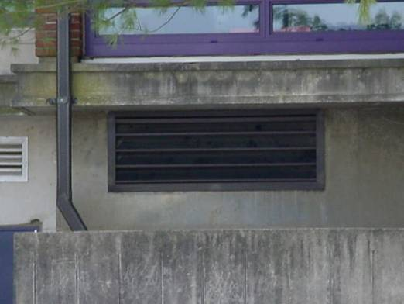

Outside Air Intake for Mechanical Ventilation System

Picture 2

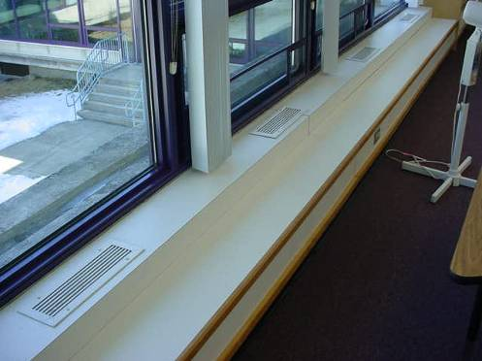

Supply Vents along Exterior Wall of Classroom
Picture 3

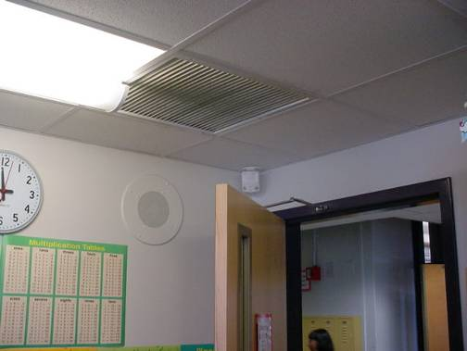

Ceiling-Mounted Return Vent, Note Dust Accumulation and Proximity
to Open Classroom/Hallway Door

Picture 4

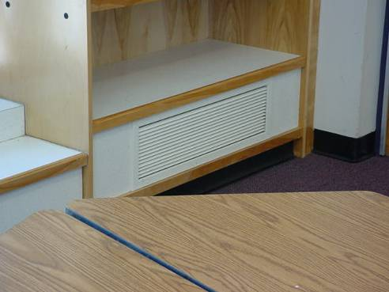

Wall-Mounted Return Vent
Picture 5

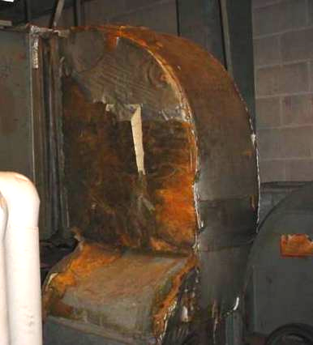

Missing/Damaged Insulation around Ductwork in Lobby Fan Room

Picture 6

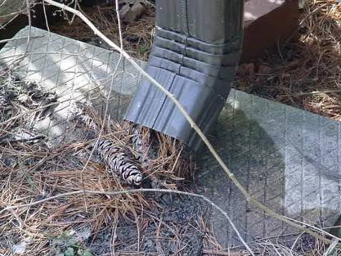

Downspout Clogged with Pine Needles and Other Debris
Picture 7

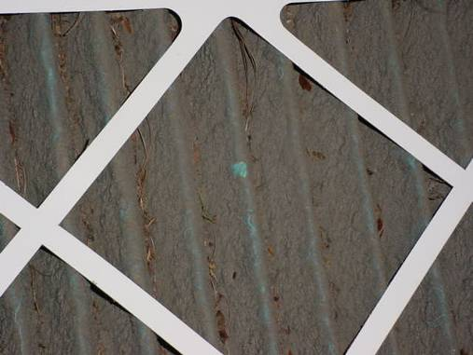

Filter Clogged with Dust and Debris in Lobby Fan Room

Picture 8

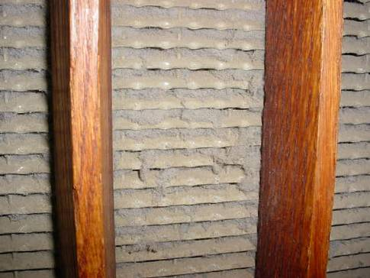

Dust Accumulation in Gymnasium Exhaust Vent
Location/ Room | Occupants  in Room | Temp  (°F) | Relative  Humidity  (%) | Carbon  Dioxide  (ppm) | Carbon Monoxide  (ppm) | TVOCs  (ppm) | PM2.5  (µg/m3) | Windows  Openable | Ventilation |  | Remarks
 |  |  |  |  |  |  |  |  | Supply | Exhaust | Remarks
background |  | 40 | 13 | 413 | ND | ND | 8
211 | 0 | 71 | 11 | 589 | ND | ND | 4 | Y | Y | Y | DO, DEM
201 | 23 | 71 | 15 | 1013 | ND | ND | 2 | Y | Y | Y | Window open, supply and exhaust weak, DEM, accumulated items
Lobby Fan Room |  |  |  |  |  |  |  |  |  |  | Damaged insulation around ductwork, pleated filters-occluded dust/debris
202 | 21 | 73 | 15 | 1024 | ND | ND | 3 | Y | Y | Y | Exhaust-dust/debris, DEM, accumulated items
203 | 22 | 73 | 15 | 958 | ND | ND | 4 | Y | Y | Y | DEM, accumulated items, DO, CD, PF
200 | 0 | 74 | 12 | 721 | ND | ND | 1 | Y | Y | Y | Food use/storage, accumulated items
204 | 2 | 75 | 12 | 767 | ND | ND | 2 | Y | Y | Y | Window open, DO, DEM
244 | 2 | 74 | 14 | 1119 | ND | ND | 2 | Y | N | N
205 | 2 | 74 | 13 | 810 | ND | ND | 3 | Y | Y | Y | DO, DEM
207 | 22 | 74 | 17 | 1061 | ND | ND | 5 | Y | Y | Y | Supply and exhaust obstructed by boxes/furniture, DEM, cleaning products, food use/storage
208 | 26 | 74 | 19 | 1392 | ND | ND | 5 | Y | Y | Y | Supply and exhaust obstructed by boxes/items/furniture, DEM, cleaning products, food use/storage, accumulated items, DO
209 | 20 | 73 | 13 | 846 | ND | ND | 5 | Y | Y | Y | Supply and exhaust obstructed by boxes/items, DEM, DO, pets, PF, stuffed animals
Conference Room | 0 | 74 | 11 | 520 | ND | ND | 2 | Y | Y | Y | DO, exhaust-dust/debris
220 | 0 | 70 | 18 | 488 | ND | ND | 6 | Y | Y | Y | Exhaust-weak, DEM, accumulated items
219 | 22 | 71 | 20 | 869 | ND | ND | 15 | Y | Y | Y | DEM, cleaning products, accumulated items
Cafeteria | ~300 | 75 | 15 | 820 | ND | ND | 5 | Y | Y | Y | DO
Science | 3 | 75 | 10 | 793 | ND | ND | 3 | Y | Y |  | DO, taxidermy, plants, nests, pets
Animal Care | 0 | 76 | 11 | 417 | ND | ND | 3 |  | Y | Y | DO, water cooler over carpet
218 | 19 | 72 | 17 | 718 | ND | ND | 5 | Y | Y | Y | DO, DEM, PF, cleaning products, accumulated items
217 | 17 | 73 | 17 | 697 | ND | ND | 6 | Y | Y | Y | DO, DEM, PF, accumulated items
Guidance Office | 1 | 71 | 19 | 650 | ND | ND | 6 | Y | N | N | DO, plants
216 | 0 | 74 | 16 | 580 | ND | ND | 6 | Y | Y | N | DEM, accumulated items
215 | 0 | 74 | 16 | 577 | ND | ND | 7 | Y | Y | N | DO, DEM
214 | 0 | 74 | 16 | 657 | ND | ND | 5 | Y | Y | Y | 24 occupants gone ~ 20 mins., PF, cleaning products, accumulated items, pets
213 | 25 | 73 | 18 | 873 | ND | ND | 9 | Y | Y | Y | DEM, PF, DO
222 | 0 | 73 | 18 | 906 | ND | ND | 4 |  | Y | Y | Exhaust vent-dust/debris, occupants @ lunch, DEM
221 | 19 | 72 | 20 | 1230 | ND | ND | 8 | Y | Y | Y | Exhaust vent-dust/debris, DEM
212 | 17 | 73 | 18 | 815 | ND | ND | 7 | Y | Y | Y | DEM, DO
210 | 1 | 72 | 16 | 740 | ND | ND | 6 | Y | Y | Y | 22 occupants gone ~20 mins, DEM
Media Center | 0 | 75 | 16 | 492 | ND | ND | 5 | Y | Y | Y | Plants on paper towels, DO
306 | 3 | 75 | 17 | 614 | ND | ND | 7 | Y | Y | Y | DO, exhaust partially obstructed by items, DEM, breach sink/countertop
305 | 0 | 75 | 12 | 510 | ND | ND | 2 | Y | Y | Y | Exhaust-dust/debris, DO, breach sink/countertop
307 | 0 | 75 | 13 | 572 | ND | ND | 3 |  | Y | Y | Cleaning products, food container re-use, pets, breach sink/countertop
308 | 18 | 76 | 19 | 846 | ND | ND | 12 | Y | Y | Y
Custodial Supply Closet | 0 | 77 | 11 | 660 | ND | ND | 9 | N | N | N | Odors of cleaning chemicals/equipment, dust treatments in science center hallway
Auditorium | 0 | 72 | 16 | 523 | ND | ND | 8 | N | Y | Y
Music | 24 | 72 | 18 | 799 | ND | ND | 8 | Y | Y | Y | 20 occupants gone ~ 30 mins
100 | 23 | 75 | 15 | 730 | ND | ND | 6 | Y | Y | Y | Exhaust not operating, two windows open, DO, DEM
101 | 20 | 77 | 17 | 623 | ND | ND | 10 | Y | Y | Y | Pets, DO
102 | 22 | 78 | 16 | 789 | ND | ND | 5 | Y | Y | Y | DEM, DO
103 | 1 | 77 | 14 | 617 | ND | ND | 5 | Y | Y | Y | Window open, DEM, PF, 23 occupants gone ~ 40 mins
104 | 4 | 76 | 15 | 778 | ND | ND | 8 | Y | Y |  | DEM
105 | 0 | 74 | 16 | 789 | ND | ND | 10 | Y | Y |  | DEM, DO
106 | 23 | 76 | 20 | 1154 | ND | ND | 10 | Y | Y | Y | Passive door vent, window open
107 | 22 | 75 | 20 | 1137 | ND | ND | 8 | Y | Y | Y | DEM
108 | 0 | 74 | 17 | 709 | ND | ND | 7 | Y | Y | Y | DEM, pets, DO
136 | 11 | 74 | 17 | 924 | ND | ND | 6 | Y | Y | Y | 1-dislodged CT, DEM, DO
112 | 17 | 76 | 18 | 920 | ND | ND | 7 | Y | Y | Y
132 rest room |  |  |  |  |  |  |  |  | N | Y | Floor drain occasional odors reported
118 | 1 | 74 | 9 | 469 | ND | ND | 2 | Y | Y | Y | Supply and exhaust obstructed by furniture and other items, DEM, DO
117 | 0 | 76 | 9 | 443 | ND | ND | 3 | Y | Y | Y | DO, WP
120 | 19 | 75 | 12 | 607 | ND | ND | 2 | Y | Y | Y | Exhaust-dust/debris, AP, DEM, cleaning products, items hung from CT system
119 | 21 | 75 | 10 | 566 | ND | ND | 2 | Y | Y | Y | Exhaust vent-dust/debris, items hung from CT system
Speech (outer) | 2 | 76 | 9 | 581 | ND | ND | 1 | Y | Y | Y | DO, supply obstructed by boxes, exhaust vent-dust/debris, DEM
Speech (inner) | 0 | 75 | 7 | 433 | ND | ND | 2 | Y | Y | Y | Window open, DO
114 | 7 | 72 | 11 | 554 | ND | ND | 2 | Y | Y | Y | CD, dust accumulation-flat surfaces, accumulated items, DEM
113 | 20 | 74 | 11 | 533 | ND | ND | 4 | Y | Y | Y | PF, cleaning products
109 | 0 | 75 | 10 | 563 | ND | ND | 2 | Y | Y | Y | Breach sink/countertop, exhaust obstructed by furniture
110 | 17 | 75 | 11 | 692 | ND | ND | 3 | Y | Y | Y | Exhaust vent obstructed by boxes, accumulated items, food container re-use/storage
111 | 6 | 74 | 11 | 654 | ND | ND | 2 | Y | Y | Y | Window open, supply and exhaust obstructed by items
Gym | 22 | 72 | 13 | 643 | ND | ND | 10 | N | Y | Y | Exhaust dust/debris

Material/Comments | Moisture Measurements
Carpeting | North  Left – Low  Right – Low  Center - Low  South  Left – Low  Right – Low  Center - Low  East  Left – Low  Right – Low  Center - Low  West  Left – Low  Right – Low  Center - Low  Center – Low
Wooden trim/shelving | North  Left – Low  Right – Low  Center - Low  South  Left – Low  Right – Low  Center - Low  East  Left – Low  Right – Low  Center - Low  West  Left – Low  Right – Low  Center - Low

