INDOOR AIR QUALITY ASSESSMENT
INCIDENT RESPONSE

Newman Elementary School
1155 Central Street
Needham, Massachusetts 02492



Prepared by:
Massachusetts Department of Public Health
Bureau of Environmental Health
Indoor Air Quality Program
October 2008

Background/Introduction
On the morning of September 22, 2008, the Massachusetts Department of Public Health (MDPH) Bureau of Environmental Health (BEH) was asked to provide immediate assistance regarding an indoor air quality incident related to an oil spill in the boiler room at the Newman Elementary School (NES) in Needham, Massachusetts. MDPH has been working with parents, schools, and health officials in addressing unrelated indoor air quality issues at the NES for the past year. Sometime between 3:30 PM Sunday September 21, 2008 and 7:30 AM Monday September 22, 2008, a switch reportedly failed in a hot water heater pump leading to excessive amounts of oil overflowing a containment reservoir. As a result, a small amount of #2 fuel oil seeped onto the concrete floor of the boiler room (Picture 1).
Cory Holmes, Environmental Analyst/Regional Indoor Air Quality (IAQ) Inspector in BEH’s IAQ Program, arrived on-scene at the NES to perform an IAQ assessment at approximately 9:00 AM on September 22, 2008. Also on-scene were Janice Burns, Director of Public Health, Needham Health Department; a representative for Fuss and O’Neill EnviroScience, the school’s environmental consultant; Chip Laffey, Needham Director of Public Facilities; Paul Buckley, Chief, Needham Fire Department; and Steve Ross, Environmental Analyst for the Massachusetts Department of Environmental Protection. On September 23, 2008, Mr. Holmes, along with Fuss and O’Neill, returned to the NES to examine clean-up efforts in the boiler room and conduct follow-up testing prior to school opening.

Methods
Screening for total volatile organic compounds (TVOCs) was conducted using a Thermo Environmental Instruments Inc., Model 580 Series Photo Ionization Detector (PID). BEH staff also performed a visual inspection of the boiler room and surrounding areas for pathways of odor migration. Test results appear in Tables 1 and 2.

Discussion/Results
Total Volatile Organic Compounds (TVOCs)
TVOCs are carbon-containing substances that have the ability to evaporate at room temperature. Frequently, exposure to low levels of total VOCs may produce eye, nose, throat and/or respiratory irritation in some sensitive individuals.
Outdoor TVOC concentrations on September 22, 2008, were non-detect (ND) (Table 1). Although slight odors were detected in areas adjacent to the boiler room (hallway/stairwell, gymnasium and parts of the cafeteria near the stairwell) no measurable levels of TVOCs were detected. Low levels of TVOCs were detected in the lower level of the boiler room (2-4) ppm; measurements were taken at the breathing zone at a height of approximately 3-5 feet. Higher readings recorded were in the upper portion of the boiler room near the spill (4-6 ppm). The highest readings were recorded from a floor drain (Picture 2) that fuel oil had seeped into (285 ppm); this measurement was taken directly at floor level. The drain was covered with a rubber membrane temporarily to reduce odors. In an effort to direct odors away from occupied areas of the building, BEH staff instructed NES maintenance staff to set up fans in and around the boiler room and out an exterior door to place it under negative pressure.
Needham maintenance staff conducted cleaning and remediation of affected areas overnight. The next morning, an inspection of the affected areas the next morning showed that all of the oil collected in the reservoir had been drained and the spillage and absorbent material on the boiler room floor was removed (Pictures 3 to 5). Efforts to remove oil from the saturated concrete floor were largely successful. Outdoor TVOC concentrations on September 23, 2008, were ND (Table 2). Follow-up testing inside the building indicated that no measurable levels of TVOCs were detected in any areas outside the boiler room. A TVOC measurement of 16 ppm was detected at floor level near an area with residual staining (Pictures 4 and 5). Finally, an elevated TVOC measurement of 112 ppm was detected at the floor drain when the rubber mat covering the drain was removed (Picture 6). This measurement was reduced in half compared to the previous day (285 ppm). However, the drain will continue to provide a source of odors and VOCs until further cleaning can be conducted.

Conclusions/Recommendations
In view of the findings at the time of the assessment, the following recommendations are made:
- Continue to keep floor drain covered until further cleaning is conducted. Seal rubber membrane “cover” with duct tape to create an airtight seal.
- Clean floor drain and residual staining on concrete floor with an appropriate detergent/emulsifier and nylon bristle brush. Clean, rinse and repeat as necessary.
- Clean residual oil from surface of switch pump and overflow reservoir.
Picture 1

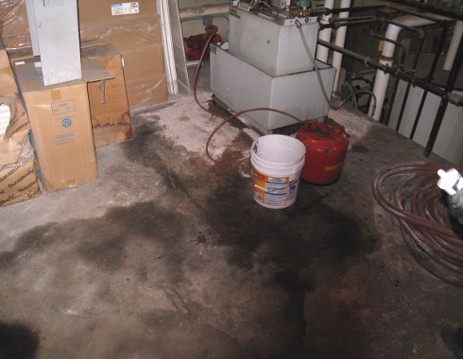

Water Heater Pump and Overflow Reservoir, Note Oil-Stained Concrete Floor in Foreground

Picture 2

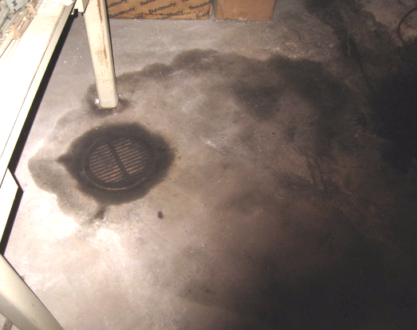

Floor Drain and Oil-Stained Concrete
Picture 3

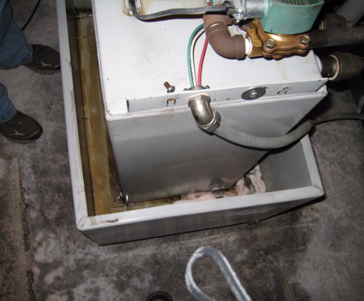

Overflow Reservoir Drained of Oil, Note Residual Staining on Concrete Floor

Picture 4
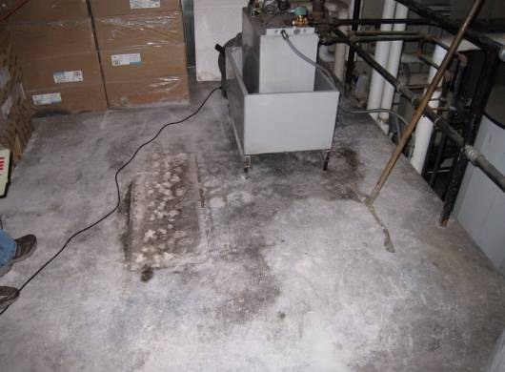

Boiler Room Floor Post Clean-up, Note Residual Staining
Picture 5

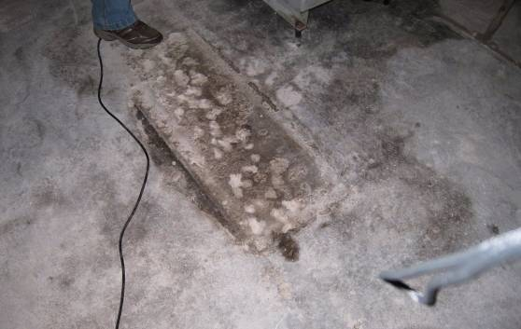

Close-Up of Residual Staining on Concrete Floor

Picture 6

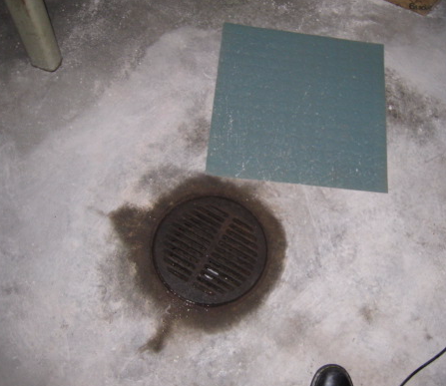

Oil-Stained Concrete around Floor Drain
Table 1

Total Volatile Organic Compounds (TVOCs)
Newman Elementary School, Needham MA
September 22, 2008

Location | TVOCs (ppm*) | Remarks
Outside Front of Building | ND** | Cool, cloudy, winds NE 10-16 mph
West Wing Corridor | ND
West Wing Walkway/Overpass | ND
Cafeteria | ND | Doors to stairway leading to boiler room/gym hallway open, windows open
Ground Floor Hallway (outside Boiler Room) | ND
Gym | ND | Exterior/interior doors open
Main Boiler Room (lower level) | 2-4
Upper level of Boiler Room | 4-6 | Concrete floor saturated with oil/absorbent material
Floor Drain | 285 | Drain filled with oil/measurement taken directly  at floor level
Outside Boiler Room Exterior Door | ND
Science Center | ND

*ppm = parts per million of air
**ND = non-detect

Table 2

Total Volatile Organic Compounds (TVOCs)
Newman Elementary School, Needham MA
September 23, 2008

Location | TVOCs (ppm*) | Remarks
Outside Front of Building | ND** | Cool, clear skies, winds light and variable
West Wing Corridor | ND
West Wing Walkway/Overpass | ND
Cafeteria | ND | Doors to stairway leading to boiler room/gym hallway open, windows open
Ground Floor Hallway (outside Boiler Room) | ND
Gym | ND | Exterior/interior doors open
Main Boiler Room (lower level) | ND
Upper level of Boiler Room | ND
Residual Stained Concrete Floor Upper Level  (near Overflow Reservoir) | 16 | Measurement taken directly at floor level of residual staining
Floor Drain | 112 | Concrete around drain stained with oil, measurement taken directly at floor level of drain
Outside Boiler Room Exterior Door | ND
Hallway outside of Science Center | ND
Administrative Offices | ND

*ppm = parts per million of air
**ND = non-detect

