INDOOR AIR QUALITY REASSESSMENT

Newman Elementary School
1155 Central Street
Needham, Massachusetts 02492

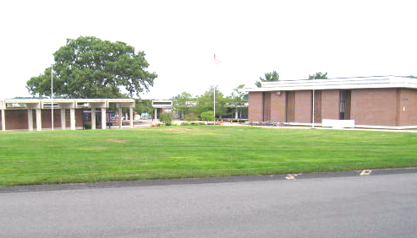

Prepared by:
Massachusetts Department of Public Health
Bureau of Environmental Health
Indoor Air Quality Program
January 2009

Background/Introduction
At the request of Superintendant Dan Gutekanst and the Newman School’s Indoor Air Quality (IAQ) Team, the Massachusetts Department of Public Health (MDPH), Bureau of Environmental Health (BEH) visited the Newman Elementary School (NES) to conduct a follow-up IAQ assessment. The purpose of this assessment was to evaluate on-going efforts to monitor and improve IAQ at the NES. On November 5, 2008, a visit to conduct an IAQ assessment was made by Cory Holmes and Sharon Lee, Environmental Analysts/Indoor Air Quality Inspectors for BEH’s IAQ Program.

Methods
Air tests for carbon dioxide, carbon monoxide, temperature and relative humidity were conducted with the TSI, Q-TRAK™ IAQ Monitor, Model 7565/8554. Air tests for airborne particle matter with a diameter less than 2.5 micrometers were taken with the TSI, DUSTTRAK™ Aerosol Monitor Model 8520. Screening for total volatile organic compounds (TVOCs) was conducted using a Thermo Environmental Instruments Inc., Model 580 Series Photo Ionization Detector (PID). BEH staff also performed a visual inspection of building materials for water damage and/or microbial growth.

Results
The NES currently houses grades kindergarten through 5th, with a student population of approximately 720 and a staff of approximately 50 to 60. Tests were taken under normal operating conditions and results appear in Tables 1 and 2.

Discussion

Ventilation

It can be seen from Table 1 that carbon dioxide levels were above 800 parts per million (ppm) in 4 of 24 areas surveyed in the East Wing, indicating adequate ventilation in the majority of areas surveyed during the assessment (Table 1). Mechanical ventilation in the East Wing is currently being provided by a temporary HVAC system installed along the perimeter of the building (Pictures 1 through 4).
Carbon dioxide levels in the West Wing were above 800 ppm in of 31 of 51 areas (Table 2) indicating poor air exchange in more than half of the areas surveyed during the assessment. It is important to note that while efforts have been made to improve ventilation in the West Wing, the original mechanical ventilation system remains in operation. However, over the last several months the town of Needham has commissioned an HVAC feasibility study, which was recently completed. The study details a number of HVAC options, all of which recommend removal or abandonment of the existing mechanical ventilation system (Newman HVAC Study, 2008).
To maximize air exchange, the MDPH recommends that both supply and exhaust ventilation operate continuously during periods of school occupancy. In order to have proper ventilation with a mechanical supply and exhaust system, the systems must be balanced to provide an adequate amount of fresh air to the interior of a room while removing stale air from the room. It is recommended that HVAC systems be re-balanced every five years to ensure adequate air systems function (SMACNA, 1994).
The Massachusetts Building Code requires that each room have a minimum ventilation rate of 15 cubic feet per minute (cfm) per occupant of fresh outside air or openable windows (SBBRS, 1997; BOCA, 1993). The ventilation must be on at all times that the room is occupied. Providing adequate fresh air ventilation with open windows and maintaining the temperature in the comfort range during the cold weather season is impractical. Mechanical ventilation is usually required to provide adequate fresh air ventilation.
Carbon dioxide is not a problem in and of itself. It is used as an indicator of the adequacy of the fresh air ventilation. As carbon dioxide levels rise, it indicates that the ventilating system is malfunctioning or the design occupancy of the room is being exceeded. When this happens, a buildup of common indoor air pollutants can occur, leading to discomfort or health complaints. The Occupational Safety and Health Administration (OSHA) standard for carbon dioxide is 5,000 parts per million parts of air (ppm). Workers may be exposed to this level for 40 hours/week, based on a time-weighted average (OSHA, 1997).
The MDPH uses a guideline of 800 ppm for publicly occupied buildings. A guideline of 600 ppm or less is preferred in schools due to the fact that the majority of occupants are young and considered to be a more sensitive population in the evaluation of environmental health status. Inadequate ventilation and/or elevated temperatures are major causes of complaints such as respiratory, eye, nose and throat irritation, lethargy and headaches. For more information concerning carbon dioxide, consult Appendix A.
Temperature measurements the day of the assessment ranged from 68º F to 78º F in the East Wing (Table 1) and from 71º F to 74º F in the West Wing (Table 2). These temperatures were within or very close to the MDPH recommended comfort range. The MDPH recommends that indoor air temperatures be maintained in a range of 70º F to 78º F in order to provide for the comfort of building occupants. In many cases concerning indoor air quality, fluctuations of temperature in occupied spaces are typically experienced, even in a building with an adequate fresh air supply.
The relative humidity measured in the building ranged from 43 to 59 percent in the East Wing (Table 1) and 46 to 54 percent in the West Wing (Table 2), which were within the MDPH recommended comfort range in all areas on the day of the assessment. The MDPH recommends a comfort range of 40 to 60 percent for indoor air relative humidity. Relative humidity levels in the building would be expected to drop during the winter months due to heating. The sensation of dryness and irritation is common in a low relative humidity environment. Low relative humidity is a very common problem during the heating season in the northeast part of the United States.

Other IAQ Evaluations
Indoor air quality can be negatively influenced by the presence of respiratory irritants, such as products of combustion. The process of combustion produces a number of pollutants. Common combustion emissions include carbon monoxide, carbon dioxide, water vapor and smoke (fine airborne particle material). Of these materials, exposure to carbon monoxide and particulate matter with a diameter of 2.5 micrometers (μm) or less (PM2.5) can produce immediate, acute health effects upon exposure. To determine whether combustion products were present in the school environment, BEH staff obtained measurements for carbon monoxide and PM2.5.

Carbon Monoxide
Carbon monoxide is a by-product of incomplete combustion of organic matter (e.g., gasoline, wood and tobacco). Exposure to carbon monoxide can produce immediate and acute health affects. Several air quality standards have been established to address carbon monoxide and prevent symptoms from exposure to these substances. The MDPH established a corrective action level concerning carbon monoxide in ice skating rinks that use fossil-fueled ice resurfacing equipment. If an operator of an indoor ice rink measures a carbon monoxide level over 30 ppm, taken 20 minutes after resurfacing within a rink, that operator must take actions to reduce carbon monoxide levels (MDPH, 1997).
The American Society of Heating Refrigeration and Air-Conditioning Engineers (ASHRAE) has adopted the National Ambient Air Quality Standards (NAAQS) as one set of criteria for assessing indoor air quality and monitoring of fresh air introduced by HVAC systems (ASHRAE, 1989). The NAAQS are standards established by the US EPA to protect the public health from six criteria pollutants, including carbon monoxide and particulate matter (US EPA, 2006). As recommended by ASHRAE, pollutant levels of fresh air introduced to a building should not exceed the NAAQS levels (ASHRAE, 1989). The NAAQS were adopted by reference in the Building Officials & Code Administrators (BOCA) National Mechanical Code of 1993 (BOCA, 1993), which is now an HVAC standard included in the Massachusetts State Building Code (SBBRS, 1997). According to the NAAQS, carbon monoxide levels in outdoor air should not exceed 9 ppm in an eight-hour average (US EPA, 2006).
Carbon monoxide should not be present in a typical, indoor environment. If it is present, indoor carbon monoxide levels should be less than or equal to outdoor levels. On the day of assessment, outdoor carbon monoxide concentrations were non-detect (ND) (Tables 1 and 2). No levels of carbon monoxide were detected inside the building (Tables 1 and 2).
Particulate Matter (PM2.5)
The US EPA has established NAAQS limits for exposure to particulate matter. Particulate matter is airborne solids that can be irritating to the eyes, nose and throat. The NAAQS originally established exposure limits to particulate matter with a diameter of 10 μm or less (PM10). According to the NAAQS, PM10 levels should not exceed 150 microgram per cubic meter (μg/m³) in a 24-hour average (US EPA, 2006). These standards were adopted by both ASHRAE and BOCA. Since the issuance of the ASHRAE standard and BOCA Code, US EPA established a more protective standard for fine airborne particles. This more stringent PM2.5 standard requires outdoor air particle levels be maintained below 35 μg/m³ over a 24-hour average (US EPA, 2006). Although both the ASHRAE standard and BOCA Code adopted the PM10 standard for evaluating air quality, MDPH uses the more protective PM2.5 standard for evaluating airborne particulate matter concentrations in the indoor environment.
Outdoor PM2.5 concentrations were measured at 25 μg/m³ (Tables 1 and 2). PM2.5 levels ranged from 1 to 19 μg/m³ in the East Wing (Table 1) and from 2 to 21 μg/m³ in the West Wing (Table 2). Hence PM2.5 levels were below the NAAQS PM2.5 level of 35 μg/m³ both outdoors and indoors. Frequently, indoor air levels of particulates (including PM2.5) can be at higher levels than those measured outdoors. A number of mechanical devices and/or activities that occur in schools can generate particulate during normal operations. Sources of indoor airborne particulates may include but are not limited to particles generated during the operation of fan belts in the HVAC system, cooking in the cafeteria stoves and microwave ovens; use of photocopiers, fax machines and computer printing devices; operation of an ordinary vacuum cleaner and heavy foot traffic indoors.

Total Volatile Organic Compounds (TVOCs)
Indoor air concentrations can be greatly impacted by the use of products containing volatile organic compounds (VOCs). VOCs are carbon-containing substances that have the ability to evaporate at room temperature. Frequently, exposure to low levels of total VOCs (TVOCs) may produce eye, nose, throat and/or respiratory irritation in some sensitive individuals. For example, chemicals evaporating from a paint can stored at room temperature would most likely contain VOCs. In an effort to determine whether measurable levels of VOCs were present in the building, air monitoring for TVOCs was conducted. Outdoor air samples were taken for comparison. Outdoor TVOC concentrations were ND (Tables 1 and 2). No levels of TVOCs were detected indoors in either the East or West Wings (Tables 1 and 2).
In September 2008, BEH IAQ staff responded to a #2 fuel oil spill that occurred in the boiler. This spill occurred in the boiler room and not in an occupied area of the building. Despite initial clean-up efforts by Needham DPW and maintenance staff, residual oil stains were observed on concrete (Pictures 5 and 6) and measurable levels of TVOCs were detected on the boiler room floor during the September 2008 visit (MDPH, 2008). BEH staff examined the boiler room during the most recent assessment and found that the residual staining had been cleaned (Pictures 7 and 8), with no measurable levels of TVOCs from the areas formerly stained with oil in the boiler room (Table 1).

Conclusions/Recommendations
In view of the findings at the time of the assessment, the following recommendations are made to further improve indoor air quality:
- Continue with efforts to implement previous MDPH and HVAC Team recommendations.
- Develop an Operation and Maintenance (O&M) Plan to monitor outdoor temporary HVAC components and, in particular, mastic/seals between ductwork to ensure/maintain integrity.
- Use portable fans and openable windows in conjunction with mechanical ventilation to introduce fresh air and facilitate air exchange. Care should be taken to ensure windows are properly closed at night and weekends during winter months to avoid the freezing of pipes and potential flooding.
- Consider adopting the US EPA (2000) document, “Tools for Schools”, as an instrument for maintaining a good indoor air quality environment in the building. This document is available at: http://www.epa.gov/iaq/schools/index.html.
- Refer to resource manual and other related indoor air quality documents located on the MDPH’s website for further building-wide evaluations and advice on maintaining public buildings. These documents are available at: http://mass.gov/dph/indoor_air.
References
ASHRAE. 1989. ASHRAE Standard: Ventilation for Acceptable Indoor Air Quality. Sections 5.11, 5.12. American Society of Heating, Refrigerating and Air-Conditioning Engineers, Inc. Atlanta, GA.
BOCA. 1993. The BOCA National Mechanical Code/1993. 8th ed. Building Officials and Code Administrators International, Inc., Country Club Hill, IL.
MDPH. 1997. Requirements to Maintain Air Quality in Indoor Skating Rinks (State Sanitary Code, Chapter XI). 105 CMR 675.000. Massachusetts Department of Public Health, Boston, MA.

MDPH. 2008. Indoor Air Quality Assessment, Incident Response. Newman Elementary School, Needham, MA. Massachusetts Department of Public Health, Bureau of Environmental Health, Boston, MA. September 2008.

Newman HVAC Study. 2008. Newman Elementary School, Needham, MA. HVAC and Building Upgrades Feasibility Study. November 18, 2008.
OSHA. 1997. Limits for Air Contaminants. Occupational Safety and Health Administration. Code of Federal Regulations. 29 C.F.R 1910.1000 Table Z-1-A.
SBBRS. 1997. Mechanical Ventilation. State Board of Building Regulations and Standards. Code of Massachusetts Regulations. 780 CMR 1209.0.
SMACNA. 1994. HVAC Systems Commissioning Manual. 1st ed. Sheet Metal and Air Conditioning
US EPA. 2006. National Ambient Air Quality Standards (NAAQS). US Environmental Protection Agency, Office of Air Quality Planning and Standards, Washington, DC. http://www.epa.gov/air/criteria.html.
Picture 1

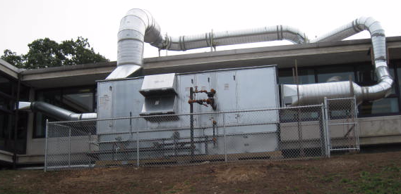

Temporary HVAC System for East Wing

Picture 2

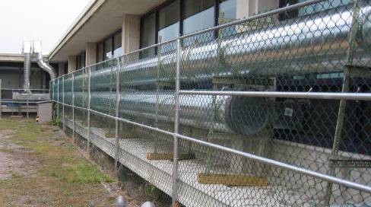

Temporary HVAC System for East Wing
Picture 3

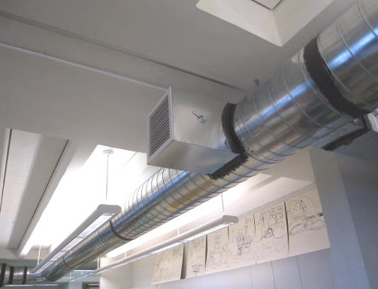

Supply Vent for the Temporary HVAC System for East Wing

Picture 4

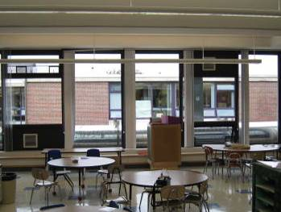
Return
Supply

Supply and Return Vents for the Temporary HVAC System for East Wing
Picture 5
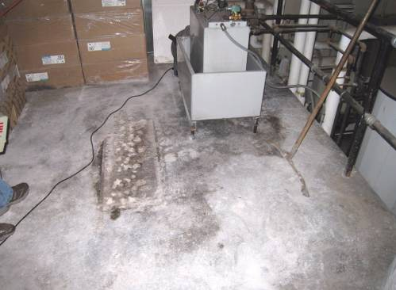

Boiler Room Floor Post Clean-up, Note Residual Staining (Picture Taken September 23, 2008)

Picture 6

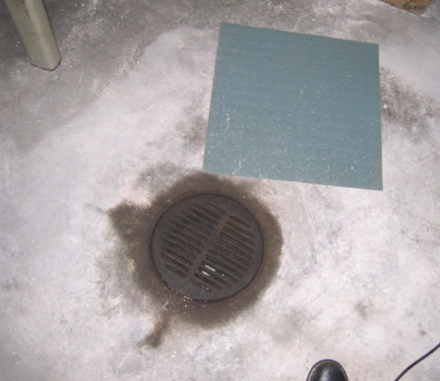

Residual Oil-Staining on Concrete around Floor Drain (Picture Taken September 23, 2008)
Picture 7

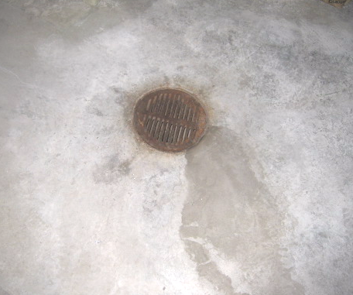

Residual Oil Staining on Concrete Cleaned (Picture Taken November 5, 2008)

Picture 8

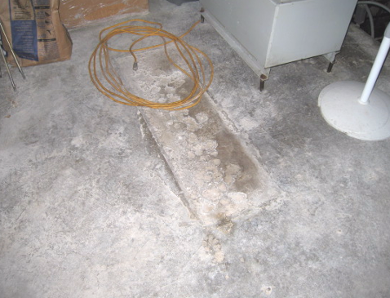

Residual Oil Staining on Concrete Cleaned (Picture Taken November 5, 2008)
Location/ Room | Occupants  in Room | Temp  (°F) | Relative  Humidity  (%) | Carbon  Dioxide  (ppm) | Carbon Monoxide  (ppm) | PM2.5  (µg/m³) | TVOCs  (ppm) | Windows  Openable | Ventilation |  | Remarks
 |  |  |  |  |  |  |  |  | Supply | Exhaust | Remarks
Background |  | 55 | 71 | 405 | ND | 25 | ND |  |  |  | Cool, overcast
Auditorium | 25 | 68 | 53 | 557 | ND | 7 | ND | N | Y | Y
Boiler room | 0 | 73 | 59 | 592 | ND | 16 | ND | N | N | N
Cafeteria | 100 | 69 | 57 | 604 | ND | 7 | ND | Y | Y | Y | DO
Conference room | 0 | 75 | 43 | 664 | ND | 2 | ND | Y | Y | Y | DO, DEM
Gym | 2 | 68 | 57 | 589 | ND | 13 | ND | N | Y | Y
Main office | 4 | 77 | 43 | 642 | ND | 2 | ND | N | Y | Y | DO, DEM
Media Center | 23 | 74 | 50 | 687 | ND | 3 | ND | Y | Y | Y | DO
Music room | 17 | 70 | 57 | 776 | ND | 13 | ND | Y | Y | Y
NEAT Center | 20 | 74 | 48 | 795 | ND | 5 | ND | Y | Y | Y | DO, Plants, AC
Principal’s office | 4 | 77 | 43 | 606 | ND | 1 | ND | Y | Y | Y | DO
Science center animal room | 0 | 70 | 57 | 638 | ND | 9 | ND | N | Y | Y
Science center office | 3 | 69 | 57 | 429 | ND | 10 | ND | Y | Y | Y | Exterior door open, nest
Teachers’ lounge | 0 | 70 | 53 | 557 | ND | 2 | ND | N | Y | Y | DO
177 | 2 | 68 | 56 | 670 | ND | 13 | ND | N | Y | Y | Passive door vent
305 | 20 | 69 | 53 | 1039 | ND | 6 | ND | Y | Y | Y  Dusty
306 | 23 | 69 | 52 | 1052 | ND | 10 | ND | Y | Y | Y
307 | 5 | 69 | 53 | 1029 | ND | 6 | ND | Y | Y | Y  Dusty
308 | 1 | 69 | 53 | 920 | ND | 7 | ND | Y | Y | Y | 22 occupants left 20 minutes prior to assessment, plants
311 | 6 | 68 | 57 | 675 | ND | 13 | ND | Y  1/1 open | Y | Y
314 (Office) | 0 | 74 | 47 | 668 | ND | 3 | ND | N | N | N | DO
332 | 0 | 69 | 55 | 586 | ND | 16 | ND | Y | Y | Y
377 | 23 | 78 | 47 | 752 | ND | 11 | ND | Y | Y | Y | DO, Plants, toaster oven, cleaners
404 | 0 | 69 | 54 | 706 | ND | 9 | ND | Y  2/2 open | Y | Y | DO, 4 WD-CT
408 | 1 | 68 | 56 | 637 | ND | 19 | ND | N | Y | Y | DO
409 | 0 | 68 | 56 | 685 | ND | 12 | ND | N | Y | Y | DO

Location/ Room | Occupants  in Room | Temp  (°F) | Relative  Humidity  (%) | Carbon  Dioxide  (ppm) | Carbon Monoxide  (ppm) | PM2.5  (µg/m³) | TVOCs  (ppm) | Windows  Openable | Ventilation |  | Remarks
 |  |  |  |  |  |  |  |  | Supply | Exhaust | Remarks
Background |  | 55 | 71 | 405 | ND | 25 | ND |  |  |  | Cool, overcast
100 | 18 | 73 | 53 | 883 | ND | 6 | ND | Y | Y | Y | PF
101 | 2 | 73 | 50 | 798 | ND | 6 | ND | Y | Y | Y
102 | 20 | 71 | 51 | 580 | ND | 13 | ND | Y | Y | Y | DO
103 | 20 | 72 | 51 | 1020 | ND | 14 | ND | Y | Y | Y | DO
104 | 1 | 71 | 50 | 862 | ND | 4 | ND | Y | Y  blocked | Y | DO
105 | 0 | 72 | 48 | 800 | ND | 14 | ND | Y | Y | Y | DO
106 | 17 | 73 | 50 | 1150 | ND | 9 | ND | Y | Y | Y | Passive door vent
107 | 0 | 74 | 47 | 900 | ND | 9 | ND | Y | Y | Y | DO
108 | 17 | 74 | 48 | 1020 | ND | 14 | ND | Y | Y | Y | DO
109 | 0 | 71 | 50 | 822 | ND | 11 | ND | Y | Y | Y | DO
110 | 0 | 71 | 49 | 750 | ND | 12 | ND | Y | Y | Y | DO
111 | 0 | 71 | 49 | 700 | ND | 14 | ND | Y | Y | Y | DO
112 | 1 | 72 | 48 | 620 | ND | 12 | ND | Y | Y | Y | Plants
113 | 26 | 71 | 53 | 557 | ND | 11 | ND | Y | Y | Y | exterior DO, DO
114 | 2 | 72 | 49 | 544 | ND | 7 | ND | Y | Y | Y | DO, DEM
117 | 19 | 73 | 52 | 910 | ND | 13 | ND | Y | Y | Y | DO, occupants left 2 mins prior to assessment
118 | 17 | 73 | 52 | 820 | ND | 17 | ND | Y  open | Y | Y | DO
119 | 21 | 72 | 54 | 1130 | ND | 13 | ND | Y | Y | Y | DO
120 | 18 | 71 | 54 | 1250 | ND | 15 | ND | Y | Y | Y | DO
136 | 2 | 72 | 49 | 881 | ND | 3 | ND | Y | Y | Y
152 | 0 | 74 | 49 | 875 | ND | 4 | ND | Y | Y | Y | inter DO, DEM
153 | 1 | 73 | 50 | 904 | ND | 6 | ND | Y | Y | Y
153A | 0 | 72 | 51 | 893 | ND | 6 | ND | Y |  | Y | DO
161 | 2 | 71 | 49 | 787 | ND | 3 | ND | N | Y | Y | DO
162 | 0 | 71 | 49 | 722 | ND | 4 | ND | N | Y | Y
165 | 0 | 71 | 49 | 782 | ND | 2 | ND | N | Y | Y
166 | 0 | 71 | 49 | 787 | ND | 3 | ND | Y | Y | Y | DO
200 | 0 | 73 | 50 | 780 | ND | 10 | ND | Y | Y | Y | DO
201 | 16 | 72 | 51 | 950 | ND | 12 | ND | Y | Y | Y | DO
202 | 20 | 73 | 51 | 954 | ND | 15 | ND | Y | Y | Y | DO
203 | 21 | 73 | 50 | 664 | ND | 12 | ND | Y  2/4 open | Y | Y | DO, PF, DEM, items
204 | 2 | 74 | 51 | 750 | ND | 10 | ND | Y | Y | Y
204A | 0 | 74 | 48 | 805 | ND | 11 | ND | yy | N | N | DO
205 | 0 | 74 | 50 | 770 | ND | 9 | ND | Y | Y | Y
207 | 6 | 74 | 46 | 903 | ND | 2 | ND | Y | Y  books | Y  dusty | DEM, PF, fridge
208 | 26 | 74 | 49 | 1101 | ND | 3 | ND | Y | Y | Y | DO, AP (off, not in use), cleaners
209 | 0 | 72 | 51 | 900 | ND | 18 | ND | Y  open | Y | Y | occ left 2 mins prior to assessment
210 | 21 | 72 | 50 | 950 | ND | 18 | ND | Y  open | Y | Y
211 | 23 | 73 | 50 | 1100 | ND | 20 | ND | Y | Y | Y | plants, PF
212 | 21 | 72 | 51 | 1080 | ND | 21 | ND | Y | Y | Y | DO
213 | 23 | 72 | 50 | 586 | ND | 7 | ND | Y | Y | Y | DO, PF, DEM
214 | 16 | 73 | 52 | 714 | ND | 9 | ND | Y | Y | Y | DEM
215 | 0 | 72 | 50 | 729 | ND | 6 | ND | Y | Y | Y | DO
217 | 0 | 72 | 52 | 1050 | ND | 13 | ND | Y | Y | Y | DO
218 | 21 | 72 | 52 | 1550 | ND | 18 | ND | Y | Y | Y | DO, AP
219 | 23 | 72 | 53 | 1500 | ND | 14 | ND | Y | Y | Y | DO
220 | 5 | 72 | 50 | 1000 | ND | 9 | ND | Y | Y | Y
221 | 20 | 72 | 49 | 1063 | ND | 5 | ND | Y | Y | Y | DEM
222 | 20 | 72 | 51 | 1001 | ND | 4 | ND | Y  2/2 open | Y | Y | DEM
235 | 0 | 72 | 50 | 785 | ND | 11 | ND | N | Y | Y | DO
243 | 2 | 73 | 49 | 1159 | ND | 7 | ND | Y | Y | Y

