INDOOR AIR QUALITY
SUPPLEMENTARY ASSESSMENT

Newman Elementary School
1155 Central Street
Needham, Massachusetts 02492

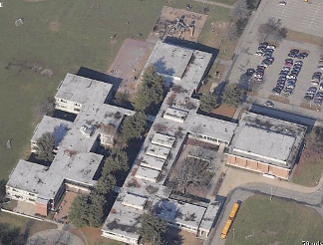

Prepared by:
Massachusetts Department of Public Health
Bureau of Environmental Health
Indoor Air Quality Program
August 2008

Background/Introduction
At the request of faculty members, parents and the Needham School Department (NSD), the Massachusetts Department of Public Health (MDPH) Bureau of Environmental Health (BEH) returned to the Newman Elementary School (NES) to conduct an indoor air quality assessment of selected areas. On June 10, 2008, the NES was visited by Cory Holmes, an Indoor Air Quality (IAQ) Inspector within BEH’s IAQ Program. Areas evaluated include:
- Rooms 161-166, which are a conference room and suite of small offices/rooms that were not previously surveyed;
- Classroom 109, where occupants reported headaches and have since been relocated to the music/performance room (359);
- Music/performance room 359;
- Classroom 221, where an occupant experienced exacerbation of allergic symptoms due to heat sensitivity, lack of air-conditioning, and excessive pollen counts likely entrained into the room; and
- Several general classrooms for comparison.
It is important to note that the assessment occurred on the fourth day of a four-day heat wave (NOAA, 2008), during which several state and federal governmental agencies predicted poor outdoor air quality conditions for the New England area based on elevated heat, humidity, ozone and airborne particulates (MDEP, 2008; NOAA, 2008, AIRNow 2008).

Methods/Results
Air tests were conducted for carbon dioxide, carbon monoxide, temperature and relative humidity with the TSI, Q-TRAK™ IAQ Monitor, Model 8551. Air tests for airborne particle matter with a diameter less than 2.5 micrometers were taken with the TSI, DUSTTRAK™ Aerosol Monitor Model 8520. BEH staff also performed a visual inspection of building materials for water damage and/or microbial growth. Tests were taken during normal operations at the school and results appear in Table 1.

Discussion
Ventilation
It can be seen from Table 1 that carbon dioxide levels were above 800 parts per million (ppm) in of 8 of 16 areas, indicating limited air exchange in several areas surveyed during the assessment. It is important to note that several classrooms had open windows and/or were empty/sparsely populated; either/both of these factors can result in reduced carbon dioxide levels. Carbon dioxide levels would be expected to increase with full occupancy and with windows closed. This increase in carbon dioxide levels was reflected by testing conducted in room 359 prior to (664 ppm) and during occupancy (866 ppm) (Table 1). It is also important to note that rooms 161-166, as well as room 221 are equipped with central air-conditioning, which limits outside air intake on hot, humid days (as was the case during this assessment). Limiting outside air intake can also contribute to an increase in carbon dioxide levels.
As detailed in the previous assessment (MDPH, 2008), mechanical ventilation throughout the NES is provided by air-handling units (AHUs) located in mechanical rooms. This equipment was operating during the assessment with the exception of the return vent in ELC room 114, which was partially obstructed by classroom items due to end of the year packing activities (Picture 1). Room 164 (in the suite of offices 161-166) is an unoccupied storage room that has no mechanical ventilation components.
To maximize air exchange, the MDPH recommends that both supply and exhaust ventilation operate continuously during periods of school occupancy. In order to have proper ventilation with a mechanical supply and exhaust system, the systems must be balanced to provide an adequate amount of fresh air to the interior of a room while removing stale air from the room. It is recommended that HVAC systems be re-balanced every five years to ensure adequate air systems function (SMACNA, 1994). The HVAC systems at NES are scheduled to undergo a detailed evaluation by an HVAC engineering firm over the summer. Based on the age, configuration and physical deterioration of ventilation components, such an evaluation is necessary to determine the operability and feasibility of repairing/replacing the equipment.
The Massachusetts Building Code requires that each room have a minimum ventilation rate of 15 cubic feet per minute (cfm) per occupant of fresh outside air or openable windows (SBBRS, 1997; BOCA, 1993). The ventilation must be on at all times that the room is occupied. Providing adequate fresh air ventilation with open windows and maintaining the temperature in the comfort range during the cold weather season is impractical. Mechanical ventilation is usually required to provide adequate fresh air ventilation.
Carbon dioxide is not a problem in and of itself. It is used as an indicator of the adequacy of the fresh air ventilation. As carbon dioxide levels rise, it indicates that the ventilating system is malfunctioning or the design occupancy of the room is being exceeded. When this happens, a buildup of common indoor air pollutants can occur, leading to discomfort or health complaints. The Occupational Safety and Health Administration (OSHA) standard for carbon dioxide is 5,000 parts per million parts of air (ppm). Workers may be exposed to this level for 40 hours/week, based on a time-weighted average (OSHA, 1997).
The MDPH uses a guideline of 800 ppm for publicly occupied buildings. A guideline of 600 ppm or less is preferred in schools due to the fact that the majority of occupants are young and considered to be a more sensitive population in the evaluation of environmental health status. Inadequate ventilation and/or elevated temperatures are major causes of complaints such as respiratory, eye, nose and throat irritation, lethargy and headaches. For more information concerning carbon dioxide, consult Appendix A.
Temperature measurements in air-conditioned areas surveyed on the day of the assessment ranged from 72º F to 79º F (Table 1), which were within or very close to the MDPH recommended comfort range. Temperature measurements in non-conditioned areas ranged from 81º F to 84º F (Table 1), which were above the MDPH recommended comfort range. The MDPH recommends that indoor air temperatures be maintained in a range of 70º F to 78º F in order to provide for the comfort of building occupants. However it is difficult to maintain temperatures during summer months within the comfort range without air-conditioning. As mentioned previously, the assessment occurred on the fourth (and hottest) day (96º F) of a four-day heat wave over New England (NOAA, 2008). In order to reduce heat exposure outdoor/physical activities were limited, fluorescent lighting was shut off in many areas and windows and portable fans were being utilized. Room 221 is specially equipped with central AC to relieve an occupant’s heat sensitivity. It was reported that the main compressor to this unit recently failed; maintenance staff continued to operate the unit on a back up compressor, albeit at a reduced capacity. At the time of the assessment, a large portable AC unit was installed to maintain comfort (Picture 2).
The relative humidity measured in air conditioned areas surveyed ranged from 57 to 67 percent (Table 1), which was above the MDPH recommended comfort range in several areas. Relative humidity measurements in non-conditioned areas ranged from 66 to 78 percent (Table 1), which were above the MDPH recommended comfort range. The MDPH recommends a comfort range of 40 to 60 percent for indoor air relative humidity. While temperature is mainly a comfort issue, relative humidity in excess of 70 percent for extended periods of time can provide an environment for mold and fungal growth (ASHRAE, 1989). Relative humidity levels in the building would be expected to drop during the winter months due to heating. The sensation of dryness and irritation is common in a low relative humidity environment. Low relative humidity is a very common problem during the heating season in the northeast part of the United States.

Microbial/Moisture Concerns
Evidence of water penetration was noted in some areas, such as in classroom 109, where slight discoloration of concrete along the exterior wall/ceiling was observed, and room 213, where staining along a roof drain/pipe was noted (Picture 3). At the time of the assessment, the roof drain in room 213 had reportedly been repaired. No current evidence of water penetration was observed/reported in room 109. The areas appeared dry, with no visible mold growth observed.
A water cooler was observed on carpeting in room 165. In a warm, moist environment, condensation can form on the surface of a water cooler/water cooling coils. The condensation can drip from the cooler and moisten carpeting. Overflow or spills that often occur around the water source can also moisten carpeting.

Other IAQ Evaluations
Indoor air quality can be negatively influenced by the presence of respiratory irritants, such as products of combustion. The process of combustion produces a number of pollutants. Common combustion emissions include carbon monoxide, carbon dioxide, water vapor and smoke (fine airborne particle material). Of these materials, exposure to carbon monoxide and particulate matter with a diameter of 2.5 micrometers (μm) or less (PM2.5) can produce immediate, acute health effects upon exposure. To determine whether combustion products were present in the school environment, BEH staff obtained measurements for carbon monoxide and PM2.5.
Carbon monoxide is a by-product of incomplete combustion of organic matter (e.g., gasoline, wood and tobacco). Exposure to carbon monoxide can produce immediate and acute health affects. Several air quality standards have been established to address carbon monoxide and prevent symptoms from exposure to these substances. The MDPH established a corrective action level concerning carbon monoxide in ice skating rinks that use fossil-fueled ice resurfacing equipment. If an operator of an indoor ice rink measures a carbon monoxide level over 30 ppm, taken 20 minutes after resurfacing within a rink, that operator must take actions to reduce carbon monoxide levels (MDPH, 1997).
The American Society of Heating Refrigeration and Air-Conditioning Engineers (ASHRAE) has adopted the National Ambient Air Quality Standards (NAAQS) as one set of criteria for assessing indoor air quality and monitoring of fresh air introduced by HVAC systems (ASHRAE, 1989). The NAAQS are standards established by the US EPA to protect the public health from six criteria pollutants, including carbon monoxide and particulate matter (US EPA, 2006). As recommended by ASHRAE, pollutant levels of fresh air introduced to a building should not exceed the NAAQS levels (ASHRAE, 1989). The NAAQS were adopted by reference in the Building Officials & Code Administrators (BOCA) National Mechanical Code of 1993 (BOCA, 1993), which is now an HVAC standard included in the Massachusetts State Building Code (SBBRS, 1997). According to the NAAQS, carbon monoxide levels in outdoor air should not exceed 9 ppm in an eight-hour average (US EPA, 2006).
Carbon monoxide should not be present in a typical, indoor environment. If it is present, indoor carbon monoxide levels should be less than or equal to outdoor levels. On the day of assessment, outdoor carbon monoxide concentrations were non-detect (ND). Carbon monoxide levels in the school were also ND (Table 1).
The US EPA has established NAAQS limits for exposure to particulate matter. Particulate matter is airborne solids that can be irritating to the eyes, nose and throat. The NAAQS originally established exposure limits to particulate matter with a diameter of 10 μm or less (PM10). According to the NAAQS, PM10 levels should not exceed 150 microgram per cubic meter (μg/m³) in a 24-hour average (US EPA, 2006). These standards were adopted by both ASHRAE and BOCA. Since the issuance of the ASHRAE standard and BOCA Code, US EPA established a more protective standard for fine airborne particles. This more stringent PM2.5 standard requires outdoor air particle levels be maintained below 35 μg/m³ over a 24-hour average (US EPA, 2006). Although both the ASHRAE standard and BOCA Code adopted the PM10 standard for evaluating air quality, MDPH uses the more protective PM2.5 standard for evaluating airborne particulate matter concentrations in the indoor environment.
Outdoor PM2.5 concentrations were measured at 96 μg/m³, above the NAAQS PM2.5 level of 35 μg/m³ (Table 1). PM2.5 levels measured in the school ranged between 21 and 78 μg/m³, which were above the NAAQS of 35 μg/m³ in the majority of areas (Table 1) and reflective of elevated outdoor levels. At the time of the assessment, BEH staff did not observe any outdoor activities (e.g., mowing, vehicle idling) that would have contributed to increased outdoor PM2.5 levels. However, as discussed previously, the assessment occurred on the fourth day of a four-day heat wave being experienced in New England (NOAA, 2008). Openable windows and fans were being utilized to reduce heat. Outdoor PM2.5 levels for the day of the assessment were predicted to be between 51-150 μg/m³, which can be unhealthy for sensitive groups (AIRNow, 2008). The U.S. Environmental Protection Agency, National Oceanic and Atmospheric Agency, National Park Services, tribal, state, and local agencies developed the AIRNow website to provide the public with easy access to national air quality information. Predicted levels are calculated using a method that averages particulate levels measured over a 12-hour period average and an adjusted 4-hour average (AIRNow, 2008).
Frequently, indoor air levels of particulates (including PM2.5) can be at higher levels than those measured outdoors. A number of mechanical devices and/or activities that occur in schools can generate particulate during normal operations. Sources of indoor airborne particulates may include but are not limited to particles generated during the operation of fan belts in the HVAC system, cooking in the cafeteria stoves and microwave ovens; use of photocopiers, fax machines and computer printing devices; operation of an ordinary vacuum cleaner and heavy foot traffic indoors.
Indoor air concentrations can be greatly impacted by the use of products containing volatile organic compounds (VOCs). VOCs are carbon-containing substances that have the ability to evaporate at room temperature. Frequently, exposure to low levels of total VOCs (TVOCs) may produce eye, nose, throat and/or respiratory irritation in some sensitive individuals. For example, chemicals evaporating from a paint can stored at room temperature would most likely contain VOCs. In an effort to identify materials that can potentially increase indoor VOC concentrations, BEH staff examined classrooms for products containing these respiratory irritants.
Classrooms contained dry erase boards and dry erase board markers. Materials such as dry erase markers and dry erase board cleaners may contain VOCs, such as methyl isobutyl ketone, n-butyl acetate and butyl-cellusolve (Sanford, 1999), which can be irritating to the eyes, nose and throat.
Other conditions that can affect indoor air quality were observed during the assessment. In several areas, items were observed on the floor, windowsills, tabletops, counters, bookcases and desks. The large number of items stored in classrooms provides a source for dusts to accumulate. These items (e.g., papers, folders, boxes) make it difficult for custodial staff to clean. Items should be relocated and/or be cleaned periodically to avoid excessive dust build up. In addition, these materials can accumulate on flat surfaces (e.g., desktops, shelving and carpets) in occupied areas and subsequently be re-aerosolized causing further irritation.
Missing ceiling tiles (2) were observed in performance room 359 (Picture 4). These breaches can provide pathways for drafts, dust/particulates and odors to migrate into occupied areas.
Finally, musty odors were reported in music/performance room 359. Performance room 359 is constructed as an amphitheater that contains wall to wall carpeting and porous/fabric acoustical wall materials to absorb sound. During hot and humid weather, porous materials can be prone to absorb moisture and may produce odors. A number of areas in the school were opening windows to help circulate air; however, room 359 was not, which may have contributed to the accumulation of these odors. It was reported that the carpeting was to be removed over the summer, which should eliminate this as a potential source of odors. In addition, the acoustical wall material is covered with a metal grate (Pictures 5 and 6) making it prone to dust/debris accumulation, which can also contribute to odors.

Conclusions/Recommendations
In view of the findings at the time of the assessment, the following recommendations are made to improve indoor air quality:
- Continue with on-going plans to implement previous MDPH (MDPH, 2008) and HVAC Team recommendations over the summer.
- Continue to operate all ventilation systems throughout the building (e.g., gym, auditorium, classrooms) continuously during periods of school occupancy to maximize air exchange.
- Ensure doors are closed to improve air exchange.
- Consider installing passive vents in storeroom 164 to provide air exchange.
- Remove all obstructions from supply and exhaust/return vents to facilitate airflow.
- Continue with plans to remove carpeting.
- Conduct a thorough cleaning of the acoustical wall material in performance room 359. Due to the specific nature/configuration of the acoustical wall material, consider consulting with a professional cleaning firm for most effective methods.
- Ensure leaks in rooms 109 (building envelope) and 213 (roof drain) are repaired, using high pressure water or other method. Once leaks are repaired clean, prep and repaint water damaged areas.
- Replace ceiling tiles or seal breaches in performance room 359 ceiling.
- Use openable windows in conjunction with mechanical ventilation to introduce fresh air. Care should be taken to ensure windows are properly closed at night and weekends during winter months to avoid the freezing of pipes and potential flooding. In addition, occupants with sensitive populations should be aware of elevated pollen counts and/or particulates. Daily forecasts can be monitored via several websites such as:
- The Massachusetts Department of Environmental Protection http://www.mass.gov/dep/air/airquali.htm
- The US Environmental Protection Agency http://www.epa.gov/asthma/outdoorair.html; and
- AIRNow http://airnow.gov/
- For buildings in New England, periods of low relative humidity during the winter are often unavoidable. Therefore, scrupulous cleaning practices should be adopted to minimize common indoor air contaminants whose irritant effects can be enhanced when the relative humidity is low. To control for dusts, a high efficiency particulate arrestance (HEPA) filter equipped vacuum cleaner in conjunction with wet wiping of all surfaces is recommended. Drinking water during the day can help ease some symptoms associated with a dry environment (e.g., throat and sinus irritations).
- Relocate or consider reducing the amount of materials stored in classrooms to allow for more thorough cleaning. Clean items regularly with a wet cloth or sponge to prevent excessive dust build-up.
- If carpeting in room 165 is not removed, place rubber/plastic matting beneath water cooler to prevent water damage to carpeting. Clean and disinfect reservoir periodically to prevent mold/bacterial growth.
- Consider adopting the US EPA document, Tools for Schools (US EPA, 2000), as a means to maintaining a good indoor air quality environment in the building. This document can be downloaded from the Internet at http://www.epa.gov/iaq/schools/index.html.
- Refer to resource manuals and other related indoor air quality documents for further building-wide evaluations and advice on maintaining public buildings. Copies of these materials are located on the MDPH’s website: http://mass.gov/dph/indoor_air
References
AirNow. 2008. Air Quality Map of Particles (PM2.5) for June 10, 2008. http://airnow.gov/index.cfm?action=airnow.displaymaps&Pollutant=PM2.5&StateID=60&domain=super#map
ASHRAE. 1989. ASHRAE Standard: Ventilation for Acceptable Indoor Air Quality. Sections 5.11, 5.12. American Society of Heating, Refrigerating and Air-Conditioning Engineers, Inc. Atlanta, GA.
BOCA. 1993. The BOCA National Mechanical Code/1993. 8th ed. Building Officials and Code Administrators International, Inc., Country Club Hill, IL.
MDEP. 2008. MassDEP daily ozone and fine particulates forecast for June 10, 2008. http://www.mass.gov/?pageID=mg2ozonepage&L=1&sid=massgov2&U=airquality_ozone%3f

MDPH. 1997. Requirements to Maintain Air Quality in Indoor Skating Rinks (State Sanitary Code, Chapter XI). 105 CMR 675.000. Massachusetts Department of Public Health, Boston, MA.

MDPH. 2008. Indoor Air Quality Assessment. Newman Elementary School, Needham, MA. Massachusetts Department of Public Health, Bureau of Environmental Health, Boston, MA. May 2008.

NOAA. 2008. National Oceanic and Atmospheric Administration’s National Weather Service. http://www.crh.noaa.gov/product.php?site=NWS&format=CI&version=1&glossary=0&highlight=off&issuedby=BOX&product=PNS
OSHA. 1997. Limits for Air Contaminants. Occupational Safety and Health Administration. Code of Federal Regulations. 29 C.F.R 1910.1000 Table Z-1-A.
Sanford. 1999. Material Safety Data Sheet (MSDS No: 198-17). Expo® Dry Erase Markers Bullet, Chisel, and Ultra Fine Tip. Sanford Corporation. Bellwood, IL.
SBBRS. 1997. Mechanical Ventilation. State Board of Building Regulations and Standards. Code of Massachusetts Regulations. 780 CMR 1209.0.
SMACNA. 1994. HVAC Systems Commissioning Manual. 1st ed. Sheet Metal and Air Conditioning
US EPA. 2000. Tools for Schools. Office of Air and Radiation, Office of Radiation and Indoor Air, Indoor Environments Division (6609J). EPA 402-K-95-001, Second Edition. http://www.epa.gov/iaq/schools/tools4s2.html
US EPA. 2006. National Ambient Air Quality Standards (NAAQS). US Environmental Protection Agency, Office of Air Quality Planning and Standards, Washington, DC. http://www.epa.gov/air/criteria.html.
Picture 1

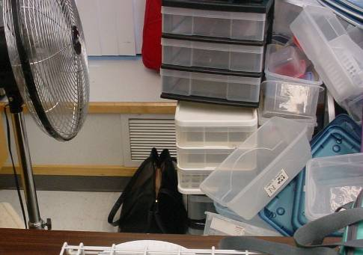

Partially Obstructed Exhaust/Return Vent in ELC Room 114,
Note Vent was not Drawing at Time of the Assessment

Picture 2

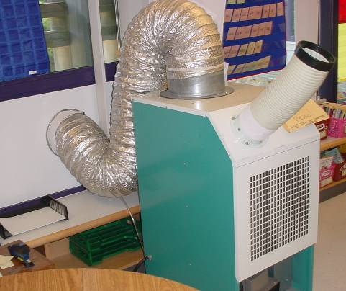

Portable AC in Room 221
Picture 3

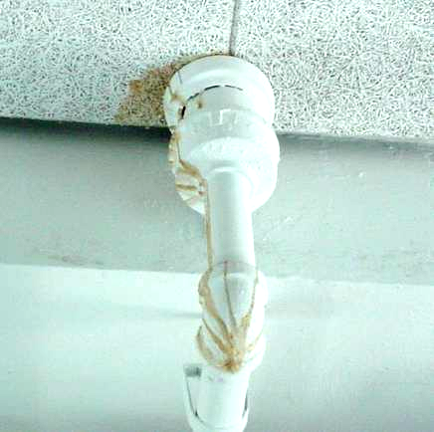

Staining of Ceiling Tile and Roof Drain/Pipe

Picture 4

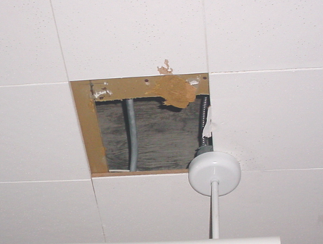

Missing Ceiling Tile in Performance Room 359
Picture 5

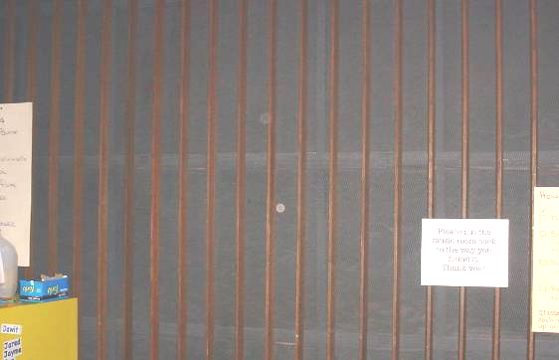

Acoustical Wall Material Covered With Metal Grate

Picture 6

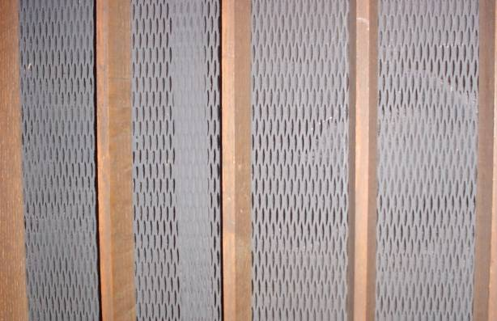

Close-Up of Acoustical Wall Material Covered With Metal Grate
Location/ Room | Occupants  in Room | Temp  (°F) | Relative  Humidity  (%) | Carbon  Dioxide  (ppm) | Carbon Monoxide  (ppm) | PM2.5  (µg/m³) | Windows  Openable | Ventilation |  | Remarks
 |  |  |  |  |  |  |  | Supply | Exhaust | Remarks
background |  | 96 | 63 | 342 | ND | 96 |  |  |  | Excessive heat warning, poor air quality advisory, winds light and variable
166 conference room | 0 | 77 | 57 | 1026 | ND | 40 | Y | Y | Y | Can house up to 12 occupants at a time
165 | 2 | 76 | 59 | 1135 | ND | 38 | N | Y | Y | Water cooler on carpet
164 | 0 | 75 | 61 | 1278 | ND | 39 | N | N | N | Storage room, recommend passive door vents
161 | 0 | 73 | 65 | 1080 | ND | 39 | N | Y | Y | DEM
162 | 2 | 72 | 67 | 1037 | ND | 39 | N | Y | Y | PF-dusty, DEM
207 | 24 | 84 | 73 | 794 | ND | 78 | Y | Y | Y | 3 PFs - on with windows open and 2 interior doors open, fan in window blowing in
213 | 24 | 83 | 74 | 747 | ND | 63 | Y | Y | Y | DO, 5 windows open, previous roof drain leak-repaired
359 Performance Arts | 0 | 82 | 70 | 664 | ND | 65 | Y | Y | Y | occupants at lunch, 2 MT, 3 PFs - on, interior DO
Exterior Hallway (outside 359) | 0 | 83 | 78 | 602 | ND | 73 | N | N | N | Exterior doors closed
Interior Hallway (359/café) | 0 | 81 | 78 | 667 | ND | 78 | N | N | N | Interior doors open
Cafeteria | ~125 | 81 | 78 | 908 | ND | 75 | Y | Y | Y | 2 exterior doors closed, 2nd lunch
Music 311 | 26 | 84 | 73 | 717 | ND | 65 | Y | Y | Y | 3 windows open, DO
ELC/114 | 11 | 79 | 73 | 864 | ND | 49 | Y | Y | Y | Accumulated items obstructing exhaust vent-no draw, PF on
312 | 0 | 83 | 66 | 489 | ND | 61 | Y | Y | Y | PF on, window open, 6 WD CTs
109 | 0 | 81 | 68 | 488 | ND | 52 | Y | Y | Y | 2 windows open, historic water damage-staining along concrete above windows, room unoccupied
221 | 21 | 76 | 59 | 920 | ND | 21 | Y | Y | Y | Portable AC supplementing central AC, air purifier
359 Performance Arts  (retested with occupancy) | 22 | 84 | 66 | 866 | ND | 50 | Y | Y | Y | Occupied < 1 hour

