Job Aid: Professional Claims Submission

This job aid reviews the process for submitting an electronic professional claim in the Provider Online Service Center (POSC). For specific billing information, providers should refer to the relevant MassHealth Billing Guides available at www.mass.gov/masshealthpubs under the Provider Library heading.

Professional claims are used when submitting a claim for professional services, such as physician services.

This job aid describes how to:

- Enter and submit a single professional claim for a member who has MassHealth coverage.

Note: Fields with an asterisk are required fields and must be completed to proceed to the next panel.

Submit MassHealth Claim
From the POSC home page:
- Click Manage Claims and Payments to submit the professional claim.
- Click Enter Single Claim. The Claims Templates panel displays.
On the Claims Templates panel:
- Click Professional Claim. The Billing Information panel displays.
Note: The Billing Information panel opens under the Billing and Service tab. This tab and the Extended Services and Coordination of Benefits tabs make up the Claim header.
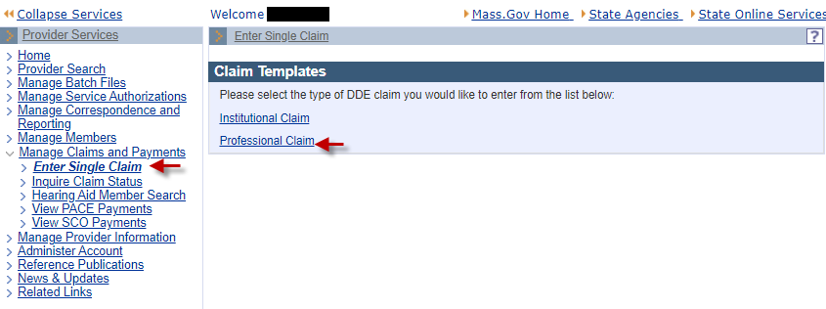

Billing and Service Tab: Billing Information
On the Billing Information panel:
- Select the Billing Provider ID* from the dropdown list.
- Enter the Member ID*.
- Enter the Patient Account #*.
- Enter the member’s Last Name*.
- Select the member’s Gender* from the dropdown list.
- Enter the member’s First Name*.
- Enter the member’s date of birth in the DOB* field.
- Enter the member’s street address in the Member Address 1* field.
Note: Additional address information (for example, apartment numbers) can be entered in the Member Address 2 field.
- Enter the member’s City*.
- Enter the member’s State* from the dropdown list.
- Enter the member’s Zip* code.
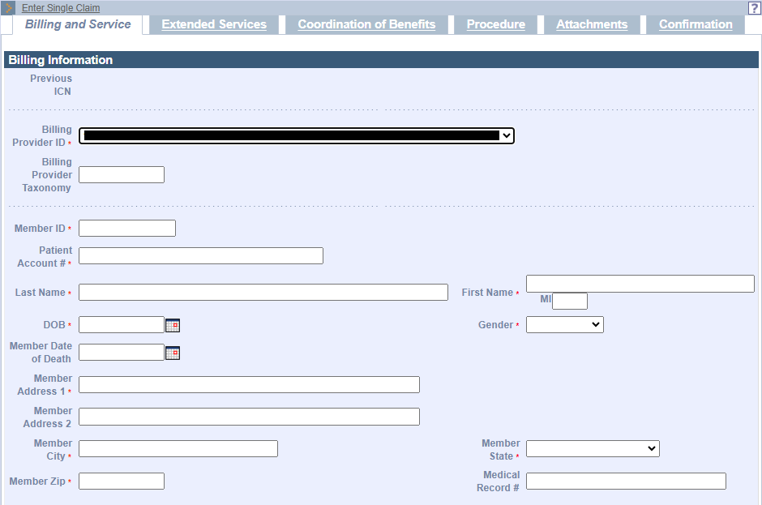

- Enter the Rendering Provider Name (for group practices only).
Note: To pre-populate these fields, click the magnifying glass to the right. Enter the provider NPI number and Business Name or Last Name and First Name. Then click Search. The provider name will appear below. Click on the name to prepopulate.
- Enter Referring Provider Name, if applicable.
Note: To pre-populate these fields, click the magnifying glass to the right. Enter the provider NPI number and Business Name or Last Name and First Name. Then click Search. The provider name will appear below. Click on the name to prepopulate.
- In the Supervising Provider Last Name and Supervising Provider First Name fields, enter the name of the supervising physician associated with the claim, if applicable.
- Enter the Supervising Provider NPI.
Note: All providers must be actively enrolled with MassHealth, at least as a nonbilling provider, if included on the claim.
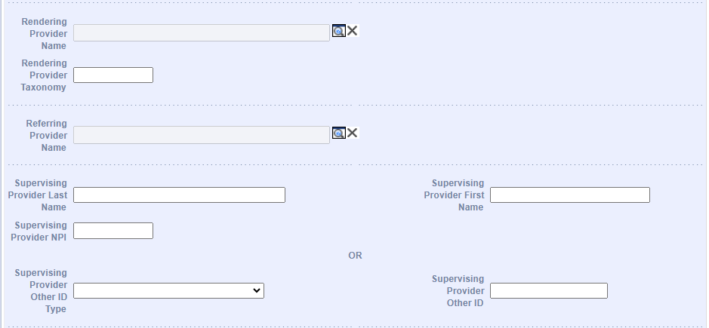
- Select Release of Information* from the dropdown list.
- Select Place of Service* from the dropdown list.
- Select Assignment of Benefits Ind* from the dropdown list.
- Select Signature on File* from the dropdown list.
- Select Provider Accepts Assignment* from the dropdown list.
- Select Claim Filing Indicator* from the drop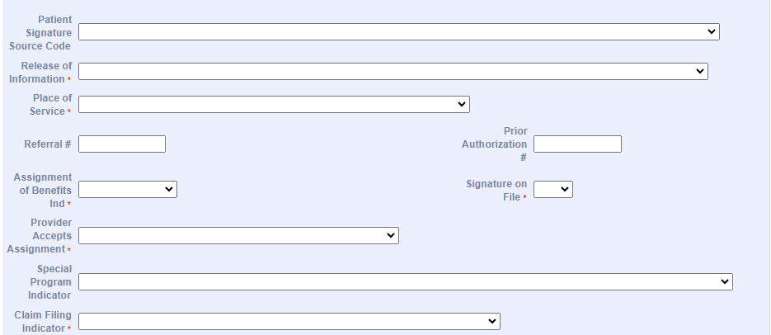down list.

Billing Information Tab: Service Information and Claims Charges
- Select ICD Version*.
Note: Select ICD-9 for claims with a date of service before October 1, 2015. Select ICD-10 for claims with a date of service on or after that date. The system defaults to ICD-10.
- Enter Diagnosis Codes* (minimum of one required).
Note: When entering diagnosis codes, please be sure to enter the primary diagnosis code in field 1. Where relevant, enter the secondary diagnosis code in field 2 and the tertiary diagnosis code in field 3. The remaining fields may be used for any additional diagnosis codes related to the claim to be submitted. Providers may submit up to 12 diagnosis codes per transaction.
- Enter Total Charges*.
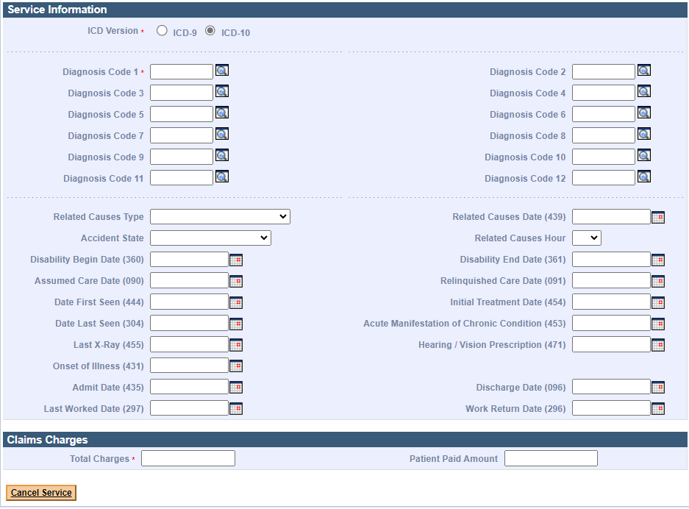
When all the information is entered on the Billing and Services tab, scroll to the top to click the Extended Services tab.
Note: Clicking the Extended Services tab will save data entered so far and will check for any required fields that have not been populated with information.

Extended Services Information and Service Facility Provider
On the Extended Services Information panel:
- Enter or select the following, as appropriate.
- CLIA Number
- Homebound Indicator
- IDE Number
- EPSDT Referral
- EPSDT Condition Indicator 1
- EPSDT Condition Indicator 2
- EPSDT Condition Indicator 3
- Pregnancy Indicator
- Birth Weight
- Delay Reason Code
- Last Menstrual Period
- Estimated Date of Birth
- Mammography Certification
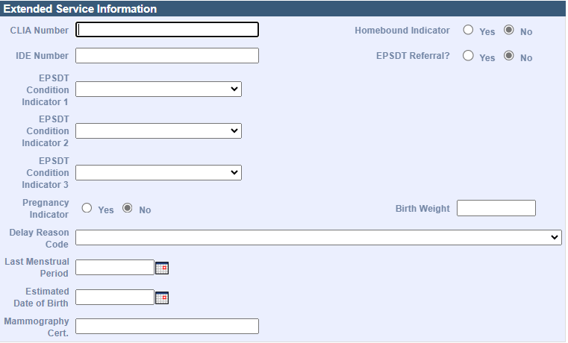

Delay Reason Codes:
- When submitting a 90-Day Waiver Request, enter one of the following Delay Reason Codes:
1-Proof of Eligibility Unknown or Unavailable
4-Delay in Certifying Provider
8-Delay in Eligibility Determination
- When submitting a Final Deadline Appeal Request, enter the following Delay Reason Code:
9-Original Claim Rejected or Denied Due to a Reason Unrelated to the Billing Limitation
- When submitting a National Correct Coding Initiative/Medically Unlikely Edit (NCCI/MUE) Review Request or a Special Handle Claim Review Request, you must include a detailed letter of why the claim needs to be reviewed. Enter the following Delay Reason Code:
11-Other
Note: Supporting documentation must be uploaded with the claim when using a Delay Reason Code. The claim will not suspend for review if the supporting documentation is not uploaded.

On the Service Facility Provider panel:
- Enter the Service Facility Provider Name if the Service Facility Location Address fields are entered.
- Enter the Service Facility Provider NPI if the location of services is different than that of the billing provider’s and the entity is not a sub-part of the billing provider.
- In the Service Facility Address 1, City, State, and Zip Code fields, enter the Service Facility Address if the Service Facility Provider Name is entered.
Note: The Service Facility Location Address is required if the Service Facility Provider Name is entered on the claim, and vice versa.
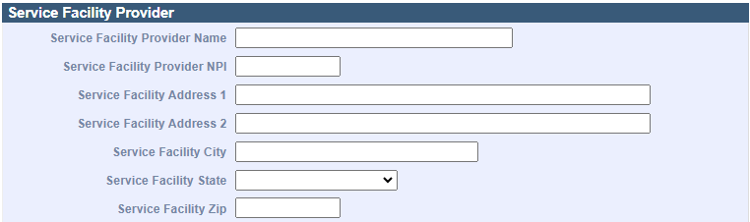

List of Claim Notes
On the List of Claim Notes panel, if applicable:
- Click New Item. The Claim Notes Detail panel displays.
Note: A maximum of 10 claim notes can be added to a claim.

Claim Notes Detail
On the Claim Notes Detail panel:
- Select Claim Note Type from the dropdown list.
- Enter Claim Note Description.
- Click Add.
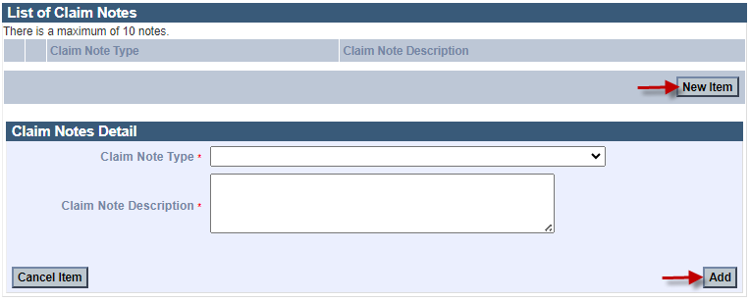

Ambulance Transport and Certification
On the Ambulance Transport and Certification panel:
- Enter or select the following, as appropriate.
- Patient Weight
- Transport Reason Code
- Transport Distance
- Roundtrip Purpose Description
- Stretcher Purpose Description
- Certification Condition Indicator
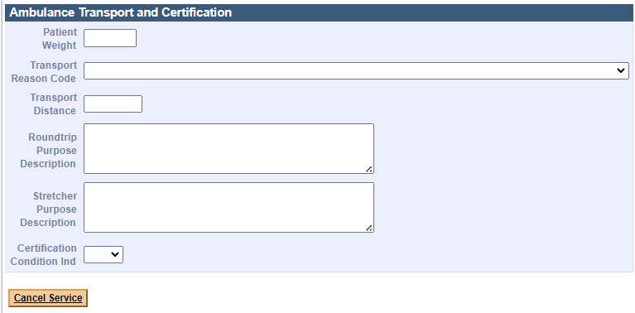
Note: If there is a third party to bill, you will need to complete the Coordination of Benefits (COB) panel before adding the Procedure information. Please refer to the Coordination of Benefits Job Aid.
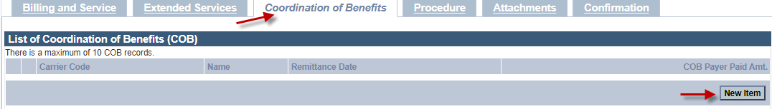
- Once you’ve completed the Coordination of Benefits panel, scroll to the top to click the Procedure tab.

Procedure Tab
On the List of Professional Services panel:
- Click New Item. The Professional Services Detail panel displays.
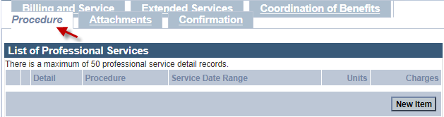

Professional Services Detail
On the Professional Services Detail panel:
- Enter the HCPCS Procedure Code*.
- Enter modifiers, if applicable.
- If billing for an unlisted Procedure Code, enter a description of service, up to 80 characters.
- Enter From Date of Service*.
- Enter To Date of Service*.
- Select Place of Service from the dropdown list.
- Enter the diagnosis cross-reference number (Diag. CrossRef*).
Note: If applicable, enter the number (1–12) corresponding to the primary, secondary, or tertiary diagnosis code(s) entered for the claim that is related to the service being entered. Up to four diagnosis cross-references can be entered. When multiple services are performed, enter the primary reference for each service first, followed by other applicable services. Please ensure that the correct diagnosis code is cross-referenced to the appropriate procedure code, as claims that do not contain compatible diagnosis and procedure codes will be denied.
- Enter Charges*.
- Enter Units*.

- Select Units of Measurement* from the dropdown list.
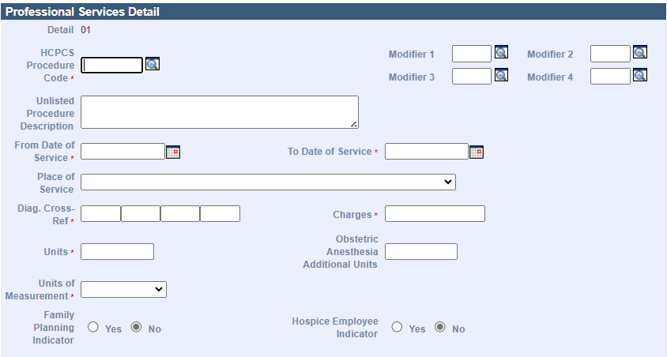
- If applicable, enter the Rendering Provider Name. The rendering provider should be actively participating or enrolled with MassHealth as at least a nonbilling provider.
Note: Enter the rendering provider only if it is different from the one entered on the Billing and Service tab.
- If applicable, enter Rendering Provider Taxonomy.
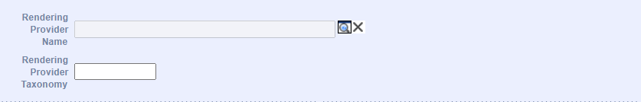
- If applicable, enter Ordering Provider Last Name and First Name. The Ordering provider must be actively participating or enrolled with MassHealth as at least a nonbilling provider.
- If applicable, enter Ordering Provider NPI or, if identifying the ordering provider by a different method, select the Ordering Provider Other ID Type from the dropdown list and enter Ordering Provider Other ID.
- If applicable, use the magnifying glass to search for the Supervising Provider Name.
Note: Enter the Last Name and First Name, NPI, or Provider ID (PID) to search for the supervising provider. Then select the desired provider from the List of Servicing Providers panel.
- Select the Emergency option from the dropdown list, if applicable.
- Select the EPSDT* option from the dropdown list.
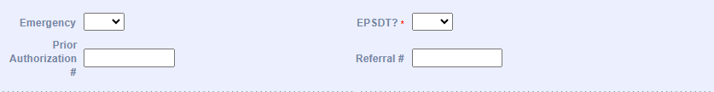
- If the claim includes charges for a National Drug Code (NDC), complete the following fields as appropriate.
- NDC – enter the complete ID number of drug
- Units
- Units of Measurement
- Rx Qualifier
- Rx Number
- Rx Date
Note: If this completes the procedure information, click Add at the bottom of the panel. If not, scroll down to continue entering information.
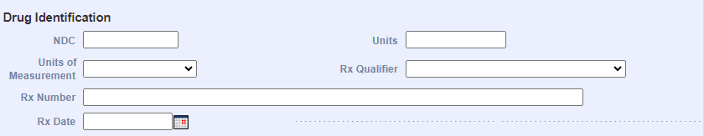

Professional Services Detail: Durable Medical Equipment Service
- If the claim includes a Durable Medical Equipment (DME) service, complete the following fields as appropriate.
- DME Length of Medical Necessity
- DME Purchase Price
- DME Rental
- DME Unit Price Indicator
Note: If this completes the procedure information, click Add at the bottom of the panel. If not, scroll down to continue entering information.
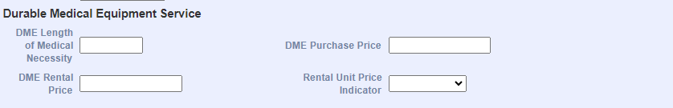

Professional Services Detail: Ambulance Service
- If the claim includes Ambulance services, complete the following fields as appropriate.
- Patient Weight
- Patient Count
- Transport Reason Code
- Transport Distance
- Round Trip Purpose Description
- Stretcher Purpose Description
- Certification Condition Indicator
- Enter the Ambulance Pick-up Location.
- Enter the Ambulance Drop-off Location.
- Click Add.
Note: The information you enter will be added to the List of Professional Services.
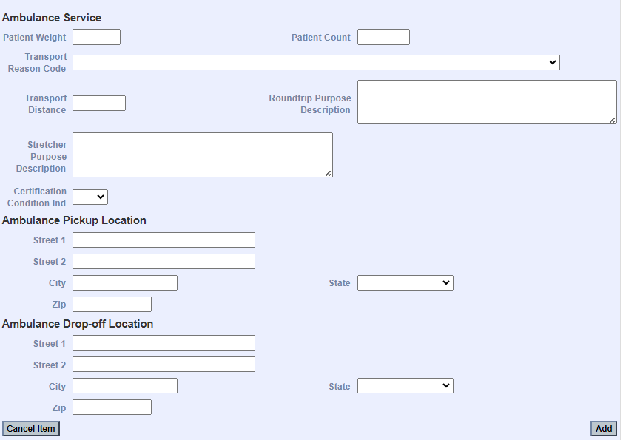

List of Notes
On the List of Notes panel:
- Click New Item to add a note for the service (in addition to those entered on the Extended Services panel). The Notes Detail panel displays.
Note: A maximum of 10 claim notes can be added to a claim.
On the Notes Detail panel:
- Select Note Type from the dropdown list.
- Enter Note Description.
- Click Add.
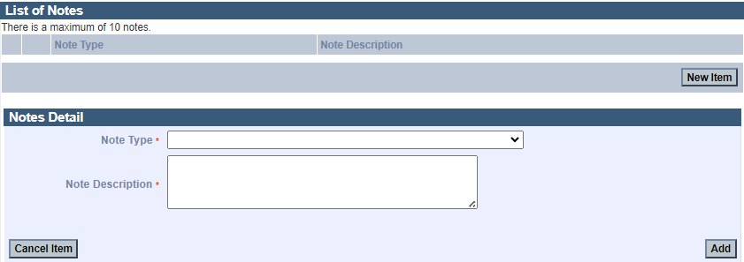
Note: The List of COB Line Items is used when the member also has Other Insurance or Medicare. Please refer to the Coordination of Benefits Job Aid.
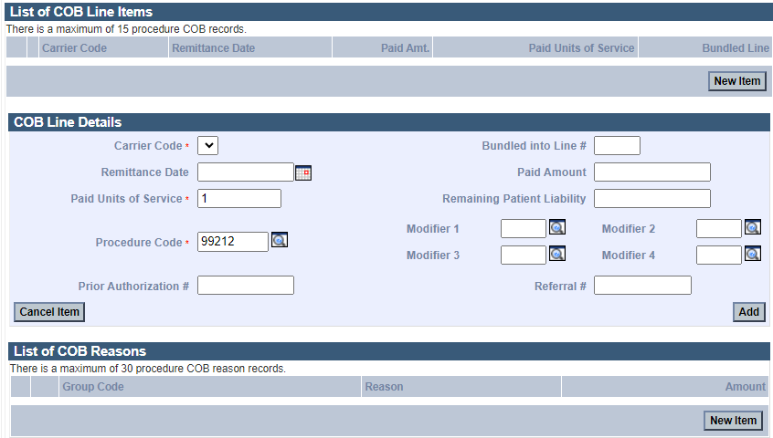

Attachments Tab: List of Attachments
On the List of Attachments panel:
- Click New Item. The Attachments Detail panel displays.
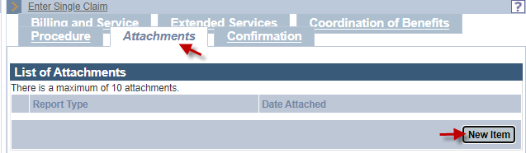
On the Attachments Detail panel:
- Select Report Type* from the dropdown list.
Note: If you are using this panel, all fields are required.
- Select Transmission Code* from the dropdown list.
- Click Browse and navigate to the attachment file.
- Select the desired file and click Open.
- Click Add/Upload.
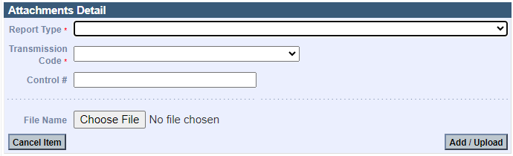
- Click the Confirmation tab.

Confirmation Tab
On the Confirmation panel:
- Confirm the information is accurate.
- Click Submit.
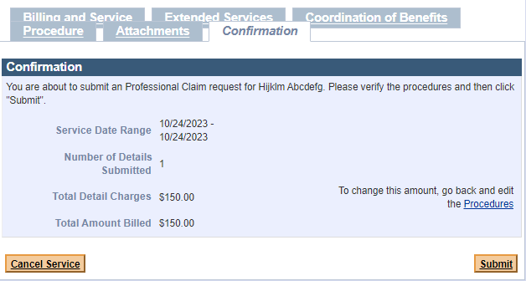

Explanation of Benefits (EOB) Codes
On the Explanation of Benefits (EOB) panel:
- Review any EOB codes that may appear.
- Click Close to exit.
