WATER DAMAGE ASSESSMENT

Newton South High School
Weight Room
140 Brandeis Road
Newton Centre, MA

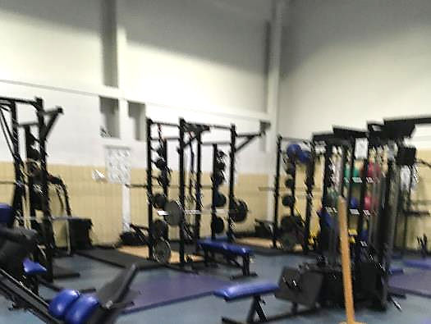

Prepared by:
Massachusetts Department of Public Health
Bureau of Environmental Health
Indoor Air Quality Program
May 2019

Background

Building: | Newton South High School, Weight Room
Address: | 140 Brandeis Rd, Newton Centre MA
Reason for Request: | Concerns regarding mushrooms growing from floor
Date of Assessment: | May 2, 2019
Massachusetts Department of Public Health/Bureau of Environmental Health (MDPH/BEH) Staff Conducting Assessment: | Michael Feeney, Director, Indoor Air Quality (IAQ) Program
Building Description: | Weight room is located above a full basement in the athletic complex of the NSHS campus
Windows: | Not openable

BACKGROUND
A section of the weight room had mushrooms growing from the floor. The weight room has a flooring covering installed over cement. The floor consists of two layers of plywood. A cell plastic pad was installed between the plywood and cement (Picture 1). Covering the plywood is a rubber interlocking mat.
The weight room has experienced a number of water leaks originating from the roof and/or skylight above the water damage. Newton Public Schools (NPS) officials reported that roof repairs were initiated to spot the leaks. Outdoor debris (dirt, debris and fungal spores) in the rainwater likely penetrated through seams at the floor/wall junction between the cement and plywood and remained moistened despite efforts to dry the plywood layers.
At the time of this assessment, the damaged area of plywood was removed, exposing the cement floor (Picture 2). Drying fans were placed over the cement floor to draw out water that likely saturated the cement. The amount of water that had accumulated in this area was not measurable; however, signs of water damage to areas outside the weight room indicate the possible extent of water damage, including water damage to the underside of the floor decking directly beneath this area (Picture 3).

Methods
Please refer to the IAQ Manual for methods, sampling procedures, and interpretation of results (MDPH, 2015).

IAQ Testing Results
Please refer to the IAQ Manual for methods, sampling procedures, and interpretation of results (MDPH, 2015). The following is a summary of testing results.
- Temperature was below the recommended range of 70°F to 78°F in the weight room.
- Relative humidity was within the recommended range of 40 to 60% in areas tested at the time of the assessment.
- Moisture Measurements in cement indicated the cement was wet.

Discussion

Microbial/Moisture Concerns
On the day of the assessment IAQ staff did not detect musty/wood odors or visible mold growth on any building materials. In general, floors should have roughly uniform moisture measurements that can change due to weather conditions. The measurement of the floor cement may indicate that the cement is likely moistened. In general, the US Environmental Protection Agency (US EPA) and the American Conference of Governmental Industrial Hygienists (ACGIH) recommends that porous materials (e.g., plywood and padding) be dried with fans and heating within 24 to 48 hours of becoming wet (US EPA, 2008; ACGIH, 1989). If porous materials are not dried within this time frame, mold growth may occur.

Conclusions/Recommendations
Based on the observations made during this assessment, NPS officials are remediating the water damage in a proper manner by fixing roof leaks and removing/drying water damaged materials consistent with appropriate water damage remediation practice. By removing the pad and plywood, the mold growth media has been removed. Other non-porous materials, such and cement and floor tiles do not support mold growth and need to be cleaned rather than removed. The following additional recommendations were made at the time of this assessment.
- Remove plastic coving from cement walls in weight room and hallway to check for mold growth. If found, remediate in a manner consistent with the US EPA’s “Mold Remediation in Schools and Commercial Buildings” (available at: http://www.epa.gov/mold/mold-remediation-schools-and-commercial-buildings-guide) as a guideline for remediation efforts.
- Remove interlocking rubber pads near the remediation area to increase drying.
- Continue to operate floor fans over cement to decrease moisture content prior to reinstalling flooring.
- Refer to resource manuals and other related IAQ documents for further building-wide evaluations and advice on maintaining public buildings. Copies of these materials are located on the MDPH’s website: http://mass.gov/dph/iaq.

REFERENCES
ACGIH. 1989. Guidelines for the Assessment of Bioaerosols in the Indoor Environment. American Conference of Governmental Industrial Hygienists, Cincinnati, OH.
MDPH. 2015. Massachusetts Department of Public Health. “Indoor Air Quality Manual: Chapters I-III”. Available at: http://www.mass.gov/eohhs/gov/departments/dph/programs/environmental-health/exposure-topics/iaq/iaq-manual/.
US EPA. 2008. Mold Remediation in Schools and Commercial Buildings. US Environmental Protection Agency, Office of Air and Radiation, Indoor Environments Division, Washington, D.C. EPA 402-K-01-001. http://www.epa.gov/mold/mold-remediation-schools-and-commercial-buildings-guide.
Picture 1
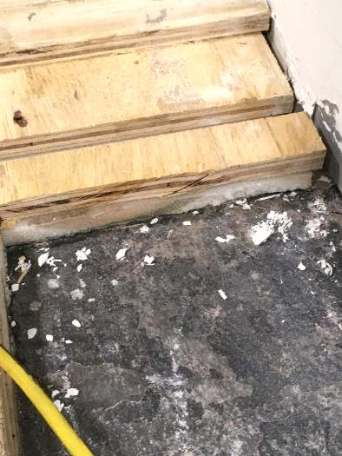
Floor consists of two layers of plywood with a cell plastic pad (arrow)
between the plywood layers and cement

Picture 2

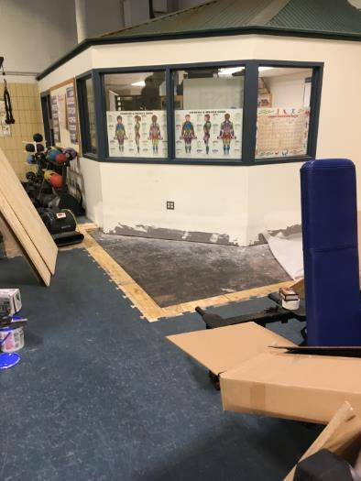

Floor area under remediation

Picture 3

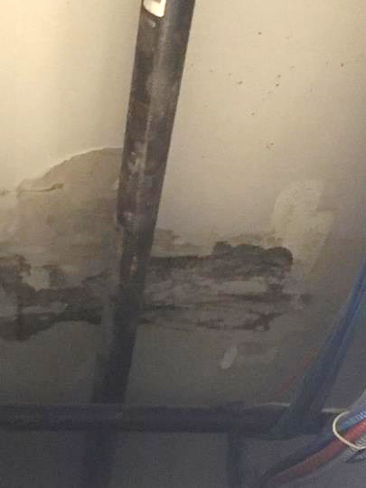

Water damage to floor decking beneath weight room

