Bureau of Infectious Disease and Laboratory Sciences
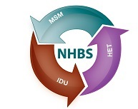
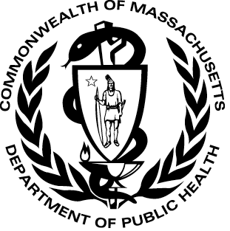
Office of HIV/AIDS and Office of Research and Evaluation
Status Report – National HIV Behavioral Surveillance Study (NHBS)

Reportable Disease: HIV

- Of the 1,553 men diagnosed with HIV/AIDS in Massachusetts from 2011-2014, 61% reported MSM as primary risk.
- Pre-Exposure Prophylaxis (PrEP) is medication for HIV-uninfected individuals at high risk for sexually acquired HIV infection to prevent new infection.
- Surveys of men who have sex with men (NHBS and American Men’s Internet Survey (AMIS) in Metro Boston indicate:
  - Increased reports of high risk sex.
  - Over half of the men surveyed in 2014 have heard of PrEP and around 50% would be willing to take it.
  - Among men willing to take PrEP, 80% had private insurance.
For more information
MDPH PrEP
CDC

More Information
PrEp website
CDC More info msm risk

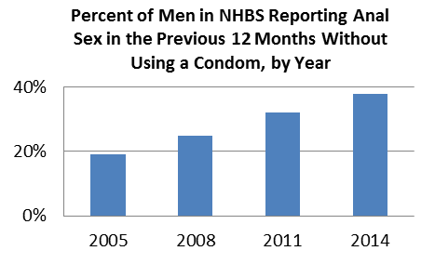
N=876 N=277 N=440 N=316
Data released 3/24/2016

NHBS MSM Data
Released 3/24/2016
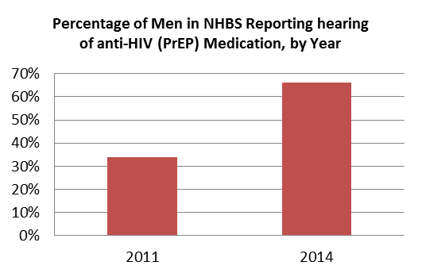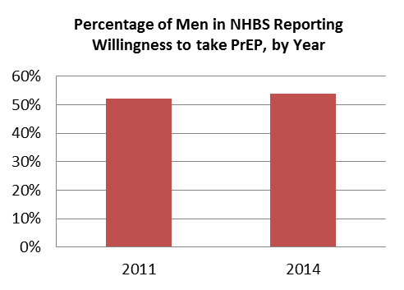
N=396 N=298 N=396 N=298
AMIS Data
Released 12/28/2015
Data released 3/24/2016
Data released 3/24/2016
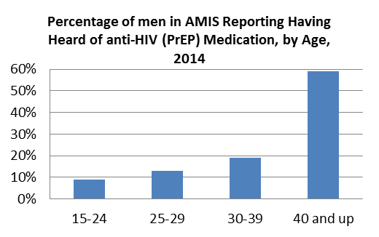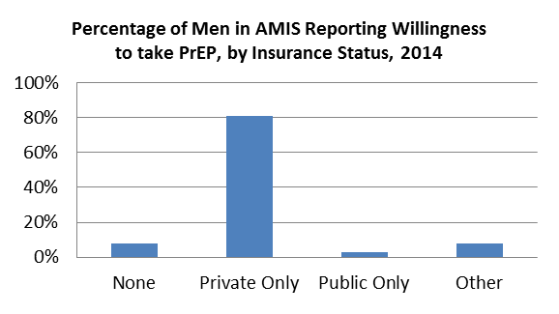
N=101 N=36

