Maria has TB infection

and feels healthy.

You can have a type of TB and still feel healthy. This is called TB infection.

Your doctor can test you for TB infection. If you have TB infection, your doctor can give you medicine.

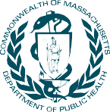
This material was developed by the Massachusetts Department of Public Health. December 2014. For more information, visit www.mass.gov/dph/cdc/tb

