ODOR ASSESSMENT

Rupert A Nock Middle School
70 Low Street
Newburyport, Massachusetts

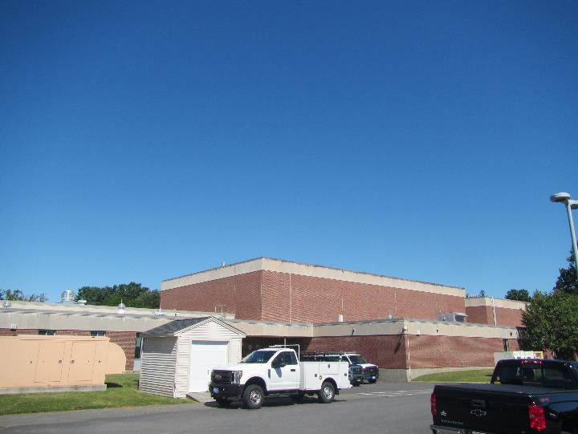

Prepared by:
Massachusetts Department of Public Health
Bureau of Environmental Health
Indoor Air Quality Program
December 2019

Background
Building: | Rupert A Nock Middle School (NMS)
Address: | 70 Low Street, Newburyport, Massachusetts
Assessment Coordinated Through: | Stephen C. Bergholm, Director of Facilities, Newburyport Public Schools
Reason for Request: | Intermittent odor complaints in classroom 219
Date of Assessment: | August 30, 2019
Massachusetts Department of Public Health/Bureau of Environmental Health (MDPH/BEH) Staff Conducting Assessment: | Mike Feeney, Director, Indoor Air Quality (IAQ) Program and Jason Dustin, Environmental Analyst/Inspector, IAQ Program
Building Description: | Room 219 is a general classroom located on the second floor of the NMS. The room contains office furniture, tile floor and suspended ceiling tiles. The building opened in 1972 with recent renovations in 2014.
Windows: | Windows are openable in the space.

Methods
Please refer to the IAQ Manual and appendices for methods, sampling procedures, and interpretation of results (MDPH, 2015).

Results and Discussion
The following is a summary of indoor air testing results:
- Carbon dioxide measurements were below the MDPH recommended level of 800 parts per million (ppm) in room 219, indicating adequate air exchange at the time of the assessment. It should be noted that the classroom was not fully occupied which would reduce the carbon dioxide typically experienced during a full class.
- Temperature was within the MDPH recommended range of 70°F to 78°F at the time of assessment.
- Relative humidity was slightly above the MDPH recommended range of 40 to 60% in room 219, likely due to the unit ventilator being off and floor cleaning/waxing activities taking place on the second floor.
- Carbon monoxide levels were non-detectable (ND).
- Particulate matter (PM2.5) concentrations measured were below the National Ambient Air Quality (NAAQS) level of 35 μg/m³.
- Total Volatile Organic Compounds (TVOCs) levels were ND in room 219.

Ventilation
A heating, ventilating and air-conditioning (HVAC) system has several functions. First it provides heating and, if equipped, cooling. Second, it is a source of fresh air. Finally, an HVAC system will dilute and remove normally-occurring indoor environmental pollutants by not only introducing fresh air, but also filtering the airstream and ejecting stale air to the outdoors via exhaust ventilation. Even if an HVAC system is operating as designed, point sources of respiratory irritants may be present and produce symptoms in sensitive individuals.
Mechanical ventilation for classroom 219, and most general classrooms, is provided by newer unit ventilators (univents) located near classroom windows (Picture 1). The univents at the NMS draw air from the outdoors through a fresh air intake located on the exterior wall of the building (Picture 2). Classroom exhaust air is drawn through an exhaust vent with a pleated filter located on the right side of the unit (Picture 3) and is ejected outdoors through an exhaust terminus vent immediately adjacent to the fresh air intake vent. Fresh and exhaust air streams pass through an energy recovery wheel (ERW) in opposing directions. ERWs are designed to save energy by capturing the heat of the exhaust stream and transferring that energy to the incoming fresh air stream. The ERWs at the NMS also transfer moisture (water vapor) between the streams as well. The fresh air is then filtered, heated (if needed) and provided to rooms through an air diffuser located on the top of the unit (Picture 4). Although the room exhaust stream passes through a pleated filter prior to entering the ERW, the fresh air stream only passes through a mesh pre-filter with a low removal efficiency (Picture 5) before entering the ERW. This condition may allow pollen, dust, and small debris to collect on the ERW. NMS staff reported that regular maintenance is carried out, including both filter changes and vacuuming/blowing out the ERW and univent cabinet. However, the exterior side of the ERW wheel is inaccessible for cleaning unless the whole unit is disassembled. Lastly, according to the manufacturer website airxchange.com, these ERWs are made of fibrous materials and coated with silica gel desiccant to adsorb moisture. This type of ERW is more susceptible to fouling and resultant odors than metal ERWs having molecular sieves, and they are also more difficult to properly clean.
As stated previously, the univent in classroom 219 was deactivated (in the off cycle); therefore no mechanical source of fresh air was being introduced at the time of assessment. It was reported that univents are controlled by an integrated computer system and their operation is tied to a carbon dioxide sensor. Once the carbon dioxide sensor exceeds its set point, the univent activates. It was believed by NMS facilities staff that the system was set to activate at 800 ppm. This should be verified. In addition, gas sensors, including carbon dioxide, should be calibrated or replaced periodically per the manufacturer’s instructions.
Classrooms with mechanical ventilation typically have separate exhaust vents installed to remove airborne pollutants and improve air exchange. The separate exhaust vent in room 219 was reportedly sealed as part of an energy saving program when the new univents were installed approximately five years ago (Picture 6). Therefore, the only exhaust for the room is a smaller exhaust fan contained in the univent itself. The capacity of the supply air fan is larger than the exhaust fan, which would lead to an unbalanced air flow and a largely pressurized classroom. This condition may lead to the failure to adequately exhaust odors and moisture from the room. In addition, the efficiency of the ERW would be affected since more outside air is passing through the wheel and is not tempered properly by an equal amount of room exhaust air. In humid weather conditions, this configuration may not allow for the adequate drying out of the moisture in the ERW.
In order to have proper ventilation with a mechanical supply and exhaust system, the systems must be balanced to provide an adequate amount of fresh air to the interior of a room while removing stale air from the room. It is recommended that HVAC systems be re-balanced every five years to ensure adequate air systems function (SMACNA, 1994).
To maximize air exchange, the BEH/IAQ Program recommends that mechanical ventilation systems operate continuously during periods of school occupancy. Without the system operating, normally occurring pollutants cannot be diluted or removed, allowing them to build up and lead to IAQ/comfort complaints.

Odor concerns
Facilities staff reported that musty odor complaints have occurred in room 219 in the last two or three years on an intermittent basis. Occupants of the class did not complain of the odors, but visitors to the classroom reportedly detected the odors periodically. Facilities staff reported that the room was thoroughly cleaned and emptied of all contents. In addition, the wooden cabinets were inspected on either side of the univent and no water infiltration was observed. A small area of roofing insulation was reported to have a water stain, so the roof was repaired in that area and the water-damaged insulation was replaced. BEH staff inspected the space above the ceiling tiles in classroom 219 and did not detect any moisture, visible mold, water damage or musty odors in the space (Picture 7). BEH IAQ staff also did not detect any musty odor when the univent was turned on but did detect a slight “burning/dust” odor.
After NMS facilities staff disassembled the univent, BEH IAQ staff detected a “grape juice-like” odor on the air diffuser insulation plate on the top section of the univent. It is likely that liquid with fruit flavoring was spilled or poured into the air diffuser and moistened/soaked into the porous insulation below the diffuser grate (Picture 8). Odors can then be released when the material is heated or moistened. NMS facilities staff also detected the odor and removed the insulation plate during this assessment.
As mentioned above, the musty odor was not present in room 219 during this assessment. However, the configuration for the newer univents may contribute to future musty odors. Small particles from the incoming air stream adhering to the ERW, coupled with moisture/humidity, create conditions conducive to microbial growth and associated odors. This would be especially apparent if the ERW does not have adequate drying cycles and has an imbalance of supply air to exhaust air as explained above. Further, the location of the univent exhaust and supply vents on the inside of the room and the vent proximity on the outside of the room may allow for significant “short circuiting”. This is a condition where supply air can be entrained into the exhaust vent inside the room or where exhaust air can be entrained into the fresh air supply vent outside (Pictures 9 and 10).
A portable air filter was installed in classroom 219 (Picture 11). Some models of UV light air filters have been shown to produce ozone, which is a known lung irritant (EPA, 2019). In addition, a fragrance/deodorizing agent was noted in the unit. Fragrances merely mask odors and may also have irritant effects to occupants with respiratory sensitivities (e.g., asthmatics). This unit should be run on particulate filter mode only and not on the UV light mode if possible. Air filters should be cleaned/maintained in accordance with manufacturer’s instructions.

Conclusions and Recommendations
The following recommendations regarding Classroom 219 were made at the time of the visit and are reiterated below:
- Continue to monitor the univent in classroom 219 for any further odors or excess noise following the removal of the juice/water-damaged air diffuser insulation plate. Make a log of time, weather conditions, and univent function (on/off) if any future odors are detected.
- Operate the univents in all classrooms continuously to provide for adequate air exchange during occupied hours.
- Monitor the carbon dioxide sensors during full classroom attendance to ensure that the univents are providing for adequate air exchange. Should the levels of carbon dioxide consistently exceed 800 ppm, consider reactivating the original room exhaust vents in those classrooms.
- Ensure that the carbon dioxide detectors in classrooms are calibrated or replaced according to manufacturer recommendations.
- Should musty odors return, consider changing out the ERW cassette with a compatible cassette from an area with more volume and lower average occupancy (e.g., library).
- Follow manufacturer recommendations regarding the proper cleaning/maintenance of the ERW. Request manufacturer information regarding increasing filtering capacity of incoming air stream and adding a regular “drying cycle” to remove any moisture from the ERW when not in use especially during humid weather.
- Refrain from using the UV function on the portable air filter in classroom 219 to avoid producing ozone, a known lung irritant. Also, refrain from using deodorizers and fragrances to mask odors since these may have irritant effects on occupants with respiratory sensitivities (e.g., asthma). Perform regular cleaning and filter changes for this unit as recommended.
- Consider adopting the US EPA (2000) document, “Tools for Schools”, as an instrument for maintaining a good IAQ environment in the building available at: http://www.epa.gov/iaq/schools/index.html.
- Refer to resource manual and other related IAQ documents located on the MDPH’s website for further building-wide evaluations and advice on maintaining public buildings. These documents are available at http://mass.gov/dph/iaq.

References
EPA. 2019. Ozone Generators that are Sold as Air Filters. United States Environmental Protection Agency website: https://www.epa.gov/indoor-air-quality-iaq/ozone-generators-are-sold-air-cleaners .
MDPH. 2015. Massachusetts Department of Public Health. Massachusetts Department of Public Health Indoor Air Quality Manual: Chapters I-III. Available at: http://www.mass.gov/eohhs/gov/departments/dph/programs/environmental-health/exposure-topics/iaq/iaq-manual/.
SMACNA. 1994. HVAC Systems Commissioning Manual. 1st ed. Sheet Metal and Air Conditioning Contractors’ National Association, Inc., Chantilly, VA.
US EPA. 2000. Tools for Schools. Office of Air and Radiation, Office of Radiation and Indoor Air, Indoor Environments Division (6609J). EPA 402-K-95-001, Second Edition. http://www.epa.gov/iaq/schools/index.html.
Picture 1
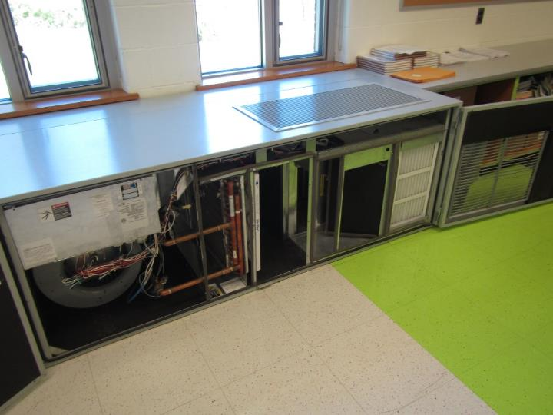
Newer classroom univent with cabinet opened
Picture 2
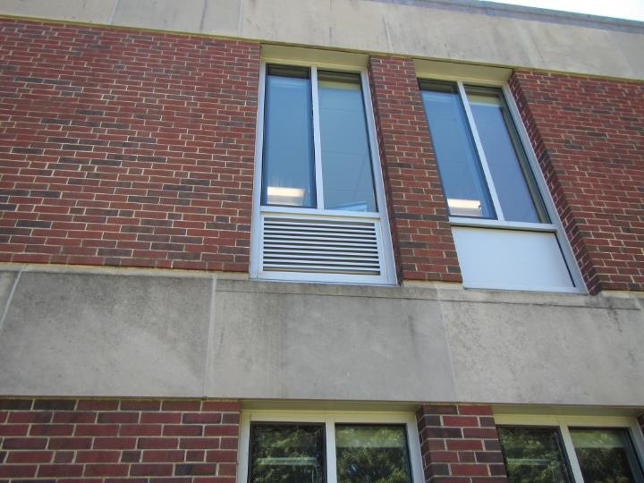
Univent fresh air intake on right side of vent; exhaust is left side of vent
Picture 3
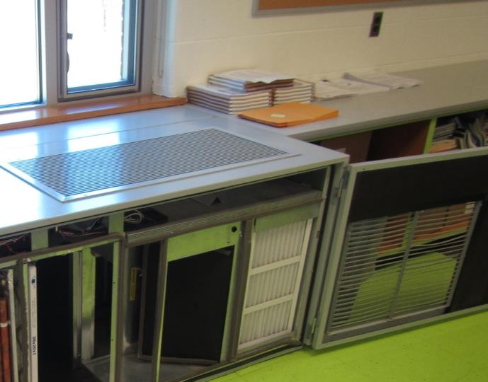
Room exhaust vent (note pleated filter)
Picture 4
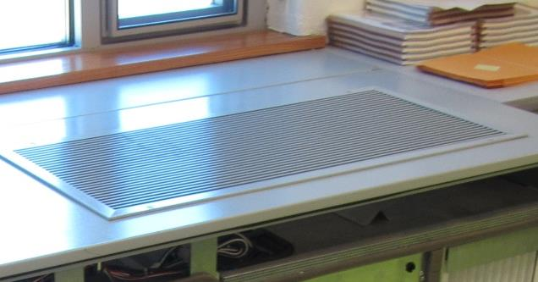
Supply air diffuser on top of univent
Picture 5
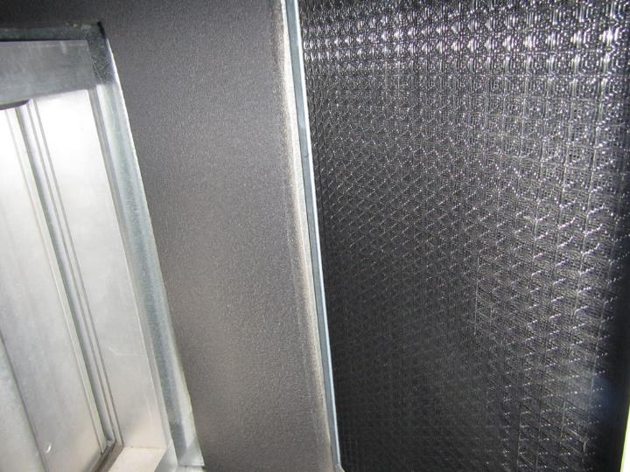
Inefficient screen filter for fresh air intake prior to entering ERW
Picture 6
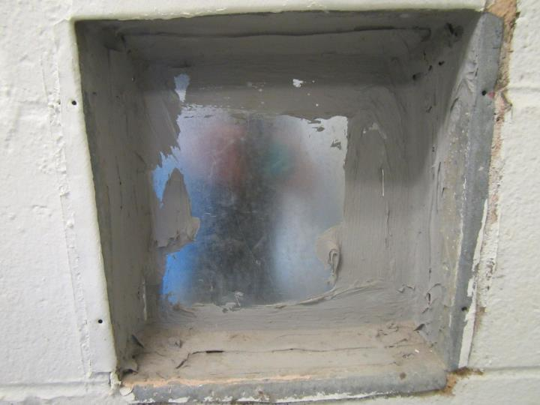
Separate wall-mounted exhaust vent that was sealed/abandoned
Picture 7
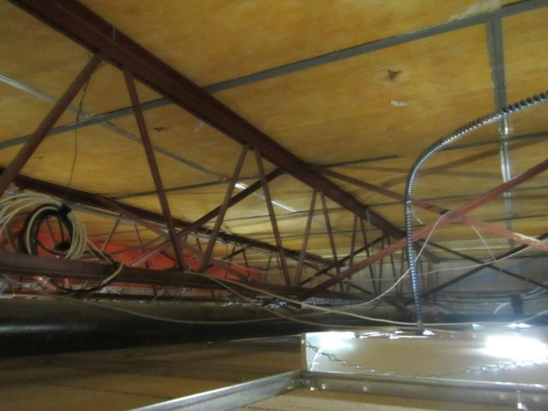
Space above ceiling showing no signs of water damage or odors
Picture 8
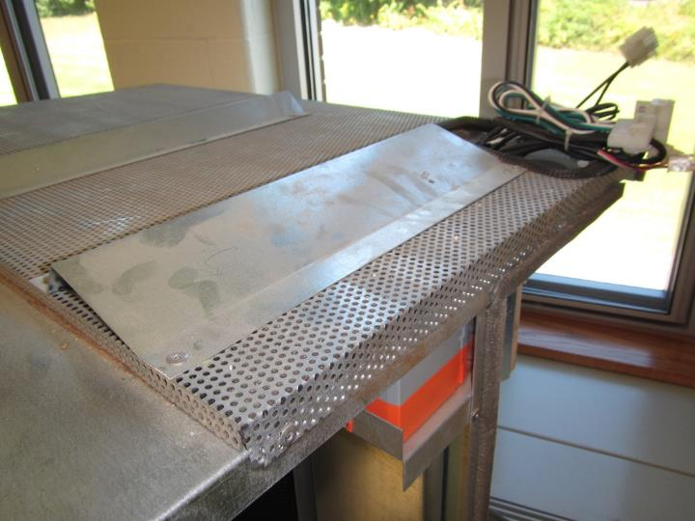
Supply air diffuser plate with grape odor and porous insulation below metal
Picture 9
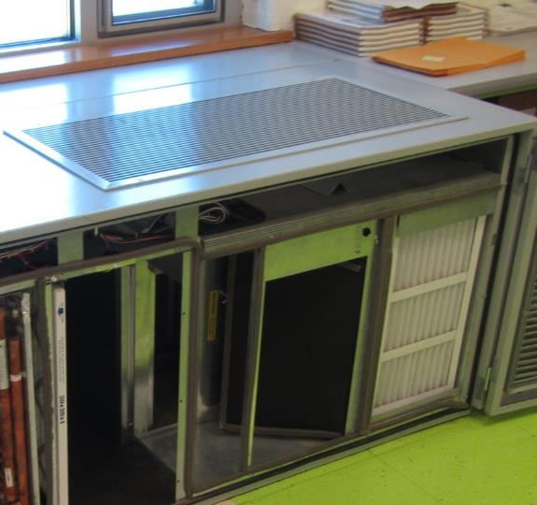
Proximity of supply/exhaust vents may allow for “short circuiting”
Picture 10
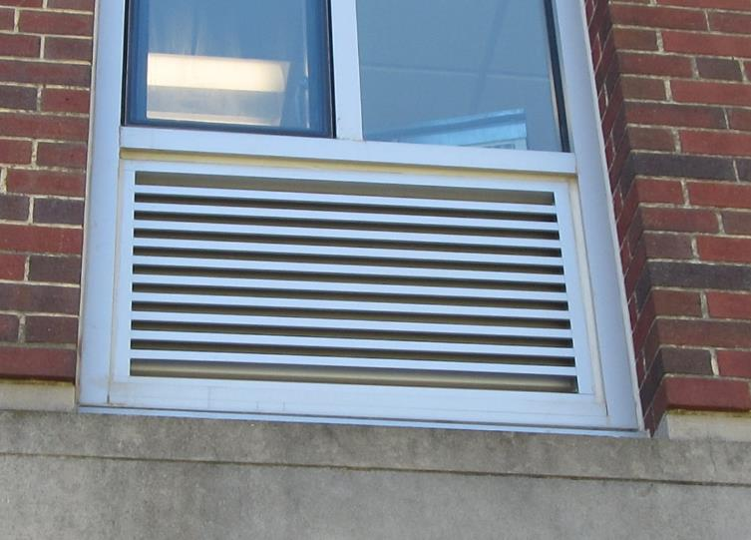
Proximity of supply/exhaust vents may allow for “short circuiting”
Picture 11
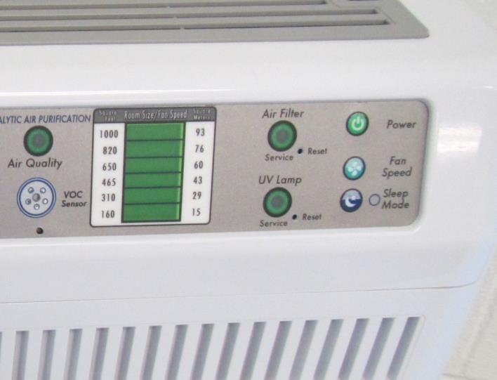
Portable air filter used in classroom 219 equipped with UV light

