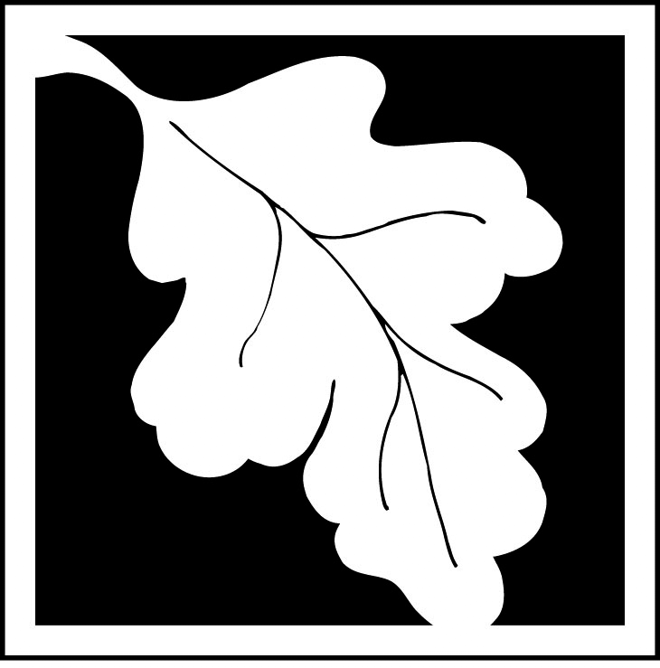 | Massachusetts Department of Environmental Protection  Bureau of Resource Protection - Wetlands  NOI Wetland Fee Transmittal Form  Massachusetts Wetlands Protection Act M.G.L. c. 131, §40
Important: When filling out forms on the computer, use only the tab key to move your cursor - do not use the return key.  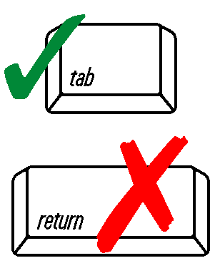 | A. Applicant Information
 | 1. Location of Project:
 | a. Street Address |  |  |  | b. City/Town
 | c. Check number |  |  |  | d. Fee amount
 | 2. Applicant Mailing Address:
 | a. First Name |  |  |  | b. Last Name
 | c. Organization
 | d. Mailing Address
 | e. City/Town |  |  |  |  |  | f. State |  |  | g. Zip Code
 | h. Phone Number | i. Fax Number |  |  | j. Email Address
 | 3. Property Owner (if different):
 | a. First Name |  |  |  | b. Last Name
 | c. Organization
 | d. Mailing Address
 | e. City/Town |  |  |  |  |  | f. State |  |  | g. Zip Code
 | h. Phone Number | i. Fax Number |  |  | j. Email Address
To calculate  filing fees, refer to the category fee list and examples in the instructions for filling out WPA Form 3 (Notice of Intent). | B. Fees
Fee should be calculated using the following process & worksheet. Please see Instructions before filling out worksheet.

Step 1/Type of Activity: Describe each type of activity that will occur in wetland resource area and buffer zone.

Step 2/Number of Activities: Identify the number of each type of activity.

Step 3/Individual Activity Fee: Identify each activity fee from the six project categories listed in the instructions.

Step 4/Subtotal Activity Fee: Multiply the number of activities (identified in Step 2) times the fee per category (identified in Step 3) to reach a subtotal fee amount. Note: If any of these activities are in a Riverfront Area in addition to another Resource Area or the Buffer Zone, the fee per activity should be multiplied by 1.5 and then added to the subtotal amount.

Step 5/Total Project Fee: Determine the total project fee by adding the subtotal amounts from Step 4.

Step 6/Fee Payments: To calculate the state share of the fee, divide the total fee in half and subtract $12.50. To calculate the city/town share of the fee, divide the total fee in half and add $12.50.
 | B. Fees (continued)
 | Step 1/Type of Activity |  | Step 2/Number  of Activities |  |  | Step 3/Individual Activity Fee |  |  | Step 4/Subtotal Activity Fee
 |  |  | Step 5/Total Project Fee:
 |  |  | Step 6/Fee Payments:
 |  |  |  | Total Project Fee: |  |  |  | a. Total Fee from Step 5
 |  |  |  | State share of filing Fee: |  |  |  | b. 1/2 Total Fee less $12.50
 |  |  |  | City/Town share of filling Fee: |  |  |  | c. 1/2 Total Fee plus $12.50
C. Submittal Requirements

- Complete pages 1 and 2 and send with a check or money order for the state share of the fee, payable to the Commonwealth of Massachusetts.

Department of Environmental Protection
Box 4062
Boston, MA 02211

- To the Conservation Commission: Send the Notice of Intent or Abbreviated Notice of Intent; a copy of this form; and the city/town fee payment.

To MassDEP Regional Office (see Instructions): Send a copy of the Notice of Intent or Abbreviated Notice of Intent; a copy of this form; and a copy of the state fee payment. (E-filers of Notices of Intent may submit these electronically.)

