Noise Policy Discussion Document 3/2/2026

Introduction

The Massachusetts Department of Environmental Protection (MassDEP) plans to revise its 1990 Noise Policy to increase clarity and provide guidance regarding how MassDEP will evaluate compliance with the noise requirements pursuant to MassDEP’s air quality regulations (310 CMR 7.10).

The 1990 Noise Policy describes MassDEP’s guidance for evaluating compliance with the noise regulations at 310 CMR 7.10. MassDEP is issuing this guidance based on the following:
- MassDEP's experience in utilizing this policy/guidance to evaluate compliance with the noise provisions and advancements in the field of noise assessment and mitigation;
- Input from the regulated community and noise consultants regarding how to most effectively assess noise issues;
- Requests from local health officials on greater clarity on how to evaluate compliance with noise regulations; and
- The recommendation of the Clean Energy Infrastructure Siting and Permitting Commission that:
“MassDEP should be directed to update its noise pollution policy to address the disparity of treatment of projects proposed in rural versus urban areas. The current policy makes it easier to site certain infrastructure in areas with higher levels of ambient noise, which are often more urban and densely developed communities. In contrast, the standard makes it very difficult to site projects, even those with minimal incremental noise impacts, in areas with lower levels of ambient noise.”
Comments on this document and the issues described below should be submitted by 5:00 pm on March 23, 2026 via email to Michael.Woodman@mass.gov or by mail to Michael Woodman, MassDEP, Bureau of Air and Waste, 100 Cambridge Street, Boston, MA 02114.

Noise Regulations

Noise is a form of regulated air pollution that falls within the scope of MassDEP authority under M.G.L. Chapter 111, Sections 142 A-M. MassDEP promulgated Noise Regulations at 310 CMR 7.10, which are part of the Air Pollution Control Regulations (310 CMR 7.00). The noise regulations are enforceable by MassDEP and local officials [e.g., Boards of Health, 310 CMR 7.10(4)]. The definition of “noise,” “condition of air pollution,” and the noise regulations are below.

310 CMR 7.00 Definitions

Noise means sound of sufficient intensity and/or duration as to cause a condition of
air pollution.

Air pollution means the presence in the ambient air space of one or more air contaminants
or combinations thereof in such concentrations and of such duration as to: (a) cause a nuisance; (b) be injurious, or be on the basis of current information, potentially injurious to human health or animal life, to vegetation, or to property; or (c) unreasonably interfere with the comfortable enjoyment of life and property or the conduct of business.

310 CMR 7.10: U Noise

(1) No person owning, leasing, or controlling a source of sound shall willfully, negligently, or through failure to provide necessary equipment, service, or maintenance or to take necessary precautions cause, suffer, allow, or permit unnecessary emissions from said source of sound that may cause noise.

(2) 310 CMR 7.10(1) shall pertain to, but shall not be limited to, prolonged unattended sounding of burglar alarms, construction and demolition equipment which characteristically emit sound but which may be fitted and accommodated with equipment such as enclosures to suppress sound or may be operated in a manner so as to suppress sound, suppressible and preventable industrial and commercial sources of sound, and other man-made sounds that cause noise.

(3) 310 CMR 7.10(1) shall not apply to sounds emitted during and associated with:
(a) parades, public gatherings, or sporting events, for which permits have been issued provided that said parades, public gatherings, or sporting events in one city or town do not cause noise in another city or town;
(b) emergency police, fire, and ambulance vehicles;
(c) police, fire, and civil and national defense activities;
(d) domestic equipment such as lawn mowers and power saws between the hours of 7:00A.M. and 9:00 P.M.

(4) 310 CMR 7.10(1) is subject to the enforcement provisions specified in 310 CMR 7.52.

1990 Noise Policy

In 1990 MassDEP published guidance describing how MassDEP would assess compliance with MassDEP’s noise regulation. The 1990 Noise Policy states the following:

A source of sound will be considered to be violating the Department’s noise regulation (310 CMR 7.10) if the source:

- Increases the broadband sound level by more than 10 dB(A) above ambient, or

- Produces a “pure tone” condition – when any octave band center frequency sound pressure level exceeds the two adjacent center frequency sound pressure levels by 3 decibels or more.

These criteria are measured both at the property line and at the nearest inhabited residences or other sensitive receptors. Ambient is defined as the background A-weighted sound level that is exceeded 90% of the time measured during equipment operating hours. The ambient may also be established by other means with the consent of the Department.

This 1990 Noise Policy did not set an enforceable regulatory standard but rather describes sound levels that MassDEP would consider when determining compliance with MassDEP’s noise regulation.

The sound level exceeded 90 percent of the time during a measurement period is known as the “L90” and represents the steady, underlying background sound level, excluding short-term intrusive sounds.

When MassDEP investigates a noise complaint, it typically conducts short-term sound monitoring (e.g., 5 - 20 minutes) at the complaint location (usually a residential property) with the sound source not operating to determine the ambient L90. This sound monitoring is conducted during the time of day or night that the source normally operates and that is representative of the quietest background conditions (e.g., not during inclement weather). MassDEP then conducts short-term monitoring with the source operating and determines the average sound emitted by the source. The average sound level when the source is operating is compared to the ambient L90 sound level to determine if the sound is 10 dBA or more above ambient. Depending on the nature of the emitted sound, sound monitoring also may be conducted to determine if the sound is producing a pure tone.

Based on experience implementing the 1990 Noise Policy, MassDEP published “Noise Pollution Policy Interpretation” to provide additional guidance regarding the 1990 Noise Policy. This Policy Interpretation clarified that sound levels exceeding 10 dBA at the source’s property line are not necessarily a violation of the noise regulations, but rather a consideration in determining whether a violation occurred, and that MassDEP’s focus is “on protecting affected people at their residences and in other buildings that are occupied by sensitive receptors from nuisances and the public health effects of noise.”

Noise Policy Revisions

MassDEP plans to revise its 1990 Noise Policy and seeks comment on the issues described below. This policy is intended to provide guidance for situations where the facility does not have a permit issued by MassDEP, the Energy Facilities Siting Board, or local officials that includes regulatory conditions related to noise. In those cases, compliance should be determined by compliance with the specific provisions of the relevant permit/authorization.

Baseline Sound Level

In very quiet areas, the use of night-time background L90s can result in extremely low ambient noise levels. Evaluating compliance based on the 1990 Noise Policy “no more than 10 dBA above ambient” criterion can limit the increase in sound level in areas where the night-time background L90 sound levels may be as low as 20 dBA to 30 dBA, which is extremely quiet (a typical library is 40 dBA). Increased noise levels in such situations may not result in air pollution or “unnecessary emissions” that may cause noise pursuant to 310 CMR 7.00. Other state and local jurisdictions that have regulatory sound limits typically set the residential night-time limits in the range of 45 dBA to 50 dBA. While MassDEP believes using 10 dBA increase over background is appropriately protective in many situations, it is reasonable to allow a low sound level of 40 dBA below which the 10 dBA above ambient would not apply for purposes of evaluating compliance with 310 CMR 7.00. In addition to establishing a reasonable sound level for compliance purposes, this would “address the disparity of treatment of projects proposed in rural versus urban areas” raised by the Clean Energy Infrastructure Siting and Permitting Commission. MassDEP seeks comments on establishing guidance that would presume that sound levels of 40 dBA are acceptable for sensitive receptors and below which the “no more than 10 dBA above ambient” criterion would not apply.

Property Line vs. Affected People

MassDEP’s 1990 Noise Policy references measurement both at the property line of a sound source and at the nearest inhabited residences or other sensitive receptors. In practice MassDEP generally focuses compliance at the location of sensitive receptors and not a source’s property line (unless there are sensitive receptors at the property line). This aligns with the noise regulations which are designed to protect people being adversely affected by noise (as opposed to establishing sound limits where no one is affected by sound emissions). MassDEP believes it is reasonable to clarify that compliance with the noise regulations should be based at the location where people are or could be adversely affected (e.g., residences, schools, day care facilities, elder care facilities, hospitals) and apply the noise policy criteria at the location of the existing sensitive receptors rather than the sound source’s property line. MassDEP seeks comments on this revision.

Compliance Evaluation for Permitted Sound Sources

If a sound source has been permitted by MassDEP, EFSB, or local officials with specific noise requirements and conditions, MassDEP’s compliance evaluation will focus primarily on the requirements and conditions included in the permit. MassDEP seeks comments on this approach.

Tonal Sound

Since the 1990 Noise Policy was published, sound meters and practice have improved so that current acoustical industry best practice for evaluating tonal sounds (i.e., pure tones) is based on 1/3 octave bands as described in ANSI S12.9-2005/Part 4 Annex C. MassDEP believes it is reasonable to provide guidance on what is considered tonal sound to be based on 1/3 octave bands as described in ANSI S12.9-2005/Part 4 Annex C or other generally accepted industry standard (including full octave band where appropriate). MassDEP seeks comments on providing guidance on defining tonal sound including what flexibility should be considered for different approaches.

Revised Approach for Sources Conducting Sound Studies

In addition to seeking input on revisions to MassDEP’s noise compliance policy, MassDEP plans to revise and clarify the process for establishing background (ambient) when conducting a sound study for a new sound source.

As part of MassDEP’s air plan approval process pursuant to 310 CMR 7.00, MassDEP has required that significant air pollution sources that emit sound conduct a sound study that uses the lowest hourly L90 sound level out of seven or more days of continuous monitoring results to establish ambient sound levels (in 2011 MassDEP published an AQ Sound Form that states that “…background shall be established via a minimum of seven consecutive days of continuous monitoring at multiple locations with the dBA L 90 data and pure tone data reduced to one-hour averages” and that “[a]mbient is defined as the lowest one-hour background A-weighted sound pressure level that is exceeded 90 percent of the time.)

Use of the lowest 1-hour L90 sound level out of 7 days of sound monitoring can result in very low ambient sound level from which a developer must design a project so that it does not increase sound levels at its property line more than 10 dBA over ambient. The lowest 1-hour L90 is not representative of typical background sound. Current acoustical consulting practice is to establish background based on the average of lowest hourly L90s sound levels measured during each daytime and nighttime period at nearby representative receptor locations (e.g., residential dwellings). Other approaches include basing background on the average of all hourly L90 sound levels measured for each nighttime and daytime period. MassDEP is proposing to use the average of lowest hourly L90s.

Attachment 1 shows the difference in background sound level each of these approaches makes using select data from completed sound studies MassDEP has analyzed (each graph shows measured sound levels at one receptor location from the sound study). Note that in quieter areas there is more variation in L90 results than in louder urban areas (e.g., Worcester). MassDEP is proposing to revise the approach to establishing ambient/representative background to utilize the average of the lowest hourly L90s and seeks comments on the appropriate sound measurement guidance.

Attachment 1

Night-time Hourly L90 Calculation Options

Seekonk
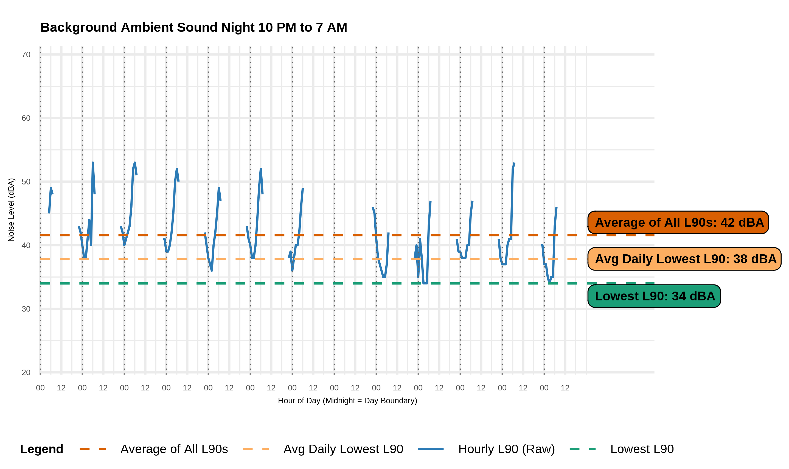

Somerset
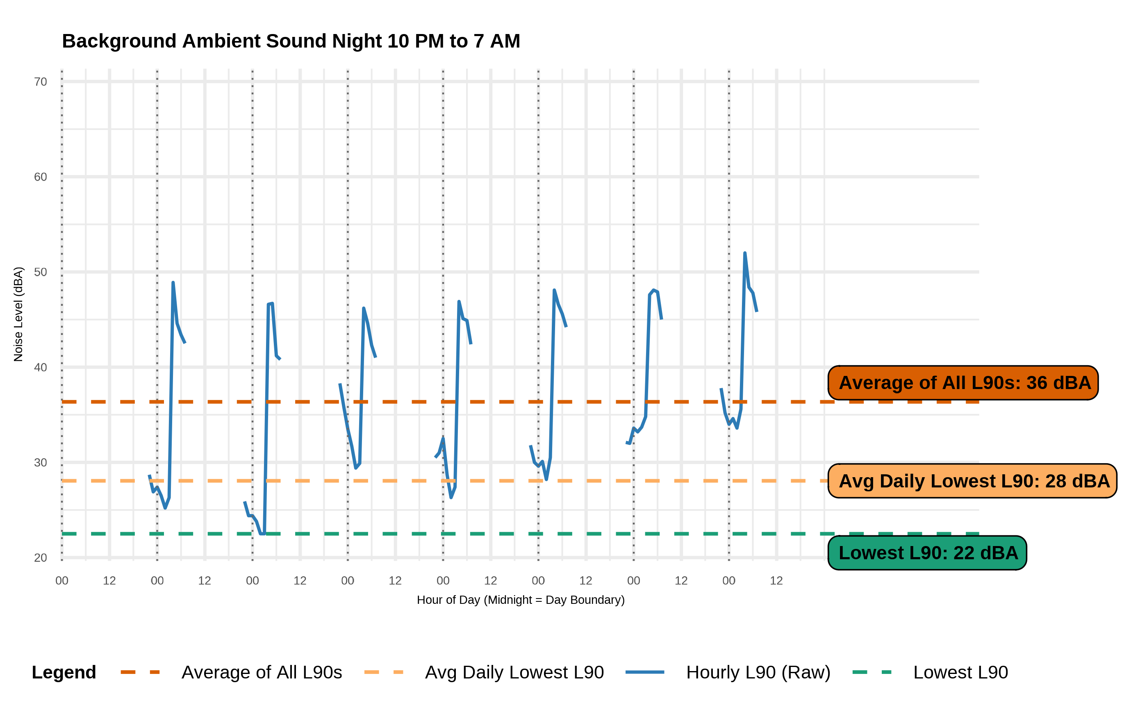

Devens
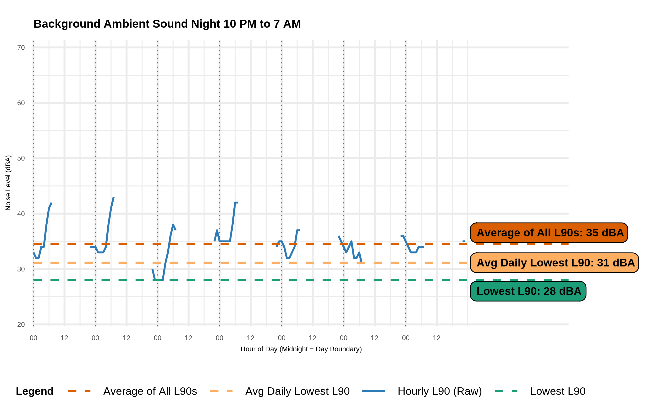

Adams
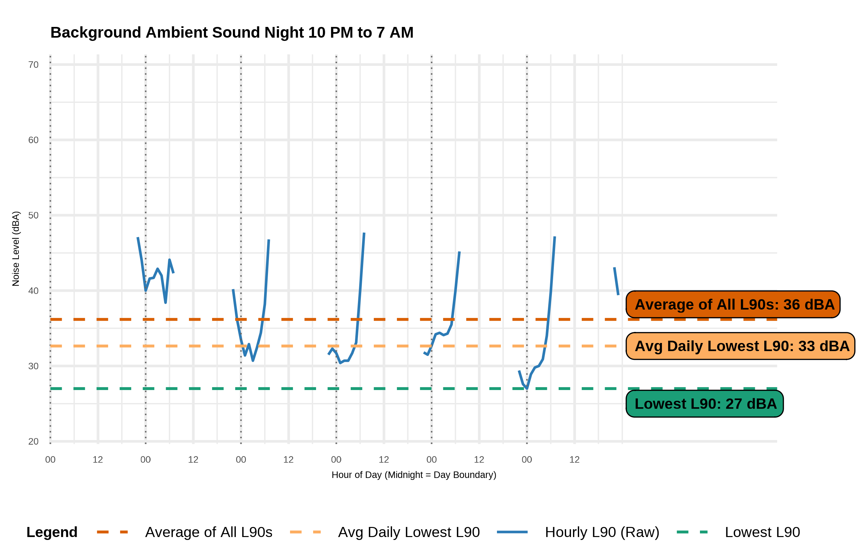

West Brookfield
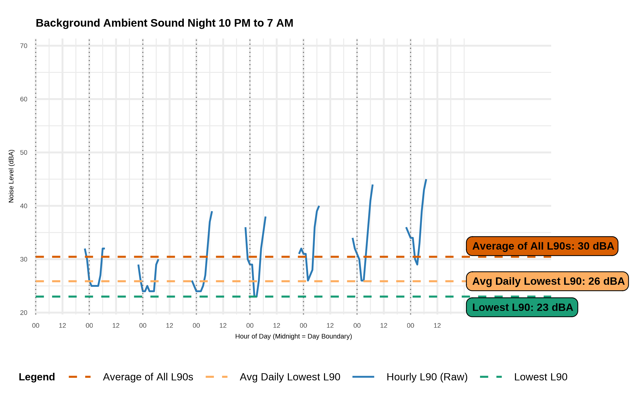

Worcester
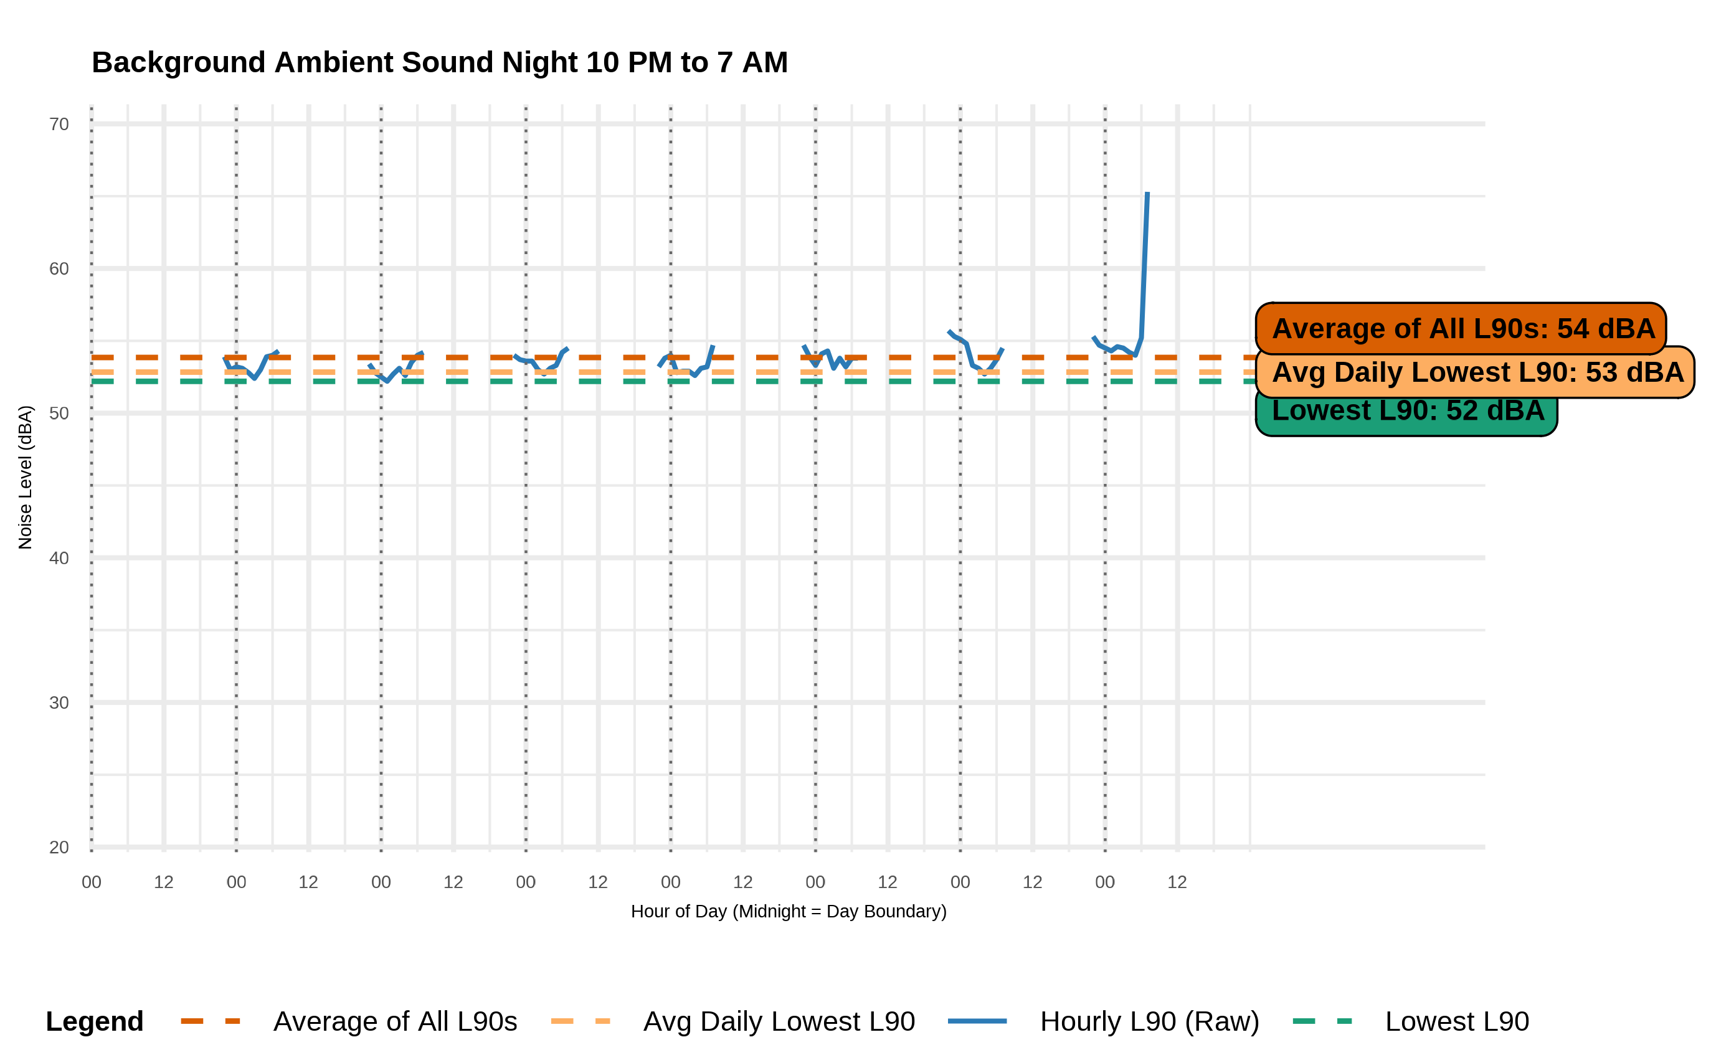

Other legal standards may apply outside of MassDEP’s noise regulations and its interpretation of those regulations. Noise may also be regulated as a nuisance by local boards of health pursuant to M.G.L. c. 111, § 122. Massachusetts cities and towns may also adopt bylaws or ordinances that set permissible sound levels, hours of operation, and enforcement processes.
310 CMR 7.52 authorizes police departments, fire departments and local boards of health officials to enforce the noise regulations.

