INDOOR AIR QUALITY ASSESSMENT

Norman E. Day School
75 East Prescott Street
Westford, Massachusetts

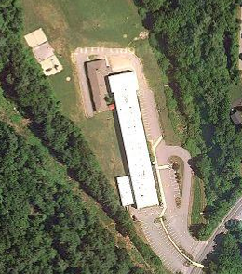

Prepared by:
Massachusetts Department of Public Health
Bureau of Environmental Health
Indoor Air Quality Program
February 2011

Background/Introduction
At the request of Everett V. Olsen Jr., Superintendant, Westford Public Schools, the Massachusetts Department of Public Health (MDPH), Bureau of Environmental Health (BEH) conducted an indoor air quality (IAQ) assessment at the Day Elementary School (DES), 75 East Prescott Street, Westford, Massachusetts. On June 15, 2010, Lisa Hébert, Environmental Analyst/Regional Inspector, of BEH’s IAQ Program visited the school to conduct an assessment of the building.
The DES is a two-story brick building that was originally built as a middle school in 1965. The school contains general classrooms, a kitchen/cafeteria, music and art rooms, a library, gymnasium and office space. In 1998, additional classroom space was constructed on the northwest corner of the school. Windows are openable throughout the building.

Methods
Air tests for carbon monoxide, carbon dioxide, temperature and relative humidity were conducted with the TSI, Q-Trak, IAQ Monitor, Model 7565. Air tests for airborne particle matter with a diameter less than 2.5 micrometers were taken with the TSI, DUSTTRAK™ Aerosol Monitor Model 8520. BEH staff also performed visual inspection of building materials for water damage and/or microbial growth.

Results
The school houses approximately 425 students in grades three through five and a staff of approximately 70. Tests were taken during normal operations and results appear in Table 1.

Discussion

Ventilation
It can be seen from Table 1 that carbon dioxide levels were below 800 parts per million (ppm) in 37 of 46 areas indicating adequate air exchange in the majority of rooms surveyed (Table 1). Fresh air is introduced into classrooms by means of wall or ceiling-mounted unit ventilator (univent) systems (Figure 1). A univent draws air from the outdoors through a fresh air intake located on the exterior wall of the building and returns air through an air intake located at the base of the unit. Fresh and return air are mixed, filtered, heated and provided to classrooms through an air diffuser located in the top of the unit (Picture 1).
Stale air is removed from classrooms by either ducted ceiling mounted exhaust vents or vents that are located in coat closets (Pictures 2 and 3). Univents as well as exhaust vents were found to be obstructed and/or deactivated in a number of areas during the assessment. To function as designed, ventilation equipment must be free of obstructions (Picture 4). Importantly, these units must be activated and allowed to operate. If not activated, air can backdraft through exhaust vents into the building, depending on weather conditions. Drafts can also introduce any particulates that may have accumulated in the ducts into the building. Several closets were unable to be easily opened due to dry erase boards that had been mounted on their doors (Picture 5).
To maximize air exchange, the MDPH recommends that both supply and exhaust ventilation operate continuously during periods of occupancy. In order to have proper ventilation with a mechanical supply and exhaust system, the systems must be balanced to provide an adequate amount of fresh air to the interior of a room while removing stale air from the room. It is recommended that HVAC systems be re-balanced every five years to ensure adequate air systems function (SMACNA, 1994). The date the system was last balanced was unavailable at the time of assessment.
The Massachusetts Building Code requires that each room have a minimum ventilation rate of 15 cubic feet per minute (cfm) per occupant of fresh outside air or openable windows (SBBRS, 1997; BOCA, 1993). The ventilation must be on at all times that the room is occupied. Providing adequate fresh air ventilation with open windows and maintaining the temperature in the comfort range during the cold weather season is impractical. Mechanical ventilation is usually required to provide adequate fresh air ventilation.
Carbon dioxide is not a problem in and of itself. It is used as an indicator of the adequacy of the fresh air ventilation. As carbon dioxide levels rise, it indicates that the ventilating system is malfunctioning or the design occupancy of the room is being exceeded. When this happens, a buildup of common indoor air pollutants can occur, leading to discomfort or health complaints. The Occupational Safety and Health Administration (OSHA) standard for carbon dioxide is 5,000 parts per million parts of air (ppm). Workers may be exposed to this level for 40 hours/week, based on a time-weighted average (OSHA, 1997).
The MDPH uses a guideline of 800 ppm for publicly occupied buildings. A guideline of 600 ppm or less is preferred in schools due to the fact that the majority of occupants are young and considered to be a more sensitive population in the evaluation of environmental health status. Inadequate ventilation and/or elevated temperatures are major causes of complaints such as respiratory, eye, nose and throat irritation, lethargy and headaches. For more information concerning carbon dioxide, consult Appendix A.
Indoor temperatures ranged from 68º F to 77º F, which were within the MDPH recommended comfort range in all but three areas surveyed on the day of the assessment (Table 1). The MDPH recommends that indoor air temperatures be maintained in a range of 70º F to 78º F in order to provide for the comfort of building occupants. In many cases concerning indoor air quality, fluctuations of temperature in occupied spaces are typically experienced, even in a building with an adequate fresh air supply.
The relative humidity measured in the building ranged from 40 to 62 percent, which was within the MDPH recommended comfort range in all but three areas surveyed during the assessment (Table 1). The MDPH recommends a comfort range of 40 to 60 percent for indoor air relative humidity. Relative humidity levels in the building would be expected to drop during the winter months due to heating. The sensation of dryness and irritation is common in a low relative humidity environment. Low relative humidity is a very common problem during the heating season in the northeast part of the United States.

Microbial/Moisture Concerns
Several classrooms had water-damaged ceiling tiles, which can indicate sources of water penetration from either the building envelope or plumbing system (Picture 6; Table 1). Water-damaged ceiling tiles can provide a source of mold and should be replaced after a water leak is discovered and repaired. A cracked pane of glass was observed in the music room. Gaps (i.e. missing caulking and/or door sweeps) were observed on the bottom of several exterior doors at the DES. These conditions may allow unconditioned air to enter the DES, potentially causing condensation to occur on interior surfaces. If these surfaces are porous, mold colonization may result. Severely damaged/loose/missing interior caulking around windows was noted throughout the building. In addition to the potential of allowing unconditioned air into the DES, depending on its age, this sealant may contain regulated materials (e.g., asbestos, polychlorinated biphenyls or PCBs). If so, materials should be addressed in accordance with state and federal regulations/guidance. For further information on regulatory compliance with asbestos and/or PCBs, consult the US EPA, Massachusetts Department of Environmental Protection and the Massachusetts Department of Occupational Safety. For guidance on addressing PCB-containing materials in schools, consult MDPH guidance (Appendix B).
BEH staff examined the exterior of the building to identify breaches in the building envelope and other conditions that could provide a source of water penetration. Several potential sources were identified:
- Standing water was observed on several areas of the roof (Picture 7);
- Roof drains were obstructed by an accumulation of silt and debris (Picture 8);
- Severely deteriorated caulking was observed on the exterior of the DES (Picture 9). This material may also be composed of regulated materials;
- Peeling paint was observed on several areas of plywood on the exterior of the building. Over time, this condition will cause deterioration of the plywood;
- Expansion joint sealant is dry, cracked and deteriorating. Expansion joints must be watertight and airtight, while at the same time must allow the joint to expand as necessary (Accommodating Expansion, 2006) (Picture 10).
- Gutter downspouts deposit water directly adjacent to foundation (Picture 11);
- Plants and shrubs were also observed growing in close proximity to the building. The growth of roots against exterior walls can bring moisture in contact with the foundation. Plant roots can eventually penetrate, leading to cracks and/or fissures in the sublevel foundation.
The aforementioned conditions represent potential water penetration sources. Over time, these conditions can undermine the integrity of the building envelope and provide a means of water entry into the building via capillary action through foundation concrete and masonry (Lstiburek & Brennan, 2001). The freezing and thawing action of water during the winter months can create cracks and fissures in the foundation. In addition, these breaches may provide a means for pests/rodents to enter the building.
The US Environmental Protection Agency (US EPA) and the American Conference of Governmental Industrial Hygienists (ACGIH) recommend that porous materials be dried with fans and heating within 24 to 48 hours of becoming wet (US EPA, 2001; ACGIH, 1989). If not dried within this time frame, mold growth may occur. Once mold has colonized porous materials, they are difficult to clean and should be removed and discarded.
Plants were noted in several classrooms. Plants can be a source of pollen and mold which can be respiratory irritants to some individuals. Plants should be properly maintained and equipped with drip pans and should be located away from univents to prevent the aerosolization of dirt, pollen and mold.

Other IAQ Evaluations
Indoor air quality can be negatively influenced by the presence of respiratory irritants, such as products of combustion. The process of combustion produces a number of pollutants. Common combustion emissions include carbon monoxide, carbon dioxide, water vapor, and smoke (fine airborne particle material). Of these materials, exposure to carbon monoxide and particulate matter with a diameter of 2.5 micrometers (μm) or less (PM2.5) can produce immediate, acute health effects upon exposure. To determine whether combustion products were present in the building environment, BEH staff obtained measurements for carbon monoxide and PM2.5.

Carbon Monoxide
Carbon monoxide is a by-product of incomplete combustion of organic matter (e.g., gasoline, wood and tobacco). Exposure to carbon monoxide can produce immediate and acute health effects. Several air quality standards have been established to address carbon monoxide and prevent symptoms from exposure to these substances. The MDPH established a corrective action level concerning carbon monoxide in ice skating rinks that use fossil-fueled ice resurfacing equipment. If an operator of an indoor ice rink measures a carbon monoxide level over 30 ppm, taken 20 minutes after resurfacing within a rink, that operator must take actions to reduce carbon monoxide levels (MDPH, 1997).
The American Society of Heating Refrigeration and Air-Conditioning Engineers (ASHRAE) has adopted the National Ambient Air Quality Standards (NAAQS) as one set of criteria for assessing indoor air quality and monitoring of fresh air introduced by HVAC systems (ASHRAE, 1989). The NAAQS are standards established by the US EPA to protect the public health from six criteria pollutants, including carbon monoxide and particulate matter (US EPA, 2006). As recommended by ASHRAE, pollutant levels of fresh air introduced to a building should not exceed the NAAQS levels (ASHRAE, 1989). The NAAQS were adopted by reference in the Building Officials & Code Administrators (BOCA) National Mechanical Code of 1993 (BOCA, 1993), which is now an HVAC standard included in the Massachusetts State Building Code (SBBRS, 1997). According to the NAAQS, carbon monoxide levels in outdoor air should not exceed 9 ppm in an eight-hour average (US EPA, 2006).
Carbon monoxide should not be present in a typical, indoor environment. If it is present, indoor carbon monoxide levels should be less than or equal to outdoor levels. Outdoor carbon monoxide concentrations were non-detect (ND) the day of the assessment (Table 1). No measureable levels of carbon monoxide were detected in the building during the assessment (Table 1).

Particulate Matter
The US EPA has established NAAQS limits for exposure to particulate matter. Particulate matter is airborne solids that can be irritating to the eyes, nose and throat. The NAAQS originally established exposure limits to particulate matter with a diameter of 10 μm or less (PM10). According to the NAAQS, PM10 levels should not exceed 150 micrograms per cubic meter (μg/m³) in a 24-hour average (US EPA, 2006). These standards were adopted by both ASHRAE and BOCA. Since the issuance of the ASHRAE standard and BOCA Code, US EPA established a more protective standard for fine airborne particles. This more stringent PM2.5 standard requires outdoor air particle levels be maintained below 35 μg/m³ over a 24-hour average (US EPA, 2006). Although both the ASHRAE standard and BOCA Code adopted the PM10 standard for evaluating air quality, MDPH uses the more protective PM2.5 standard for evaluating airborne particulate matter concentrations in the indoor environment.
Outdoor PM2.5 concentrations measured 14 μg/m³ (Table 1). PM2.5 levels measured indoors ranged from 9 to 23 μg/m³ (Table 1), which were below the NAAQS PM2.5 level of 35 μg/m³. Frequently, indoor air levels of particulates (including PM2.5) can be at higher levels than those measured outdoors. A number of indoor activities and /or mechanical devices can generate particulate during normal operations. Sources of indoor airborne particulates may include but are not limited to particles generated during the operation of fan belts in the HVAC system, use of stoves and/or microwave ovens in kitchen areas; use of photocopiers, fax machines and computer printing devices; operation of an ordinary vacuum cleaner and heavy foot traffic indoors.

Volatile Organic Compounds
Indoor air concentrations can be greatly impacted by the use of products containing volatile organic compounds (VOCs). VOCs are carbon-containing substances that have the ability to evaporate at room temperature. Frequently, exposure to low levels of total VOCs (TVOCs) may produce eye, nose, throat and/or respiratory irritation in some sensitive individuals. For example, chemicals evaporating from a paint can stored at room temperature would most likely contain VOCs. In an effort to identify materials that can potentially increase VOC concentrations, BEH staff examined classrooms for products that may contain these respiratory irritants.
Several classrooms contained permanent markers, dry erase boards and dry erase board markers (Picture 12). Materials such as permanent markers, dry erase markers and dry erase board cleaners may contain VOCs, such as methyl isobutyl ketone, n-butyl acetate and butyl-cellusolve (Sanford, 1999), which can be irritating to the eyes, nose and throat.
Cleaning products were also observed in a number of classrooms. Like dry erase materials, cleaning products contain VOCs and other chemicals. These chemicals can be irritating to the eyes, nose and throat and should be kept out of reach of students. Additionally, a Material Safety Data Sheet (MSDS) should be available at a central location for each product in the event of an emergency. Cans of spray enamel paints were observed stored in the art room.
BEH staff observed tennis balls which had been sliced open and placed on chair and/or table legs (Picture 13). Tennis balls are made of a number of materials that are a source of respiratory irritants. Constant wearing of tennis balls can produce fibers and cause VOCs to off-gas. Tennis balls are made with a natural rubber latex bladder, which becomes abraded when used as a chair leg pad. Use of tennis balls in this manner may introduce latex dust into the school environment. Some individuals are highly allergic to latex (e.g., spina bifida patients) (SBAA, 2001). It is recommended that the use of materials containing latex be limited in buildings to reduce the likelihood of symptoms in sensitive individuals (NIOSH, 1997).

Other Conditions
Other conditions that can affect indoor air quality were observed during the assessment. Breaches were observed in the exhaust duct for the art room kiln (Picture 14). To ensure products of combustion do not enter the classroom, breaches should be properly sealed.
A number of univents, air diffusers, exhaust vents and personal fans were observed to have accumulated dust/debris (Picture 15). This equipment should be routinely cleaned in order to prevent dust/debris from being aerosolized and redistributed throughout the room.
A broom was observed stored on top of a univent, which can aerosolize dust and particulates (Picture 16). The top of univents should remain clear of stored materials. Plants were observed in close proximity to univents (Picture 17). Plants should be located away from the air stream of ventilation sources to prevent aerosolization of mold, pollen and particulate matter.
In several classrooms, items were observed on the floor, windowsills, tabletops, counters, bookcases and desks. The large number of items stored in classrooms provides a source for dusts to accumulate. These items (e.g., papers, folders, boxes) make it difficult for custodial staff to clean. Items should be relocated and/or be cleaned periodically to avoid excessive dust build up. In addition, these materials can accumulate on flat surfaces (e.g., desktops, shelving and carpets) in occupied areas and subsequently be re-aerosolized causing further irritation.
Upholstered furniture, cloth chairs and mats were noted in some classrooms (Picture 18). Close contact with such items can leave behind oils, perspiration, hair and skin cells. Dust mites feed upon human skin cells and excrete waste products that contain allergens. As discussed, dust can be irritating to the eyes, nose and respiratory system.
Chalk dust accumulation was observed in some classrooms. Chalk dust is a fine particulate, which can be easily aerosolized and serve as an eye and respiratory irritant. Chalk trays should be regularly cleaned.
Wall and window-mounted air conditioners were observed. These units typically have filters, which should be cleaned as per the manufacturer’s instructions to prevents reaerosolization of dust and debris.

Conclusions/Recommendations
In view of the findings at the time of the visit, the following recommendations are provided:
- Operate all ventilation systems throughout the building (e.g., gym, cafeteria, classrooms) continuously during periods of occupancy independent of thermostat control to maximize air exchange.
- Examine if fresh air supply can be increased in areas that measured over 800 ppm carbon dioxide.
- Ensure ventilation components are operational and free from obstructions (e.g., dry erase boards, classroom items, furniture) and are easily accessible for maintenance and repairs.
- Consider adopting a balancing schedule of every 5 years for all mechanical ventilation systems, as recommended by ventilation industrial standards (SMACNA, 1994).
- Use openable windows in conjunction with mechanical ventilation to facilitate air exchange. Care should be taken to ensure windows are properly closed at night and weekends to avoid the freezing of pipes and potential flooding.
- For buildings in New England, periods of low relative humidity during the winter are often unavoidable. Therefore, scrupulous cleaning practices should be adopted to minimize common indoor air contaminants whose irritant effects can be enhanced when the relative humidity is low. To control dusts, a high efficiency particulate arrestance (HEPA) filter equipped vacuum cleaner in conjunction with wet wiping of all surfaces is recommended. Avoid the use of feather dusters. Drinking water during the day can help ease some symptoms associated with a dry environment (throat and sinus irritations).
- Repair any existing water leaks and replace any remaining water-damaged ceiling tiles. Examine the area above these tiles for mold growth. Disinfect areas of water leaks with an appropriate antimicrobial, as needed.
- Repair cracked panes of glass.
- Reseal window panes and frames to prevent water penetration drafts and pest entry. If caulking and expansion joint sealants contain regulated materials, these materials should be addressed in accordance with EPA regulations. For further information on addressing PCB-containing materials in schools, consult MDPH guidance (Appendix B).
- Routinely examine and clear roof drains of materials and debris to eliminate standing water from accumulating on roof.
- Seal spaces in masonry/expansion joints.
- Seal spaces beneath exterior doors using door sweeps. Inspect for light penetration to ensure proper seal.
- Maintain painted exterior surfaces and examine plywood surfaces to ensure openings are weathertight.
- All plants in contact with the foundation or walls should be removed. Cut shrubbery in a manner to maintain a space of 5 feet from the building.
- Ensure downspouts from gutter system deposit water several feet away from the building.
- Ensure plants are equipped with drip pans. Examine drip pans periodically for mold growth and disinfect with an appropriate antimicrobial, as needed. Move plants away from fresh air supply sources.
- Consider using low odor permanent and dry erase markers in order to reduce exposure to VOCs.
- Store cleaning products properly and out of reach of students. All cleaning products used at the facility should be approved by the school department with MSDS’ available at a central location.
- Discontinue use of spray enamel paints in the classroom.
- Consider replacing tennis balls with latex-free tennis balls or glides.
- Discontinue storage of school materials, brooms, plants, etc. on or in close proximity to univents.
- Relocate or consider reducing the amount of materials stored in classrooms to allow for more thorough cleaning of classrooms. Clean items regularly with a wet cloth or sponge to prevent excessive dust build-up.
- Clean accumulated dust and debris periodically from the surface of air diffusers, exhaust vents and blades of personal and ceiling fans.
- Consider professionally cleaning upholstered furniture annually.
- Routinely clean accumulated dust from chalk and dry erase board trays.
- Change/clean filters for air handling equipment (e.g., AHUs, univents, ACs) as per the manufacturers’ instructions or more frequently if needed. The interior of units should be cleaned/vacuumed on a regular basis (e.g., during filter changes) prior to activation to prevent the aerosolization of dirt, dust and particulate matter.
- Inspect and seal all breaches in kiln exhaust system to ensure proper removal of pollutants and products of combustion.
- Consider adopting the US EPA (2000) document, “Tools for Schools”, as an instrument for maintaining a good indoor air quality environment in the building. This document is available at: http://www.epa.gov/iaq/schools/index.html.
- Refer to resource manual and other related indoor air quality documents located on the MDPH’s website for further building-wide evaluations and advice on maintaining public buildings. These documents are available at: http://mass.gov/dph/iaq.

References
Accommodating Expansion of Brickwork (November 2006). Technical Notes on Brick Construction. Retrieved on May 16, 2008 from: http://www.bia.org/bia/technotes/t18a.pdf.
ACGIH. 1989. Guidelines for the Assessment of Bioaerosols in the Indoor Environment. American Conference of Governmental Industrial Hygienists, Cincinnati, OH.
ASHRAE. 1989. Ventilation for Acceptable Indoor Air Quality. American Society of Heating, Refrigeration and Air Conditioning Engineers. ANSI/ASHRAE 62-1989.
BOCA. 1993. The BOCA National Mechanical Code/1993. 8th ed. Building Officials and Code Administrators International, Inc., Country Club Hill, IL.
Lstiburek, J. & Brennan, T. 2001. Read This Before You Design, Build or Renovate. Building Science Corporation, Westford, MA. U.S. Department of Housing and Urban Development, Region I, Boston, MA.
MDPH. 1997. Requirements to Maintain Air Quality in Indoor Skating Rinks (State Sanitary Code, Chapter XI). 105 CMR 675.000. Massachusetts Department of Public Health, Boston, MA.
NIOSH. 1997. NIOSH Alert: Preventing Allergic Reactions to Natural Rubber Latex in the Workplace. National Institute for Occupational Safety and Health, Atlanta, GA.
OSHA. 1997. Limits for Air Contaminants. Occupational Safety and Health Administration. Code of Federal Regulations. 29 C.F.R 1910.1000 Table Z-1-A.
Sanford. 1999. Material Safety Data Sheet (MSDS No: 198-17). Expo® Dry Erase Markers Bullet, Chisel, and Ultra Fine Tip. Sanford Corporation. Bellwood, IL.
SBAA. 2001. Latex In the Home And Community Updated Spring 2001. Spina Bifida Association of America, Washington, DC.
SBBRS. 1997. Mechanical Ventilation. State Board of Building Regulations and Standards. Code of Massachusetts Regulations. 780 CMR 1209.0.
SMACNA. 1994. HVAC Systems Commissioning Manual. 1st ed. Sheet Metal and Air Conditioning Contractors’ National Association, Inc., Chantilly, VA.
US EPA. 2000. Tools for Schools. Office of Air and Radiation, Office of Radiation and Indoor Air, Indoor Environments Division (6609J). EPA 402-K-95-001, Second Edition. http://www.epa.gov/iaq/schools/tools4s2.html
US EPA. 2001. “Mold Remediation in Schools and Commercial Buildings”. Office of Air and Radiation, Indoor Environments Division, Washington, DC. EPA 402-K-01-001. March 2001. Available at: http://www.epa.gov/iaq/molds/mold_remediation.html
US EPA. 2006. National Ambient Air Quality Standards (NAAQS). US Environmental Protection Agency, Office of Air Quality Planning and Standards, Washington, DC. http://www.epa.gov/air/criteria.html

Picture 1

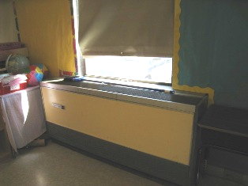

Unit Ventilator (Univent)

Picture 2

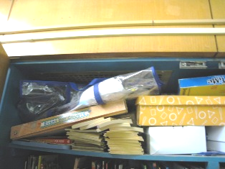

Exhaust Vent in Closet (Arrow)
Note Exhaust is Obstructed with Stored Materials
Picture 3

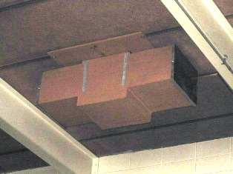

Ceiling Mounted Exhaust Vent
Note Ends are Capped (Arrows)

Picture 4



Univent Obstructed by Stored Materials
Picture 5

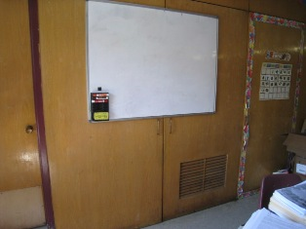

Dry Erase Board Covers Door to Exhaust Vent

Picture 6

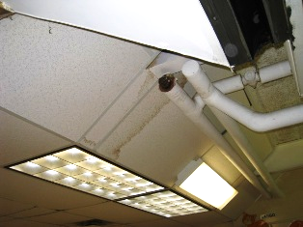

Water-Damaged Ceiling Tiles

Picture 7

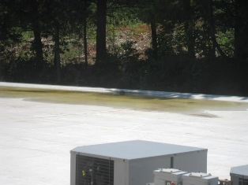

Standing Water on Roof

Picture 8

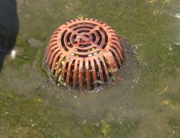

Accumulation of Debris around Perimeter of Roof Drain

Picture 9

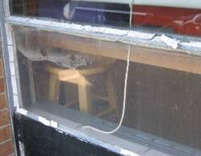

Cracked, Deteriorated and Missing Window Glazing/Sealant

Picture 10

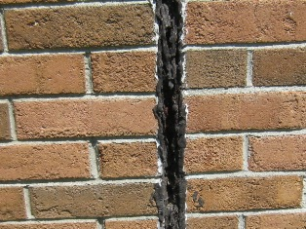

Deteriorated Expansion Joint Sealant

Picture 11

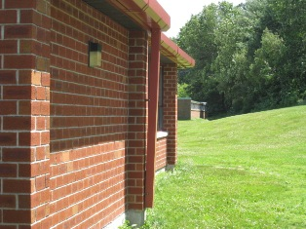

Downspout Deposits Water Directly onto Foundation (Arrow)

Picture 12

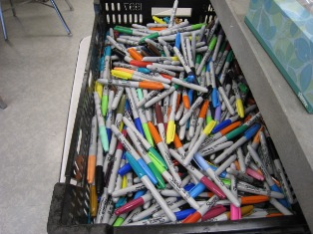

Permanent Markers

Picture 13

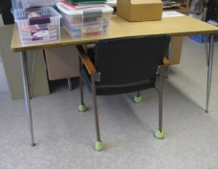

Latex Tennis Balls in Use as Glides on Chair

Picture 14

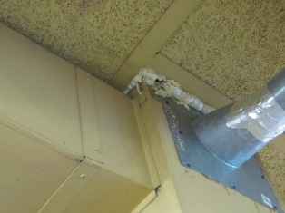

Breaches in Exhaust Duct for Kiln (Arrow)

Picture 15

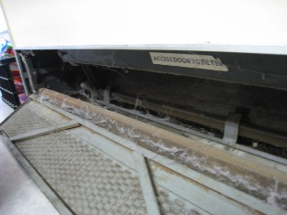

Dust and Debris on Interior of Univent

Picture 16

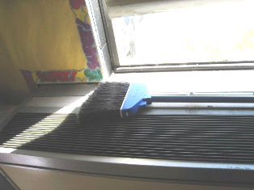

Broom Stored on Top of Univent

Picture 17

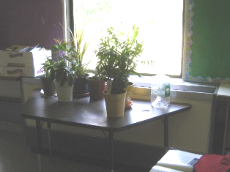

Plants Located in Front of Univent

Picture 18

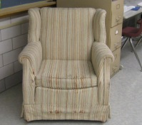

Upholstered Chair in Classroom
Location/ Room | Occupants  in Room | Temp  (°F) | Relative  Humidity  (%) | Carbon  Dioxide  (ppm) | Carbon Monoxide  (ppm) | PM2.5  (µg/m3) | Windows  Openable | Ventilation |  | Remarks
 |  |  |  |  |  |  |  | Supply | Exhaust | Remarks
background |  | 70 | 52 | 328 | ND | 14 |  |  |  | Clear, breezy, wind speed 5mph (W), visibility 10 miles (Weather Underground)
Girls Room |  |  |  |  |  |  | Y | Y | Y
Boys Room |  |  |  |  |  |  | Y | Y | Y
Gymnasium | 0 | 73 | 47 | 521 | ND | 18 | N | Y | Y | DO
Girls room |  |  |  |  |  |  | N | N | Y
Room A107  (clinic) | 2 | 77 | 50 | 695 | ND | 17 | Y | N | N | DO
A106  (mail room) | 3 | 77 | 47 | 482 | ND | 19 | Y  1/1 | N | N | DO
Girls Room |  |  |  |  |  |  | N | N | Y
Teachers’ Lounge | 1 | 74 | 50 | 502 | ND | 15 | Y | N | N | AC
Women’s Room |  |  |  |  |  |  | N | N | Y
Office  (front) | 3 | 75 | 47 | 563 | ND | 19 | N | N | N | DO
Principal | 0 | 75 | 47 | 541 | ND | 19 | Y | N | N | DO
Asst. Principal | 1 | 75 | 46 | 628 | ND | 19 | N | N | N | DO, window mounted AC
Guidance | 1 | 76 | 40 | 472 | ND | 16 | Y  ½ | N | N | DO
Kitchen | 4 | 74 | 52 | 688 | ND | 17 | N | Y | Y
Cafeteria | 40 | 75 | 45 | 646 | ND | 16 | Y  4/7 | Y | Y | Exhaust blocked
Boiler Room | 0 | 73 | 45 | 502 | ND | 17 | N | Y | N
Room 100 | 1 | 69 | 56 | 577 | ND | 19 | Y | Y | Y | DO, CD, broken window
Room 101 | 0 | 70 | 55 | 638 | ND | 17 | Y | Y | Y | DO
Room 102 | 22 | 73 | 54 | 798 | ND | 18 | N | Y | Y | WD CTs
Room 103  (comp. room) | 1 | 74 | 50 | 512 | ND | 17 | Y | Y | Y | DO, DEM, ACs, no air movement detected in supply or exhaust
Room 104 | 0 | 74 | 42 | 418 | ND | 15 | Y  2/2 | N | Y | PF, AC
Room 105  (Library A) | 21 | 74 | 55 | 868 | ND | 16 | Y | Y | N | DO, no exhaust observed, univent obstructed
Room 106 | 23 | 77 | 54 | 712 | ND | 15 | Y | Y | Y | PFs, CD, DEM
Room 107  (Library B) | 0 | 73 | 55 | 817 | ND | 15 | Y | Y | Y | DO, PFs
Room 108 | 21 | 75 | 55 | 757 | ND | 17 | Y | Y | Y
Room 109 | 20 | 73 | 59 | 2027* | ND | 17 | Y | Y | Y | CD, Access to exhaust in closet blocked by dry erase board, *class was very active
Room 110 | 24 | 77 | 51 | 694 | ND | 17 | Y  1/1 | Y | Y | DEM, PF, exhaust in closet blocked by DEM, univent off, cleaning products
Room 111 | 20 | 74 | 57 | 1243 | ND | 19 | Y | Y | Y | DO, CD, DEM, PF, supply and exhaust obstructed
Room 112 | 23 | 74 | 61 | 1058 | ND | 18 | Y | Y | Y | PF, DEM, univent obstructed
Room 113 | 23 | 71 | 55 | 888 | ND | 16 | Y | Y | Y | PF, CD, dust on fan blades, cloth furnishings
Room 114 | 0 | 70 | 59 | 457 | ND | 13 | Y | Y | Y | DO, CD, DEM, refrigerator bathroom sink has dry trap, possible leak in drain line, weak exhaust in bathroom
Room 115 | 17 | 71 | 55 | 763 | ND | 9 | Y | Y | Y | PF,DEM, cleaning products, paper accumulation
Room 116 | 20 | 76 | 51 | 749 | ND | 19 | Y | Y | Y | PF, cleaning products
Room 117 | 1 | 68 | 60 | 535 | ND | 13 | Y | Y | Y | DO, PF, refrigerator, coffee pot
Room 118 | 19 | 69 | 62 | 914 | ND | 13 | Y | Y | Y | DEM, CD, PF (dust on fan blades), cleaning products
Room 119 | 23 | 70 | 61 | 684 | ND | 12 | Y | Y | Y | DO, DEM, univent air supply partially blocked
Room 201 | 6 | 73 | 51 | 573 | ND | 17 | Y  1/1 | Y | Y | DO, UF, CF, DEM, univent off, exhaust off
Room 202 | 2 | 75 | 48 | 496 | ND | 18 | Y | Y | Y | DO, CD, PF,TB, CF univent off
Room 203 | 1 | 74 | 51 | 523 | ND | 16 | Y | Y | Y | CD, univent obstructed, exhaust off
Room 204 | 0 | 74 | 50 | 579 | ND | 20 | Y | Y | Y | DO, CD, WD CT, univent off
Room 205 | 16 | 75 | 44 | 591 | ND | 19 | Y | Y | Y | DO, DEM, CD, cleaning products, plants in front of univent
Room 206 | 23 | 77 | 50 | 638 | ND | 20 | Y | Y | Y | CD, PF,
Room 207 | 22 | 74 | 50 | 600 | ND | 16 | Y | Y | Y | DO, CF, PF, DEM
Room 208 | 17 | 76 | 46 | 606 | ND | - | Y | Y | Y | CF, DEM
Room 209 | 17 | 74 | 50 | 978 | ND | 23 | Y | Y | Y | DO, DEM, exhaust off
Room 210 | 21 | 76 | 50 | 765 | ND | 20 | Y | Y | Y | DEM, PF,CF
Room 211 | 19 | 74 | 52 | 870 | ND | 20 | Y | Y | Y | DEM, CF
Room 212 | 22 | 74 | 53 | 590 | ND | 22 | Y  1/1 | Y | Y | DEM, CF, PF, exhaust obstructed
Room 213 | 0 | 72 | 52 | 562 | ND | 16 | Y | Y | Y | DO, DEM, CF, AC, dry drain
Room 213A | 3 | 72 | 56 | 626 | ND | 22 | Y | N | N | AC, ceiling -mounted heater
Room 214 | 9 | 73 | 54 | 709 | ND | 20 | Y  2/4 | Y | Y | Enamel spray paints, kiln has exhaust

An Information Booklet Addressing PCB-Containing Materials in the Indoor Environment of Schools
and Other Public Buildings



Prepared by

Bureau of Environmental Health
Massachusetts Department of Public Health
December 2009
INTRODUCTION
The purpose of this information booklet is to provide assistance to school and public building officials and the general public in assessing potential health concerns associated with polychlorinated biphenyl (PCB) compounds in building materials used in Massachusetts and elsewhere. Recently, the U.S. Environmental Protection Agency (EPA) provided broad guidance relative to the presence of PCBs in building materials, notably PCBs in caulking materials. The most common building materials that may contain PCBs in facilities constructed or significantly renovated during the 1950s through the 1970s are fluorescent light ballasts, caulking, and mastic used in tile/carpet as well as other adhesives and paints.
This information booklet, developed by the Massachusetts Department of Public Health’s Bureau of Environmental Health (MDPH/BEH), is designed to supplement guidance offered by EPA relative to potential health impacts and environmental testing. It also addresses managing building materials, such as light ballasts and caulking, containing PCBs that are likely to be present in many schools and public buildings across the Commonwealth. This is because the Northeastern part of the country, and notably Massachusetts, has a higher proportion of schools and public buildings built during the 1950s through 1970s than many other parts of the U.S. according to a 2002 U.S. General Accounting Office report. The Massachusetts School Building Authority noted in a 2006 report that 53 percent of over 1,800 Massachusetts school buildings surveyed were built during the 1950s through 1970s. This information booklet contains important questions and answers relative to PCBs in the indoor environment and is based on the available scientific literature and MDPH/BEH’s experience evaluating the indoor environment of schools and public buildings for a range of variables, including for PCBs as well as environmental data reviewed from a variety of sources.
1. What are PCBs?
Polychlorinated biphenyl (PCB) compounds are stable organic chemicals used in products from the 1930s through the late 1970s. Their popularity and wide-spread use were related to several factors, including desirable features such as non-flammability and electrical insulating properties. Although the original use of PCBs was exclusive to closed system electrical applications for transformers and capacitors (e.g., fluorescent light ballasts), their use in other applications, such as using PCB oils to control road dust or caulking in buildings, began in the 1950s.
2. When were PCBs banned from production?
Pursuant to the Toxic Substance Control Act (TSCA) of 1976 (effective in 1979), manufacturing, processing, and distribution of PCBs was banned. While the ban prevented production of PCB-containing products, it did not prohibit the use of products already manufactured that contained PCBs, such as building materials or electrical transformers.
3. Are PCBs still found in building materials today?
Yes. Products made with PCBs prior to the ban may still be present today in older buildings. In buildings constructed during the 1950s through 1970s, PCBs may be present in caulking, floor mastic, and in fluorescent light ballasts. Available data reviewed by MDPH suggests that caulking manufactured in the 1950s through 1970s will likely contain some levels of PCBs. Without testing it is unclear whether caulking in a given building may exceed EPA’s definition of PCB bulk product waste of 50 parts per million (ppm) or greater. If it does, removal and disposal of the caulk is required in accordance with EPA’s TSCA regulations (40 CFR § 761).
4. Are health concerns associated with PCB exposure opportunities?
Although the epidemiological evidence is sometimes conflicting, most health agencies have concluded that PCBs may reasonably be anticipated to be a carcinogen, i.e., to cause cancer.
PCBs can have a number of non-cancer effects, including those on the immune, reproductive, neurological and endocrine systems. Exposure to high levels of PCB can have effects on the liver, which may result in damage to the liver. Acne and rashes are symptoms typical in those that are exposed to high PCB levels for a short period of time (e.g., in industry / occupational settings).
5. If PCBs are present in caulking material, does that mean exposure and health impacts are likely?
No. MDPH/BEH’s review of available data suggests that if caulking is intact, no appreciable exposures to PCBs are likely and hence health effects would not be expected. MDPH has conducted indoor tests and reviewed available data generated through the efforts of many others in forming this opinion.
6. How can I tell if caulking or light ballasts in my building may contain PCBs?
If the building was built sometime during the 1950s through 1970s, then it is likely that the caulking in the building and/or light ballasts may contain some level of PCBs. Light ballasts manufactured after 1980 have the words “No PCBs” printed on them. If the light ballast does not have this wording or was manufactured before 1980, it should be assumed that it contains PCBs.
7. What are light ballasts?
A light ballast is a piece of equipment that controls the starting and operating voltages of fluorescent lights. A small capacitor within older ballasts contains about one ounce of PCB oil. If light bulbs are not changed soon after they go out, the ballast will continue to heat up and eventually result in the release of low levels of PCBs into the indoor air.
8. Does the presence of properly functioning fluorescent light ballasts in a building present an environmental exposure concern?
No appreciable exposure to PCBs is expected if fluorescent light ballasts that contain PCBs are intact and not leaking or damaged (i.e., no visible staining of the light lenses), and do not have burned-out bulbs in them.

9. Should I be concerned about health effects associated with exposure to PCBs as a result of PCB-containing light ballasts?
While MDPH has found higher PCB levels in indoor air where light bulbs have burned-out, the levels are still relatively low and don’t present imminent health threats. A risk assessment conducted recently at one school did not suggest unusual cancer risks when considering a worst case exposure period of 35 years for teachers in that school. Having said this, MDPH believes that facility operators and building occupants should take prompt action to replace bulbs and/or ballasts as indicated to reduce/eliminate any opportunities for exposure to PCBs associated with PCB-containing light ballasts.
10. When should PCB-containing light ballasts be replaced?
If ballasts appear to be in disrepair, they should be replaced immediately and disposed of in accordance with environmental regulatory guidelines and requirements. However, if light bulbs burn out, the best remedy is to change them as soon as possible. If light bulbs are not changed soon after they go out, the ballast will continue to heat up and eventually result in the release of low levels of PCBs into the indoor air. Thus, burned-out bulbs should be replaced promptly to reduce overheating and stress on the ballast. As mentioned, ballasts that are leaking or in any state of disrepair should be replaced as soon as possible.
It should be noted that although older light ballasts may still be in use today, the manufacturers’ intended lifespan of these ballasts was 12 years. Thus, to the extent feasible or in connection with repair/renovation projects, the older light ballasts should be replaced consistent with the intended lifespan specified by the manufacturers.
11. Does MDPH recommend testing of caulking in buildings built during the 1950s -1980?
Caulking that is intact should not be disturbed. If caulking is deteriorating or damaged, conducting air and surface wipe testing in close proximity to the deteriorating caulking will help to determine if indoor air levels of PCBs are a concern as well as determining the need for more aggressive cleaning. Results should be compared with similar testing done in an area without deteriorating caulking. In this way, a determination can be made regarding the relative contribution of caulking materials to PCBs in the general indoor environment.
12. What if we determine that caulking in our building is intact and not deteriorating?
Based on a review of available data collected by MDPH and others, the MDPH does not believe that intact caulking presents appreciable exposure opportunities and hence should not be disturbed for testing. As with any building, regular operations and maintenance should include a routine evaluation of the integrity of caulking material. If its condition deteriorates then the steps noted above should be followed. Consistent with EPA advice, if buildings may have materials that contain PCBs, facility operators should ensure thorough cleaning is routinely conducted.
13. Should building facilities managers include information about PCB-containing building materials in their Operations and Maintenance (O&M) plans?
Yes. All buildings should have an O&M plan that includes regular inspection and maintenance of PCB building materials, as well as thorough cleaning of surfaces not routinely used. Other measures to prevent potential exposure to PCBs include increasing ventilation, use of HEPA filter vacuums, and wet wiping. These O&M plans should be available to interested parties.
14. Are there other sources of PCBs in the environment?
Yes. The most common exposure source of PCBs is through consumption of foods, particularly contaminated fish. Because PCBs are persistent in the environment, most residents of the U.S. have some level of PCBs in their bodies.
15. Where can I obtain more information?
For guidance on replacing and disposing of PCB building materials, visit the US EPA website: http://www.epa.gov/pcbsincaulk/. For information on health concerns related to PCBs in building materials, please contact MDPH/BEH at 617-624-5757.

