**WATER DAMAGE ASSESSMENT**

**North Andover Middle School**

**495 Main Street**

**North Andover**

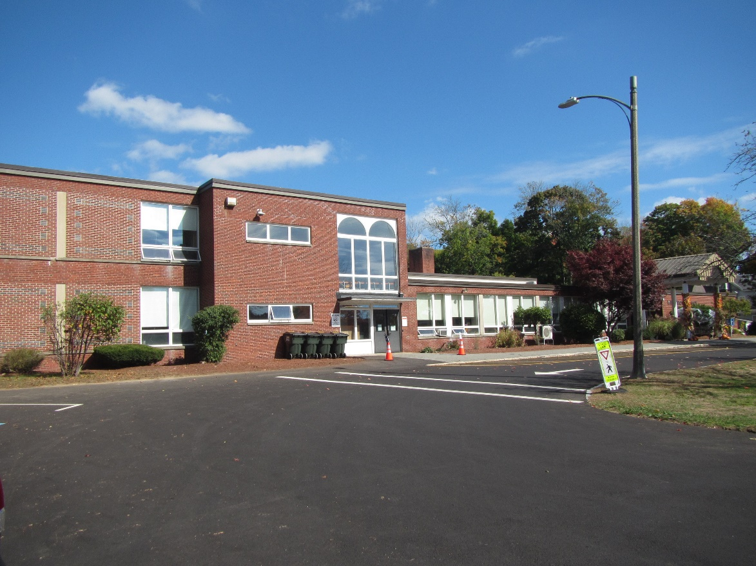

Prepared by:

Massachusetts Department of Public Health

Bureau of Climate and Environmental Health

November 2024

# BACKGROUND

|  |  |
| --- | --- |
| Building: | North Andover Middle School (NAMS) |
| Address: | 495 Main Street, North Andover, MA |
| Requestor: | Stephen E. Foster, Facilities Director,  North Andover |
| Reason for Request: | Water damage and mold odors in classrooms adjacent to interior courtyard in the 1998 wing and a classroom built over a crawlspace in the 1963 wing. |
| Date of Assessment: | October 3, 2024 |
| Massachusetts Department of Public Health/Bureau of Environmental Health (MDPH/BCEH) Staff Conducting Assessment: | Michael Feeney, Senior Bureau Advisor, BCEH |
| Building Description: | The NAMS is a multi-wing brick building constructed in 1954. The building was renovated with the addition of new wings that were added in 1998. |
| Windows: | Openable |

# EXECUTIVE SUMMARY

BCEH staff was asked to examine NAMS for the presence of water damage/mold odor resulting from high relative humidity that occurred during August 2024. The NAMS experienced water damage in two separate locations: classrooms near the northwest courtyard in the 1998 wing and classrooms in the 1954 wing. According to facility staff, contractors used the US EPA guidelines Mold Remediation in Schools and Commercial Buildings (<https://www.epa.gov/mold/mold-remediation-schools-and-commercial-buildings-guide-chapter-1>) to conduct water damage remediation including:

* Identifying the source of moisture,
* Removing water-damaged porous materials capable of supporting mold growth (ceiling tiles, carpeting and various stored materials), and
* Cleaning water-damaged non-porous surfaces (e.g., painted cement walls, laminated counters, floor tile).

BCEH staff examined the classrooms in the 1998 wing where the mold odor was reported to have occurred. Based on observations, the source of the water vapor was most likely due to the configuration of the walls and ground inside the interior courtyard. Odors in other classrooms in the 1963 wing are related to odors drawn from the wet crawlspace by the classroom univent via holes in the floor used for univent wiring and pipes.

Based on these observations, the removal of soil against classroom courtyard exterior walls that buries the exterior wall/floor slab junction is recommended. This may include the removal of cement planters to prevent the retention of water against classroom courtyard exterior walls.

# METHODS

Visual inspections were conducted in ground floor areas. Air temperature and relative humidity were measured in each room. Surface temperatures of floors and walls were measured to determine if building components were at or below the dew point (temperature where condensation will occur). Please refer to the IAQ Manual for methods, equipment, sampling procedures, and interpretation of results (MDPH, 2015).

# RESULTS AND DISCUSSION

## Ventilation System

Fresh air in most classrooms is supplied by unit ventilators (univents). Univents were installed in classrooms during the 1993 renovation. Univents draw air from the outdoors through a fresh air intake located on the exterior wall of the building and return air through an air intake located at the base of the unit (Picture 1). Fresh and return air are mixed, filtered, heated, or cooled, and provided to rooms through an air diffuser located in the top of the unit (Figure 1).

Mechanical exhaust ventilation in classrooms is provided by wall-mounted exhaust vents connected to rooftop motors. The MDPH BCEH recommends that supply and exhaust ventilation operate continuously during occupied periods to provide air exchange and filtration. Without sufficient supply and exhaust ventilation, normally-occurring environmental pollutants can build-up and lead to indoor air quality/comfort complaints.

It is important to note that despite ongoing maintenance and replacement of parts/components by facilities staff, many of the HVAC units are at the end of their life cycle. According to the American Society of Heating, Refrigeration, and Air-Conditioning Engineering (ASHRAE), the service life[1] of this type of unit is 15-20 years, assuming routine maintenance of the equipment (ASHRAE, 1991). However, during the course of this assessment, a project to replace some univents in below-grade space was initiated.

To have proper ventilation with a mechanical ventilation system, the systems must be balanced after installation to provide an adequate amount of fresh air to the interior of a room while removing stale air from the room. It is recommended that HVAC systems be re-balanced every five years to ensure adequate air systems function (SMACNA, 1994). Based on the age and condition of the univents, balancing of the HVAC system may not be possible.

The univents at NAMS do not supply cooling/air conditioning. Univents operating during warm weather directly introduce unconditioned outdoor air into classrooms. Operating univents and/or opening windows during summer weather can draw in hot, humid air which can lead to water damage indoors. The sources of moisture causing water damage was a combination of high relative humidity weather that occurred in August 2024, potentially combined with water vapor migration from school water drains with dry drain traps. Heavy rain entering the North Andover storm/sewer system may have forced water vapor and air to back up the sink drain system, which then caused condensation on stored materials and building components.

## Water Damage Issues

BCEH staff did not detect any mold odors, visible mold growth, or conditions that could result in water vapor moistening building components or stored materials during the visit. NAMS staff reported that the following efforts to remediate water damage in the building were conducted: cleaning, examining gypsum wallboard along exterior walls, and use of dehumidifiers to reduce relative humidity.

In hot, humid weather conditions, buildings that have floor slabs that rest on soil may have temperatures below the dew point, which would cause condensation to accumulate on the floor, moistening carpeting and other materials resting on the floor.

Of note is that the univents have air intakes at ground level that can draw moisture from soil. Pipes intended for univent condensation drainage (Picture 2) were not sealed appropriately in the 1993 wing. Open space around utility pipes also were found in univents of the 1963 wing. Such open space can be a pathway for crawlspace odors and water vapor to be drawn by the univent fans and distributed to occupied areas.

One sign of long periods of high relative humidity in the NAMS is the presence of bowed ceiling tiles (Picture 3). If a building experiences high relative humidity indoors over an extended period, moisture exposure may cause ceiling tiles to bow. Bowed ceiling tiles without discoloration/stains are not mold colonized, but are a sign of long-term water vapor exposure, which causes sagging due to the weight of water in the ceiling tile and its effect on binders that hold the tile intact.

Bowing ceiling tiles are often found in classrooms and cafeterias with sink or floor drains where the trap has dried out. A trap is a section of pipe below the drain opening that fills with water to form an airtight seal. The airtight seal prevents combustible sewer gas, odors, and water vapor from the drain systems from backing up the drain to enter occupied space. Water evaporates from the trap if plumbing is not used for several days, or weeks, depending on ambient conditions. Wetting of all drain traps regularly to maintain the airtight water seal is particularly important when heavy rains occur, which may pressurize combined storm/sanitary sewer systems and force sewer gas and water vapor/odors/pollutants up the drainpipe. Schools are particularly vulnerable to dry drain traps due to the extended summer vacation.

It is also important to note that the NAMS HVAC system does not have the capacity to chill air during hot weather. In addition to providing cooling, air conditioning also reduces indoor humidity during operation. Use of dehumidifiers on the ground floor during hot, humid weather may reduce humidity and associated water damage issues.

### Poor drainage in courtyards

NAMS has a large interior courtyard that has strips of soil beneath univent fresh air intakes (Picture 4) as well as large cement planters (Picture 5) that have soil in direct contact with exterior walls and signs of poor water drainage. The cement planters lack any visible means to drain water. Without drainage, heavy rains can fill the planters and create standing water that will create the conditions for growing bacteria and mold.

Accumulated rainwater likely pools against the exterior walls beneath the univent fresh air intake and other similar locations in the courtyard. Over time, rainwater falling inside the courtyard compresses soil to produce depressions adjacent to the foundation slab, which, in turn, can result in water pooling. This condition can result in univents drawing water vapor from these pools, which can: corrode the univent cabinet, wet cardboard-framed filters to cause mold growth, and increase relative humidity inside the building. Such pooling can also result in excessive water exposure to foundation walls and floor, which can then lead to water penetrating through exterior walls. In addition, the courtyard outside classrooms with reported mold growth appears to have a slope that can direct water towards the walls, especially during extreme rainfall.

Enhancing water retention and likely affecting courtyard drainage is the presence of large trees in both courtyards that also overhang the roof. These trees pose a number of issues/hazards:

* Leaves and other tree debris accumulate around roof drains, which inhibits rainwater drainage. This can also lead to ice accumulation blocking drains. Ineffective drains can lead to water running off the roof to moisten exterior walls.
* Trees prevent sunlight from drying courtyard exterior walls and soil.
* The trees are a possible danger to the NAMS due to the distance from exterior walls.
  + The recommended safe distance that any tree should be planted is the minimum of the expected maximum growth height of the species from the exterior of a building (BI, 2015).
  + Soil subsidence may also be caused by tree roots, which can undermine the structure of a building to cause wall and floor cracking as well as other related damage. To prevent subsidence, a sufficient distance appropriate for the trees species is recommended (Williams, 2006).
  + Even within the recommended distance, severe weather may result in trees falling onto the building or having roots damage the foundation.
  + Also of note is resistance of trees to uprooting during high wind events accompanied by rain. In general, a tree root system will spread out in all directions from its trunk. In some cases, tree roots can extend for over 100 feet from its trunk. Any structure disrupting the root structure may make the tree unstable if subjected to high winds from a certain direction. Based on the location, the foundation walls likely disrupt the roots of a number of trees.

The Federal Emergency Management Agency (FEMA) provides a number of recommendations in order to prepare for severe thunderstorms. Of note, FEMA recommends “Cut down or trim trees that may be in danger of falling on your [building]” (FEMA, 2018). Given the proximity to the exterior walls, removal of trees from the courtyard should be strongly considered.

### Building materials prone to condensation

The floor slabs and walls are in direct contact with soil. Uninsulated floors and walls would be likely to have temperatures significantly below air temperature. Given this, it is likely that the lowest levels of the building have both floors and walls that are prone to condensation during hot, humid weather.

The key to managing condensation is understanding dew point. The dew point is the temperature that air must reach for saturation to occur. When warm, moist air passes over a cooler surface, condensation can form. If a building material/component has a temperature below the dew point, condensation will accumulate on that material. Porous materials can be moistened by condensation or by droplets resulting from condensation on nearby surfaces, which creates conditions where mold may grow. Porous building materials such as gypsum wallboard, and stored materials such as cardboard, cloth, paper, and soft wood can all become water-damaged and, if exposed to moisture for longer than 24 to 48 hours, mold colonization can occur.

The guideline “Preventing Mold Growth In Schools During Hot, Humid Weather” <https://www.mass.gov/info-details/preventing-mold-growth-in-massachusetts-schools-during-hot-humid-weather> should be used to minimize the impact of such weather on classroom materials. This includes the use of air conditioning and dehumidifiers, ensuring exhaust vents are on and operable, keeping windows closed, and ensuring air can circulate around porous materials.

### Mold Testing Recommendations

The presence of mold found by a test does not necessarily indicate a problem. Visual evidence of mold growth and/or the presence of musty odors are reliable indicators of mold problems that are correlated with health risks in buildings where indoor environmental complaints have been made. Mold spores waft through the indoor and outdoor air continually There is no practical way to eliminate all mold and mold spores in the indoor environment; the way to control indoor mold growth is to control moisture (US EPA, 2024).

There is no means by which to determine whether an individual’s symptoms or reactions were caused by mold by conducting environmental air testing for mold. While mold, spores, and other associated materials can make allergies and asthma symptoms worse, different people react differently to mold and mold spores. In addition to mold, reactions experienced by individuals could be caused by bacteria, other compounds in the air caused by the breakdown of wet building materials, or something different altogether (NIOSH, 2024; California DPH, unknown; Mendell, M. J., Mirer, A. G., Cheung, K., & Douwes, J. 2011; WHO. 2009).

The U.S. Environmental Protection Agency (EPA) does not recommend testing. DPH follows the guidelines contained in the U.S. EPA Mold Remediation in Schools and Commercial Buildings report for cleaning and removing water-damaged materials. US EPA’s guidelines recommend, in most cases, that if visible mold growth is present, mold sampling is not necessary. A number of international, US federal, and state agencies either do not have or recommend against conducting mold testing as part of mold remediation (see **REFERENCES** headings: **Agencies with guidelines recommending against mold testing,** and **Reference from government agencies, industrial hygiene groups and or other environmental professional guidelines that denote that no mold exposure limits have been established for mold in workplace, government buildings or residences).** For **e**xample, the U.S. Department of Housing and Urban Development (HUD) does not recommend conducting environmental mold testing:

*“No matter what kind of mold you have, you need to get rid of it and fix the moisture problems that made it grow. Most experts think it’s better to spend your time and money on cleaning up the problem than testing” (HUD. 2024).*

Multiple worker safety agencies and organizations have no worker safety air levels established for exposure to species of mold. The following agencies and professional industrial hygiene agencies have not established mold exposure levels in the workplace that would justify air testing. The following industrial safety guidelines do not list any mold species and air level concentrations:

* US Occupational Safety And Health Administration has not established any mold Permissible Exposure Limits (PELs) for mold air levels.
* American Conference of Governmental Industrial Hygienists (ACGIH) has no established Threshold Limit Values (TLVs) for mold air levels.
* National Institute of Occupational Safety and Health (NIOSH) has no established Recommended Exposure Limits (RELs) for mold air levels.
* American Industrial Hygiene Association (AIHA) has no established Workplace Environmental Exposure Levels (WEELs) for mold air levels.

Additionally, even if worker safety exposure limits existed for mold, such guidelines **would not apply** to non-employees in a building. These individuals include: students in primary education schools; students in secondary education facilities; adults outside worker ages as defined by OSHA; individuals with chronic health conditions; patients in any medical facility; adults who are invitees, customers, or visitors to the workplace and other members of the general public.

For non-employees, there are **no established mold exposure limits** (international, Federal, or state regulations, building standards or guidelines) on how much mold can exist in air before health impacts are expected for the general population. In addition, the international, Federal, state or building standards agency have not established mold remediation clean-up levels that must be achieved after mold remediation efforts are completed.

This means that even if tests are conducted, there is no way to compare results or determine whether the measured level could cause health effects or meet clean up levels. Multiple federal agencies, including the US EPA, US Department of Housing and Urban Development and the US Federal Emergency Management Agency (FEMA) have not established mold exposure standard or recommend environmental mold testing in any water damage/flood recovery guidelines. With no established workers or general public safety exposure limits, air testing will not influence how mold remediation efforts would be conducted.

To remove mold from buildings, of primary importance is to identify, repair and/ or limiting the moisture source cause damage in the building. Once moisture source is remediated, then discarding and/or cleaning of mold contaminated materials can be completed.

# CONCLUSIONS/RECOMMENDATIONS

Based on the observations made during the visit, it appears that most water-damaged materials were thoroughly dried and/or removed. The following additional recommendations are made:

1. Remove all plants within 3 feet of univent fresh air intakes.
2. Remove univent condensation drainpipes from exterior walls. Permanently render pipe openings weathertight after removal.
3. Consideration should be given to increasing drainage below univent fresh air intakes in the courtyard, which may include removal of all soil in courtyard planters.
4. Consider removing or relocating cement planter to prevent soil direct contact with exterior walls and floor slab.
5. Ensure that drains in all sinks have wetted drain traps by pouring water down the sink once a week to maintain airtight seal.
6. Given the proximity to the exterior walls, removal of trees from the courtyard should be strongly considered.
7. For more information on mold refer to the US EPA’s “Mold Remediation in Schools and Commercial Buildings,” available at: <http://www.epa.gov/mold/mold-remediation-schools-and-commercial-buildings-guide>.
8. Management of buildings in extreme relative humidity and rain can be challenging. The following documents can provide guidance that can be used to reduce the impact of hot, humid weather in buildings:
   1. Mold Growth Prevention During Hot, Humid Weather <https://www.mass.gov/service-details/preventing-mold-growth-in-massachusetts-schools-during-hot-humid-weather> and
   2. Remediation and Prevention of Mold Growth and Water Damage in Public Schools <https://www.mass.gov/service-details/remediation-and-prevention-of-mold-growth-and-water-damage-in-public-schools-and>.
9. Refer to resource manuals and other related documents for further building-wide evaluations and advice on maintaining public buildings. Copies of these materials are located on the MDPH’s website: <http://mass.gov/dph/iaq>.

# REFERENCES

## General References

ACGIH. 1989. Guidelines for the Assessment of Bioaerosols in the Indoor Environment. American Conference of Governmental Industrial Hygienists, Cincinnati, OH.

ASHRAE. 1991. ASHRAE Applications Handbook, Chapter 33 “Owning and Operating Costs”. American Society of Heating, Refrigeration and Air Conditioning Engineers, Atlanta, GA.

ASHRAE, 2019. American Society of Heating, Refrigeration and Air Conditioning Engineers (ASHRAE) Ventilation for Acceptable Indoor Air Quality. ANSI/ASHRAE Standard 62.1-2019. Atlanta, GA.

BI. 2015. A List of Trees and the Recommended Safe Distance from Buildings. Bickers Insurance, Littlehampton, West Sussex, UK. <https://www.bickersinsurance.co.uk/about-us/latest-news/property-owners-news/a-list-of-trees-and-the-recommended-safe-distance-from-buildings/>

FEMA. 2018. How to Stay Safe When a Thunderstorm Threatens. Federal Emergency Management Agency, Washington, DC. FEMA V-1009/May 2018.

MDPH. 2015. Massachusetts Department of Public Health. Indoor Air Quality Manual: Chapters I-III. Available at: <https://www.mass.gov/lists/indoor-air-quality-manual-and-appendices>.

SMACNA. 1994. HVAC Systems Commissioning Manual. 1st ed. Sheet Metal and Air Conditioning Contractors’ National Association, Inc., Chantilly, VA.

US EPA. 2008. “Mold Remediation in Schools and Commercial Buildings”. Office of Air and Radiation, Indoor Environments Division, Washington, DC. EPA 402-K-01-001. September 2008. Available at: <http://www.epa.gov/mold/mold-remediation-schools-and-commercial-buildings-guide>

Williams, A. 2006. The Distance at Which Trees Can Affect a Building is Quite Significant. The Architects’ Journal. <https://www.architectsjournal.co.uk/home/the-distance-at-which-trees-can-affect-a-building-is-quite-significant/130858.article>

## Mold Testing References

ACGIH, 1989. Guidelines for the Assessment of Bioaerosols in the Indoor Environment. American Conference of Governmental Industrial Hygienists, Cincinnati, OH

CA DPH, unknown. California Department of Public Health Statement on Building Dampness, Mold, and Health. [California Department of Public Health Statement on Building Dampness Mold and Health](https://www.cdph.ca.gov/Programs/cls/dehl/ehl/CDPH%20Document%20Library/MoldDampStatement2017_ENG.pdf)

HUD. 2024. Help Yourself to a Healthy Home. US Department of Housing and Urban Development. Washington, DC. PAGES and Cover002.indd (hud.gov)

Mendell, M. J., Mirer, A. G., Cheung, K., & Douwes, J. 2011. Respiratory and allergic health effects of dampness, mold, and dampness-related agents: a review of the epidemiologic evidence. Environmental Health Perspectives 119(6):748. <https://pubmed.ncbi.nlm.nih.gov/21269928/>

NIOSH, 2024. [Mold, Testing, and Remediation | Workplace Mold | CDC](https://www.cdc.gov/niosh/mold/testing-remediation/index.html)

US EPA, 2008. “Mold Remediation in Schools and Commercial Buildings”. Office of Air and Radiation, Indoor Environments Division, Washington, DC. EPA 402-K-01-001. September 2008. Available at: <http://www.epa.gov/mold/mold-remediation-schools-and-commercial-buildings-guide>

U.S. EPA, 2024, Frequent Questions on Mold and Moisture, Updated: October 14, 2024. [Mold Frequently Asked Questions | US EPA](https://www.epa.gov/mold/mold-frequently-asked-questions)

WHO, 2009. WHO Guidelines for Indoor Air Quality: Dampness and Mould. World Health Organization Copenhagen: WHO Europe. WHO guidelines for indoor air quality : dampness and mould <https://www.who.int/publications/i/item/9789289041683>

## Agencies with guidelines recommending against mold testing

APHC. Residential Indoor Mold and Residential Mold Air Sample Results What Do They Mean? FACT SHEET 55-026-0319. U.S. Army Public Health Center, Industrial Hygiene Field Services Program, Aberdeen Proving Ground, Maryland.

CA HESIS. 2005. Molds in Indoor Workplaces. California Hazard Evaluation System and Information Service. P.2 Molds in Indoor Workplaces: Fact Sheet for Workers and Employers (ca.gov) Nov. 2005

CDC. 2024. Mold. Centers for Disease Control. Atlanta, GA. [Mold | Mold | CDC](https://www.cdc.gov/mold-health/about/index.html).

CTDPH. 2012. Get The Mold Out: Mold Clean-Up Guidance for Residences Fact Sheet. Connecticut Department of Public Health Environmental & Occupational Health Assessment Program Environmental Health Secon 410 Capitol Avenue, MS # 11EOH. [Get The Mold Out_ fact sheet082012](https://portal.ct.gov/-/media/departments-and-agencies/dph/dph/environmental_health/eoha/pdf/getthemoldoutpdf.pdf)

FEMA, unk. Homeowner’s and Renter’s Guilder o Mold Cleanup after Disasters. <https://www.fema.gov/sites/default/files/documents/fema_hm-cdc-homeowners-and-renters-mold-guide_english.pdf>

Health Canada. Guide to addressing moisture and mould indoors. <https://www.canada.ca/en/health-canada/services/publications/healthy-living/addressing-moisture-mould-your-home.html>

MDHHS. 2010. Mold Fact Sheet. Maine Department of Health and Human Services, Bangor, ME. <https://www.maine.gov/dhhs/mecdc/infectious-disease/epi/disease/documents/pdf/mold.pdf>

MNDPH. 2024. Testing For Mold. [Testing For Mold - MN Dept. of Health (state.mn.us)](https://www.health.state.mn.us/communities/environment/air/mold/moldtest.html)

NHDHHS. 2013. Mold and moisture. New Hampshire Department of Health and Human Services, Concord, NH. [https://www.dhhs.nh.gov/sites/g/files/ehbemt476/files/documents/2021-11/holu-dphs-mold-policy-letter.pdf](https://www.dhhs.nh.gov/sites/g/files/ehbemt476/files/documents/2021-11/holu-dphs-mold-policy-letter.pdf#:~:text=Although%20a%20handful%20of%20states%20have%20passed%20their,when%20ever%20you%20see%20mold%20or%20smell%20mildew.)

NIOSH. 2024. Mold, Testing, and Remediation. National Institute of Occupational Safety and Health, Cincinnati, OH.

NYDOL. Mold Assessment and Remediation in New York State. Mold Assessment and Remediation in New York State. New York Department of Labor. [p227.pdf (ny.gov)](https://dol.ny.gov/system/files/documents/2021/03/p227.pdf)

ODHS. Unk. FAST FACTs: Household Mold. Oregon Department of Human Services, Public Health Division, Office of Environmental Public Health: Toxicology Consulting Services. [Moldfactsheet.pdf (oregon.gov)](https://www.oregon.gov/oha/ph/HealthyEnvironments/TrackingAssessment/EnvironmentalHealthAssessment/Documents/Moldfactsheet.pdf)

OSHA. Mold. US Occupational Safety and Health Administration. [Mold - Recognize Mold Hazards | Occupational Safety and Health Administration (osha.gov)](https://www.osha.gov/mold/hazards)

USAPHC. 2018. Technical Guide 278 Industrial Hygiene Public Health Mold Assessment Guide. US Army Public Health Center, Public Health 6582 Magrath Ave BLDG 2059 Fort Carson, Colorado. <https://ph.health.mil/PHC%20Resource%20Library/TG278.pdf> .

VTDH. 2024. Mold Inside Home and Other Buildings. <https://www.healthvermont.gov/sites/default/files/document/env-hh-mold-indoors.pdf>

WSDH. Unk. Mold. Washington State Department of Health, [Mold | Washington State Department of Health](https://doh.wa.gov/community-and-environment/contaminants/mold)

## References from government agencies, industrial hygiene groups, and/or other environmental professional guidelines that denote that no mold exposure limits have been established for mold in workplace, government buildings or residences.

AIHA. 2019. FAQs About Spore Trap Air Sampling for Mold for Direct Microscopical Examination Mold Analysis Document. American Industrial Hygiene Association, Falls Church, VA. <https://aiha-assets.sfo2.digitaloceanspaces.com/AIHA/resources/FAQs-About-Spore-Trap-Air-Sampling-for-Mold-for-Direct-Examination-Guidance-Document.pdf>

APHC. Residential Indoor Mold and Residential Mold Air Sample Results What Do They Mean? FACT SHEET 55-026-0319. U.S. Army Public Health Center, Industrial Hygiene Field Services Program, Aberdeen Proving Ground, Maryland.

FEMA, unk. Homeowner’s and Renter’s Guilder o Mold Cleanup after Disasters. <https://www.fema.gov/sites/default/files/documents/fema_hm-cdc-homeowners-and-renters-mold-guide_english.pdf>

MDHHS. 2010. Mold Fact Sheet. Maine Department of Health and Human Services, Bangor, ME. <https://www.maine.gov/dhhs/mecdc/infectious-disease/epi/disease/documents/pdf/mold.pdf>

OHHN. 2023. Mold Basics. Ohio Healthy Homes Network, Columbus, Ohio. [Mold Basics | Ohio Healthy Homes Network (ohhn.org)](https://www.ohhn.org/mold-basics/)

WDHS. 2021. Controlling Mold and Moisture Household Mold Guidance for Local Health Professionals Wisconsin Department of Health Services, Indoor Air and Radon Program Division of Public Health, Bureau of Environmental and Occupational Health. <https://www.dhs.wisconsin.gov/publications/p02069.pdf>

WHO, 2009. WHO Guidelines for Indoor Air Quality: Dampness and Mould. World Health Organization Copenhagen: WHO Europe. WHO guidelines for indoor air quality : dampness and mould <https://www.who.int/publications/i/item/9789289041683>

**Figure 1**

**Unit Ventilator (Univent)**

Mixed Air

Air Diffuser

**Outdoors Indoors**

Fan

Heating/Cooling Coil

Air Mixing Plenum

Filter

Outdoor Return

Air Air

Air

Flow

Control

Louvers

**Air Flow**

= Fresh Air/Return Air

= Mixed Air

**Picture 1**

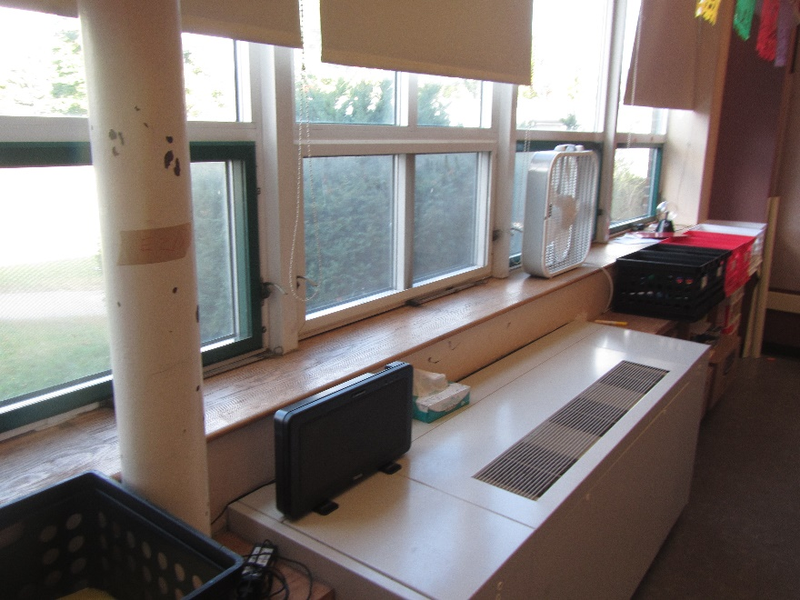

**Univent**

**Picture 2**

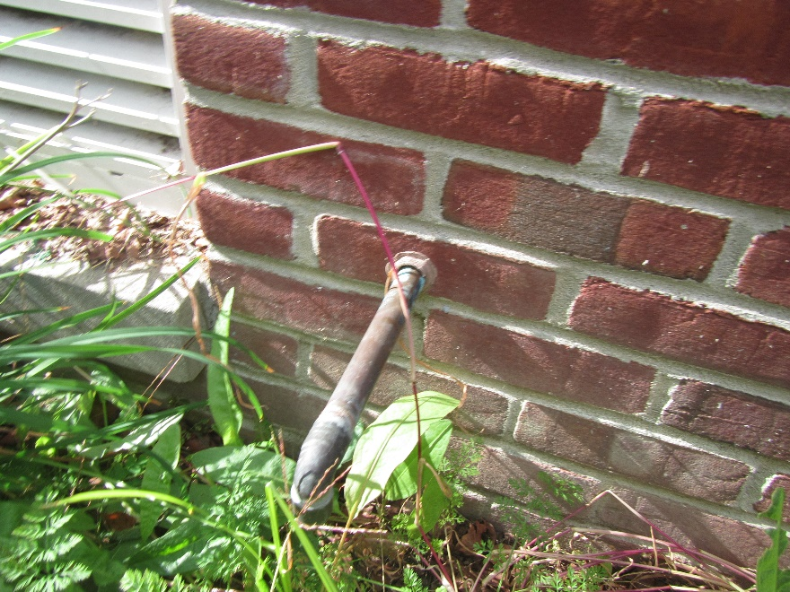

**Unused univent condensation drain pipe installed in exterior wall**

**Picture 3**

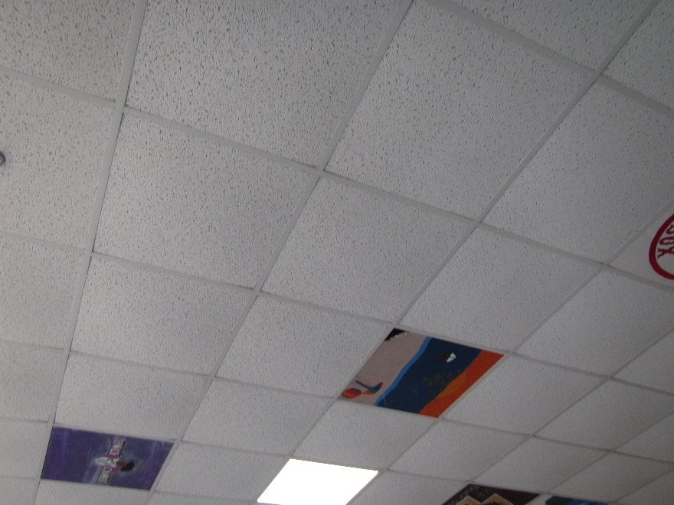

**Bowed ceiling tiles**

**Picture 4**

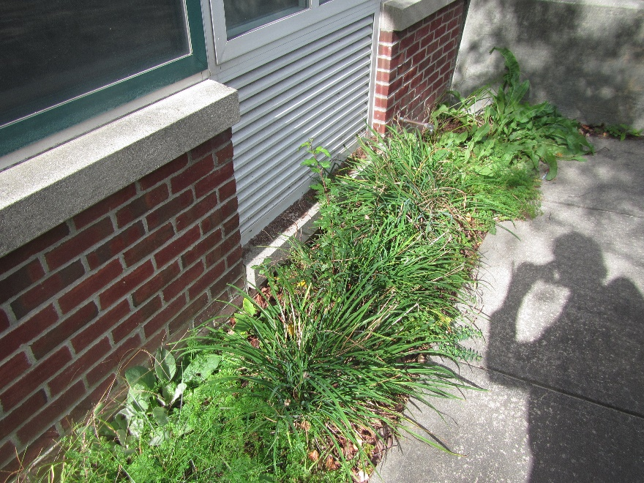

**Univent fresh air intake above moistened soil, note walkway creating dam to hold water against building**

**Picture 5**

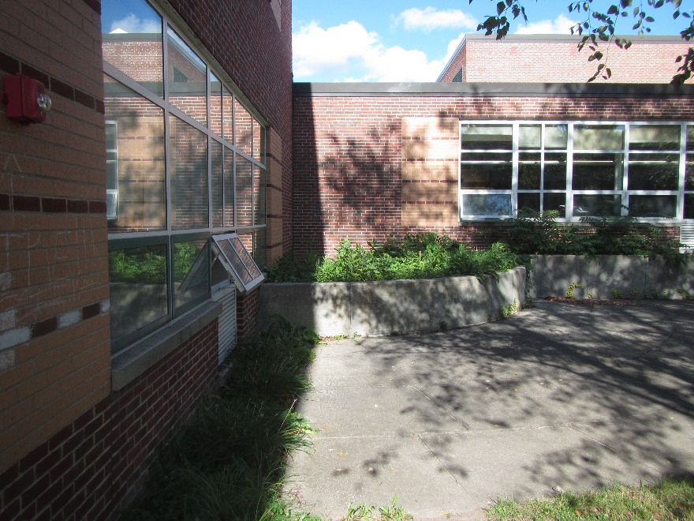

**Cement planter with no visible means to drain water**

1. The service life is the median time during which a particular system or component of …[an HVAC]… system remains in its original service application and then is replaced. Replacement may occur for any reason, including, but not limited to, failure, general obsolescence, reduced reliability, excessive maintenance cost, and changed system requirements due to such influences as building characteristics or energy prices (ASHRAE, 1991).