INDOOR AIR QUALITY ASSESSMENT

Community School
45 South Washington Street
North Attleborough, MA

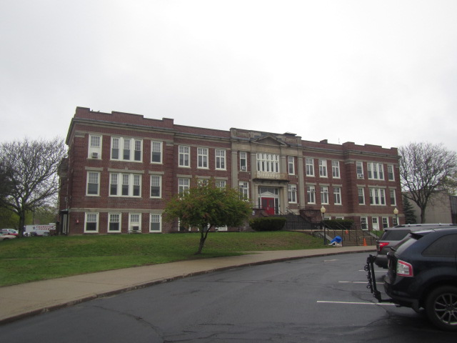

Prepared by:
Massachusetts Department of Public Health
Bureau of Environmental Health
Indoor Air Quality Program
June 2019

Background

Building: | Community School
Address: | 45 South Washington Street, North Attleborough, MA
Assessment Requested by: | Scott Holcomb, Superintendent, North Attleborough Public Schools (NAPS)
Reason for Request: | General indoor air quality (IAQ) and water damage/mold concerns
Date of Assessment: | April 30, 2019
Massachusetts Department of Public Health/Bureau of Environmental Health (MDPH/BEH) Staff Conducting Assessment: | Michael Feeney, Director, IAQ Program  Cory Holmes, Environmental Analyst/Inspector, IAQ Program
Date of Building Construction: | The Community School was constructed in 1918-1919 and formerly served as the North Attleborough High School. Two additions were constructed in the 1930s and in the 1950s.
Building Description: | The school is a two-story, red brick/plaster building with an occupied basement.
Building Population: | 306 students in grades K through 5 with a staff of approximately 45
Windows: | Windows are openable; replaced throughout the building in 2004 and in the gym in 2018.

METHODS
Please refer to the IAQ Manual for methods, sampling procedures, and interpretation of results (MDPH, 2015).

IAQ Testing Results
The following is a summary of indoor air testing results (Table 1).
- Carbon dioxide levels were above the MDPH Guideline of 800 parts per million (ppm) in sixteen of fifty-five areas surveyed, indicating a lack of air exchange in these areas, mainly due to deactivated/outdated ventilation components. This is explained further in the Ventilation section of this report.
- Temperature was within or close to the MDPH recommended range of 70°F to 78°F in areas tested. Room 305 has chronic issues with overheating/temperature control.
- Relative humidity was within or close to the MDPH recommended range of 40 to 60% in areas tested.
- Carbon monoxide levels were non-detectable (ND) in all areas tested.
- Fine particulate matter (PM2.5) concentrations measured were below the National Ambient Air Quality Standard (NAAQS) of 35 μg/m³ in all areas tested.

Ventilation
A heating, ventilating and air conditioning (HVAC) system has several functions. First it provides heating and, if equipped, cooling. Second, it is a source of fresh air. Finally, an HVAC system will dilute and remove normally occurring indoor environmental pollutants by not only introducing fresh air, but by filtering the airstream and ejecting stale air to the outdoors via exhaust ventilation. Even if an HVAC system is operating as designed, point sources of respiratory irritation may exist and cause symptoms in sensitive individuals.
It is important to note that windows were open in a number of classrooms, which can greatly contribute to reduced carbon dioxide levels. Further, due to the condition of the ventilation systems, carbon dioxide levels (i.e., >800 ppm) would be expected to be higher during the heating season when exterior doors and windows are normally shut.
The school is comprised of three separate sections (1918-19, 1938, and 1954) that have different types of ventilation systems. The 1938 and 1954 additions have similar systems. For this reason, the ventilation section of this report is divided into two sub-sections; the original 1918-1919 building and the 1938 and 1954 additions.

Original 1918-1919 Building
The original building does not have an operating mechanical system. The original ventilation system appears to have been abandoned for decades due to mechanical failure. Fresh air was originally provided by a mechanical system located in a vault-like room on the ground floor connected to ductwork leading to air diffusers (Picture 1). Fresh air was drawn into the building through a ducted air intake in the air mixing room (Picture 2). Air was then drawn through heating elements into a fan unit (Picture 3), which was then distributed via wall-mounted fresh air grills throughout the 1918-1919 section.
A corresponding vent exists in each room (Picture 4) at floor level that is connected to an exhaust ventilation shaft which runs from the roof to the basement. Classrooms were constructed around these shafts to provide exhaust ventilation.
Pressurization created by the fresh air supply system also originally provided classroom exhaust ventilation. As mentioned, each classroom is connected by ventilation shafts to the basement beneath the heating elements in a hearth-like structure. As the heating elements draw air into the ducts, return air is drawn from the “hearths” at the bottom of the exhaust ventilation shafts. Negative pressure is created in these shafts, which in turn draw air into the exhaust vents of each classroom. The draw of air into these vents is controlled by a draw chain pulley system. Because this system has been abandoned, no means of mechanical supply or exhaust ventilation exists. Unless the ventilation system can be restored to its original design (which may be cost prohibitive), the sole source of ventilation in this section of the building is via openable windows. Several occupants reported periodic odors coming from the vents. If these vents are not mechanically operating as designed they can serve as a conduit for odors, drafts and a source of accumulated dust/particulates between floors/rooms, thus they should be sealed.

1938 & 1954 Additions

Fresh air in classrooms of these sections of the building is supplied by a unit ventilator (univent) system (Picture 5). Univents draw air from outdoors through a fresh air intake located on the exterior walls of the building (Picture 6) and return air through an air intake located at the base of each unit (Figure 1). Fresh and return air are mixed, filtered, heated and provided to classrooms through a fresh air diffuser located in the top of the unit.
Univents were deactivated in the majority of classrooms surveyed. Obstructions to airflow, such as books, papers and posters on top of univents, as well as bookcases, tables and desks in front of univent returns, were seen in a number of classrooms (Picture 7). To function as designed, univent air diffusers and return vents must remain free of obstructions. Importantly, these units must be activated and allowed to operate during hours of school occupation.
According to the American Society of Heating, Refrigeration and Air-Conditioning Engineers (ASHRAE), the service life for a unit heater, hot water or steam is 20 years, assuming routine maintenance of the equipment (ASHRAE, 1991). Despite attempts to maintain the univents (e.g., oiling bearings, changing filters regularly), the operational lifespan of this equipment has been exceeded. Maintaining the balance of fresh to exhaust air will become more difficult as the equipment ages and as replacement parts become increasingly difficult to obtain.
Mechanical exhaust ventilation for these wings consists of wall-mounted exhaust vents (Picture 8) that are connected by ductwork to rooftop motors. Air was either drawing weakly or not at all in a number of classrooms, which can indicate that exhaust vents were deactivated or that rooftop motors were not functioning. As with the univents, exhaust vents in several classrooms were blocked with books, carts, desks and other obstructions. In order to function properly, these vents must be activated and remain free of obstructions. Without proper supply/exhaust ventilation, environmental pollutants can build up in the indoor environment and lead to IAQ/comfort complaints.
Some areas are equipped with window-mounted air conditioners (ACs). These units have “fan only” and/or “exhaust open” options (Picture 9), which can exchange a limited amount of outside air without conditioning it. Rooms without functioning ventilation systems should utilize these ACs to supplement open windows to provide fresh air.
The gymnasium has mechanical ventilation provided by two air handling units (AHUs). Air is distributed by wall-mounted vents (near the ceiling) and returned to the units via exhaust grills (Picture 10). It is important to note that AHUs not only provide heat but also introduce outside air to ventilate the space.
To maximize air exchange, the BEH recommends that both supply and exhaust ventilation operate continuously during periods of school occupancy. In order to have proper ventilation with a mechanical supply and exhaust system, the systems must be balanced to provide an adequate amount of fresh air to the interior of a room while removing stale air from the room. It is recommended that existing ventilation systems be re-balanced every five years to ensure adequate air systems function (SMACNA, 1994). The majority of mechanical components in their current state are not able to be balanced.
Restrooms are equipped with exhausts that vent directly to the outside. Several of these exhausts were not drawing air. Dedicated exhaust ventilation for restrooms is necessary to remove moisture and odors. The fans/ductwork for the restroom exhaust vents should be examined to determine why they are not functioning, and repaired as needed.

Microbial/Moisture Concerns
In order for building materials to support mold growth, a source of water exposure is necessary. The US Environmental Protection Agency (US EPA) and the American Conference of Governmental Industrial Hygienists (ACGIH) recommends that porous materials (e.g., wallboard, carpeting) be dried with fans and heating within 24 to 48 hours of becoming wet (US EPA, 2008; ACGIH, 1989). If porous materials are not dried within this time frame, mold growth may occur. It is important to note that although evidence of water penetration issues were obvious, as evidenced by stains/damaged wall/ceiling plaster in a number of areas (Table 1), the majority of building materials observed were non-porous surfaces (i.e., brick, plaster, concrete, floor tiles), which are not conducive to mold growth as opposed to porous materials such as gypsum wallboard, carpet and fibrous ceiling tiles.
Water-damaged ceiling tiles were observed in some areas (Table 1). In a few areas, modern suspended ceiling tile systems were installed (Pictures 11 and 12); whereas in the majority of areas ceiling tiles are adhered directly to ceiling masonry (Pictures 13 and 14). These indicate current/historic roof leaks, plumbing leaks or other water infiltration. Water-damaged ceiling tiles can provide a source of mold and should be replaced after a water leak is discovered and repaired. Suspended tiles can be easily removed/replaced, where the original ceiling tiles require destructive removal techniques. In addition, due to the age of the building, mastics/adhesives used to secure the tiles to the substrate may be asbestos-containing materials (ACM). Which would require planning/notification and adherence to federal and state hazardous waste regulations.
Plants were observed in a few areas (Table 1). Plants can be a source of pollen and mold, which can be respiratory irritants to some individuals. Plants should be properly maintained and equipped with drip pans and should be located away from air diffusers to prevent the aerosolization of dirt, pollen and mold.
Aquariums and terrariums were found in a few areas (Table 1). These need to be kept clean so that stagnant water and organic matter (e.g., soil, vegetation) do not become a source of odors.
Visible mold growth was observed in the Faculty Lounge. A refrigerator had mold on the doors/gaskets, which were freely hanging (Pictures 15 through 17). Refrigerators should be cleaned out regularly to prevent odors and microbial growth. Gaskets should be cleaned with a mild antimicrobial solution; if they are too heavily stained to be cleaned/damaged, they should be replaced.
Musty odors were detected in Room 213. Although water damage/evidence of leaks were present, all materials were dry at the time of the visit. The room contains wall to wall carpet, which although dry, may be a source of odors. In addition, an open hole in the ceiling was noted (Picture 18), which can also serve as a pathway for odors to migrate into the area.
Dripping/stains were noted on a pipe/elbow in Room 201 (Picture 19). It was not clear, however if this was a current leak or historic evidence of leakage. Room 309 had an AC installed in an interior wall (Picture 20). It was not clear where this unit was draining; Community School maintenance staff should ensure that this unit is draining properly into a sink/drain or outside the building.
The outside of the building was examined for conditions that may impact IAQ. Leaves/debris were noted in a subterranean pit used for univent air intakes (Picture 21). These air intakes should be cleaned out periodically as they can be a source of moisture, odors, pollen and debris inside the building.
The roof of the building was also examined. This building has a large roof surface (more than 115,000 square feet) that comprises several renovations and additions. There are also penetrations such as skylights. This means that there are a number of locations where joints/breaches in the materials are prone to leaks, particularly during heavy/wind-driven rain events (Picture 10). Roof repairs have reportedly been ongoing; further examination of roof membranes, joints, and flashing should be conducted with repairs as needed. A hole in the membrane (Picture 22) as well as pooling water was observed the roof in a few areas (Picture 23), which makes leaking more likely. Debris is also present, which holds moisture on the roof and can be a source of mold odors and pests. Note that due to the size and complexity of the roof, leaks may reoccur. Procedures should be in place to report suspected leaks (e.g., wet ceiling tiles) as well as to periodically examine and clean the roof.
Of note was the condition of flashing around the roof parapet. The soil at the base of the south wall has a trough created by draining rain water through the underside of the roof parapet (Picture 24), which is an unusual condition for a flat-roofed structure. The upper flat side of the parapet is covered with copper flashing (Picture 25). Each copper flashing section should be joined to create a seamless, watertight seal. Sections of the flashing seemed to have crimped/crushed edges that have a sealant compound applied (Picture 26) to seal openings. Flashing must be installed in a continuous configuration to properly direct rainwater away from exterior walls.
The building has an interior courtyard, which appears to be frequented by pigeons and other birds, as evidenced by feathers and bird waste. Mold is associated with bird waste. Exposures to bird wastes are thought to be associated with various diseases of the respiratory system, including the development of hypersensitivity pneumonitis in some individuals and psittacosis (bird fancier's disease) among those occupationally exposed or in a bird raising setting. While immune-compromised individuals have an increased risk to exposure to the materials in bird waste, these diseases may occur in healthy individuals exposed to these materials.
The front of the building has below-grade window wells that have drains clogged with dirt, leaves and other debris (Picture 27). The floor of the window wells has large cracks, which may allow water to seep against the building foundation. Under heavy rain conditions, water may accumulate in the wells to cause damage and flooding inside the basement.

Other IAQ Evaluations
Exposure to low levels of total volatile organic compounds (TVOCs) may produce eye, nose, throat, and/or respiratory irritation in some sensitive individuals. To determine if VOCs were present, BEH/IAQ staff examined rooms for products containing VOCs. BEH/IAQ staff noted air fresheners, hand sanitizers, cleaners, and dry erase materials in use within the building (Table 1). All of these products have the potential to be irritants to the eyes, nose, throat, and respiratory system of sensitive individuals.
Photocopiers and laminators were located in the Teacher’s Work Room, Main Office and a few other areas. Photocopiers can emit ozone and TVOCs, especially when they are older or heavily used and laminators give off waste heat and plastic odors. It is recommended that this equipment be used in a well-ventilated area, preferably with local exhaust ventilation.
Building staff reported furnace room odors in hallways of the basement. Spaces in the furnace room door, holes in the furnace room hallway wall (Picture 28) and other locations (Picture 29) may serve as a pathway for furnace odors to enter the hallway.
Tennis balls were found sliced open and placed on chair legs to reduce noise (Picture 30; Table 1). Tennis balls are made of a number of materials that are a source of respiratory irritants. Constant wearing of tennis balls can produce fibers and off-gas VOCs. Tennis balls are made with a natural rubber latex bladder, which becomes abraded when used as a chair leg pad. Use of tennis balls in this manner may introduce latex dust into the school environment. Some individuals are highly allergic to latex (e.g. spina bifida patients) (SBAA, 2001). It is recommended that the use of materials containing latex be limited to reduce the potential for symptoms in sensitive individuals (NIOSH, 1997). Latex-free glides should be used for this purpose.
A univent was opened and the filter examined. It was determined to be a type that provides minimal filtration (Picture 31). The BEH/IAQ Program recommends pleated filters with a Minimum Efficiency Reporting Value (MERV) of 8 which are adequate in filtering out pollen and mold spores (ASHRAE, 2012). Note, however, that an increase in filtration can cause stress on equipment, which needs to be evaluated to determine if the higher-rated filters will allow adequate function. ACs in use also have filters that need to be cleaned or changed regularly in accordance with manufacturer’s instructions to prevent the build-up of dust and debris.
Room 219 contained a portable air purifier. These units also contain filters that should be cleaned/changed per the manufacture’s recommendations. At the time of assessment, the unit filter was occluded with dust/debris and the “check filter” lights were on (Pictures 32 and 33).
Some personal fans, supply, and exhaust vents were also observed to have accumulated dust/debris (Pictures 34 and 35). Particulates can be reaerosolized from these items and they should be cleaned regularly. These should be cleaned periodically to prevent dust from being reaerosolized or becoming a medium for mold growth.
In some areas, items were observed on the floor, windowsills, tabletops, counters, bookcases, and desks. The numerous items/irregular surfaces make it difficult for custodial staff to clean.
Some classrooms had carpeting that appeared to be several decades old. In many areas, this carpeting was visibly worn/frayed. The service life of carpeting in schools is approximately 10-11 years (IICRC, 2002). Aging carpet can produce fibers that can be irritating to the respiratory system. In addition, tears or lifting carpet can create tripping hazards. Carpeting should be cleaned annually or semi-annually in soiled high traffic areas as per the recommendations of the Institute of Inspection, Cleaning and Restoration Certification (IICRC, 2012). Non-carpeted surfaces are recommended for most areas of schools. Many classrooms had area rugs (Table 1). Carpeting should be cleaned annually or semi-annually in soiled high traffic areas as per the recommendations of the Institute of Inspection, Cleaning and Restoration Certification (IICRC, 2012). It is also important to note that carpeting is not recommended in below grade areas due to condensation/chronic moisture conditions.
Many classrooms had area rugs, which should also be cleaned regularly and discarded when too worn out or soiled to be cleaned. Plush and upholstered items such as chairs, pillows/cushions, and toys were also found (Table 1, Picture 36) and should also be cleaned regularly to remove the build-up of oils and debris.
Finally, missing light covers were seen in a few areas (Table 1, Picture 37). Fixtures should be equipped with access covers installed with bulbs fully secured in their sockets. Breakage of glass can cause injuries and may release mercury and/or other hazardous compounds.

Conclusions/Recommendations
The conditions related to IAQ problems at the Community School raise a number of issues. The general building conditions, maintenance, work hygiene practices, and the condition of HVAC equipment, if considered individually, present conditions that could degrade IAQ. When combined, these conditions can serve to further degrade IAQ. Some of these conditions can be remedied by actions of building occupants. Other remediation efforts will require alteration to the building structure and equipment. For these reasons, a two-phase approach is required for remediation. The first consists of short-term measures to improve air quality and the second consists of long-term measures that will require planning and resources to adequately address overall IAQ concerns.

Short-term measures:
- Operate all ventilation systems (that are operable) throughout the building (e.g., gym, cafeteria, classrooms) continuously during periods of school occupancy and independent of thermostat control.
- Examine each univent for function. Survey classrooms for univent function to ascertain if an adequate air supply exists for each room. Consider consulting an HVAC engineer concerning the calibration of univent fresh air control dampers throughout the school.
- Operate all exhaust vents in classrooms, common areas, restrooms and internal rooms. Check exhaust vents for air draw periodically. Inspect unit exhaust motors and belts for proper function. Repair and replace as necessary.
- Remove all blockages from univents (top and front) and exhaust vents to ensure adequate airflow.
- Use openable windows in conjunction with classroom univents and exhaust vents to increase air exchange. Care should be taken to ensure windows are properly closed at night and weekends.
- Operate ACs in the “fan only” “exhaust open” mode in classrooms without operating univents to supplement open windows to provide fresh air.
- Consider adopting a balancing schedule of every 5 years for all mechanical ventilation systems, as recommended by ventilation industrial standards (SMACNA, 1994).
- Continue with plans to make roof/building envelope repairs. Once leaks are repaired replace water-damaged ceiling tiles and paint/refinish areas with water stains/peeling paint, etc.
- Avoid storage of any porous materials in areas of known leaks or in unconditioned spaces.
- Ensure all refrigerators are kept clean to prevent microbial growth and odors. Clean gaskets and other surfaces with a mild antimicrobial solution to remove debris and mold. Replace damaged gaskets.
- Properly maintain plants, including drip pans, to prevent water damage to porous materials. Plants should also be located away from air diffusers to prevent the aerosolization of dirt, pollen, and mold.
- Ensure aquariums and terrariums are well-maintained to prevent mold/bacteria and associated odors.
- Clean out subterranean univent air intakes periodically of leaves/debris.
- Clean debris from window well drains and repair cracks in concrete.
- Clean bird waste from the interior courtyard. Consider installing anti-bird netting over the interior courtyard roof opening.
- Ensure that condensation from AC equipment is draining properly (e.g., Room 309). Check collector pans, piping and any associated pumps for clogs and leaks and clean periodically to prevent stagnant water build-up and remove debris that may provide a medium for microbial growth.
- Investigate further source of odors in Room 213:
  - Ensure leaks are repaired;
  - Fill hole in ceiling with an appropriate fire-rated sealant;
  - Consider removal of carpet.
- Determine if leak from stained pipe in Room 201 is active; make repairs as necessary. If leak is fixed, repaint pipe.
- Reduce use of products and equipment that emit VOCs. Avoid the use of air freshening products including plug-ins and sprays.
- Use photocopiers and laminators in well-ventilated areas.
- Replace tennis balls on chair footings with latex-free glides.
- Consider upgrading to a pleated filter of MERV 8 in univents and AHUs, if these can be used with the current equipment. Change filters 2-4 times a year or as per the manufacture’s recommendations.
- Regularly clean/vacuum univent/AHU cabinets, supply/return vents, fans and air conditioner filters to avoid aerosolizing accumulated particulate matter.
- Clean/change filters in portable air purifiers and AC units as per the manufacture’s recommendations.
- Ensure the boiler room has tight-fitting door gaskets/sweeps and seal any penetrations/utility holes in common walls with adjacent areas. If odors outside boiler room persist, consider placing the boiler room under negative pressure (i.e., local exhaust).
- For buildings in New England, periods of low relative humidity during the winter are often unavoidable. Therefore, scrupulous cleaning practices should be adopted to minimize common indoor air contaminants whose irritant effects can be enhanced when the relative humidity is low. To control for dusts, a high efficiency particulate arrestance (HEPA) filter-equipped vacuum cleaner in conjunction with wet wiping of all surfaces is recommended. Avoid the use of feather dusters. Drinking water during the day can help ease some symptoms associated with a dry environment (throat and sinus irritation).
- Replace outdated carpeting past its useful life. Consider using non-carpet flooring in classroom areas.
- Note due to the age of the building, flooring may include asbestos-containing materials (ACM). Ensure it is known prior to carpet removal if ACM is present. Continue to follow AHERA regulations including 3-year inspections and updates/availability of the school’s asbestos management plan.
- Clean carpeting and area rugs annually or more often in high-traffic locations in accordance with IICRC recommendations (IICRC, 2012) and discard those that are worn out or too soiled to be cleaned.
- Clean upholstered and plush items regularly to remove oils, dust and debris.
- Remove/replace worn/soiled/stained chairs/furniture and area rugs.
- Consider reducing the amount of items stored in classrooms/offices to make cleaning easier. Periodically move items to clean flat surfaces.
- Replace/repair fluorescent light covers and ensure fluorescent lights are fully secured to prevent breakage.
- Encourage faculty to report classroom/building related issues via a tracking program.
- Consider adopting the US EPA (2000) document, “Tools for Schools”, as an instrument for maintaining a good IAQ environment in the building available at: http://www.epa.gov/iaq/schools/index.html.
- For more information on mold refer to “Mold Remediation in Schools and Commercial Buildings” published by the US Environmental Protection Agency (US EPA, 2008). http://www.epa.gov/mold/mold-remediation-schools-and-commercial-buildings-guide.
- Refer to resource manual and other related IAQ documents located on the MDPH’s website for further building-wide evaluations and advice on maintaining public buildings. These documents are available at: http://mass.gov/dph/iaq.

Long-term Recommendations:
- Contact an HVAC engineering firm for an assessment of the ventilation system’s components and control systems (e.g., controls, air intake louvers, thermostats). Based on the age, physical deterioration, and availability of parts for ventilation components, such an evaluation is necessary to determine the operability and feasibility of repairing/replacing the equipment.
- Examine the feasibility of repairing/rendering the parapet flashing watertight.
- If systems deemed not feasible for restoration/repair, seal all vents as well as termini at both the basement and rooftop.
- Examine the feasibility of initiating capital improvement plans for major roof/building envelope repairs/replacement.
- Install local exhaust ventilation for areas with photocopiers and lamination machines.

References
ACGIH. 1989. Guidelines for the Assessment of Bioaerosols in the Indoor Environment. American Conference of Governmental Industrial Hygienists, Cincinnati, OH.
ASHRAE. 1991. ASHRAE Applications Handbook, Chapter 33 “Owning and Operating Costs”. American Society of Heating, Refrigeration and Air Conditioning Engineers, Atlanta, GA.
ASHRAE. 2012. American Society of Heating, Refrigeration and Air Conditioning Engineers (ASHRAE) Standard 52.2-2012 -- Method of Testing General Ventilation Air-Cleaning Devices for Removal Efficiency by Particle Size (ANSI Approved). 2012.
IICRC. 2002. Institute of Inspection, Cleaning and Restoration Certification. A Life-Cycle Cost Analysis for Floor Coverings in School Facilities.
IICRC. 2012. Institute of Inspection, Cleaning and Restoration Certification. Carpet Cleaning: FAQ.
MDPH. 2015. Massachusetts Department of Public Health. “Indoor Air Quality Manual: Chapters I-III”. Available at: http://www.mass.gov/eohhs/gov/departments/dph/programs/environmental-health/exposure-topics/iaq/iaq-manual/.
NIOSH. 1997. NIOSH Alert Preventing Allergic Reactions to Natural Rubber latex in the Workplace. National Institute for Occupational Safety and Health, Atlanta, GA.
SBAA. 2001. Latex In the Home And Community Updated Spring 2001. Spina Bifida Association of America, Washington, DC.
SMACNA. 1994. HVAC Systems Commissioning Manual. 1st ed. Sheet Metal and Air Conditioning Contractors’ National Association, Inc., Chantilly, VA.
US EPA. 2000. Tools for Schools. Office of Air and Radiation, Office of Radiation and Indoor Air, Indoor Environments Division (6609J). EPA 402-K-95-001, Second Edition. http://www.epa.gov/iaq/schools/index.html.
US EPA. 2008. Mold Remediation in Schools and Commercial Buildings. US Environmental Protection Agency, Office of Air and Radiation, Indoor Environments Division, Washington, D.C. EPA 402-K-01-001. http://www.epa.gov/mold/mold-remediation-schools-and-commercial-buildings-guide.

Picture 1

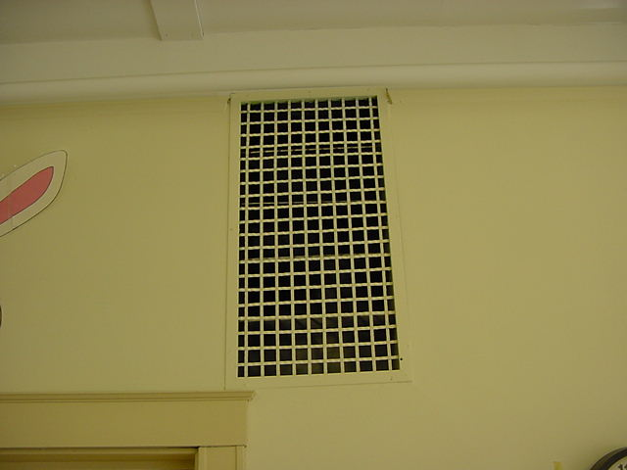

Classroom supply diffuser for abandoned mechanical ventilation system, 1918-1919 building

Picture 2

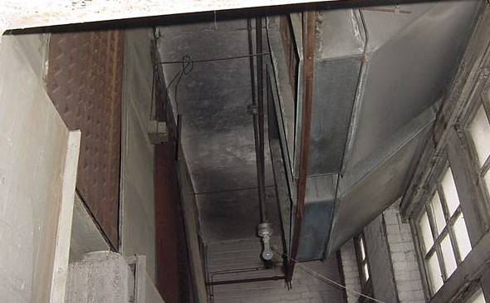
Heating Elements Ducted Air Intake

Air mixing room in basement

Picture 3

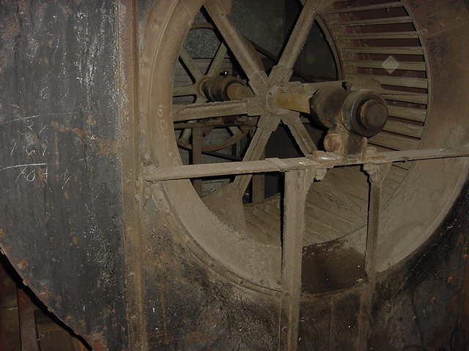

Large fan unit for abandoned mechanical ventilation system in the 1918-1919 building

Picture 4

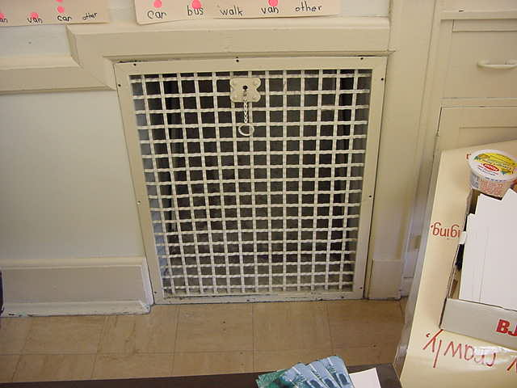

Abandoned exhaust vent in classroom of 1918-1919 building

Picture 5

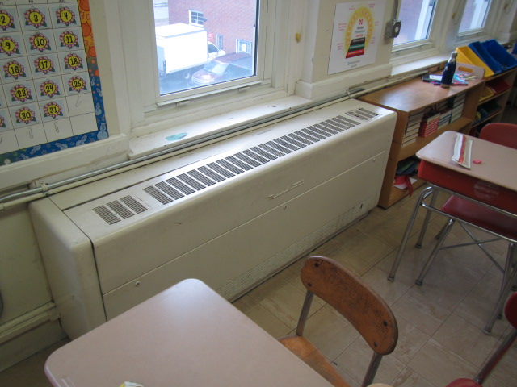

Typical classroom univent 1930s-1950s vintage

Picture 6

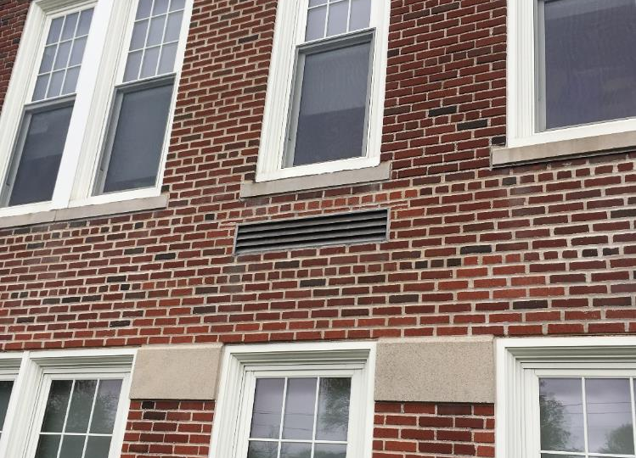

Univent fresh air intake
Picture 7

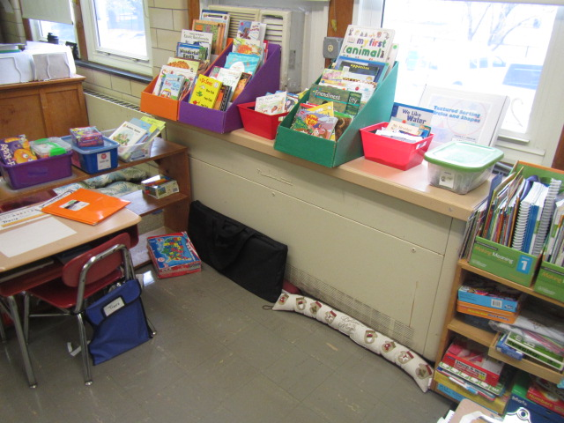
Univent airflow obstructed by items in front and on top of unit, note the return vent (front is sealed with clear packing tape)

Picture 8

Classroom exhaust vent for 1950s building

Picture 9

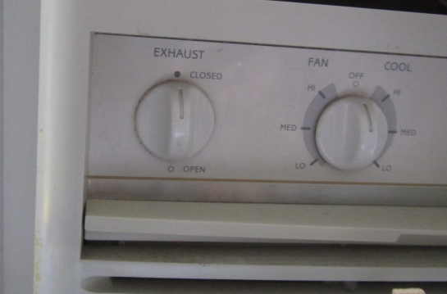

Window AC controls

Picture 10
Supply Vent
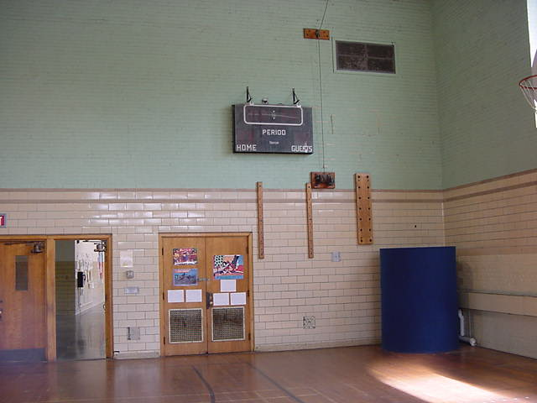
Return Vents

Gymnasium ventilation system

Picture 11

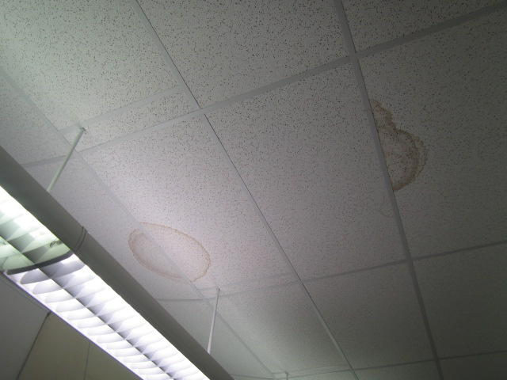

Water-damaged suspended ceiling tiles

Picture 12

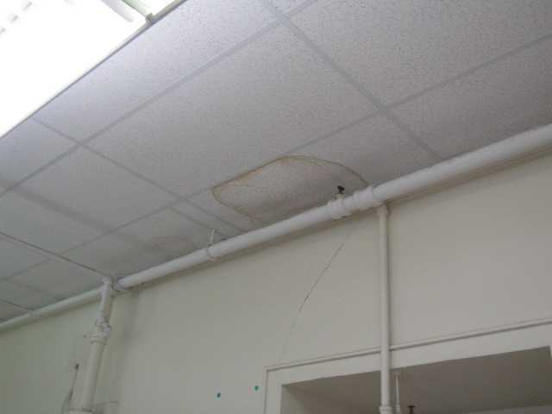

Water-damaged suspended ceiling tiles
Picture 13

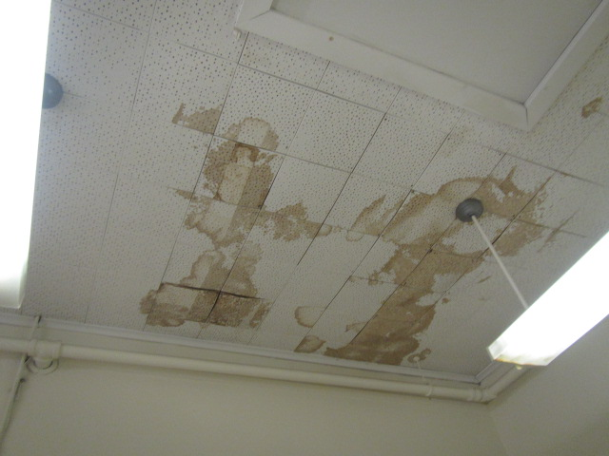

Water-damaged ceiling tiles adhered directly to ceiling

Picture 14

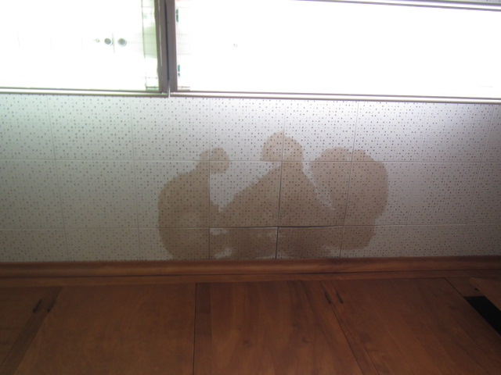

Water-damaged ceiling tiles adhered directly to ceiling
Picture 15

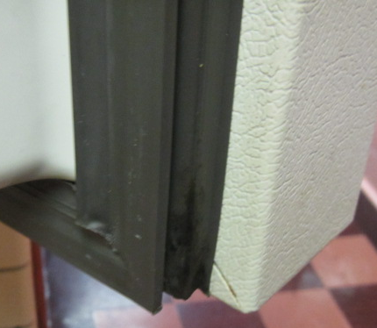

Black mold on refrigerator gasket

Picture 16

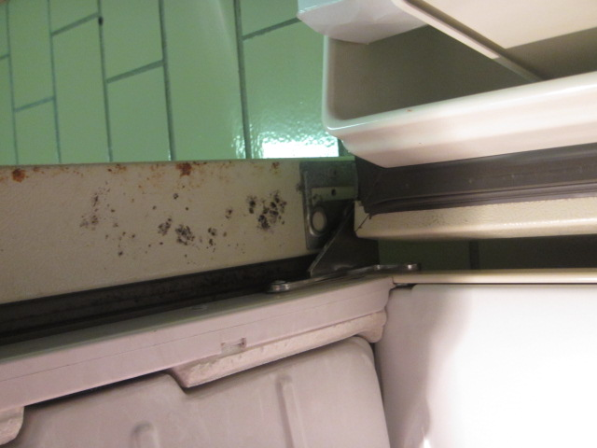
Black mold on refrigerator door

Picture 17

Damaged refrigerator gasket

Picture 18

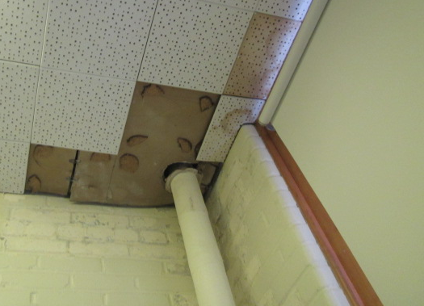

Open hole around pipe in ceiling in Room 213
Picture 19

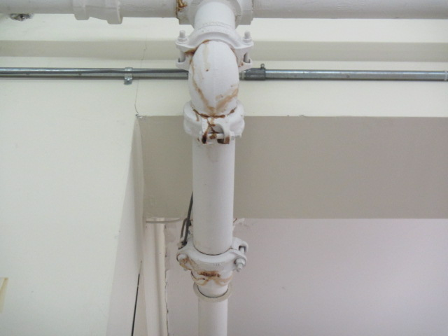

Stains on pipe/elbow in Room 201

Picture 20

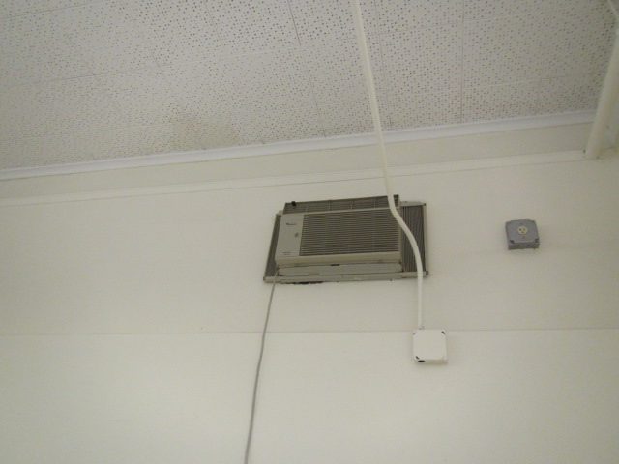

Air conditioner installed in an interior wall in Room 309

Picture 21

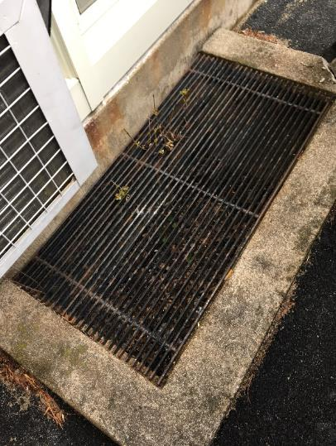

Subterranean fresh air intake pit for univent, note full of leaves/debris

Picture 22

Hole in roof membrane
Picture 23

Pooling water on roof, note seam repairs in roof membrane

Picture 24

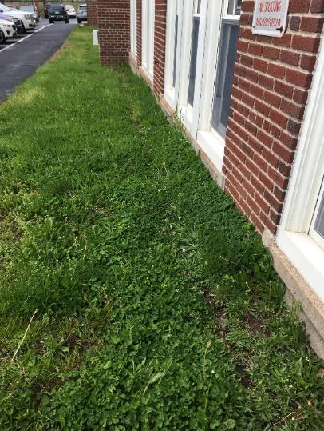

Trough in soil at base of south wall
Picture 25

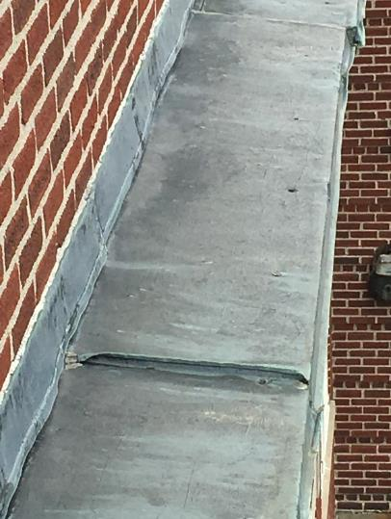

Parapet flashing

Picture 26

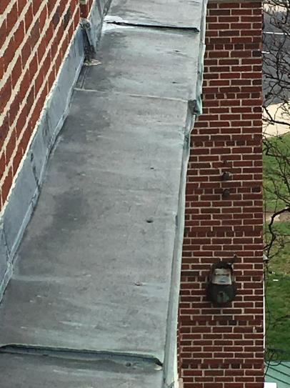

Sections of the flashing seemed to have crimped/crushed edges that have a sealant compound applied
Picture 27

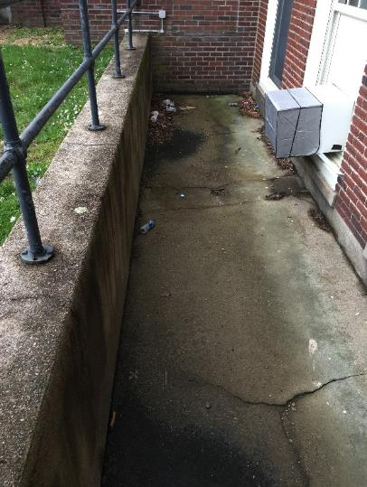

Clogged window well drains, note cement cracks

Picture 28

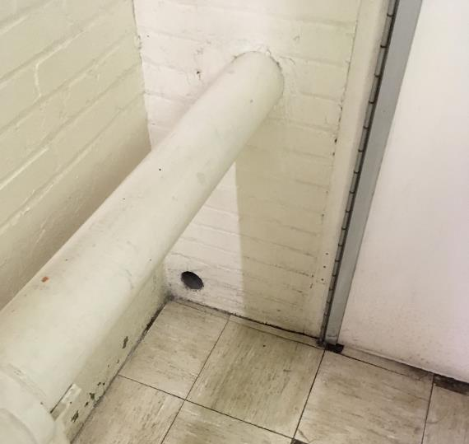

Hole in the furnace room/hallway wall
Picture 29

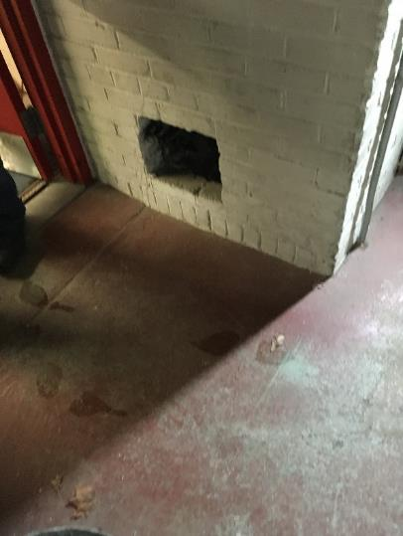

Opening in furnace room wall

Picture 30

Tennis ball on chair leg

Picture 31

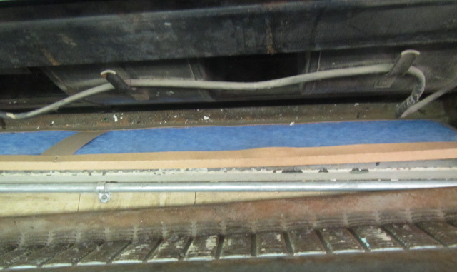

Fibrous mesh filter in classroom univent
Picture 32

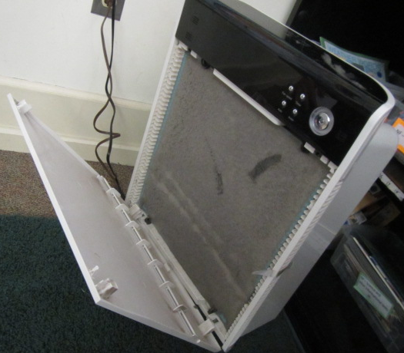

Air purifier with occluded filter in Room 219

Picture 33

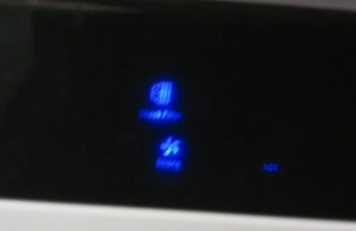

"Check Filter" light indicator for air purifier in Room 219

Picture 34

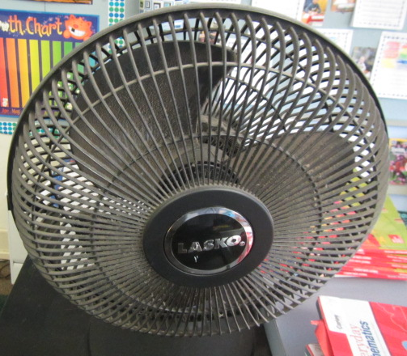

Personal fan, note accumulated dust/debris
Picture 35

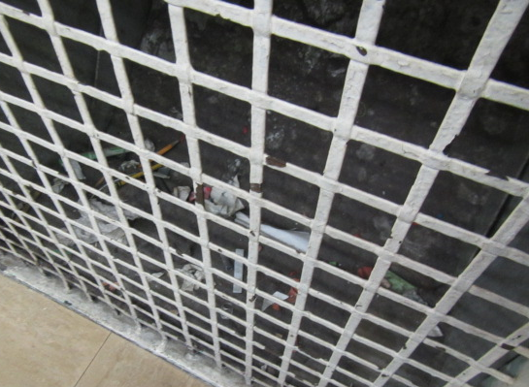

Dust/debris accumulated inside classroom exhaust vent/shaft

Picture 36

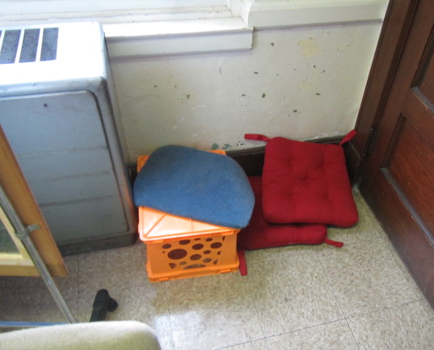

Pillows/cushions on classroom floor
Picture 37

Missing florescent light covers

Location | Carbon  Dioxide  (ppm) | Carbon Monoxide  (ppm) | Temp  (°F) | Relative  Humidity  (%) | PM2.5  (µg/m³) | Occupants  in Room | Windows  Openable | Ventilation |  | Remarks
 |  |  |  |  |  |  |  | Supply | Exhaust
Background (outside) | 395 | ND | 58 | 100 | 2 |  |  |  |  | Cloudy, light rain, cool
301 | 995 | ND | 75 | 42 | 15 | 27 | Y | Y  Off | Y  Off | Area rug, AC, WD CT/plaster corner wall
302 | 687 | ND | 74 | 32 | 3 | 1 | Y | Y  Off | Y  Off | WD CTs, area rug
303 | 708 | ND | 74 | 38 | 3 | 0 | Y | Y  Off | Y  Off | Missing light covers
304 | 899 | ND | 76 | 38 | 3 | 23 | Y | Y | Y | Exhaust blocked, DO, area rug, AC, PF, WD window frames near exterior wall, WD CTs
305 | 823 | ND | 79 | 38 | 3 | 0 | Y | Y  Off | Y  Off | Peeling paint ceiling, AC, overheating (steam leak)
307 | 823 | ND | 71 | 38 | 8 | 20 | Y | Y  Off | Y  On | Peeling paint-ceiling, AC, overheating-steam
308 | 879 | ND | 71 | 43 | 2 | 25 | Y | Y  Off | Y  Off | Area rug, PF, DO, WD ceiling, peeling paint
309 | 637 | ND | 71 | 37 | 3 | 0 | N | Y  Off | Y  Off | WD CTs-old/historic leaks, AC-in wall (drainage?)
310 | 522 | ND | 69 | 42 | 6 | 2 | Y  Open | Y  Off | Y  Off | Suspended ceiling, PFs, plant, area rug, odors reported from vents, HS
311/312 | 914 | ND | 68 | 44 | 6 | 26 | Y | Y  Off | Y  Off | Dust/debris on exhaust vent, area rug
313 | 886 | ND | 72 | 45 | 4 | 1 | Y | Y  Off | Y  Off | DO, 5 WD CTs, restroom exhaust-dust/debris
314 | 1104 | ND | 70 | 43 | 5 | 20 | Y  Open | Y  Off | Y  Off | WD CT, peeling paint, area rug/pillow
315 Faculty Lounge | 954 | ND | 72 | 41 | 3 | 5 | Y |  | Y  Off | PC, missing light covers, peeling paint, AC, visible mold growth-fridge/damaged gasket, PF
317 | 729 | ND | 73 | 38 | 3 | 7 | Y | Y  Off | Y  Off | TB, CP, AF-sink, DO, TB, PF, area rug/pillows
318 | 726 | ND | 76 | 35 | 4 | 0 | Y | Y  Off | Y  Off | 2 WD CTs
319 | 653 | ND | 75 | 36 | 3 | 3 | Y  Open | Y  Off | Y  Off | Suite-rec using windows for fresh air introduction, HS, wall to wall carpet, peeling paint-wall, DEM
320 | 1001 | ND | 79 | 38 | 3 | 28 | Y | Y  Off | Y  Off | DO, old/worn carpet, plug-in AF, AC, HS, WD CTs
201 | 905 | ND | 74 | 42 | 6 | 19 | Y | Y  Off | Y  Off | AC, wall to wall carpet, area rug, peeling paint-ceiling, drips/stains on pipe elbows, HS
203 | 541 | ND | 72 | 37 | 5 | 0 | Y | Y  Off | Y  Off | Wall to wall carpet
203 B | 719 | ND | 70 | 42 | 13 | 0 | Y | N | N | AC, wall to wall carpet
204 Nurse | 835 | ND | 73 | 40 | 6 | 5 | Y | Y  Off | Y  Off | AC, DO
205 | 837 | ND | 72 | 41 | 6 | 17 | Y | Y  Off | Y  Off | Wall to wall carpet, aquarium, terrarium, DO, area rug, TB, plants
206 Teacher’s Work Room | 544 | ND | 72 | 36 | 3 | 0 | Y | N | Y  Off | PC, lamination machine, DO
207 | 798 | ND | 73 | 41 | 5 | 18 | Y | Y  Off | Y  Off | PF, area rug, peeling paint, wall to wall carpet
208 | 522 | ND | 71 | 38 | 5 | 0 | Y | Y  Off | Y  Off | DO, 2 WD CT, wall to wall carpet, area rug, TB
209 Book Room | 698 | ND | 69 | 43 | 6 | 0 | N | N | Y  Off | Local exhaust vent, area rug
210 | 734 | ND | 70 | 44 | 4 | 7 | Y | Y  Off | Y  Off | Area rug, TB, DO, PF, peeling paint, wall to wall carpet, HS
211 Library | 535 | ND | 69 | 41 | 3 | 0 | Y | Y  Off | Y  Off | Peeling paint-ceiling, DO, wall to wall carpet
Auditorium | 695 | ND | 77 | 38 | 9 | 0 | N | Y  Off | Y  Off | DO
213 | 525 | ND | 69 | 47 | 5 | 0 | Y | N | N | Musty odors, WD CT-dry, carpet-dry, holes in ceiling-possible source of odors, wall to wall carpet
214 | 745 | ND | 69 | 43 | 5 | 5 | Y | Y  Off | Y  Off | DO, wall to wall, area rug, UV-blocked top-wood/front-tape
216 | 757 | ND | 73 | 38 | 6 | 18 | Y | Y  Off | Y  Off | PF, area rug, wall to wall carpet, 6 WD CTs (near windows)
Gym | 424 | ND | 67 | 40 | 4 | 0 | Y | Y  Off | Y  Off
Gym Office | 410 | ND | 66 | 42 | 4 | 2 | Y | Y  Off | Y  Off
217 | 563 | ND | 75 | 36 | 5 | 21 | Y  Open | Y  Off | Y  Off | HS, wall to wall carpet, DO, WD peeling paint-windows, CP-sink
218 | 707 | ND | 75 | 37 | 6 | 0 | Y | N | N | DO, wall to wall carpet
219 | 563 | ND | 75 | 36 | 5 | 21 | Y | Y  Off | Y  Off | 2 APs-filter dirty/check light “on”, peeling paint-pipe, PF-dusty, wall to wall carpet, DO, area rug
Meeting Room | 981 | ND | 71 | 50 | 2 | 7 | Y | N | N | AC
Main Office | 935 | ND | 74 | 42 | 2 | 4 | Y | N | N | PC
Principal | 705 | ND | 75 | 38 | 1 | 0 | Y | N | N | Fireplace
Reception | 797 | ND | 75 | 38 | 3 | 1 | N | N | N
101 | 591 | ND | 77 | 40 | 4 | 0 | Y | N | N | MT, abandoned chemical hood
102 | 491 | ND | 76 | 36 | 5 | 5 | Y | N | N | 3 WD CT
103 | 486 | ND | 72 | 38 | 2 | 6 | Y | N | N | AC
104 | 592 | ND | 71 | 40 | 2 | 4 | Y | N | N
105 | 567 | ND | 73 | 38 | 2 | 5 | Y | N | N | WD windows
106 | 402 | ND | 73 | 46 | 2 | 0 | Y | N | N | 20 computers, AC
107 | 468 | ND | 74 | 38 | 2 | 0 | Y | N | N | Food pantry
108 | 457 | ND | 74 | 36 | 2 | 0 | Y | N | N
109 | 727 | ND | 74 | 37 | 5 | 2 | Y | Y | N | Dry drain, pit space-leaves/debris
110 | 878 | ND | 76 | 40 | 4 | 0 | Y | N | N
111 | 520 | ND | 72 | 35 | 2 | 0 | Y | Y | Y | 10+ WD CT
112 | 412 | ND | 71 | 37 | 2 | 0 | Y | Y | Y | Bowed CTs
115 | 447 | ND | 70 | 44 | 3 | 0 | Y | N | N | Steam pipe leak
Cafeteria | 555 | ND | 71 | 42 | 3 | 100+ | Y | Y | Y

