INDOOR AIR QUALITY ASSESSMENT

North Attleborough High School
One Wilson W. Whitty Way
North Attleborough, MA

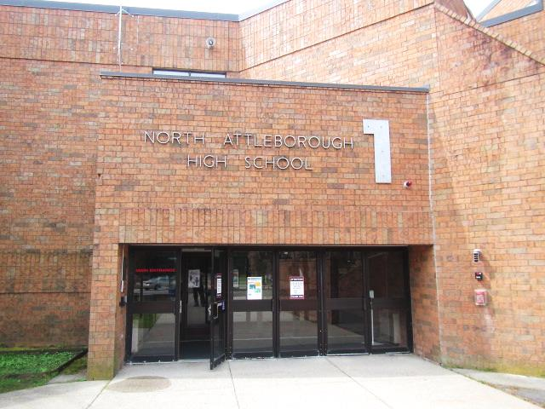

Prepared by:
Massachusetts Department of Public Health
Bureau of Environmental Health
Indoor Air Quality Program
September 2021

BACKGROUND
Building: | North Attleborough High School (NAHS)
Address: | One Wilson W. Whitty Way, North Attleborough, MA
Assessment Requested by: | North Attleborough Public Schools (NAPS)
Reason for Request: | Collaborative effort to perform general indoor air quality (IAQ) assessments throughout the NAPS
Date of Assessment: | August 3, 2021
Massachusetts Department of Public Health/Bureau of Environmental Health (MDPH/BEH) Staff Conducting Assessment: | Mike Feeney, Director, Cory Holmes, Assistant Director and Jason Dustin, Environmental Analyst/Inspector, Indoor Air Quality (IAQ) Program
Building Description: | The NAHS is a two-story, red brick building constructed in 1972. In 2013 the science wing underwent renovations on the first and second floors.
Windows: | Openable

METHODS
DPH staff conducted a series of visual assessments, temperature and relative humidity measurements to identify likely areas that could be prone to condensation in hot, humid weather. Please refer to the IAQ Manual for methods, sampling procedures, and interpretation of results (MDPH, 2015).

RESULTS and DISCUSSION
The following is a summary of testing results (Table 1):
- Temperature was within or close to the lower end of the MDPH recommended range of 70°F to 78°F in areas tested.
- Relative Humidity was within or slightly above the MDPH recommended range of 40 to 60% in the areas tested, which was similar to outside/background.

Ventilation
A heating, ventilating and air conditioning (HVAC) system has several functions. First it provides heating and, if equipped, cooling. Second, it is a source of fresh air. Finally, an HVAC system will dilute and remove normally-occurring indoor environmental pollutants by not only introducing fresh air, but by filtering the airstream and ejecting stale air to the outdoors via exhaust ventilation. Even if an HVAC system is operating as designed, point sources of respiratory irritation may exist and cause symptoms in sensitive individuals.
Mechanical ventilation at the NAHS is controlled by a computer automated system. Fresh air for interior and common areas is provided by air-handling units (AHUs) located in a mechanical penthouse (Picture 1). Fresh air is drawn into the AHUs from outside, heated or cooled, and delivered to occupied space via supply diffusers (Picture 2). Return air is drawn into ceiling (Picture 3) or wall grates and ducted back to AHUs.
Fresh air in perimeter classrooms is supplied by unit ventilators (univents, Picture 4). Univents draw air from the outdoors through a fresh air intake located on the exterior wall of the building (Picture 5) and return air through an air intake located at the base of the unit. Fresh and return air are mixed, filtered, heated or cooled and provided to rooms through an air diffuser located in the top of the unit (Figure 1). Classroom exhaust vents are located on the walls or above doors in classrooms (Picture 6) and are connected via ductwork to exhaust fans on the roof (Picture 7).
The HVAC system controls include a carbon dioxide sensor to control the amount of fresh air into the building. However, it is important to note that these systems need to be regularly maintained and calibrated in accordance with manufacturers’ instructions to ensure proper function.
It is also important to note that despite ongoing maintenance and replacement of parts/components by NAPS facilities staff, many of the HVAC units appear to be approaching the end of their life cycle. Efficient function of equipment of this age is difficult to maintain, since compatible replacement parts are often unavailable. According to the American Society of Heating, Refrigeration, and Air-Conditioning Engineering (ASHRAE), the service life of this type of unit is 15-20 years, assuming routine maintenance of the equipment (ASHRAE, 1991). It was reported that the AC component was down in one of the rooftop AHUs due to a part that would have to be specially fabricated for replacement, which may be cost prohibitive.
To maximize air exchange, the IAQ program recommends that both supply and exhaust ventilation operate continuously during periods of occupancy. To have proper ventilation with a mechanical ventilation system, the systems must be balanced after installation to provide an adequate amount of fresh air to the interior of a room while removing stale air from the room. It is recommended that HVAC systems be re-balanced every five years to ensure adequate air systems function (SMACNA, 1994).

Microbial/Moisture Concerns
This visit included a visual inspection for signs of water damage and microbial growth. Water-damaged ceilings/tiles were observed in some classrooms, hallways and common areas, which can indicate current/historic roof/plumbing leaks or other water infiltration. Water-damaged ceiling tiles can provide a source of mold and should be replaced after a water leak is discovered and repaired. In a few areas, such as the cafeteria ceiling tiles appeared “bowed” (Picture 8) which is likely the result of moisture exposure over the years, primarily from elevated relative humidity conditions. The exterior doors to the cafeteria had spaces where light could be seen penetrating around the doors, which can allow unconditioned air and pests into the building. Doors to the outside should be well-fitted without gaps.
Aquariums were observed in the science wing (Table 1). Aquariums should also be kept in good condition to prevent bacterial/algal growth and associated odors.
A perimeter inspection of the building was conducted to identify any breaches/potential pathways for water intrusion; a number of issues were found including:
- Condensation between window panes indicating caulking/seal around windows have been compromised (Pictures 9 through 11);
- Trees/branches overhanging roof (Picture 12);
- Plants in close contact with exterior walls (Picture 13); and
- Breaches/holes in exterior brickwork (Picture 14).
Over time, these conditions can undermine the integrity of the building envelope and provide a means of water entry into the building via capillary action through foundation concrete and masonry (Lstiburek & Brennan, 2001). The freezing and thawing action of water during the winter months can create cracks and fissures in the foundation. These breaches may provide a means for moisture and pests to enter the building.

Building Materials Prone to Condensation
It is important to note that Massachusetts has experienced extended periods of relative humidity during the summer of 2021. This July was the wettest ever recorded in Massachusetts, and the three-month period from June through August, known as the meteorological summer, was the fourth-wettest on record, according to the National Oceanic and Atmospheric Administration’s Centers for Environmental Information. The three-month period also was the third-warmest ever in the state and was tied for the warmest on record across the United States. (HG, 2021, NOAA, 2021)
The key to managing condensation in hot, humid weather indoors is understanding dew point. When warm, moist air passes over a cooler surface, condensation can form. Condensation is the collection of moisture on a surface at or below the dew point. The dew point is the temperature that air must reach for saturation to occur. If a building material/component has a temperature below the dew point, condensation will accumulate on that material. Over time, condensation can collect and form water droplets.
A method to locate areas in a building prone to condensation would be to measure air and building material temperatures using a laser thermometer (Table 1). If a wide temperature range exists between measurements, the building materials at the colder end of the range may be prone to becoming moistened with condensation if exposed to hot, humid weather (outdoor relative humidity >70% ) for extended periods of time (at least 48 hours). According to the test results in Table 1, a number of areas on the ground floor of the building may be prone to condensation if exposed to hot, humid weather for extended periods of time, especially locations that have building components that have temperature at least 5° F below measured air temperature.
According to American Society of Heating, Refrigerating and Air-Conditioning Engineers (ASHRAE), if relative humidity exceeds 70%, mold growth may occur due to wetting of building materials (ASHRAE, 1989). It is recommended that porous material be dried with fans and heating within 24 to 48 hours of becoming wet (US EPA, 2008, ACGIH, 1989). If porous materials are not dried within this time frame, mold growth may occur. Water-damaged porous materials cannot be adequately cleaned to remove mold growth.

Other Issues
Several areas were carpeted. Carpets should be cleaned annually (or semi-annually in soiled/high traffic areas) in accordance with Institute of Inspection, Cleaning and Restoration Certification (IICRC) recommendations, (IICRC, 2012). The service life of carpeting is approximately 10-11 years (IICRC, 2002). Regular cleaning with a high efficiency particulate air (HEPA) filtered vacuum in combination with an annual cleaning will help to reduce accumulation and potential aerosolization of materials from carpeting.
In Classroom 216 there were a number of dead bees observed on the floor near the window (Picture 15). This may indicate some sort of breach to allow entry for pests to gain access into the building. The principles of Integrated Pest Management (IPM) should be used to reduce incidence of pests and reduce pathways into and through the building. The document “Integrated Pest Management Kit for Building Managers” provides additional strategies for IPM (MDFA, 1996).
It was reported that to supplement mechanical ventilation and filtration, every classroom at NAHS is provided with a high efficiency particle arrestance (HEPA)-filtered air purifier (Picture 16). It is important to note that filters should be changed and these units be maintained in accordance with the manufacturers’ recommendations.
Missing and as mentioned, “bowed” ceiling tiles were observed in a number of areas (Table 1, Picture 8). Ceiling tiles should be complete and flush with the ceiling grid, to prevent a pathway for dust/debris above ceiling tiles to migrate into occupied areas, which can provide a source of skin, eye and respiratory irritation.
The Environmental Protection Agency (EPA) conducted a National School Radon Survey in which it discovered nearly one in five schools had “…at least one frequently occupied ground contact room with short-term radon levels above 4 [picocuries per liter] pCi/L” (US EPA, 1993). The BEH/IAQ Program therefore recommends that every school be tested for radon, and that this testing be conducted during the heating season while school is in session in a manner consistent with USEPA radon testing guidelines. Radon measurement specialists and other information can be found at www.nrsb.org and http://aarst-nrpp.com/wp, with additional information at: http://www.mass.gov/eohhs/gov/departments/dph/programs/environmental-health/exposure-topics/iaq/radon.
Finally, the MDPH recommends that HVAC equipment be outfitted with filters of a Minimum Efficiency Reporting Value (MERV) of 8 or higher, which are adequate in filtering out pollen and mold spores (ASHRAE, 2012). In addition, filters should be changed 2-4 times a year or in accordance with the manufacturers’ recommendations. The AHUs at NAHS are fitted with a MERV 9 filter media, univents with MERV 8, and both are reportedly changed 3-4 times per year.

CONCLUSIONS AND RECOMMENDATIONS
In view of the findings at the time of the visit, the following recommendations are made:

Ventilation recommendations
- As previously discussed, the age (>50 years old), physical deterioration and availability of parts for mechanical ventilation system components and controls should be fully evaluated by an HVAC engineering firm to determine the operational lifespan of existing equipment and/or examining the feasibility of repair vs. replacement.
- The U.S. Department of Education has released new guidance encouraging the use of American Rescue Plan (ARP) funds to improve ventilation systems and make other indoor air quality improvements in schools. More information can be found at this link https://www.ed.gov/coronavirus/improving-ventilation?utm_content=&utm_medium=email&utm_name=&utm_source=govdelivery&utm_term=
- Operate all supply and exhaust ventilation equipment continuously during occupied periods.
- Check exhaust vents for draw periodically and repair any non-operating vents.
- Ensure carbon dioxide sensors that regulate HVAC units are maintained/calibrated per the manufacturers’ recommendations.
- Consider adopting a balancing schedule of every 5 years for all mechanical ventilation systems, as recommended by ventilation industrial standards (SMACNA, 1994).
- Ensure fume hoods that are in use are calibrated/tested in accordance with applicable regulations and standards.
- Continue to change filters for HVAC equipment 2-4 times a year using the highest MERV rating a building’s ventilation system can accommodate to improve air filtration as much as possible without significantly reducing airflow.

Water Damage Recommendations
- Ensure roof and plumbing leaks are repaired and replace water-damaged ceiling tiles.
- Repair/replace worn gaskets and door sweeps and monitor for light penetration around exterior doors.
- Repair/seal holes and breaches in exterior walls/building envelope to eliminate drafts, moisture and pest entry.
- Remove plants and trees/branches a minimum of 5 feet away from the building.
- Replace any damaged window gaskets and repair gaps around exterior window frames to prevent water infiltration.
- Consider long-term plans/capital repair project to replace windows building-wide (with the exception of the renovated science wing).
- Properly maintain aquariums and terrariums to avoid odors.
- Closely monitor parameters such as temperature, relative humidity and dew point over summer months to prevent condensation on floors/surfaces. Refrain from storing porous items, such as cardboard and paper on floor in these areas. If carpeting is present, consider removing from areas that are prone to condensation.
- Consider using the methods described in the methods described in the document “Preventing Mold Growth in Massachusetts Schools During Hot, Humid Weather” to help reduce impact of conditions during hot, humid weather. This guideline can be found online at: https://www.mass.gov/service-details/preventing-mold-growth-in-massachusetts-schools-during-hot-humid-weather

Other Recommendations
- Ensure ceiling tiles are flush with the ceiling grid to prevent pathways for dust/debris to migrate into occupied areas.
- Reduce use of products and equipment that create VOCs and only use in well-ventilated areas. Minimize the use of air fresheners, deodorizers and scented products.
- Keep spray bottles/cleaning products out of the reach of children. Ensure that products are compatible with one another. It is suggested that only school-supplied products be used to avoid product interactions.
- Use the principles of IPM to reduce pest issues in the building, including the sealing of pathways and reduction in sources of food and harborage. Particular attention should be paid to classroom 216. Consult “Integrated Pest Management Kit For Building Managers” (MDFA, 1996). This document can be downloaded at https://www.mass.gov/files/documents/2016/08/wk/ipm-kit-for-bldg-mgrs.pdf.
- Clean carpeting annually (or semi-annually in soiled high traffic areas) as per the recommendations of the Institute of Inspection, Cleaning and Restoration Certification (IICRC, 2012).
- Consider replacing any carpeting that is beyond its service life (i.e., > 11yrs.).
- Change filters and maintain HEPA units as per manufacturers’ recommendations.
- Regularly clean/vacuum supply/return vents and personal fans to avoid aerosolizing accumulated particulate matter.
- For buildings in New England, periods of low relative humidity during the winter are often unavoidable. Therefore, scrupulous cleaning practices should be adopted to minimize common indoor air contaminants whose irritant effects can be enhanced when the relative humidity is low. To control dusts, a high efficiency particulate arrestance (HEPA) filter equipped vacuum cleaner in conjunction with wet wiping of all surfaces is recommended. Avoid the use of feather dusters. Drinking water during the day can help ease some symptoms associated with a dry environment (throat and sinus irritations).
- The school should be tested for radon by a certified radon measurement specialist during the heating season when school is in session. Radon measurement specialists and other information can be found at: www.nrsb.org, and http://aarst-nrpp.com/wp.
- To learn more about radon, review the MDPH’s Radon in Schools and Child Care Programs factsheet, with additional information at: http://www.mass.gov/eohhs/gov/departments/dph/programs/environmental-health/exposure-topics/iaq/radon.
- Consider forming an IAQ committee in each school building district-wide. Committees should have an IAQ liaison/teacher representative, a member of maintenance/facilities and administration that conduct regular walk-throughs to identify on-going and/or potential environmental issues.
- Consider adopting the US EPA (2000) document, “Tools for Schools”, as an instrument for maintaining a good IAQ environment in the building available at: https://www.epa.gov/iaq-schools/indoor-air-quality-tools-schools-action-kit
- Refer to resource manual and other related IAQ documents located on the MDPH’s website for further building-wide evaluations and advice on maintaining public buildings. These documents are available at: http://mass.gov/dph/iaq.

REFERENCES
ACGIH. 1989. Guidelines for the Assessment of Bioaerosols in the Indoor Environment. American Conference of Governmental Industrial Hygienists, Cincinnati, OH.
ASHRAE. 1989. Ventilation for Acceptable Indoor Air Quality. American Society of Heating, Refrigeration and Air Conditioning Engineers. ANSI/ASHRAE 62-1989
ASHRAE. 1991. ASHRAE Applications Handbook, Chapter 33 “Owning and Operating Costs”. American Society of Heating, Refrigeration and Air Conditioning Engineers, Atlanta, GA.
ASHRAE. 2012. American Society of Heating, Refrigeration and Air Conditioning Engineers (ASHRAE) Standard 52.2-2012 -- Method of Testing General Ventilation Air-Cleaning Devices for Removal Efficiency by Particle Size (ANSI Approved).
HG. 2021. Mold keeps South Hadley High School shuttered. Hampshire Gazette. https://www.gazettenet.com/South-Hadley-High-School-still-closed-amid-mold-remediation-42413519.
IICRC. 2002. Institute of Inspection, Cleaning and Restoration Certification. A Life-Cycle Cost Analysis for Floor Coverings in School Facilities.
IICRC. 2012. Institute of Inspection, Cleaning and Restoration Certification. Carpet Cleaning: FAQ.
Lstiburek, J. & Brennan, T. 2001. Read This Before You Design, Build or Renovate. Building Science Corporation, Westford, MA. U.S. Department of Housing and Urban Development, Region I, Boston, MA
MDFA. 1996. Integrated Pest Management Kit for Building Managers. Massachusetts Department of Food and Agriculture, Pesticide Bureau, Boston, MA. https://www.mass.gov/files/documents/2016/08/wk/ipm-kit-for-bldg-mgrs.pdf
MDPH. 2015. Massachusetts Department of Public Health. “Indoor Air Quality Manual: Chapters I-III”. Available at: https://www.mass.gov/lists/indoor-air-quality-manual-and-appendices#indoor-air-quality-manual-
NOAA. 2021. Summer 2021 neck and neck with Dust Bowl summer for hottest on record. National Oceanic and Atmospheric Administration, 1401 Constitution Avenue NW, Room 5128, Washington, DC 20230 https://www.noaa.gov/news/summer-2021-neck-and-neck-with-dust-bowl-summer-for-hottest-on-record
SMACNA. 1994. HVAC Systems Commissioning Manual. 1st ed. Sheet Metal and Air Conditioning Contractors’ National Association, Inc., Chantilly, VA.
US EPA. 1993. Radon Measurement in Schools, Revised Edition. Office of Air and Radiation, Office of Radiation and Indoor Air, Indoor Environments Division (6609J). EPA 402-R-92-014.
US EPA. 2000. Tools for Schools. Office of Air and Radiation, Office of Radiation and Indoor Air, Indoor Environments Division (6609J). EPA 402-K-95-001, Second Edition. http://www.epa.gov/iaq/schools/index.html.
US EPA. 2008. “Mold Remediation in Schools and Commercial Buildings”. Office of Air and Radiation, Indoor Environments Division, Washington, DC. EPA 402-K-01-001. September 2008. Available at: http://www.epa.gov/mold/mold-remediation-schools-and-commercial-buildings-guide.

Figure 1

Unit Ventilator (Univent)

Mixed Air

Air Diffuser

Outdoors Indoors

Fan

Heating/Cooling Coil

Air Mixing Plenum

Filter

Outdoor Return
Air Air

Air
Flow
Control
Louvers

Air Flow

= Fresh Air/Return Air

= Mixed Air

Picture 1

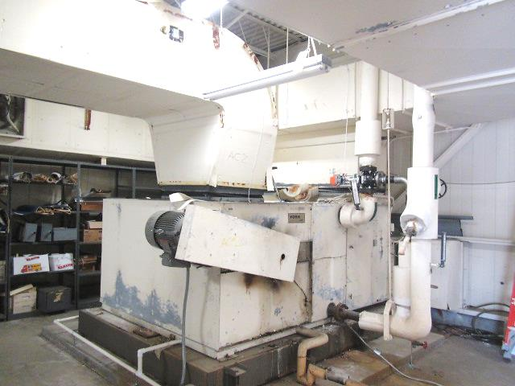
AHU in rooftop penthouse
Picture 2
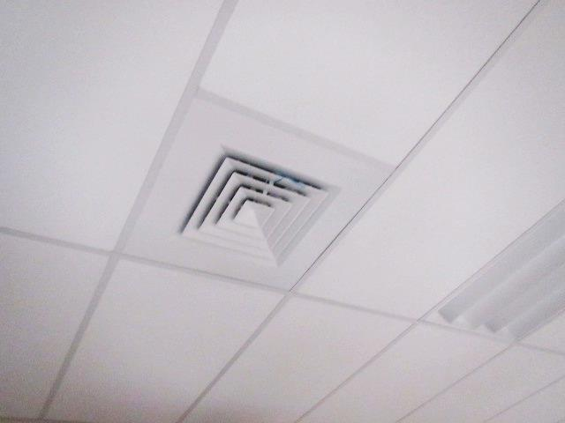
Ceiling-mounted supply diffuser
Picture 3
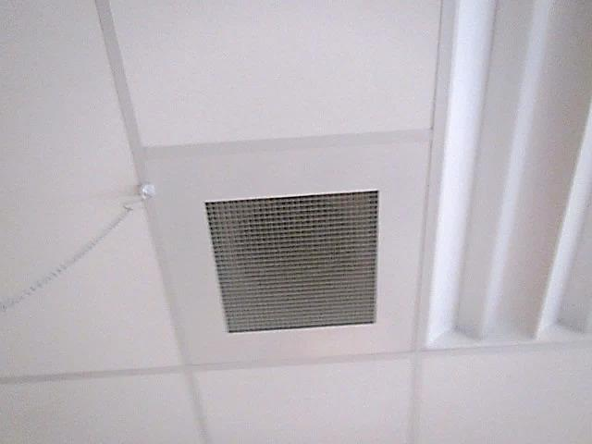
Ceiling-mounted return vent
Picture 4
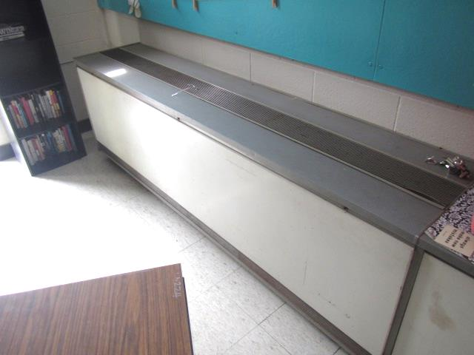
Typical classroom univent
Picture 5
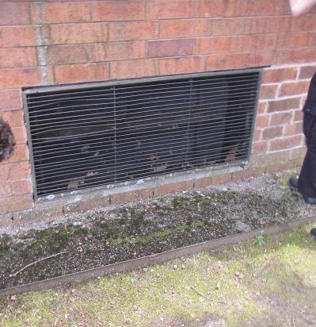
Fresh air intake for univent
Picture 6
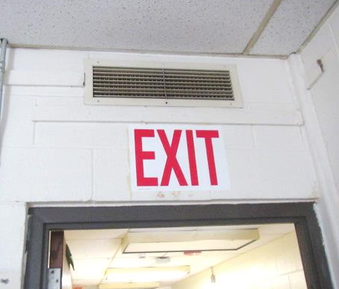
Classroom exhaust vent above door
Picture 7
Rooftop exhaust fans, note tall structures are for chemical lab hoods in the science wing
Picture 8
Bowed ceiling tiles in classroom
Picture 9
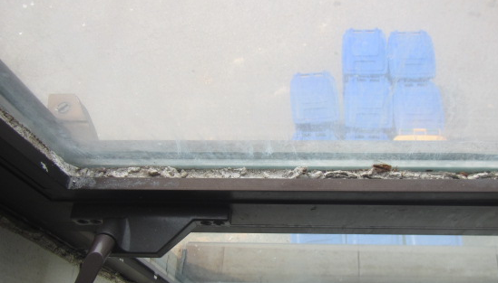
Failing caulking around window frame
Picture 10
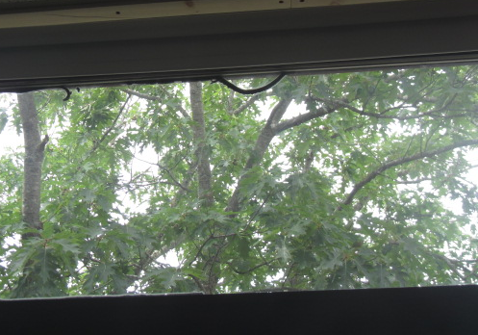
Failing caulking around window frame
Picture 11
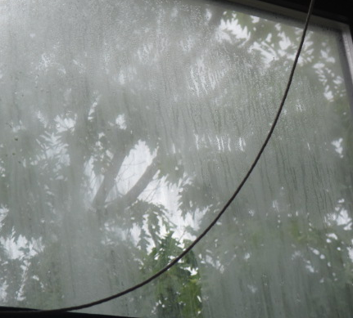
Condensation between window panes indicating seal has been compromised
Picture 12
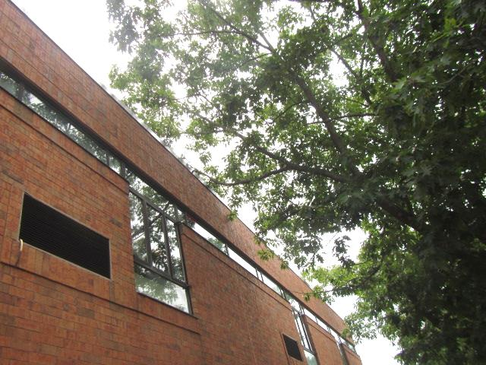
Overhanging branches
Picture 13
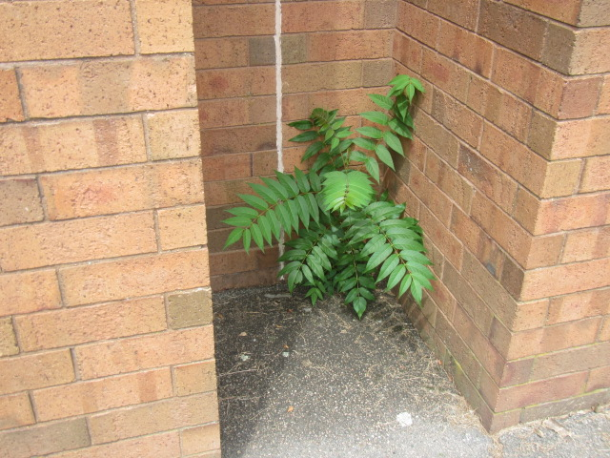
Plant growth against the building
Picture 14
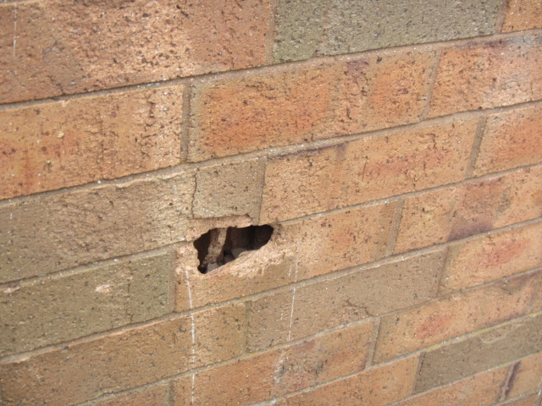
Breach in exterior wall
Picture 15
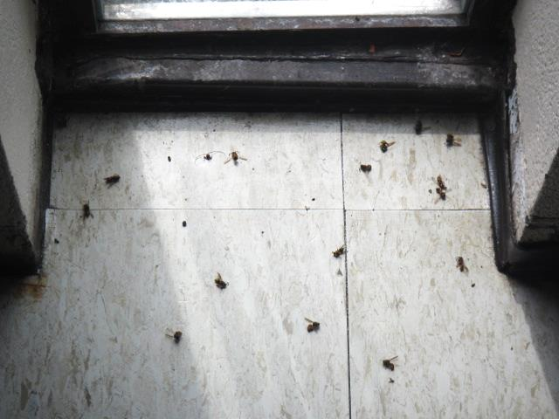
Dead bees in classroom 216
Picture 16
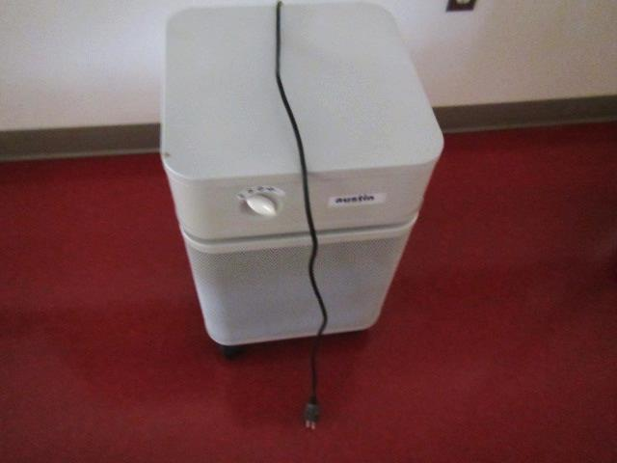
HEPA air purifiers in classrooms

Location | Air Temp  (ºF) | Relative Humidity  (%) | Dew Point  (ºF) | Floor Temp  (ºF) | Temp at Floor/ Exterior Wall Junction  (ºF) | Water-Damaged Ceiling Tiles-stained  (#) | Water-Damaged  Bowed Ceiling Tile  (#) | Ventilation |  |  | Floor to Air Temp  Difference  (ºF) | Comments
 |  |  |  |  |  |  |  | Windows openable | Supply | Exhaust
Background (outdoors) | 76 | 57 | 59 |  |  |  |  |  |  |  |  | Hazy, warm, humid
1G | 74 | 54 | 56 | 71 | 73 | - | N | N | N | Y | -3 | 1 missing CT
101 | 73 | 55 | 56 | 72 | 72 | - | Y | N | Y | Y | -1
103 Computer Room | 72 | 56 | 55 | 72 | 72 | - | Y | N | Y | Y | 0
104 | 72 | 55 | 56 | 71 | 71 | - | Y | Y | Y | Y | -1
105 | 70 | 58 | 54 | 59 | 69 | - | Y | N | Y | Y | -11
106 | 72 | 56 | 56 | 71 | 72 | - | Y | Y | Y | Y | 0
Storeroom near 108 | 71 | 58 | 56 | 71 | 71 | - | Y | N | Y | Y | 0
107 | 70 | 60 | 55 | 68 | 69 | - | Y | Y | Y | Y | -2
108 | 71 | 58 | 55 | 69 | 69 | - | Y | N | Y | Y | -2
109 | 69 | 58 | 53 | 57 | 67 | - | Y | N | Y | Y | -12
110 | 69 | 57 | 57 | 67 | 67 | - | N | Y | Y | Y | -2
112 | 68 | 63 | 55 | 65 | 66 | - | N | Y | Y | Y | -3
114 Computer Room | 73 | 56 | 56 | 71 | 71 | - |  | N | Y | Y | -2
117 | 73 | 57 | 57 | 71 | 72 | - | Y | N | Y | Y | -2
119 | 72 | 57 | 56 | 69 | 68 | - | - | N | Y | Y | -3
120 | 72 | 59 | 57 | 68 | 70 | - | - | Y | Y | Y | -4
121 | 70 | 58 | 57 | 68 | 68 | - | - | N | Y | Y | -3
122 | 69 | 49 | 49 | 64 | 64 | - | - | Y | Y | Y | -5
124 | 69 | 50 | 49 | 64 | 65 | - | - | Y | Y | Y | -5
125 | 70 | 48 | 49 | 63 | 63 | - | - | N | Y | Y | -7
126b | 74 | 50 | 55 | 71 | 72 | - | - | Y | Y | Y | -2
127 | 74 | 52 | 55 | 69 | 69 | - | - | Y | Y | Y | -5
129 | 70 | 56 | 53 | 67 | 67 | - | - | N | Y | Y | -3
Cafeteria | 68 | 54 | 52 | 64 | 64 | 5 | Y | N | Y | Y | -4 | Outdoor light through exterior doorframe
Guidance | 72 | 54 | 54 | 74 | 74 | - | Y | N | Y | Y | 2 | Carpeting
Guidance Conference Room | 72 | 54 | 55 | 74 | 73 | 3 | Y | N | Y | Y | 2 | Carpeting
131 | 72 | 58 | 57 | 72 | 72 | - | Y | Y | Y | Y | 0 | Carpeting
133 | 72 | 58 | 57 | 72 | 72 | 4 | Y | Y | Y | Y | 0 | Carpeting
Athletic director | 71 | 56 | 55 | 71 | 71 | - | Y | N | Y | N | 0 | Carpeting  Wall-mounted air-conditioner
Nurse’s Office A | 71 | 57 | 55 | 72 | 72 | - | N | N | Y | Y | 1
201 | 72 | 62 | 58 | - | - | 2 | N | N | Y | Y |  | AP, DEM
202 | 74 | 58 | 59 | 73 | 74 |  |  | Y | Y | Y | -1 | Condensation windows, AP
203 | 72 | 62 | 58 | - | - | 1 | N | N | Y | Y | - | AP, DEM
204 | 73 | 59 | 58 | 70 | 70 |  |  | Y | Y | Y | +3 | PF, failed window caulking, AP
205 | 72 | 62 | 58 | - | - | N | N | N | Y | Y | - | DEM, AP
206 | 70 | 64 | 58 | 70 | 70 | 2 |  | Y | Y | Y | 0 | Condensation windows, AP
207 | 72 | 62 | 58 | - | - | N | N | N | Y | Y | - | DEM, AP
208 | 69 | 65 | 57 | 68 | 68 |  | 4 | Y | Y | Y | +1 | Condensation windows, AP
209 | 72 | 62 | 58 | - | - | N | N | N | Y | Y | - | DEM, AP
Hallway 210 |  |  |  |  |  |  |  |  |  |  |  | WD CTs
210 | 71 | 64 | 58 | 74 | 72 |  |  | Y | Y | Y | +3 | Window condensation, AP, PF
211 | 71 | 61 | 58 | - | - | N | N | N | Y | Y | - | DEM, AP
213 | 72 | 61 | 58 | - | - | N | 1 | N | Y | Y | - | DEM, AP
214 | 69 | 59 | 58 | 70 | 70 |  |  | Y | Y | Y | +1 | Window condensation, AP
215 | 72 | 60 | 58 | - | - | N | N | N | Y | Y | - | DEM, AP, AI
216 | 69 | 60 | 54 | 69 | 69 |  |  | Y | Y | Y | 0 | Window condensation, AP, dead bees on floor near window
217 | 73 | 59 | 58 | 72 | 72 | 1 | N | N | Y | Y | -1 | AP, DEM
218 | 72 | 60 | 58 | 72 | 72 | 1 |  | Y | Y | Y | 0 | Window condensation, AP, PF
219 | 73 | 60 | 59 | - | - | 2 | 2 | N | Y | Y | - | AP, DEM
220 | 72 | 60 | 58 | 72 | 71 |  |  | Y | Y | Y | 0 | Window condensation, AP, PF
221 | 73 | 59 | 58 | 66 | 66 | N | N | N | Y | Y | -7 | AP, DEM
222 | 73 | 60 | 58 | 65 | 64 |  |  | Y | Y | Y | -8 | Window condensation, AP
223 | 75 | 56 | 58 | - | - | N | N | N | Y | Y | - | AHU, AP, DEM
224 | 74 | 58 |  |  |  |  |  | Y | Y | Y |  | Condensation windows, AP
225 | 72 | 60 | 58 | 70 | 70 |  |  | N | Y | Y | -2 | AP
226 | 73 | 60 | 58 |  |  |  |  | N | Y | Y |  | AP
227 | 73 | 56 | 56 | 75 | 74 |  |  | Y | Y | Y | +2 | AP, floor drain/emer shower, lab hood, PF
228 Prep Room | 72 | 61 | 57 |  |  |  |  | N | Y | Y
229 | 72 | 62 | 58 |  |  |  |  | Y | Y | Y |  | AP, floor drain/emer shower
230 | 72 | 61 | 58 |  |  |  |  | Y | Y | Y |  | AP, floor drain/emer shower, lab hood
231 Prep Room | 72 | 61 | 58 |  |  |  |  | N | Y | Y |  | 4 aquariums (1 empty)
232 | 72 | 63 | 59 |  |  |  |  | Y | Y | Y |  | AP, floor drain/emer shower, lab hood
233 | 72 | 63 | 59 | - | - | N | Y | N | Y | Y | - | DEM, AP
234 | 71 | 62 | 58 |  |  |  |  | Y | Y | y |  | AP, floor drain/emer shower
235 Prep Room | 70 | 62 | 57 |  |  |  |  | N | Y | Y
236 | 71 | 63 | 58 |  |  |  |  | Y | Y | Y |  | AP, floor drain/emer shower, lab hood
237 | 71 | 64 | 58 |  |  |  |  | N | Y | Y |  | AP, floor drain/emer shower, lab hood
238 | 72 | 62 | 58 | - | - | N | N | N | Y | Y | - | Ducted exhaust, storage, fridge
239 | 72 | 62 | 58 | - | - | N | N | N | Y | Y | - | Floor drain for emer shower, chem hood, DEM, AP
240 | 72 | 61 | 58 | 70 | 70 |  |  | N | Y | Y | -2 | AP, floor drain/emer shower
241 | 71 | 60 | 57 | 68 | 67 |  |  | N | Y | Y | -3 | AP, floor drain/emer shower
242 | 72 | 63 | 58 | - | - | N | N | N | Y | Y | - | AP, DEM
243 | 72 | 63 | 58 | - | - | 1 | N | N | Y | Y | - | DEM, fridge
Office: 2B | 72 | 60 | 58 | - | - | N | N | N | Y | Y | - | Carpet, PC
2E | 73 | 60 | 58 | - | - | N | N | N | Y | Y | - | Carpet, AP, DEM
2F | 73 | 61 | 59 | - | - | N | N | N | Y | Y | - | Carpet, AP, DEM
2G | 73 | 61 | 59 | - | - | N | N | N | Y | Y | - | Carpet, AP, DEM
2H | 73 | 61 | 59 | - | - | N | N | N | Y | Y | - | Carpet, AP, DEM
Library | 73 | 61 | 59 | - | - | 10+ | 50+ | N | Y | Y | - | Carpet
Librarian’s office | 73 | 59 | 58 | - | - | N | N | N | Y | Y | - | Fridge, AI

The service life is the median time during which a particular system or component of …[an HVAC]… system remains in its original service application and then is replaced. Replacement may occur for any reason, including, but not limited to, failure, general obsolescence, reduced reliability, excessive maintenance cost, and changed system requirements due to such influences as building characteristics or energy prices (ASHRAE, 1991).

