INDOOR AIR QUALITY ASSESSMENT

North Attleborough Middle School
564 Landry Avenue
North Attleborough, Massachusetts

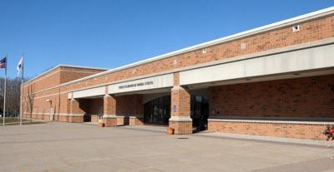

Prepared by:
Massachusetts Department of Public Health
Bureau of Environmental Health
Indoor Air Quality Program
June 2019

Background
Building: | North Attleborough Middle School (NAMS)
Address: | 564 Landry Avenue, North Attleborough, MA
Assessment Requested by: | Scott Holcomb, Superintendent, North Attleborough Public Schools (NAPS)
Date of Assessment: | May 23, 2019
Bureau of Environmental Health (BEH) Indoor Air Quality (IAQ) Program Staff Conducting Assessment: | Cory Holmes, Environmental Analyst/Inspector, IAQ Program
Date of Building Construction: | The NAMS is a three-story, red brick on slab building constructed in 1998. The school contains general classrooms, science classrooms, several music rooms, media center, gymnasium and locker rooms, cafeteria, art rooms and office space.
Reason for Request: | Proactive effort to perform general IAQ assessments in NAPS.
Building Population: | 1105 students grades 6-8 and 149 employees
Windows: | Openable

IAQ Testing Results
Please refer to the IAQ Manual for methods, sampling procedures, and interpretation of results (MDPH, 2015). The following is a summary of indoor air testing results (Table 1).
- Carbon dioxide levels were above the MDPH guideline of 800 parts per million (ppm) in 29 of 93 areas surveyed, indicating a number of areas could use more air exchange. It is also important to note that a number of classrooms had open windows or were empty/sparsely populated during the assessment, which would reduce carbon dioxide levels. Carbon dioxide levels would be expected to be higher with full occupancy/windows shut.
- Temperature was within or close to the MDPH recommended range of 70°F to 78°F in areas tested. Some occupants expressed temperature control complaints such as in Computer Lab 305, which has overheating issues.
- Relative humidity was within or close the MDPH recommended range of 40 to 60% in areas tested.
- Carbon monoxide levels were non-detectable (ND) in all areas tested.
- Fine particulate matter (PM2.5) concentrations measured were below the National Ambient Air Quality Standard (NAAQS) of 35 μg/m³ in all areas tested.

Ventilation
A heating, ventilating, and air-conditioning (HVAC) system has several functions. First it provides heating and, if equipped, cooling. Second, it is a source of fresh air. Finally, an HVAC system will dilute and remove normally-occurring indoor environmental pollutants by not only introducing fresh air, but by filtering the airstream and ejecting stale air to the outdoors via exhaust ventilation. Even if an HVAC system is operating as designed, point sources of respiratory irritation may exist and cause symptoms in sensitive individuals.
Mechanical ventilation is provided by rooftop air handling units (AHUs) ducted to ceiling-mounted supply and return vents (Pictures 1 and 2). To maximize air exchange, the BEH recommends that both supply and exhaust ventilation operate continuously during periods of occupancy. In order to have proper ventilation with a mechanical ventilation system, the systems must be balanced subsequent to installation to provide an adequate amount of fresh air to the interior of a room while removing stale air from the room. It is recommended that HVAC systems be re-balanced every five years to ensure adequate air systems function (SMACNA, 1994).

Microbial/Moisture Concerns
In order for building materials to support mold growth, a source of water is necessary. Room 105 (currently unoccupied) is experiencing issues with water infiltration, as evidenced by water damage near windows (Picture 3). Porous building materials (e.g., gypsum wallboard, ceiling tiles) can become colonized with mold if wetted repeatedly.
The United States Environmental Protection Agency (US EPA) and the American Conference of Governmental Industrial Hygienists (ACGIH) recommend that porous materials be dried with fans and heating within 24 to 48 hours of becoming wet (US EPA, 2008; ACGIH, 1989). If porous materials are not dried within this time frame, they should be removed and discarded.
Water-damaged ceiling tiles were observed in a few areas (Picture 4; Table 1), which indicate leaks from the building envelope or plumbing system. These tiles should be replaced after the leak is found and repaired.
Visible mold growth was observed in the Faculty Lounge and OT/PT Room 300. Refrigerators had mold on the doors/gaskets (Pictures 5 and 6). Refrigerators should be cleaned out regularly to prevent odors and microbial growth. Gaskets should be cleaned with a mild antimicrobial solution; if they are too heavily stained to be cleaned/damaged, they should be replaced.
Several classrooms contained dehumidifiers (Table 1). These devices must be properly cleaned/maintained to avoid bacterial/scale growth and microbial colonization from standing water.
Several areas utilize air conditioning (AC) units (Table 1). Air conditioning units collect condensation that should be drained to prevent water damage and microbial growth. Condensation collection pans/vessels and drains should be inspected for leaks and clogs and cleaned periodically to prevent stagnant water and debris that can lead to odors and microbial growth.
Water coolers were observed in carpeted areas (Table 1). Spills or leaks from this equipment can moisten carpet and lead to microbial growth and carpet degradation.
Plants, which can be a source of pollen and mold and be respiratory irritants to some individuals, were observed in a number of areas. Plants should be properly maintained and equipped with drip pans to prevent water leaks and damage. They should also be located away from air diffusers to prevent the aerosolization of dirt, pollen, and mold.

Other IAQ Evaluations

Volatile Organic Compounds (VOCs)
Exposure to low levels of total VOCs (TVOCs) may produce eye, nose, throat, and/or respiratory irritation in some sensitive individuals. IAQ staff examined rooms for products containing VOCs. IAQ staff noted hand sanitizers, cleaners and dry erase materials within the building (Table 1). Since all of these products have the potential to have an irritant effect, their use should be minimized. Hand sanitizer products may contain ethyl alcohol and/or isopropyl alcohol, which are highly volatile and may be irritating to the eyes and nose. These products may also contain fragrances to which some people may be sensitive.

Other Conditions
The MDPH recommend that HVAC units be outfitted with filters of a Minimum Efficiency Reporting Value (MERV) of 8, which are adequate in filtering out pollen and mold spores (ASHRAE, 2012). School maintenance staff report that MERV 8 filters in rooftop AHUs are changed two times per year.
Some personal fans, supply and exhaust vents were also observed to have accumulated dust/debris (Pictures 1 and 7, Table 1), this was particulary evident in the computer rooms (Picture 8, Table 1). Particulates can be reaerosolized from these items and they should be cleaned regularly.
The majority of the school is carpeted and despite its age, is in relatively good condition. Carpeting should be vacuumed regularly with a high efficiency particulate arrestance (HEPA) filter equipped vacuum cleaner to avoid particulates from causing further irritation or serving as a reservoir for microbial colonization. Also, carpeting and rugs should be cleaned at least once per year according to IICRC recommendations (IICRC 2012). However, it should be noted that the usable life of carpeting in schools is approximately 10-11 years (IICRC, 2002). Aging carpet can produce fibers that can be irritating to the respiratory system.
In several areas, items were observed on the floor, windowsills, tabletops, counters, bookcases, and desks (Picture 9). The large numbers of stored items provide a source for dusts to accumulate. These items (e.g., papers, folders, boxes) make it difficult for custodial staff to clean. Once aerosolized, they can act as irritants to eyes and the respiratory system. Items should be relocated and/or be cleaned periodically to avoid excessive dust build up.
Odors from dry drain traps were detected in both rooms 301 (shower) and 302 (greenhouse). It is important to note that drains are usually designed with traps in order to prevent the back up of sewer odors/gases from penetrating into occupied spaces. When water enters a drain, the trap fills and forms a watertight seal. Without a watertight seal, odors and sewer gas can enter occupied space. If these areas are seldom used, water should be poured down the drains regularly.
OT/PT Room 300 contained a washer and dryer (Picture 10). Although the dryer was vented, the flexible duct was “pinched” (Picture 11), which can interfere with proper exhaust. It was not clear where this dryer was vented to. Dryers should be vented to the outdoors to remove excess heat, combustion products and moisture.
Finally, occasional odors were reported in areas adjacent to the boiler room. Although no carbon monoxide and/or elevated levels of particulates associated with combustion were measured at the time of the assessment, slight “boiler room” odors were detected in this area.

Conclusions/Recommendations
In view of the findings at the time of the visit, the following recommendations are made:
- Operate the HVAC system to provide for continuous fresh air ventilation during occupied hours.
- Implement methods to increase percentage of fresh air to classrooms having elevated carbon dioxide levels (Table 1). This may include opening fresh air intakes further (weather permitting).
- Use openable windows to supplement fresh air during temperate weather. Ensure all windows are closed tightly at the end of each day.
- Close classroom doors during occupancy to allow for more effective function of exhaust vents/air exchange.
- Work with staff to troubleshoot temperature control problems (e.g., 305 computer lab).
- Utilize a system to report and track maintenance issues so that concerns can be reported by staff and maintenance staff can report when issues have been resolved.
- Consider adopting a balancing schedule of every 5 years for all mechanical ventilation systems, as recommended by ventilation industrial standards (SMACNA, 1994).
- Replace water-damaged ceiling tiles. Inspect the area above the stained tiles for water damage or odors and remediate or clean as necessary.
- Continue to investigate source of leaks damaging building materials in room 105 and make repairs as necessary. Remove water-damaged building materials in accordance with the US EPA’s “Mold Remediation in Schools and Commercial Buildings” (US EPA, 2008). Available at: http://www.epa.gov/mold/mold-remediation-schools-and-commercial-buildings-guide.
- Replace any missing/damaged ceiling tiles.
- Ensure the boiler room has tight-fitting door gaskets/sweeps and seal any penetrations/utility holes in common walls with adjacent areas. If odors outside boiler room persist, consider placing the boiler room under negative pressure (i.e., local exhaust).
- Regularly clean portable and window ACs including filters and ensure proper drainage to outside or utility sink/drain.
- Keep classroom/office plants in good condition, avoid overwatering, and keep them away from the airstream of ventilation equipment.
- Clean and disinfect interior of refrigerators and freezers with mild detergent or antimicrobial agent. Consider replacing mold-contaminated gaskets. Clean spilled food promptly, and clean out the refrigerator of expired items on a regular schedule.
- Clean/maintain dehumidifiers as per the manufacture’s recommendations.
- Consider placing water dispensers on non-carpeted areas or place a waterproof mat underneath them.
- Pour water down floor drains periodically (e.g., once/twice per week) as needed to prevent dry drain trap odors (e.g., shower room 301, greenhouse 302).
- Reduce or eliminate the use of air fresheners, scented cleaners, hand sanitizers and dry erase materials to reduce irritation.
- Continue to change filters in HVAC units 2 to 4 times a year with MERV 8 or higher filters.
- Clean supply, return/exhaust vents and fans regularly to remove accumulated dust/debris. Particular attention should be made to computer rooms; an increase in filter changes/efficiency may be warranted. If surrounding ceiling tiles cannot be cleaned, discard and replace.
- For buildings in New England, periods of low relative humidity during the winter are often unavoidable. Therefore, scrupulous cleaning practices should be adopted to minimize common indoor air contaminants whose irritant effects can be enhanced when the relative humidity is low. To control for dusts, a high efficiency particulate arrestance (HEPA) filter equipped vacuum cleaner in conjunction with wet wiping of all surfaces is recommended. Drinking water during the day can help ease some symptoms associated with a dry environment (throat and sinus irritations).
- Clean carpeting and rugs at least once per year according to IICRC recommendations (IICRC 2012). Carpets too worn to be effectively cleaned should be replaced.
- Relocate or consider reducing the amount of materials stored in classrooms to allow for more thorough cleaning of classrooms. Clean items regularly with a wet cloth or sponge to prevent excessive dust build-up.
- Use photocopiers and laminators in well-ventilated areas.
- Ensure dryer in room 300 OT/PT is properly vented to the outside.
- Utilize the US EPA’s (2000), “Tools for Schools”, as an instrument for maintaining a good IAQ environment in the building available at: http://www.epa.gov/iaq/schools/index.html.
- For more information on mold refer to the US EPA’s “Mold Remediation in Schools and Commercial Buildings” (US EPA, 2008). Available at: http://www.epa.gov/mold/mold-remediation-schools-and-commercial-buildings-guide.
- Refer to resource manuals and other related IAQ documents for further building-wide evaluations and advice on maintaining public buildings. Copies of these materials are located on the MDPH’s website: http://mass.gov/dph/iaq.

References
ACGIH. 1989. Guidelines for the Assessment of Bioaerosols in the Indoor Environment. American Conference of Governmental Industrial Hygienists, Cincinnati, OH.
ASHRAE. 2012. American Society of Heating, Refrigeration and Air Conditioning Engineers (ASHRAE) Standard 52.2-2012 -- Method of Testing General Ventilation Air-Cleaning Devices for Removal Efficiency by Particle Size (ANSI Approved).
IICRC. 2002. Institute of Inspection, Cleaning and Restoration Certification. A Life-Cycle Cost Analysis for Floor Coverings in School Facilities.
IICRC. 2012. Institute of Inspection Cleaning and Restoration Certification. Institute of Inspection, Cleaning and Restoration Certification. Carpet Cleaning: FAQ.
MDPH. 2015. Massachusetts Department of Public Health. Indoor Air Quality Manual: Chapters I-III. Available at: http://www.mass.gov/eohhs/gov/departments/dph/programs/environmental-health/exposure-topics/iaq/iaq-manual/.
SMACNA. 1994. HVAC Systems Commissioning Manual. 1st ed. Sheet Metal and Air Conditioning Contractors’ National Association, Inc., Chantilly, VA.
US EPA. 2000. Tools for Schools. Office of Air and Radiation, Office of Radiation and Indoor Air, Indoor Environments Division (6609J). EPA 402-K-95-001, Second Edition. http://www.epa.gov/iaq/schools/index.html.
US EPA. 2008. Mold Remediation in Schools and Commercial Buildings. US Environmental Protection Agency, Office of Air and Radiation, Indoor Environments Division, Washington, D.C. EPA 402-K-01-001. http://www.epa.gov/mold/mold-remediation-schools-and-commercial-buildings-guide
Picture 1
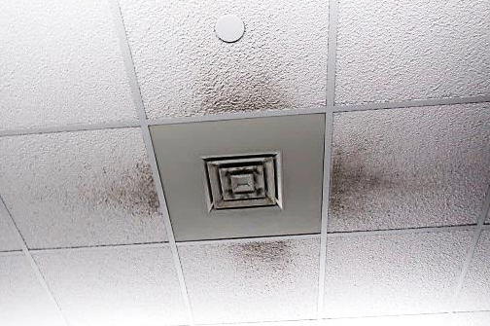
Supply diffuser, note accumulated dust/debris on vent/surrounding ceiling tiles
Picture 2
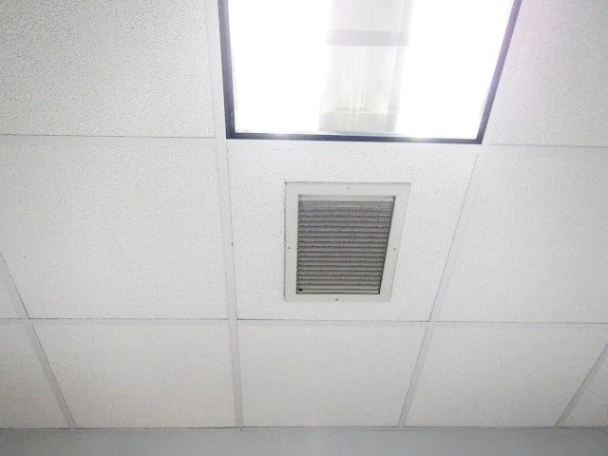
Ceiling mounted return vent
Picture 3
Water damage in room 105
Picture 4
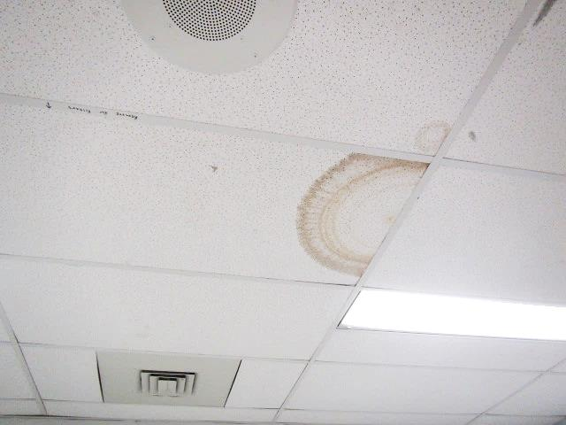
Water-damaged ceiling tiles
Picture 5
Mold growth on refrigerator gaskets
Picture 6
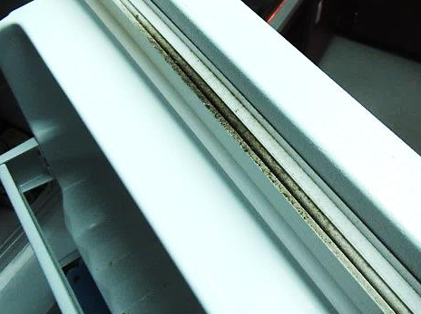
Mold growth (dark stains) on refrigerator gaskets
Picture 7
Accumulated dust/debris on fan
Picture 8
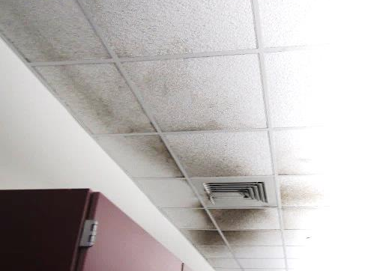
Dust/debris accumulation on vent/surrounding ceiling tiles in computer room
Picture 9
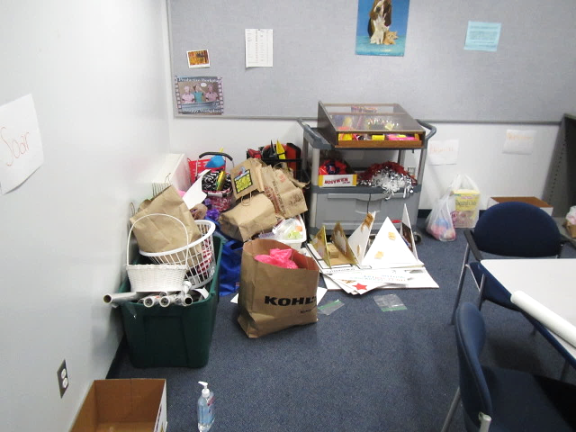
Accumulated items
Picture 10
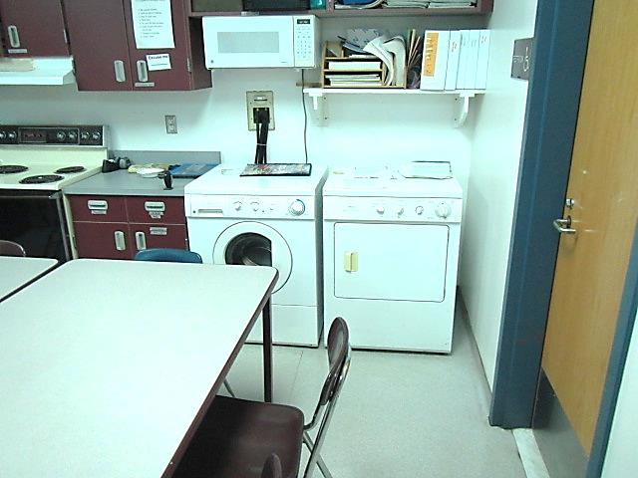
Washer and dryer in room 300 OT/PT
Picture 11
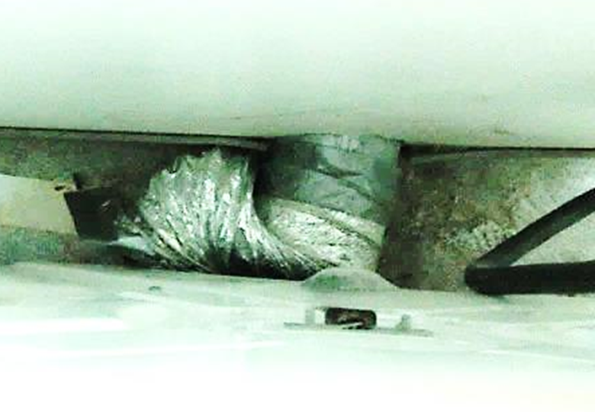
Close-up of “pinched” dryer vent in room 300 OT/PT

Location | Carbon  Dioxide  (ppm) | Carbon Monoxide  (ppm) | Temp  (°F) | Relative  Humidity  (%) | PM2.5  (µg/m³) | Occupants  in Room | Windows  Openable | Ventilation |  | Remarks
 |  |  |  |  |  |  |  | Supply | Exhaust
Background (outside) | 397 | ND | 61 | 60 | 3 |  |  |  |  | Cloudy, cool
302 Green House |  |  |  |  |  |  | Y | Y | Y | Dry floor drain trap odors
303 | 929 | ND | 73 | 45 | 3 | 24 | Y | Y | Y | DO, HS, CP
304 | 797 | ND | 73 | 46 | 2 | 18 | Y | Y | Y | Dust/debris on vents, HS, DO, PF
305 Computer Lab | 456 | ND | 79 | 38 | 1 | 0 | Y | Y | Y | 2 dehumidifiers, dust/debris on vents/CTs, overheating, HS
306 | 640 | ND | 77 | 38 | 3 | 3 | N | Y | Y | DO, HS
307 | 824 | ND | 76 | 42 | 3 | 23 | Y | Y | Y | Dust/debris on vents, DO, HS
309 | 1040 | ND | 75 | 45 | 2 | 22 | Y | Y | Y | Dust/debris on vents/CTs, CP, HS
308 | 841 | ND | 75 | 44 | 3 | 29 | Y  Open | Y | Y | Dust/debris on vents, HS
310 | 943 | ND | 75 | 44 | 3 | 22 | Y | Y | Y | PF
311 | 688 | ND | 74 | 45 | 5 | 17 | Y  Open | Y | Y | PF
312 | 799 | ND | 74 | 45 | 4 | 15 | Y | Y | Y | Dust/debris on vents/CTs, PF
314 | 556 | ND | 74 | 42 | 3 | 0 | Y | Y | Y
313 Teachers Lounge | 651 | ND | 75 | 43 | 4 | 0 | Y | Y | Y | Refrigerator-mold/gaskets
315 | 946 | ND | 75 | 45 | 3 | 26 | Y | Y | Y | DO
318 | 822 | ND | 75 | 47 | 4 | 23 | Y | Y | Y | Dust/debris on vents/CTs, DO, PF
319 | 932 | ND | 75 | 45 | 4 | 23 | Y | Y | Y | Dust/debris on vents, DO, MT, PF, HS
316 | 583 | ND | 74 | 43 | 4 | 0 | Y | Y | Y | PFs, WD CT
320 | 719 | ND | 74 | 45 | 5 | 18 | Y | Y | Y | Dust/debris on vents/CTs, DO, HS, PFs
321 | 888 | ND | 74 | 46 | 3 | 26 | Y | Y | Y | Dust/debris on vents/CTs, HS
322 | 1045 | ND | 75 | 49 | 3 | 22 | Y | Y | Y | HS
323 | 533 | ND | 73 | 42 | 3 | 0 | Y | Y | Y | PF-dusty, dust/debris on vents, HS
324 | 564 | ND | 73 | 43 | 4 | 0 | N | Y | Y | Water cooler on carpet, HS, PF, CP, dust/debris on vents
325 | 482 | ND | 72 | 44 | 3 | 0 | Y | Y | Y | HS
326 | 755 | ND | 73 | 47 | 4 | 23 | Y  Open | Y | Y | HS, dust/debris on vents
327 | 830 | ND | 74 | 46 | 3 | 19 | Y | Y | Y | HS, CP, dust/debris on vents
328 | 514 | ND | 73 | 42 | 4 | 6 | Y | Y | Y | AC, 2 WD CTs, PF
329 | 617 | ND | 72 | 45 | 4 | 14 | Y | Y | Y | HS, CP, DO, portable AC, dust/debris on vents
300 OT/PT | 511 | ND | 70 | 48 | 3 | 0 | Y | Y | Y | DO, AC, washer dryer-vent?, refrigerator-mold/gaskets
301 | 535 | ND | 71 | 47 | 3 | 8 | Y | Y | Y | Shower-dry traps (odors), AC (2)
203 | 455 | ND | 71 | 47 | 4 | 1 | Y  Open | Y | Y | DO, PF, dust/debris on vents
204 | 433 | ND | 71 | 47 | 4 | 0 | Y  Open | Y | Y | DO, HS, AC
205 Computer Lab | 977 | ND | 70 | 51 | 2 | 26 | Y | Y | Y | Dust/debris on vents/CTs, dehumidifiers (2), HS
206 | 496 | ND | 71 | 48 | 3 | 0 | Y | Y | Y | DO, HS, CP
207 | 516 | ND | 71 | 47 | 6 | 1 | Y | Y | Y | DO, PF, dust/debris on vents
208 | 485 | ND | 71 | 47 | 4 | 1 | Y  Open | Y | Y | Plants, DO
209 | 501 | ND | 72 | 47 | 3 | 0 | Y | Y | Y | Dust/debris on vents, HS
210 | 832 | ND | 73 | 48 | 4 | 0 | Y  Open | Y | Y | Dust/debris on vents/CTs, PF, CP, HS
211 | 890 | ND | 74 | 49 | 5 | 0 | Y | Y | Y | Dust/debris on vents, HS, PF
212 | 446 | ND | 72 | 47 | 4 | 0 | Y  Open | Y | Y | CP, HS
212 C | 550 | ND | 72 | 48 | 4 | 1 | Y | Y | Y
214 | 583 | ND | 73 | 46 | 4 | 0 | N | Y | Y
213 | 778 | ND | 74 | 49 | 4 | 6 | Y | Y | Y | PF
215 | 714 | ND | 74 | 48 | 4 | 0 | Y | Y | Y | WD CT
218 | 477 | ND | 73 | 47 | 4 | 0 | Y  Open | Y | Y | HS, dust/debris on vents
219 | 399 | ND | 70 | 48 | 4 | 0 | Y  Open | Y | Y | HS, PFs, dust/debris on vents
216 & 217 | 670 | ND | 72 | 49 | 4 | 19 | Y | Y | Y | PF
220 | 652 | ND | 73 | 49 | 5 | 1 | Y  Open | Y | Y | Dust/debris on vents
221 | 716 | ND | 73 | 48 | 6 | 22 | Y | Y | Y | DO, PF, dust/debris on vents
222 | 838 | ND | 74 | 50 | 5 | 29 | Y | Y | Y | DO, PF, dust/debris on vents
223 | 522 | ND | 72 | 47 | 4 | 6 | Y | Y | Y | HS, AC, dehumidifier
224 | 585 | ND | 72 | 47 | 4 | 0 | N | Y | Y | HS, PF, dust/debris on vents
226 | 764 | ND | 73 | 51 | 5 | 23 | Y | Y | Y | HS, DO, dust/debris on vents
225 | 470 | ND | 73 | 47 | 4 | 0 | Y | Y | Y | AC, HS, CP
228 | 480 | ND | 72 | 49 | 3 | 2 | N | Y | Y | DO, dust/debris on vents/CTs
Media Center | 421 | ND | 70 | 50 | 4 | 8 | Y | Y | Y
ELL | 468 | ND | 70 | 51 | 4 | 4 | N | Y | Y | DO, 2 WD CTs
Chorus | 1258 | ND | 70 | 57 | 8 | 33 | N | Y | Y | PF
Band | 632 | ND | 69 | 49 | 4 | 31 | N | Y | Y | HS
Cafeteria | 763 | ND | 67 | 55 | 4 | ~250 | Y | Y | Y
Main Office | 621 | ND | 68 | 55 | 3 | 4 | N | Y | Y
Gym | 552 | ND | 67 | 52 | 2 | 0 | N | Y | Y
Girls Locker Room | 620 | ND | 69 | 51 | 2 | 0 | N | Y | Y | Dust/debris on vents
Girls PE Office | 658 | ND | 70 | 50 | 2 | 0 | N | Y | Y | 2 WD CTs
Boys Locker Room | 570 | ND | 70 | 50 | 2 | 0 | N | Y | Y
Boys PE Office | 600 | ND | 71 | 50 | 2 | 0 | N | Y | Y | Dust/debris on vents
102 Art | 559 | ND | 70 | 52 | 6 | 6 | Y | Y | Y | 2 WD CTs, kiln-vented
Tech Dept | 459 | ND | 71 | 47 | 1 | 2 | Y | Y | Y | Water cooler on carpet
Boiler Room |  | ND |  |  |  |  |  |  |  | Occasional odors reported outside space
101 | 720 | ND | 69 | 50 | 2 | 20 | Y | Y | Y | Dehumidifier, MTs, 7 WD CTs, dust/debris on vents
103 | 837 | ND | 71 | 53 | 7 | 19 | Y | Y | Y | Dust/debris on vents/CTs
104 | 722 | ND | 72 | 51 | 6 | 19 | Y  Open | Y | Y | DO, dust/debris on vents
105 unoccupied |  |  |  |  |  |  | Y | Y | Y | WD GW near ext windows, WD CT
106 | 732 | ND | 72 | 48 | 4 | 0 | N | Y | Y
107 | 966 | ND | 73 | 50 | 4 | 23 | Y | Y | Y | Dust/debris on vents, DO
108 | 1007 | ND | 73 | 50 | 7 | 19 | Y | Y | Y | Dust/debris on vents, DO
109 | 1025 | ND | 73 | 50 | 5 | 18 | Y | Y | Y | Dust/debris on vents, DO, PF, HS
110 | 847 | ND | 73 | 49 | 6 | 20 | Y | Y | Y | Dust/debris on vents, DO, HS
111 | 844 | ND | 73 | 49 | 6 | 20 | Y | Y | Y | Dust/debris on vents, DO, PF, HS
112 A | 733 | ND | 71 | 51 | 5 | 0 | Y | Y | Y | Dust/debris on vents, DO
112 B | 552 | ND | 71 | 47 | 5 | 2 | N | Y | Y | HS
113 Teachers Room | 733 | ND | 71 | 51 | 5 | 0 | Y | Y | Y | Refrigerator-mold/gaskets, PCs, dust/debris on vents, DO
114 | 601 | ND | 71 | 48 | 4 | 0 | N | Y | Y | HS, CP
115 | 869 | ND | 71 | 51 | 5 | 19 | Y | Y | Y | Dust/debris on vents, DO
116 | 611 | ND | 72 | 48 | 4 | 7 | Y | Y | Y | DO, PF, water cooler on carpet, dust/debris on vents
117 | 570 | ND | 71 | 47 | 4 | 0 | Y | Y | Y
118 | 710 | ND | 71 | 51 | 6 | 23 | Y | Y | Y | Dust/debris on vents, DO, HS
119 | 1064 | ND | 72 | 54 | 5 | 23 | Y | Y | Y | Dust/debris on vents, CP, HS
120 | 953 | ND | 71 | 54 | 5 | 23 | Y  Open | Y | Y
121 | 817 | ND | 72 | 51 | 5 | 24 | Y  Open | Y | Y | DO, dehumidifier
122 | 971 | ND | 72 | 54 | 5 | 23 | Y | Y | Y | 2 WD CT, CP, HS, plants
124 | 747 | ND | 72 | 49 | 5 | 6 | N | Y | Y | DO, HS, CP
123 | 715 | ND | 72 | 48 | 4 | 4 | Y | Y | Y | Dust/debris on vents, PF
125 | 582 | ND | 72 | 47 | 5 | 2 | Y | Y | Y | PF
126 | 1084 | ND | 72 | 53 | 5 | 21 | Y | Y | Y | Dust/debris on vents, DO
127 | 1149 | ND | 73 | 53 | 4 | 21 | Y | Y | Y | Dust/debris on vents/CTs, HS, PFs
128 | 552 | ND | 72 | 48 | 4 | 0 | Y | Y | Y

