BACKGROUND

INDOOR AIR QUALITY ASSESSMENT

North Attleboro High School
Office 2A
One Wilson W. Whitty Way
North Attleboro, MA

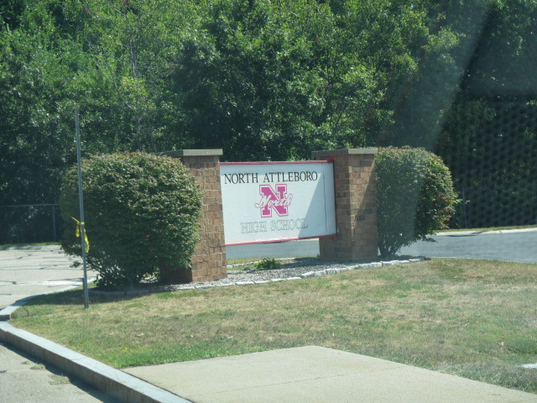

Prepared by:
Massachusetts Department of Public Health
Bureau of Environmental Health
Indoor Air Quality Program
September 2022
Building: | North Attleboro High School (NAHS)
Address: | One Wilson W. Whitty Way, North Attleboro, MA
Assessment Requested by: | Chris George, Facilities Director, North Attleboro Public Schools (NAPS)
Reason for Request: | Water damage/mold concerns in carpet of Office 2A.
Date of Assessment: | August 19, 2022
Massachusetts Department of Public Health/Bureau of Environmental Health (MDPH/BEH) Staff Conducting Assessment: | Cory Holmes, Assistant Director, Indoor Air  Quality (IAQ) Program
Building Description: | Office 2A is located off the Media Center on the second floor of the NAHS and has concrete block walls, a suspended ceiling, and wall-to-wall carpeted floor on concrete.
Windows: | There are no openable windows in Office 2A.

METHODS
In order for building materials to support mold growth, a source of water exposure is necessary. Identification and elimination of the source of water moistening building materials is necessary to control mold growth. Materials with increased moisture content over normal concentrations may indicate the possible presence of mold growth. MDPH staff performed a visual inspection of building materials for water damage and/or microbial growth. Moisture content of porous building materials (carpeting) was measured with a Delmhorst, BD-2000 Model, Moisture Detector equipped with a Delmhorst Standard Probe.

MOISTURE TESTING RESULTS
Moisture Measurements of carpeting were taken at each of the four corners of the room and in several areas in the center of the carpet. All moisture measurements were normal (i.e., dry) at the time of assessment.

Microbial/Moisture Concerns
The carpet was lifted up in several areas to observe the below conditions. No evidence of water-damaged materials, stains, musty odors, or visible mold growth were observed (Pictures 1 through 3).

Other Issues
Carpets should be cleaned annually (or semi-annually in soiled/high traffic areas) in accordance with Institute of Inspection, Cleaning and Restoration Certification (IICRC) recommendations, (IICRC, 2012). It was reported that carpets at NAHS were cleaned earlier in August 2022.
It is also important to note that the service life of carpeting is approximately 10-11 years (IICRC, 2002). Carpeting older than that becomes increasingly difficult to clean and maintain and may be a source of particulate matter to the indoor environment. Regular cleaning with a high efficiency particulate air (HEPA) filtered vacuum in combination with an annual cleaning will help to reduce accumulation and potential aerosolization of materials from carpeting.

RECOMMENDATIONS
At the time of assessment, it was reported that the NAHS was admitted to the Massachusetts School Building Authority (MSBA) program to replace the existing building through new construction or renovation. However, this process can take several years. In view of the findings at the time of the visit, the following recommendations are made:

- Consider removing carpet and clean and/or seal concrete floor.
- If removal is not feasible, continue to maintain carpets through regular vacuuming with a high efficiency particulate air (HEPA) filtered vacuum in combination with annual cleaning.
- Other carpeting too worn to be effectively cleaned/maintained should be removed.

REFERENCES
IICRC. 2002. Institute of Inspection, Cleaning and Restoration Certification. A Life-Cycle Cost Analysis for Floor Coverings in School Facilities.
IICRC. 2012. Institute of Inspection, Cleaning and Restoration Certification. Carpet Cleaning: FAQ.
MDPH. 2015. Massachusetts Department of Public Health. “Indoor Air Quality Manual: Chapters I-III”. Available at: Indoor air quality - manual and appendices | Mass.gov
SMACNA. 1994. HVAC Systems Commissioning Manual. 1st ed. Sheet Metal and Air Conditioning Contractors’ National Association, Inc., Chantilly, VA.

Picture 1
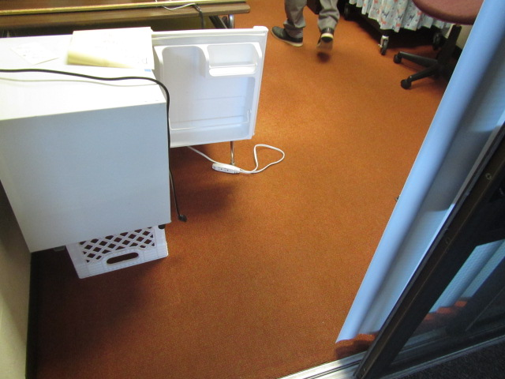
Wall to wall carpeting in Office 2A

Picture 2
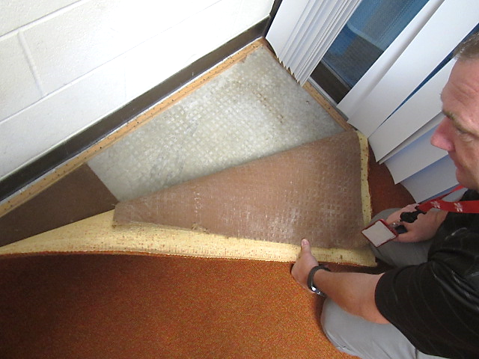
Carpeting lifted to observe conditions beneath
Picture 3
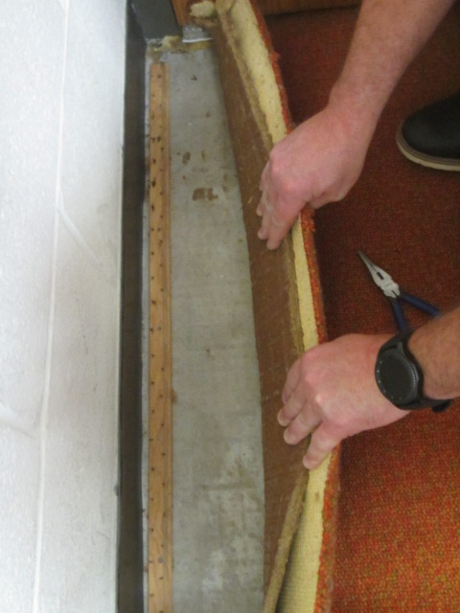
Carpeting lifted to observe conditions beneath

