**INDOOR AIR QUALITY ASSESSMENT**

**North Berkshire District Court**

**111 Holden Street**

**North Adams, Massachusetts**

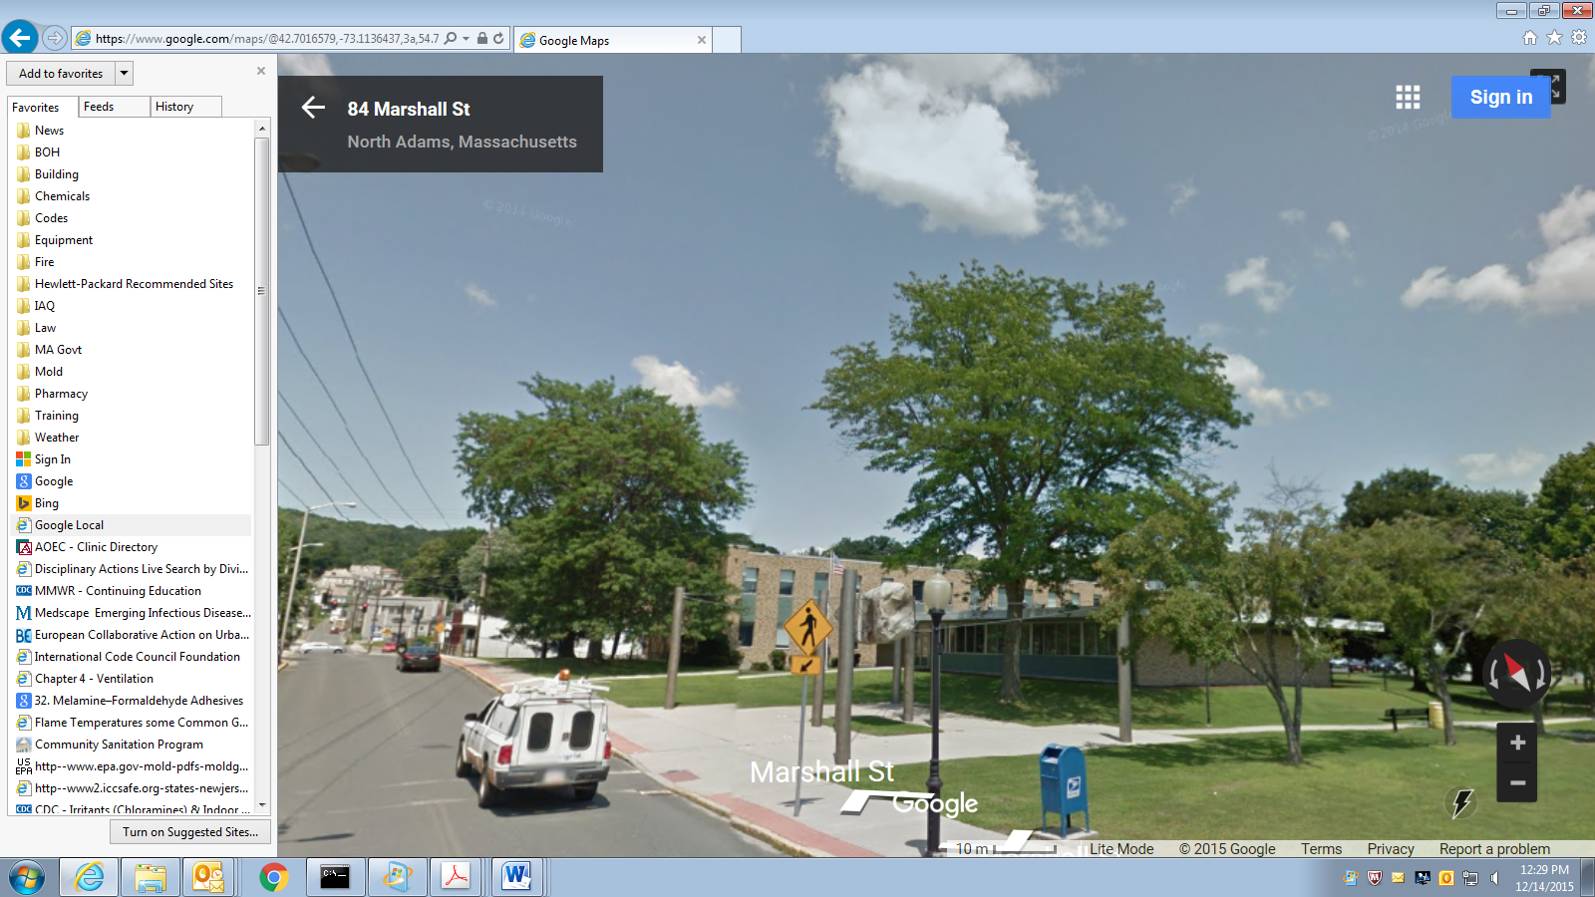

Prepared by:

Massachusetts Department of Public Health

Bureau of Environmental Health

Indoor Air Quality Program

December 2015

**Background**

|  |  |
| --- | --- |
| **Date of Assessment:** | October 29, 2015 |
| **Building:** | North Berkshire District Court (NBDC) |
| **Address:** | 111 Holden Street  North Adams, Massachusetts |
| **Assessment Requested by:** | Chris McQuade, Administrative Office of the Trial Court |
| **Massachusetts Department of Public Health/Bureau of Environmental Health (MDPH/BEH) Staff Conducting Assessment:** | Michael Feeney, Director,  Indoor Air Quality (IAQ) Program  Stefanie Santora, IAQ/Radon Unit  Brenda Netreba, Environmental Analyst, Community Assessment Program (CAP)  Carolyn Ariori, Environmental Analyst, CAP |
| **Date Building Constructed:** | 1950-1960s, with renovations in the 2005 |
| **Reason for Request:** | Concerns related to general air quality and chronic disease |

**Building Description**

The NBDC is a two-story brick and concrete building originally constructed as a research laboratory. It has a full basement that is partially below grade. The building was renovated in 2005 into the NBDC.

# Methods

Please refer to the IAQ Manual for methods, sampling procedures, and interpretation of results (MDPH, 2015).

# Results

This space is occupied by approximately 24 employees. Members of the public also visit daily. Test results are presented in Table 1.

# Discussion

## Ventilation

It can be seen from Table 1 that carbon dioxide levels were below 800 parts per million (ppm) in all areas measured, indicating adequate air exchange at the time of the assessment. The Massachusetts Department of Public Health (MDPH) recommends that carbon dioxide levels be maintained below 800 ppm for adequate ventilation. It should be noted that most areas of the NBDC were sparsely occupied and that carbon dioxide levels would be expected to rise with increased occupancy (e.g., meetings). Fresh air is provided by ceiling-mounted air handling units (AHUs) connected to fresh air diffusers by ductwork. The AHUs provide circulated air that is heated/cooled. Return air is drawn into a ceiling plenum in the office area.

NBDC staff reported concerns about the frequency of filter changes. In general, AHU filters should be changed a minimum of twice a year, generally when the system is shifted between heating/cooling seasons. Filters are designed to remove particles from the airstream. The dust spot efficiency refers to the ability of a filter to remove particulates of a certain diameter from air passing through the filter. Filters that meet the American Society of Heating, Refrigerating, and Air-Conditioning Engineers (ASHRAE) to meet its standard for a dust spot efficiency standard of a minimum of 40 percent would be sufficient to reduce many airborne particulates (Thornburg, 2000; MEHRC, 1997; ASHRAE, 1992). Pleated filters with a Minimum Efficiency Reporting Value (MERV) dust-spot efficiency of 9 or higher are recommended. The AHU filters examined at NBDC were pleated (Picture 1), which would likely be MERV 9 filters, which are adequate to remove pollen spore and other airborne particles typically found indoors.

## Temperature and Relative Humidity

Temperature measurements in occupied areas at the time of the assessment ranged from 73°F to 77°F (Table 1), which are within the MDPH recommended comfort range. The MDPH recommends that indoor temperatures be between 70°F to 78°F. Relative humidity measurements in occupied areas at the time of the assessment ranged from 50 percent to 56 percent (Table 1), which are also within the MDPH recommended comfort range. The MDPH recommends a comfort range of 40 to 60 percent for indoor air relative humidity.

## Microbial/Moisture Concerns

The NBDC has water-damaged ceiling tiles (Picture 2), carpeting (Picture 3), and signs of water penetration around window frames (Pictures 4). The source of water damage to ceiling tiles and carpeting in interior sections of the building includes roof and pipe leaks. Water damage to ceiling tiles along exterior walls and bubbling paint is attributed to water penetration through the window systems. Due to water penetration around window frames, hanging materials on walls that can support mold growth, such as cork board and paper (Picture 5), is not recommended. The United States Environmental Protection Agency (US EPA) and the American Conference of Governmental Industrial Hygienists (ACGIH) recommend that porous materials be dried with fans and heating within 24 to 48 hours of becoming wet (US EPA, 2001; ACGIH, 1989). If porous materials are not dried within this time frame, mold growth may occur. Once mold has colonized porous materials, they are difficult to clean and should be removed and discarded.

AHUs are equipped with drain pans. Some drain pans examined contain corrosion and debris, which can be a sign of poor drainage (Picture 6). Standing water in drip pans can be a source of mold, which can be entrained by the AHU as it operates. These drip pans appear to be connected to pumps (Picture 7). These units should be regularly inspected to ensure that the condensation drains and pumps are working properly and are not clogged or leaking.

Indoor plants were noted in some areas. Plants can be a source of pollen and mold, which can be respiratory irritants to some individuals. Plants should be equipped with non-porous drip pans. Plants should also be located away from ventilation sources to prevent the entrainment and/or aerosolization of dirt, pollen, or mold.

## Other IAQ Evaluations

Indoor air quality can be negatively influenced by the presence of respiratory irritants, such as products of combustion. The process of combustion produces a number of pollutants. Common combustion emissions include carbon monoxide, carbon dioxide, water vapor, and smoke (fine airborne particle material). Of these materials, exposure to carbon monoxide and particulate matter with a diameter of 2.5 micrometers (μm) or less (PM2.5) can produce immediate, acute health effects upon exposure. To determine whether combustion products were present in the indoor environment, BEH/IAQ staff obtained measurements of carbon monoxide and PM2.5.

### Carbon Monoxide

*Carbon monoxide should not be present in a typical, indoor environment*. If it *is* present, indoor carbon monoxide levels should be less than or equal to outdoor levels. On the day of the assessment, outdoor carbon monoxide concentrations were non-detect (ND) (Table 1). No measurable levels of carbon monoxide were detected inside the building (Table 1).

### Particulate Matter

Outdoor PM2.5 was measured at 10 μg/m3 (Table 1). PM2.5 levels measured in occupied areas indoors ranged from 3 to 11 μg/m3 (Table 1), which are below the NAAQS PM2.5 level of 35 μg/m3.

### Volatile Organic Compounds

To determine if volatile organic compounds (VOCs) were present, BEH/IAQ staff conducted air sampling for VOCs and inspected areas for items containing VOCs. On the day of the assessment, outdoor VOCs were non-detect (ND) (Table 1). No measurable levels of VOCs were detected on the second floor or basement. VOCs on the first floor were ND in all areas except for office/work areas 125 through 142 which had measurements in the range of 0.2 to 10 ppm (Table 1). BEH staff noted a flower-like odor on the west stairwell (Stairwell #1). A similar odor was detected in office/work areas 120 through 146 (Picture 8). The source of VOCs was traced to a bowl of molten scented wax on a hot plate (Picture 9). It appears that a number of offices contain scented candles and/or heated wax. If candles are heated or burned, both VOCs and heated wax oils are vaporized. Paraffin wax fume can be a source of eye and respiratory irritation (CDC, 2011). The fuming of paraffin wax by heating or burning is not recommended in the indoor environment.

### Other Conditions

Many areas of the NBDC are carpeted. The Institute of Inspection, Cleaning, and Restoration Certification (IICRC) recommends that carpeting be cleaned annually (or semi-annually in soiled high traffic areas) (IICRC, 2012). Regular cleaning with a high efficiency particulate air (HEPA) filtered vacuum in combination with an annual cleaning will help to reduce accumulation and potential aerosolization of materials from carpeting. The vacuum cleaner used in the NBDC does not have a HEPA filter (Picture 10).

# Health Concerns

At the request of the NDBC, BEH staff from the Community Assessment Program (CAP) conducted in-person interviews with interested Court employees at the time of the IAQ Assessment on October 29, 2015. The interviews included the administration of a questionnaire by BEH/CAP staff to obtain information on the type and frequency of symptoms experienced by some Court employees. The questionnaire was closely modeled on surveys used previously by BEH as well as those used by the National Institute of Occupational Safety and Health (NIOSH) and the U.S. Environmental Protection Agency (US EPA). The questionnaire elicited information on specific symptoms that have been reported in the scientific/medical literature as commonly experienced by occupants of buildings with indoor air quality problems as well as information on perceived air quality and personal health factors. These types of questionnaires are used to systematically collect building-related health and environmental complaints. The information collected, in conjunction with the assessment of the indoor environment, can be used to evaluate possible associations between indoor air quality and health and to recommend appropriate follow-up, if warranted.

The NBDC has an employee population of approximately 24 and six individuals (25%) participated in the BEH interview. All responses were reviewed to identify the types of diseases and symptoms that were reported, their frequency of occurrence, and whether any unusual patterns emerged suggestive of a possible association with indoor environmental conditions in the Court (Appendix A).

## Employee Interview Results

Information from the six individuals is summarized below. Under both state and federal regulations, personally-identifying information shared by employees is confidential; therefore, the following discussion provides summary information only.

## Health Effects

All six employees interviewed were female. The average age of the employees was approximately 52 years old and the average length of employment with the Court at its current location was 9 years. Smoking status was obtained in the interviews due to the role of smoking in respiratory health. Among the 6 employees, two reported that they were former smokers and four had never smoked.

The most commonly reported symptoms (with at least 4 of the 6 employees reporting that they experienced the symptom at least once in the four weeks prior to the interview) were: dry, itching, burning, watering or irritated eyes; stuffy or runny nose or sinus congestion not related to an infection; pain or stiffness in the back, shoulders or neck; headaches; and sneezing. Three of the six employees also experienced a sore, hoarse, or dry throat at least once in the last four weeks. Respondents were asked if they experienced these symptoms primarily inside the building, outside the building, or both. Employees who reported experiencing eye irritation (5), a stuffy nose (5), or a sore, hoarse, or dry throat (3) reported experiencing these symptoms primarily inside the building. Respondents were asked if there was a particular time of day or week when their symptoms became worse or occurred more frequently. Overall there did not appear to be a consistent pattern among respondents.

Employees who participated in the interviews were asked if they had any other health related concerns at the Northern Berkshire District Court that had not yet been discussed. All participants shared concerns about the incidence of cancers of female organs among the women who worked in the building, and all specifically mentioned breast cancer. A few other specific health conditions of concern were reported; however, these conditions do not appear to be related to one another, having different risk factors and/or etiologies, and are not discussed further in order to protect confidentiality.

## Building Concerns

BEH/CAP also asked the Court employees several questions about their perceptions of environmental conditions in their work surroundings. The most commonly reported conditions as reported by at least 4 of the 6 interviewees were as follows:

* air was too dry (6)
* air was too stuffy (5)
* indoor temperatures were too hot (6)

Other responses that were reported include moldy odors (3), air that is too humid (3), and indoor temperatures that are too cold (3). A few employees mentioned concerns about dirty air filters and wet ceiling tiles.

### Symptomology and Building Location

The locations where individuals reported working in the building and their health concerns were evaluated with respect to the results from the environmental testing conducted by BEH/IAQ staff. All six employees reported that there were specific locations within the Court where they spend the majority of their time. Four individuals reported working primarily in one location throughout the course of a given day. Two individuals reported having two or more locations they frequented throughout the typical workday.

# Health Discussion

The respiratory/irritant and other symptoms reported among participants in this health investigation are generally those most commonly experienced in buildings with indoor air quality problems. These included stuffy or runny nose or sinus congestion not related to an infection; sore, hoarse or dry throat; and headaches. Such symptoms are commonly associated with ventilation problems in buildings, although other factors (e.g., odors, microbiological contamination) may also contribute (Passarelli, 2009; Norbäck, 2009; Burge, 2004; Stolwijk, 1991).

During the IAQ building review, BEH staff observed scented candles in the Clerk’s Office area. Paraffin wax fumes can be released from candles when candle wax aerosolizes. These fumes can irritate the eyes, skin, and respiratory system; and cause discomfort and nausea (CDC, 2011).

### Cancer and Other Health Concerns

As mentioned previously, the incidence of cancer among employees of the Court was a concern expressed by all of those interviewed. According to the American Cancer Society, one out of three women and one out of two men develop cancer in their lifetime, and cancer will affect three out of every four families (ACS 2015). For this reason, cancers often appear to occur in “clusters,” and it is understandable that someone may perceive that there are an unusually high number of cancer cases in their neighborhood, workplace or town. Upon close examination, many of these “clusters” are not unusual increases, as first thought, but are related to such factors as local population density, variations in reporting, or chance fluctuations in occurrence. In other instances, the “cluster” in question includes a high concentration of individuals who possess related behaviors or risk factors for cancer. Some, however, are unusual; that is, they represent a true excess of cancer in a workplace, a community, or among a subgroup of people. A suspected cluster is more likely to be a true cancer cluster if it involves a high number of diagnoses of one type of cancer in a relatively short time period rather than several different types diagnosed over a long period of time (i.e., 20 years), a rare type of cancer rather than common types, and/or a large number of diagnoses among individuals in age groups not usually affected by that cancer. These types of clusters may warrant further public health investigation.

The Massachusetts Cancer Registry (MCR), a division in the MDPH Office of Data Management and Outcomes Assessment, is a population-based surveillance system that that has been monitoring cancer incidence in the Commonwealth since 1982. All new diagnoses of invasive cancer, along with several types of in situ (localized) cancer, occurring among Massachusetts residents are required by law to be reported to the MCR within six months of the date of diagnosis (M.G.L. c.111. s 111b). This information is collected and kept in a confidential database. Data are collected and reviewed for accuracy and completeness. Individuals diagnosed with cancer in Massachusetts are reported to the MCR based on their residence at diagnosis and not their workplace. For that reason, calculating an expected rate of cancer is difficult at best for a place of employment, such as a court. The most practical first step in evaluating cancer in the workplace is to determine the types of cancer reported and whether they represent an unusual pattern.

In Massachusetts, breast cancer has been the most common type of cancer diagnosed among female residents for more than a decade and prostate cancer has been the most common type diagnosed among male residents. In Massachusetts, prostate cancer accounted for approximately 27% new cancer diagnoses among males and breast cancer accounted for approximately 29% of new cancers diagnoses among females during 2008- 2012. Lung and bronchus cancers have been the second most common type of cancer diagnosed among both males and females in Massachusetts and account for approximately 14% of new cancers statewide during 2008-2012. Colorectal cancers are the third most common type of cancers diagnosed among males and females and account for approximately 8% of new cancers in Massachusetts during this time period (MCR 2015).

The chance of developing invasive breast cancer at some time in a woman’s life is about 1 in 8 (12%). A woman’s risk of developing breast cancer increases with age, with age being the strongest risk factor for breast cancer. About 1 out of 8 invasive breast cancers are found in women younger than 45. About 2 out of 3 invasive breast cancers are found in women age 55 or older (ACS 2015). Several studies have found that women who work in professional jobs tend to have an increased risk of developing breast cancer (Ruben et al. 1993; Threlfall et al., 1985; MacArthur et al., 2007; King et al., 1994; Pollan and Gustavsson, 1999) while other studies have not (Calle et al., 1998; Petralia et al., 1999). No occupational exposures have been identified in these studies. Rather, researchers suspect that established risk factors for breast cancer such as later maternal age at first birth and lower parity (the number of times a woman has given birth) may be more prevalent in women working in a professional setting than in women who do not (such as homemakers). A more detailed discussion of breast cancer risk factors can be found in Appendix B.

Due to the long latency period for most types of cancer, it is difficult to identify exposures that may have contributed to cancer development. The latency period refers to the time between exposure to a cancer causing agent and the appearance of clinical symptoms and/or diagnosis of the disease. As a solid tumor, breast cancer is believed to have a long development period, estimated to be no shorter than 10 years and possibly as long as 30 years or more (Bang, 1996; Frumkin, 1995).

Several building employees had concerns about cancers and other conditions of female reproductive organs in addition to concerns of breast cancer. While all cancers have the characteristic of abnormal and invasive cell growth, “cancer” is a general term that describes a group of different diseases. The cancers mentioned as being of concern were of different organs and have different sets of risk factors. As stated earlier, a suspected cancer cluster is more likely to be a true cancer cluster if it involves a high number of diagnoses of one type of cancer in a relatively short time period rather than several different types diagnosed over a long period of time, a rare type of cancer rather than common types, and/or a large number of diagnoses among individuals in age groups not usually affected by that cancer. To protect privacy, no further information about these other cancer types or conditions is provided here.

# Conclusions/Recommendations

Although the incidence of cancer among employees of the Court was a concern expressed by all of those interviewed, it is important to consider the following:

* Different types of cancer are individual diseases with separate causes and risk factors.
* Cancers in general have long latency or development periods that can range from 10 to 30 years in adults, particularly for solid tumors such as breast cancer.
* A great deal of research has been reported and more is being done to understand possible environmental influences on breast cancer risk. To date, however, there are no established environmental risk factors.

The conditions observed in the NBDC are somewhat complicated. **Short-term** and **long-term** recommendations are provided to address the conditions described in this assessment and improve indoor air quality. The short-term recommendations can be implemented as soon as practicable. Long-term measures are more complex and will require planning and resources to adequately address the overall indoor air quality concerns within the building.

## Short-term Recommendations

1. Discontinue the use of all paraffin wax products in the building.
2. Continue to operate the AHU during all occupied hours.
3. Repair roof and plumbing leaks.
4. Replace water-damaged ceiling tiles.
5. Replace water-damaged carpet tiles.
6. Replace AHU filters at least twice a year. Inscribe the date of installation on the filter frame in permanent marker to keep track of change date.
7. Clean the drip pans beneath each AHU after the cooling season.
8. Ensure that all drip pans are properly beveled to the drain in order to prevent standing water.
9. Ensure that all drip pan pumps are functioning properly.
10. Remove all materials hanging on exterior wall around windows to prevent mold growth.
11. For buildings in New England, periods of low relative humidity during the winter are unavoidable. Therefore, scrupulous cleaning practices should be adopted to minimize common indoor air contaminants whose irritant effects can be enhanced when the relative humidity is low. To control for dusts, a high efficiency particulate arrestance (HEPA) filter equipped vacuum cleaner in conjunction with wet wiping of all surfaces is recommended. Avoid the use of feather dusters. Drinking water during the day can help ease some symptoms associated with a dry environment (throat and sinus irritations).
12. Refer to resource manual and other related indoor air quality documents located on the MDPH’s website for further building-wide evaluations and advice on maintaining public buildings. These documents are available at <http://mass.gov/dph/iaq>.

## Long-term Recommendations

1. Consult a building engineer as to the best method for preventing or minimizing water penetration through the window frames/brickwork.

**IAQ References**

ACGIH. 1989. Guidelines for the Assessment of Bioaerosols in the Indoor Environment. American Conference of Governmental Industrial Hygienists, Cincinnati, OH.

ASHRAE. 1992. Gravimetric and Dust-Spot Procedures for Testing Air-Cleaning Devices Used in General Ventilation for Removing Particulate Matter. American Society of Heating, Refrigeration and Air Conditioning Engineers. ANSI/ASHRAE 52.1-1992.

CDC. 2011. Paraffin wax fume. NIOSH Pocket Guide. April 4, 2011. <http://www.cdc.gov/niosh/npg/npgd0477.html>

IICRC. 2012. Carpet Cleaning FAQ 4 Institute of Inspection, Cleaning and Restoration Certification. Institute of Inspection Cleaning and Restoration, Vancouver, WA.

Massachusetts Department of Public Health. (MDPH). 2015. “Indoor Air Quality Manual: Chapters I-III”. Available from [http://www.mass.gov/eohhs/gov/departments/dph/programs/environmental-health/exposure-topics/iaq/iaq-manual/](http://www.mass.gov/eohhs/gov/departments/dph/programs/environmental-health/exposure-topics/iaq/iaq-manual/" \o "Massachusetts Department of Public Health.  (MDPH). 2015.  \“Indoor Air Quality Manual: Chapters I-III\”.)

MEHRC. 1997. Indoor Air Quality for HVAC Operators & Contractors Workbook. MidAtlantic Environmental Hygiene Resource Center, Philadelphia, PA.

Thornburg, D. 2000. Filter Selection: a Standard Solution. *Engineering Systems* 17:6 pp. 74-80.

US EPA. 2001. “Mold Remediation in Schools and Commercial Buildings”. Office of Air and Radiation, Indoor Environments Division, Washington, DC. EPA 402-K-01-001. March 2001. Available at: <http://www.epa.gov/mold/mold-remediation-schools-and-commercial-buildings-guide>.

# Health Concerns References

American Cancer Society (ACS). 2015. Detailed Guide: Breast Cancer. Available at [www.cancer.org](http://www.cancer.org/)

Bang KM. 1996. Epidemiology of occupational cancer. J Occup Med; 11(3):467-85.

Burge, PS. 2004. Sick building syndrome. Occupational and Environmental Medicine 61:185-190.

Calle, E.E. et al. 1998. Occupation and breast cancer mortality in a prospective cohort of US women. American Journal of Epidemiology 148(2):191-197.

CDC. 2011. Paraffin wax fume. NIOSH Pocket Guide. April 4, 2011. <http://www.cdc.gov/niosh/npg/npgd0477.html>

Frumkin H. 1995. Carcinogens. In: Levy BS and Wegman DH, editors. Occupational Health-- Recognizing and Preventing Work-Related Disease. 3rd ed. Boston: Little, Brown and Company. p. 293.

King, A.S. et al. 1994. Mortality among female registered nurses and school teachers in British Columbia. American Journal of Industrial Medicine 26(1):125-132.

MacArthur, A.C. et al. 2007. Occupational female breast cancer and reproductive cancer mortality in British Columbia, Canada, 1950-94. Occupational Medicine 57:246-253.

Massachusetts Cancer Registry (MCR). 2015. Cancer Incidence and Mortality in Massachusetts, 2008-2012: Statewide Report. Available at [www.mass.gov/dph/mcr](http://www.mass.gov/dph/mcr)

National Institute for Occupational Safety and Health (NIOSH). 2010.

Norbäck, D. 2009. An update on sick building syndrome. Current Opinion in Allergy and Immunology 9:55-59.

Passarelli, GR. 2009. Sick building syndrome: an overview to raise awareness. Journal of Building Appraisal 5(1):55-66.

Petralia, S.A. et al. 1999. Risk of premenopausal breast cancer and patterns of established breast cancer risk factors among teachers and nurses. American Journal of Industrial Medicine 35(2):137-141.

Pollan, M. and Gustavsson, P. 1999. High-risk occupations for breast cancer in the Swedish female working population. American Journal of Public Health 89(6):875-881.

Ruben, C.H. et al. 1993. Occupation as a risk identifier for breast cancer. American Journal of Public Health 83(9):1311-1315.

Stolwijk, J. 1991.  Sick-building syndrome.  Environmental Health Perspectives 95:99-100.

Threlfall, W.J. et al. 1985. Reproductive variables as possible confounders in occupational studies of breast and ovarian cancer in females. Journal of Occupational Medicine 27(6):448- 450.

**Picture 1**

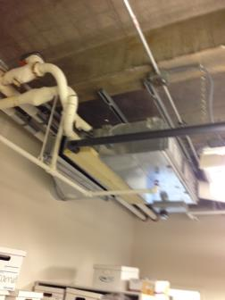

**Pleated filter installed in AHU**

**Picture 2**

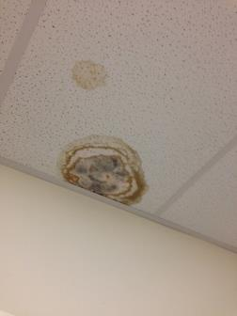

**Water-damaged ceiling tile**

**Picture 3**



**Water-damaged carpeting**

**Picture 4**

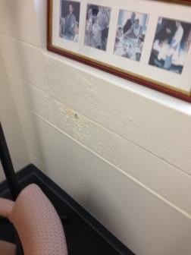

**Bubbling paint beneath window**

**Picture 5**



**Cork board beneath window**

**Picture 6**

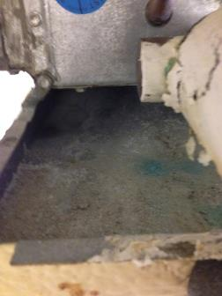

**Corrosion on surface of AHU drip pan**

**Picture 7**

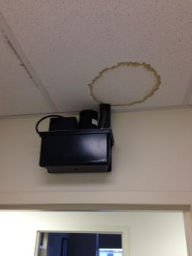

**Condensation pump (Note water-damaged ceiling tile around pump hose)**

**Picture 8**

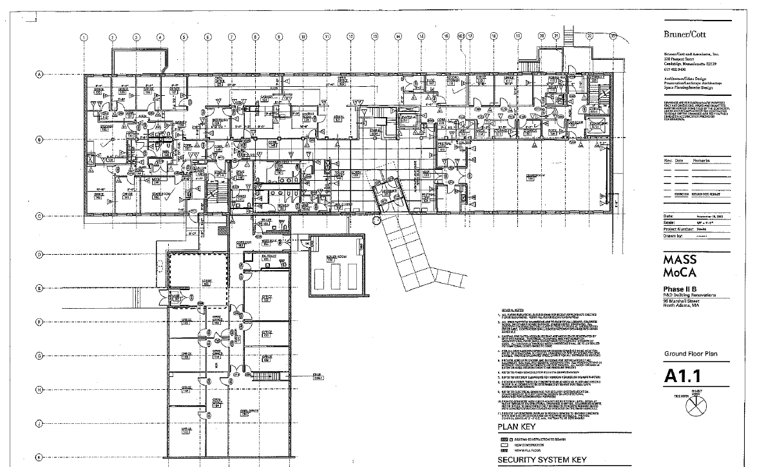

**Area on First Floor with Floral Odor (Shaded)**

**Picture 9**



**Bowl of molten scented wax on a hot plate**

**Picture 10**

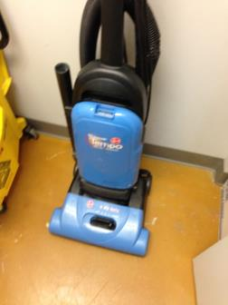

**Vacuum cleaner in NBDC**

| Location | **Carbon**  **Dioxide**  **(ppm)** | **Carbon Monoxide**  **(ppm)** | **Temp**  **(°F)** | **Relative**  **Humidity**  **(%)** | **TVOCs**  **(ppm)** | **PM2.5**  **(µg/m3)** | **Occupants**  **in Room** | **Windows**  **Openable** | **Ventilation** | | | **Remarks** |
| --- | --- | --- | --- | --- | --- | --- | --- | --- | --- | --- | --- | --- |
| **Intake** | **Exhaust** | |
| Background (outdoors) | 438 | ND | 66 | 75 | ND | 10 |  |  |  | |  |  |
| 222 | 476 | ND | 75 | 52 | ND | 4 | 0 | N | Y | | Y |  |
| 223 | 457 | ND | 75 | 54 | ND | 4 | 0 | N | Y | | Y |  |
| 225 | 456 | ND | 76 | 54 | ND | 3 | 0 | N | Y | | Y | 3 water-damaged ceiling tiles |
| 229 | 472 | ND | 75 | 51 | ND | 4 | 0 | N | Y | | Y | 2 water-damaged ceiling tiles |
| 231 rest room |  |  |  |  |  |  |  | N | Y | | Y | 1 water-damaged ceiling tiles |
| 232 rest room |  |  |  |  |  |  |  | N | Y | | Y |  |
| 234 | 457 | ND | 76 | 53 | ND | 6 | 0 | N | Y | | Y |  |
| 235 | 436 | ND | 77 | 52 | ND | 5 | 0 | N | Y | | Y |  |
| 236 | 437 | ND | 76 | 53 | ND | 7 | 0 | N | Y | | Y |  |
| 233 | 491 | ND | 77 | 50 | ND | 5 | 0 | N | Y | | Y |  |
| 207 | 505 | ND | 74 | 54 | ND | 5 | 0 | N | N | | N |  |
| 210A | 504 | ND | 75 | 52 | ND | 5 | 0 | N | Y | | Y |  |
| 211 |  |  |  |  |  |  |  |  |  | |  | Water damage to rug in hallway  Water leak |
| 213 | 505 | ND | 75 | 53 | ND | 6 | 0 | N | Y | | Y |  |
| 214 | 488 | ND | 75 | 52 | ND | 6 | 0 | N | Y | | Y | 2 water-damaged ceiling tiles |
| 215 rest room |  |  |  |  |  |  |  |  |  | |  | 1 water-damaged ceiling tile |
| 216 rest room |  |  |  |  |  |  |  |  |  | |  | 1 water-damaged ceiling tile |
| 218 | 509 | ND | 77 | 50 | ND | 6 | 0 | N | Y | | Y |  |
| 220 | 527 | ND | 77 | 51 | ND | 5 | 0 | N | Y | | Y |  |
| 221 | 563 | ND | 75 | 56 | ND | 5 | 0 | N | Y | | Y |  |
| 203 | 437 | ND | 75 | 52 | ND | 6 | 0 | N | Y | | Y | 2 water-damaged ceiling tile  1 mold-colonized ceiling tile |
| 204 | 433 | ND | 75 | 53 | ND | 6 | 0 | N | Y | | Y |  |
| 205 | 451 | ND | 74 | 53 | ND | 7 | 0 | N | Y | | Y |  |
| 102 | 515 | ND | 75 | 53 | ND | 7 | 2 | N | Y | | Y | Plants |
| 104 | 436 | ND | 75 | 52 | ND | 7 | 0 | N | Y | | Y | 1 water-damaged ceiling tile |
| 105 | 442 | ND | 75 | 52 | ND | 7 | 0 | N | Y | | Y | 2 water-damaged ceiling tiles  1 mold-colonized ceiling tiles |
| 106 | 437 | ND | 74 | 53 | ND | 6 | 0 | N | Y | | Y |  |
| 109 | 459 | ND | 74 | 53 | ND | 6 | 0 | N | Y | | Y |  |
| 110 | 533 | ND | 75 | 53 | ND | 8 | 0 | N | Y | | Y |  |
| 111 | 495 | ND | 75 | 52 |  | 7 | 0 | N | Y | | Y |  |
| 112 |  |  |  |  | N |  |  |  |  | |  | Leak from condensation pump |
| 113 |  |  |  |  | ND |  |  |  |  | |  | Water-damaged pipe insulation |
| 115 | 461 | ND | 74 | 53 | ND | 7 | 0 | N | Y | | Y | Efflorescence under window |
| 117 | 486 | ND | 75 | 50 | ND | 7 | 1 | N | Y | | Y |  |
| 118 | 495 | ND | 75 | 50 | ND | 7 | 0 | N | Y | | Y |  |
| 119 | 471 | ND | 75 | 50 | ND | 11 | 0 | N | Y | | Y |  |
| 120 | 589 | ND | 76 | 52 | ND | 8 | 0 | N | Y | | Y |  |
| 120 | 533 | ND | 75 | 52 | ND | 9 | 0 | N | Y | | Y |  |
| 121/122 | 532 | ND | 76 | 52 | ND | 9 | 0 | N | Y | | Y | Photocopier |
| 125 | 536 | ND | 75 | 53 | 10 | 8 | 0 | N | Y | | Y | Plants  Wax on hot plate |
| 126 | 528 | ND | 75 | 52 | 0.3 | 8 | 0 | N | Y | | Y |  |
| 127 | 564 | ND | 75 | 52 | 0.3 | 7 | 0 | N | Y | | Y |  |
| 128 | 604 | ND | 75 | 53 | 0.3 | 7 | 1 | N | Y | | Y |  |
| 129 | 632 | ND | 75 | 53 | 0.7 | 7 | 1 | N | Y | | Y | Efflorescence  Wax on hot plate |
| 130 | 624 | ND | 74 | 53 | 0.6 | 7 | 0 | N | Y | | Y | Efflorescence  Candle |
| 132 | 559 | ND | 74 | 53 | 0.3 | 6 | 0 | N | Y | | Y |  |
| 140 | 557 | ND | 75 | 53 | 0.3 | 8 | 0 | N | Y | | Y | 1 water-damaged ceiling tile |
| 141 | 586 | ND | 75 | 55 | 0.2 | 8 | 1 | N | Y | | Y |  |
| 142 | 578 | ND | 75 | 54 | 0.8 | 7 | 0 | N | Y | | Y | Plants |
| 146 | 527 | ND | 75 | 53 | ND | 7 | 0 | N | Y | | Y | 1 water-damage ceiling tile |
| 147 | 527 | ND | 75 | 53 | ND | 7 | 0 | N | Y | | Y |  |
| Basement hall | 560 | ND | 73 | 52 | ND | 9 | 0 | N | Y | | Y |  |
| B11 | 474 | ND | 73 | 53 | ND | 7 | 0 | N | Y | | Y |  |
| B05 | 593 | ND | 73 | 55 | ND | 6 | 0 | N | Y | | Y |  |
| Basement stairwell |  |  |  |  |  |  |  |  |  | |  | Efflorescence |

Appendix A, page 1

**How to Use this Factsheet**

This risk factor summary was developed to serve as a general fact sheet. It is an overview and should not be considered exhaustive. For more information on other possible risk factors and health effects being researched, please see the References section.

A risk factor is anything that increases a person’s chance of developing cancer. Some risk factors can be controlled while others cannot. Risk factors can include *hereditary conditions*, *medical conditions or treatments*, *infections*, *lifestyle factors*, or *environmental exposures*. Although risk factors can influence the development of cancer, most do not directly cause cancer. An individual’s risk for developing cancer may change over time due to many factors and it is likely that multiple risk factors influence the development of most cancers. Knowing the risk factors that apply to specific concerns and discussing them with your health care provider can help to make more informed lifestyle and health care decisions.

For those cancer types with environmentally-related risk factors, an important factor in evaluating cancer risk is the route of exposure. This is particularly relevant when considering exposures to chemicals in the environment. For example, a particular chemical may have the potential to cause cancer if it is inhaled, but that same chemical may not increase the risk of cancer through skin contact. In addition, the dose and duration of time one might be exposed to an environmental agent is important in considering whether an adverse health effect might be expected.

Gene-environment interactions are another important area of cancer research. An individual’s risk of developing cancer may depend on a complex interaction between their genetic makeup and exposure to an environmental agent (for example, a virus or a chemical contaminant). This may explain why some individuals have a fairly low risk of developing cancer as a result of an environmental factor or exposure, while others may be more vulnerable.

**Key Statistics**

Breast cancer is the most frequently diagnosed cancer among women in the United States, except for skin cancers. The American Cancer Society estimates that in 2015, approximately 231,840 women in the U.S. and 5,890 women in Massachusetts will be diagnosed with breast cancer. The disease is expected to account for approximately 29% of all new cancer diagnoses in females.1 Between 2007 and 2011, invasive breast cancer accounted for 29.0% of cancer diagnoses in females in Massachusetts.11

In the United States, breast cancer rates stabilized in the early 1990s, increased in the latter half of the 1990s, and dropped sharply between 2002 and 2003. The sharp drop has been attributed to decreased use of menopausal hormones following the 2002 publication of the Women’s Health Initiative study results. This study linked the use of hormone therapy to an increased risk of breast cancer.2 In Massachusetts, the incidence of invasive breast cancer in females remained stable over the years 2007-2011.11

The chance of developing invasive breast cancer at some time in a woman's life is about 1 in 8. Women are 100 times more likely than men to develop this disease.2 Men can also develop breast cancer, but male breast cancer is rare, accounting for 1% of all breast cancer cases.1, 9 For more information on breast cancer in men, visit the American Cancer Society website at www.cancer.org.5

A woman’s risk of developing breast cancer increases with age. About 12-13% of invasive breast cancers are found in women younger than 45, while about 66% are found in women age 55 or older. White women are slightly more likely to develop breast cancer than women of other races and ethnicities.2

**Types of Breast Cancer**

The term "cancer" is used to describe a variety of diseases associated with abnormal cell and tissue growth. Cancers are classified by the location in the body where the disease originated (the primary site) and the tissue or cell type of the cancer (histology).

There are several types of breast cancer, although some of them are quite rare. In some cases a single breast tumor can have a combination of these types or have a mixture of invasive and *in situ* cancer.

*In situ* breast cancers are considered the earliest stage of cancer, when it is confined to the layer of cells where it began. They have not invaded into deeper tissues in the breast or spread to other organs in the body, and are sometimes referred to as non-invasive breast cancers.2 The remainder of this risk factor summary pertains to invasive breast cancers. Additional information on *in situ* breast cancers and other benign breast conditions can be found at www.cancer.org (American Cancer Society).3

An invasive, or infiltrating, cancer is one that has already grown beyond the layer of cells where it started (as opposed to carcinoma *in situ*). Most breast cancers are invasive carcinomas – either invasive ductal carcinoma or invasive lobular carcinoma.2

Breast cancer most commonly involves either the milk-producing lobules or the tubular ducts that connect the lobules to the nipple.6 Roughly 80% of all breast cancers originate in the ducts, and are known as invasive ductal carcinoma (IDC). An additional 10% begin in the lobules, and are known as invasive lobular carcinoma (ILC). Invasive lobular carcinoma may be harder to detect by a mammogram than invasive ductal carcinoma. Both types of cancer can spread (metastasize) from the original site to other parts of the body.2, 6

Other less common types of invasive breast cancer2 include:

* inflammatory breast cancer
* triple-negative breast cancer
* medullary carcinoma
* metaplastic carcinoma
* mucinous carcinoma
* Paget’s disease
* tubular carcinoma
* papillary carcinoma
* Phyllodes tumor
* adenoid cystic carcinoma or adenocystic carcinoma
* angiosarcoma

**Established Risk Factors**

*Hereditary Conditions*

Having a family history of breast cancer increases a woman’s risk of developing the disease. Women who have a first-degree relative (i.e., mother, sister) with breast cancer have about twice the risk of developing breast cancer themselves. Having two first-degree relatives with this disease increases a woman’s risk by three- to five-fold.2, 6 The risk is also elevated if several close relatives from either side of the family have been diagnosed with breast or ovarian cancer, especially before age 50.6, 13 Overall, less than 15% of women with breast cancer have a family member with the same disease. Therefore, over 85% of women who have breast cancer have no familial link to the disease.2

About 5-10% of breast cancer diagnoses are thought to be due to an inherited genetic mutation.2, 15 Most of these mutations occur in the *BRCA1* and *BRCA2* genes. Other genes that may lead to an increased risk for developing breast cancer include *ATM*, *CHEK2*, *TP53* and *PTEN*. Women who inherit these gene mutations have up to an 80% chance of developing breast cancer during their lifetime.2

*Medical Conditions and Treatments*

Certain benign breast conditions may increase one’s risk for breast cancer. Women with proliferative lesions without atypia (i.e., abnormal or unusual cells), which have excessive growth of cells in the ducts or lobules of breast tissue, are 1.5 to 2 times more likely to develop breast cancer compared with women who have non-proliferative lesions.15 Proliferative lesions with atypia, when the cells are excessively growing and no longer appear normal, raise one’s risk by 3.5 to 5 times. Women with denser breast tissue (as seen on a mammogram) have more glandular tissue and less fatty tissue, and have a higher risk of breast cancer.2

A woman with cancer in one breast is 3 to 4 times more likely to develop a new cancer in the other breast or in another part of the same breast. In addition, a previous diagnosis of an *in situ* breast cancer puts a woman at increased risk for an invasive breast cancer.2

Cumulative exposure of the breast tissue to estrogen is associated with breast cancer risk. Several factors can influence estrogen levels. Women who started menstruating at an early age (before age 12) and/or went through menopause at a later age (after age 55) have a slightly higher risk of breast cancer. Also, women who have had no children or those whose first pregnancy occurred when they were over the age of 30 have an increased risk for developing breast cancer.2 Women who have had more children and those who have breast-fed seem to be at lower risk.15

Use of hormone replacement therapy is another factor that may affect breast cancer risk. Long-term use (several years or more) of combined post-menopausal hormone therapy (PHT) increases the risk of breast cancer. The increased risk from combined PHT appears to apply only to current and recent users. A woman's breast cancer risk seems to return to that of the general population within 5 years of stopping combined PHT. The use of estrogen-only replacement therapy (ERT) does not appear to increase the risk of breast cancer significantly but when used long-term (for more than 10 years), ERT has been found to increase the risk of ovarian cancer in some studies.2, 15

Women who had radiation therapy to the chest area as treatment for another cancer (i.e., ionizing radiation for Hodgkin disease) are at significantly increased risk for breast cancer.15 This risk appears to be highest if the radiation is given during adolescence or puberty, when the individual’s breasts are developing.2

From the 1940s through the 1960s some pregnant women were given the drug diethylstilbestrol (DES) because it was thought to lower their chances of miscarriage. These women have a slightly increased risk of developing breast cancer. A woman whose mother took DES while pregnant may also have a slightly higher risk of breast cancer.2

*Lifestyle Factors*

Alcohol consumption has also been associated with increased risk for breast cancer. Compared with non-drinkers, women who consume one alcoholic drink a day have a very small increase in risk whereas those who have 2 to 5 drinks daily have about 1½ times the risk of women who drink no alcohol.2

**Possible Risk Factors**

*Environmental Exposures*

A great deal of research has been reported and more is being done to understand possible environmental influences on breast cancer risk. Of special interest are compounds in the environment that have been found in animal studies to have estrogen-like properties, which could in theory affect breast cancer risk. For example, substances found in some plastics, certain cosmetics and personal care products, pesticides (such as DDE), and PCBs (polychlorinated biphenyls) seem to have such properties. To date, however, there is not a clear link between breast cancer risk and exposure to these substances.2

*Lifestyle Factors*

For a long time, the role of cigarette smoking in the development of breast cancer was unclear. Recent research, however, supports a consistent association between smoking and an increased risk of breast cancer, with long-term heavy smokers at highest risk.16, 2

Some studies suggest a relationship between secondhand smoking and an increased risk for breast cancer; however, confirming this relationship has been difficult and is still the subject of active research.2, 15, 16

Recent studies have indicated that being overweight or obese after menopause may put a woman at increased risk of breast cancer.2, 6, 15  Similarly, women who are physically inactive throughout life may have an increased risk of breast cancer.2

Studies have found that women using oral contraceptives (birth control pills) have a slightly greater risk of breast cancer than women who have never used them, but this risk seems to decline once their use is stopped. Women who stopped using oral contraceptives for more than 10 years do not appear to have any increased breast cancer risk. When thinking about using oral contraceptives, women should discuss their other risk factors for breast cancer with their physician.2

Lifetime risk of breast cancer is increased in women of higher socioeconomic status (SES) (e.g. income, education). Research suggests that this may be due to reproductive and lifestyle factors (age at first full-term birth, physical activity, diet, cultural practices, etc.).6, 15

Several recent studies have also suggested that working the night shift may be associated with an increased risk of breast cancer. The light-sensitive hormone melatonin may play a role in this link, and further research is being conducted in this area.2, 10

**Other Risk Factors That Have Been Investigated**

*Lifestyle Factors*

Though links have been suggested, antiperspirants, bras, and breast implants have all been investigated as possible risk factors for breast cancer but no associations have been found.2, 15

Dietary fat intake is another factor that has been suggested to increase a woman’s risk for breast cancer. Though studies have found decreased breast cancer rates in countries with a diet typically lower in fat, studies in the U.S. have not shown an association between the amount of fat in the diet and increased risk of breast cancer.2, 15

**References/For More Information**

*Much of the information contained in this summary has been taken directly from the following sources. This material is provided for informational purposes only and should not be considered as medical advice. Persons with questions regarding a specific medical problem or condition should consult their physician.*

American Cancer Society (ACS). [http://www.cancer.org](http://www.cancer.org/)

1. ACS. 2015. Cancer Facts & Figures 2015.
2. ACS. 2015. Detailed Guide: Breast Cancer.
3. ACS. 2015. Non-Cancerous Breast Conditions.
4. ACS. 2014. Inflammatory Breast Cancer.
5. ACS. 2015. Detailed Guide: Breast Cancer in Men.

American Society of Clinical Oncology (ASCO). [http://www.cancer.net](http://www.cancer.net/)

1. ASCO. 2013. Guide to Breast Cancer.
2. ASCO. 2013. Guide to Breast Cancer – Inflammatory.
3. ASCO. 2014. Guide to Breast Cancer – Metaplastic.
4. ASCO. 2014. Guide to Breast Cancer – Male.

International Agency for Research on Cancer (IARC). <http://www.iarc.fr/>

1. IARC. 2010. IARC Monographs on the Evaluation of Carcinogenic Risks to Humans, Volume 98: Painting, Firefighting and Shiftwork. Available at: <http://monographs.iarc.fr/ENG/Monographs/vol98/index.php>

Massachusetts Cancer Registry (MCR), Massachusetts Department of Public Health.

1. MCR. 2014. Cancer Incidence and Mortality in Massachusetts 2007-2011: Statewide Report. Available at: [http://www.mass.gov/eohhs/docs/dph/cancer/state/registry-statewide-report-07-11.pdf](http://www.mass.gov/eohhs/docs/dph/cancer/state/registry-statewide-report-07-11.pdf" \o "11.MCR. 2014. Cancer Incidence and Mortality in Massachusetts 2007-2011: Statewide Report)

National Cancer Institute (NCI). [http://www.cancer.gov](http://www.cancer.gov/)

1. NCI. 2012. What You Need to Know About Breast Cancer.
2. NCI. 2015. Genetics of Breast and Gynecologic Cancers.
3. Surveillance, Epidemiology, and End Results Program (SEER). 2014. Interactive Tools: Fast Stats. Statistics by Cancer Site. Incidence of Breast Cancer, Females, 1975-2011. Generated at: <http://seer.cancer.gov/faststats/index.php>

Schottenfeld and Fraumeni.

1. Colditz GA, Baer HJ and Tamimi RM. 2006. Breast Cancer, Chapter 51 in Cancer Epidemiology and Prevention. 3nd ed. Schottenfeld D and Fraumeni JF Jr.,eds. Oxford University Press. pp: 995-1012.

U.S. Department of Health and Human Services (USDHHS).

1. Cancer, Chapter 6 in 50 Years of Progress: A Report of the Surgeon General, 2014. Available at <http://www.surgeongeneral.gov/library/reports/50-years-of-progress/50-years-of-progress-by-section.html>