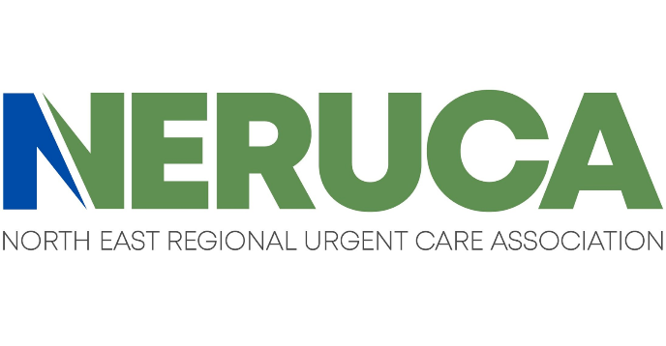
Memo in Support

Proposed Amendments to 105 CMR 125.000, Licensing of Radiologic Technologists
The Northeast Regional Urgent Care Association (NERUCA) was founded in 2013 to represent the interests of urgent care practice and policy in the Northeast region of the United States. NERUCA membership includes participants in Connecticut, Massachusetts, Maine, New Hampshire, New Jersey, New York, Pennsylvania, Rhode Island, and Vermont, representing more than 1800 local practices within the region, including approximately 100 within the Commonwealth of Massachusetts. NERUCA is dedicated to ensuring that urgent care owners, operators, and providers have the resources they need to continue to provide the communities they serve with the care they deserve.
NERUCA strongly supports the proposed Amendments to 105 CMR 125.000, Licensing of Radiologic Technologists, which would create a registration and licensing process for limited-scope radiographers (the “Amendments”). Nationally, there is a severe shortage of radiologic technologists (RTs). The American Society of Radiologic Technologists (ASRT) recently evaluated this shortage in its “White Paper From the 2024 Consensus Committee on the Future of Medical Imaging and Radiation Therapy,” revealing that the vacancy rate for radiographers was 18.1% in 2023, three times higher than what it was in 2021. This is the highest vacancy rate recorded since the ASRT began evaluating staffing metrics in 2003. Urgent care is not immune from this shortage. Worse, the issue is exacerbated in the urgent care setting. Radiologic technologists attend a rigorous two-year academic program in radiologic technology, where they learn everything about radiography, including OR imaging, fluoroscopy, portable imaging, and radiographic contrast administration. Only a fraction of this skill set is typically utilized in the urgent care setting, which magnifies the difficulty urgent care centers face in sourcing and retaining these highly qualified professionals. Given that current state law only allows a radiologic technologist or licensed physician to perform radiography, urgent care in Massachusetts faces an almost insurmountable challenge in continuing to provide this vital service to our patients. When urgent care lacks the ability to perform on-site X-ray imaging, patients must be redirected elsewhere to obtain desired studies, often ending up in hospital emergency departments as an unnecessary visit, contradicting the state's recent successful efforts to combat emergency department overcrowding in eastern Massachusetts. .
NERUCA believes these Amendments offer a common-sense fix to this problem. Across America, thirty-five (35) states currently offer a pathway for limited scope radiography, which allows an individual who, after meeting the requirements outlined by the state (often including clinical/didactic education requirements and passing the ARRT Limited Scope of Practice in Radiography Exam), are only permitted to perform plain radiographs of the anatomical region/s in which they are licensed. The anatomical regions in which other states typically offer limited scope licensure include the chest, extremities, spine/sacrum, skull, and podiatry.
The Amendments create a sensible and achievable pathway to licensure as a limited scope radiographer in Massachusetts. If a limited scope licensure pathway is adopted, it would allow urgent care centers to train new and existing staff to perform the basic X-ray studies regularly sought in the urgent care setting. Allowing for this licensure will preserve patient safety and care quality, improve patient compliance and outcomes, keep overall healthcare costs low, and ensure radiologic technologists can more properly utilize the full scope of their skill set in the areas where that expertise is needed most, as well as create an additional pathway for employment and advancement within the health professions.
NERUCA strongly supports the Amendments and urges their passage.

