INDOOR AIR QUALITY ASSESSMENT

North Elementary School
580 Whetstone Hill Road
Somerset, MA

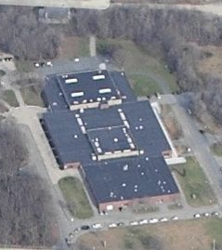

Prepared by:
The Massachusetts Department of Public Health
Bureau of Environmental Health
Indoor Air Quality Program
April 2013

Background/Introduction
At the request of a parent, the Massachusetts Department of Public Health (MDPH), Bureau of Environmental Health (BEH) conducted an indoor air quality (IAQ) assessment at the North Elementary School (NES), located at 580 Whetstone Hill Road, Somerset, Massachusetts. The assessment was coordinated through Mr. Richard Medeiros, Superintendent, Berkeley-Somerset School District.
BEH/IAQ staff previously visited the NES in August 2012 to conduct a mold investigation. A report detailing conditions observed at that time and recommendations for improving the indoor environment was issued (MDPH, 2012). Actions on previous recommendations are included as Appendix A.
On April 4, 2013, Ms. Ruth Alfasso, Environmental Engineer/Inspector, Mr. Cory Holmes, Environmental Analyst/Inspector, and Ms. Sharon Lee, Environmental Analyst/Inspector within BEH’s IAQ Program, visited the NES to assess general IAQ conditions in the building while the heating/mechanical ventilation system was operating and the building was occupied. BEH/IAQ staff were accompanied by Elaine Sabra, NES Principal, Carl Campos, School Buildings and Grounds Supervisor, and Mr. Medeiros.
The NES is a split-level building originally constructed as a middle school in 1973. The NES was converted into an elementary school in the late 1980s. Classrooms in the school are in a pod-style configuration. As mentioned in the previous report, the type of design used to build the NES resembles those more typically found in a low precipitation environment such as the southwest United States. This design - which includes unit ventilator fresh air intakes at or near ground level, large balconies, and exterior doors with little or no shelter from direct rain impingement - can make the building susceptible to water and/or humidity issues, particularly in a coastal municipality like Somerset, Massachusetts. Some areas of the NES are air-conditioned in summer months. The school contains a limited number of openable windows throughout the building.

Methods
Air tests for carbon monoxide, carbon dioxide, temperature and relative humidity were conducted with the TSI, Q-Trak, IAQ Monitor, Model 7565. Air tests for airborne particle matter with a diameter less than 2.5 micrometers were taken with the TSI, DUSTTRAK™ Aerosol Monitor, Model 8520. BEH/IAQ staff also performed visual inspection of building materials for water damage and/or microbial growth. Test results are listed in Table 1.

Results
The NES houses approximately 500 students in grades K through 5 and has a staff of approximately 35. The tests were taken under normal operating conditions. Test results appear in Table 1.

Discussion

Ventilation
It can be seen from Table 1 that carbon dioxide levels were below 800 parts per million (ppm) in 36 of 43 areas, indicating adequate air exchange in the majority of areas at the time of assessment. Mechanical ventilation for most classrooms and common areas is provided by air-handling units (AHUs) located in a penthouse and in mechanical rooms (Picture 1). AHUs draw air in from outside through fresh air intakes. Air is filtered, heated and/or cooled by the AHU before it is distributed to occupied areas via ceiling-mounted air diffusers (Picture 2). Exhaust air is drawn into wall or ceiling-mounted vents and returned back to the AHUs via ductwork (Picture 3). Some of the return vents were partially obstructed by classroom items, which can inhibit airflow.
Fresh air in six classrooms is supplied by unit ventilator (univent) systems (Picture 4). A univent draws air from the outdoors through a fresh air intake located on the exterior wall of the building (Picture 5) and returns air through an air intake located at the base of the unit. Fresh and return air are mixed, filtered, heated and provided to classrooms through an air diffuser located in the top of the unit (Figure 1). Univents have fan settings of “low” and “high”. Several of the univents were found deactivated or obstructed by classroom items at the time of assessment. In order to provide fresh air as designed, univents must be operating and free of obstructions. Classrooms with univents are typically outfitted with a corresponding exhaust vent (usually on an opposite wall) to remove stale air and pollutants. Exhaust vents could not be identified in these rooms. Without adequate supply/exhaust ventilation, excess heat and normally-occurring environmental pollutants can build up leading to indoor air/comfort complaints.
To maximize air exchange, the MDPH recommends that both supply and exhaust ventilation operate continuously during periods of building occupancy. In order to have proper ventilation with a mechanical supply and exhaust system, the systems must be balanced to provide an adequate amount of fresh air to the interior of a room while removing stale air from the room.
Minimum design ventilation rates are mandated by the Massachusetts State Building Code (MSBC). Until 2011, the minimum ventilation rate in Massachusetts was higher for both occupied office spaces and general classrooms, with similar requirements for other occupied spaces (BOCA, 1993). The current version of the MSBC, promulgated in 2011 by the State Board of Building Regulations and Standards (SBBRS), adopted the 2009 International Mechanical Code (IMC) to set minimum ventilation rates. Please note that the MSBC is a minimum standard that is not health-based. At lower rates of cubic feet per minute (cfm) per occupant of fresh air, carbon dioxide levels would be expected to rise significantly. A ventilation rate of 20 cfm per occupant of fresh air provides optimal air exchange resulting in carbon dioxide levels at or below 800 ppm in the indoor environment in each area measured. MDPH recommends that carbon dioxide levels be maintained at 800 ppm or below. This is because most environmental and occupational health scientists involved with research on IAQ and health effects have documented significant increases in indoor air quality complaints and/or health effects when carbon dioxide levels rise above the MDPH guidelines of 800 ppm for schools, office buildings and other occupied spaces (Sundell, J. et al., 2011). The ventilation must be on at all times that the room is occupied. Providing adequate fresh air ventilation with open windows and maintaining the temperature in the comfort range during the cold weather season is impractical. Mechanical ventilation is usually required to provide adequate fresh air ventilation.
Carbon dioxide is not a problem in and of itself. It is used as an indicator of the adequacy of the fresh air ventilation. As carbon dioxide levels rise, it indicates that the ventilating system is malfunctioning or the design occupancy of the room is being exceeded. When this happens, a buildup of common indoor air pollutants can occur, leading to discomfort or health complaints. The Occupational Safety and Health Administration (OSHA) standard for carbon dioxide is 5,000 parts per million parts of air (ppm). Workers may be exposed to this level for 40 hours/week, based on a time-weighted average (OSHA, 1997).
The MDPH uses a guideline of 800 ppm for publicly occupied buildings. A guideline of 600 ppm or less is preferred in schools due to the fact that the majority of occupants are young and considered to be a more sensitive population in the evaluation of environmental health status. Inadequate ventilation and/or elevated temperatures are major causes of complaints such as respiratory, eye, nose and throat irritation, lethargy and headaches. For more information concerning carbon dioxide, consult Appendix B.
Temperature measurements ranged from 68°F to 74°F, which were within or very close to the MDPH recommended comfort range at the time of assessment (Table 1). The MDPH recommends that indoor air temperatures be maintained in a range of 70°F to 78°F in order to provide for the comfort of building occupants. In many cases concerning indoor air quality, fluctuations of temperature in occupied spaces are typically experienced, even in a building with an adequate fresh air supply.
The relative humidity measured in the building ranged from 11 to 21 percent, which was below the MDPH recommended comfort range the day of assessment (Table 1). The MDPH recommends a comfort range of 40 to 60 percent for indoor air relative humidity. Relative humidity levels in the building would be expected to drop during the winter months due to heating. The sensation of dryness and irritation is common in a low relative humidity environment. Low relative humidity is a very common problem during the heating season in the northeast part of the United States.

Microbial/Moisture Concerns
As mentioned previously, the request for an assessment was originally prompted by mold concerns that occurred over the summer of 2012. At the time of the April 4, 2013 visit, BEH/IAQ staff did not observe any mold growth or musty odors in the areas assessed.
A few areas throughout the school had water-damaged ceiling tiles (Table 1; Picture 6). In some cases, ceiling tiles were of the inter-locking type, which are often difficult to replace and may require destruction of the ceiling/substrate or removal of large areas (Picture 7). Water-damaged ceiling tiles can provide a source of mold growth and should be replaced after a water leak is discovered and repaired.
Staff reported an intermittent leak against the interior wall near the reading room. Mr. Campos reported that this leak periodically occurs during heavy, wind-driven rain events and that ceiling tiles are changed after the leaks are reported. The leak is attributed to water intrusion through an air intake for an AHU (Picture 8). Water enters through the fresh air intake and then drains against the interior cement block wall, where it pools on the floor, and ultimately into the classroom area through breaches around the supply ductwork (Picture 9). Please note, missing flashing was observed around ductwork, likely resulting in the reported leaks (Picture 10).
The cabinets under sinks were examined and many had evidence of past water leakage or condensation (Picture 11). Cabinets were also found to contain items, including porous materials such as paper or cardboard (Picture 12). The area under sinks is often a moist environment. Porous items stored there are subject to water damage and/or mold growth. In addition, the storage of large amounts of materials there can prevent detection of leaks which can damage the wood of the cabinets themselves.
The US Environmental Protection Agency (US EPA) and the American Conference of Governmental Industrial Hygienists (ACGIH) recommend that porous materials be dried with fans and heating within 24 to 48 hours of becoming wet (US EPA, 2001; ACGIH, 1989). If not dried within this time frame, mold growth may occur. Once mold has colonized porous materials, they are difficult to clean and should be removed/discarded.
A number of classrooms had plants. Plants can be a source of pollen and mold, which can serve as respiratory irritants for some sensitive individuals. Plants should be properly maintained and equipped with drip pans to prevent water damage to porous building materials. Plants should also be located away from ventilation sources (e.g., univent air diffusers) to prevent the aerosolization of dirt, pollen or mold. An aquarium with standing water was observed in classroom K 2 (Picture 13). Aquariums should be properly maintained to prevent microbial/algae growth, which can emit unpleasant odors.

Other Indoor Air Evaluations
Indoor air quality can be negatively influenced by the presence of respiratory irritants, such as products of combustion. The process of combustion produces a number of pollutants. Common combustion emissions include carbon monoxide, carbon dioxide, water vapor, and smoke (fine airborne particle material). Of these materials, exposure to carbon monoxide and particulate matter with a diameter of 2.5 micrometers (μm) or less (PM2.5) can produce immediate, acute health effects upon exposure. To determine whether combustion products were present in the indoor environment, BEH/IAQ staff obtained measurements for carbon monoxide and PM2.5.

Carbon Monoxide
Carbon monoxide is a by-product of incomplete combustion of organic matter (e.g., gasoline, wood and tobacco). Exposure to carbon monoxide can produce immediate and acute health affects. Several air quality standards have been established to address carbon monoxide and prevent symptoms from exposure to these substances. The MDPH established a corrective action level concerning carbon monoxide in ice skating rinks that use fossil-fueled ice resurfacing equipment. If an operator of an indoor ice rink measures a carbon monoxide level over 30 ppm, taken 20 minutes after resurfacing within a rink, that operator must take actions to reduce carbon monoxide levels (MDPH, 1997).
The American Society of Heating Refrigeration and Air-Conditioning Engineers (ASHRAE) has adopted the National Ambient Air Quality Standards (NAAQS) as one set of criteria for assessing indoor air quality and monitoring of fresh air introduced by HVAC systems (ASHRAE, 1989). The NAAQS are standards established by the US EPA to protect the public health from six criteria pollutants, including carbon monoxide and particulate matter (US EPA, 2006). As recommended by ASHRAE, pollutant levels of fresh air introduced to a building should not exceed the NAAQS levels (ASHRAE, 1989). The NAAQS were adopted by reference in the Building Officials & Code Administrators (BOCA) National Mechanical Code of 1993 (BOCA, 1993), which is now an HVAC standard included in the Massachusetts State Building Code (SBBRS, 2011). According to the NAAQS, carbon monoxide levels in outdoor air should not exceed 9 ppm in an eight-hour average (US EPA, 2006).
Carbon monoxide should not be present in a typical, indoor environment. If it is present, indoor carbon monoxide levels should be less than or equal to outdoor levels. Outdoor carbon monoxide concentrations were non-detect (ND) at the time of assessment (Tables 1). No measurable levels of carbon monoxide were detected inside the building during the assessment (Tables 1).

Particulate Matter
The US EPA has established NAAQS limits for exposure to particulate matter. Particulate matter includes airborne solids that can be irritating to the eyes, nose and throat. The NAAQS originally established exposure limits to PM with a diameter of 10 μm or less (PM10). In 1997, US EPA established a more protective standard for fine airborne particulate matter with a diameter of 2.5 μm or less (PM2.5). The NAAQS has subsequently been revised, and PM2.5 levels were reduced. This more stringent PM2.5 standard requires outdoor air particle levels be maintained below 35 μg/m³ over a 24-hour average (US EPA, 2006). Although both the ASHRAE standard and BOCA Code adopted the PM10 standard for evaluating air quality, MDPH uses the more protective PM2.5 standard for evaluating airborne PM concentrations in the indoor environment.
Outdoor PM2.5 concentrations the day of the assessment were measured at 5 μg/m³. PM2.5 levels measured inside the building ranged from 2 to 12 μg/m³ (Table 1). Both indoor and outdoor PM2.5 levels were below the NAAQS PM2.5 level of 35 μg/m³. Frequently, indoor air levels of particulates (including PM2.5) can be at higher levels than those measured outdoors. A number of mechanical devices and/or activities that occur indoors can generate particulate during normal operations. Sources of indoor airborne particulates may include but are not limited to particles generated during the operation of fan belts in the HVAC system, use of stoves and/or microwave ovens in kitchen areas; use of photocopiers, fax machines and computer printing devices; operation of an ordinary vacuum cleaner and heavy foot traffic indoors.

Volatile Organic Compounds
Indoor air concentrations can be greatly impacted by the use of products containing volatile organic compounds (VOCs). VOCs are carbon-containing substances that have the ability to evaporate at room temperature. Frequently, exposure to low levels of total VOCs (TVOCs) may produce eye, nose, throat and/or respiratory irritation in some sensitive individuals. For example, chemicals evaporating from a paint can stored at room temperature would most likely contain VOCs. In an effort to identify materials that can potentially increase VOC concentrations, BEH/IAQ staff examined classrooms for products that may contain these respiratory irritants.
Cleaning products and air fresheners were found in several rooms (Picture 14; Table 1). Cleaning products contain chemicals that can be irritating to the eyes, nose and throat of sensitive individuals. These products should be properly labeled and stored in an area inaccessible to children. Additionally, an MSDS should be available at a central location for each product in the event of an emergency. Consideration should be given to providing teaching staff with school issued cleaning products and supplies to ensure that MSDS information is available for all products used at the school. Air fresheners also contain VOCs that can be irritating to the eyes, nose and throat of sensitive individuals. Many air fresheners contain 1,4-dichlorobenzene, a VOC which may cause reductions in lung function (NIH, 2006). Deodorant materials do not remove materials causing odors, but rather mask odors which may be present in the area.
Classrooms contained dry erase boards and dry erase board markers. Materials such as permanent markers, dry erase markers and dry erase board cleaners may contain VOCs, such as methyl isobutyl ketone, n-butyl acetate and butyl-cellusolve (Sanford, 1999), which can be irritating to the eyes, nose and throat.
The copy room contains several photocopiers. VOCs and ozone can be produced by photocopiers, particularly if the equipment is older and in frequent use. Ozone is a respiratory irritant (Schmidt Etkin, 1992). Although the room contained an exhaust vent, it was not operating at the time of assessment. This vent should be activated and/or repaired if needed to help reduce excess heat and odors.

Other Conditions
Other conditions that can affect indoor air quality were observed during the assessment. In many classrooms, accumulated items were observed on floors, windowsills, tabletops, counters, bookcases and desks. The large number of items stored in classrooms provides a source for dusts to accumulate. These items (e.g., papers, folders, boxes) make it difficult for custodial staff to clean. Items should be relocated and/or cleaned periodically to avoid excessive dust build up. A number of personal fans in classrooms and common areas were observed to have accumulated dust/debris. Re-activated fans can aerosolize dust accumulated on fan blades/housing.
Restrooms are equipped with mechanical exhaust vents. A number of the restroom exhaust vents were not drawing air at the time of the assessment, which can indicate that they were deactivated or not functional. Exhaust ventilation is necessary in restrooms to remove excess moisture and to prevent odors from penetrating into adjacent areas.
Finally, carpeting in some areas of the building (e.g., auditorium) appeared to be past its useful lifespan, with some areas observed to be damaged, worn or soiled. Since the average lifespan of a carpet is approximately eleven years (Bishop, 2002), MDPH recommends removal/replacement of carpeting as funds become available. As discussed in Appendix A, measures have been taken to replace carpet in hallways. School officials reported that the school plans to phase out carpeting in the school over the next several years.

Conclusions/Recommendations
In view of the findings at the time of the visit, the following recommendations are provided:
- Continue to implement recommendations in Appendix A which have not yet been addressed or need further attention.
- Continue to operate all ventilation systems throughout the building (e.g., gym, cafeteria, classrooms) continuously during periods of occupancy independent of thermostat control to maximize air exchange.
- Adjust the percentage of fresh air supplied to and/or exhausted by the HVAC system to improve air exchange.
- Remove all blockages from univents (top and front) to ensure adequate airflow.
- Work with HVAC engineer/facilities department to determine if classrooms with univents are equipped with exhaust vents. If not, examine the feasibility of installing them to facilitate air exchange.
- Close classroom doors to maximize exhaust capabilities and air exchange as designed.
- To increase fresh airflow/exchange operate univents in the fan “high” mode.
- Ensure exhaust vents and the interiors of univent cabinets are thoroughly cleaned of dirt, dust and loose debris on a regular basis (e.g., during regular filter changes).
- For buildings in New England, periods of low relative humidity during the winter are often unavoidable. Therefore, scrupulous cleaning practices should be adopted to minimize common indoor air contaminants whose irritant effects can be enhanced when the relative humidity is low. To control dusts, use of a vacuum cleaner equipped with a HEPA filter in conjunction with wet wiping of all surfaces is recommended. Drinking water during the day can help ease some symptoms associated with a dry environment (throat and sinus irritation).
- Ensure all roof/plumbing leaks are repaired and replace water-damaged ceiling tiles. Examine the area above and around water-damaged areas for mold growth. Disinfect areas with an appropriate antimicrobial as needed.
- Replace missing flashing observed (Picture 10). Consider supplementing with additional sealing products (i.e. silicone) as an additional measure to prevent water leakage into occupant areas.
- Contact HVAC/building engineer/roofing contractor to determine best methods to eliminate/reduce water penetration through intake vents on roof.
- Ensure plants are equipped with non-porous drip pans. Avoid over-watering and examine drip pans periodically for mold growth. Disinfect with an appropriate antimicrobial where necessary.
- Clean and maintain aquariums and terrariums to prevent mold growth and associated odors.
- Reactivate/repair exhaust vent in copy room to help reduce excess heat and odors.
- Restore exhaust ventilation to restrooms to remove excess moisture and odors. Ensure that exhaust vents are ducted to the outside of the building.
- Clean accumulated dust and debris periodically from the blades of personal fans.
- Relocate or consider reducing the amount of materials stored in classrooms to allow for more thorough cleaning of classrooms. Clean items regularly with a wet cloth or sponge to prevent excessive dust build-up. Consider storing classroom items in plastic totes/cases that can be easily cleaned.
- Continue with plans to phase-out carpeting in school as funds become available.
- Until carpeting can be replaced with a non-porous surface, continue to clean carpeting annually or semi-annually in soiled high traffic areas as per the recommendations of the Institute of Inspection, Cleaning and Restoration Certification (IICRC). Copies of the IICRC fact sheet can be downloaded at: http://1.cleancareseminars.net/?page_id=185 (IICRC, 2005).
- Consider adopting the US EPA (2000) document, “Tools for Schools”, as an instrument for maintaining a good indoor air quality environment in the building. This document is available at: http://www.epa.gov/iaq/schools/index.html.
- Refer to resource manual and other related indoor air quality documents located on the MDPH’s website for further building-wide evaluations and advice on maintaining public buildings. These documents are available at: http://mass.gov/dph/iaq.

References
ACGIH. 1989. Guidelines for the Assessment of Bioaerosols in the Indoor Environment. American Conference of Governmental Industrial Hygienists, Cincinnati, OH.
ASHRAE. 1989. Ventilation for Acceptable Indoor Air Quality. American Society of Heating, Refrigeration and Air Conditioning Engineers. ANSI/ASHRAE 62-1989.
Bishop. 2002. Bishop, J. & Institute of Inspection, Cleaning and Restoration Certification. A Life Cycle Cost Analysis for Floor Coverings in School Facilities.
BOCA. 1993. The BOCA National Mechanical Code/1993. 8th ed. Building Officials and Code Administrators International, Inc., Country Club Hill, IL.
IICRC. 2005. Carpet Cleaning FAQ 4 Institute of Inspection, Cleaning and Restoration Certification. Institute of Inspection Cleaning and Restoration, Vancouver, WA.
MDPH. 1997. Requirements to Maintain Air Quality in Indoor Skating Rinks (State Sanitary Code, Chapter XI). 105 CMR 675.000. Massachusetts Department of Public Health, Boston, MA.
MDPH. 2013. Indoor Air Quality Assessment. Mold Investigation. North Elementary School, Somerset, MA. Massachusetts Department of Public Health, Bureau of Environmental Health, Boston, MA. August 2013.
NIH. 2006. Chemical in Many Air Fresheners May Reduce Lung Function. NIH News. National Institute of Health. July 27, 2006. http://www.nih.gov/news/pr/jul2006/niehs-27.htm
OSHA. 1997. Limits for Air Contaminants. Occupational Safety and Health Administration. Code of Federal Regulations. 29 C.F.R 1910.1000 Table Z-1-A.
Sanford. 1999. Material Safety Data Sheet (MSDS No: 198-17). Expo Dry Erase Markers Bullet, Chisel, and Ultra Fine Tip. Sanford Corporation. Bellwood, IL.
SBBRS. 2011. Mechanical Ventilation. State Board of Building Regulations and Standards. Code of Massachusetts Regulations, 8th edition. 780 CMR 1209.0
Schmidt Etkin, D. 1992. Office Furnishings/Equipment & IAQ Health Impacts, Prevention & Mitigation. Cutter Information Corporation, Indoor Air Quality Update, Arlington, MA.
Sundell, J., H. Levin, W. W. Nazaroff, W. S. Cain, W. J. Fisk, D. T. Grimsrud, F. Gyntelberg, Y. Li, A. K. Persily, A. C. Pickering, J. M. Samet, J. D. Spengler, S. T. Taylor, and C. J. Weschler. 2011. Ventilation rates and health: multidisciplinary review of the scientific literature. Indoor Air, Volume 21: pp 191–204.
US EPA. 2000. Tools for Schools. Office of Air and Radiation, Office of Radiation and Indoor Air, Indoor Environments Division (6609J). EPA 402-K-95-001, Second Edition. http://www.epa.gov/iaq/schools/tools4s2.html
US EPA. 2001. Mold Remediation in Schools and Commercial Buildings. US Environmental Protection Agency, Office of Air and Radiation, Indoor Environments Division, Washington, D.C. EPA 402-K-01-001. March 2001.
US EPA. 2006. National Ambient Air Quality Standards (NAAQS). US Environmental Protection Agency, Office of Air Quality Planning and Standards, Washington, DC. http://www.epa.gov/air/criteria.html.
Picture 1

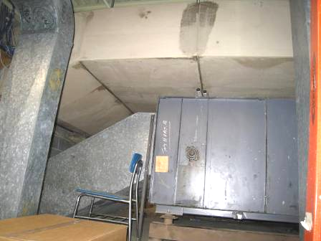

Air handling unit in mechanical room

Picture 2

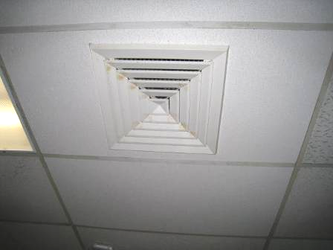

Ceiling-mounted supply diffuser

Picture 3

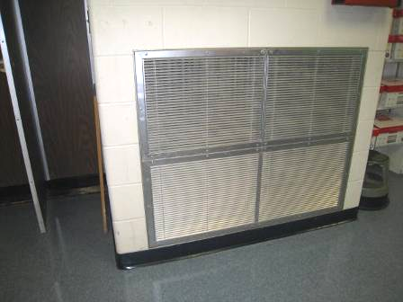

Wall-mounted exhaust/return vent

Picture 4

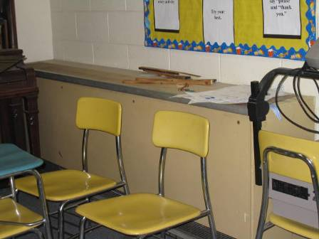

Classroom unit ventilator (univent)

Picture 5

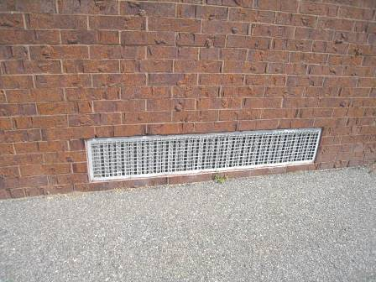

Univent fresh air intake

Picture 6

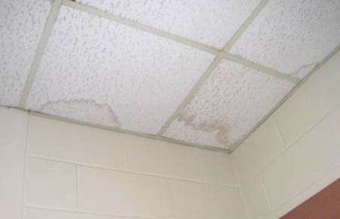

Water-damaged ceiling tiles

Picture 7

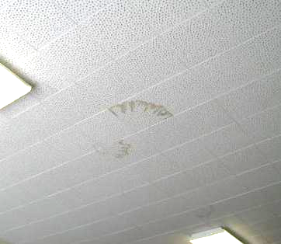

Water-damaged interlocking ceiling tiles

Picture 8

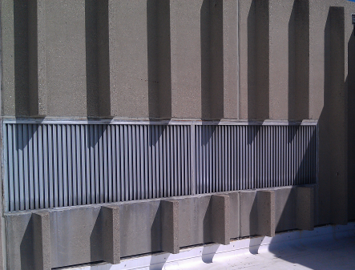

AHU fresh air intake

Picture 9

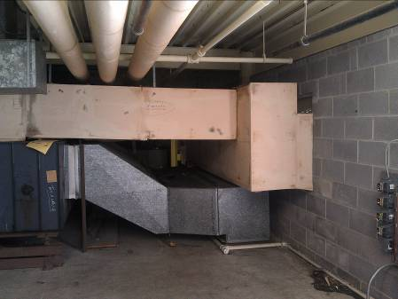

Interior wall where water drains and collects onto floor

Picture 10

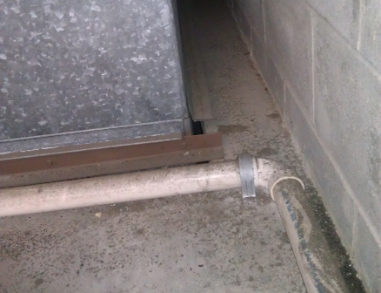

Missing flashing around ductwork, which results in leakage to classroom

Picture 11

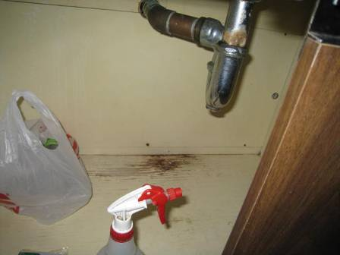

Water-damaged wood under sink

Picture 12

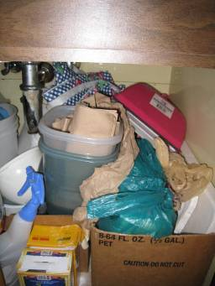

Porous items stored under sink

Picture 13

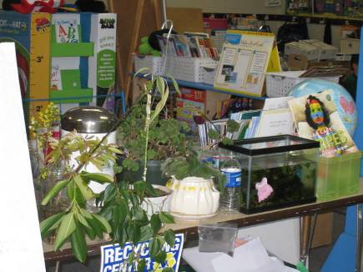

Aquarium in classroom

Picture 14

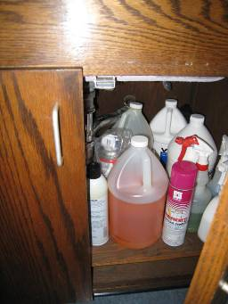

Cleaning products under sink
Location | Carbon  Dioxide  (*ppm) | Carbon Monoxide  (*ppm) | Temp  (°F) | Relative  Humidity  (%) | PM2.5  (ug/m³) | Occupants  in Room | Windows  Openable | Ventilation |  |  | Remarks
 |  |  |  |  |  |  |  | Intake | Exhaust |  | Remarks
Background | 394 | ND | 55 | 16 | 5 |  |  |  |  |  | Sunny, very light breeze
Art | 908 | ND | 70 | 18 | 6 | 21 | N | Y |  | Y
Music | 636 | ND | 69 | 16 | 7 | 1 | N | Y |  | Y | 2 UVs-off, 6 WD CT-interlocking, DO, items on UVs, wall-to-wall carpet
K 5 | 1153 | ND | 70 | 21 | 10 | 19 | N | Y |  |  | Exhaust could not be identified, AC, UV-dust/debris, items in front of UV return vent, DO
K 4 | 876 | ND | 72 | 17 | 11 | 21 | N | Y |  |  | Exhaust could not be identified
K 3 | 612 | ND | 73 | 13 | 7 | 0 | N | Y |  | Y | AC, restroom exhaust-no draw
K 2 | 659 | ND | 74 | 14 | 6 | 18 | N | Y |  | Y | Plants, aquarium-standing water, restroom exhaust-no draw, DO
1 M | 861 | ND | 68 | 20 | 4 | 19 | N | Y |  | Y | PF, CP
1 H | 781 | ND | 71 | 15 | 5 | 21 | N | Y |  | Y
1 K | 822 | ND | 70 | 19 | 5 | 17 | N | Y |  | Y | CP, DEM odors
2 T | 767 | ND | 71 | 15 | 6 | 21 | N | Y |  | Y
2 R | 753 | ND | 71 | 14 | 6 | 23 | N | Y |  | Y
2 S | 768 | ND | 71 | 14 | 5 | 24 | N | Y |  | Y
2 D | 804 | ND | 71 | 15 | 8 | 18 | N | Y |  | Y | CP
3 S | 668 | ND | 72 | 14 | 8 | 3 | N | Y |  | Y
3 A | 635 | ND | 72 | 11 | 7 | 20 | N | Y |  | Y | Exhaust partially obstructed
3 B | 654 | ND | 72 | 13 | 8 | 22 | N | Y |  | Y | PF, 2 WD CTs
3 C | 686 | ND | 72 | 13 | 10 | 20 | Y | Y |  | Y | CP, PF
3 D | 630 | ND | 72 | 12 | 6 | 19 | N | Y |  | Y
4 V | 703 | ND | 71 | 14 | 3 | 20 | N | Y |  | Y
4 M | 636 | ND | 70 | 13 | 3 | 17 | N | Y |  | Y
4 S | 680 | ND | 69 | 14 | 4 | 23 | N | Y |  | Y
4 R | 644 | ND | 69 | 14 | 5 | 3 | N | Y |  | Y
5 A | 669 | ND | 71 | 14 | 8 | 21 | N | Y |  | Y | Emergency shower drain partially sealed
5 S | 654 | ND | 71 | 14 | 8 | 20 | N | Y |  | Y
5 F | 678 | ND | 71 | 14 | 8 | 15 | N | Y |  | Y | PF
5 M | 654 | ND | 70 | 14 | 8 | 17 | N | Y |  | Y | PF, CP
Reading room | 607 | ND | 69 | 14 | 5 | 2 | N | Y |  | Y | TB, PF-dusty, abandoned sink
Gym | 496 | ND | 68 | 13 | 5 | 0 | N | Y |  | Y | Locker rooms-used as storage
Lab (Rogonesi) | 635 | ND | 69 | 14 | 7 | 0 | N | Y |  | Y
Transition/Resource Room | 507 | ND | 70 | 14 | 3 | 0 | Y | Y |  | Y | Exhaust behind door-weak, TB, CD, DO, perfume
Nook Office | 919 | ND | 71 | 17 | 8 | 0 | N | Y |  | Y | DO, exhaust off
Health Waiting Room | 710 | ND | 71 | 15 | 7 | 0 | N | Y |  | N | DO
Nurse’s Office | 605 | ND | 72 | 14 | 5 | 2 | N | Y |  | Y | PF, DO
Nurse’s Exam Room (Left) | 597 | ND | 73 | 14 | 2 | 0 | N | Y |  | Y | DO
Nurse’s Exam Room (Large) | 559 | ND | 73 | 14 | 4 | 5 | Y | Y |  | Y | DO
Cafeteria | 555 | ND | 71 | 17 | 7 | 0 | N | Y |  | Y
Auditorium | 673 | ND | 71 | 12 | 5 | 0 | N | Y |  | Y | Original carpet (1970’s), PFs-dusty
Lab | 723 | ND | 72 | 14 | 8 | 9 | N | Y |  | Y | CP
Library | 655 | ND | 71 | 14 | 8 | 30 | N | Y |  | Y
Library Small Group | 701 | ND | 72 | 14 | 7 | 10 | N | Y |  | Y | Exhaust off, PF
Copy Room | 602 | ND | 73 | 13 | 10 | 0 | N | Y |  | Y | Exhaust off, DO, PCs, soda machine
Staff Room | 658 | ND | 72 | 14 | 12 | 1 | N | Y |  | Y | Exhaust off, 3 WD CTs, food uncovered food, toaster, microwave, fridge
Vasquez/DiBiasio | 724 | ND | 72 | 14 | 10 | 0 | N | N |  | Y | CP, open to library

Actions on MDPH Recommendations at
North Elementary School, Somerset, MA

The following is a status report of action(s) taken on MDPH recommendations made in the August 2012 MDPH report (in bold) based on reports from school officials, maintenance staff, documents, photographs and MDPH staff observations taken during the April 2013 visit.

- Continue with plans to replace the carpeting in the kindergarten hallway and classrooms since it is likely moistened by condensation and past its service life.
Action: The carpet in the kindergarten hallway had been removed, and the hallway was tiled at the time of the April 2013 assessment. School officials reportedly plan on replacing carpet in the enclosed kindergarten classrooms over the 2013 summer break. Carpeting in other areas of the school will be gradually removed and replaced as funds become available.
- Seal all sink and floor drains in the area bounded by corridors A, B, C and D. Disconnect water service to the science sinks to prevent accidental flooding.
- Action: Duct tape was used to seal all the sink drains and floor drains in the former science area. Water service to one lab island sink was found to be on, and some water was pooled in the basin. Water service to all other unused lab sinks was disconnected. School maintenance staff reportedly plan to remove and/or cap plumbing to unused sinks, including complete removal of the lab islands and removal of the unnecessary safety showers fixtures. Tape used to seal some of the floor drains had been damaged from foot traffic or contact with students. Until a more permanent solution to sealing floor drains can be applied, the tape should be monitored regularly for integrity and replaced as necessary.
- Relocate the pottery kiln to the former shop area where existing exhaust ventilation systems could be used to vent pollutants to the outdoors.
- Action: The kiln has been moved to a room in the former shop area. This room previously contained a spray booth, so it equipped with operable, dedicated exhaust ventilation and a passive wall vent to allow proper airflow for the exhaust. Students do not have access to this area. Some items in the rooms, such as paint cans, should be moved away from the kiln and other heat sources.
- Keep exterior doors closed to prevent hot, moist air penetration into the building. Ensure tightness of doors by monitoring for light penetration and drafts around doorframes.
- Action: Exterior doors were found to be closed during the reassessment. Most door seals/sweeps were found to be intact; however, gaps were visible beneath the exterior hallway door in the kindergarten wing.
- Replace tennis balls with latex-free tennis balls or glides.
- Action: Most tennis balls had been removed from chair/table legs at the time of the April 2013 visit. A few remaining tennis balls were found in two areas. BEH staff notified school staff of remaining tennis balls, which were promptly removed. School officials also reported that tennis balls have been removed from chair/table legs in all other schools in the district based on this recommendation.

