MOLD Assessment

North Elementary School
580 Whetstone Hill Road
Somerset, Massachusetts

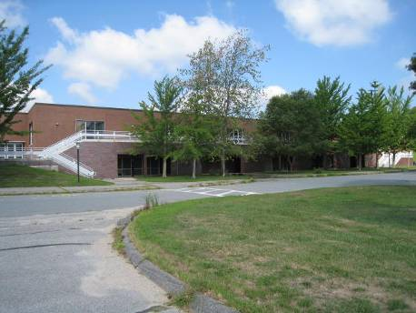

Prepared by:
Massachusetts Department of Public Health
Bureau of Environmental Health
Indoor Air Quality Program
August 2012

Background/Introduction
At the request of Mr. Richard Medeiros, Superintendent, Berkeley-Somerset School District, the Massachusetts Department of Public Health (MDPH), Bureau of Environmental Health (BEH) conducted an indoor air quality (IAQ) assessment at the North Elementary School (NES), located at 580 Whetstone Hill Road, Somerset, Massachusetts. The request was prompted by concerns related to mold. On August 9, 2012, a visit was made to the NES by Michael Feeney, Director of BEH’s IAQ program, and Ruth Alfasso, Environmental Analyst/Inspector in the IAQ Program. BEH staff were accompanied by Mr. Medeiros and Carl Campos, School Buildings and Grounds Supervisor.
BEH staff conducted a limited assessment of the building related to identification of sources of water vapor/moisture and respiratory irritants. The overall function of the heating, ventilating, and air-conditioning (HVAC) system was not assessed during this visit because the building was largely unoccupied.
The NES is a split-level building with pod-style classrooms, which had been originally constructed as a middle school in 1973. The NES was converted into an elementary school in the late 1980s. The type of design used to build the NES resembles those more typically found in a low precipitation environment such as the southwest United States. This design, which includes unit ventilator fresh air intakes at or near ground level (Pictures 1 and 2), large balconies and exterior doors with little or no shelter from direct rain impingement (Picture 3), can make the building susceptible to water and/or humidity issues, particularly in a coastal municipality like Somerset, Massachusetts. The NES is partially air-conditioned in summer months. Windows are openable throughout the building.

Methods
Air tests for temperature and relative humidity were conducted with the TSI, Q-Trak, IAQ Monitor, Model 7565. Surface temperatures of floors were measured with a ThermoTrace infrared thermometer. BEH staff also performed a visual inspection of building materials for water damage and/or microbial growth.

Results
The NES houses approximately 500 students in grades K through 5 and has a staff of approximately 35. The tests were taken during summer break with the building partially occupied with adults but no children. Test results appear in Table 1.

Discussion

Microbial/Moisture Concerns
BEH staff conducted a visual inspection of the building and found no evidence of water damage attributable to roof or window leaks (such as stained ceiling tiles or damaged wall plaster). However, the ceiling tile system throughout the main floor was found to have significantly bowing tiles (Pictures 4 and 5). While this condition does not represent mold contamination, it suggests that there are chronic levels of water vapor/high relative humidity in the building. On the day of the assessment, the outdoor relative humidity was measured at 68 percent (Table 1). Thirty-four of the forty-one locations tested had relative humidity higher than the outdoor relative humidity (by one to eleven percent). In addition, thirty-two of these areas had a relative humidity of 70% or greater (Table 1). According to the American Society of Heating Refrigeration and Air-Conditioning Engineers (ASHARE), sustained relative humidity indoors of 70 percent or greater can wet building components, which will then result in fungal growth (ASHRAE, 1989). The indoor relative humidity measurements indicate that a significant source of water vapor exists within the NES.
The most likely source of the high relative humidity noted in the building is in the center of the main floor bounded by Corridors A, B, C and D (Figure 1). This area originally served as a science area, and it contains multiple floor drains (Picture 6) and sinks (Picture 7), which are no longer in use since the conversion of the NES from a middle to an elementary school. All of the drains in these areas will have traps to prevent the backflow of gases (including methane) and water vapor from the sewer system back into the building; these traps rely on the regular introduction of water into the drain to maintain a seal. If the sinks are not in use, the traps will dry out and water vapor and gases from the drainage system can be drawn into the building and become a source of water vapor to the interior. Since the ceiling tiles in areas immediately adjacent to the former science area are significantly bowed, the drainage system appears to be a significant water vapor source.
Doors in the building were found propped open. Outdoor humidity can readily enter the NES through open doors to add to the overall indoor water vapor load. Door should be closed as much as feasible during hot, humid weather.
Of note was the condition of flooring in the hallway of the kindergarten classrooms as well as around exterior doors of classrooms. As noted previously, the exterior doors in these areas are not sheltered and appear to have had water penetration through/around the door thresholds (Picture 8). The carpeting in the hallway is water-stained, likely via rain penetration through the door. As reported by school officials, the carpeting was installed in 1997. The Institute of Inspection, Cleaning and Restoration Certification (IICRC), recommends that carpeting be cleaned annually (or semi-annually in soiled high traffic areas) (IICRC, 2005). Since the average service time of carpeting in a school environment is approximately eleven years (Bishop, 2002), consideration should be given to planning for the installation of new flooring as funds become available.
BEH staff were informed that the carpeting contained antimicrobial materials. While these treatments may limit the growth of microbes in the carpet, the effectiveness and potential side effects of these treatments, particularly after significant water damage, is not optimal.
Temperatures in the building were measured in a range of 73°F to 83°F (Table 1). The dew point was also measured in the building. Dew point is another way of representing humidity; the dew point is the temperature at which the water vapor in the air will start to condense. If a surface in contact with the air has a temperature at or below the dew point, it will collected condensed moisture and become wet. Dew points in the building ranged from 56°F to 71°F (Table 1), with the lowest values measured in the air-conditioned portions of the building.
BEH staff also conducted surface temperature measurement of floors throughout the building in order to determine whether the floors would be prone to generating condensation. If the floors of the building are properly insulated, the temperature of the interior side of floors would be expected to be close to the indoor temperature. Floor temperatures were measured to be in a range of 69° F to 83° F (Table 1), often lower than the corresponding air temperature. Some locations were at or very close to the corresponding dew point for each area (Table 1). The areas with the lower floor temperatures were those that were located directly on slab. Under slightly altered conditions, the areas with low floor temperature would be prone to generating condensation.
It is also likely that the exterior doors are not energy efficient and can serve as a thermal bridge. Where a thermal bridge exists, condensation is likely to form on the warm air side of the cold object which can moisten materials, such as floors. In hot humid weather, the lowering of temperature of the slab/exterior brickwork would likely lead to the accumulation of condensation along the interior side at the base of the exterior wall.
The US Environmental Protection Agency (US EPA) and the American Conference of Governmental Industrial Hygienists (ACGIH) recommends that porous materials be dried with fans and heating within 24 to 48 hours of becoming wet (US EPA, 2001; ACGIH, 1989). If porous materials are not dried within this time frame, mold growth may occur. Water-damaged porous materials cannot be adequately cleaned to remove mold growth. The application of a mildewcide to moldy porous materials is not recommended.

Other IAQ Evaluations
BEH staff observed two other potential sources of respiratory irritants. In the art area is an unvented pottery kiln (Picture 9). Pottery kilns can be a significant source of water vapor, particulate and other related pollutants when operating. In addition, a pottery kiln is a source of waste heat that can present a safety/fire hazard. This type of equipment should be vented directly outdoors and kept away from students.
BEH staff observed tennis balls which had been sliced open and placed on chair legs, presumably to reduce noise (Picture 10). Tennis balls are made of a number of materials that are a source of respiratory irritants. Constant wearing of tennis balls can emit fibers and cause VOCs to off-gas. Tennis balls are made with a natural rubber latex bladder, which becomes abraded when used as a chair leg pad. Use of tennis balls in this manner may introduce latex dust into the school environment. Some individuals are highly allergic to latex (e.g., spina bifida patients) (SBAA, 2001). It is recommended that the use of materials containing latex be limited in buildings to reduce the likelihood of symptoms in sensitive individuals (NIOSH, 1997).

Conclusions/Recommendations
As noted previously, this assessment was limited to sources of moisture/water vapor and respiratory irritants because the building was not at typical occupancy. Upon request, the BEH IAQ Program can return to the building when it is fully occupied and the heating system is activated in order to conduct a full IAQ investigation, most likely in the fall. In view of the findings at the time of the visit, the following recommendations are provided:
- Continue with plans to replace the carpeting in the kindergarten hallway and classrooms since it is likely moistened by condensation and past its service life.
- Seal all sink and floor drains in the area bounded by corridors A, B, C and D. Disconnect water service to the science sinks to prevent accidental flooding.
- Relocate the pottery kiln to the former shop area where existing exhaust ventilation systems could be used to vent pollutants to the outdoors.
- Keep exterior doors closed to prevent hot, moist air penetration into the building. Ensure tightness of doors by monitoring for light penetration and drafts around doorframes.
- Replace tennis balls with latex-free tennis balls or glides.
- Consider adopting the US EPA (2000) document, “Tools for Schools”, to maintain a good indoor air quality environment in the building. This document can be downloaded from the Internet at http://www.epa.gov/iaq/schools/index.html.
- Refer to resource manuals and other related indoor air quality documents for further building-wide evaluations and advice on maintaining public buildings. Copies of these materials are located on the MDPH’s website: http://mass.gov/dph/iaq.

References
ASHRAE. 1989. ASHRAE Standard: Ventilation for Acceptable Indoor Air Quality. Sections 5.11, 5.12. American Society of Heating, Refrigerating and Air-Conditioning Engineers, Inc. Atlanta, GA.
ACGIH. 1989. Guidelines for the Assessment of Bioaerosols in the Indoor Environment. American Conference of Governmental Industrial Hygienists, Cincinnati, OH.
Bishop, J. & Institute of Inspection, Cleaning and Restoration Certification. 2002. A Life Cycle Cost Analysis for Floor Coverings in School Facilities.
IICRC. 2000. IICRC S001. Reference Guideline for Professional On-Location Cleaning of Textile Floor Covering Materials. Institute of Inspection, Cleaning and Restoration Certification. Institute of Inspection Cleaning and Restoration, Vancouver, WA.
IICRC. 2005. Carpet Cleaning FAQ 4 Institute of Inspection, Cleaning and Restoration Certification. Institute of Inspection Cleaning and Restoration, Vancouver, WA.
NIOSH. 1997. NIOSH Alert Preventing Allergic Reactions to Natural Rubber latex in the Workplace. National Institute for Occupational Safety and Health, Atlanta, GA.
SBAA. 2001. Latex In the Home And Community Updated Spring 2001. Spina Bifida Association of America, Washington, DC.
US EPA. 2000. Tools for Schools. Office of Air and Radiation, Office of Radiation and Indoor Air, Indoor Environments Division (6609J). EPA 402-K-95-001, Second Edition. http://www.epa.gov/iaq/schools/tools4s2.html
US EPA. 2001. “Mold Remediation in Schools and Commercial Buildings”. Office of Air and Radiation, Indoor Environments Division, Washington, DC. EPA 402-K-01-001. March 2001. Available at: http://www.epa.gov/iaq/molds/mold_remediation.html
Picture 1

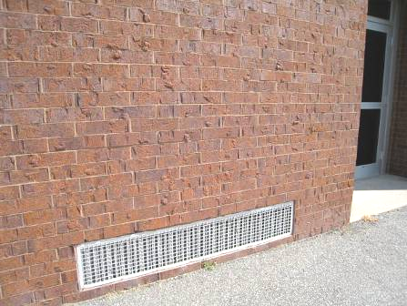

Univent air intake at ground level

Picture 2

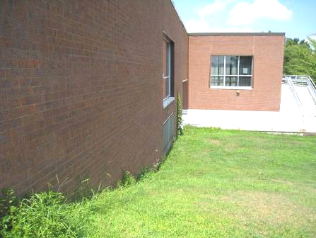

Univent air intake at ground level (arrow)

Picture 3

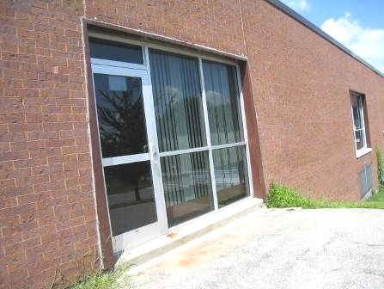

Exterior door with minimal rain protection

Picture 4

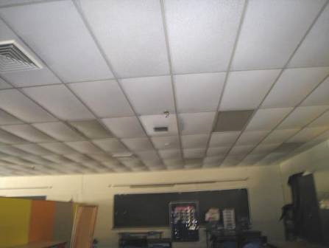

Ceiling in 5th grade area (old science area) showing bowed tiles

Picture 5

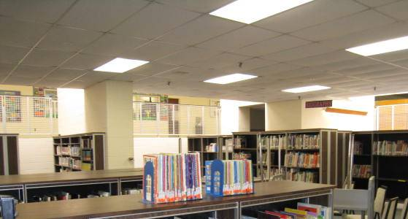

Bowed ceiling tiles in the library

Picture 6

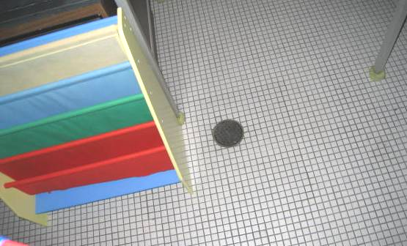

Floor drain in the 5th Grade area (old science area)

Picture 7

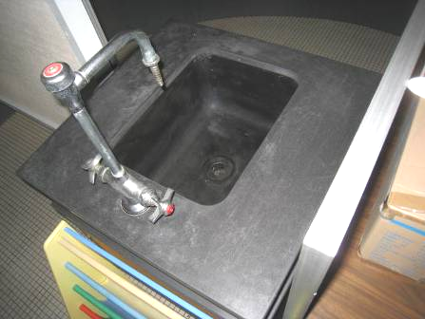

Unused sink in 5th grade area (old science area)

Picture 8

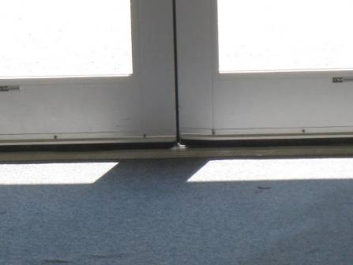

Door threshold at the end of the kindergarten wing with water-damaged carpeting

Picture 9

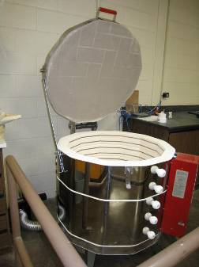

Pottery kiln in art area

Picture 10

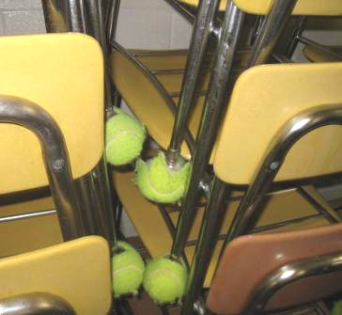

Tennis balls on chair legs
Location/Room | Dew Point (°F) | Temp  (°F) | Relative  Humidity  (%) | Floor Temperature (°F) | Remarks
Background | 70 | 82 | 68 |  | Partly cloudy, light breeze (9:30 am)
Cafeteria | 70 | 79 | 72 |  | Doors to outside, tile floor
Superintendent’s office | 56 | 73 | 55 |  | Air conditioned
Corridor D | 66 | 74 | 79
5 (KB) | 66 | 79 | 65 | 78 | Univent
4 (KS) | 65 | 80 | 73 | 78 | Window air conditioner recently on, univent, carpet odor
3 (KW) | 68 | 79 | 69 | 83 | Air conditioning on, floor temperature taken by the door (in sun)
2 (KR) | 71 | 79 | 74 | 73
1 (K-2) | 71 | 80 | 73 | 76
Kindergarten hallway | 70 | 79 | 74 | 76 | Carpeted, door at the end
Kindergarten hallway at outside door | 69 | 79 | 71 | 75 | Tennis balls on stacked chairs
Music | 67 | 79 | 67 | 77-78
Music 6 | 69 | 78 | 74 | 74
Music 7 | 69 | 78 | 74 | 74
Music practice 2 | 69 | 78 | 74 | 70
Music practice 1 | 68 | 79 | 70
Art 15 (next to Kindergarten hallway) | 69 | 79 | 73 | 75
Art 14 | 70 | 79 | 72 | 75 | Kiln
Art 13 | 70 | 80 | 72 | 76
Boys restroom | 69 | 80 | 70 | 71
Girls restroom | 68 | 79 | 70 | 75
1H | 70 | 80 | 72 | 76
11 (1K) | 70 | 79 | 73 | 74
12 (1M) | 70 | 80 | 72 | 71
2R | 70 | 80 | 72 | 75
2T | 70 | 80 | 73 | 74
2-5 | 70 | 80 | 73 | 73
3C | 70 | 83 | 66 | 81
3-5 | 70 | 79 | 72 | 74
4M | 70 | 81 | 71 | 78
4S | 70 | 83 | 67 | 80
5A | 69 | 79 | 71 | 75 | Sinks
5F | 69 | 80 | 72 | 74
5M | 70 | 80 | 71 | 75
5S | 70 | 79 | 71 | 75 | Tennis balls on chairs, sinks
Reading clinic | 70 | 80 | 72 | 75
Mini auditorium (conference) | 70 | 82 | 66 | 81 | Tiered floor
Gym | 79 | 80 | 69 | 81
School committee room | 59 | 78 | 52 | 69
Transition room | 71 | 80 | 74
Library | 69 | 79 | 72 | 76
Lab | 70 | 80 | 73 | 73

A thermal bridge is an object (usually metallic) in a wall space through which heat is transferred at a greater rate than materials surrounding it. During the heating season, the window comes in contact with heated air from the interior and chilled air from the outdoors, resulting in condensation formation if the window temperature is below the dew point.
Condensation is the collection of moisture on a surface with a temperature below the dew point. The dew point is a temperature determined by air temperature and relative humidity. For example, at a temperature of 73º F and relative humidity of 57 percent indoors, the dew point for water to collect on a surface is approximately 57 º F (IICRC, 2000).

