INDOOR AIR QUALITY
ASSESSMENT

Northern Essex Community College
360 Merrimack Street
Lawrence, Massachusetts



Prepared by:
Massachusetts Department of Public Health
Bureau of Environmental Health
Indoor Air Quality Program
March 2011

Background/Introduction
In response to a request from Lisa Verrochi, Project Manager, Division of Capital Asset Management (DCAM), the Massachusetts Department of Public Health (MDPH), Bureau of Environmental Health (BEH) conducted air testing at the Northern Essex Community College (NECC) at 360 Merrimack Street, Lawrence, Massachusetts. This air sampling was conducted to assess the indoor air quality (IAQ) of newly occupied space leased by Massachusetts state agencies. On September 21, 2010, an initial visit to the NECC was made by Michael Feeney, Director of BEH’s IAQ Program. On October 12, 2010, Sharon Lee, an Environmental Analyst/Inspector within BEH’s IAQ Program, returned to the NECC to conduct a general air quality assessment.
The NECC is located on the third and fourth floors of a rehabilitated mill building along the south shore of the Merrimack River. The building has no openable windows.

Methods
Air tests were taken on October 12, 2010 for carbon dioxide, carbon monoxide, temperature and relative humidity with the TSI, Q-Trak, IAQ Monitor 7565. Air tests for airborne particle matter with a diameter less than 2.5 micrometers were taken with the TSI, DUSTTRAK™ Aerosol Monitor Model 8520. Screening for total volatile organic compounds (TVOCs) was conducted using a MiniRAE 2000 Portable VOC Monitor, Model PGM 7600. BEH staff also performed visual inspection of building materials for water damage and/or microbial growth.

Results
This NECC location has a staff of approximately 30 and can be visited by up to 400 students daily. Tests were taken during normal operations, and results appear in Table 1.

Discussion

Ventilation
It can be seen from Table 1 that carbon dioxide levels exceeded 800 parts per million (ppm) in only 1 of 35 areas, indicating adequate air exchange at the time of assessment (Table 1). Please note, many of the areas assessed were not occupied at the time of assessment. With increased occupancy, carbon dioxide levels tend to increase.
Fresh air is provided by three air handling units (AHUs) located in mechanical rooms or on the building’s rooftop. Air is heated or cooled and delivered to occupied areas via ducted air diffusers (Picture 1) and returned to the AHU via wall- or ceiling-mounted return vents (Picture 2). Airflow to the space is regulated by thermostats that are connected to variable air volume boxes. Please note, in some areas, supply diffusers were adjacent to return vents (Picture 3). The efficacy of the ventilation system to dilute/remove pollutants is reduced due to the proximity of these vents to each other. Furthermore, some return vents were located near hallway doors (Picture 4). When the hallway door is left open, the exhaust vent tends to draw air from the hallway, thereby reducing the effectiveness of the vents to remove common environmental pollutants from the room.
To maximize air exchange, the MDPH recommends that both supply and exhaust ventilation operate continuously during periods of occupancy. In order to have proper ventilation with a mechanical supply and exhaust system, the systems must be balanced to provide an adequate amount of fresh air to the interior of a room while removing stale air from the room. It is recommended that HVAC systems be re-balanced every five years to ensure adequate air systems function (SMACNA, 1994). The HVAC equipment was balanced prior to occupancy.
The Massachusetts Building Code requires that each area have a minimum ventilation rate of 20 cubic feet per minute (cfm) per occupant of fresh outside air or openable windows in each room (SBBRS, 1997; BOCA, 1993). The ventilation must be on at all times that the room is occupied. Providing adequate fresh air ventilation with open windows and maintaining the temperature in the comfort range during the cold weather season is impractical. Mechanical ventilation is usually required to provide adequate fresh air ventilation.
Carbon dioxide is not a problem in and of itself. It is used as an indicator of the adequacy of the fresh air ventilation. As carbon dioxide levels rise, it indicates that the ventilating system is malfunctioning or the design occupancy of the room is being exceeded. When this happens, a buildup of common indoor air pollutants can occur, leading to discomfort or health complaints. The Occupational Safety and Health Administration (OSHA) standard for carbon dioxide is 5,000 parts per million parts of air (ppm). Workers may be exposed to this level for 40 hours/week, based on a time-weighted average (OSHA, 1997).
The MDPH uses a guideline of 800 ppm for publicly occupied buildings. A guideline of 600 ppm or less is preferred in schools due to the fact that the majority of occupants are young and considered to be a more sensitive population in the evaluation of environmental health status. Inadequate ventilation and/or elevated temperatures are major causes of complaints such as respiratory, eye, nose and throat irritation, lethargy and headaches. For more information concerning carbon dioxide, please see Appendix A.
Indoor temperatures ranged from 70°F to 75°F (Table 1), which were within the MDPH recommended comfort range. The MDPH recommends that indoor air temperatures be maintained in a range of 70 º F to 78 º F in order to provide for the comfort of building occupants. In many cases concerning indoor air quality, fluctuations of temperature in occupied spaces are typically experienced, even in a building with an adequate fresh air supply.
Relative humidity measurements ranged from 34 to 40 percent, which were at or below the lower end of the MDPH recommended comfort range the day of the assessment (Table 1). The MDPH recommends a comfort range of 40 to 60 percent for indoor air relative humidity. Relative humidity levels in the building would be expected to drop during the winter months due to heating. The sensation of dryness and irritation is common in a low relative humidity environment. Low relative humidity is a very common problem during the heating season in the northeast part of the United States.

Microbial/Moisture Concerns
The condition of the window systems, including damaged concrete window ledges and missing window gaskets (Picture 5 and 6), can result in moisture and pests to penetrate the building. Plywood was observed in place of glass in one window (Picture 7). The integrity of the window system must be maintained in order to prevent damage to the building’s interior. Measures should be taken to re-cement the window ledges and replace failing gaskets and the missing pane of glass.
Some areas of interior brickwork showed signs of efflorescence near windows (Picture 8). Efflorescence is caused by water penetration dissolving minerals within the brick/mortar as it flows through. It is important to note that efflorescence is not mold. Rather, it results when water evaporates on the surface of the brick leaving behind a dry white residue. Efflorescence is a characteristic sign of water penetration. Although some efflorescence was seen, water penetration issues appeared to be minimal.
The custodial closet contains a large slop sink (Picture 9). A water impermeable surface installed around the sink does not extend beyond the sink to gypsum wallboard (GW) that can be readily moistened from normal use of this faucet. In order to prevent chronic exposure of GW, it is suggested that the water impermeable surface be extended from the sink to the brick wall, as depicted in Picture 9.
A water cooler and refrigerator were observed on carpeting (Picture 10). Overflow/leaks/spills that can occur around these appliances can result in the moistening of carpets. Consideration should be given to installing plastic mats beneath these appliances. In addition, the catch basins of water coolers should be cleaned regularly. Stagnant water that collects in basins can become a source of odors, and accumulated materials (i.e., dust/debris) can provide a medium for mold growth.
Water-damaged ceiling tiles were observed in one area of the building (Picture 11; Table 1). Water-damaged ceiling tiles can indicate sources of water penetration and provide a source of mold. Ceiling tiles should be replaced after a water leak is discovered and repaired.
The US Environmental Protection Agency (US EPA) and the American Conference of Governmental Industrial Hygienists (ACGIH) recommends that porous materials be dried with fans and heating within 24 to 48 hours of becoming wet (ACGIH, 1989; US EPA, 2001). If not dried within this timeframe, mold growth may occur. Once mold has colonized porous materials, they are difficult to clean and should be removed/discarded.

Other Indoor Air Evaluations
Indoor air quality can be negatively influenced by the presence of respiratory irritants, such as products of combustion. The process of combustion produces a number of pollutants. Common combustion emissions include carbon monoxide, carbon dioxide, water vapor, and smoke (fine airborne particle material). Of these materials, exposure to carbon monoxide and particulate matter with a diameter of 2.5 micrometers (μm) or less (PM2.5) can produce immediate, acute health effects upon exposure. To determine whether combustion products were present in the indoor environment, BEH staff obtained measurements for carbon monoxide and PM2.5.

Carbon Monoxide
Carbon monoxide is a by-product of incomplete combustion of organic matter (e.g., gasoline, wood and tobacco). Exposure to carbon monoxide can produce immediate and acute health affects. Several air quality standards have been established to address carbon monoxide and prevent symptoms from exposure to these substances. The MDPH established a corrective action level concerning carbon monoxide in ice skating rinks that use fossil-fueled ice resurfacing equipment. If an operator of an indoor ice rink measures a carbon monoxide level over 30 ppm, taken 20 minutes after resurfacing within a rink, that operator must take actions to reduce carbon monoxide levels (MDPH, 1997).
The American Society of Heating Refrigeration and Air-Conditioning Engineers (ASHRAE) has adopted the National Ambient Air Quality Standards (NAAQS) as one set of criteria for assessing indoor air quality and monitoring of fresh air introduced by HVAC systems (ASHRAE, 1989). The NAAQS are standards established by the US EPA to protect the public health from six criteria pollutants, including carbon monoxide and particulate matter (US EPA, 2006). As recommended by ASHRAE, pollutant levels of fresh air introduced to a building should not exceed the NAAQS levels (ASHRAE, 1989). The NAAQS were adopted by reference in the Building Officials & Code Administrators (BOCA) National Mechanical Code of 1993 (BOCA, 1993), which is now an HVAC standard included in the Massachusetts State Building Code (SBBRS, 1997). According to the NAAQS, carbon monoxide levels in outdoor air should not exceed 9 ppm in an eight-hour average (US EPA, 2006).
Carbon monoxide should not be present in a typical, indoor environment. If it is present, indoor carbon monoxide levels should be less than or equal to outdoor levels. On the day of the assessment, outdoor carbon monoxide concentrations were non-detect (ND) (Table 1). No measureable levels of carbon monoxide were detected in the building during the assessment (Table 1).

Particulate Matter
The US EPA has established NAAQS limits for exposure to particulate matter. Particulate matter is airborne solids that can be irritating to the eyes, nose and throat. The NAAQS originally established exposure limits to particulate matter with a diameter of 10 μm or less (PM10). According to the NAAQS, PM10 levels should not exceed 150 micrograms per cubic meter (μg/m³) in a 24-hour average (US EPA, 2006). These standards were adopted by both ASHRAE and BOCA. Since the issuance of the ASHRAE standard and BOCA Code, US EPA established a more protective standard for fine airborne particles. This more stringent PM2.5 standard requires outdoor air particle levels be maintained below 35 μg/m³ over a 24-hour average (US EPA, 2006). Although both the ASHRAE standard and BOCA Code adopted the PM10 standard for evaluating air quality, MDPH uses the more protective PM2.5 standard for evaluating airborne particulate matter concentrations in the indoor environment.
Outdoor PM2.5 was measured at 8 μg/m³ (Table 1). Indoor PM2.5 levels ranged from 8 to 15 μg/m³ (Table 1), which were below the NAAQS PM2.5 level of 35 μg/m³. Frequently, indoor air levels of particulates (including PM2.5) can be at higher levels than those measured outdoors. A number of mechanical devices and/or activities that occur indoors can generate particulate matter during normal operations. Sources of indoor airborne particulates may include but are not limited to particles generated during the operation of fan belts in the HVAC system, use of stoves and/or microwave ovens in kitchen areas; use of photocopiers, fax machines and computer printing devices; operation of an ordinary vacuum cleaner and heavy foot traffic indoors.

Volatile Organic Compounds
Indoor air concentrations can be greatly impacted by the use of products containing volatile organic compounds (VOCs) within the building. VOCs are carbon-containing substances that have the ability to evaporate at room temperature. Frequently, exposure to low levels of total volatile organic compounds (TVOCs) may produce eye, nose, throat and/or respiratory irritation in some sensitive individuals. For example, chemicals evaporating from a paint can stored at room temperature would most likely contain VOCs.
In an effort to determine whether VOCs were present in the building, air monitoring for TVOCs was conducted. Outdoor air samples were taken for comparison. Outdoor TVOC concentrations the day of the assessment were ND (Table 1). No measurable levels of TVOCs were detected in the building during the assessment (Table 1).

Other Conditions
At the time of assessment, the ceiling system in one area was unfinished (Picture 12; Table 1). Ceiling systems should be intact to prevent debris from entering occupied spaces.
An open pipe and a number of utility holes were also observed in areas throughout the NECC (Pictures 13 and 14). Open pipes and breaches/chaseways can allow odors to move to occupied areas. In order to prevent possible odor migrations from one location to another in a retrofitted building; it is good practice to seal abandoned pipes.

Conclusions/Recommendations
In view of the findings at the time of the visit, the following recommendations are made:
- Consider re-locating return vents away from supply diffusers and doorways to increase efficiency/efficacy of pollutant removal/air exchange.
- Close doors to facilitate exhaust ventilation/air exchange.
- Consider adopting a balancing schedule of every 5 years for all mechanical ventilation systems, as recommended by ventilation industrial standards (SMACNA, 1994).
- For buildings in New England, periods of low relative humidity during the winter are often unavoidable. Therefore, scrupulous cleaning practices should be adopted to minimize common indoor contaminants whose irritant effects can be enhanced when the relative humidity is low. To control dusts, a high efficiency particulate arrestance (HEPA) filter equipped vacuum cleaner in conjunction with wet wiping of all surfaces is recommended. Avoid the use of feather dusters. Drinking water during the day can help ease some symptoms associated with a dry environment (throat and sinus irritations).
- Repair the window system (i.e., re-cement the ledge, replace gaskets, replace missing window pane) to prevent water/pest issues.
- Clean efflorescence from interior brick walls and monitor for further water penetration. If further water penetration occurs, exterior brick may need re-pointing/waterproofing.
- Ensure leaks are repaired and replace water-damaged ceiling tiles.
- Finish ceiling system in room 310/312.
- Seal all open abandoned pipes and utility holes.
- Extend the water impermeable covering over all GW surfaces in the custodial closet.
- Install mats beneath water coolers and refrigerators to prevent moistening of carpets.
- Refer to resource manual and other related indoor air quality documents located on the MDPH’s website for further building-wide evaluations and advice on maintaining public buildings. These documents are available at: http://mass.gov/dph/iaq.

References
ACGIH. 1989. Guidelines for the Assessment of Bioaerosols in the Indoor Environment. American Conference of Governmental Industrial Hygienists, Cincinnati, OH.
ASHRAE. 1989. Ventilation for Acceptable Indoor Air Quality. American Society of Heating, Refrigeration and Air Conditioning Engineers. ANSI/ASHRAE 62-1989.
BOCA. 1993. The BOCA National Mechanical Code/1993. 8th ed. Building Officials and Code Administrators International, Inc., Country Club Hill, IL.
MDPH. 1997. Requirements to Maintain Air Quality in Indoor Skating Rinks (State Sanitary Code, Chapter XI). 105 CMR 675.000. Massachusetts Department of Public Health, Boston, MA.
OSHA. 1997. Limits for Air Contaminants. Occupational Safety and Health Administration. Code of Federal Regulations. 29 C.F.R 1910.1000 Table Z-1-A.
SBBRS. 1997. Mechanical Ventilation. State Board of Building Regulations and Standards. Code of Massachusetts Regulations. 780 CMR 1209.0
SMACNA. 1995. IAQ Guidelines for Occupied Buildings Under Construction. 1st ed. Sheet Metal and Air Conditioning Contractors’ National Association, Inc., Chantilly, VA.
US EPA. 2001. “Mold Remediation in Schools and Commercial Buildings”. Office of Air and Radiation, Indoor Environments Division, Washington, DC. EPA 402-K-01-001. March 2001. Available at: http://www.epa.gov/iaq/molds/mold_remediation.html.
US EPA. 2006. National Ambient Air Quality Standards (NAAQS). US Environmental Protection Agency, Office of Air Quality Planning and Standards, Washington, DC. http://www.epa.gov/air/criteria.html
Picture 1

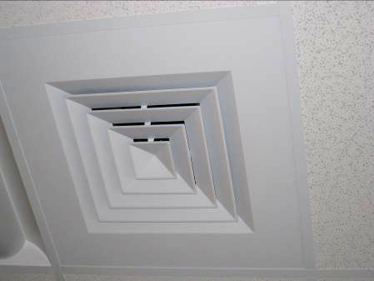

Ceiling-mounted supply diffuser

Picture 2

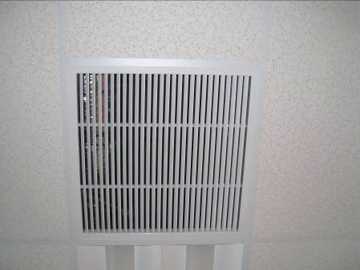

Ceiling-mounted return vent

Picture 3

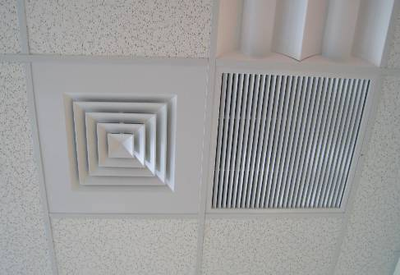

Ceiling-mounted supply diffuser adjacent to ceiling-mounted return vent

Picture 4

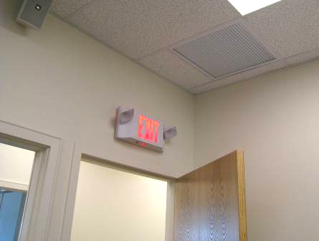

Ceiling-mounted return vent in close proximity to open hallway door

Picture 5

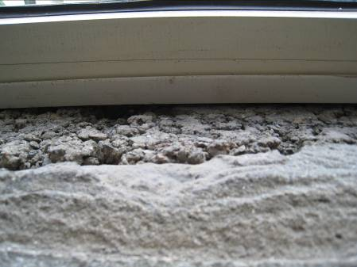

Damaged concrete window ledge

Picture 6

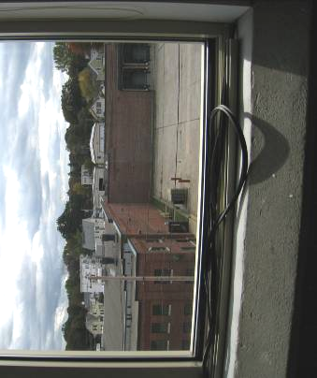

Damaged window gaskets

Picture 7

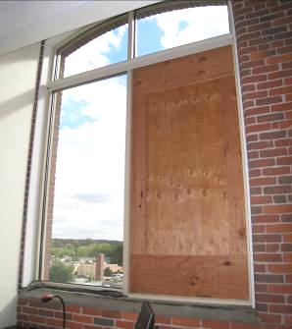

Plywood in place of glass window pane

Picture 8

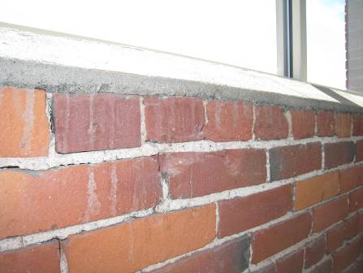

Efflorescence on brick beneath window

Picture 9

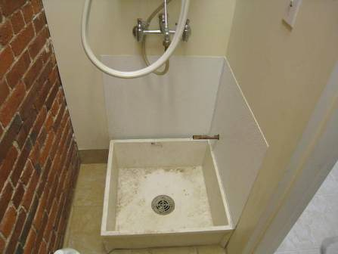

Exposed gypsum wallboard that may be prone to water exposure in sink closet

Picture 10

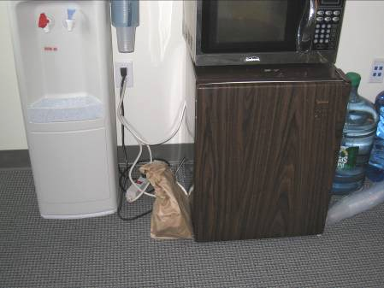

Water cooler and refrigerator on carpet

Picture 11

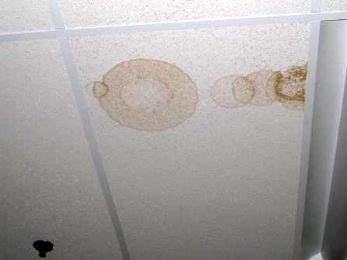

Water-damaged ceiling tile

Picture 12

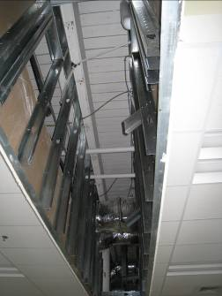

Unfinished ceiling system

Picture 13

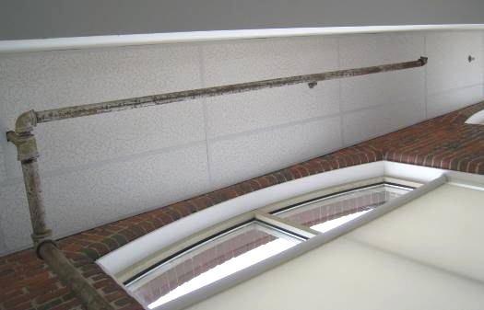

Open pipe

Picture 14

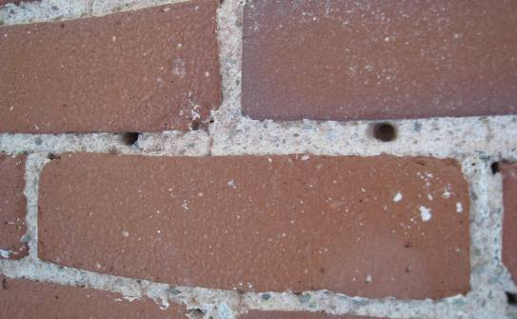

Utility holes in wall
Location/ Room | Carbon  Dioxide  (ppm) | Carbon Monoxide  (ppm) | Temp  (°F) | Relative  Humidity  (%) | TVOCs  (ppm) | PM2.5  (µg/m³) | Occupants  in Room | Windows  Openable | Ventilation |  | Remarks
 |  |  |  |  |  |  |  |  | Supply | Exhaust | Remarks
background | 372 | ND | 64 | 43 | ND | 8 |  |  |  |  | Overcast
301  vending room | 572 | ND | 72 | 39 | ND | 13 | 0 | N | Y | N | DO
308 | 599 | ND | 70 | 38 | ND | 13 | 0 | N | Y | Y | DO
309 | 650 | ND | 74 | 38 | ND | 11 | 11 | N | Y | Y | DO
310/312  Multipurpose room | 575 | ND | 71 | 40 | ND | 11 | 0 | N | Y | Y | DO, unfinished ceiling opening
314 conference | 674 | ND | 72 | 37 | ND | 12 | 0 | N | Y | Y | DO, DEM, Fridge on carpet
315 | 350 | ND | 73 | 34 | ND | 12 | 1 | N | Y | N | DO
316 | 555 | ND | 73 | 34 | ND | 11 | 0 | N | Y | Y | Computers
317 | 609 | ND | 73 | 37 | ND | 12 | 0 | N | Y | N
318 | 692 | ND | 74 | 34 | ND | 10 | 7 | N | Y | Y | DO, 24 computers
319 | 636 | ND | 74 | 37 | ND | 12 | 0 | N | Y | N
321 | 550 | ND | 74 | 35 | ND | 10 | 0 | N | Y | Y
322 | 725 | ND | 74 | 36 | ND | 11 | 6 | N | Y | Y | DO, 24 computers
324 | 615 | ND | 73 | 34 | ND | 13 | 0 | N | Y | Y | DEM
325 | 748 | ND | 73 | 39 | ND | 11 | 17 | N | Y | Y | DO
328 | 574 | ND | 73 | 36 | ND | 10 | 0 | N | Y | Y
3rd floor Main office | 627 | ND | 73 | 38 | ND | 12 | 4 | N | Y | N
401 | 579 | ND | 71 | 38 | ND | 13 | 0 | N | Y | N | DO
406 | 644 | ND | 72 | 37 | ND | 11 | 0 | N | Y | Y | DO
408 | 825 | ND | 73 | 39 | ND | 12 | 8 | N | Y | Y | DO
409 | 600 | ND | 72 | 38 | ND | 13 | 0 | N | Y | Y | DO
410 | 663 | ND | 73 | 37 | ND | 11 | 2 | N | Y | Y | DO
411 | 606 | ND | 73 | 36 | ND | 14 | 0 | N | Y | Y  VL
412 | 612 | ND | 75 | 36 | ND | 13 | 0 | N | Y | Y
414 | 649 | ND | 74 | 37 | ND | 12 | 0 | N | Y | Y | DO
417 | 594 | ND | 72 | 39 | ND | 14 | 0 | N | Y | N | PC
418 | 573 | ND | 72 | 37 | ND | 9 | 0 | N | Y | Y
420 | 554 | ND | 72 | 37 | ND | 9 | 0 | N | Y | Y | DO, DEM
421 | 689 | ND | 73 | 40 | ND | 15 | 2 | N | Y | N | DO, PF
422 | 545 | ND | 71 | 37 | ND | 8 | 0 | N | Y | Y | Wood panel in window
424 | 556 | ND | 72 | 37 | ND | 9 | 0 | N | Y | Y
425 | 534 | ND | 72 | 39 | ND | 10 | 0 | N | Y | Y | WD-CT
426 | 539 | ND | 71 | 38 | ND | 12 | 0 | N | Y | Y
427 | 549 | ND | 71 | 39 | ND | 14 | 0 | N | Y | Y
429 | 508 | ND | 71 | 39 | ND | 12 | 0 | N | Y | Y
4th floor main office | 659 | ND | 72 | 40 | ND | 15 | 3 | N | Y | Y | DO

