ODOR INVESTIGATION

North Middlesex Regional School
19 Main Street
Townsend, MA

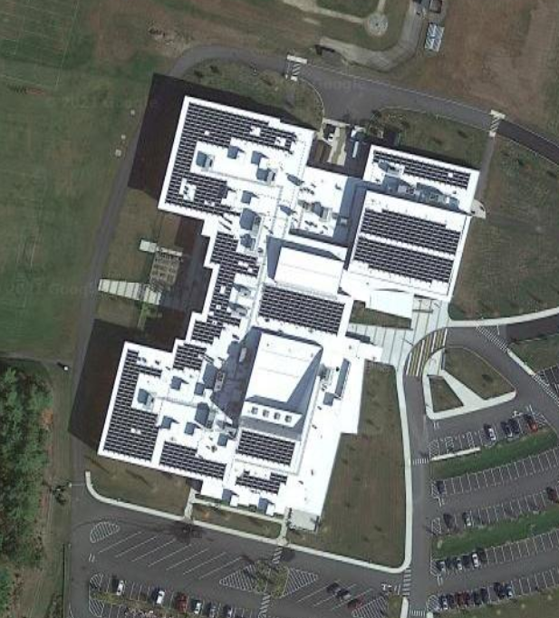

Prepared by:
Massachusetts Department of Public Health
Bureau of Environmental Health
Indoor Air Quality Program
January 2022

Background
Building: | North Middlesex Regional High School (NMRHS)
Address: | 19 Main Street, Townsend, MA
Assessment Coordinated Through: | Oscar Hills, Facility Director  North Middlesex Regional School District
Reason for Request: | Unidentified odor in a classroom
Date of Assessment: | November 5, 2021
Massachusetts Department of Public Health/Bureau of Environmental Health (MDPH/BEH) Staff Conducting Assessment: | Michael Feeney, Director, Indoor  Air Quality (IAQ) Program
Building Description: | The NMRHS is a large Regional High School that was opened in 2017. The room assessed is a computer classroom located over a technology center.
Windows: | Windows openable to the outdoors in one of six areas assessed.

METHODS
DPH staff conducted a series of visual assessments, and testing for carbon dioxide, carbon monoxide, temperature, and relative humidity. Please refer to the IAQ Manual for methods, sampling procedures, and interpretation of results (MDPH, 2015).

RESULTS AND DISCUSSION
The following is a summary of indoor air testing results (Table 1):
- Carbon Dioxide was above the MDPH recommended guideline of 800 parts per million (ppm) in two of the areas assessed.
- Temperature was within the MDPH recommended range of 70°F to 78°F.
- Relative Humidity was below the MDPH recommended range of 40 to 60%.
- Carbon Monoxide was not detected (ND) in the area tested.

Ventilation
A heating, ventilating and air conditioning (HVAC) system has several functions. First, it provides heating and, if equipped, cooling. Second, it is a source of fresh air. Finally, an HVAC system will dilute and remove normally occurring indoor environmental pollutants by not only introducing fresh air, but by filtering the airstream and ejecting stale air to the outdoors via exhaust ventilation. Even if an HVAC system is operating as designed, point sources of respiratory irritation may exist and cause symptoms in sensitive individuals.
Fresh air in the space is provided by a rooftop air handling unit (AHU) that has a heat-recovery wheel. Fresh air is drawn into the AHU from outside, heated or cooled, and delivered to occupied space via supply diffusers. Return air is drawn into ceiling grates and ducted back to the AHU. The carbon dioxide readings suggest that rooms 262 and 264 would benefit from additional fresh air when they are occupied.
To maximize air exchange, the IAQ program recommends that both supply and exhaust ventilation operate continuously during periods of occupancy. To have proper ventilation with a mechanical ventilation system, the systems must be balanced after installation to provide an adequate amount of fresh air to the interior of a room while removing stale air from the room. It is recommended that HVAC systems be re-balanced every five years to ensure adequate air systems function (SMACNA, 1994).

HVAC System and Classroom Configuration
The room with the reported odor is one of two computer rooms that are above two classrooms. These four rooms are adjacent to a two-story open room used for technology classes that use computer 3D printing equipment. All five rooms appear to share common HVAC system ductwork that is connected to the rooftop AHU unit.

Odor Source
The two-story classroom contained a number of 3D computer printers (Picture 1). According to equipment instructions, plastic that serves as the printer materials is melted at a temperature in excess of 200°C (424°F). The molten plastic is sprayed, which then can produce particulates and fumes. None of the 3D printers appear to have any dedicated exhaust ventilation equipment to remove particulates and fumes from printer operation.
The National Institute of Occupational Safety and Health (NIOSH), provides the following research information concerning the use of 3D printers:
[I]nvestigators found that a desktop 3D printer emitted smaller particles than those from laser printers that use plastic toner and far greater amounts of certain chemicals linked to asthma. In what they believe is the first discovery of its kind, the investigators also found that 3D printers emit chemicals that combine to form new compounds, including a chemical linked to asthma [and] suggest the need to take precautions to reduce emissions from desktop 3D printers in the home and office… [It is important to use] controls to reduce emissions from desktop 3D printers in non-industrial settings. To reduce emissions, the investigators recommend five specific steps:
- Always use the manufacturer’s supplied controls (full enclosure appears more effective at controlling emissions than a cover).
- Use the printer in a well-ventilated place, and directly ventilate the printer.
- Maintain a distance from the printer to minimize breathing in emitted particles and choose a low-emitting printer and filament when possible.
- Turn off the printer if the printer nozzle jams and allow it to ventilate before removing the cover.
- Use engineering measures first, such as manufacturer-supplied equipment and proper ventilation, then use materials with lower emissions. Finally, wear protective equipment, such as respirators. (NIOSH, 2016).
Implementation of these control measures would reduce odors and any associated irritation due to this equipment.
In addition to 3D printers, woodworking equipment and a portable wood-dust collection system were located in one classroom beneath the computer classrooms (Picture 2). These locations also do not appear to have any dedicated exhaust ventilation systems that would vent respirable wood dust or other pollutants directly to the outdoors. Wood-dust collectors collect visible sawdust but can readily aerosolize respirable wood dust. Aerosolized pollutants may be captured by the HVAC system to be directed to the rooftop AHU. Once in the AHU, particle pollutants can accumulate in the heat recovery wheel to reduce its efficiency. Any other pollutants generated in this location from glues, paints or other processes can also adhere to the heat recovery wheel. A contaminated heat recovery wheel can be an ongoing source of odors.

CONCLUSIONS AND RECOMMENDATIONS
Based on observation, equipment is operated in a location that lacks the ability to directly vent pollutants outdoors during use. It is likely that the HVAC system serves as a pathway for such pollutants to migrate to locations outside the technology center. In view of the findings at the time of the visit, the following recommendations are made:

Ventilation/Odor Recommendations
- Move 3D printers to a location where adequate exhaust ventilation exists or can be created, such as a science room with an existing chemical hood or to a location on an exterior wall. Ensure 3D printers can be vented outdoors in a manner consistent with manufacturers’ recommendations.
- Discontinue use of all woodworking, dust collecting and other related activities to an area without appropriate exhaust ventilation. Each piece of woodworking equipment should have an exhaust vent to collect wood dust at/immediately adjacent to the woodworking surface to capture respirable dust. Recommended guidelines for health and safety concerning wood-working machines can be found in the National Institute for Occupational Safety and Health (NIOSH) document, Woodworking Machinery General Requirements (NIOSH, 2003) at https://www.cdc.gov/niosh/docs/2004-101/chklists/r1n46m~1.htm.
- It is not recommended to operate 3D printers, woodworking machines or other activities that produce vapors, fumes or dusts in a location equipped only with general ventilation ductwork, particularly one that is connected to an AHU with a heat recovery wheel.
- Once the woodworking and 3D printing devices are moved, continue to operate the HVAC system to provide for continuous fresh air ventilation and filtration during occupied hours.
- Continue with regular filter changes for HVAC equipment using the best quality/highest Minimum Efficiency Reporting Value (MERV) rated filters that can be used with current equipment.
- Consider adopting a balancing schedule of every 5 years for all mechanical ventilation systems, as recommended by ventilation industrial standards (SMACNA, 1994).
- The U.S. Department of Education has released new guidance encouraging the use of American Rescue Plan (ARP) funds to improve ventilation systems and make other indoor air quality improvements in schools. More information can be found at this link https://www.ed.gov/coronavirus/improving-ventilation.

Other Recommendations
- For buildings in New England, periods of low relative humidity during the winter are often unavoidable. Therefore, scrupulous cleaning practices should be adopted to minimize common indoor air contaminants whose irritant effects can be enhanced when the relative humidity is low. To control dusts, a high efficiency particulate arrestance (HEPA) filter equipped vacuum cleaner in conjunction with wet wiping of all surfaces is recommended. Avoid the use of feather dusters. Drinking water during the day can help ease some symptoms associated with a dry environment (throat and sinus irritations).
- Consider forming an IAQ committee in each school building district wide. Committees should have an IAQ liaison/teacher representative, a member of maintenance/facilities, and a member of administration that conduct regular walk-throughs to identify on-going and/or potential environmental issues.
- Consider adopting the US EPA (2000) document, “Tools for Schools”, as an instrument for maintaining a good IAQ environment in the building available at: https://www.epa.gov/iaq-schools/indoor-air-quality-tools-schools-action-kit
- Refer to resource manual and other related IAQ documents located on the MDPH’s website for further building-wide evaluations and advice on maintaining public buildings. These documents are available at: http://mass.gov/dph/iaq.

REFERENCES
MDPH. 2015. Massachusetts Department of Public Health. “Indoor Air Quality Manual: Chapters I-III”. Available at: https://www.mass.gov/lists/indoor-air-quality-manual-and-appendices#indoor-air-quality-manual-
NIOSH. 2016. Control Measures Critical for 3D Printers. NIOSH Research Rounds. National Institute for Occupational Safety and Health, Cincinnati, OH. Volume 1, Number 12 (June 2016). https://www.cdc.gov/niosh/research-rounds/resroundsv1n12.html
NIOSH. 2003. Woodworking Machinery General Requirements. National Institute of Occupational Safety and Health. Woodworking Machinery General Requirements | NIOSH | CDC
SMACNA. 1994. HVAC Systems Commissioning Manual. 1st ed. Sheet Metal and Air Conditioning Contractors’ National Association, Inc., Chantilly, VA. SMACNA. 1994. HVAC Systems Commissioning Manual. 1st ed. Sheet Metal and Air Conditioning Contractors’ National Association, Inc., Chantilly, VA.

Picture 1
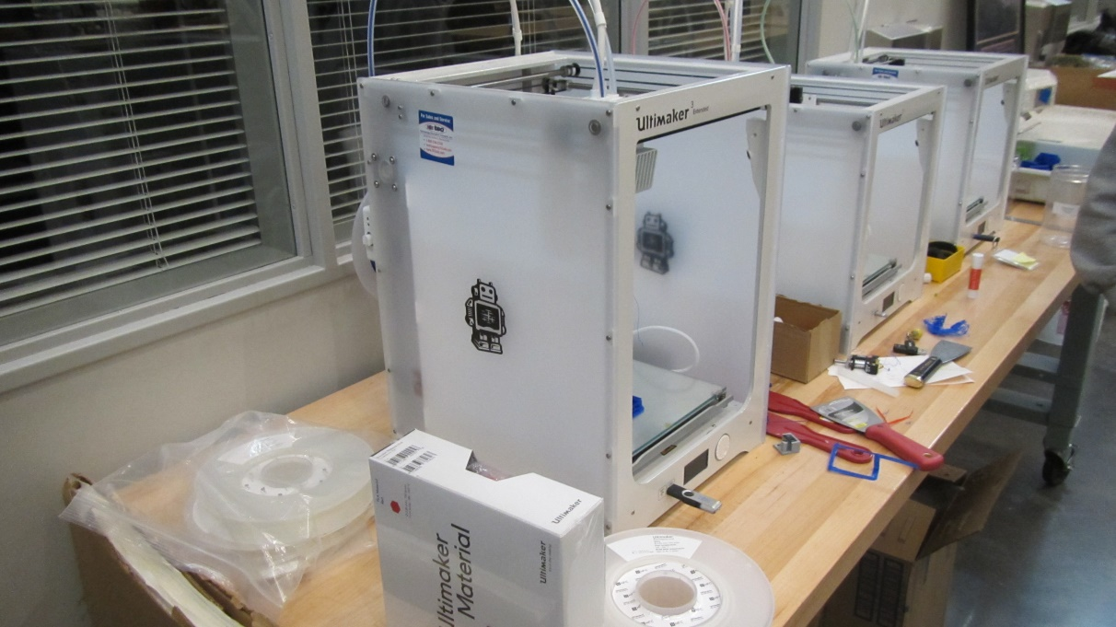
3D Printers
Picture 2
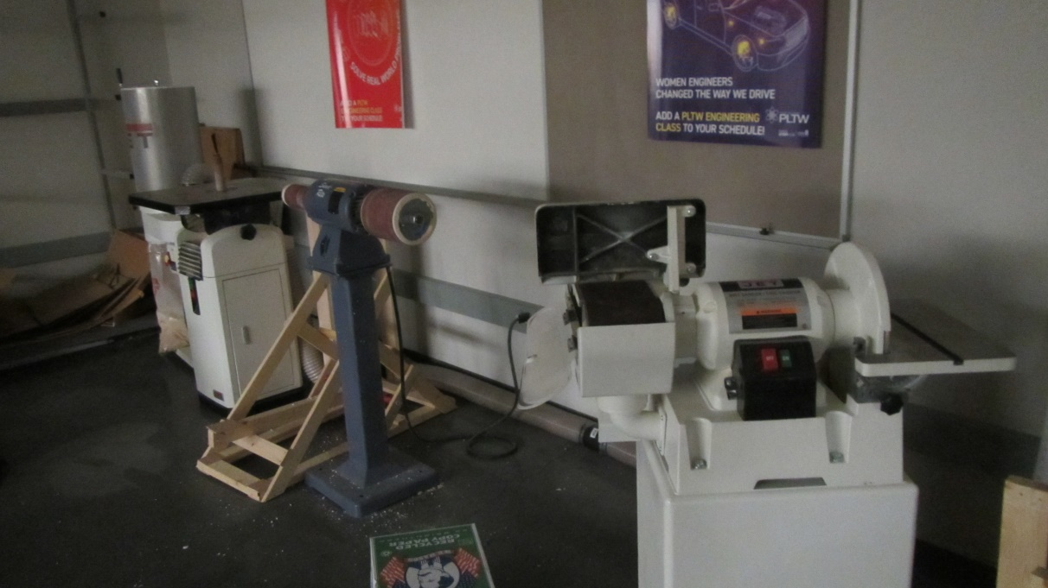
Woodworking machines
Location | Carbon  Dioxide  (ppm) | Carbon Monoxide  (ppm) | Temp  (°F) | Relative  Humidity  (%) | Occupants  in Room | Windows  Openable | Ventilation |  | Remarks
 |  |  |  |  |  |  | Supply | Exhaust
Background | 363 | ND | 64 | 64
1811 | 482 | ND | 70 | 21 | 0 | N | Y | Y | 3D computer printers
160 | 684 | ND | 70 | 21 | 14 | N | Y | Y
162 | 611 | ND | 71 | 20 | 1 | Y | Y | Y | 32 computers
164 | 465 | ND | 71 | 16 | 0 | N | Y | Y | Woodworking machines
264 | 999 | ND | 72 | 24 | 16 | N | Y | Y | 21 computers
262 | 962 | ND | 74 | 20 | 24 | N | Y | Y

