INDOOR AIR QUALITY ASSESSMENT

North Pembroke Elementary School
72 Pilgrim Road
Pembroke, Massachusetts

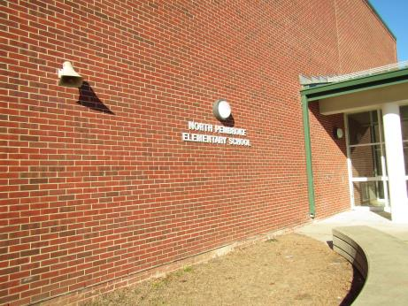

Prepared by:
Massachusetts Department of Public Health
Bureau of Environmental Health
Indoor Air Quality Program
December 2018

BACKGROUND
Building: | North Pembroke Elementary School (NPES)
Address: | 72 Pilgrim Road, Pembroke, MA
Assessment Requested by: | Justin J. Domingos,  Director of Athletics/Facilities, Pembroke Public Schools
Reason for Request: | General indoor air quality (IAQ) assessment
Date of Assessment: | December 18, 2018
Massachusetts Department of Public Health/Bureau of Environmental Health (MDPH/BEH) Staff Conducting Assessment: | Ruth Alfasso, Environmental Inspector and Cory Holmes, Environmental Inspector, IAQ Program
Date of Building Construction: | Originally constructed in the 1960s with remodeling/additions in 2001.
Building Description: | This is a single-story brick building with interior courtyards and a flat rubber-membrane roof, which was redone in 2015.
Windows: | Openable

METHODS
Please refer to the IAQ Manual and appendices for methods, sampling procedures, and interpretation of results (MDPH, 2015).

RESULTS and DISCUSSION
The following is a summary of indoor air testing results (Table 1).
- Carbon dioxide levels were above the MDPH recommended level of 800 parts per million (ppm) in almost half of the areas surveyed, which indicates a lack of air exchange in many classrooms at the time of assessment.
- Temperature was within the MDPH recommended range of 70°F to 78°F in most occupied areas, with some below and one above this range. Temperature control issues (excessive heat) were reported in the music areas.
- Relative humidity was below the MDPH recommended range of 40 to 60% in areas tested the day of assessment which is typical of conditions during the heating season.
- Carbon monoxide levels were non-detectable (ND) in all areas tested.
- Particulate matter (PM2.5) concentrations measured were below the National Ambient Air Quality (NAAQS) level of 35 μg/m³ in all areas tested.

Ventilation
A heating, ventilating and air conditioning (HVAC) system has several functions. First it provides heating and, if equipped, cooling. Second, it is a source of fresh air. Finally, an HVAC system will dilute and remove normally-occurring indoor environmental pollutants by not only introducing fresh air, but by filtering the airstream and ejecting stale air to the outdoors via exhaust ventilation. Even if an HVAC system is operating as designed, point sources of respiratory irritation may exist and cause symptoms in sensitive individuals.
Fresh air in classrooms is supplied by unit ventilators (univents, Picture 1). Univents draw air from the outdoors through a fresh air intake located on the exterior wall of the building (Picture 2) and return air through an air intake located at the base of the unit. Fresh and return air are mixed, filtered, heated or cooled and provided to rooms through an air diffuser located in the top of the unit (Figure 1). In many rooms, univents fans were off (Table 1). Some univent fans had been turned off at the unit (Picture 3), and others cycle on and off due to settings on the building’s energy management system. The top and/or front of some univents were blocked by furniture or items (Pictures 1 and 4); univents need to be unobstructed to function properly.
Air handling units (AHU) on the roof supply fresh air to offices and common areas. Fresh air is provided by ceiling-mounted diffusers (Picture 5) connected to the AHUs by ductwork. In areas served by the AHUs, air is returned to the AHU through ducted return vents. NPES staff reported that one AHU had been deactivated two or three years previously due to a “fishy” odor that could not be resolved by a plumber, electrician or HVAC contractor working on the affected unit. As this AHU only served hallways and storage areas, it is possible for the building to be occupied without this AHU operating; however, if possible this AHU should be returned to service. Odors described as “fishy” in nature may result from organic deposits and microbial growth on pipes, fins and condensation collection pans/hoses. It may also result from heat-related damage to wiring or other electrical components.
Exhaust vents (Picture 6) in some classrooms, as well as bathrooms, are ducted out of the building to fans on the roof. Some of these exhaust vents were also not drawing air. Note that in many classrooms, exhaust vents were located near classroom doors. This design works best with the doors to the hallway closed, otherwise the exhaust vents tend to draw air from the hallway rather than the room which reduces the effectiveness of air circulation.
To maximize air exchange, the IAQ program recommends that both supply and exhaust ventilation operate continuously during periods of occupancy. It is especially important to have exhaust ventilation in areas where pollutants are generated such as restrooms. In order to have proper ventilation with a mechanical ventilation system, the systems must be balanced after installation to provide an adequate amount of fresh air to the interior of a room while removing stale air from the room. It is recommended that HVAC systems be re-balanced every five years to ensure adequate air systems function (SMACNA, 1994). It is not known when the HVAC system was last balanced.

Microbial/Moisture Concerns
Water-damaged ceiling tiles were observed in a number of areas (Pictures 7 and 8), which reportedly stem from historic leaks since the roof was repaired/replaced in 2015, and are located in areas which are difficult to remove (e.g., around sprinkler heads). The roof area above the gym office continues to leak and many of the ceiling tiles are currently removed due to chronic water penetration (Picture 9). It was believed that the leaks occur through seams in the roof around penetrations for AHU piping. A roofing contractor should be contacted to determine how best to seal these penetrations and render the roof watertight. Until that time, no porous materials should be stored in the area of the leaks and water should be cleaned up as soon as possible each time leaks occur.
In order for mold growth to occur, materials must be exposed to chronic moisture. Relative humidity in excess of 70 percent for extended periods of time, even in the absence of other sources of water, can provide an environment for mold and fungal growth (ASHRAE, 1989). In general, the US Environmental Protection Agency (US EPA) and the American Conference of Governmental Industrial Hygienists (ACGIH) recommends that porous materials (e.g., GW, carpeting) be dried with fans and heating within 24 to 48 hours of becoming wet (US EPA, 2008; ACGIH, 1989). If porous materials are not dried within this time frame, mold growth may occur.
Plants were present in some classrooms and other areas (Pictures 4 and 10). Plants should be well maintained, not overwatered, and not placed on porous materials or in the airstream of ventilation equipment. An aquarium was found in one classroom. Aquariums should also be kept in good condition to prevent odors.
Many classrooms had sinks. Some of the backsplashes of the sinks had a gap which can allow water to damage the material and may lead to mold growth (Picture 11). In addition, porous items should not be stored on or under sinks where they may be subject to moistening.
Ductless air conditioners (also known as mini-splits) were found in some rooms (Pictures 12 and 13). These units create condensate that needs to be drained out of the building. As shown in Pictures 12 and 13, the condensate drain hoses or pumps may be subject to leaking, which can lead to water damage. These hoses and pumps should be examined periodically when the units are in use and cleaned or repaired as needed. Window air conditioners can also produce condensation, and if not tightly sealed in the window/wall, they can allow water into the building around the casing to cause water damage (Picture 14).
It was reported that the locker rooms adjacent to the gym are rarely used. If the drains in this room are not periodically moistened, the traps will dry out and allow sewer gas and moisture into the building.
Occupants in room 317 reported that there had been a strong “rotten egg” odor in this room in the past. They believed it was originating near or in the exhaust vent. Many steps had been taken to identify and remediate the odor including cleaning the drain and placing “odor eaters” near the vent. While no odor was detected on the day of the assessment, several conditions can lead to an odor that may be described like “rotten eggs”. Sewer gas, which may enter through dry drain traps or cracks in sewer or vent piping, can be a source of this odor. A plumber may be able to assist in determining if these conditions exist via a smoke test. The odorant added to natural gas has a similar odor. If there is the potential for any gas leaks they should be found and fixed as soon as possible. A decaying animal may also have caused the odor, as it was reported that there are pest traps above the ceiling tiles in some areas. This type of odor will typically dissipate after a short time once the source is removed.
The exterior of the building was examined for potential sources of water penetration and other sources of IAQ issues. As shown in Picture 2, there were signs that plants grow directly adjacent to univents. These can be a source of pollen, debris and odors to occupied areas. Plants can hold moisture against the exterior and prevent drying. Plant roots can also damage the building foundation. Plants close to the building can also provide harborage for pests. Care should be taken, especially in the courtyards of this building, that plants are trimmed away from the building and do not overgrow.

Other Conditions
Exposure to low levels of total volatile organic compounds (TVOCs) may produce eye, nose, throat, and/or respiratory irritation in some sensitive individuals. BEH/IAQ staff examined rooms for products containing VOCs. BEH/IAQ staff noted hand sanitizers, scented products, cleaners, and dry erase materials in use within the building (Picture 15; Table 1). These products have the potential to be irritants to the eyes, nose, throat, and respiratory system of sensitive individuals.
In some classrooms, tennis balls had been sliced open and placed on table/chair footings to reduce noise (Picture 16; Table 1). Tennis balls are made of a number of materials that are a source of respiratory irritants. Constant wearing of tennis balls can produce fibers and lead to off-gassing of VOCs. Tennis balls are made with a natural rubber latex bladder, which becomes abraded when used as a chair leg pad. Use of tennis balls in this manner may introduce latex dust into the school environment. Some individuals are highly allergic to latex (e.g., spina bifida patients) (SBAA, 2001). It is recommended that the use of materials containing latex be limited in buildings to reduce the likelihood of symptoms in sensitive individuals (NIOSH, 1997; NIOSH, 1998).
Rodents were reported in the building and droppings were observed in a cabinet (Picture 17). Note that rodent infestation can result in IAQ related symptoms due to materials in their wastes. Mouse urine contains a protein that is a known sensitizer (US EPA, 1992). A sensitizer is a material that can produce symptoms (e.g., running nose or skin rashes) in sensitive individuals after repeated exposure. To eliminate exposure to allergens, rodents must be removed from the building. Please note that removal, even after cleaning, may not provide immediate relief since allergens can exist in the interior for several months after rodents are eliminated (Burge, 1995). Once the infestation is eliminated, a combination of cleaning and increased ventilation and filtration should serve to reduce allergens associated with rodents.
The air handling units and univents have filters that need to be changed regularly, a minimum of two times a year. At least some filters present in the building had a Minimum Efficiency Rating Value (MERV) of 10, which is better than MERV 8, which are recommended for use in schools and offices. Building facility staff report that filters are changed at least twice a year. Window air conditioners also have filters which need to be cleaned periodically, typically before and after the cooling season (Picture 18).
In some areas, supply and exhaust vents and personal fans were dusty. This dust can be reaerosolized under certain conditions, and can also be a medium for mold growth. Univent cabinets can also accumulate dust and debris which should be cleaned when the filters are changed. In some rooms, debris or items were present in the top grill of the univent (Picture 19). When heated, items such as crayons, plastic toys, and pencil shavings can give off odors. These grills should be cleaned out periodically.
Area rugs were observed in most classrooms and carpeting was present in some rooms and offices (Picture 20; Table 1). Carpets should be cleaned annually (or semi-annually in soiled/high traffic areas) in accordance with Institute of Inspection, Cleaning and Restoration Certification (IICRC) recommendations, (IICRC, 2012). Regular cleaning with a high efficiency particulate air (HEPA) filtered vacuum in combination with an annual cleaning will help to reduce accumulation and potential aerosolization of materials from carpeting. Area carpets too worn to be effectively cleaned should be replaced. Area rugs should be rolled up and stored in a clean, dry place when rooms are not occupied during the summer months to prevent moistening due to condensation. Upholstered items and pillows/stuffed toys in classrooms should also be cleaned regularly.
Note that the Environmental Protection Agency (EPA) conducted a National School Radon Survey in which it discovered nearly one in five schools had “…at least one frequently occupied ground contact room with short-term radon levels above 4 [picocuries per liter] pCi/L” (US EPA 1993). The BEH/IAQ Program therefore recommends that every school be tested for radon, and that this testing be conducted during the heating season while school is in session in a manner consistent with USEPA radon testing guidelines. Radon measurement specialists and other information can be found at www.nrsb.org and http://aarst-nrpp.com/wp, with additional information at: http://www.mass.gov/eohhs/gov/departments/dph/programs/environmental-health/exposure-topics/iaq/radon.

RECOMMENDATIONS
In view of the findings at the time of the visit, the following recommendations are made:
- Operate the HVAC system to provide for continuous fresh air ventilation during occupied hours. Ensure fresh air intake louvers are functioning properly to adjust outside air intake. Make adjustments to louvers and energy management systems as needed.
- Remove furniture and items blocking the front and top of univents.
- Periodically assess whether exhaust vents are drawing air and repair as needed to provide the removal of stale air from rooms.
- Work with Music Instruction staff (and other areas of temperature/comfort issues) to troubleshoot control problems.
- Use openable windows to supplement fresh air during temperate weather. Ensure all windows are closed tightly at the end of each day.
- Consider closing classroom doors during occupancy to allow for more effective function of exhaust vents.
- Utilize a system to report and track maintenance issues such as broken univents, odors, leaks and cleaning issues so that concerns can be reported by the staff that observes them, and maintenance staff can report when the issues have been resolved.
- Consider contracting for another opinion on the odors/conditions that lead to the AHU for hallways and storage being deactivated. Returning this AHU to active service will improve air exchange in the rooms it serves.
- Consider adopting a balancing schedule of every 5 years for all mechanical ventilation systems, as recommended by ventilation industrial standards (SMACNA, 1994).
- For buildings in New England, periods of low relative humidity during the winter are often unavoidable. Therefore, scrupulous cleaning practices should be adopted to minimize common indoor air contaminants whose irritant effects can be enhanced when the relative humidity is low. To control for dusts, a high efficiency particulate arrestance (HEPA) filter equipped vacuum cleaner in conjunction with wet wiping of all surfaces is recommended. Avoid the use of feather dusters. Drinking water during the day can help ease some symptoms associated with a dry environment (throat and sinus irritations).
- Work with a roofing contractor to determine how to render the roof around the AHU weather-tight. Until this has been completed, continue to avoid storing porous materials in the gym office.
- Replace water-damaged ceiling tiles once leaks are repaired. Inspect the area above the stained tiles for water damage or odors and remediate or clean as necessary.
- Remove or remediate/clean other water-damaged materials.
- Keep classroom/office plants in good condition, avoid overwatering, and keep them away from the airstream of ventilation equipment.
- Repair sink blackplashes with appropriate caulking.
- Avoid storing porous materials on or under sinks.
- Monitor condensate drains and pumps for ductless air conditioners for clogs and leaks and clean/repair as needed.
- Ensure window air conditioners can drain properly outside and that the windows are sealed to prevent water penetration.
- Periodically fill unused drains such as in locker rooms with water to prevent dry drain traps.
- If odors in room 317 reoccur, consider contracting with a plumber to test for damaged sewer/vent pipes and natural gas leaks.
- Keep logs of intermittent odors, including time, location and weather/other conditions to assist in determining a cause.
- Remove plants and debris/leaves from within five feet of the edge of the building and especially around air intakes and windows.
- Ensure all doors to the exterior or between occupied and unoccupied areas are weather-tight and kept closed. Monitor for light and drafts periodically.
- Reduce or eliminate the use of air fresheners, scented cleaners, hand sanitizers and dry erase materials to reduce irritation.
- Replace tennis balls on chair/table footings with latex-free glides.
- Use photocopiers and laminators in well-ventilated areas.
- Use the principles of Integrated Pest Management (IPM) and the services of a licensed pest control operator to remove rodents and reduce the potential for pest infestation. Ensure that any area where rodents may have been is thoroughly cleaned to remove allergens.
- Keep cooking equipment clean and any food tightly sealed to prevent attracting pests.
- Continue to change filters in AHUs and univents at least twice a year with MERV 8 or better (e.g., the MERV 10 in use now) filters.
- Clean filters on window/wall air conditioners regularly.
- Clean supply and exhaust vents and fans regularly to remove dust build.
- Clean the top of univent grills to remove debris/items.
- Clean classroom items regularly with a wet cloth or sponge to prevent excessive dust build-up.
- Clean carpeting and rugs at least once per year according to IICRC recommendations (IICRC 2012). Area carpets too worn to be effectively cleaned should be replaced. Roll up and store are rugs in a clean, dry place during the summer
- Clean upholstered items and pillows/stuffed toys regularly.
- Ensure filters for AHUs are of a pleated variety, Minimum Efficiency Reporting Value (MERV) dust-spot efficiency 8 or higher, which are adequate in filtering out pollen and mold spores (ASHRAE, 2012). Filters should be changed 2-4 times a year. If filters have large accumulations of dust when changed, increase frequency.
- Consider adopting the US EPA (2000) document, “Tools for Schools”, as an instrument for maintaining a good IAQ environment in the building available at: http://www.epa.gov/iaq/schools/index.html.
- The school should be tested for radon by a certified radon measurement specialist during the heating season when school is in session. Radon measurement specialists and other information can be found at: www.nrsb.org, and http://aarst-nrpp.com/wp.
- Refer to resource manuals and other related IAQ documents for further building-wide evaluations and advice on maintaining public buildings. Copies of these materials are located on the MDPH’s website: http://mass.gov/dph/iaq.

REFERENCES
ACGIH. 1989. Guidelines for the Assessment of Bioaerosols in the Indoor Environment. American Conference of Governmental Industrial Hygienists, Cincinnati, OH.
ASHRAE. 1989. Ventilation for Acceptable Indoor Air Quality. American Society of Heating, Refrigeration and Air Conditioning Engineers. ANSI/ASHRAE 62-1989.
ASHRAE. 2012. American Society of Heating, Refrigeration and Air Conditioning Engineers (ASHRAE) Standard 52.2-2012 -- Method of Testing General Ventilation Air-Cleaning Devices for Removal Efficiency by Particle Size (ANSI Approved). 2012.
Burge, H.A. 1995. Bioaerosols. Lewis Publishing Company, Boca Raton, FL.
IICRC. 2012. Institute of Inspection Cleaning and Restoration Certification. Institute of Inspection, Cleaning and Restoration Certification. Carpet Cleaning: FAQ.
MDPH. 2015. Massachusetts Department of Public Health. Indoor Air Quality Manual: Chapters I-III. Available at: http://www.mass.gov/eohhs/gov/departments/dph/programs/environmental-health/exposure-topics/iaq/iaq-manual/.
NIOSH. 1997. National Institute for Occupational Safety and Health. Alert Preventing Allergic Reactions to Natural Rubber latex in the Workplace. National Institute for Occupational Safety and Health, Atlanta, GA.
NIOSH. 1998. National Institute for Occupational Safety and Health. Latex Allergy A Prevention. National Institute for Occupational Safety and Health, Atlanta, GA.
SBAA. 2001. Latex In the Home And Community Updated Spring 2001. Spina Bifida Association of America, Washington, DC.
SMACNA. 1994. HVAC Systems Commissioning Manual. 1st ed. Sheet Metal and Air Conditioning Contractors’ National Association, Inc., Chantilly, VA.
US EPA. 1992. Indoor Biological Pollutants. US Environmental Protection Agency, Environmental Criteria and Assessment Office, Office of Health and Environmental Assessment, research Triangle Park, NC. EPA 600/8-91/202. January 1992.
US EPA. 1993. Radon Measurement in Schools, Revised Edition. Office of Air and Radiation, Office of Radiation and Indoor Air, Indoor Environments Division (6609J). EPA 402-R-92-014. https://www.epa.gov/sites/production/files/2014-08/documents/radon_measurement_in_schools.pdf
US EPA. 2000. Tools for Schools. Office of Air and Radiation, Office of Radiation and Indoor Air, Indoor Environments Division (6609J). EPA 402-K-95-001, Second Edition. http://www.epa.gov/iaq/schools/index.html.
US EPA. 2008. Mold Remediation in Schools and Commercial Buildings. US Environmental Protection Agency, Office of Air and Radiation, Indoor Environments Division, Washington, D.C. EPA 402-K-01-001. http://www.epa.gov/mold/mold-remediation-schools-and-commercial-buildings-guide.
Picture 1
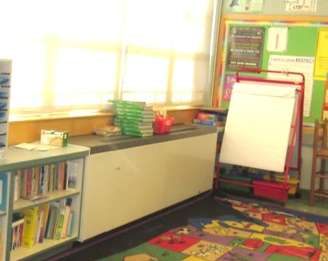
Classroom univent, note books on top
Picture 2
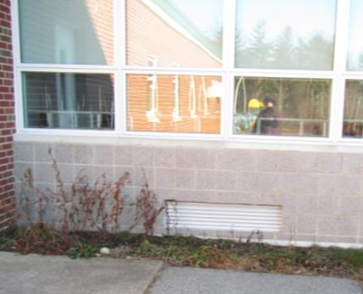
Univent fresh air intake, note plants
Picture 3
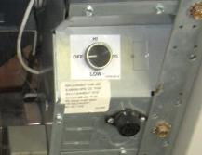
Univent turned off
Picture 4
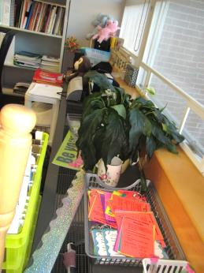
Univent top and front blocked by items
Picture 5
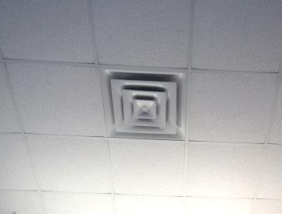
Ceiling-mounted supply vent
Picture 6
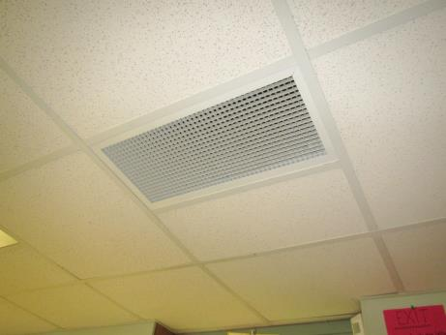
Typical exhaust or return grate
Picture 7
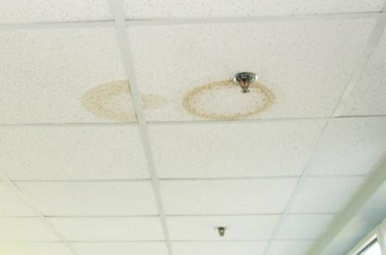
Water-damaged ceiling tiles in a hallway
Picture 8
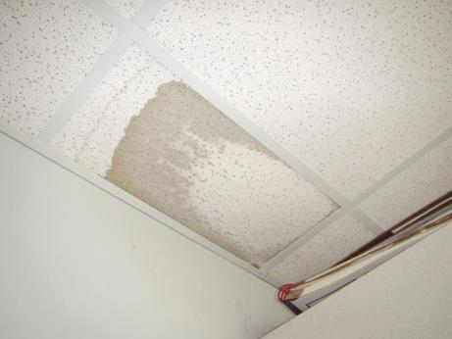
Water-damaged ceiling tile in classroom, dry at the time of the assessment
Picture 9
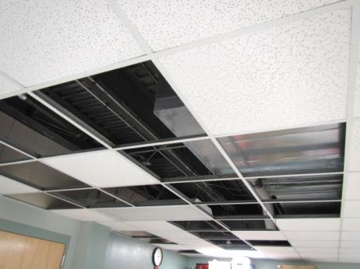
Ceiling tiles removed from the gym office due to chronic leaks
Picture 10
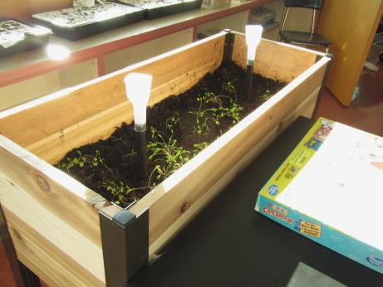
Plant box in classroom
Picture 11
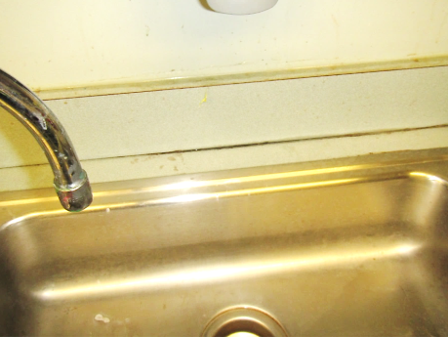
Gap in sink backsplash
Picture 12
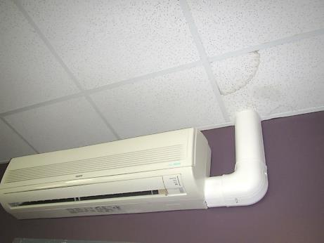
Ductless air conditioner with stained ceiling tiles that may indicate condensate leaks
Picture 13
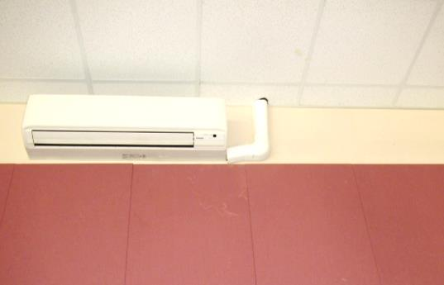
Water stain on material under the ductless air conditioner indicating likely condensate leaks
Picture 14
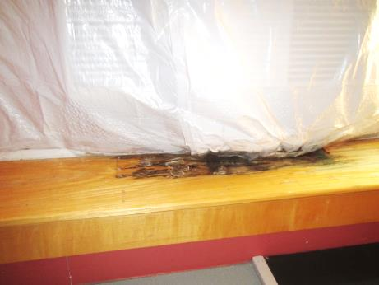
Water-damaged wood under window air conditoner
Picture 15
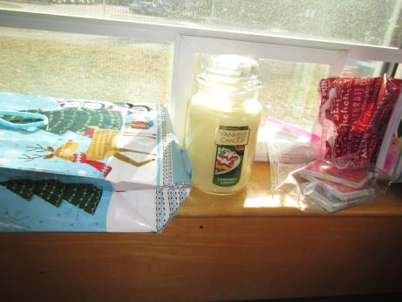
Scented candle
Picture 16
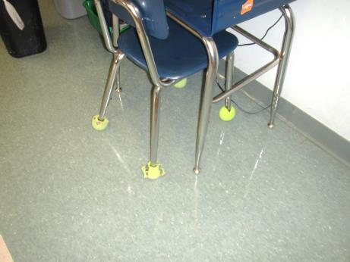
Tennis balls used as chair glides
Picture 17
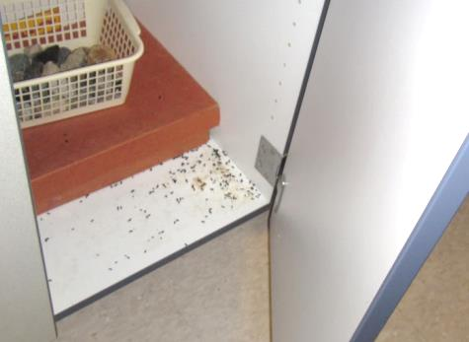
Rodent droppings in a cabinet
Picture 18
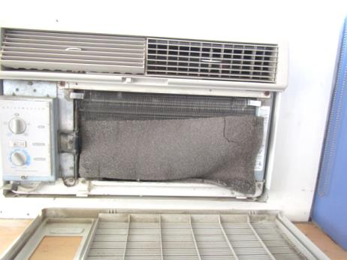
Dusty, poorly fitted filter in a window air conditioner
Picture 19
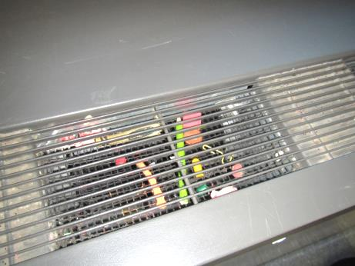
Debris and items in univent grill
Picture 20
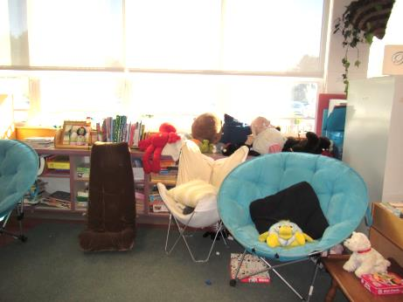
Area rug, upholstered furniture and plush items
Location | Carbon  Dioxide  (ppm) | Carbon Monoxide  (ppm) | Temp  (°F) | Relative  Humidity  (%) | PM2.5  (µg/m³) | Occupants  in Room | Windows  Openable | Ventilation |  | Remarks
 |  |  |  |  |  |  |  | Supply | Exhaust
Background/  Outdoors | 405 | 1 | <32 | 19 | 1 |  |  |  |  | Windy/cold
101 | 1132 | ND | 73 | 21 | 5 | 19 | Y | Y | Y | Area rug, DEM, TBs
Teacher’s lunch | 669 | ND | 64 | 25 | ND | 3 | Y | Y | Y | UV on, fridge, microwave
102 | 831 | ND | 75 | 17 | 1 | 3 | Y | Y | Y | TBs, HS, area rug, DEM
103 | 1077 | ND | 74 | 18 | 1 | 21 | Y | Y | Y | TBs, HS, area rug, DEM
104 | 1520 | ND | 73 | 20 | 12 | 23 | Y | Y | Y | area rug, DEM, PF - dusty, HS
105 | 633 | ND | 74 | 13 | 1 | 0 | Y | Y | Y | area rug, PF, DEM, UF
106 | 1312 | ND | 71 | 23 | 4 | 24 | Y Open | Y  Off | Y  Off | TB, items in front of UV, DO, area rug
107 | 1572 | ND | 68 | 33 | 2 | 17 | Y | Y  Off | Y  Off | Items on UV and in grate, TB, PF, DO, area rug
108 | 727 | ND | 76 | 18 | 1 | 2 | Y | Y | Y | TBs, UV on, CPs, PF - dusty, area rug, fridge and microwave
Storage Room | 1194 | ND | 69 | 31 | 3 | 0 | N | Y | Y | HVAC reportedly deactivated due to odors
109 | 1300 | ND | 72 | 27 | 1 | 19 | Y | Y | Y | UV off, area rug, DEM, TBs, CP, PS
110 | 1290 | ND | 71 | 39 | 2 | 19 | Y | Y | Y | UV off, PF, TB, area rug, plant, DEM
111 | 1134 | ND | 69 | 33 | 1 | 17 | Y | Y | Y | TB, DEM, UF off, PF, area rugs, scented candle
Men’s Restroom 3rd grade wing |  |  |  |  |  |  | N | N | Y  Off
Female Restroom 3rd grade wing |  |  |  |  |  |  | N | N | Y  Off
Music | 1024 | ND | 75 | 26 | 23 | 21 | Y | Y | Y | TB, heat control/HVAC issues reported, PF
Music Office | 742 | ND | 74 | 21 | 4 | 0 | N | Y | Y  Off | Wall to wall carpet
Teacher’s Planning | 606 | ND | 72 | 18 | 1 | 0 | Y | Y  Off | Y  Off | AC filter-dirty, TB, DO, area rug
201 | 851 | ND | 71 | 18 | 1 | 18 | Y | Y on | Y | Area rug, DEM, TBs, PF
202 | 846 | ND | 71 | 21 | 3 | 16 | Y | Y | Y | AI, DEM, area rug
203 | 680 | ND | 69 | 18 | 2 | 0 | Y | Y | Y | Office/storage area, TBs, CP
Copy Room | 1162 | ND | 70 | 36 | 6 | 0 | N | Y | Y | PC, laminator
Women’s Restroom |  |  |  |  |  |  | N | Y | Y | Exhaust vent dusty
Teacher’s Dining Room | 671 | ND | 67 | 21 | 4 | 0 | Y | Y | Y | AC, DO
Mr. Shute, custodian | 647 | ND | 69 | 13 | 2 | 0 | Y 1 open | Y | Y | NC, WAC - dusty, DEM, custodial materials
204 | 1530 | ND | 71 | 30 | 9 | 15 | Y | Y | Y | Reports of odors (“fishy”), UV part obstructed, DEM
205 | 1819 | ND | 71 | 30 | 18 | 20 | Y | Y | Y | Area rug, DEM
206 | 1786 | ND | 72 | 31 | 2 | 19 | Y | Y on | Y | PF - dusty, DEM
Girls restroom |  |  |  |  |  |  |  | Y | Y off
Book storage |  |  |  |  |  |  |  | Y | Y | Boxes on floor
Boys Restroom |  |  |  |  |  |  | N | N | Y  Off | Exhaust vent dusty
207 | 1680 | ND | 74 | 32 | 3 | 19 | Y | Y | Y  Off | PF, DO, plants, area rug
208 | 1788 | ND | 76 | 31 | 1 | 27 | Y | Y | Y | Area rug, TBs
209 | 1986 | ND | 71 | 35 | 3 | 15 | Y | Y | Y | DEM
209 prep room |  |  |  |  |  |  |  |  |  | Dead moths on windowsill
210 | 1997 | ND | 71 | 39 | 4 | 15 | Y | Y On | Y | TBs, DEM
210 closet |  |  |  |  |  |  |  | Y | Y | AI
211 | 1540 | ND | 71 | 34 | 5 | 0 | Y | Y  Off | Y  Off | PF, space between countertop and sink
Cafeteria | 954 | ND | 72 | 19 | 9 | ~100 | Y | Y | Y | Some exhausts off
Restroom next to cafeteria |  |  |  |  |  |  | N |  | Y on
212 | 741 | ND | 71 | 21 | 2 | 0 | Y | Y | Y dusty | Plants in box
213 | 750 | ND | 72 | 23 | 3 | 1 | Y | Y  Off | Y | PF, area rug, AI, stained CTs
214 | 912 | ND | 72 | 21 | 2 | 4 | Y | Y | Y | Plant, TBs, DEM
Nurse | 571 | ND | 71 | 11 | 2 | 2 | N | Y | Y | AI
Office Main | 662 | ND | 71 | 16 | 1 | 2 | N | Y | Y | PC, electric fireplace
Office Conference | 735 | ND | 71 | 18 | 2 | 0 | N | Y | Y | DEM
Office Workroom | 639 | ND | 71 | 17 | 2 | 0 | N | Y | Y | Fridge, NC
Assistant principal | 623 | ND | 71 | 17 | 1 | 0 | Y | Y | Y | WAC - dusty
Principal | 645 | ND | 71 | 17 | 1 | 2 | Y | Y | Y | WAC, CP, DEM
Conference | 508 | ND | 73 | 13 | 2 | 0 | Y | Y off | Y | Carpet
268 | 518 | ND | 71 | 15 | 2 | 0 | Y | Y | Y | Mouse droppings, sinks, WD CT (dry)
Restroom |  |  |  |  |  |  |  | Y | Y | Scented product
Library | 702 | ND | 71 | 21 | 3 | 2 | Y | Y | Y | Wall to wall carpet
Library Work Room | 710 | ND | 71 | 22 | 2 | 0 | N | Y | Y | Wall to wall carpet, PC
301 | 574 | ND | 76 | 13 | 2 | 0 | Y | Y | Y | TBs, MT, DEM, plant, PF
302 | 629 | ND | 78 | 13 | 2 | 0 | Y | Y | Y | TBs
303 | 902 | ND | 76 | 17 | 3 | 11 | Y | Y | Y | Debris in UV, HS, area rug
304 | 757 | ND | 75 | 19 | 2 | 20 | Y | Y | Y | DEM, area rug
305 | 656 | ND | 85 | 16 | 1 | 0 | Y | Y | Y | Occupational therapy room, PF, UF, room very hot
306 | 1201 | ND | 73 | 29 | 9 | 22 | Y | Y  Off | Y | UV-operational issues reported, TB, DO, area rug
307 | 801 | ND | 72 | 25 | 2 | 12 | Y | Y | Y | Debris in UV, area rug, PF
Custodial Closet |  |  |  |  |  |  | N | N | Y  Off
308 Art | 616 | ND | 76 | 16 | 0 | 0 | Y | Y | Y | Kiln with exhaust hood, art supplies, NC
308 restroom area |  |  |  |  |  |  |  |  | Y
Boys Restroom |  |  |  |  |  |  | N | Y | Y  Off
309 | 1335 | ND | 72 | 26 | 5 | just left | Y | Y | Y | Area rug, sink backsplash gap
310 | 1055 | ND | 73 | 21 | 3 | 10 | Y | Y | Y | UV obstructed, TBs, area rug,
311 | 1180 | ND | 73 | 26 | 3 | 18 | Y | Y | Y | UV obstructed, area rug, dust on sprinkler
312 | 929 | ND | 74 | 21 | 2 | 5 | Y | Y | Y | Area rug, TBs, UV obstructed
Restrooms |  |  |  |  |  |  | Y |  | Y
Special Education Office | 596 | ND | 71 | 18 | 3 | 1 | N | N | Y | Wall AC unit, DO, wall to wall carpet, DO
Special Education Inner Office | 588 | ND | 71 | 20 | 3 | 1 | Y | Y  Off | N | Wall AC, DO, wall to wall carpet
315 | 589 | ND | 73 | 17 | 2 | 4 | Y | Y | Y | Area rug, PF
Restroom (near 315) |  |  |  |  |  |  | N | N | Y | Exhaust vent dusty
317 | 721 | ND | 73 | 15 | 4 | 5 | y | y | y | DEM, reports of previous odor (“rotten eggs”), area rug, DEM, UV has debris, plants, WD CT
417 | 903 | ND | 72 | 20 | 6 | 1 | Y | N | Y | Carpet, DEM
Mrs. Doucette | 921 | ND | 71 | 21 | 34 | 1 | N | N | Y | Carpet, food
Superintendent | 646 | ND | 71 | 18 | 2 | 1 | Y | Y | Y | Rodents reported, WD CT, ductless AC
Erin Tinker office | 625 | ND | 71 | 16 | 1 | 0 | Y | Y | Y | WAC - WD windowsill beneath
Reception/  transportation | 645 | ND | 72 | 18 | 2 | 0 | N | Y | Y | Carpet, PF
Colleen | 683 | ND | 74 | 17 | 5 | 1 | Y | Y | Y | WAC, UV open
Jerry | 693 | ND | 74 | 17 | 3 | 1 | Y | Y | Y | UV half in Colleen office, WAC covered
Payroll | 652 | ND | 74 | 15 | 2 | 1 | Y | Y | Y | Carpet, PC, sink
HR | 624 | ND | 73 | 15 | 2 | 1 | N | Y | Y | Carpet
Assistant Superintendent | 609 | ND | 73 | 14 | 3 | 1 | N | Y | Y | Carpet, ductless AC, DEM
Communication | 619 | ND | 73 | 15 | 2 | 1 | Y | Y | Y
Gym | 490 | ND | 69 | 9 | 1 | 30 | N | Y | Y
Large Instruction | 500 | ND | 71 | 15 | 2 | 0 | Y | Y | Y | Carpet, DEM, WD CT, ductless AC with evidence of leaks.

