**INDOOR AIR QUALITY ASSESSMENT**

**North Reading High School**

**189 Park Street**

**North Reading, MA**

Exterior view of North Reading High School

Prepared by:

Massachusetts Department of Public Health

Bureau of Environmental Health

Indoor Air Quality Program

March 2019

# Background

|  |  |
| --- | --- |
| Building: | North Reading High School (NRHS) |
| Address: | 189 Park Street North Reading, MA |
| Assessment Requested by: | Wayne Hardacker, Supervisor of Buildings & Grounds, North Reading Public Schools |
| Reason for Request: | General indoor air quality (IAQ) |
| Date of Assessment: | February 12, 2019 |
| Massachusetts Department of Public Health/Bureau of Environmental Health (MDPH/BEH) Staff Conducting Assessment: | Jason Dustin, Environmental Analyst/Inspector, IAQ Program  Ruth Alfasso, Environmental Engineer/Inspector, IAQ Program |
| Building Description: | The NRHS is a three-story, brick building completed in 2015 |
| Building Population: | Approximately 860 total students and staff |
| Windows: | Some windows are openable |

# IAQ Testing Results

Please refer to the IAQ Manual for methods, sampling procedures, and interpretation of results (MDPH, 2015). The following is a summary of indoor air testing results (Table 1).

* ***Carbon dioxide levels*** were above the MDPH guideline of 800 parts per million (ppm) in approximately one third of occupied classrooms tested, indicating inadequate air exchange in those areas.
* ***Temperature*** was within or close to the MDPH recommended range of 70°F to 78°F the day of the assessment. Occupants in a few areas expressed temperature complaints especially in perimeter classrooms.
* ***Relative humidity*** was below the MDPH recommended range of 40 to 60% in all areas the day of assessment as is typical during the heating season.
* ***Carbon monoxide*** levels were non-detectable (ND) in all areas tested.
* ***Fine particulate matter (PM2.5)*** concentrations measured were below the National Ambient Air Quality (NAAQS) limit of 35 μg/m3 in all areas tested.
* ***Total Volatile Organic Compounds (TVOCs)*** were non-detectable in all areas tested.

## Ventilation

A heating, ventilating and air conditioning (HVAC) system has several functions. First it provides heating and, if equipped, cooling. Second, it is a source of fresh air. Finally, an HVAC system will dilute and remove normally occurring indoor environmental pollutants by not only introducing fresh air, but by filtering the airstream and ejecting stale air to the outdoors via exhaust ventilation. Even if an HVAC system is operating as designed, point sources of respiratory irritation may exist and cause symptoms in sensitive individuals.

Fresh air is provided by roof top air handling units (AHUs). Air from the AHUs is filtered, heated or cooled as needed, and delivered to rooms via ducted supply vents (Pictures 1 and 2). Exhaust air is drawn in through ceiling-mounted vents (Picture 3). The NRHS also utilizes heat recovery wheels which capture heat/energy from the exhaust air as it exits the building. The building also uses a cooling tower and chillers for air conditioning in the warmer months. These systems were reported to be under contract for regular maintenance by HVAC professionals.

NRHS facilities personnel reported that the AHUs are computer controlled (Picture 4). The control system utilizes remote sensors and carbon dioxide meters in each room to respond to changing conditions. Typically, the controls impact the temperature as well as the fresh air intake louvre control but the fan is reported to be on continuously as recommended. As shown in Table 1, areas having elevated carbon dioxide readings were found mainly in classes having full attendance. One factor which may have slightly limited the fresh air to the classrooms is the set point for the carbon dioxide sensors. BEH staff noted that the set point for the carbon dioxide sensors was 900 ppm. This is slightly above the MDPH recommended guideline of 800 ppm. To maximize air exchange, the MDPH recommends that both supply and exhaust ventilation operate *continuously* during periods of occupancy.

In order to have proper ventilation with a mechanical supply and exhaust system, these systems must be balanced to provide an adequate amount of fresh air while removing stale air from a room. It is recommended that existing ventilation systems be re-balanced every five years to ensure adequate air systems function (SMACNA, 1994).

## Microbial/Moisture Concerns

Water-damaged ceiling tiles were observed in a few areas (Pictures 5 and 6, Table 1), which indicate leaks from the building envelope or plumbing system. Most of these areas were reported to be from historic water leaks that have since been repaired. Ceiling tiles are considered porous and if exposed to chronic moisture may become a source for microbial colonization. These tiles should be discarded and replaced new. No visible mold or musty odors were detected at the time of this assessment.

Indoor plants were observed in a few areas (Picture 7). Plants can be a source of pollen and mold, which can be respiratory irritants to some individuals. Plants should be properly maintained, equipped with non-porous drip pans, and should be located away from air diffusers to prevent the aerosolization of dirt, pollen and mold.

BEH staff noted gaps in some exterior doors where light could be seen penetrating (Picture 8). This is an indicator that these doors need to be fitted with tighter fitting weather stripping/door sweeps to prevent moisture, pests, and unconditioned air from infiltrating occupied areas.

## Other IAQ Evaluations

Exposure to low levels of total volatile organic compounds (TVOCs) may produce eye, nose, throat, and/or respiratory irritation in some sensitive individuals. To determine if VOCs were present, BEH/IAQ staff examined rooms for products containing VOCs. BEH/IAQ staff noted hand sanitizers, scented cleaners, air fresheners, and dry erase materials in use within the building (Pictures 9 and 10). All of these products have the potential to be irritants to the eyes, nose, throat, and respiratory system of sensitive individuals (e.g., asthmatics). Due to the pervasive use of these products in schools throughout Massachusetts, the MDPH has produced a guideline called “Clean Air Is Odor-Free” which is included as [Appendix A](https://www.mass.gov/doc/clean-air-is-odor-free-removing-fragrances-to-improve-indoor-air-quality-in-schools-and-0/download).

There were numerous open paint cans in the music office (Picture 11). It was reported that these were old paint cans from the art and drama department that were being dried for disposal. Paints can have numerous VOCs that will have an irritant effect if left uncovered to off gas indoors.

The supply vents for some classrooms were blocked by furniture or other items (Picture 12). These vents should be free of obstructions to allow the proper flow of air into the rooms.

Kitchen appliances (e.g., toaster ovens) were noted to contain accumulated food particles (Picture 13). Unless cleaned regularly, these appliances will serve as a source of airborne particulates, odors, and pest food source.

Some occupants reported a musty odor that occurs when the HVAC system changes from cooling to heating. No odor was present during this assessment. BEH staff has experienced this odor in buildings with similar HVAC technologies and have found that the root cause is typically the buildup of residue (i.e., fouling) on cooling or heating coils in the AHU units. Proper cleaning of the coils between each season usually resolves this issue. Proper cleaning of the heat recovery wheel itself is also required to prevent further odors especially if more humid streams of air pass through the heat recovery wheels. Ensuring AHU filters are of adequate efficiency prevents larger dust particles from occluding the heating/cooling coils as well as the buildup of dust on the heat recovery/energy wheels.

Other odor complaints have come from teacher planning rooms. A very slight burning odor was detected in room #318. This odor seemed to be emanating from the exhaust of a photocopier that was located in this room. These appliances should be regularly cleaned/maintained and located in areas with adequate ventilation.

Some classrooms had personal fans. Some of these had dusty blades/housings (Table 1). Some supply diffusers and exhaust/return vents were also observed to be dusty (Picture 14). This dust can be reaerosolized when the equipment is activated.

In many areas, accumulated items including books, papers, and decorative items were observed on floors, windowsills, tabletops, counters, bookcases, and desks. Excess items on surfaces can make it more difficult for custodial staff to clean.

Carpets should be cleaned annually (or semi-annually in soiled/high traffic areas) in accordance with Institute of Inspection, Cleaning and Restoration Certification (IICRC) recommendations, (IICRC, 2012). Regular cleaning with a high efficiency particulate air (HEPA) filtered vacuum in combination with an annual cleaning will help to reduce accumulation and potential aerosolization of materials from carpeting.

Note that the Environmental Protection Agency (EPA) conducted a National School Radon Survey in which it discovered nearly one in five schools had “…at least one frequently occupied ground contact room with short-term radon levels above 4 [picocuries per liter] pCi/L” (US EPA 1993). The BEH/IAQ Program therefore recommends that every school be tested for radon, and that this testing be conducted during the heating season while school is in session in a manner consistent with USEPA radon testing guidelines. Radon measurement specialists and other information can be found at [www.nrsb.org](http://www.nrsb.org) and <http://aarst-nrpp.com/wp>, with additional information at: <http://www.mass.gov/eohhs/gov/departments/dph/programs/environmental-health/exposure-topics/iaq/radon>.

# Conclusions/Recommendations

The following recommendations are made to assist in improving IAQ:

1. Make necessary adjustments to AHU controls/fresh air louvres to allow an increase in fresh air to the rooms showing slightly elevated carbon dioxide levels (Table 1).
2. Consider reducing the carbon dioxide sensor set point to 800 ppm so that commonly found indoor air pollutants are not allowed to buildup in occupied areas. Also, follow manufacturer recommendations regarding regular calibration of these sensors.
3. Continue to operate all supply and exhaust ventilation equipment continuously during occupied hours.
4. Remove items and furniture blocking fresh air supply vents.
5. Temperature/comfort complaints should be made through proper channels and followed up by facilities staff.
6. Use openable windows to supplement fresh air during temperate weather. Ensure all windows are tightly closed at the end of the day or during the use of air conditioning.
7. Check exhaust vents classrooms and restrooms for draw periodically and repair any non-operating motors/vents.
8. Consider adopting a balancing schedule of every 5 years for all mechanical ventilation systems, as recommended by ventilation industrial standards (SMACNA, 1994).
9. Ensure any roof and plumbing leaks are repaired promptly and replace any remaining water-damaged ceiling tiles or other porous building materials.
10. Properly maintain plants, including drip pans, to prevent water damage to porous materials. Plants should also be located away from air diffusers to prevent the aerosolization of dirt, pollen, and mold.
11. Eliminate the use of products and equipment that contain VOCs (e.g., air fresheners, scented cleaning wipes, scented hand sanitizer, humidifiers/diffusers, etc.).
12. Ensure any solvent-based paint or adhesive lids are closed when not in use. Use adequate exhaust ventilation when using these products during projects.
13. Ensure that cooling/heating coils and heat recovery wheel are properly cleaned between heating and cooling seasons to prevent odors due to fouling. Consult manufacturer recommendations on proper cleaning methods.
14. Install tight-fitting door gaskets/door sweeps on any exterior doors lacking them to prevent the infiltration of moisture, pests, and particulates.
15. Continue to change filters for HVAC equipment 2-4 times a year. The MDPH recommends using pleated filters of Minimum Efficiency Reporting Value (MERV) of 8, which are adequate in filtering out pollen and mold spores (ASHRAE, 2012), if these can be used with current equipment.
16. Regularly clean supply/return/exhaust vents and fans to avoid aerosolizing accumulated particulate matter. To clean ceiling grills, remove and wash.
17. Consider reducing the amount of items stored in rooms to make cleaning easier. Periodically move items to clean flat surfaces. Store porous items on shelving and away from walls.
18. Regularly clean all kitchen appliances (e.g., toaster ovens, microwaves) to avoid them serving as a source of odors, particulates, and pest food source.
19. HEPA vacuum carpeting daily and clean carpeting annually (or semi-annually in soiled high traffic areas). Clean area rugs similarly.
20. Consider having the photocopier in room #318 inspected by the vendor to determine the source of the slight burning odor. These devices should be regularly cleaned/maintained and used with adequate ventilation.
21. For buildings in New England, periods of low relative humidity during the winter are often unavoidable. Therefore, scrupulous cleaning practices should be adopted to minimize common indoor air contaminants whose irritant effects can be enhanced when the relative humidity is low. To control dusts, a high efficiency particulate arrestance (HEPA) filter equipped vacuum cleaner in conjunction with wet wiping of all surfaces is recommended. Avoid the use of feather dusters. Drinking water during the day can help ease some symptoms associated with a dry environment (throat and sinus irritations).
22. The school should be tested for radon by a certified radon measurement specialist during the heating season when school is in session. Radon measurement specialists and other information can be found at: [www.nrsb.org](http://www.nrsb.org/), and <http://aarst-nrpp.com/wp>.
23. Consider adopting the US EPA (2000) document, “Tools for Schools”, as an instrument for maintaining a good IAQ environment in the building available at: <http://www.epa.gov/iaq/schools/index.html>
24. Refer to resource manual and other related IAQ documents located on the MDPH’s website for further building-wide evaluations and advice on maintaining public buildings. These documents are available at: <http://mass.gov/dph/iaq>.

# References

ASHRAE. 2012. American Society of Heating, Refrigeration and Air Conditioning Engineers (ASHRAE) Standard 52.2-2012 -- Method of Testing General Ventilation Air-Cleaning Devices for Removal Efficiency by Particle Size (ANSI Approved).

IICRC. 2012. Carpet Cleaning FAQ 4 Institute of Inspection, Cleaning and Restoration Certification. Institute of Inspection Cleaning and Restoration, Vancouver, WA.

MDPH. 2015. Massachusetts Department of Public Health. “Indoor Air Quality Manual: Chapters I-III”. Available at: <http://www.mass.gov/eohhs/gov/departments/dph/programs/environmental-health/exposure-topics/iaq/iaq-manual/>.

SMACNA. 1994. HVAC Systems Commissioning Manual. 1st ed. Sheet Metal and Air Conditioning Contractors’ National Association, Inc., Chantilly, VA.

US EPA. 1993. Radon Measurement in Schools, Revised Edition. Office of Air and Radiation, Office of Radiation and Indoor Air, Indoor Environments Division (6609J). EPA 402-R-92-014. <https://www.epa.gov/sites/production/files/2014-08/documents/radon_measurement_in_schools.pdf>

US EPA. 2000. Tools for Schools. Office of Air and Radiation, Office of Radiation and Indoor Air, Indoor Environments Division (6609J). EPA 402-K-95-001, Second Edition. <http://www.epa.gov/iaq/schools/index.html>.

**Picture 1**

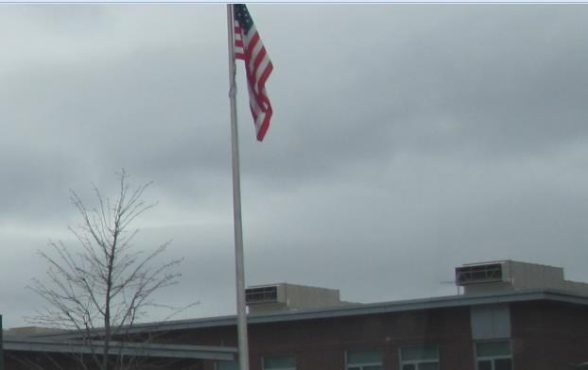

**Rooftop AHU units**

**Picture 2**

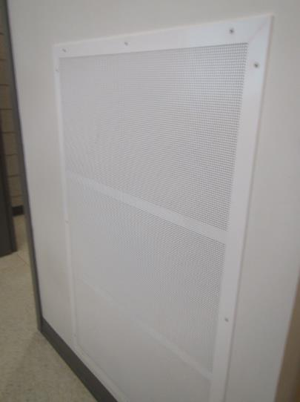

**Wall-mounted supply air diffuser**

**Picture 3**

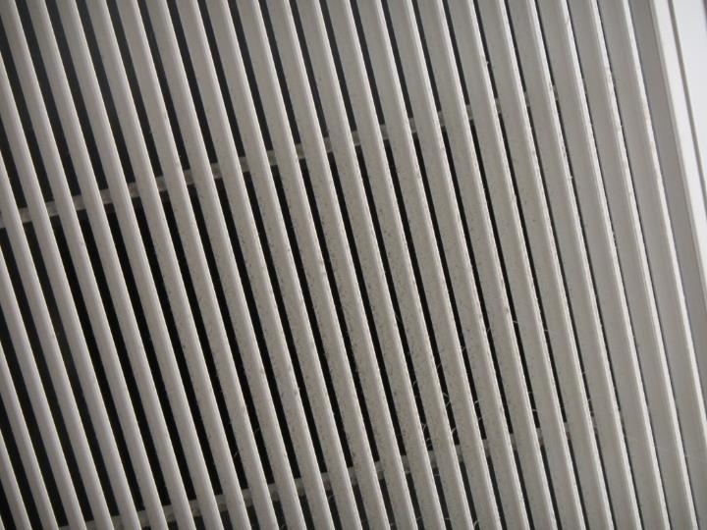

**Ceiling-mounted return/exhaust vent**

**Picture 4**

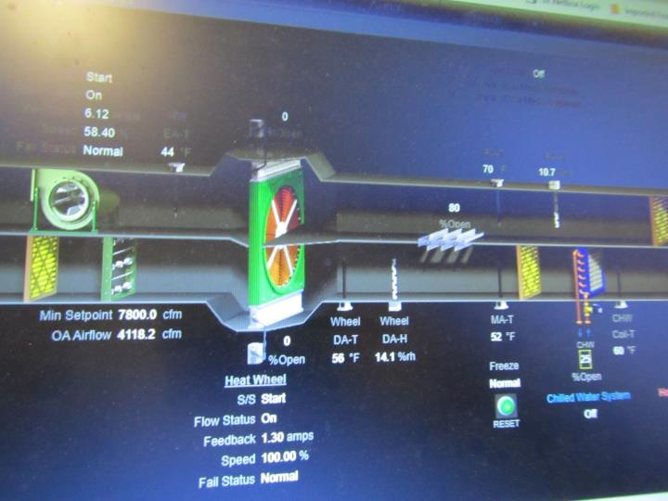

**Computer controlled AHU graphic user interface**

**Picture 5**

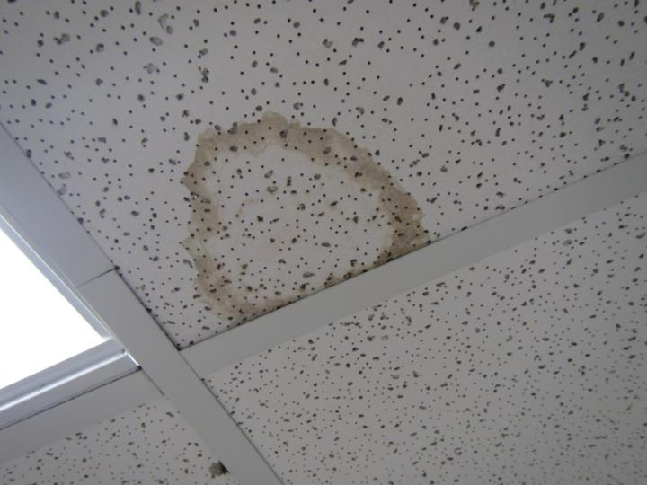

**Water-damaged ceiling tile**

**Picture 6**

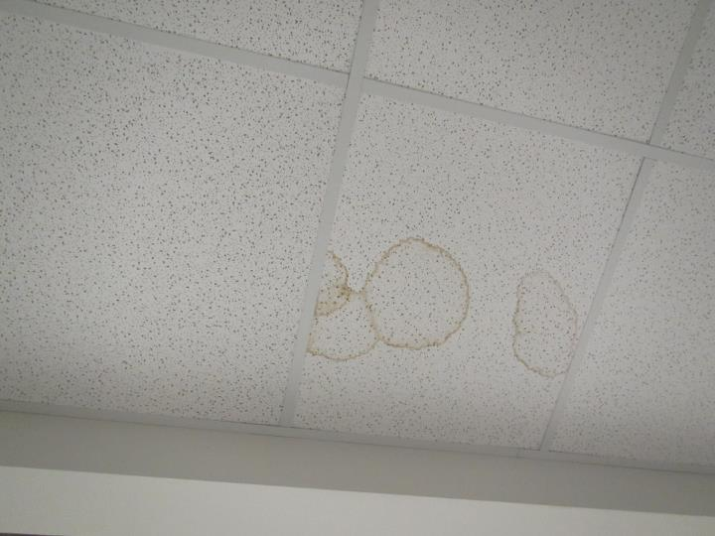

**Water-damaged ceiling tile**

**Picture 7**

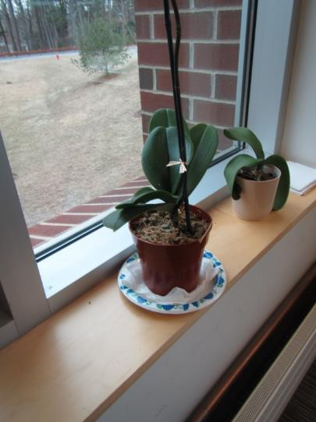

**Plant placed on porous materials**

**Picture 8**

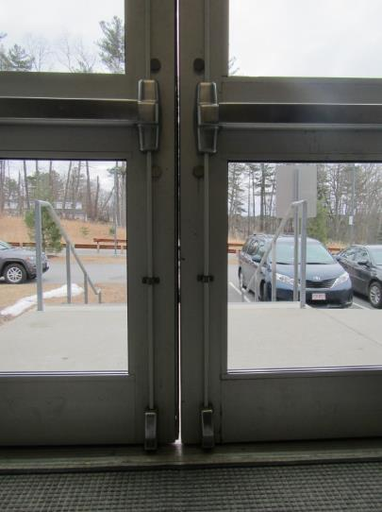

**Exterior door showing large gaps**

**Picture 9**

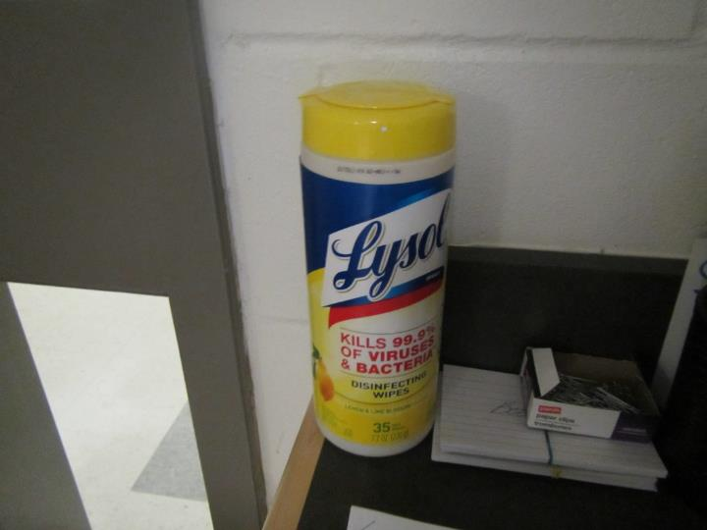

**Cleaning product containing VOCs**

**Picture 10**

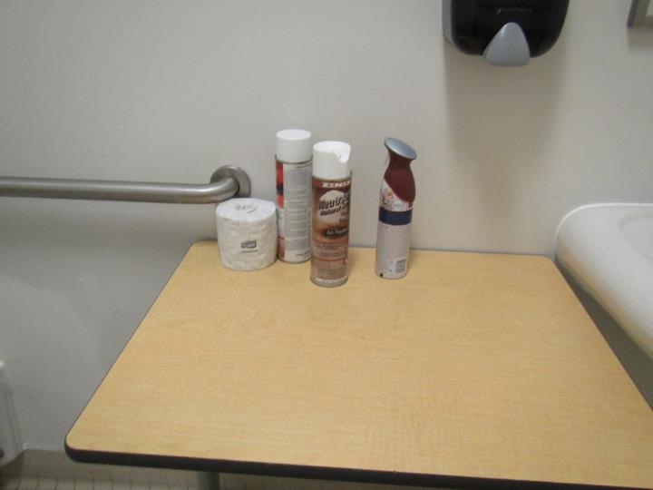

**Air fresheners in use**

**Picture 11**

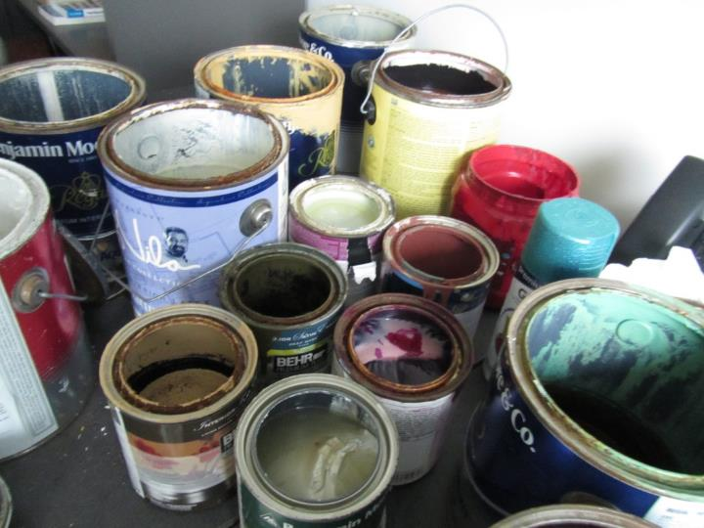

**Open paint cans in music office**

**Picture 12**

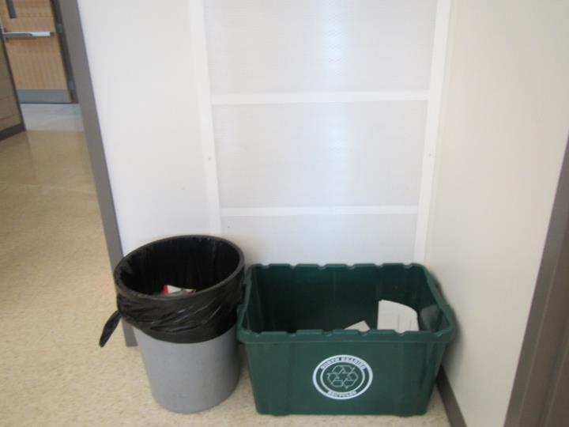

**Supply air diffuser partially obstructed by items**

**Picture 13**

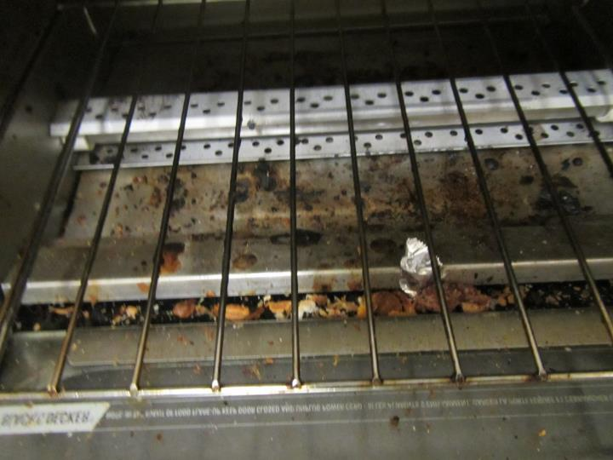

**Toaster oven showing accumulated crumbs**

**Picture 14**

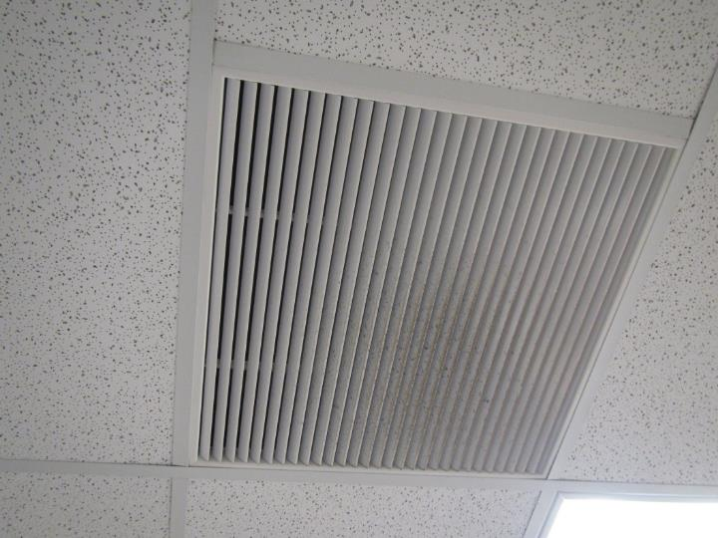

**Dusty return/exhaust vent**

| Location | **Carbon**  **Dioxide**  **(ppm)** | **Carbon Monoxide**  **(ppm)** | **Temp**  **(°F)** | **Relative**  **Humidity**  **(%)** | **PM2.5**  **(µg/m3)** | **TVOC**  **(ppm)** | **Occupants**  **in Room** | **Windows**  **Openable** | **Ventilation** | | **Remarks** |
| --- | --- | --- | --- | --- | --- | --- | --- | --- | --- | --- | --- |
| **Supply** | **Exhaust** |
| Background | 364 | ND | 31 | 19 | 8 | ND | - | - | - | - | Overcast, cold |
| principal’s office | 897 | ND | 68 | 20 | 4 | ND | 4 | Y | Y | Y | Carpet, plants, DEM, plug-in |
| B-5 assistant principal | 754 | ND | 70 | 15 | 1 | ND | 1 | N | Y | Y | Carpet, DEM |
| B-7 | 633 | ND | 70 | 13 | 0 | ND | 0 | N | Y | Y | DEM, plant, HS |
| B-9 | 675 | ND | 71 | 13 | 4 | ND | 4 | N | Y | Y | Carpet |
| B-13 | 824 | ND | 71 | 14 | 1 | ND | 1 | N | Y | Y | Fridge, carpet |
| B-10 | 612 | ND | 71 | 11 | 1 | ND | 1 | N | Y | Y | Plants, coffee maker, PF |
| B-1 office | 713 | ND | 71 | 12 | 2 | ND | 2 | Y | Y | Y | Carpet |
| HS 125 open area | 698 | ND | 69 | 10 | 0 | ND | 0 | N | Y | Y | UF, NC, DEM |
| HS 119 | 852 | ND | 70 | 13 | 7 | ND | 15 | Y | Y | Y | NC, DEM |
| HS 118 | 858 | ND | 70 | 13 | 6 | ND | 17 | Y | Y | Y | NC, DEM |
| HS 117 | 902 | ND | 70 | 13 | 6 | ND | 21 | Y | Y | Y | NC, DEM, HS |
| HS 116 | 1054 | ND | 73 | 13 | 5 | ND | 18 | Y | Y | Y | NC, DEM |
| HS 114 | 888 | ND | 70 | 14 | 6 | ND | 0 | Y | Y | Y | Science prep, hood — note date 2015, science items on floor and shelves, some chemicals mostly seem non-hazardous, DEM, sink |
| HS 109 | 903 | ND | 70 | 14 | 6 | ND | 13 | N | Y | Y | NC, DEM, PF - dusty, computers |
| HS 108 | 1048 | ND | 71 | 15 | 4 | ND | 19 | Y | Y | Y | DEM, HS, NC |
| HS 121 | 931 | ND | 71 | 14 | 4 | ND | 3 | N | Y | Y | PC, NC, sink, fridge |
| women’s RR |  |  |  |  |  |  |  | N | Y | Y |  |
| HS 105 | 973 | ND | 71 | 14 | 4 | ND | 16 | Y | Y | Y | NC, DEM |
| HS 104 | 931 | ND | 71 | 41 | 4 | ND | 16 | Y | Y | Y | NC, DEM |
| 1st floor faculty women’s RR |  |  |  |  |  |  |  | N | Y | Y | CP/AF |
| HS 102 | 923 | ND | 70 | 13 | 4 | ND | 12 | Y | Y | Y | DEM, NC, books |
| HS 101 | 1084 | ND | 70 | 15 | 2 | ND | 0 (class just left) | Y | Y | Y |  |
| HS 222 seminar | 767 | ND | 72 | 11 | 5 | ND | 0 | N | Y | Y | UF, NC, DEM |
| HS 215 | 966 | ND | 73 |  | 4 | ND | 21 | Y | Y | Y | NC, DEM, food |
| HS 223 | 747 | ND | 73 | 13 | 3 | ND | 2 | N | Y | Y | Planning room, sink and fridge, PC, CP, food |
| HS 214 | 673 | ND | 74 | 12 | 7 | ND | 4 | Y | Y | Y | DEM, UF, NC |
| HS 209 | 915 | ND | 73 | 14 | 6 | ND | 25 | Y | Y | Y | NC, DEM, science sinks, safety shower |
| HS 212 prep | 675 | ND | 72 | 11 | 4 | ND | 0 | Y | Y | Y | Hood, sink, dishwasher, NC |
| HS 208 | 849 | ND | 72 | 13 | 3 | ND | 0 | Y | Y | Y | NC, DEM |
| HS 207 | 788 | ND | 72 | 12 | 3 | ND | 2 | Y | Y | Y | NC, DEM, HS, food, beanbag, computers |
| HS 206 | 847 | ND | 70 | 13 | 3 | ND | 1 | Y | Y | Y | cooking equipment, Fridge, PF, 2 WD CT, kitchen hood |
| HS 204 | 880 | ND | 70 | 13 | 4 | ND | 1 | Y | Y | Y | HS, DEM, NC |
| 2nd floor faculty women’s room |  |  |  |  |  |  | 0 | N | Y | Y | AF |
| HS 208 | 1039 | ND | 71 | 14 | 4 | ND | 20 | Y | Y | Y | NC, DEM |
| HS 303 | 928 | ND | 71 | 14 | 4 | ND | 11 | Y | Y | Y | DEM, NC, HS |
| 3rd floor faculty women’s restroom |  |  |  |  |  |  | 0 | N | Y | Y | CP, AF |
| HS 301 | 948 | ND | 71 | 15 | 3 | ND | 8 | Y | Y | Y | NC, DEM, HS |
| M-2 | 638 | ND | 79 | 11 | 8 | ND | 0 | Y | Y | Y | Carpet, DEM |
| M-3 | 567 | ND | 70 | 11 | 8 | ND | 0 | Y | Y | Y | Carpeted, laminator, sink, microwave |
| M-5 | 541 | ND | 70 | 11 | 7 | ND | 0 | Y | Y | Y | Carpet, plants |
| M-4 | 577 | ND | 71 | 13 | 7 | ND | 0 | N | Y | Y | Large pile of power cords, carpet |
| library conference | 584 | ND | 71 | 11 | 8 | ND | 0 | N | Y | Y | Carpet |
| Special Ed office | 734 | ND | 72 | 12 | 9 | ND | 1 plus group just left | N | Y | Y | DEM, carpet, food |
| HS 121 | 700 | ND | 69 | 13 | 3 | ND | 20 | Y | Y | Y | Computers, paint |
| A 27 wood shop for theater | 564 | ND | 68 |  | 4 | ND | 4 | N and door | Y | Y | NC, paper mache, many cans of paint, wood shop items |
| HS 322 seminar | 771 | ND | 72 | 11 | 3 | ND | 7 | N | Y | Y | NC, UF, DEM,WD CT |
| HS 316 | 956 | ND | 71 | 13 | 3 | ND | 23 | Y | Y | Y | NC, DEM |
| HS 315 | 771 | ND | 71 | 12 | 3 | ND | 0 | Y | Y | Y | NC, DEM, plant, CP |
| HS 314 | 1049 | ND | 72 | 13 | 3 | ND | 20 | Y | Y | Y | NC, DEM, item hanging from ceiling |
| HS 313 | 820 | ND | 72 | 12 | 5 | ND | 16 | Y | Y | Y | DEM, NC |
| HS 309 | 729 | ND | 70 | 12 | 4 | ND | 11 | Y | Y | Y | DEM, NC, science sinks, |
| HS 312 prep |  |  |  |  |  |  |  |  | Y | Y | AI, items in sink, PF |
| DLL | 612 | ND | 71 | 10 | 3 | ND |  | Y | Y | Y | Carpet |
| HS 307 | 716 | ND | 70 | 12 | 3 | ND | 0 | Y | Y | Y | NC, DEM, carpets |
| women’s restroom |  |  |  |  |  |  |  | N | Y | Y |  |
| HS 306 | 800 | ND | 71 | 13 | 4 | ND | 5 | Y | Y | Y | Plants, NC, DEM, HS |
| HS 306 interior restroom |  |  |  |  |  |  |  | N | Y | Y | CP, AF, |
| HS 305 | 790 | ND | 70 | 13 | 3 | ND | 6 | Y | Y | Y | DEM, NC, HS |
| A-22 practice | 782 | ND | 68 | 15 | 1 | ND | 0 | N | Y | Y | NC, drums, piano |
| A-21 practice | 711 | ND | 68 | 15 | 2 | ND | 0 | N | Y | Y | Piano |
| A-19 music office | 612 | ND | 67 | 14 | 1 | ND | 0 | Y | Y | Y | Many paint cans drying, items |
| A-13 band office | 660 | ND | 68 | 20 | ND | ND | 0 | N | Y | Y | Microwave and fridge |
| theater | 659 | ND | 68 | 15 | 1 | ND | 2 | Y | Y | Y | Microwave, items |
| A-43 | 609 | ND | 67 | 15 | 3 | ND | 1 | N | Y | Y | NC, DEM, CP |
| A-40 | 565 | ND | 69 | 14 | 9 | ND | 0 | N | Y | Y | 1 WD CT, |
| Middle School CAF | 702 | ND | 70 | 14 | 5 | ND | >100 |  | Y | Y | NC |
| G-23 Girls Locker | 452 | ND | 66 | 10 | 1 | ND | 0 | N | Y | Y | Skylight |
| Girls Middle School locker | 555 | ND | 68 | 13 | 9 | ND | 1 | N | Y | Y | 1 WD CT |
| G-32 |  |  |  |  |  |  |  | N | Y | Y |  |
| Mail room | 709 | ND | 65 | 20 | 7 | ND | 1 | Y | Y | Y | Carpet, fridge on carpeting |
| B-8 | 722 | ND | 68 | 19 | 8 | ND | 1 | Y | Y | Y | Carpet tile |
| B-10 | 672 | ND | 68 | 15 | 11 | ND | 0 | Y | Y | Y | Carpet, plant |
| HS-126 | 615 | ND | 71 | 12 | 2 | ND | 1 | Y | Y | Y | PC, odor/heat complaints |
| HS-113 | 624 | ND | 70 | 12 | 1 | ND | 1 | Y | Y | Y | Science hood, DEM |
| HS-111 | 737 | ND | 70 | 14 | 4 | ND | 24 | Y | Y | Y | DEM |
| HS-110 | 672 | ND | 69 | 13 | 1 | ND | 2 | Y | Y | Y | DEM, CPs |
| HS-107 | 763 | ND | 70 | 14 | 2 | ND | 10 | Y | Y | Y |  |
| HS-106 | 741 | ND | 70 | 14 | 2 | ND | 7 | Y | Y | Y | HS, temperature complaint |
| HS-103 | 1064 | ND | 70 | 17 | 1 | ND | 25 | Y | Y | Y | HS, DEM |
| Atrium-1st floor | 835 | ND | 70 | 14 | 1 | ND | 50+ | Y | Y | Y | Carpet |
| HS-216 | 875 | ND | 71 | 15 | 3 | ND | 11 | Y | Y | Y |  |
| HS-213 | 770 | ND | 72 | 13 | 2 | ND | 9 | Y | Y | Y | DEM |
| HS-211 | 681 | ND | 71 | 12 | 4 | ND | 1 | Y | Y | Y |  |
| DL-1 | 504 | ND | 71 | 8 | 2 | ND | 18 | Y | Y | Y | New furnishings odor |
| HS-218 | 738 | ND | 71 | 14 | 2 | ND | 2 | Y | Y | Y |  |
| HS-205 | 989 | ND | 71 | 16 | 4 | ND | 21 | Y | Y | Y | DEM |
| HS-203 | 800 | ND | 71 | 14 | 3 | ND | 1 | Y | Y | Y |  |
| HS-201 | 1043 | ND | 71 | 11 | 4 | ND | 25 | Y | Y | Y |  |
| HS-323 | 654 | ND | 72 | 12 | 3 | ND | 2 | Y | Y | Y | AI, NC |
| HS-311 | 671 | ND | 71 | 13 | 7 | ND | 17 | Y | Y | Y | DEM, CPs |
| HS-308 | 976 | ND | 71 | 17 | 4 | ND | 14 | Y | Y | Y | HS, DEM |
| HS-318 | 918 | ND | 72 | 16 | 5 | ND | 3 | Y | Y | Y | PC has slight burning odor, stored food |
| HS-304 | 933 | ND | 71 | 15 | 7 | ND | 15 | Y | Y | Y | AI, boxes on floor |
| HS-302 | 1047 | ND | 72 | 17 | 5 | ND | 20 | Y | Y | Y | AI, DEM |
| Library-front | 687 | ND | 71 | 13 | 8 | ND | 35 | Y | Y | Y | Carpet, UF |
| Library-rear | 637 | ND | 71 | 13 | 8 | ND | 15 | Y | Y | Y |  |
| M-6 | 605 | ND | 72 | 12 | 8 | ND | 1 | Y | Y | Y | DEM |
| A-4 | 475 | ND | 70 | 13 | 2 | ND | 0 | N | Y | Y | NC, computers |
| A-5 | 445 | ND | 70 | 12 | 3 | ND | 1 | N | Y | Y | TV studio controls |
| A-7 | 446 | ND | 70 | 11 | 2 | ND | 2 | N | Y | Y |  |
| Stage | 436 | ND | 68 | 13 | 2 | ND | 3 | N | Y | Y |  |
| A-23 | 809 | ND | 68 | 19 | 5 | ND | 19 | N | Y | Y | AI, UF, DEM, CPs |
| A-20 | 540 | ND | 68 | 15 | 2 | ND | 3 | N | Y | Y | NC |
| A-14 | 684 | ND | 68 | 17 | 3 | ND | 3 | N | Y | Y | Instrument storage |
| A-42 | 525 | ND | 66 | 14 | 3 | ND | 0 | N | Y | N |  |
| HS- Cafeteria | 654 | ND | 71 | 14 | 5 | ND | 60+ | N | Y | Y | NC |