INDOOR AIR QUALITY ASSESSMENT

North Reading High School
191 Park Street
North Reading, Massachusetts 01864

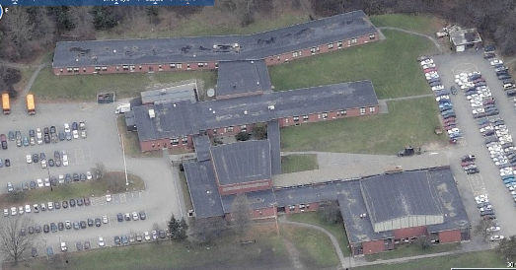

Prepared by:
Massachusetts Department of Public Health
Bureau of Environmental Health
Indoor Air Quality Program
May 2010

Background/Introduction
At the request of Wayne Hardacker, Supervisor of Buildings and Grounds, North Reading Public Schools, the Massachusetts Department of Public Health (MDPH), Bureau of Environmental Health (BEH) provided assistance and consultation regarding indoor air quality at the North Reading High School (NRHS) located at 191 Park Street, North Reading, Massachusetts. On April 13, 2009, Sharon Lee and James Tobin, Environmental Analysts/Inspectors for BEH’s Indoor Air Quality (IAQ) Program, visited the NRHS to conduct an assessment. During the assessment, BEH staff were accompanied by Mr. Hardacker and Principal Jon Bernard.
The NRHS is a one-story, cinderblock and brick building with a ventilated basement crawlspace originally built in 1957. The school has four distinct areas: A-wing, B-wing, C-wing and D-wing. The building has undergone renovations including the addition of a library between B- and C-wings in 1989 and modular classrooms (D-wing) in 2004. The school is graded downhill in a step-like fashion from the C-wing at the top of the hill to the A-wing at the bottom.
The A-wing houses general classrooms, art rooms, auditorium, office space, music room and band practice rooms. The A-wing also has a basement level which contains a crawlspace, boiler room, maintenance office, batting cages and storage space. The crawlspace can be entered through several access points throughout the school. The B-wing houses general classrooms, a library, kitchen, cafeteria, darkroom, TV studio and office space. The C-wing houses general classrooms, computer labs and science classrooms. The D-wing consists of modular classrooms. Windows are openable throughout the building.
BEH staff previously assessed the school in February 2001. A report detailing conditions observed at the time of that assessment was issued with recommendations to improve indoor air quality (MDPH, 2001). Actions taken in response to previous MDPH recommendations are included in Appendix A.

Methods
Air tests for carbon dioxide, temperature, relative humidity and carbon monoxide were conducted with the TSI, Q-Trak, IAQ Monitor, Model 7565. Air tests for airborne particle matter with a diameter less than 2.5 micrometers were taken with the TSI, DUSTTRAK™ Aerosol Monitor Model 8520. BEH staff also performed visual inspection of building materials for water damage and/or microbial growth.

Results
The school houses approximately 740 students in grades 9 through 12 with approximately 75 staff members. Tests were taken during normal operations and results appear in Table 1.

Discussion

Ventilation
It can be seen from Table 1 that carbon dioxide levels were above 800 parts per million (ppm) in 45 of 70 areas, indicating poor air exchange in the building at the time of the assessment. The ventilation system was operating in the majority of areas sampled; however, vents in a number of rooms were blocked with materials stored on/against louvers (and in one instance, the equipment was turned off). Furthermore, many offices lack mechanical supply and exhaust ventilation to allow for removal/dilution of normally occurring pollutants.
Fresh air for classrooms is supplied by unit ventilator (univent) systems (Picture 1). A univent draws outdoor air through a fresh air intake located on the exterior wall of the building (Picture 2), and return air from the room through an air intake located at the base of the unit (Figure 1). Fresh and return air are mixed, filtered, heated and distributed to the room through an air diffuser located in the top of the unit.
Univents were operating in the majority of rooms at the time of the assessment; however, despite reports of staff being made aware of the need to keep vents areas free from blockage, univent air diffusers and returns were blocked by books, furniture and other stored items in front and on top of the univent, preventing fresh air from being introduced and limiting airflow in these rooms (Picture 3). In order for univents to provide fresh air as designed, air diffusers, intakes and returns must remain free of obstructions. Importantly, these units must remain “on” and be allowed to operate while rooms are occupied. A univent operating in a mode that provides a constant supply of fresh, outdoor air can improve both indoor air quality and comfort, since this continual source of fresh air dilutes pollutants that typically accumulate in an indoor environment.
Exhaust ventilation in classrooms is provided by wall vents ducted to rooftop motors (Pictures 4 and 5). Exhaust ventilation systems continuously remove air that has become stale from moisture, odors, and pollutants. As with the univents, exhaust vents were operating in the majority of rooms during the assessment; however, BEH staff again found several exhaust vents blocked by furniture and other stored items preventing air from moving toward the vents (Pictures 5 and 6). In order to function properly, exhaust vents must be activated and allowed to operate without obstruction while rooms are occupied. Without adequate exhaust ventilation, excess heat and stale air can build up leading to indoor air quality and comfort complaints.
In the cafeteria, exhaust ventilation is provided by a large exhaust hood located in the kitchen (Picture 7). When activated, the exhaust hood draws air from the cafeteria through a series of passive vents into the kitchen, and out the exhaust hood. The kitchen exhaust hood was off at the time of the assessment.
At NRHS, dedicated local exhaust ventilation is used in areas where activities involve the use of chemicals including art and science rooms. In science classrooms and the dark room, manual timer switches on the wall activate ceiling-mounted exhaust vents to provide supplemental exhaust ventilation during experiments and photography activities (Picture 8). Kilns in the art room have dedicated exhaust ventilation that removes pollutants produced by the firing process.
Art room A101 lacks exhaust ventilation, general or dedicated. An abandoned exhaust vent is located in the exterior wall of the room (Picture 9). This vent was used for a spray booth previously housed in this art room. MDPH recommends providing exhaust ventilation to this room. Consideration should be given to using the abandoned exhaust vent in the wall; however, it is important that the exhaust vent is ducted up and away from a univent fresh air intake, which is located below the exhaust vent on the building exterior (Picture 10).
The heating, ventilating and air conditioning (HVAC) systems for the auditorium, gymnasium, library, TV studio and modular classrooms consist of air-handling units (AHUs). AHUs draw in fresh, outdoor air through air intakes; filter, heat and/or cool the air; and, then distribute it to rooms via ceiling- or wall-mounted air diffusers. Exhaust air is drawn through ceiling- or wall-mounted vents. Thermostats that control the HVAC system in the modular classrooms have fan settings of “on” and “automatic.” At the time of the assessment, thermostats were set to the fan “automatic” setting. The “automatic” setting on the thermostat activates the HVAC system at a preset temperature, and then deactivates the system once the preset temperature is reached. In the fan “on” setting, the HVAC system provides continuous airflow to the rooms.
To maximize air exchange, the MDPH recommends that both supply and exhaust ventilation operate continuously during periods of school occupancy. In order to have proper ventilation with a mechanical supply and exhaust system, the systems must be balanced to provide an adequate amount of fresh air to the interior of a room while removing stale air from the room. It is recommended that HVAC systems be re-balanced every five years to ensure adequate air systems function (SMACNA, 1994).
The Massachusetts Building Code requires that each room have a minimum ventilation rate of 15 cubic feet per minute (cfm) per occupant of fresh outside air or openable windows (SBBRS, 1997; BOCA, 1993). The ventilation must be on at all times that the room is occupied. Providing adequate fresh air ventilation with open windows and maintaining the temperature in the comfort range during the cold weather season is impractical. Mechanical ventilation is usually required to provide adequate fresh air ventilation.
Carbon dioxide is not a problem in and of itself. It is used as an indicator of the adequacy of the fresh air ventilation. As carbon dioxide levels rise, it indicates that the ventilating system is malfunctioning or the design occupancy of the room is being exceeded. When this happens, a buildup of common indoor air pollutants can occur, leading to discomfort or health complaints. The Occupational Safety and Health Administration (OSHA) standard for carbon dioxide is 5,000 parts per million parts of air (ppm). Workers may be exposed to this level for 40 hours/week, based on a time-weighted average (OSHA, 1997).
The MDPH uses a guideline of 800 ppm for publicly occupied buildings. A guideline of 600 ppm or less is preferred in schools due to the fact that the majority of occupants are young and considered to be a more sensitive population in the evaluation of environmental health status. Inadequate ventilation and/or elevated temperatures are major causes of complaints such as respiratory, eye, nose and throat irritation, lethargy and headaches. For more information concerning carbon dioxide, consult Appendix B.
Indoor temperature measurements ranged from 70º F to 79º F, which for the most part were within the MDPH recommended comfort range (Table 1). The MDPH recommends that indoor air temperatures be maintained in a range of 70º F to 78º F in order to provide for the comfort of building occupants. In many cases concerning indoor air quality, fluctuations of temperature in occupied spaces are typically experienced, even in a building with an adequate fresh air supply. Chronic heat complaints due to sun exposure were reported in the C-wing classrooms facing south. Solar gain from sun exposure can combine with waste heat from building occupants and electrical equipment to cause thermal discomfort. However, it is difficult to control temperature and maintain comfort without operating ventilation equipment as designed (e.g., univents/exhaust vents deactivated/blocked).
The relative humidity in the building ranged from 16 to 47 percent, with many areas below the MDPH recommended comfort range (Table 1). The MDPH recommends a comfort range of 40 to 60 percent for indoor air relative humidity. Relative humidity levels in the building would be expected to drop during the winter months due to heating. The sensation of dryness and irritation is common in a low relative humidity environment. Low relative humidity is a very common problem during the heating season in the northeast part of the United States.

Microbial/Moisture Concerns
BEH staff examined building materials for water damage and/or microbial growth. In order for building materials to support mold growth, a source of water exposure is necessary. Identification and elimination of the source of water moistening building materials is necessary to control mold growth.
The basement crawlspace has a dirt floor. Within the crawlspace, the soil and other materials including carpets, pipe insulation and stored items can support mold growth when exposed to moisture. Carpets were spread over the dirt floor of the crawlspace in the area used for baseball batting and pitching drills, where BEH found them worn and water-damaged (Picture 11).
A number of rooms had water-damaged ceiling tiles, which can indicate leaks from the roof or plumbing system (Picture 12). Water-damaged ceiling tiles can indicate sources of water penetration and provide a source of mold growth. Ceiling tiles should be replaced after a water leak is discovered and repaired.
The US Environmental Protection Agency (US EPA) and the American Conference of Governmental Industrial Hygienists (ACGIH) recommend that porous materials be dried with fans and heating within 24 to 48 hours of becoming wet (US EPA, 2001; ACGIH, 1989). If not dried within this time frame, mold growth may occur. Once mold has colonized porous materials, they are difficult to clean and should be removed and discarded.
Several classrooms had a number of plants. Moistened plant soil and drip pans can be sources of mold growth. Plants should be equipped with drip pans; the lack of drip pans can lead to water pooling and mold growth. Plants are also a source of pollen and should be located away from the air stream of air diffusers to prevent the aerosolization of mold, pollen or particulate matter throughout the classroom.

Other IAQ Evaluations
Indoor air quality can be negatively influenced by the presence of respiratory irritants, such as products of combustion. The process of combustion produces a number of pollutants. Common combustion emissions include carbon monoxide, carbon dioxide, water vapor and smoke (fine airborne particle material). Of these materials, exposure to carbon monoxide and particulate matter with a diameter of 2.5 micrometers (μm) or less (PM2.5) can produce immediate, acute health effects upon exposure. To determine whether combustion products were present in the school environment, BEH staff obtained measurements for carbon monoxide and PM2.5.

Carbon Monoxide
Carbon monoxide is a by-product of incomplete combustion of organic matter (e.g., gasoline, wood and tobacco). Exposure to carbon monoxide can produce immediate and acute health affects. Several air quality standards have been established to address carbon monoxide and prevent symptoms from exposure to these substances. The MDPH established a corrective action level concerning carbon monoxide in ice skating rinks that use fossil-fueled ice resurfacing equipment. If an operator of an indoor ice rink measures a carbon monoxide level over 30 ppm, taken 20 minutes after resurfacing within a rink, that operator must take actions to reduce carbon monoxide levels (MDPH, 1997).
The American Society of Heating Refrigeration and Air-Conditioning Engineers (ASHRAE) has adopted the National Ambient Air Quality Standards (NAAQS) as one set of criteria for assessing indoor air quality and monitoring of fresh air introduced by HVAC systems (ASHRAE, 1989). The NAAQS are standards established by the US EPA to protect the public health from six criteria pollutants, including carbon monoxide and particulate matter (US EPA, 2006). As recommended by ASHRAE, pollutant levels of fresh air introduced to a building should not exceed the NAAQS levels (ASHRAE, 1989). The NAAQS were adopted by reference in the Building Officials & Code Administrators (BOCA) National Mechanical Code of 1993 (BOCA, 1993), which is now an HVAC standard included in the Massachusetts State Building Code (SBBRS, 1997). According to the NAAQS, carbon monoxide levels in outdoor air should not exceed 9 ppm in an eight-hour average (US EPA, 2006).
Carbon monoxide should not be present in a typical, indoor environment. If it is present, indoor carbon monoxide levels should be less than or equal to outdoor levels. Outdoor carbon monoxide concentrations were non-detect (ND) at the time of the assessment (Table 1). Carbon monoxide levels measured inside the building were also ND with the exception of the boiler room (Table 1). Carbon monoxide levels measured in the boiler room ranged from ND – 2 ppm. Measurable carbon monoxide levels were likely related to the boiler and cigarette smoke.
BEH staff detected the odor of cigarette smoke in the boiler room during this assessment. NRHS administration reported that cigarette smoking does occur periodically in the boiler room. Environmental Tobacco Smoke (ETS) is a mixture of gases and fine particles emitted by the burning of tobacco products and smoke exhaled by the smoker (USDHHS, 2006). ETS is a pollutant which can have a marked effect on indoor air quality and cause adverse health effects. ETS can exacerbate the frequency and severity of symptoms in individuals with respiratory conditions (i.e. asthma), as well as those with existing or known heart conditions. The most effective method of preventing exposure to environmental tobacco smoke is to have smoke free buildings. Under a law commonly referred to as the “Education Reform Act”, Massachusetts requires that all public schools through high school prohibit smoking and use of tobacco products on school grounds, on school buses, and at school sponsored events (MGL ch. 270, §22(b)(2); MGL ch. 71, §§2A, 37H; ch. 90, §7B(10)).

Particulate Matter (PM2.5)
The US EPA has established NAAQS limits for exposure to particulate matter. Particulate matter is airborne solids that can be irritating to the eyes, nose and throat. The NAAQS originally established exposure limits to particulate matter with a diameter of 10 μm or less (PM10). According to the NAAQS, PM10 levels should not exceed 150 microgram per cubic meter (μg/m³) in a 24-hour average (US EPA, 2006). These standards were adopted by both ASHRAE and BOCA. Since the issuance of the ASHRAE standard and BOCA Code, US EPA established a more protective standard for fine airborne particles. This more stringent PM2.5 standard requires outdoor air particle levels be maintained below 35 μg/m³ over a 24-hour average (US EPA, 2006). Although both the ASHRAE standard and BOCA Code adopted the PM10 standard for evaluating air quality, MDPH uses the more protective PM2.5 standard for evaluating airborne particulate matter concentrations in the indoor environment.
Outdoor PM2.5 concentrations the day of the assessment were measured at 5 μg/m³. PM2.5 levels measured inside the school were below the NAAQS PM2.5 level of 35 μg/m³ in all but one area, the boiler room, where PM2.5 levels measured 63 and 163 μg/m³. Indoor measurements in all other areas ranged from 3 to 12 μg/m³ (Table 1). Elevated PM2.5 levels in the boiler room were resultant of the boiler and the previously discussed cigarette smoke.
Frequently, indoor air levels of particulates (including PM2.5) can be at higher levels than those measured outdoors. A number of mechanical devices and/or activities that occur in schools can generate particulate during normal operations. Sources of indoor airborne particulates may include but are not limited to: particles generated during the operation of fan belts in the HVAC system; cooking in the cafeteria stoves and microwave ovens; use of photocopiers, fax machines and computer printing devices; operation of an ordinary vacuum cleaner; and, heavy foot traffic indoors.

Volatile Organic Compounds
Indoor air concentrations can be greatly impacted by the use of products containing volatile organic compounds (VOCs). VOCs are carbon-containing substances that have the ability to evaporate at room temperature. Frequently, exposure to low levels of total VOCs (TVOCs) may produce eye, nose, throat and/or respiratory irritation in some sensitive individuals. For example, chemicals evaporating from a paint can stored at room temperature would most likely contain VOCs. In an effort to identify materials that can potentially increase indoor VOC concentrations, BEH staff examined rooms for products containing these respiratory irritants.
Cleaning products were found in rooms throughout the building (Picture 11). Cleaning products contain chemicals that can be irritating to the eyes, nose and throat of sensitive individuals. These products should be properly labeled and stored in an area inaccessible to children. Additionally, a Material Safety Data Sheet (MSDS) should be available at a central location for each product in the event of an emergency. Consideration should be given to providing teaching staff with school issued cleaning products and supplies to prevent any potential for adverse chemical interactions between residues left from cleaners used by the schools facilities staff and those left by cleaners brought in by others.
Several classrooms contained dry erase boards and related materials. Materials such as dry erase markers and dry erase board cleaners may contain VOCs, such as methyl isobutyl ketone, n-butyl acetate and butyl-cellusolve (Sanford, 1999), which can be irritating to the eyes, nose and throat.
Plug-in air fresheners were in use in several areas. Air fresheners contain chemicals that can be irritating to the eyes, nose and throat of sensitive individuals. Further, air fresheners do not remove materials causing odors, but rather, mask odors which may be present in the area.
BEH found rubber cement stored in an art room (Picture 14). Rubber cement consists of natural rubber dissolved in solvent, typically heptane or n-hexane (Union Rubber, Inc., 2009). It is an extremely flammable material, and can be irritating to the eyes, nose and throat. Rubber cement should be stored in a flammables storage cabinet, and used in a well-ventilated area according to the manufacturer’s instructions.

Other Conditions
Other conditions that can affect indoor air quality were observed during the assessment. In several classrooms, items were observed on windowsills, tabletops, counters, bookcases and desks. The large number of items stored in classrooms provides a source for dusts to accumulate. These items (e.g., papers, folders, boxes) make it difficult for custodial staff to clean. Items should be relocated and/or be cleaned periodically to avoid excessive dust build up. In addition, these materials can accumulate on flat surfaces (e.g., desktops, shelving and carpets) in occupied areas and subsequently be re-aerosolized causing further irritation.
An accumulation of chalk dust and dry erase particulate was observed in some classrooms. When windows are opened or univents are operating, these materials can become airborne. Once aerosolized, they can act as irritants to the eyes and respiratory system.
Lastly, a number of univent/supply air diffusers, exhaust vents and personal fans in classrooms were observed to have accumulated dust/debris (Picture 15). Re-activated supply vents/fans can aerosolize dust accumulated on fan blades/housing. If exhaust vents are not functioning, backdrafting can occur, which can re-aerosolize dust particles.

Conclusions/Recommendations
In view of the findings at the time of the assessment, the following recommendations are made to improve indoor air quality:
- Operate all ventilation systems (e.g., univents and AHUs) throughout the building continuously during periods of school occupancy.
- To increase airflow in classrooms, set univent controls to “high.” Set thermostat for AHUs to the fan “on” setting in order to provide continuous airflow to the rooms.
- Inspect all exhaust motors and belts periodically for proper function. Repair and replace as necessary.
- Remove all blockages from univents and exhaust vents to ensure adequate airflow. School staff should be encouraged not to deactivate classroom univents; rather, report any complaints concerning temperature control to the facilities department.
- Utilize dedicated exhaust ventilation in science classrooms, the dark room, and art rooms; particularly, during activities involving the use of chemicals and the kiln firing process.
- Provide exhaust ventilation to art room A101. Consider using abandoned exhaust vent in exterior wall of room.
- Use openable windows in conjunction with mechanical ventilation to increase air exchange. Care should be taken to ensure windows are properly closed at night and weekends to avoid the freezing of pipes and potential flooding.
- Consider adopting a balancing schedule of every 5 years for all mechanical ventilation systems, as recommended by ventilation industrial standards (SMACNA, 1994).
- Consider applying a tinted film to the windows of classrooms on south side of the C-wing (and other areas if necessary) to reduce solar gain.
- Prohibit smoking on school premise, as required by the “Education Reform Act” (MGL ch. 270, §22(b)(2); MGL ch. 71, §§2A, 37H; ch. 90, §7B(10)). Monitor boiler room periodically to ensure smoking is not occurring.
- For buildings in New England, periods of low relative humidity during the winter are often unavoidable. Therefore, scrupulous cleaning practices should be adopted to minimize common indoor air contaminants whose irritant effects can be enhanced when the relative humidity is low. To control for dusts, a high efficiency particulate arrestance (HEPA) filter equipped vacuum cleaner in conjunction with wet wiping of all surfaces is recommended. Avoid the use of feather dusters. Drinking water during the day can help ease some symptoms associated with a dry environment (throat and sinus irritations).
- Install a rubber membrane or a similar non-porous material in the basement baseball area instead of using carpeting. If carpeting is deemed necessary, install the rubber membrane under the carpeting.
- Ensure seal around crawlspace access points are intact in order to prevent odors from moving in to occupied areas.
- Repair any existing water leaks and replace any remaining water-damaged ceiling tiles. Examine the area above these tiles for mold growth. Disinfect areas of water leaks with an appropriate antimicrobial, as needed.
- Ensure plants have drip pans. Examine drip pans periodically for mold growth and disinfect with an appropriate antimicrobial where necessary. Move plants away from the air stream of ventilation sources.
- Store cleaning products properly. All cleaning products used at the facility should be approved by the school department with MSDS’ available at a central location.
- Refrain from using air fresheners or other air deodorizers to prevent exposure to VOCs.
- Clean dry erase board and chalk trays periodically to prevent particulate accumulation.
- Store rubber cement in a flammables storage cabinet.
- Relocate or consider reducing the amount of materials stored in classrooms to allow for more thorough cleaning of classrooms. Clean items regularly with a wet cloth or sponge to prevent excessive dust build-up. Clean accumulated dust and debris periodically from univent air diffusers, exhaust vents and blades of personal fans.
- Consider adopting the US EPA (2000) document, “Tools for Schools”, as an instrument for maintaining a good indoor air quality environment in the building. This document is available at: http://www.epa.gov/iaq/schools/index.html.
- Refer to resource manual and other related indoor air quality documents located on the MDPH’s website for further building-wide evaluations and advice on maintaining public buildings. These documents are available at: http://mass.gov/dph/iaq.

References
ACGIH. 1989. Guidelines for the Assessment of Bioaerosols in the Indoor Environment. American Conference of Governmental Industrial Hygienists, Cincinnati, OH.
ASHRAE. 1989. Ventilation for Acceptable Indoor Air Quality. American Society of Heating, Refrigeration and Air Conditioning Engineers. ANSI/ASHRAE 62-1989.
BOCA. 1993. The BOCA National Mechanical Code/1993. 8th ed. Building Officials & Code Administrators International, Inc., Country Club Hills, IL.
MDPH. 1997. Requirements to Maintain Air Quality in Indoor Skating Rinks (State Sanitary Code, Chapter XI). 105 CMR 675.000. Massachusetts Department of Public Health, Boston, MA.
MDPH. 2001. Indoor Air Quality Assessment, North Reading High School, North Reading, MA. Massachusetts Department of Public Health, Bureau of Environmental Health Assessment, Boston, MA. May 2001.
M.G.L. 2004. Smoke-Free Workplace Law, Massachusetts General Laws. M.G.L. Chapter 270, section 22.
OSHA. 1997. Limits for Air Contaminants. Occupational Safety and Health Administration. Code of Federal Regulations. 29 C.F.R 1910.1000 Table Z-1-A.
Sanford. 1999. Material Safety Data Sheet (MSDS No: 198-17). Expo® Dry Erase Markers Bullet, Chisel, and Ultra Fine Tip. Sanford Corporation. Bellwood, IL.
SBBRS. 1997. Mechanical Ventilation. State Board of Building Regulations and Standards. Code of Massachusetts Regulations. 780 CMR 1209.0
SMACNA. 1994. HVAC Systems Commissioning Manual. 1st ed. Sheet Metal and Air Conditioning Contractors’ National Association, Inc., Chantilly, VA.
Union Rubber, Inc. 2009. Material Safety Data Sheet: Best Test Rubber Cement. Union Rubber, Inc., Trenton, NJ.
US EPA. 2000. Tools for Schools. Office of Air and Radiation, Office of Radiation and Indoor Air, Indoor Environments Division (6609J). EPA 402-K-95-001, Second Edition. http://www.epa.gov/iaq/schools/tools4s2.html.
US EPA. 2001. “Mold Remediation in Schools and Commercial Buildings”. Office of Air and Radiation, Indoor Environments Division, Washington, DC. EPA 402-K-01-001. March 2001. Available at: http://www.epa.gov/iaq/molds/mold_remediation.html.
US EPA. 2006. National Ambient Air Quality Standards (NAAQS). US Environmental Protection Agency, Office of Air Quality Planning and Standards, Washington, DC. http://www.epa.gov/air/criteria.html.
U.S. Department of Health and Human Services. 2006. The Health Consequences of Involuntary Exposure to Tobacco Smoke: A Report of the Surgeon General. U.S. Department of Health and Human Services, Centers for Disease Control and Prevention, Coordinating Center for Health Promotion, National Center for Chronic Disease Prevention and Health Promotion, Office on Smoking and Health, Atlanta, GA.
Picture 1

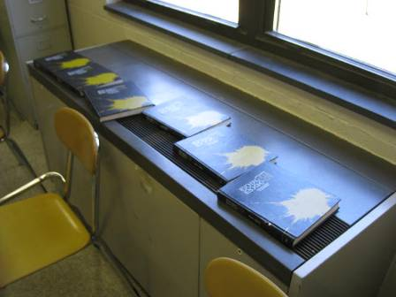

Classroom Univent, Note Books on Air Diffuser

Picture 2

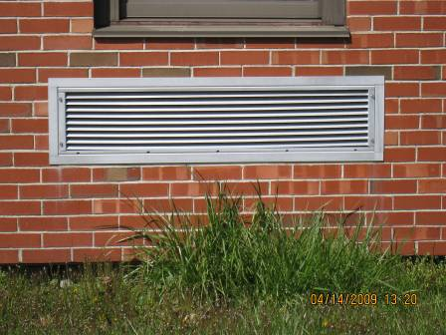

Univent Air Intake on Exterior Wall

Picture 3

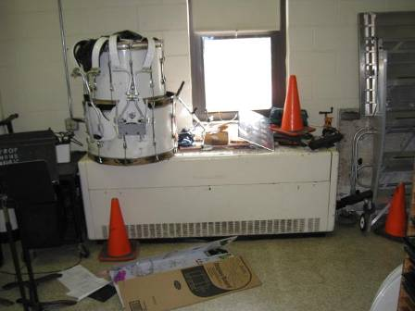

Equipment on Univent

Picture 4

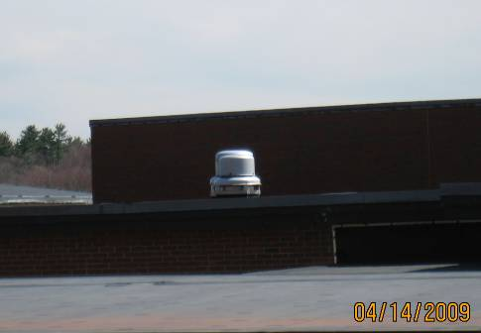

Rooftop Exhaust Motor

Picture 5

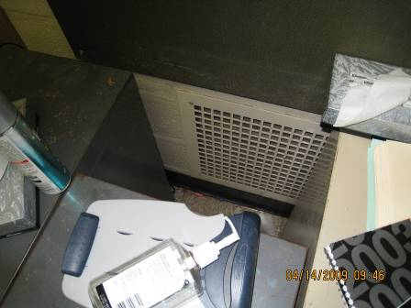

Exhaust Vent on Wall, Note Items Blocking

Picture 6

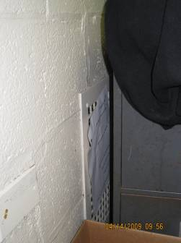

Exhaust Vent Blocked by Furniture

Picture 7

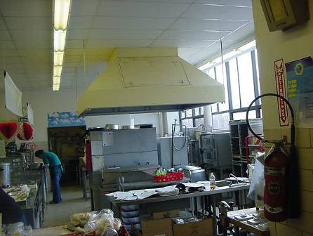

Exhaust Hood in Kitchen

Picture 8

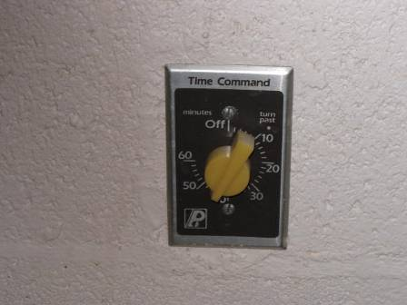

Manual Timer Switches in Science Classrooms

Picture 9

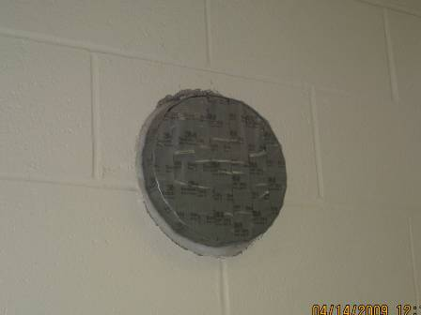

Abandoned Exhaust Vent in Exterior Wall of Room

Picture 10

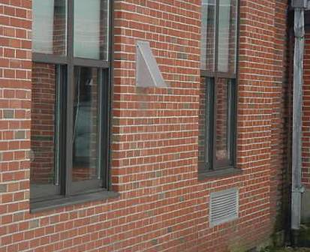

Univent Fresh Air Intake Below Exhaust Vent on Building Exterior

Picture 11

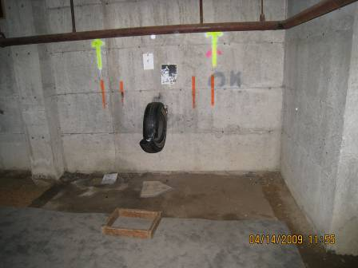

Carpeting over Dirt Floor in Crawlspace

Picture 12

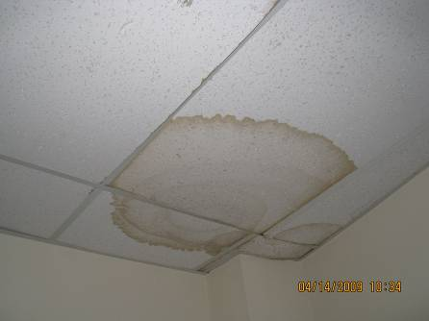

Water-Damaged Ceiling Tiles

Picture 13

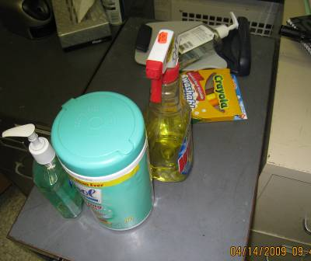

Cleaning Products on Cabinet

Picture 14

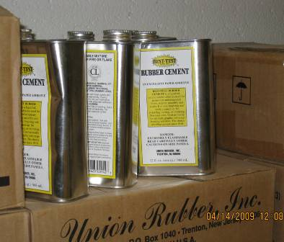

Rubber Cement in Art Room

Picture 15

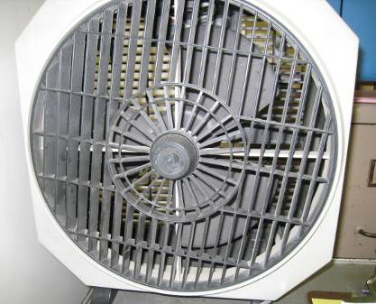

Accumulated Dust on Fan Blades
Location/ Room | Occupants  in Room | Temp  (°F) | Relative  Humidity  (%) | Carbon  Dioxide  (ppm) | Carbon Monoxide  (ppm) | PM2.5  (µg/m³) | Windows  Openable | Ventilation |  | Remarks
 |  |  |  |  |  |  |  | Supply | Exhaust | Remarks
background |  | 52 | 15 | 413 | ND | 5 |  |  |  | Sunny, Slight Breeze
C120 | 27 | 73 | 32 | 1597 | ND | 7 | Y | Y  stored items | Y  blocked by furniture | PFs; DEM; DO; computers
C121 | 27 | 74 | 26 | 1023 | ND | 9 | Y | Y  whiteboard | Y | DEM; MT; DO; computers
C122 | 28 | 74 | 29 | 1377 | ND | 10 | Y | Y | Y  blocked by furniture | PFs; DEM with odors
C123 | 0 | 79 | 26 | 821 | ND | 5 | Y | Y  dust, debris | Y  blocked by furniture | DEM; DO
C124 | 1 | 73 | 23 | 606 | ND | 5 | Y | Y  stored items | Y | CD; DO
C125 | 20 | 73 | 23 | 901 | ND | 5 | Y | Y  stored items | Y  blocked | DEM; Plants; Stored Items
C126 | 26 | 74 | 30 | 943 | ND | 5 | Y | Y  stored items | Y | Computers; CD; DEM; PF
Foreign Language/ Math Office | 0 | 70 | 47 | 543 | ND | 8 | Y | N | N | DO; crawlspace access
C-wing Girls Room |  |  |  |  |  |  | Y | N | Y
C129 | 1 | 74 | 28 | 956 | ND | 5 | Y | Y | N | 21 computers; DEM
Science Office | 1 | 73 | 25 | 721 | ND | 4 | Y | N | Y
C131 | 15 | 72 | 26 | 914 | ND | 5 | Y | Y | Y | DEM; DO; PF; stored items
C132 | 23 | 71 | 27 | 1083 | ND | 5 | Y | Y | Y | DEM
C133 | 13 | 71 | 28 | 918 | ND | 7 | Y | Y | Y | DEM; DO
C101 | 9 | 75 | 31 | 1067 | ND | 6 | Y | Y  blocked by furniture | Y | DEM; DO
D106 | 14 | 72 | 20 | 654 | ND | 3 | Y | Y | Y
D105 | 18 | 71 | 23 | 861 | ND | 3 | Y | Y | Y | DEM
D104 | 15 | 72 | 23 | 841 | ND | 6 | Y | Y | Y  dust | AT; DEM
B104 | 2 | 73 | 21 | 642 | ND | 4 | Y | Y  plants | Y | Plants; DEM; AD
Dark Room | 0 | 72 | 24 | 838 | ND | 5 | N | Y  passive | Y | General and dedicated exhaust
B103 | 15 | 73 | 26 | 1014 | ND | 6 | Y | Y  books, debris in diffuser | Y | DEM
B102 | 23 | 72 | 20 | 915 | ND | 6 | Y  1 of 3 open | Y | Y | DEM; occupants left 5 minutes prior
B101 | 25 | 72 | 26 | 1156 | ND | 9 | Y | Y | Y  weak | DEM
TV studio | 2 | 72 | 38 | 909 | ND | 6 | N | Y  off | Y  off | AHU off
B108 conference | 0 | 72 | 20 | 594 | ND | 5 | Y | Y | Y | WD CTs
Cafeteria | 150 | 72 | 26 | 1387 | ND | 12 | Y | Y  2 UV | Y  passive vent on wall | Kitchen exhaust off
A105 | 15 | 74 | 23 | 1114 | ND | 9 | Y | Y | Y | CPs; DEM
Suspension Room | 1 | 73 | 29 | 631 | ND | 5 | Y | N | Y | MTs
Boiler Room:  Upper and Lower Level |  | 74 | 17 |  | ND – 2 | Upper: 63  Lower: 163 |  |  |  | Upper Level: cigarette smoke odor  Lower Level: gas odor near boiler
A104 | 1 | 72 | 16 | 512 | ND | 4 | Y  1 of 3 open | Y  off | Y | Dedicated exhaust on; rubber cement on counter
Music practice A | 0 | 70 | 23 | 503 | ND | 3 | N | Y | Y | DO
Music practice B | 0 | 70 | 23 | 453 | ND | 3 | N | Y | Y | DO
Music office | 0 | 70 | 28 | 484 | ND | 4 | Y | N | N
Nurse’s office | 0 | 71 | 31 | 1015 | ND | 6 | Y | N | Y  off | PF
Giuliotti office | 1 | 72 | 29 | 1156 | ND | 5 | Y | N | N | DO
Rezmiarck office | 0 | 72 | 27 | 935 | ND | 5 | Y | N | N | DO
Main office | 1 | 71 | 28 | 966 | ND | 4 | Y | N | N | Plants
Principal | 0 | 71 | 27 | 815 | ND | 10 | Y | N | N | Fridge on carpet
C118 | 20 | 71 | 31 | 702 | ND | 4 | Y | Y | Y | General exhaust vent on wall; Dedicated exhaust on ceiling off; DEM
C115 | 23 | 73 | 29 | 849 | ND | 5 | Y | Y | Y | General exhaust vent on wall; Dedicated exhaust on ceiling off; DO; DEM
C113 | 0 | 71 | 28 | 692 | ND | 5 | Y | Y | Y | General exhaust vent on wall blocked; Dedicated exhaust on ceiling off; DEM; WD CTs
C112 Chemical Prep | 0 | 73 | 27 | 714 | ND | 6 | N | N | Y  dust
C111 | 16 | 75 | 25 | 826 | ND | 5 | Y | Y  stored items | Y | General exhaust vent on wall blocked by cabinet; Dedicated exhaust on ceiling off, WD CTs around ceiling exhaust; DEM; DO; PF
C110 | 22 | 75 | 25 | 873 | ND | 6 | Y | Y  stored items | Y
C105 | 22 | 76 | 34 | 1309 | ND | 5 | Y | Y | weak | Computers; DEM; WD CTs
C104 | 17 | 76 | 29 | 1088 | ND | 4 | Y | Y | Y  blocked by furniture | DEM odor
C103 | 19 | 75 | 25 | 783 | ND | 6 | Y  2 of 4 open | Y  stored items | Y | AT; DEM
C102 | 16 | 74 | 30 | 879 | ND | 6 | Y | Y | Y | DO; DEM
C134 | 23 | 74 | 27 | 989 | ND | 6 | Y | Y | Y | DO; DEM
Library | 9 | 73 | 27 | 895 | ND | 4 | Y | Y | Y  dust | WD CTs
Library Computer Room | 24 | 76 | 25 | 901 | ND | 8 | Y  1 of 3 open | Y | Y | WD CTs; AT; 24 computers
D101 | 12 | 71 | 30 | 1255 | ND | 5 | Y | Y | Y | DEM
D102 | 13 | 72 | 30 | 705 | ND | 6 | Y | Y | Y | DEM
D103 | 20 | 72 | 28 | 835 | ND | 5 | Y | Y | Y | DEM
B140 | 8 | 72 | 22 | 711 | ND | 7 | Y | Y | Y | AD; DO; computers
B141 | 15 | 73 | 22 | 955 | ND | 6 | Y | Y  stored items | Y  blocked by furniture | DEM
B142 | 0 | 73 | 29 | 1291 | ND | 10 | Y | Y  books on diffuser | Y  blocked by furniture | DEM
B143 | 0 | 70 | 29 | 1554 | ND | 7 | Y | Y  books | Y  blocked by furniture | PF; DEM
English Office | 1 | 70 | 28 | 978 | ND | 10 | Y | N | N | Book storage; DO
B109 | 0 | 72 | 22 | 826 | ND | 8 | Y | Y  Scented markers and books | Y  blocked by furniture
Server | 1 | 72 | 22 | 578 | ND | 6 | N | Y | Hole in wall | PF; DO
Supplemental Cafeteria | 50 | 72 | 26 | 1218 | ND | 10 | Y | Y | Y
Gymnasium | 0 | 70 | 21 | 419 | ND | 6 | N | Y | Y
A108 | 0 | 71 | 19 | 453 | ND | 7 | Y | Y | Y  off | Ceramics equipment; kilns with dedicated local exhaust system
Boys Locker |  |  |  |  |  |  |  | Y | Y
A143 | 0 | 69 | 27 | 769 | ND | 5 | Y | Y | Y  blocked by furniture | DEM
A101 | 1 | 72 | 23 | 476 | ND | 5 | Y | Y | N
A144 | 21 | 72 | 23 | 761 | ND | 6 | Y | Y | Y | DEM; DO
A153 | 0 | 70 | 21 | 418 | ND | 5 | Y | off  band equipment, diffuser hot | blocked by band equipment | DO
Athletic office | 1 | 71 | 29 | 441 | ND | 5 | Y | N | N
Guidance Main | 1 | 71 | 29 | 838 | ND | 5 | N | N | Y  dust
Rosa office | 2 | 71 | 31 | 931 | ND | 5 | Y | N | N | PF; DO
Vice Principal | 0 | 71 | 29 | 852 | ND | 6 | Y | Y

Actions on Previous MDPH Recommendations

The following is a status report of action(s) taken on MDPH recommendations (in bold) based on reports from NRHS officials, faculty, maintenance personnel and BEH staff observations.
- To maximize air exchange, the BEH recommends that both supply and exhaust ventilation operate continuously during periods of school occupancy independent of classroom thermostat.
Action Taken: All classroom, univents and exhaust units reportedly operate continuously whenever students and staff are present.
- Examine each univent for function. Survey classrooms for univent function to ascertain if an adequate air supply exists for each room. Consider contacting an HVAC engineer concerning the repair and calibration of thermostats and pneumatic controls for AHUs and univent fresh air control dampers school-wide.
Action Taken: Licensed HVAC technician was reportedly hired by the school department to maintain and test all univents, classroom exhausts and pneumatically controlled thermostats.
- Once HVAC repairs/calibrations are complete, the systems should be balanced by a ventilation engineer.
Action Taken: Engineering company is reportedly being considered to be hired to balance HVAC system when funds become available. Currently, original HVAC system, 1955, working well due to increase in maintenance frequency by school staff.
- Inspect exhaust motors and belts for proper function, repair and replace as necessary.
Action Taken: All classroom exhaust motors and drive belts are reportedly being serviced on a regular basis.
- Ensure kitchen vent hood is activated to provide exhaust ventilation to the kitchen/cafeteria. Examine the feasibility of providing independent exhaust ventilation to the cafeteria.
Action Taken: Kitchen exhaust hood working as specified. Cafeteria has univent to provide fresh air supply ventilation.
- Remove all blockages from univents and exhaust vents.
Action Taken: Teaching staff has reportedly been instructed to keep univents and exhausts clear of school supplies and equipment. Blockage of univents were found in a number of classrooms.
- For buildings in New England, periods of low relative humidity during the winter are often unavoidable. Therefore, scrupulous cleaning practices should be adopted to minimize common indoor air contaminants whose irritant effects can be enhanced when the relative humidity is low. To control for dusts, a HEPA filter equipped vacuum cleaner in conjunction with wet wiping of all non-porous surfaces is recommended. Drinking water during the day can help ease some symptoms associated with a dry environment (throat and sinus irritations).
Action Taken: All High School custodial staff are reportedly aware of need to keep classrooms as clean as possible ton control airborne particles. HEPA rated vacuums purchased to assist with daily cleaning.
- Change filters in HVAC equipment as per the manufacturer’s instructions to prevent the re-aerosolization of dirt, dust and particulate matter. Examine univents to ascertain whether filters with an increased dust efficiency that fit univent filter racks flush can be installed. Consider the use of disposable filters.
Action Taken: All univents and associated equipment reportedly have air filters replaced on a regular basis. Most air filters are disposable and have been standardized by staff, HVAC technician at all 5 schools for ease of installation and replacement.
- Keep plants away from univents in classrooms. Ensure plants have drip pants and examine drip pants for mold growth. Disinfect areas with an appropriate antimicrobial where necessary.
Action Taken: Classroom plants are reportedly closely inspected for proper care to monitor for any mold growth.
- Examine the feasibility of improving drainage or using sump pumps in subterranean ventilation pits to prevent water pooling and microbial growth.
Action Taken: Entire school has ventilated crawlspace and is reportedly monitored frequently for pooling water. Replacement crawlspace, air circulation fans purchased.
- Repair roof leaks and replace any water-stained ceiling tiles. Examine the area above and around these areas for mold growth. Disinfect areas of water leaks with an appropriate antimicrobial.
Action Taken: Roof leaks are reportedly repaired as soon as feasible. Stained ceiling tiles are reportedly replaced as needed. Water soaked areas treated to control any mold growth.
- Clean chalkboards and trays regularly to prevent the build-up of excessive chalk dust.
Action Taken: Most chalkboards have been replaced with white boards. Any remaining chalkboards are reportedly cleaned frequently.
- Relocate or consider reducing the amount of materials stored in classrooms to allow for more thorough cleaning. Clean items regularly with a wet cloth or sponge to prevent excessive dust build-up.
Action Taken: All surfaces are reportedly cleaned according to a regular cleaning schedule and cleaning monitored by supervisor.
- Store chemicals and cleaning products properly and out of reach of students.
Action Taken: Science teaching staff have reportedly been made aware of the need to properly and safely store school chemicals. All custodian cleaning products stored in locked custodial closets.
- Prohibit smoking in this building in accordance with Massachusetts law (M.G.L. Chapter 270, Sec. 22).
Action Taken: Smoking is prohibited and reportedly monitored on a regular basis.
- Inspect flammable cabinet venting system to ensure it is equipped with a damper or mechanical exhaust motor to prevent backdrafting into cabinet. If neither mechanism is present, remove vent piper altogether and seal hole to make airtight.
Action Taken: All flammable, storage cabinets are reportedly vented or sealed as required.
- Have a chemical inventory done in all storage areas and classrooms. Discard hazardous materials or empty containers of hazardous materials in a manner consistent with environmental statutes and regulations. Label chemical containers with the chemical name of its contents. Follow proper procedures for storing and securing hazardous materials.
Action Taken: Reportedly, EPA was on site recently to inventory and assist with proper chemical disposal. All other classroom, science experiment chemicals cataloged and stored properly.
- Consider reconfiguring the photo developing sink and local exhaust ventilation in the darkroom to draw chemical vapors away from occupants. Consider consulting a ventilation engineer to assess the existing exhaust mechanical ventilation system can be adapted.
Action Taken: Ventilation in school, photo dark room are reportedly checked frequently for proper operation.
- Provide adequate local exhaust ventilation for lamination machines, photocopiers and mimeographs when used.
Action Taken: Additional ventilation for copy machines, etc. is reportedly being investigated. Existing ventilation where these machines are based is reportedly checked frequently for proper operation.
- Wet traps of drains at least once a week or properly seal abandoned drains to prevent the back up of sewer gas.
Action Taken: All floor drains are reportedly checked frequently and filled with water as needed to prevent odor back-up.
- Relocate bus parking area or have buses shut off engines after five minutes as required by Massachusetts General Laws 90:16A.
Action Taken: Bus idling time was reported to be A decrease in school bus warm-up time being checked for compliance with 5-minute shut down requirement.
- Remove carpets from crawlspace and replace with non-porous, water resistant material (e.g., rubber or plastic).
Action Taken: Carpets in crawlspace are reportedly replaced as needed.

