INDOOR AIR QUALITY ASSESSMENT

North Reading Middle School
189 Park Street
North Reading, MA

Prepared by:
Massachusetts Department of Public Health
Bureau of Environmental Health
Indoor Air Quality Program
February 2019

Background

Building: | North Reading Middle School (NRMS)
Address: | 189 Park Street, North Reading, MA
Assessment Requested by: | Wayne Hardacker, Supervisor of Buildings & Grounds, North Reading Public Schools
Reason for Request: | General indoor air quality (IAQ)
Date of Assessment: | January 31, 2019
Massachusetts Department of Public Health/Bureau of Environmental Health (MDPH/BEH) Staff Conducting Assessment: | Jason Dustin, Environmental Analyst/Inspector, IAQ Program
Building Description: | The NRMS is a two-story, brick building opened in 1965 with additions and complete renovation completed in 2015
Building Population: | Approximately 700 total students and staff
Windows: | Some windows are openable

IAQ Testing Results
Please refer to the IAQ Manual for methods, sampling procedures, and interpretation of results (MDPH, 2015). The following is a summary of indoor air testing results (Table 1).
- Carbon dioxide levels were below 800 parts per million (ppm) in three quarters of areas tested, indicating adequate air exchange in these areas. Some fully populated areas were elevated which may be attributed to the extreme cold weather and possible dampening of the fresh air louvres to prevent freezing of HVAC coils.
- Temperature was within or close to the recommended range of 70°F to 78°F the day of the assessment. Occupants in a few areas expressed temperature complaints.
- Relative humidity was below the recommended range of 40 to 60% in all areas the day of assessment as is typical during the heating season.
- Carbon monoxide levels were non-detectable (ND) in all areas tested.
- Fine particulate matter (PM2.5) concentrations measured were below the National Ambient Air Quality (NAAQS) limit of 35 μg/m³ in all areas tested.
- Total Volatile Organic Compounds (TVOCs) were non-detectable in all but one room which had a very low level due to the use of rubber cement in an art project.

Ventilation
A heating, ventilating and air conditioning (HVAC) system has several functions. First it provides heating and, if equipped, cooling. Second, it is a source of fresh air. Finally, an HVAC system will dilute and remove normally occurring indoor environmental pollutants by not only introducing fresh air, but by filtering the airstream and ejecting stale air to the outdoors via exhaust ventilation. Even if an HVAC system is operating as designed, point sources of respiratory irritation may exist and cause symptoms in sensitive individuals.
Fresh air is provided by roof top air handling units (AHUs). Air from the AHUs is filtered, heated or cooled as needed, and delivered to rooms via ducted supply vents (Pictures 1 and 2). Exhaust air is drawn in through ceiling-mounted vents (Picture 3). The NRMS also utilizes heat recovery wheels which capture heat/energy from the exhaust air as it exits the building. The building also uses a cooling tower and chillers for air conditioning in the warmer months. These systems were reported to be under contract for regular maintenance by HVAC professionals.
NRMS facilities personnel reported that the AHUs are computer controlled (Picture 4). The control system utilizes remote sensors and carbon dioxide meters in each room to respond to changing conditions. Typically, the controls impact the temperature as well as the fresh air intake louvre control but the fan is reported to be on continuously as recommended. As shown in Table 1, areas having slightly elevated carbon dioxide readings were found mainly in classes having full attendance. As mentioned above, the temperature was extremely cold on the day of this assessment. This condition may have limited some of the fresh air from being supplied to classrooms to avoid freezing HVAC coils. Another factor which may have slightly limited the fresh air to the classrooms is the set point for the carbon dioxide sensors. BEH staff noted that the set point for the carbon dioxide sensors was 900 ppm. This is slightly above the MDPH recommended guideline of 800 ppm. To maximize air exchange, the MDPH recommends that both supply and exhaust ventilation operate continuously during periods of occupancy.
In order to have proper ventilation with a mechanical supply and exhaust system, these systems must be balanced to provide an adequate amount of fresh air while removing stale air from a room. It is recommended that existing ventilation systems be re-balanced every five years to ensure adequate air systems function (SMACNA, 1994).

Microbial/Moisture Concerns
Water-damaged ceiling tiles were observed in a few areas (Picture 5, Table 1), which indicate leaks from the building envelope or plumbing system. Most of these areas were reported to be from historic water leaks that have since been repaired. Ceiling tiles are considered porous and if exposed to chronic moisture may become a source for microbial colonization. These tiles should be discarded and replaced. One area of missing ceiling tiles was reported to have an active leak which is currently being repaired (Picture 6). BEH staff noted a small area of water-damaged gypsum wallboard ceiling that was beneath a skylight (Picture 7). Gypsum wallboard is also porous and should be removed if not dried within 24 to 48 hours of being wet to prevent any microbial colonization. No visible mold or musty odors were detected at the time of this assessment.
Indoor plants were observed in a few areas (Picture 8). Plants can be a source of pollen and mold, which can be respiratory irritants to some individuals. Plants should be properly maintained, equipped with non-porous drip pans, and should be located away from air diffusers to prevent the aerosolization of dirt, pollen and mold.
BEH staff noted a gap in an exterior door where light was penetrating (Picture 9). This is an indicator that this door needs to be fitted with weather stripping and door sweep to prevent moisture, pests, and particulates from infiltrating occupied areas.

Other IAQ Evaluations
Exposure to low levels of total volatile organic compounds (TVOCs) may produce eye, nose, throat, and/or respiratory irritation in some sensitive individuals. To determine if VOCs were present, BEH/IAQ staff examined rooms for products containing VOCs. BEH/IAQ staff noted hand sanitizers, scented cleaners, essential oil diffusers, and dry erase materials in use within the building (Pictures 10 to 12). All of these products have the potential to be irritants to the eyes, nose, throat, and respiratory system of sensitive individuals (e.g., asthmatics). Due to the pervasive use of these products in schools throughout Massachusetts, the MDPH has produced a guideline called “Clean Air Is Odor-Free” which is included as Appendix A.
The supply vents for some classrooms were blocked by furniture or other items (Picture 13). These vents should be free of obstructions to allow the proper flow of air into the rooms.
BEH staff noted a urinal in the locker room area that was out of order (Picture 14). Plumbing fixtures utilize a water trap that if left unused could evaporate and allow sewer gases into occupied areas. Any unused plumbing fixtures should be promptly repaired or properly capped if no longer needed to prevent sewer gases from entering the space.
Some occupants reported a musty odor that is sometimes experienced during the change over from cooling to heating season. No odor was present during this assessment. BEH staff has experienced this odor in buildings with similar HVAC technologies and have found that the root cause is typically the buildup of residue (i.e., fouling) on cooling or heating coils in the AHU units. Proper cleaning of the coils between each season usually resolves this issue. Proper cleaning of the heat recovery wheel itself is also required to prevent further odors especially if more humid streams of air pass through the heat recovery wheels. Ensuring AHU filters are of adequate efficiency prevents larger dust particles from occluding the heating/cooling coils as well as the buildup of dust on the energy wheels.
Some classrooms had personal fans. Some of these had dusty blades/housings (Table 1). Some supply diffusers and exhaust/return vents were also observed to be dusty (Picture 15). This dust can be reaerosolized when the equipment is activated.
In many areas, accumulated items including books, papers, and decorative items were observed on floors, windowsills, tabletops, counters, bookcases, and desks. Excess items on surfaces can make it more difficult for custodial staff to clean.
Carpets should be cleaned annually (or semi-annually in soiled/high traffic areas) in accordance with Institute of Inspection, Cleaning and Restoration Certification (IICRC) recommendations, (IICRC, 2012). Regular cleaning with a high efficiency particulate air (HEPA) filtered vacuum in combination with an annual cleaning will help to reduce accumulation and potential aerosolization of materials from carpeting.
Note that the Environmental Protection Agency (EPA) conducted a National School Radon Survey in which it discovered nearly one in five schools had “…at least one frequently occupied ground contact room with short-term radon levels above 4 [picocuries per liter] pCi/L” (US EPA 1993). The BEH/IAQ Program therefore recommends that every school be tested for radon, and that this testing be conducted during the heating season while school is in session in a manner consistent with USEPA radon testing guidelines. Radon measurement specialists and other information can be found at www.nrsb.org and http://aarst-nrpp.com/wp, with additional information at: http://www.mass.gov/eohhs/gov/departments/dph/programs/environmental-health/exposure-topics/iaq/radon.

Conclusions/Recommendations
The following recommendations are made to assist in improving IAQ:
- Make necessary adjustments to AHU controls/fresh air louvres to allow an increase in fresh air to the rooms showing slightly elevated carbon dioxide levels (Table 1).
- Consider reducing the carbon dioxide sensor set point to 800 ppm so that commonly found indoor air pollutants are not allowed to buildup in occupied areas. Also, follow manufacturer recommendations regarding regular calibration of these sensors.
- Continue to operate all supply and exhaust ventilation equipment continuously during occupied hours.
- Remove items and furniture blocking fresh air supply vents.
- Temperature/comfort complaints should be made through proper channels and followed up by facilities staff.
- Any unused plumbing fixtures (e.g., urinal in Picture 14) should be promptly repaired (or properly capped if no longer needed) to prevent sewer gases from entering the space when the water in the drain trap evaporates.
- Use openable windows to supplement fresh air during temperate weather. Ensure all windows are tightly closed at the end of the day or during the use of air conditioning.
- Check exhaust vents (in classrooms and restrooms) for draw periodically and repair any non-operating motors/vents.
- Consider adopting a balancing schedule of every 5 years for all mechanical ventilation systems, as recommended by ventilation industrial standards (SMACNA, 1994).
- Ensure any roof, skylight, and plumbing leaks are repaired promptly and replace any remaining water-damaged ceiling tiles and building materials (e.g., gypsum wallboard).
- Properly maintain plants, including drip pans, to prevent water damage to porous materials. Plants should also be located away from air diffusers to prevent the aerosolization of dirt, pollen, and mold.
- Minimize the use of products and equipment that contain VOCs (e.g., air fresheners, cleaning wipes, hand sanitizer, scent diffusers, etc.).
- Ensure that cooling/heating coils and heat recovery wheel are properly cleaned between heating and cooling seasons to prevent odors due to fouling. Consult manufacturer’s recommendations on proper cleaning methods.
- Install tight-fitting weather-stripping and door sweeps on any exterior doors lacking them to prevent the infiltration of moisture, pests, and particulates.
- Continue to change filters for HVAC equipment 2-4 times a year. The MDPH recommends using pleated filters of Minimum Efficiency Reporting Value (MERV) of 8, which are adequate in filtering out pollen and mold spores (ASHRAE, 2012), if these can be used with current equipment.
- Regularly clean supply/return/exhaust vents and fans to avoid aerosolizing accumulated particulate matter. To clean ceiling grills, remove and wash.
- Consider reducing the amount of items stored in rooms to make cleaning easier. Periodically move items to clean flat surfaces. Store porous items on shelving and away from walls.
- HEPA vacuum carpeting daily and clean carpeting annually (or semi-annually in soiled high traffic areas). Clean area rugs similarly.
- For buildings in New England, periods of low relative humidity during the winter are often unavoidable. Therefore, scrupulous cleaning practices should be adopted to minimize common indoor air contaminants whose irritant effects can be enhanced when the relative humidity is low. To control dusts, a high efficiency particulate arrestance (HEPA) filter equipped vacuum cleaner in conjunction with wet wiping of all surfaces is recommended. Avoid the use of feather dusters. Drinking water during the day can help ease some symptoms associated with a dry environment (throat and sinus irritations).
- The school should be tested for radon by a certified radon measurement specialist during the heating season when school is in session. Radon measurement specialists and other information can be found at: www.nrsb.org, and http://aarst-nrpp.com/wp.
- Consider adopting the US EPA (2000) document, “Tools for Schools”, as an instrument for maintaining a good IAQ environment in the building available at: http://www.epa.gov/iaq/schools/index.html
- Refer to resource manual and other related IAQ documents located on the MDPH’s website for further building-wide evaluations and advice on maintaining public buildings. These documents are available at: http://mass.gov/dph/iaq.

References
ASHRAE. 2012. American Society of Heating, Refrigeration and Air Conditioning Engineers (ASHRAE) Standard 52.2-2012 -- Method of Testing General Ventilation Air-Cleaning Devices for Removal Efficiency by Particle Size (ANSI Approved).
IICRC. 2012. Carpet Cleaning FAQ 4 Institute of Inspection, Cleaning and Restoration Certification. Institute of Inspection Cleaning and Restoration, Vancouver, WA.
MDPH. 2015. Massachusetts Department of Public Health. “Indoor Air Quality Manual: Chapters I-III”. Available at: http://www.mass.gov/eohhs/gov/departments/dph/programs/environmental-health/exposure-topics/iaq/iaq-manual/.
SMACNA. 1994. HVAC Systems Commissioning Manual. 1st ed. Sheet Metal and Air Conditioning Contractors’ National Association, Inc., Chantilly, VA.
US EPA. 1993. Radon Measurement in Schools, Revised Edition. Office of Air and Radiation, Office of Radiation and Indoor Air, Indoor Environments Division (6609J). EPA 402-R-92-014. https://www.epa.gov/sites/production/files/2014-08/documents/radon_measurement_in_schools.pdf
US EPA. 2000. Tools for Schools. Office of Air and Radiation, Office of Radiation and Indoor Air, Indoor Environments Division (6609J). EPA 402-K-95-001, Second Edition. http://www.epa.gov/iaq/schools/index.html.
Picture 1
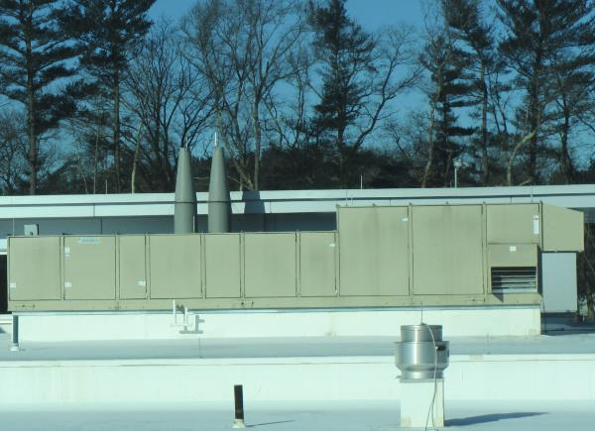
Packaged roof top AHU unit
Picture 2
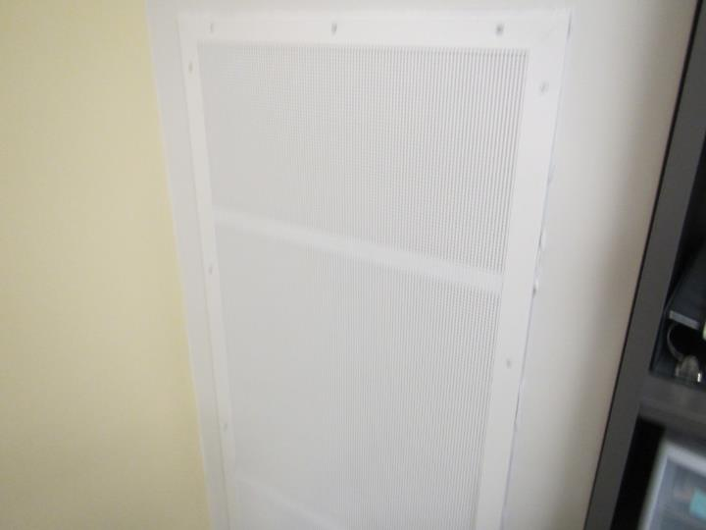
Wall-mounted supply diffuser
Picture 3
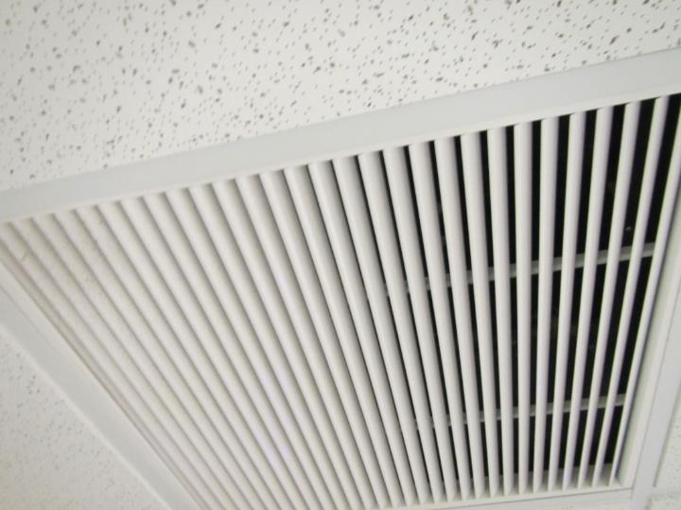
Ceiling-mounted return/exhaust vent
Picture 4
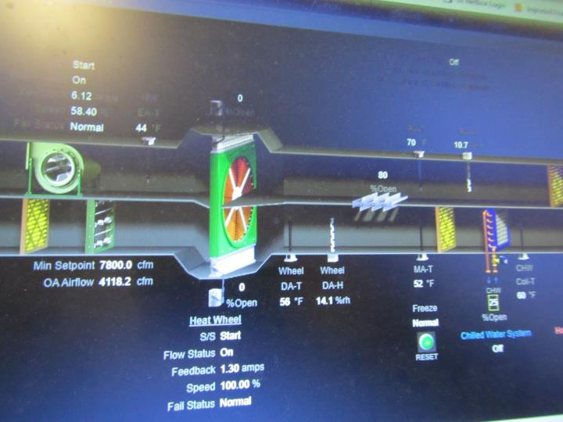
Computer controlled AHU graphic user interface
Picture 5
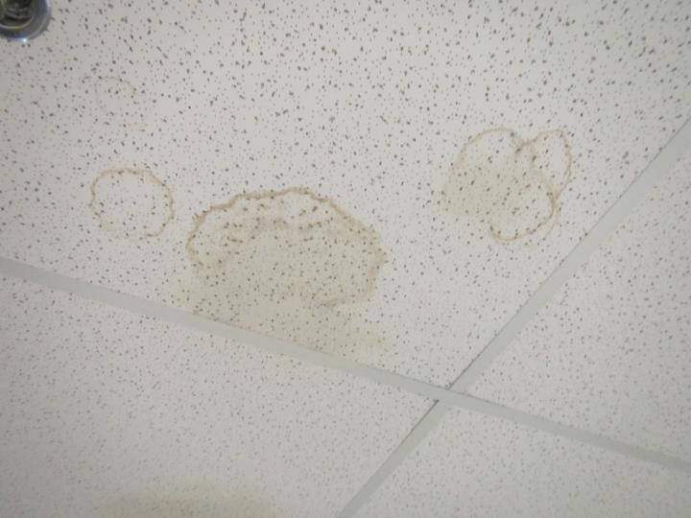
Water-damaged ceiling tile
Picture 6
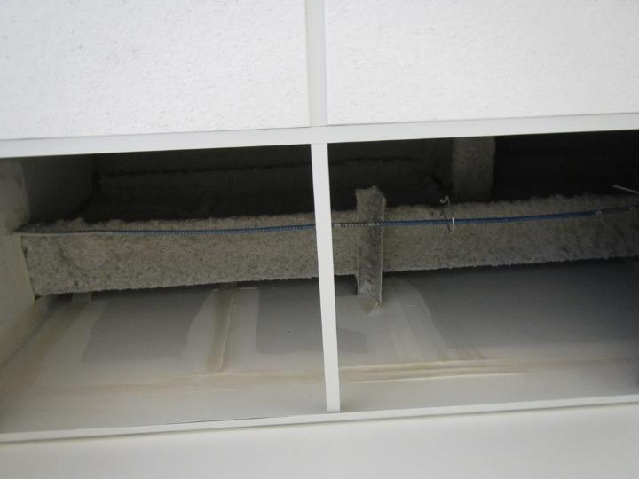
Area of active water leak currently being repaired
Picture 7
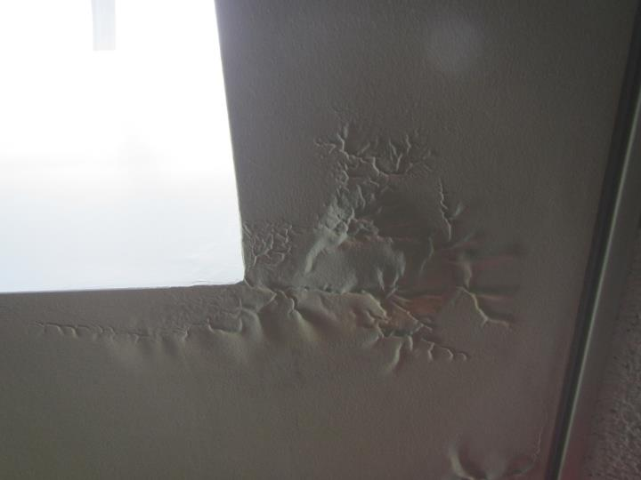
Water-damaged gypsum wallboard ceiling beneath skylight
Picture 8
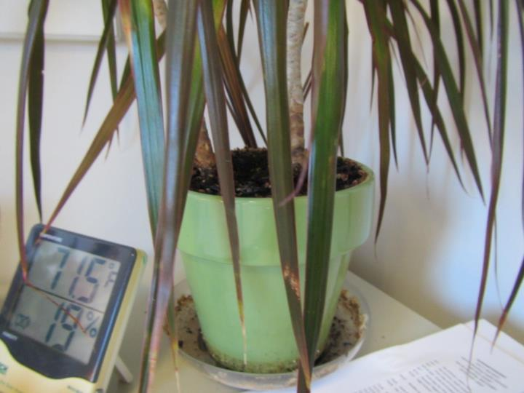
Plant showing drip pan with accumulated residue
Picture 9
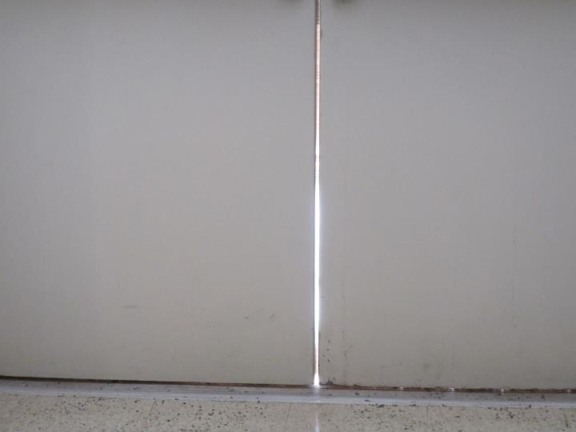
Exterior door showing gap with light penetrating
Picture 10
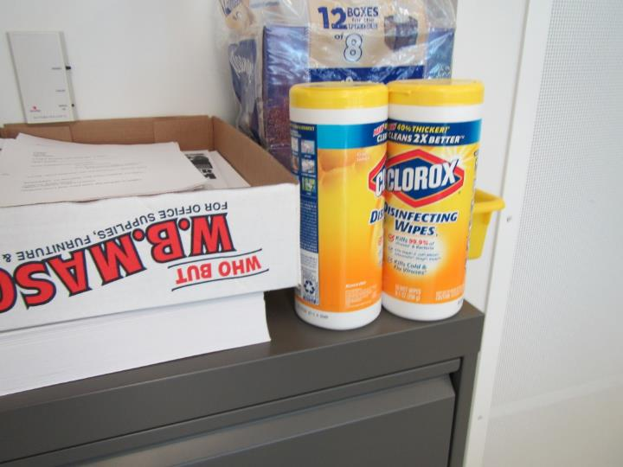
Cleaning products
Picture 11
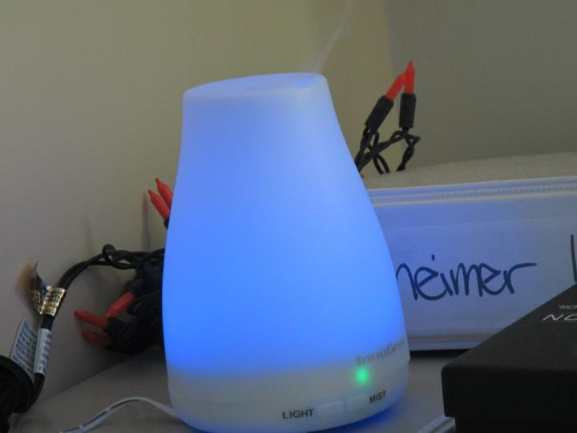
Essential oil diffuser
Picture 12
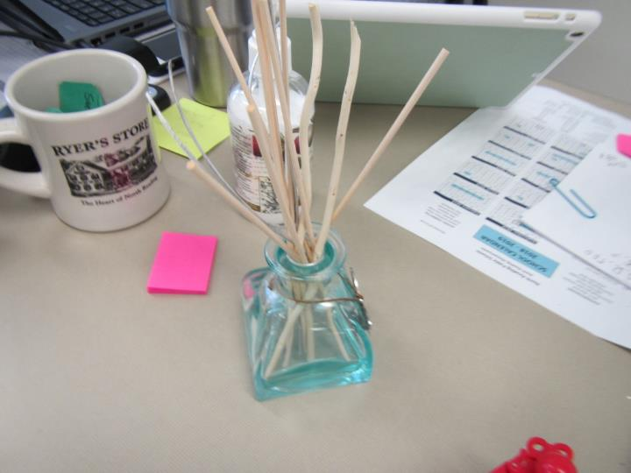
Reed air freshener/diffuser
Picture 13
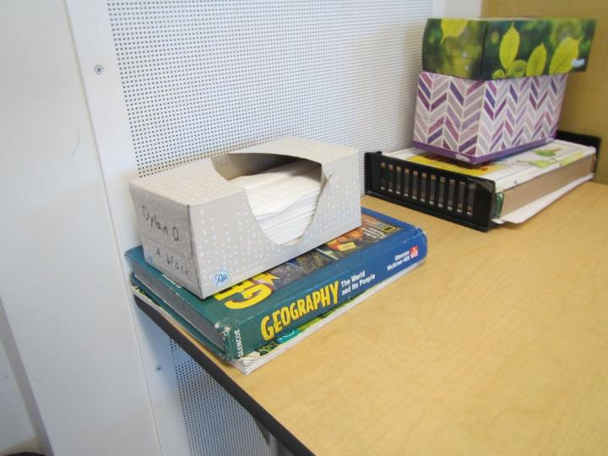
Supply air vent partially obstructed by items
Picture 14
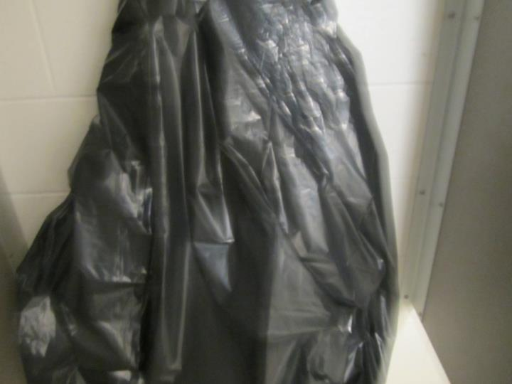
Urinal in locker area apparently out of order
Picture 15
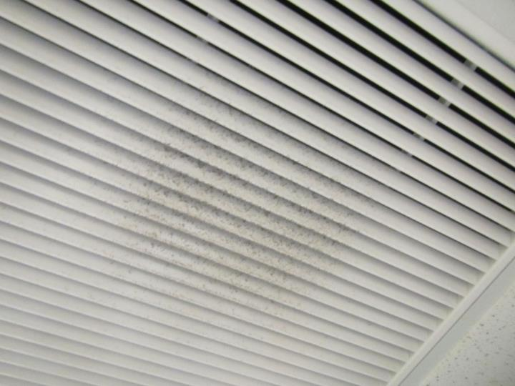
Dusty return/exhaust vent

Location | Carbon  Dioxide  (ppm) | Carbon Monoxide  (ppm) | Temp  (°F) | Relative  Humidity  (%) | PM2.5  (µg/m³) | TVOC  (ppm) | Occupants  in Room | Windows  Openable | Ventilation |  | Remarks
 |  |  |  |  |  |  |  |  | Supply | Exhaust
Background | 343 | ND | 12 | 16 | 8 | ND | - | - | - | - | Extreme cold/dry air
Principal | 851 | ND | 69 | 19 | 6 | ND | 3 | Y | Y | Y | Carpet
201 | 954 | ND | 71 | 14 | 2 | ND | 18 | Y | Y | Y
202 | 715 | ND | 72 | 11 | 3 | ND | 1 | N | Y | Y | Tile
203 | 835 | ND | 71 | 12 | 7 | ND | 15 | Y | Y | Y | DEM
204 | 821 | ND | 72 | 12 | 3 | ND | 23 | Y | Y | Y | DEM, plants
206 | 787 | ND | 73 | 11 | 3 | ND | 14 | Y | Y | Y | DEM, temperature complaints
209 | 842 | ND | 73 | 11 | 3 | ND | 18 | Y | Y | Y | DEM, blocked supply vent
210 | 891 | ND | 72 | 12 | 2 | ND | 20 | Y | Y | Y | DEM
211 | 676 | ND | 69 | 10 | 2 | ND | 5 | Y | Y | Y | DEM, HS
213 | 573 | ND | 70 | 9 | 1 | ND | 0 | Y | Y | Y | DEM
214 | 840 | ND | 70 | 10 | 1 | ND | 9 | Y | Y | Y | HS, DEM
215 | 776 | ND | 70 | 11 | 1 | ND | 22 | N | Y | Y | HS odor, DEM, CPs
Hall outside 215 | - | - | - | - | - | - | - | - | - | - | WD CTs
218 | 703 | ND | 70 | 10 | 4 | ND | 20 | N | Y | Y | CPs, chemical storage closet
223 | 647 | ND | 71 | 9 | 1 | ND | 2 | N | Y | Y | DEM, CPs, HS
AR 8-10 | 553 | ND | 69 | 10 | 1 | ND | 10 | N | Y | Y | HS, unvented “hood box”
AR-4 | 556 | ND | 69 | 9 | 2 | ND | 1 | N | Y | Y | Ceramics
Kiln room | - | - | - | - | - | - | - | - | - | - | Electric kiln local vent, room return vent, WD CT
AR-2 | 705 | ND | 70 | 11 | 2 | 1.4 | 7 | Y | Y | Y | Rubber cement odor
MS-104 | 669 | ND | 69 | 10 | 2 | ND | 3 | Y | Y | Y | Blocked vents, HS, AF
MS-105 | 581 | ND | 69 | 8 | 3 | ND | 1 | Y | Y | Y | DEM, HS
MS-106 | 622 | ND | 70 | 11 | 10 | ND | 2 | Y | Y | Y | DEM, humidifier/AF diffuser
MS-107 | 562 | ND | 70 | 8 | 3 | ND | 3 | Y | Y | Y | DEM
MS-108 | 760 | ND | 70 | 12 | 1 | ND | 21 | Y | Y | Y | DEM, AF odor, CPs, HS
MS-109 | 663 | ND | 72 | 9 | 1 | ND | 14 | Y | Y | Y | DEM, HS
MS-110 | 819 | ND | 72 | 10 | 3 | ND | 19 | Y | Y | Y | DEM, PF, HS
MS-111 | 722 | ND | 71 | 10 | 5 | ND | 15 | Y | Y | Y | Plants
MS-112 | 792 | ND | 71 | 10 | 3 | ND | 18 | Y | Y | Y | DEM
MS-113 | 795 | ND | 71 | 10 | 2 | ND | 20 | Y | Y | Y | DEM
C-5 | 582 | ND | 72 | 6 | 2 | ND | 0 | Y | Y | Y | Carpet, plant
C-6 | 549 | ND | 72 | 6 | 2 | ND | 0 | Y | Y | Y
Conference | 486 | ND | 72 | 4 | 3 | ND | 2 | Y | Y | Y | CO2 meter, carpet tile on slab
C-7 | 501 | ND | 73 | 5 | 2 | ND | 1 | Y | Y | Y | HS, AF reeds
C-4 | 541 | ND | 73 | 5 | 2 | ND | 3 | N | Y | Y | PC
General open area | 531 | ND | 73 | 5 | 3 | ND | 5 | N | Y | Y | CPs
C-9A | 473 | ND | 68 | 5 | 3 | ND | 1 | Y | Y | Y | Carpet
C-17 | 460 | ND | 71 | 4 | 2 | ND | 1 | N | Y | Y | CPs
C-10A | 453 | ND | 72 | 4 | 3 | ND | 1 | Y | Y | Y | DEM, AF
C-11 | 504 | ND | 71 | 4 | 1 | ND | 1 | Y | Y | Y | HS
C-12 | 618 | ND | 72 | 7 | 3 | ND | 3 | Y | Y | Y
MS-114 | 537 | ND | 70 | 7 | 2 | ND | 1 | Y | Y | Y | DEM
MS-115 | 654 | ND | 70 | 8 | 3 | ND | 5 | Y | Y | Y | DEM, HS, CPs
MS-120 | 733 | ND | 70 | 12 | 2 | ND | 3 | Y | Y | Y | DEM
MS-121 | 837 | ND | 70 | 11 | 2 | ND | 23 | Y | Y | Y | DEM
MS-147 | 730 | ND | 71 | 10 | 3 | ND | 14 | N | Y | Y | DEM, HS
MS-145 | 593 | ND | 71 | 8 | 3 | ND | 19 | N | Y | Y | DEM, CPs, HS
MS-122 | 834 | ND | 70 | 12 | 3 | ND | 25 | Y | Y | Y | Plants
MS-123 | 851 | ND | 70 | 13 | 3 | ND | 16 | Y | Y | Y | DEM
MS-124 | 876 | ND | 70 | 12 | 2 | ND | 19 | Y | Y | Y | DEM
MS-125 | 854 | ND | 71 | 13 | 2 | ND | 10 | Y | Y | Y | HS, DEM
MS-151 | 703 | ND | 70 | 10 | 3 | ND | 3 | N | Y | Y | PC, boxes on floor
MS-126 | 849 | ND | 71 | 12 | 5 | ND | 22 | N | Y | Y
MS-127 | 843 | ND | 71 | 13 | 3 | ND | 12 | N | Y | Y | Cold radiator complaint, CPs, DEM
MS-153 | 352 | ND | 72 | 7 | 3 | ND | 17 | N | Y | Y | Science
MS-155 | 594 | ND | 71 | 7 | 3 | ND | 15 | N | Y | Y | HS, DEM
MS-128 | 763 | ND | 71 | 11 | 2 | ND | 8 | Y | Y | Y | HS, DEM
MS-129 | 626 | ND | 72 | 9 | 2 | ND | 2 | Y | Y | Y | HS
MS-132 | 718 | ND | 74 | 9 | 2 | ND | 6 | Y | Y | Y | HS
MS-135 | 582 | ND | 71 | 8 | 2 | ND | 11 | Y | Y | Y | DEM
MS-136 | 541 | ND | 72 | 8 | 3 | ND | 10 | Y | Y | Y | DEM
B-41 | 613 | ND | 70 | 9 | 12 | ND | 1 | Y | Y | Y | HS, historic WD, MTs, humidifier
MS- cafeteria | 517 | ND | 69 | 9 | 5 | ND | 10 | N | Y | Y
MS-cafeteria (fully occupied) | 951 | ND | 71 | 11 | 6 | ND | 80+ | N | Y | Y
B-17 | 515 | ND | 71 | 8 | 22 | ND | 1 | N | Y | Y | Humidifier/AF diffuser
B-19 | 541 | ND | 72 | 8 | 2 | ND | 2 | N | Y | Y | Carpet
B-20 | 624 | ND | 72 | 9 | 3 | ND | 2 | N | Y | Y | Carpet
B-22 | 519 | ND | 72 | 7 | 2 | ND | 2 | N | Y | Y
B-21 | 501 | ND | 72 | 6 | 2 | ND | 1 | N | Y | Y | PC
B-23 | 487 | ND | 72 | 6 | 2 | ND | 0 | N | Y | Y | Storage, carpet
B-24 | 607 | ND | 73 | 8 | 3 | ND | 2 | N | Y | Y | Carpet
B-24 | 560 | ND | 73 | 7 | 2 | ND | 3 | N | Y | Y | HS
B-26 | 542 | ND | 72 | 7 | 3 | ND | 1 | N | Y | Y | HS, carpet tiles
A-1 performing arts | 753 | ND | 70 | 12 | 3 | ND | ~600 | N | Y | Y
Library | 561 | ND | 70 | 9 | 3 | ND | 11 | N | Y | Y | Carpet tiles
Gym- G11 | 520 | ND | 69 | 10 | 5 | ND | 7 | N | Y | Y
Weights | 476 | ND | 68 | 8 | 4 | ND | 2 | N | Y | Y
G-33 | 572 | ND | 68 | 9 | 4 | ND | 25 | N | Y | Y
G-37 | 491 | ND | 69 | 2 | 3 | ND | 0 | N | Y | Y
Kitchen office | 667 | ND | 68 | 13 | 7 | ND | 3 | N | Y | Y

