Background/Introduction

INDOOR AIR QUALITY ASSESSMENT

North Reading Middle School
191 Park Street
North Reading, Massachusetts

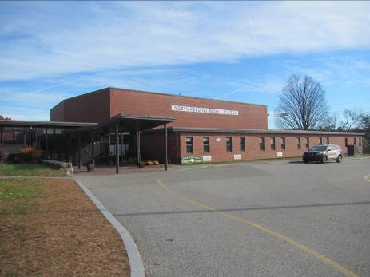

Prepared by:
Massachusetts Department of Public Health
Bureau of Environmental Health
Indoor Air Quality Program
January 2015
At the request of Wayne Hardacker, Supervisor of Buildings and Grounds, North Reading Public Schools, the Massachusetts Department of Public Health (MDPH), Bureau of Environmental Health (BEH) provided assistance and consultation regarding indoor air quality (IAQ) at the North Reading Middle School (NRMS) located at 191 Park Street, North Reading, Massachusetts. On November 13, 2014, Sharon Lee, Environmental Analyst/Inspector, and Ruth Alfasso, Environmental Engineer/Inspector, in BEH’s IAQ Program visited the school to conduct an assessment.
This building previously housed students and staff of the North Reading High School (NRHS). It is currently being used as swing space for the NRMS until construction of the new Middle School is completed; this is expected to be in time for the beginning of the 2015/2016 school year. This building was previously visited in May of 2010, when it was the old NRHS. The report from that visit is available on the MDPH website (http://www.mass.gov/eohhs/docs/dph/environmental/iaq/2010/north-reading-high-school-2010-05.doc).
The NRMS is a one-story, cinderblock and brick building with a ventilated basement crawlspace originally built in 1957. The school has four distinct areas: A-wing, B-wing, C-wing and D-wing. The building has undergone renovations including the addition of a library between B- and C-wings in 1989 and modular classrooms (D-wing) in 2004. The school is graded downhill in a step-like fashion from the C-wing at the top of the hill to the A-wing at the bottom.
The A-wing houses general classrooms, art rooms, auditorium, office space, music room and band practice rooms. The A-wing also has a basement level which contains a crawlspace, boiler room, maintenance office, batting cages and storage space. The crawlspace can be entered through several access points throughout the school. The B-wing houses general classrooms, a library, kitchen, cafeteria and office space. The C-wing houses general classrooms, computer labs and science classrooms. The D-wing consists of modular classrooms. Windows are openable throughout the building.

Methods
Air tests for carbon monoxide, carbon dioxide, temperature and relative humidity were conducted with the TSI, Q-Trak, IAQ Monitor, Model 7565. Air tests for airborne particle matter with a diameter less than 2.5 micrometers were taken with the TSI, DUSTTRAK™ Aerosol Monitor Model 8520 and the TSI, DUSTTRAK™ Aerosol Monitor Model 8532. BEH/IAQ staff also performed visual inspection of building materials for water damage and/or microbial growth.

Results
The school houses approximately 640 students in grades 6 through 8 and a staff of about 100. Tests were taken during normal operations at the school. Results appear in Table 1.

Discussion

Ventilation
It can be seen from Table 1 that carbon dioxide levels were above 800 parts per million (ppm) in 60 out of 77 areas, indicating a lack of air exchange in most areas examined. Fresh air in A-, B- and C-wing classrooms is supplied by unit ventilators (univents) (Pictures 1 and 2). A univent is designed to draw air from outdoors through a fresh air intake located on the exterior wall of the building (Picture 3). Return air is drawn through an air intake located at the base of each unit where fresh and return air are mixed, filtered, heated or cooled and provided to classrooms through an air diffuser located in the top of the unit (Figure 1). Univents were found deactivated or obstructed with classroom items/furniture on top/front of units in a number of areas (Picture 2 and Table 1). In order for univents to provide fresh air as designed, intakes/returns must remain free of obstructions. Importantly, these units must remain on and be allowed to operate while rooms are occupied.
Note that the univents in this school are original equipment, more than 50 years old in the original wing. Function of equipment of this age is difficult to maintain, since compatible replacement parts are often unavailable. According to the American Society of Heating, Refrigeration and Air-Conditioning Engineers (ASHRAE), the service life for a unit heater, hot water or steam is 20 years, assuming routine maintenance of the equipment (ASHRAE, 1991). Despite attempts to maintain the univents, the operational lifespan of the equipment has been exceeded. Maintaining the balance of fresh air to exhaust air will become even more difficult as the equipment ages and as replacement parts become increasingly difficult to obtain.
Exhaust ventilation in classrooms in the A-, B- and C-wings is provided by wall-mounted exhaust vents ducted to fans on the roof. These vents were observed to be off or drawing weakly in some areas. Some exhaust vents were also blocked by items or furniture (Picture 4).
The modular classrooms of D-wing have ceiling-mounted supply and exhaust vents connected to air-handling units (AHUs) on the side of the building. AHUs in some modular areas were operating on the automatic setting. The automatic setting on the thermostat activates the HVAC system at a pre-set temperature. Once the pre-set temperature is reached, the HVAC system is deactivated. Therefore, no mechanical ventilation is provided until the thermostat re-activates the system and airflow is limited. The automatic setting can lead to IAQ/comfort complaints due to lack of air exchange. The MDPH typically recommends that thermostats be set to the fan on setting during occupied hours to provide continuous air circulation. When the fan is set to on, the system provides a continuous source of air circulation and filtration.
Ventilation for common areas such as the gym and cafeteria is provided either by ceiling- or rooftop-mounted AHUs, which deliver air to ceiling-mounted supply diffusers. Ducted return vents in the gym return air to the AHU. In the cafeteria, exhaust ventilation is provided by a large exhaust hood located in the kitchen. When activated, the exhaust hood draws air from the cafeteria through a series of passive vents into the kitchen, and out the exhaust hood.
Several occupied areas did not appear to have a means for natural ventilation (i.e., windows) or mechanical ventilation supply (Table 1). Under the building code, occupied areas are required to have a provision of fresh outside air either by windows or mechanical ventilation.
To maximize air exchange, the MDPH recommends that both supply and exhaust ventilation operate continuously during periods of occupancy. In order to have proper ventilation with a mechanical supply and exhaust system, the systems must be balanced to provide an adequate amount of fresh air to the interior of a room while removing stale air from the room. It is recommended that heating, ventilating and air conditioning (HVAC) systems be re-balanced every five years to ensure adequate air systems function (SMACNA, 1994). The date of the last balancing of these systems was not available at the time of the assessment.
Minimum design ventilation rates are mandated by the Massachusetts State Building Code (MSBC). Until 2011, the minimum ventilation rate in Massachusetts was higher for both occupied office spaces and general classrooms, with similar requirements for other occupied spaces (BOCA, 1993). The current version of the MSBC, promulgated in 2011 by the State Board of Building Regulations and Standards (SBBRS), adopted the 2009 International Mechanical Code (IMC) to set minimum ventilation rates. Please note that the MSBC is a minimum standard that is not health-based. At lower rates of cubic feet per minute (cfm) per occupant of fresh air, carbon dioxide levels would be expected to rise significantly. A ventilation rate of 20 cfm per occupant of fresh air provides optimal air exchange resulting in carbon dioxide levels at or below 800 ppm in the indoor environment in each area measured. MDPH recommends that carbon dioxide levels be maintained at 800 ppm or below. This is because most environmental and occupational health scientists involved with research on IAQ and health effects have documented significant increases in indoor air quality complaints and/or health effects when carbon dioxide levels rise above the MDPH guidelines of 800 ppm for schools, office buildings and other occupied spaces (Sundell et al., 2011). The ventilation must be on at all times that the room is occupied. Providing adequate fresh air ventilation with open windows and maintaining the temperature in the comfort range during the cold weather season is impractical. Mechanical ventilation is usually required to provide adequate fresh air ventilation.
Carbon dioxide is not a problem in and of itself. It is used as an indicator of the adequacy of the fresh air ventilation. As carbon dioxide levels rise, it indicates that the ventilating system is malfunctioning or the design occupancy of the room is being exceeded. When this happens, a buildup of common indoor air pollutants can occur, leading to discomfort or health complaints. The Occupational Safety and Health Administration (OSHA) standard for carbon dioxide is 5,000 parts per million parts of air (ppm). Workers may be exposed to this level for 40 hours/week, based on a time-weighted average (OSHA, 1997).
The MDPH uses a guideline of 800 ppm for publicly occupied buildings. A guideline of 600 ppm or less is preferred in schools due to the fact that the majority of occupants are young and considered to be a more sensitive population in the evaluation of environmental health status. Inadequate ventilation and/or elevated temperatures are major causes of complaints such as respiratory, eye, nose and throat irritation, lethargy and headaches. For more information concerning carbon dioxide, consult Appendix A.
Indoor temperature measurements the day of the assessment ranged from 68°F to 75°F (Table 1), most of which were within the MDPH recommended comfort range. The MDPH recommends that indoor air temperatures be maintained in a range of 70°F to 78°F in order to provide for the comfort of building occupants. In many cases concerning indoor air quality, fluctuations of temperature in occupied spaces are typically experienced, even in a building with an adequate fresh air supply. In addition, it is difficult to control temperature and maintain comfort without operating the ventilation equipment as designed (e.g., univents/exhaust vents deactivated/obstructed).
The indoor relative humidity measured the day of the assessment ranged from 24 to 55 percent; approximately half of which were below the MDPH recommended comfort range (Table 1). The MDPH recommends a comfort range of 40 to 60 percent for indoor air relative humidity. Relative humidity levels in the building would be expected to drop during the winter months due to heating. The sensation of dryness and irritation is common in a low relative humidity environment. Low relative humidity is a very common problem during the heating season in the northeast part of the United States.

Microbial/Moisture Concerns
Water-damaged ceiling tiles were observed in a few of areas throughout the building (Picture 5; Table 1); these can indicate active/historic leaks from either the roof/building envelope or plumbing system. If repeatedly moistened, ceiling tiles serve as a mold growth medium. Water-damaged tiles should be replaced after a water leak is discovered and repaired.
The US Environmental Protection Agency (US EPA) and the American Conference of Governmental Industrial Hygienists (ACGIH) recommend that porous materials (e.g., carpeting, gypsum wallboard) be dried with fans and heating within 24 to 48 hours of becoming wet (US EPA, 2001; ACGIH, 1989). If not dried within this time frame, mold growth may occur. Once mold has colonized porous materials, they are difficult to clean and should be removed/discarded.
Plants were noted in some classrooms and offices (Table 1). Plants can be a source of pollen and mold which can be respiratory irritants to some individuals. Plants should be properly maintained and equipped with drip pans and should be located away from univents to prevent the aerosolization of dirt, pollen and mold.
Porous items were observed to be stored under sinks in some areas. The area under sinks is a moist environment that can lead to water damage and microbial growth on porous items. In addition, some of the laboratory sinks in science classrooms were reported to be used intermittently. If a sink is not used for some time, the drain traps can dry out and allow sewer gas to enter occupied areas. Sink traps should be maintained by pouring water down them periodically when not in regular use.
Portable air conditioners were observed in some areas. These devices usually have a receptacle for collecting water condensed as a part of the operation of the air conditioner. These receptacles should be emptied and cleaned on a regular basis when the portable air conditioners are in use.
The exterior of the building was examined for conditions that might lead to indoor air quality concerns. Doors to the exterior were seen to be missing weather stripping (Picture 6), which can allow unconditioned air, moisture and pests into the building.

Other IAQ Evaluations
Indoor air quality can be negatively influenced by the presence of respiratory irritants, such as products of combustion. The process of combustion produces a number of pollutants. Common combustion emissions include carbon monoxide, carbon dioxide, water vapor and smoke (fine airborne particle material). Of these materials, exposure to carbon monoxide and particulate matter with a diameter of 2.5 micrometers (μm) or less (PM2.5) can produce immediate, acute health effects upon exposure. To determine whether combustion products were present in the indoor environment, BEH/IAQ staff obtained measurements for carbon monoxide and PM2.5.

Carbon Monoxide
Carbon monoxide is a by-product of incomplete combustion of organic matter (e.g., gasoline, wood and tobacco). Exposure to carbon monoxide can produce immediate and acute health effects. Several air quality standards have been established to address carbon monoxide and prevent symptoms from exposure to these substances. The MDPH established a corrective action level concerning carbon monoxide in ice skating rinks that use fossil-fueled ice resurfacing equipment. If an operator of an indoor ice rink measures a carbon monoxide level over 30 ppm, taken 20 minutes after resurfacing within a rink, that operator must take actions to reduce carbon monoxide levels (MDPH, 1997).
The American Society of Heating Refrigeration and Air-Conditioning Engineers (ASHRAE) has adopted the National Ambient Air Quality Standards (NAAQS) as one set of criteria for assessing indoor air quality and monitoring of fresh air introduced by HVAC systems (ASHRAE, 1989). The NAAQS are standards established by the US EPA to protect the public health from six criteria pollutants, including carbon monoxide and particulate matter (US EPA, 2006). As recommended by ASHRAE, pollutant levels of fresh air introduced to a building should not exceed the NAAQS levels (ASHRAE, 1989). The NAAQS were adopted by reference in the Building Officials & Code Administrators (BOCA) National Mechanical Code of 1993 (BOCA, 1993), which is now an HVAC standard included in the Massachusetts State Building Code (SBBRS, 2011). According to the NAAQS, carbon monoxide levels in outdoor air should not exceed 9 ppm in an eight-hour average (US EPA, 2006).
Carbon monoxide should not be present in a typical, indoor environment. If it is present, indoor carbon monoxide levels should be less than or equal to outdoor levels. On the day of the assessment, outdoor carbon monoxide concentration was measured at 0.7 ppm (Table 1), likely due to vehicles in the parking lot. All indoor carbon monoxide measurements were non-detectable except for one area with a reading of 1.0 ppm (Table 1). This was most likely due to vehicles in the nearby parking lot.

Particulate Matter
The US EPA has established NAAQS limits for exposure to particulate matter. Particulate matter includes airborne solids that can be irritating to the eyes, nose and throat. The NAAQS originally established exposure limits to PM with a diameter of 10 μm or less (PM10). In 1997, US EPA established a more protective standard for fine airborne particulate matter with a diameter of 2.5 μm or less (PM2.5). This more stringent PM2.5 standard requires outdoor air particle levels be maintained below 35 μg/m³ over a 24-hour average (US EPA, 2006). Although both the ASHRAE standard and BOCA Code adopted the PM10 standard for evaluating air quality, MDPH uses the more protective PM2.5 standard for evaluating airborne PM concentrations in the indoor environment.
Outdoor PM2.5 concentrations were measured at 12 to 16 μg/m³ (Table 1). PM2.5 levels measured indoors ranged from 3 to 43 μg/m³ (Table 1). All but one reading was below the NAAQS PM2.5 level of 35 μg/m³. The one reading that was above the NAAQS (43 μg/m³) was measured in a receiving area. Frequently, indoor air levels of particulate matter (including PM2.5) can be at higher levels than those measured outdoors. A number of activities that occur indoors and/or mechanical devices can generate particulate matter during normal operations. Sources of indoor airborne particulate matter may include but are not limited to particles generated during the operation of fan belts in the HVAC system, use of stoves and/or microwave ovens in kitchen areas; use of photocopiers, fax machines and computer printing devices; operation of an ordinary vacuum cleaner and heavy foot traffic indoors.

Volatile Organic Compounds
Indoor air concentrations can be greatly impacted by the use of products containing volatile organic compounds (VOCs). VOCs are carbon-containing substances that have the ability to evaporate at room temperature. Frequently, exposure to low levels of total VOCs (TVOCs) may produce eye, nose, throat and/or respiratory irritation in some sensitive individuals. For example, chemicals evaporating from a paint can stored at room temperature would most likely contain VOCs. In an effort to identify materials that can potentially increase indoor VOC concentrations, BEH/IAQ staff examined rooms for products containing these respiratory irritants.
NRMS staff reported noticing chemical odors when entering into the C-wing. At the time of the assessment, MDPH/BEH staff noted an odor and also observed a photocopier operating in a small room right at the entrance to the wing. This copier is reportedly used heavily by school staff. Photocopiers can be sources of pollutants such as VOCs, ozone, heat and odors, particularly if the equipment is older and in frequent use. Both VOCs and ozone are respiratory irritants (Schmidt Etkin, 1992). Photocopiers should be kept in well ventilated rooms, and should be located near windows or exhaust vents. It is important to note that not only does the C-wing room housing the photocopier not have a fresh air supply but the area lacks exhaust ventilation to remove particulate matter, odors and heat from the use of this copying machine. The lack of exhaust allows odors to penetrate the hallway, resulting in complaints. To reduce the proliferation of odors, functional exhaust ventilation should be added to this room or the copier should be moved to a location with exhaust ventilation.
A laminator was observed in the library; a sign on the laminator indicates it should only be used after 2:30 pm, when the majority of occupants have left the building (Picture 7). Although this measure will serve to reduce exposure to pollutants and odors caused by the melting of plastic, laminators should also be located in areas with exhaust ventilation.
Classrooms contained dry erase boards and related materials. Materials such as dry erase markers and dry erase board cleaners may contain VOCs, such as methyl isobutyl ketone, n-butyl acetate and butyl-cellusolve (Sanford, 1999), which can be irritating to the eyes, nose and throat.
Cleaning and sanitizing products were observed on/under sinks in some rooms (Table 1). These products contain chemicals that can be irritating to the eyes, nose and throat of sensitive individuals. Cleaning products should be properly labeled and stored in an area inaccessible to children. In addition, a Material Safety Data Sheet (MSDS) should be available at a central location for each product in the event of an emergency. Consideration should be given to providing teaching staff with school issued cleaning products and supplies to prevent any potential for adverse chemical interactions between residues left from cleaners used by the facilities staff and those left by cleaners brought in by others.
Plug-in air fresheners and other air deodorizers were also observed in the school (Picture 8; Table 1). Air deodorizers contain chemicals that can be irritating to the eyes, nose and throat of sensitive individuals. Many air fresheners contain 1,4-dichlorobenzene, a VOC which may cause reductions in lung function (NIH, 2006). Furthermore, deodorizing agents do not remove materials causing odors, but rather mask odors that may be present in the area.

Other Conditions
In addition to the copier odors referenced above, several other conditions were noted that are likely contributing to odors in the C-wing. A strong odor detected in the chemical storage area (next to room C111) was traced to a refrigerator that was empty and not in use/operation. This refrigerator should be removed as soon as possible. Some cabinets in this room are designed to store chemicals (e.g. flameproof, vented outdoors for storage of flammable and corrosive materials). Although the cabinets are currently used to store a few items, debris/staining was noted in several storage units; stains were also observed on shelves in the storeroom (Picture 9). Since spilled chemicals can emit odors, the storage units in the room should be cleaned to prevent odors over time. Any new spills should be cleaned immediately.
It was reported that a chemical cleanout had been conducted during the move of the Middle School operations into this building. Regular review and cleaning of stocks of chemicals in science laboratories is recommended to remove outdated and unneeded chemical storage and to remove any damaged containers before they can leak.
Another area of concern is room B111, where the occupant reported a musty odor. At the time of the assessment, BEH/IAQ staff detected an odor in the room. While examining the conditions within the univent cabinet, breaches were observed where the pipes penetrate through the floor (Picture 10). This breach not only allows for unconditioned air and odors from the crawlspace to be distributed into occupied areas, but also allow pests to enter into occupant areas. BEH/IAQ staff observed rodent waste (e,.g., droppings) within the univent cabinet (Picture 11). When operating, the univent can heat and magnify odors, which are subsequently distributed. At the time of the assessment, BEH/IAQ staff alerted Mr. Hardacker to this concern and provided recommendations for repair.
Rodent infestation can result in indoor air quality related symptoms due to materials in their wastes. Mouse urine contains a protein that is a known sensitizer (US EPA, 1992). A sensitizer is a material that can produce symptoms including running nose or skin rashes in sensitive individuals after repeated exposure. A three-step approach is necessary to eliminate rodent infestation:
- Removal of the rodents;
- Cleaning of waste products from the interior of the building; and
- Reduction/elimination of pathways/food sources that are attracting rodents.
To eliminate exposure to allergens, rodents must be removed from the building. Please note that removal, even after cleaning, may not provide immediate relief since allergens can exist in the interior for several months after rodents are eliminated (Burge, 1995). A combination of cleaning, along with an increase in ventilation and filtration should serve to reduce rodent associated allergens once the infestation is eliminated. Sealing the holes in the univent cabinets with an appropriate fire-rated sealant foam will assist in both excluding rodents as well as preventing the distribution of air from the crawlspace.
Musty odors were reported in other locations, including the guidance wing. The univent cabinets in these areas should also be inspected. All breaches should be sealed to prevent migration of moisture and odors.
Accumulated chalk dust was noted in a few classrooms. Chalk dust is a fine particulate, which can become easily aerosolized and serve as a source of eye and respiratory irritation.
Tennis balls were observed on chair legs in a few classrooms (Picture 12, Table 1). These tennis balls were likely installed as an effort to reduce noise from sliding chairs. Tennis balls are made of a number of materials that are a source of respiratory irritants. Constant wearing of tennis balls can produce fibers and off gas VOCs. Tennis balls are made with a natural rubber latex bladder, which becomes abraded when used as a chair leg pad. Use of tennis balls in this manner may introduce latex dust into the school environment. Some individuals are highly allergic to latex (e.g., spina bifida patients) (SBAA, 2001). It is recommended that the use of materials containing latex be limited in buildings to reduce the likelihood of symptoms in sensitive individuals (NIOSH, 1997).
Other conditions that can affect IAQ were observed during the assessment. In some classrooms, a large number of items were on floors, windowsills, tabletops, counters, bookcases and desks, which provide a source for dusts to accumulate. These items (e.g., papers, folders, boxes) make it difficult for custodial staff to clean. Items should be relocated and/or be cleaned periodically to avoid excessive dust build up. In addition, dust and debris can accumulate on flat surfaces (e.g., desktops, shelving and floors) in occupied areas and subsequently be re-aerosolized causing further irritation. Items were also found hanging from the ceiling tile grid, which can collect/reaerosolize dusts; disturbing the tile system can lead to particulate matter from the ceiling tiles or from above the tiles entering the occupied space as well.
Some areas in the school (e.g., the library) were carpeted. The Institute of Inspection, Cleaning and Restoration Certification (IICRC) recommends that carpeting be cleaned annually (or semi-annually in soiled high traffic areas) (IICRC, 2012). Regular cleaning with a high efficiency particulate air (HEPA) filtered vacuum in combination with an annual cleaning will help to reduce accumulation and potential aerosolization of materials from the carpeting.
A number of exhaust vents and personal fans were found to have accumulated dust/debris (Table 1). If exhaust vents are not functioning, backdrafting can occur, which can re-aerosolize accumulated dust particles. Re-activated supply, exhaust/return vents and fans can also aerosolize dust accumulated on vents/fan blades.
Some univents were opened, and the filters were examined. In one instance, the univent examined lacked a filter. Filters consisted of a sleeve that fit around metal frames (Pictures 13 and 14). These filters have a low dust removal efficiency and can be time consuming to install. The dust spot efficiency is the ability of a filter to remove particulate matter of a certain diameter from air passing through the filter. Filters that have been determined by ASHRAE to meet its standard for a dust spot efficiency of a minimum of 40 percent would be sufficient to reduce many airborne particulates (Thornburg, 2000; MEHRC, 1997; ASHRAE, 1992).
It is likely that disposable filters with a higher dust spot efficiency can be installed in place of the existing cages. Pleated filters with a Minimum Efficiency Reporting Value dust-spot efficiency of 9 or higher are recommended. Note that increasing filtration can reduce airflow (called pressure drop), which can subsequently reduce the efficiency of the unit due to increased resistance. Prior to any increase of filtration, the univents should be evaluated by a ventilation engineer to ascertain whether it can maintain function with filters that are more efficient.
Univent filters should be changed as per the manufacturer’s recommendations (typically 2-4 times a year). In addition, some of the univent cabinets and diffuser grills had debris in them which can lead to aerosolized particulate matter and odors. When filters are changed in the univents, cabinets should also be vacuumed out.
Upholstered furniture, pillows/cushions and large stuffed animals were seen in a few classrooms. Upholstered furniture, pillows and cushions are covered with fabric that comes in contact with human skin. This type of contact can leave oils, perspiration, hair and skin cells on the furniture. Dust mites feed upon human skin cells and excrete waste products that contain allergens. In addition, if relative humidity levels increase above 60 percent, dust mites tend to proliferate (US EPA, 1992). In order to remove dust mites and other pollutants, frequent vacuuming of upholstered furniture is recommended (Berry, M.A., 1994). It is also recommended that upholstered furniture (if present in schools), be professionally cleaned on an annual basis. If outdoor conditions or indoor activities (e.g., renovations) create an excessively dusty environment, cleaning frequency should be increased (every six months) (IICRC, 2000).

Conclusions/Recommendations
In view of the findings at the time of the visit, the following is recommended:
- Operate all ventilation systems throughout the building (e.g., classrooms, gym, cafeteria) continuously during periods of occupancy to maximize air exchange. If increased airflow is desired, operate univents in fan “high” mode.
- Restore exhaust ventilation throughout the building. Inspect motors and belts for proper function, and perform repairs and adjustments as necessary.
- Remove blockages/items from the surface of univent air diffusers and along front/bottom of return vents.
- Remove all blockages from exhaust vents to ensure adequate airflow.
- Maintaining the balance of fresh air to exhaust air will become more difficult as the equipment ages (i.e., classroom univents, exhaust vents and AHUs in gym/cafeteria) and as replacement parts become increasingly difficult to obtain. Based on the age, physical deterioration and availability of parts, the BEH recommends that an HVAC engineering firm evaluate options to determine feasibility of repairing.
- Change filters for all air-handling equipment (univents and AHUs) as per the manufacturer’s instructions (typically 2-4 times a year). Thoroughly clean/vacuum out all units during each filter change. Consider using disposable filters with a higher dust spot efficiency instead of the current type.
- Examine the feasibility of balancing the HVAC system once the system is operable. Consider adopting a balancing schedule of every 5 years for all mechanical ventilation systems, as recommended by ventilation industrial standards (SMACNA, 1994).
- Use openable windows in conjunction with mechanical ventilation to facilitate air exchange. Care should be taken to ensure windows are properly closed at night and weekends to avoid the freezing of pipes and potential flooding.
- For buildings in New England, periods of low relative humidity during the winter are often unavoidable. Therefore, scrupulous cleaning practices should be adopted to minimize common indoor air contaminants whose irritant effects can be enhanced when the relative humidity is low. To control dusts, a high efficiency particulate arrestance (HEPA) filter equipped vacuum cleaner in conjunction with wet wiping of all surfaces is recommended. Avoid the use of feather dusters. Drinking water during the day can help ease some symptoms associated with a dry environment (throat and sinus irritations).
- Ensure indoor plants are equipped with drip pans. Examine drip pans periodically for mold growth and disinfect with an appropriate antimicrobial, as needed. Move plants away from the air stream of mechanical ventilation equipment.
- Examine areas of leakage and ensure any water-damaged ceiling tiles and wall materials are repaired and/or replaced. Examine the area above ceiling tiles for mold growth. Disinfect areas of water leaks with an appropriate antimicrobial, as needed.
- Avoid storing porous items under sinks.
- For sinks that are not used for periods of time, e.g. in laboratories, pour water down each drain at least once a week to prevent the traps from drying out.
- Maintain portable air conditioners in accordance with manufacturers’ instructions, including emptying of any condensate receptacles.
- Ensure that doors to the outside close/fit tightly to prevent the ingress of unconditioned air, moisture and pests. Replace weather stripping and monitor for light and drafts.
- Refrain from storing flammable products in classrooms. Store cleaning products properly and out of reach of students. Ensure spray bottles are properly labeled. All cleaning products used at the facility should be approved by the school department with MSDSs available at a central location.
- Consider moving the C-wing copier to a location with exhaust ventilation or an operable window, or consider adding exhaust ventilation to the copy room.
- Remove the unused refrigerator from the storage room for room C111.
- Consider moving laminators to areas with exhaust ventilation.
- Avoid the use of air freshener/deodorizing materials.
- Seal breaches in univent cabinets with an appropriate fire-rated sealant to prevent air from the crawlspace/basement area from being distributed to occupied areas and to exclude rodents.
- It is highly recommended that the principles of integrated pest management (IPM) be used to rid the building of pests. A copy of the IPM recommendations can be obtained from the Massachusetts Department of Food and Agriculture (MDFA) website at the following website: http://www.state.ma.us/dfa/pesticides/publications/IPM_kit_for_bldg_mgrs.pdf. Activities that can be used to eliminate pest infestation may include the following activities:
  - Rinse out recycled food containers. Seal recycled containers in a tight fitting lid to prevent rodent access.
  - Remove non-food items that rodents are consuming.
  - Store food in tight fitting containers.
  - Avoid eating at workstations. In areas were food is consumed, periodic vacuuming to remove crumbs is recommended.
  - Regularly clean crumbs and other food residues from ovens, toasters, toaster ovens, microwave ovens, coffee pots and other food preparation equipment.
  - Holes as small as ¼” are enough space for rodents to enter an area. Examine each room and the exterior walls of the building for means of rodent egress and seal. If doors do not seal at the bottom, install a weather strip as a barrier to rodents. Reduce harborages (cardboard boxes) where rodents may reside (MDFA, 1996).
- Clean chalk and dry erase boards and trays to prevent accumulation of materials.
- Clean any chemical debris from shelving in storage rooms.
- Continue with ongoing chemical cleanouts.
- Relocate or consider reducing the amount of materials stored in classrooms to allow for more thorough cleaning of classrooms. Clean items regularly with a wet cloth or sponge to prevent excessive dust build-up.
- Consider replacing tennis balls with latex-free chair glides.
- Clean area carpets annually or semi-annually in soiled high traffic areas as per the recommendations of the Institute of Inspection, Cleaning and Restoration Certification (IICRC). Copies of the IICRC fact sheet can be downloaded at: http://cleancareseminars.net/?page_id=185 . (IICRC, 2005)
- Clean personal fans, air diffusers and return vents periodically of accumulated dust.
- Clean upholstered furniture, cloth curtains, stuffed animals, and pillows on a regular schedule. If not possible/practical, consider removing from classrooms.
- Refrain from hanging items from the ceiling tile system.
- Consider adopting the US EPA (2000) document, “Tools for Schools”, as an instrument for maintaining a good indoor air quality environment in the building. This document is available at: http://www.epa.gov/iaq/schools/index.html.
- Refer to resource manual and other related indoor air quality documents located on the MDPH’s website for further building-wide evaluations and advice on maintaining public buildings. These documents are available at: http://mass.gov/dph/iaq.

References
ACGIH. 1989. Guidelines for the Assessment of Bioaerosols in the Indoor Environment. American Conference of Governmental Industrial Hygienists, Cincinnati, OH.
ASHRAE. 1989. Ventilation for Acceptable Indoor Air Quality. American Society of Heating, Refrigeration and Air Conditioning Engineers. ANSI/ASHRAE 62-1989.
ASHRAE. 1991. ASHRAE Applications Handbook, Chapter 33 “Owning and Operating Costs”. American Society of Heating, Refrigeration and Air Conditioning Engineers, Atlanta, GA.
ASHRAE. 1992. Gravimetric and Dust-Spot Procedures for Testing Air-Cleaning Devices Used in General Ventilation for Removing Particulate Matter. American Society of Heating, Refrigeration and Air Conditioning Engineers. ANSI/ASHRAE 52.1-1992.
Berry, M.A. 1994. Protecting the Built Environment: Cleaning for Health, Michael A. Berry, Chapel Hill, NC.
BOCA. 1993. The BOCA National Mechanical Code/1993. 8th ed. Building Officials and Code Administrators International, Inc., Country Club Hill, IL.
Burge, H.A. 1995. Bioaerosols. CRC Publishing, Boca Raton, FL. p. 110.
IICRC. 2000. IICRC S001 Reference Guideline for Professional On-Location Cleaning of Textile Floor Covering Materials Institute of Inspection, Cleaning and Restoration Certification. Institute of Inspection Cleaning and Restoration, Vancouver, WA.
IICRC. 2012. Carpet Cleaning FAQ 4 Institute of Inspection, Cleaning and Restoration Certification. Institute of Inspection Cleaning and Restoration, Vancouver, WA.
MDPH. 1997. Requirements to Maintain Air Quality in Indoor Skating Rinks (State Sanitary Code, Chapter XI). 105 CMR 675.000. Massachusetts Department of Public Health, Boston, MA.
MEHRC. 1997. Indoor Air Quality for HVAC Operators & Contractors Workbook. MidAtlantic Environmental Hygiene Resource Center, Philadelphia, PA.
MDFA. 1996. Integrated Pest Management Kit for Building Managers. Massachusetts Department of Food and Agriculture, Pesticide Bureau, Boston, MA.
NIH. 2006. Chemical in Many Air Fresheners May Reduce Lung Function. NIH News. National Institute of Health. July 27, 2006. http://www.nih.gov/news/pr/jul2006/niehs-27.htm
NIOSH. 1997. NIOSH Alert Preventing Allergic Reactions to Natural Rubber latex in the Workplace. National Institute for Occupational Safety and Health, Atlanta, GA
OSHA. 1997. Limits for Air Contaminants. Occupational Safety and Health Administration. Code of Federal Regulations. 29 C.F.R 1910.1000 Table Z-1-A.
Sanford. 1999. Material Safety Data Sheet (MSDS No: 198-17). Expo® Dry Erase Markers Bullet, Chisel, and Ultra Fine Tip. Sanford Corporation. Bellwood, IL.
SBAA. 2001. Latex In the Home And Community Updated Spring 2001. Spina Bifida Association of America, Washington, DC.
SBBRS. 2011. Mechanical Ventilation. State Board of Building Regulations and Standards. Code of Massachusetts Regulations, 8th edition. 780 CMR 1209.0
Schmidt Etkin, D. 1992. Office Furnishings/Equipment & IAQ Health Impacts, Prevention & Mitigation. Cutter Information Corporation, Indoor Air Quality Update, Arlington, MA.
SMACNA. 1994. HVAC Systems Commissioning Manual. 1st ed. Sheet Metal and Air Conditioning Contractors’ National Association, Inc., Chantilly, VA.
Sundell. 2011. Sundell, J., H. Levin, W. W. Nazaroff, W. S. Cain, W. J. Fisk, D. T. Grimsrud, F. Gyntelberg, Y. Li, A. K. Persily, A. C. Pickering, J. M. Samet, J. D. Spengler, S. T. Taylor, and C. J. Weschler. 2011. Ventilation rates and health: multidisciplinary review of the scientific literature. Indoor Air, Volume 21: pp 191–204.
Thornburg, D. 2000. Filter Selection: a Standard Solution. Engineering Systems 17:6 pp. 74-80.
US EPA. 1992. Indoor Biological Pollutants. US Environmental Protection Agency, Environmental Criteria and Assessment Office, Office of Health and Environmental Assessment, research Triangle Park, NC. EPA 600/8-91/202. January 1992.
US EPA. 2000. Tools for Schools. Office of Air and Radiation, Indoor Environments Division (6609J). EPA 402-K-95-001, Second Edition. http://www.epa.gov/iaq/schools/tools4s2.html.
US EPA. 2001. Mold Remediation in Schools and Commercial Buildings. US Environmental Protection Agency, Office of Air and Radiation, Indoor Environments Division, Washington, D.C. EPA 402-K-01-001. March 2001.
US EPA. 2006. National Ambient Air Quality Standards (NAAQS). US Environmental Protection Agency, Office of Air Quality Planning and Standards, Washington, DC. http://www.epa.gov/air/criteria.html.
Picture 1
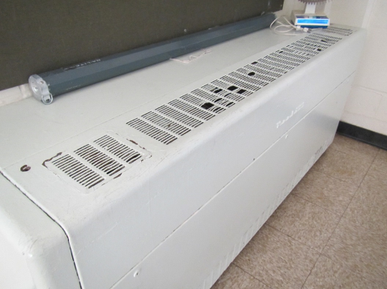
Univent cabinet
Picture 2
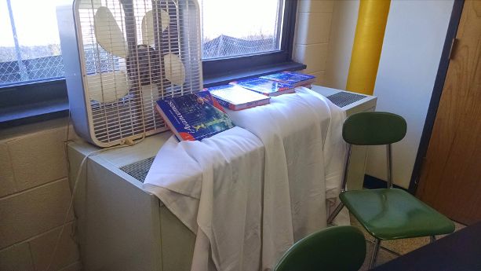
Univent with items on top blocking airflow
Picture 3
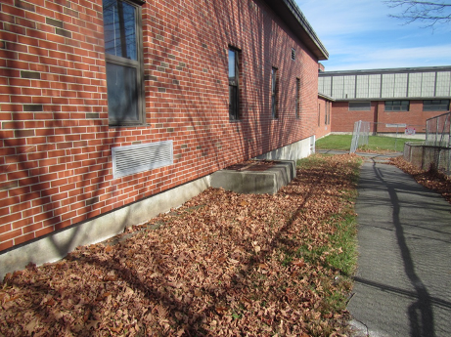
Univent intake on exterior of building
Picture 4
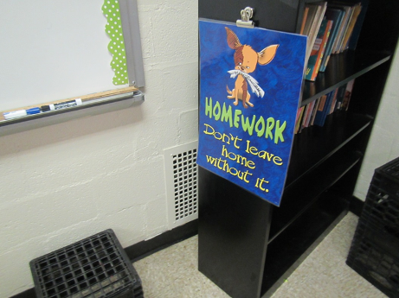
Exhaust vent located behind bookcase (bookcase pulled away from wall during assessment)
Picture 5
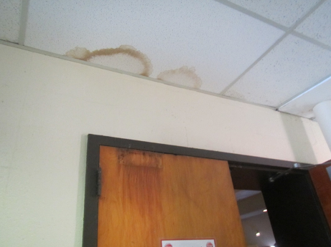
Water-damaged ceiling tiles
Picture 6
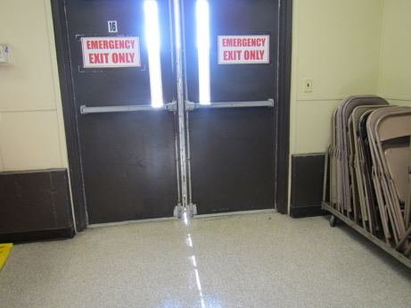
Light visible between doors showing lack of weather stripping
Picture 7
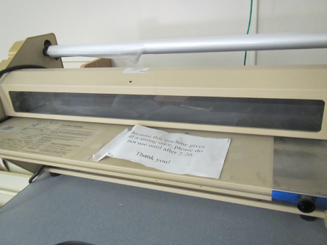
Laminator with sign
Picture 8
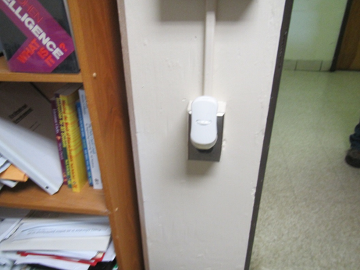
Plug-in air freshener
Picture 9
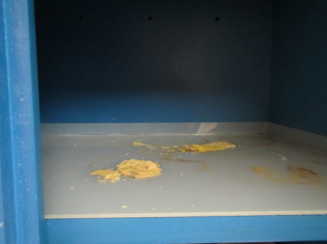
Chemical debris on shelf
Picture 10
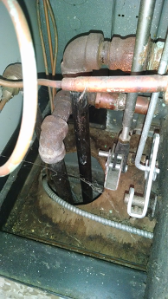
Breaches around pipes in univent cabinet
Picture 11
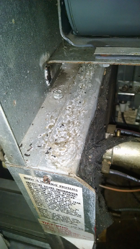
Rodent droppings univent cabinet
Picture 12
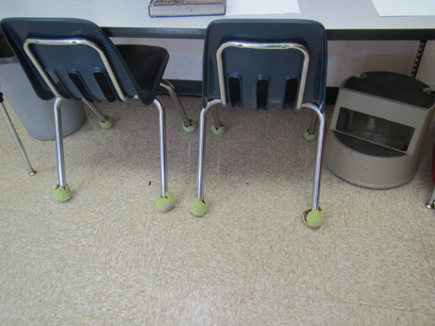
Tennis balls used as chair glides
Picture 13
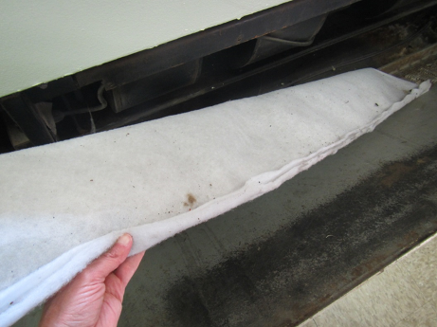
Sleeve of filter material for univent around frame
Picture 14
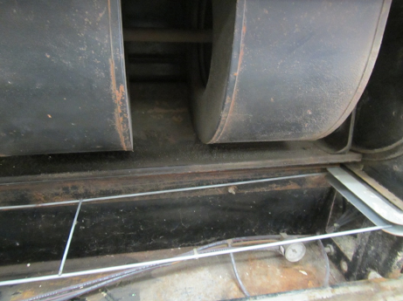
Univent filter frame with no filter
Location | Carbon  Dioxide  (ppm) | Carbon Monoxide  (ppm) | Temp  (°F) | Relative  Humidity  (%) | PM2.5  (µg/m³) | Occupants  in Room | Windows  Openable | Ventilation |  |  | Remarks
 |  |  |  |  |  |  |  | Supply | Exhaust
Background | 427 | 0.7 | 50 | 31 | 12-16 |  |  |  |  |  | Clear, windy
A Office | 863 | ND | 74 | 36 | 6 | 0 | y | N |  | Y | WD-CT
A Wing Faculty restroom |  |  |  |  |  |  |  |  |  | Y | MT, CP/AD
A101 | 470 | ND | 71 | 24 | 8 | 10 | Y  1/4 open | Y UV |  | Y blocked | DO, PF, paint, CPs
A104 | 563 | ND | 74 | 25 | 6 | 0 | Y | Y UV |  | Y off | DO, PF
A105 | 839 | ND | 73 | 32 | 6 | 0 | N | N |  | Y | DO
A108 | 595 | ND | 72 | 31 | 12 | 0 | Y | Y |  | Y | PF
A111 receiving area | 595 | ND | 69 | 39 | 43 | 0 | N | N |  | Y | Chemical storage
A143 | 1094 | ND | 71 | 38 | 7 | 18 | Y | Y UV on |  | Y on | DEM, PF, AP
A144 | 1001 | ND | 74 | 32 | 5 | 13 | Y | Y UV on |  | Y on | Plush animals,. DEM, items from ceiling
Academic Services | 818 | ND | 72 | 41 | 8 | 0 | Y | N |  | N | DEM, plants, plug-in
Athletic office | 566 | ND | 71 | 28 | 7 | 0 | N | N |  | Y | DO
Auditorium | 527 | ND | 70 | 41 | 5 | 0 | N | Y |  | Y
B occupational therapy | 1075 | ND | 71 | 37 | 7 | 0 | N | N |  | N | Solar gain, DEM, unused portable air conditioner
B101 | 1649 | ND | 71 | 35 | 22 | 27 | Y | Y UV |  | Y off | DEM, PF
B102 | 1149 | ND | 72 | 32 | 23 | 15 | Y | Y  UV on |  | Y obst. Off | 2 PF, DEM
B103 | 987 | ND | 71 | 37 | 16 | 4 | Y | Y UV on |  | Y | Bean bag chairs, HS
B104 | 1054 | ND | 72 | 31 | 4 | 5 | Y open | Y UV |  | Y | DEM, tennis balls, bean bag chair, HS
B107 computers | 1139 | ND | 70 | 43 | 5 | 0 | N | Y off |  | Y off | 4 PCs
B107 main | 1154 | ND | 70 | 42 | 5 | 0 | N | Y off |  | Y off | CPs, DEM, PF
B107 small classroom | 1140 | ND | 70 | 44 | 5 | 0 | N | Y off |  | Y off | WD CT
B108 | 745 | ND | 70 | 28 | 6 | 0 | Y | Y UV |  | Y blocked | HS, AD, 6 WD CT, DEM
B109 | 910 | ND | 71 | 31 | 6 | 3 | Y | Y UV off |  | Y blocked | 1 WD CT, PF, appliances, CPs
B110 | 816 | ND | 72 | 34 | 5 | 1 | Y | Y UV debris, off |  | Y off | AD, AP on floor, breach around UV pipe, rodent droppings
B140 | 743 | ND | 72 | 35 | 5 | 5 | Y | Y UV |  | Y | Copier, food, appliances
B141 | 665 | ND | 73 | 30 | 5 | 0 | Y | Y UV |  | Y off | HS, DEM, tennis balls
B142 | 1468 | ND | 73 | 36 | 7 | 23 | Y | Y |  | Y off | DEM, PF, HS
B143 | 1469 | ND | 71 | 34 | 7 | 24 | Y | Y |  | Y blocked, off | Items, DO
B-3 conference | 741 | ND | 70 | 43 | 6 | 0 | Y | N |  | N | Carpet, HS
C 121 office | 1100 | ND | 70 | 38 | 5 | 0 | Y | N |  | N | DO
C 128 | 969 | ND | 73 | 36 | 11 | 0 | N | N |  | N
C boys room |  |  |  |  |  |  |  | N |  | Y on
C copy room |  |  |  |  |  |  | N | N |  | N | DO, copy odors
C girls room |  |  |  |  |  |  |  | N |  | Y weak
C101 | 838 | ND | 73 | 34 | 9 | 0 | Y | Y UV on |  | Y | Debris on/in UV, DEM, chalk
C102 | 925 | ND | 74 | 33 | 13 | 15 | Y | Y UV on |  | Y on | Debris on/in UV, HS, DEM
C103 | 858 | ND | 75 | 29 | 10 | 18 | Y open | Y on |  | Y on | PF on, DEM
C104 | 1323 | ND | 74 | 39 | 20 | 21 | Y | Y obst. |  | Y on | DEM, HS, 2 PF
C105 | 1475 | ND | 73 | 42 | 14 | 24 | Y | Y UV on, obst. |  | Y weak | Solar gain, plants, DEM, HS
C110 | 1107 | ND | 74 | 33 | 18 | 0 | Y | Y |  | Y | DEM, PF, solar gain, items
C111 | 1780 | ND | 72 | 47 | 11 | 22 | Y | Y UV on |  | Y weak | Sinks, eyewash, DEM
C111 Chemical storage |  |  |  |  |  |  | N | N |  | N | Fridge, turned off with strong odor inside
C113 | 3225 | 1.0 | 72 | 53 | 16 | 32 | Y | Y UV off |  | Y weak or off | PF, HS, sink, DEM
C115 | 901 | ND | 70 | 37 | 12 | 1 | Y | Y UV no filter |  | Y | Eyewash and safety shower, porous items under sinks, DEM
C118 | 1054 | ND | 70 | 37 | 14 | 1 | Y open | Y UV |  | Y | DEM, 2 PF –dusty, sinks (used sometimes), hood (off, not used), gas service (used sometimes)
C118 Chemical storage |  |  |  |  |  |  | N |  |  | Y | Exhaust on light switch, chemical stain in cabinets, WD CT, some chemical storage cabinets vented
C120 | 858 | ND | 68 | 39 | 5 | 0 | Y | Y UV on |  | Y | DEM, HS, DO
C121 | 1093 | ND | 70 | 37 | 5 | 21 | Y | Y UV on |  | Y | 27 computers, DO
C122 | 625 | ND | 70 | 30 | 5 | 1 | Y | Y UV on |  | Y | Items, HS, PS
C123 | 905 | ND | 71 | 36 | 4 | 1 | Y | Y UV on, blocked |  | Y blocked with items | DO, PF, CPs, DEM
C124 | 935 | ND | 72 | 34 | 4 | 0 | Y | Y |  | Y | DEM, DO, PF
C125 | 828 | ND | 70 | 35 | 5 | 1 | Y | Y UV on |  | Y | DO, PF, DEM, CPs
C126 | 1517 | ND | 72 | 37 | 5 | 18 | y | Y UV items |  | Y | PFs, 26 computers, portable AC, items/papers,
C129 | 1130 | ND | 73 | 43 | 5 | 1 | Y | Y UV plant |  | Y
C130 | 1007 | ND | 73 | 43 | 5 | 1 | Y | N |  | Y | Plants, PF, CP, AD
C131 | 1064 | ND | 73 | 37 | 7 | 21 | Y | Y UV |  | Y | PF, DEM, HS
C132 | 1212 | ND | 72 | 39 | 5 | 21 | Y | Y UV |  | Y | DEM, HS
C133 | 1146 | ND | 72 | 41 | 5 | 22 | Y | Y |  | Y | DO, DEM, PF
C134 | 1248 | ND | 75 | 40 | 5 | 15 | Y | Y UV |  | Y | DEM, PF, HS
Cafeteria | 1772 | ND | 72 | 51 | 29 | 220 | Y | Y UV off |  | Y off | DO
D101 | 1998 | ND | 73 | 48 | 21 | 27 | Y | Y |  | Y | DO, CP, DEM
D102 | 1589 | ND | 71 | 48 | 22 | 25 | Y | Y |  | Y | Solar gain, DO
D103 | 1390 | ND | 70 | 47 | 16 | 11 | Y | Y |  | Y | Solar gain, HS, DO, DEM
D104 | 4658 | ND | 70 | 45 | 7 | 6 | Y | Y off |  | Y | DEM, HS, broken CT
D105 | 2779 | ND | 74 | 55 | 10 | 26 | Y | Y off |  | Y off | HS, CPs, DEM
D106 | 2061 | ND | 72 | 50 | 10 | 25 | Y | Y off |  | Y off | CPs,. Items, DEM
Guidance (Dr. Flynn office) | 875 | ND | 73 | 42 | 7 | 1 | Y, but difficult to open/close | N |  | N | DO, musty odor reports
Guidance (Ryna office) | 830 | ND | 73 | 36 | 5 | 1 | Y, but difficult to open/close | N |  | N | DO
Guidance Administrative office (left) | 838 | ND | 73 | 46 | 6 | 0 | Y, but difficult to open/close | N |  | Y | DO
Guidance main office | 810 | ND | 71 | 43 | 21 | 3 | N |  |  | Y | Food, mild musty odor, PC
Guidance office | 619 | ND | 70 | 41 | 6 | 2 | Y |  |  |  | AP, HS
Guidance/Admin staff kitchenette | 808 | ND | 73 | 40 | 9 | 0 | Y, but difficult to open/close | N |  | N | Doof, microwave, fridge, DO
Guidance/Admin office (right) | 817 | ND | 73 | 37 | 5 | 0 | Y, but difficult to open/close | N |  | N | DO, HS
Gym | 541 | ND | 70 | 25 | 5 | 0 | N (doors to outside) | Y |  | Y
Lactation/test room | 552 | ND | 70 | 43 | 4 | 0 | N | N
Library | 1097 | ND | 72 | 38 | 3 | 33 | N | Y |  | Y | Laminator, CP, carpets –worn, PF on, door to outside
Library classroom | 1338 | ND | 71 | 37 | 4 | 17 | N | Y |  | Y | NC, WD CT
Library workroom |  |  |  |  |  |  | N | Y |  | Y | PF, sink
Main Admin Office | 1142 | ND | 70 | 48 | 3 | 2 | Y | Y |  | Y | DEM, HS
Mrs ?? | 549 | ND | 71 | 43 | 6 | 0 | N | Y |  | N
Music office | 556 | ND | 70 | 42 | 5 | 0 | Y open | N |  | N
Music/cafeteria extension | 1269 | ND | 71 | 47 | 9 | 2 | N door to outside | Y |  | Y | DEM, music instruments
Nurse | 708 | ND | 71 | 44 | 5 | 3 | N | Y |  | Y | Plant, DO, sink, PF
Nurse restroom |  |  |  |  |  |  |  |  |  | Y on
Principal’s office | 1422 | ND | 71 | 42 |  | 7 | Y | Y |  | Y | Plant
Staff restroom |  |  |  |  |  |  |  |  |  | Y on
Teacher’s lunch | 1226 | ND | 71 | 48 | 26 | 0 | N | Y UV |  |  | Sink, stove, microwave, fridge, PF

The service life is the median time during which a particular system or component of …[an HVAC]… system remains in its original service application and then is replaced. Replacement may occur for any reason, including, but not limited to, failure, general obsolescence, reduced reliability, excessive maintenance cost, and changed system requirements due to such influences as building characteristics or energy prices (ASHRAE, 1991).

