Mold/Water Damage Remediation
Assessment

North Reading Middle School
Modular Buildings
19 Sherman Road
North Reading, Massachusetts

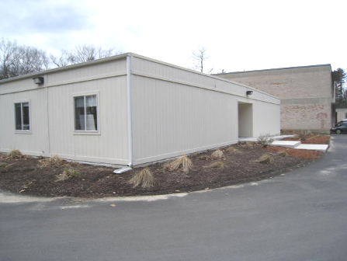

Prepared by:
Massachusetts Department of Public Health
Bureau of Environmental Health
Indoor Air Quality Program
June 2011

Background/Introduction
In response to concerns from Mr. Mark Gorgenyi, Union Representative from the North Reading Middle School (NRMS) and in cooperation with Mr. Wayne Hardacker, Facilities Director, North Reading Public Schools (NRPS), the Massachusetts Department of Public Health (MDPH), Bureau of Environmental Health (BEH) provided assistance and consultation regarding water damage in the modular building at the NRMS located at 19 Sherman Road, North Reading, Massachusetts. On April 28, 2011, Sharon Lee, an Environmental Analyst/Inspector within BEH’s Indoor Air Quality (IAQ) Program, visited the NRMS to conduct an indoor environmental assessment. Ms. Lee was accompanied by Mr. Hardacker and Mr. Gorgenyi during the assessment.
BEH staff received a call from Mr. Gorgenyi in March 2011 concerning water leaks experienced in the modular building at the rear of the school’s building complex. Water leaking through the roof reportedly caused damage to insulation and other building materials in direct contact with moisture. Staff in these areas also reported odors thought to be attributed to the water damage caused by a combination of precipitation experienced during this time in conjunction with thawing/melting of snow accumulated from previous months.
BEH staff also spoke with Mr. Hardacker, who confirmed the presence of water leaks occurring in the roof in some areas of the modular building. Mr. Hardacker indicated that over February vacation, he and his staff removed ceiling tiles and opened up walls and ductwork insulation in the ceiling plenum for examination, as well as to increase airflow to dry these materials. Mr. Hardacker reported that moisture testing conducted on these materials by NRPS staff in the days following, showed that they were dry.
In the weeks prior to the MDPH assessment, Mr. Hardacker was able to determine the source of leaks. The roof leaks are reportedly the result of water penetrating through the beams where the two portions of the building are joined. Over the April vacation, work was conducted to seal/replace roofing materials around these areas to prevent further water penetration.
As mentioned, NRMS staff reported a strong odor in classrooms where water damage was sustained. Given the amount of water damage reported, the source of the odors was likely saturated ceiling tiles. Ceiling tiles consist of a number of materials, including cellulose and starch. In the process of binding these materials, butyric acid is created, which can become trapped in the ceiling tiles. Excessive moisture within a room (i.e., relative humidity above 80%) or prolonged moistening through leaks can result in the release of butyric acid from ceiling tiles, creating an unpleasant “vomit-like” odor (Lstiburek, 2009).

Methods
MDPH staff performed a visual inspection of building materials for water damage and/or microbial growth in three classrooms (M5, M7, and M8). Moisture content of porous building materials [i.e., gypsum wallboard (GW), wood and fiberglass insulation] was measured with a Delmhorst, BD-2000 Model, Moisture Detector equipped with a Delmhorst Standard Probe and/or Tramex Non-Destructive Moisture Encounter Plus.

Results/Discussion
At the time of assessment, all water-damaged ceiling tiles had been replaced. No odors were detected in any of the classrooms examined. During the BEH assessment, Mr. Hardacker removed ceiling tiles in areas where leaks had occurred and GW and insulation was cut open (Pictures 1 through 3). MDPH staff observed conditions in the ceiling plenum and noted water staining on the wooden beams where the building is joined (Picture 2). Cross-sections of GW that had been cut appeared free of mold growth or water staining. Most of the remaining GW was free of stains and appeared intact. Where stains exist, measures should be taken to examine the paper backing of the GW for mold growth. Insulation appeared dry, free of stains and intact (Picture 3). BEH staff detected airflow from the space above the GW as well as within the plenum. As indicated previously, airflow from above and below the GW played a significant role in drying the material and preventing mold growth. Moisture measurements taken of the wooden beams, GW and insulation in the plenum space confirmed that these materials were dry.
The exterior walls along the seam in these classrooms were also examined to determine whether draining water impacted GW. Vinyl coving removed from these areas showed some dark staining and potential mold growth on the GW around the seam (Pictures 4 and 5). Moisture measurements confirmed that GW in these areas was wet at the time of testing (Picture 6). An assessment of these classrooms showed that GW was only moist in classrooms (M5 and M7) where furniture (e.g., bookcases) was placed in front of this seam. The combination of furniture placed against exterior walls inhibiting airflow to the GW and vinyl trim can serve to trap moisture and preventing drying, and if not remediated, lead to mold growth.
Subsequent conversation with Mr. Hardacker revealed that the source of moisture is an open exterior trim strip that runs along the perimeter at the base of these modular classrooms (personal communication, May 4, 2011). While GW in these areas was moist, no other materials (e.g., insulation) were damaged. Mr. Hardacker reported that this void would be sealed with caulking.
The US Environmental Protection Agency (US EPA) and the American Conference of Governmental Industrial Hygienists (ACGIH) recommend that porous materials be dried with fans and heating within 24 to 48 hours of becoming wet (US EPA, 2001; ACGIH, 1989). If not dried within this time frame, mold growth may occur. Once mold has colonized porous materials, they are difficult to clean and should be removed/discarded.

Conclusions/Recommendations
It appears that remediation of mold/water damage related to roof leaks thus far has been successful. However, additional damage noted should be addressed as soon as feasible. In view of the findings at the time of assessment, the following recommendations are made:
- Examine exterior trim around the base perimeter of all modular classrooms. Seal voids with an appropriate caulking.
- Remove furniture placed against the exterior wall in modular classrooms, remove vinyl coving and conduct moisture testing to determine whether any other classrooms were impacted by moisture penetrating through the exterior trim.
- Remove and replace water-damaged/mold colonized GW in a manner consistent with US EPA’s (2001) guidance.
- Repair/seal GW and insulation wrap to prevent aerosolization of materials in the plenum space.
- Replace any remaining water-damaged ceiling tiles.
- Refer to resource manual and other related indoor air quality documents located on the MDPH’s website for further building-wide evaluations and advice on maintaining public buildings. These documents are available at: http://mass.gov/dph/iaq.
References
ACGIH. 1989. Guidelines for the Assessment of Bioaerosols in the Indoor Environment. American Conference of Governmental Industrial Hygienists, Cincinnati, OH.
Lstiburek, J. 2009. Understanding Indoor Air Quality(2). Green Building Advisor Website. August 11, 2009. http://www.greenbuildingadvisor.com/book/export/html/14301 (accessed May 16, 2011).
US EPA. 2001. Mold Remediation in Schools and Commercial Buildings. US Environmental Protection Agency, Office of Air and Radiation, Indoor Environments Division, Washington, D.C. EPA 402-K-01-001. March 2001.
Picture 1
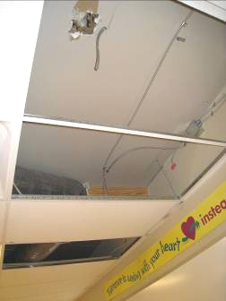
An area where roof leaks occurred

Picture 2
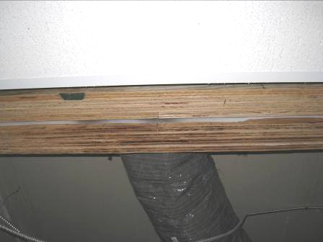
Water-stained wooden beam
Picture 3
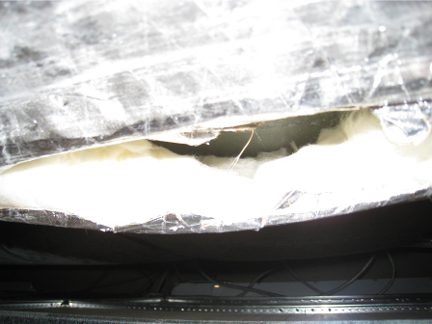
Ductwork insulation

Picture 4
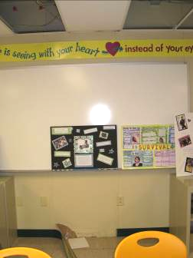
Area with water-damaged GW at wall base
Picture 5
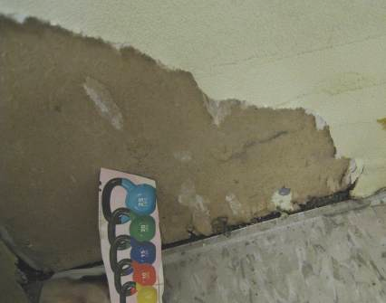
Water damage/mold growth on GW

Picture 6
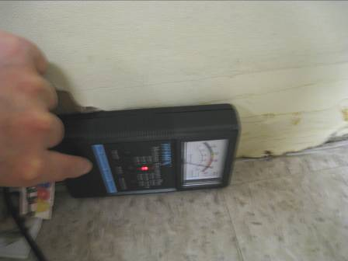
Moisture meter indicating GW wet at time of assessment

