INDOOR AIR QUALITY ASSESSMENT

North Reading Town Hall
235 North Street
North Reading, MA 01864



Prepared by:
Massachusetts Department of Public Health
Bureau of Environmental Health
Indoor Air Quality Program
April 2013

Background/Introduction
At the request of Greg Balukonis, Town Administrator, Town of North Reading, the Massachusetts Department of Public Health (MDPH), Bureau of Environmental Health (BEH) provided assistance and consultation regarding indoor air quality at the North Reading Town Hall (NRTH) located at 235 North Street, North Reading, Massachusetts. On June 26, 2012, Sharon Lee, an Environmental Analyst within BEH’s Indoor Air Quality (IAQ) Program, conducted an assessment at the NRTH. BEH/IAQ staff were accompanied by Christine Gorwood and Brenda Netreba, Environmental Analysts/Risk Communication Specialists in BEH’s Community Assessment Program (CAP). The assessment was prompted by health concerns that staff suspected may be associated with the indoor environment. Details associated with these concerns are provided in the Health Concerns section of this report.
The NRTH is a single-story brick building on a slab foundation constructed in 1958. The building was originally a school. Classrooms in the building were converted to office space when NRTH staff began occupying the space in 1987. In some areas, classrooms were subdivided into individual offices. Windows are openable throughout the building.

Methods
Air tests for carbon monoxide, carbon dioxide, temperature and relative humidity were conducted with the TSI, Q-Trak, IAQ Monitor, Model 7565. Air tests for airborne particle matter with a diameter less than 2.5 micrometers were taken with the TSI, DUSTTRAK™ Aerosol Monitor Model 8520. Air testing for total volatile organic compounds (TVOCs) was conducted using a MiniRAE 2000 photo ionization detector (PID). Moisture content of porous building materials was measured with a Delmhorst, BD-2100 Model, Moisture Detector equipped with a Delmhorst Standard Probe BEH staff also performed visual inspection of building materials for water damage and/or microbial growth.

Results
The building has approximately 40 staff members. Tests were taken during normal operations, and results appear in Table 1.

Discussion

Ventilation
It can be seen from Table 1 that carbon dioxide levels were above 800 parts per million (ppm) in 2 of 35 areas, indicating adequate air exchange in the building at the time of the assessment. Please note, however, the building was sparsely populated at the time of assessment. Greater occupancy would increase carbon dioxide levels, especially in smaller office areas.
Fresh air to office spaces was originally supplied by unit ventilator (univent) systems (Picture 1). A univent draws outdoor air through a fresh air intake located on the exterior wall of the building (Picture 2) and returns air from the room through an air intake located at the base of the unit (Figure 1). Fresh and return air are mixed, filtered, heated, and then provided through an air diffuser located in the top of the unit. Some newer univents (installed in the 1990s) were found operating at the time of assessment but most univents were not. In a majority of areas, air diffusers, intakes and returns were obstructed by items. Univents must remain free of obstructions and be allowed to operate while rooms are occupied.
Please note that most univents are original to the construction of the building. Function of equipment of this age is difficult to maintain, since compatible replacement parts are often unavailable. According to the American Society of Heating, Refrigeration and Air-Conditioning Engineers (ASHRAE), the service life for a unit heater, hot water or steam is 20 years, assuming routine maintenance of the equipment (ASHRAE, 1991). Despite attempts to maintain the univents, the operational lifespan of the equipment has been exceeded by over 60 years. Maintaining the balance of fresh air to exhaust air will become more difficult as the equipment ages and as replacement parts become increasingly difficult to obtain. Currently, ventilation in the NRTH is controlled by the use of openable windows.
BEH/IAQ staff also examined the interior conditions of a few univents. Dust and debris were found accumulated inside cabinets and on radiator fins (Picture 3); this material should be removed through vacuuming during each filter change. Some univents did not have filters installed; filters are needed to remove particulates from the air before it is circulated. Disposable filters with an appropriate dust spot efficiency should be installed in univents. The dust spot efficiency is the ability of a filter to remove particulates of a certain diameter from air passing through the filter. Filters that have been determined by ASHRAE to meet its standard for a dust spot efficiency of a minimum of 40% would be sufficient to reduce airborne particulates (MEHRC, 1997; ASHRAE, 1992). Note that increased filtration can reduce airflow produced by the AHU by increased resistance. Prior to any increase of filtration, each AHU should be evaluated by a ventilation engineer as to whether it can maintain function with more efficient filters.
Spaces were also observed around pipes in some univent cabinets (Picture 4). These gaps should be sealed with an appropriate fire-rated material to prevent the draw of odors and materials from other areas of the building into the univent. Please note, some univents are difficult to access due to partition walls that prevent access to the main compartment (Picture 1).
Exhaust ventilation in offices is provided by vents located in closets and ducted to rooftop motors (Pictures 5 and 6). The exhaust ventilation system is designed to continuously remove moisture, odors, and pollutants from the indoor environment. As with the univents, exhaust vents were not operating in the majority areas surveyed during the assessment. NRTH Staff indicate that these exhaust vents are not operated regularly. In many areas, furniture and other items were hindering the flow of air into the exhaust vent. In order to function properly, exhaust vents must be activated and allowed to operate, without obstructions, while rooms are occupied. Without adequate exhaust ventilation, excess heat and normally occurring indoor air pollutants can accumulate, leading to indoor air/comfort complaints. Operating exhaust ventilation will not only aid removal of pollutants, but also aid air movement within the space.
Air-conditioning units were installed throughout the building as a means for cooling office areas during the summer. In some areas, the units were installed through the hallway wall (Picture 7). In this configuration, air drawn from the hallway is mixed with air drawn from the cooled space before it is “re-cooled”, and provided to the office or room; warm, moist air is exhausted through ductwork to the ceiling plenum in the building’s hallway. This configuration can result in pressurization of the ceiling plenum, resulting in movement of materials from the plenum into the occupied areas. Air-conditioning units are also equipped with washable filters, which were occluded with dust at the time of assessment (Picture 8). These filters should be cleaned periodically as per manufacturer’s instructions to avoid the build-up and re-aerosolization of dirt, dust and particulate matter. Air-conditioning units are often equipped with a “fan only” or “exhaust open” setting. In this mode of operation, the unit can provide air circulation by delivering fresh air without cooling.
To maximize air exchange, the MDPH recommends that both supply and exhaust ventilation operate continuously during periods of occupancy. In order to have proper ventilation with a mechanical supply and exhaust system, the systems must be balanced to provide an adequate amount of fresh air to the interior of a room while removing stale air from the room. It is recommended that HVAC systems be re-balanced every five years to ensure adequate air systems function (SMACNA, 1994).
Minimum design ventilation rates are mandated by the Massachusetts State Building Code (MSBC). Until 2011, the minimum ventilation rate in Massachusetts was higher for both occupied office spaces and general classrooms, with similar requirements for other occupied spaces (BOCA, 1993). The current version of the MSBC, promulgated in 2011 by the State Board of Building Regulations and Standards (SBBRS), adopted the 2009 International Mechanical Code (IMC) to set minimum ventilation rates. Please note that the MSBC is a minimum standard that is not health-based. At lower rates of cubic feet per minute (cfm) per occupant of fresh air, carbon dioxide levels would be expected to rise significantly. A ventilation rate of 20 cfm per occupant of fresh air provides optimal air exchange resulting in carbon dioxide levels at or below 800 ppm in the indoor environment in each area measured. MDPH recommends that carbon dioxide levels be maintained at 800 ppm or below. This is because most environmental and occupational health scientists involved with research on IAQ and health effects have documented significant increases in indoor air quality complaints and/or health effects when carbon dioxide levels rise above the MDPH guidelines of 800 ppm for schools, office buildings and other occupied spaces (Sundell et al., 2011). The ventilation must be on at all times that the room is occupied. Providing adequate fresh air ventilation with open windows and maintaining the temperature in the comfort range during the cold weather season is impractical. Mechanical ventilation is usually required to provide adequate fresh air ventilation.
Carbon dioxide is not a problem in and of itself. It is used as an indicator of the adequacy of the fresh air ventilation. As carbon dioxide levels rise, it indicates that the ventilating system is malfunctioning or the design occupancy of the room is being exceeded. When this happens, a buildup of common indoor air pollutants can occur, leading to discomfort or health complaints. The Occupational Safety and Health Administration (OSHA) standard for carbon dioxide is 5,000 parts per million parts of air (ppm). Workers may be exposed to this level for 40 hours/week, based on a time-weighted average (OSHA, 1997).
The MDPH uses a guideline of 800 ppm for publicly occupied buildings. A guideline of 600 ppm or less is preferred in schools due to the fact that the majority of occupants are young and considered to be a more sensitive population in the evaluation of environmental health status. Inadequate ventilation and/or elevated temperatures are major causes of complaints such as respiratory, eye, nose and throat irritation, lethargy and headaches. For more information concerning carbon dioxide, consult Appendix A.
Indoor temperature measurements ranged from 74ºF to 82ºF, which were within or above the MDPH recommended comfort range (Table 1). The MDPH recommends that indoor air temperatures be maintained in a range of 70ºF to 78ºF in order to provide for the comfort of building occupants. In many cases concerning indoor air quality, fluctuations of temperature in occupied spaces are typically experienced, even in a building with an adequate fresh air supply.
The relative humidity in the building on the day of the assessment ranged from 42 to 60 percent, which was within the MDPH recommended comfort range (Table 1). The MDPH recommends a comfort range of 40 to 60 percent for indoor air relative humidity. Relative humidity levels in the building would be expected to drop during the winter months due to heating. The sensation of dryness and irritation is common in a low relative humidity environment. Low relative humidity is a very common problem during the heating season in the northeast part of the United States.

Microbial/Moisture Concerns
In order for building materials to support mold growth, a source of water exposure is necessary. Identification and elimination of the source of water moistening building materials is necessary to control mold growth. MDPH/BEH staff examined the building to identify possible sources of moisture and water penetration. Of note is the air-conditioning unit configuration. As mentioned, moist, hot air is exhausted from air conditioners into the hallway ceiling plenum (Picture 7). This configuration can result in chronic moistening of ceiling tiles and materials (i.e., dust, debris) collected on tiles. Prolonged moistening of debris can result in mold growth in the ceiling plenum. Exhaust from air-conditioning units can pressurize the plenum, which can potentially result in the movement of debris (including mold spores) from the plenum into the hallway through spaces or breaches that exist where ceiling tiles are ajar or not flush. The wall separating the hallway and offices should be examined to ensure that the wall continues to the decking rather than ending at the ceiling plenum. A continuous wall to the decking will prevent movement of moisture and materials from the hallway ceiling plenum area into the office plenum.
Evidence of water penetration through an exterior door was observed in the vault/records storage area in the Assessor’s Department (Picture 9). Moisture measurements taken of gypsum wallboard (GW) revealed that the GW was wet at the time of the assessment (Picture 10). These materials have likely become wet repeatedly. GW is a porous material that can become a source of mold growth/exposure. Discoloration/staining observed on the GW suggests the presence of mold on these walls. Measures should be taken to remove and replace these damaged materials in conformance with available guidance (US EPA, 2001).
NRTH staff in the Assessor’s Department also reported window leaks. BEH/IAQ staff examined the window and the bookcase along this wall. These original windows appeared to be single-paned glass framed in wood. Evidence of age-related damage was observed, including peeling paint, brittle caulking, and wood splintering (Picture 11). Deterioration observed around the windows, particularly missing/damaged caulking, can result in air/moisture infiltration and damage to interior building materials. Depending on its age, window (and joint) sealant may be composed of regulated materials [i.e., polychlorinated biphenyls (PCBs)]. If so, materials should be addressed in accordance with US Environmental Protection Agency (US EPA) regulations. For additional information regarding PCBs, please consult MDPH guidance (Appendix B).
At the time of assessment, portions of the bookcase in the Assessor’s Department were wet. Measures should be taken to dismantle and/or remove the bookcase so that damage to the wall can be examined. As mentioned previously, water-damaged porous material like GW will require removal and replacement. Semi-porous walls (i.e., cement) should be cleaned and disinfected.
A number of rooms had water-damaged ceiling tiles, which can indicate leaks from the roof or plumbing system and provide a source of mold growth. Ceiling tiles should be replaced after a water leak is discovered and repaired. Missing ceiling tiles, which were observed in some areas, can result in movement of particles into occupied areas.
The US EPA and the American Conference of Governmental Industrial Hygienists (ACGIH) recommend that porous materials be dried with fans and heating within 24 to 48 hours of becoming wet (US EPA, 2001; ACGIH, 1989). If not dried within this time frame, mold growth may occur. Mold-]colonized porous materials are difficult to clean and should be removed and discarded.
Several offices had a number of plants (Table 1). In some areas, plants were placed directly on or hanging above heating and ventilation equipment (Picture 12), which can result in debris dropping into the equipment. Moistened plant soil and drip pans can be sources of mold spores. Plants should be equipped with drip pans; the lack of drip pans can lead to water pooling and mold growth. Plants are also a source of pollen and should be located away from the air stream of air diffusers to prevent the aerosolization of mold, pollen or particulate matter throughout the room.
Water-stained carpet was observed in a few areas (Pictures 13 and 14), likely contributing to the musty odors observed in the carpeted areas. Spills from a water dispenser placed on the carpet likely resulted in the staining shown in Picture 14. Carpeting moistened for a prolonged period of time can lead to mold growth. When possible, water-dispensing units should be located in tiled areas or placed on a waterproof mat that can catch spilled water.

Other IAQ Evaluations
Indoor air quality can be negatively influenced by the presence of respiratory irritants, such as products of combustion. The process of combustion produces a number of pollutants. Common combustion emissions include carbon monoxide, carbon dioxide, water vapor and smoke (fine airborne particle material). Of these materials, exposure to carbon monoxide and particulate matter with a diameter of 2.5 micrometers (μm) or less (PM2.5) can produce immediate, acute health effects upon exposure. To determine whether combustion products were present in the indoor environment, BEH staff obtained measurements for carbon monoxide and PM2.5.

Carbon Monoxide
Carbon monoxide is a by-product of incomplete combustion of organic matter (e.g., gasoline, wood and tobacco). Exposure to carbon monoxide can produce immediate and acute health affects. Several air quality standards have been established to address carbon monoxide and prevent symptoms from exposure to these substances. The MDPH established a corrective action level concerning carbon monoxide in ice skating rinks that use fossil-fueled ice resurfacing equipment. If an operator of an indoor ice rink measures a carbon monoxide level over 30 ppm, taken 20 minutes after resurfacing within a rink, that operator must take actions to reduce carbon monoxide levels (MDPH, 1997).
The American Society of Heating Refrigeration and Air-Conditioning Engineers (ASHRAE) has adopted the National Ambient Air Quality Standards (NAAQS) as one set of criteria for assessing indoor air quality and monitoring of fresh air introduced by HVAC systems (ASHRAE, 1989). The NAAQS are standards established by the US EPA to protect the public health from six criteria pollutants, including carbon monoxide and particulate matter (US EPA, 2006). As recommended by ASHRAE, pollutant levels of fresh air introduced to a building should not exceed the NAAQS levels (ASHRAE, 1989). The NAAQS were adopted by reference in the Building Officials & Code Administrators (BOCA) National Mechanical Code of 1993 (BOCA, 1993), which is now an HVAC standard included in the Massachusetts State Building Code (SBBRS, 2011). According to the NAAQS, carbon monoxide levels in outdoor air should not exceed 9 ppm in an eight-hour average (US EPA, 2006).
Carbon monoxide should not be present in a typical, indoor environment. If it is present, indoor carbon monoxide levels should be less than or equal to outdoor levels. Outdoor carbon monoxide concentrations were non-detect (ND) at the time of the assessment (Table 1). Carbon monoxide levels measured inside the building were also ND (Table 1).

Particulate Matter (PM2.5)
The US EPA has established NAAQS limits for exposure to particulate matter. Particulate matter is airborne solids that can be irritating to the eyes, nose and throat. The NAAQS originally established exposure limits to particulate matter with a diameter of 10 μm or less (PM10). In 1997, US EPA established a more protective standard for fine airborne particulate matter with a diameter of 2.5 μm or less (PM2.5). The NAAQS has subsequently been revised, and PM2.5 levels were reduced. This more stringent PM2.5 standard requires outdoor air particle levels be maintained below 35 μg/m³ over a 24-hour average (US EPA, 2006). Although both the ASHRAE standard and BOCA Code adopted the PM10 standard for evaluating air quality, MDPH uses the more protective PM2.5 standard for evaluating airborne PM concentrations in the indoor environment.
Outdoor PM2.5 concentrations were measured at 10 μg/m³ (Table 1). PM2.5 levels measured inside the NRTH were between 3 to 8 μg/m³ (Table 1). Both indoor and outdoor PM2.5 levels were below the NAAQS PM2.5 level of 35 μg/m³. Frequently, indoor air levels of particulates (including PM2.5) can be at higher levels than those measured outdoors. A number of mechanical devices and/or activities that occur in buildings can generate particulate during normal operations. Sources of indoor airborne particulates may include but are not limited to particles generated during the operation of fan belts in the HVAC system, cooking in the cafeteria stoves and microwave ovens; use of photocopiers, fax machines and computer printing devices; operation of an ordinary vacuum cleaner and heavy foot traffic indoors.

Volatile Organic Compounds
Indoor air concentrations can be greatly impacted by the use of products containing volatile organic compounds (VOCs). VOCs are carbon-containing substances that have the ability to evaporate at room temperature. Frequently, exposure to low levels of total VOCs (TVOCs) may produce eye, nose, throat and/or respiratory irritation in some sensitive individuals. For example, chemicals evaporating from a paint can stored at room temperature would most likely contain VOCs. In order to determine if VOCs were present, testing for TVOCs was conducted. No measureable levels of TVOCs were detected in background (outdoors), or inside the NRTH (Table 1).
BEH staff also examined rooms for products containing these respiratory irritants. Cleaning products were found in a number of areas. Cleaning products contain chemicals that can be irritating to the eyes, nose and throat of sensitive individuals. These products should be properly labeled and stored in an area that is not accessible to children. Additionally, a Material Safety Data Sheet (MSDS) should be available at a central location for each product in the event of an emergency.
Air fresheners/deodorizers were observed in some areas (Picture 15). Air fresheners contain chemicals that can be irritating to the eyes, nose and throat of sensitive individuals. Further, air fresheners do not remove materials causing odors, but rather mask odors which may be present in the area.

Other Conditions
In several areas, items were observed on windowsills, tabletops, counters, bookcases and desks. The large number of items stored in offices provides a source for dusts to accumulate. These items (e.g., papers, folders, boxes) make it difficult for custodial staff to clean. Items should be relocated and/or be cleaned periodically to avoid excessive dust build up. In addition, these materials can accumulate on flat surfaces (e.g., desktops, shelving and carpets) in occupied areas and subsequently be re-aerosolized causing further irritation.
A number of univent/supply air diffusers, exhaust vents and personal fans in offices were observed to have accumulated dust/debris. Re-activated supply vents/fans can aerosolize dust accumulated on fan blades/housing. If exhaust vents are not functioning, backdrafting can occur, which can re-aerosolize dust particles.
Breaches were observed around exhaust ductwork; ceiling panels in some closets were also missing (Picture 16). Breaches and missing panels should be sealed/replaced to prevent movement of materials/debris into occupant areas.
The majority of floor surfaces are covered by wall-to-wall carpeting. It was not clear whether a carpet cleaning program is in place. The Institute of Inspection, Cleaning and Restoration Certification (IICRC), recommends that carpeting be cleaned annually (or semi-annually in soiled high traffic areas) (IICRC, 2005). Carpets have a finite life expectancy (10+ years in general) that can be rapidly reduced due to failure to maintain the carpeting properly. Considering the age of the carpet, consideration should be given to replacing with carpet squares or vinyl floor tiles.
Pests and termites were reported to have been seen in the lunch room. Under current Massachusetts law (effective November 1, 2001) the principles of integrated pest management (IPM) must be used to remove pests in state buildings (Mass Act, 2000). Pesticide use indoors can introduce chemicals into the indoor environment that can be sources of eye, nose and throat irritation. The reduction/elimination of pathways/food sources that are attracting these insects should be the first step taken to prevent or eliminate infestation. Screens should also be installed on windows to prevent pests from entering through openable windows.
Lastly, exposed insulation was observed in the ceiling plenum of the health office. Given the age of the building, measures should be taken to determine whether this material may contain asbestos. Intact asbestos-containing materials (ACM) do not pose a health hazard. If damaged, however, ACM can be rendered friable and become aerosolized. Friable asbestos is a chronic (long-term) health hazard, but will not produce acute (short-term) health effects (e.g., headaches) typically associated with buildings believed to have indoor air quality problems. If ACM are damaged, the materials should be removed or remediated in a manner consistent with Massachusetts asbestos remediation laws (MDLI, 1993).

Health Concerns
On May 23, 2011 BEH received a list of reported health concerns that staff suspected might be related to indoor environmental conditions at the town hall. A wide variety of health conditions were reported among current and former staff in the NRTH covering more than 20 years. The types of conditions reported included respiratory symptoms, cancer, reproductive outcomes and skin disorders.
BEH/CAP staff conducted interviews with NRTH staff at the time of the IAQ inspection to determine the type and frequency of the symptoms experienced by some NRTH employees.
The questionnaire was closely modeled on surveys used previously by BEH as well as those used by the National Institute of Occupational Safety and Health (NIOSH) and the U.S. Environmental Protection Agency (USEPA). It included questions on specific symptoms (those commonly experienced by occupants of buildings with indoor air problems), perceived air quality, and personal factors. The information collected, in conjunction with the assessment of the indoor environment, can be used to evaluate possible associations between indoor air quality and health and to recommend appropriate follow-up if warranted.
The NRTH has an employee population of approximately 40 individuals. On June 26, 2012, BEH staff offered to conduct in-person interviews with NRTH employees. A total of eight NRTH employees asked to participate in the interview. The interviews each took approximately 30 minutes. All responses were reviewed to identify the types of diseases and symptoms that were reported, their frequency of occurrence, and whether any unusual patterns emerged suggestive of a possible association with indoor environmental conditions in the NRTH (Appendix C).

Employee Interview Results
Information from the eight individuals (representing roughly 20% of the HRTH employees) is summarized below. Under both state and federal regulations, personally-identifying information shared by employees is confidential; therefore, the following discussion provides summary information only.

Health Effects
Of the eight employees interviewed, seven were female and one was a male. The average age of the employees was approximately 55 years old and the average length of employment with NRTH was about 11 years. Smoking status was obtained in the interviews due to the role of smoking in respiratory health. Among the eight employees, three people reported that they are current or former smokers; five reported that they have never smoked.
The most commonly reported symptoms (with at least four of the eight employees reporting that they experienced the symptom at least once in the past four weeks) were: itchy, runny or watery eyes (n=7); stuffy or runny nose and sinus congestion (n=5); pain or stiffness in back, shoulder, or neck (n=4); sore, hoarse or dry throat (n=4); and skin irritation, dryness, redness or rash (n=4). Most of these employees reported that their symptoms were worse while inside the building and their symptoms did improve once they left the building.
Other symptoms that were reported by three of the eight employees to have been experienced at least once in the past four weeks included the following: difficulty remembering things or concentrating (n=3) and coughing (n=3). Respondents were asked if there was a particular time of day or week when their symptoms usually became worse or more frequent; most employees reported no particular temporal pattern.
Employees who participated in the MDPH interview were also asked if they had been diagnosed by a doctor with any of the following conditions: asthma, eczema, hay fever/allergies, or migraine headaches. Of the eight participating employees, four reported being diagnosed with asthma, four with migraine headaches, one with hay fever, and one with eczema. One of the four individuals with a reported diagnosis of asthma told MDPH that they had been diagnosed with their condition prior to working at NRTH.
Three individuals reported having been diagnosed with cancer. These individuals were diagnosed with three different types of cancers over about a 15-year time period. One of these individuals reported that they were diagnosed with cancer prior to working in the NRTH.

Building Concerns
The eight NRTH employees interviewed responded to questions that pertained to their perceptions of environmental conditions in their work environment. Responses that were reported by at least 5 of the employees were as follows:
- musty or moldy smells
- the air is too stuffy
- the air was either too humid or too dry, depending on the season
- the indoor temperature was too hot
- unusual or unpleasant dust
- other unusual or unpleasant odors, such as a gas or sewage
Of the employees who reported that the air was too humid, the majority also reported that at different times the air was too dry. Similarly, some of the employees who reported that the indoor temperature was too hot also reported that the indoor temperature was consistently too cold. This suggests that the indoor air conditions in the NRTH are inconsistent and likely vary by season.

Other Reported Concerns
When individuals who participated in the interview were asked if they had any other building or health-related concerns at the NRTH that had not yet been discussed, a number of other concerns were reported. Staff were concerned that the IAQ testing was not being done under normal working conditions, i.e., windows open, ventilation off. Staff reported that the ventilation system was turned on during the week prior to MDPH’s site visit. Staff also mentioned concerns about potential chemical exposures from work conducted in the building, e.g., pest extermination and roof work. Other building related concerns reported during the interviews included, asbestos; the safety of the town hall’s drinking water; mold; old and poorly cleaned carpets; and dirty air filters. Some staff also reported that there were a high number of cancer diagnoses among residents of the Martin Pond Area of North Reading, a neighborhood in the northwest corner of North Reading.

Discussion
The irritant symptoms and other health concerns reported among participants in this health investigation are generally those most commonly experienced in buildings with indoor air quality problems. These include sore, hoarse or dry throat; dry, itchy eyes; stuffy or runny nose; and skin irritation, dryness, redness or rash. Such symptoms are commonly associated with ventilation problems in buildings, although other factors (e.g., odors, microbiological contamination) may also contribute (Passarelli 2009; Norbäck 2009; Burge 2004; Stolwijk et al. 1991).
During BEH’s inspection on June 26, 2012, carbon dioxide was found above 800 ppm in two of the 35 test locations; however, with greater occupancy and the ventilation system off, these results would be expected to be higher. As mentioned, carbon dioxide is not a problem in and of itself; however, it is used as an indicator of the adequacy of the fresh air supply.
Four of the eight individuals reported having asthma and/or allergies. The onset of allergic reactions to mold/moisture can be either immediate or delayed. Allergic responses include hay fever-type symptoms such as runny nose and red eyes. Some of the individuals were diagnosed with these conditions prior to working at the NRTH; however, exposure to irritants (e.g., mold/moisture, dust) as well as low relative humidity environments coupled with a lack of fresh air ventilation can exacerbate pre-existing symptoms. It is likely that some individuals may be impacted differently than the general population.

Cancer and Other Health Concerns
As mentioned previously, the incidence of cancer among current and former employees of the NRTH was a concern to some of those interviewed. According to the American Cancer Society, not only will one out of three women and one out of two men develop cancer in their lifetime, but cancer will affect three out of every four families. For this reason, cancers often appear to occur in “clusters,” and it is understandable that someone may perceive that there are an unusually high number of cancer cases in their neighborhood, workplace or community. Upon close examination, many of these “clusters” are not unusual increases, as first thought, but are related to such factors as local population density, variations in reporting, or chance fluctuations in occurrence. In other instances, the “cluster” in question includes a high concentration of individuals who possess related behaviors or risk factors for cancer. Some, however, are unusual; that is, they represent a true excess of cancer in a workplace, a community, or among a subgroup of people. A suspected cluster is more likely to be a true cancer cluster if it involves a high number of diagnoses of one type of cancer in a relatively short time period rather than several different types diagnosed over a long period of time (i.e., 20 years), a rare type of cancer rather than common types, and/or a large number of diagnoses among individuals in age groups not usually affected by that cancer. These types of clusters may warrant further public health investigation.
The Massachusetts Cancer Registry (MCR), a division in the MDPH Bureau of Health Information, Statistics, Research, and Evaluation, is a population-based surveillance system that has been monitoring cancer incidence in the Commonwealth since 1982. All new diagnoses of invasive cancer, along with several types of in situ (localized) cancer, occurring among Massachusetts residents are required by law to be reported to the MCR within six months of the date of diagnosis (M.G.L. c.111. s 111b). This information is collected and kept in a confidential database. Data are collected on a daily basis and reviewed for accuracy and completeness on an annual basis. Individuals diagnosed with cancer in Massachusetts are reported to the MCR based on their residence at diagnosis and not their workplace. For that reason, calculating an expected rate of cancer is difficult at best for a place of employment, such as a school or municipal office. The most practical first step in evaluating cancer in the workplace is to determine the types of cancer reported and whether they represent an unusual pattern (i.e., are the cancers reported the same type and/or are they rare cancers?).
The list of health concerns provided to BEH on May 23, 2011 (prior to the interviews) included many different types of cancer reportedly diagnosed in NRTH employees between 1995 and 2009. Based on a review of the list, the pattern of cancer did not appear unusual. The most common cancer type reported was breast cancer. In Massachusetts, breast cancer has been the most common type of cancer diagnosed among female residents for more than a decade and prostate cancer has been the most common type diagnosed among male residents. Each of these cancer types accounts for approximately 28% of new cancers diagnosed among females and males statewide, respectively, during 2004-2008. Lung and bronchus cancers have been the second most common type of cancer diagnosed among both males and females in Massachusetts and account for approximately 14% of new cancer diagnoses statewide during 2004-2008. Colorectal cancers are the third most common type of cancers diagnosed among males and females and account for approximately 10% of new cancers in Massachusetts during this time period (MCR 2011). According to the American Cancer Society, breast cancer affects an estimated one of every eight woman. In a list of reported cancer diagnoses that is comprised mainly of women (as was the case with the NRTH), it is not unusual to have breast cancer be the most frequently diagnosed type of cancer. The ages at diagnosis for the individual types of cancer appeared to be consistent with what would be expected based on the epidemiologic literature. No unusual concentration of rare types of cancer was noted. Therefore, overall, the pattern of cancers reported did not appear to be different from what would be expected.

Cancer in the Martins Pond Neighborhood of North Reading
Calculating cancer incidence rates for areas smaller than a census tract is generally not done due to statistical instability. In order to address staff questions about cancer incidence in the Martins Pond Neighborhood, the CAP staff conducted a qualitative review of cancer diagnoses that occurred from 1982 - 2008 in this area. To determine whether any cancer type appeared to be concentrated within this area of North Reading, place of residence at the time of diagnosis was mapped and evaluated for all individuals diagnosed with cancer in the area that is bordered to the north and west by the Andover and Wilmington town lines, to the east by Main Street, and to the south by North and Lowell Streets.
A total of 133 cancer diagnoses occurred among 124 individuals within the neighborhood of interest during this 27-year time period. These individuals were diagnosed with more than 23 different types of cancer. Slightly more than half (53%) of the cancer diagnoses in this neighborhood were of the most common types of cancer diagnosed among Massachusetts residents (i.e., breast cancer, prostate cancer, cancers of the lung and bronchus, and colorectal cancer). For the remaining types of cancer, no more than 5 diagnoses occurred over the entire 27-year time period. Overall, no unusual spatial or temporal patterns of cancer were observed in this area. It should be noted that the Martins Pond neighborhood is one of the more densely populated areas in the town of North Reading.

Water Quality Concerns
To address concern about the quality of drinking water at the NRTH, CAP staff reviewed the 2011 Consumer Confidence Report, which is required to be provided to community residents by federal law. Its purpose is to inform residents about the quality of their municipal drinking water. The North Reading Water System source water is obtained from four active wellfields: the Lakeside Boulevard Wellfield, the Route 125 Well, the Railroad Bed Wellfield, and the Central Street Wellfield. In addition to these wellfields, they maintain two active interconnections with the Town of Andover that are used to supplement the wells. No exceedances of drinking water standards were noted in the most recent report (North Reading Water Department 2011).

Conclusions/Recommendations
Based on measurements and observations at the time of the assessment, the following recommendations are made to improve indoor air quality:
- Examine insulation in the ceiling plenum to determine whether it is an asbestos-containing material. Remediate any asbestos-containing material in friable condition, in conformance with Massachusetts asbestos remediation and hazardous waste disposal laws and regulations.
- Consider re-grading the apron near the exterior door to the vault/records storage area in the Assessor’s Department to prevent water infiltration into the building. Install a sweep or gasket to render the door more weatherproof.
- Re-seal damaged windows with new caulking to prevent water infiltration, particularly outside the Assessor’s Department office. Remove/handle old caulking in conformance with appropriate regulations if it is found to contain regulated materials such as PCBs.
- Remove and replace water-damaged wallboard near the doorway in the vault/records storage area as well as behind the bookcase in the Assessor’s Department office. Repair or replace the water-damaged bookcase and examine any items that were stored on it for water damage.
- Examine walls between offices and the hallway in the plenum area to ensure they are continuous and separate the office plenum areas from hallway plenums. As discussed, the configuration of ducted exhaust for air-conditioning systems installed in the hallway can result in moistening of materials in the ceiling plenum system, which could potentially result in mold growth.
- Examine, clean and vacuum the interior of all HVAC equipment, including univents, radiators, and air-conditioning units, to prevent the aerosolization of dirt, dust and particulates. Change filters as per manufacturer’s recommendation or more frequently if needed and install filters in univents lacking them. Ensure filters fit flush in their racks with no spaces in between allowing bypass of unfiltered air into the unit.
- Operate all ventilation systems (e.g., univents and AHUs) throughout the building continuously during periods of occupancy and independent of thermostat control.
- Inspect all exhaust motors and belts periodically for proper function. Repair and replace as necessary.
- Remove all blockages from univents and exhaust vents to ensure adequate airflow. NRTH staff should be encouraged not to deactivate univents and to report any complaints concerning temperature control to the facilities department.
- Replace missing components in the ceiling in closets to prevent movement of materials through breaches into occupied areas.
- Use openable windows in conjunction with mechanical ventilation to increase air exchange. Care should be taken to ensure windows are properly closed at night and weekends to avoid the freezing of pipes and potential flooding.
- Supplement fresh air by operating window-mounted air conditioners in the "fan only" “fresh air” mode, which introduces outside air by mechanical means.
- Consider adopting a balancing schedule of every 5 years for all mechanical ventilation systems, as recommended by ventilation industrial standards (SMACNA, 1994).
- For buildings in New England, periods of low relative humidity during the winter are often unavoidable. Therefore, scrupulous cleaning practices should be adopted to minimize common indoor air contaminants whose irritant effects can be enhanced when the relative humidity is low. To control for dusts, a high efficiency particulate arrestance (HEPA) filter equipped vacuum cleaner in conjunction with wet wiping of all surfaces is recommended. Avoid the use of feather dusters. Drinking water during the day can help ease some symptoms associated with a dry environment (throat and sinus irritations).
- Repair any existing water leaks and replace any remaining water-damaged ceiling tiles. Examine the area above these tiles for mold growth. Disinfect areas of water leaks with an appropriate antimicrobial, as needed.
- Ensure plants have drip pans. Examine drip pans periodically for mold growth and disinfect with an appropriate antimicrobial where necessary. Move plants away from the air stream of mechanical ventilation.
- Equip water-dispensing equipment with waterproof mats or move these items to a non-carpeted area.
- Refer to “Mold Remediation in Schools and Commercial Buildings” published by the US Environmental Protection Agency (US EPA, 2001) for information concerning mold growth and remediation of water-damaged materials. This document can be downloaded from the US EPA website at: http://www.epa.gov/iaq/molds/mold_remediation.html.
- Store cleaning products properly. All cleaning products used at the facility should be approved by facilities staff and MSDSs should be available at a central location.
- Refrain from using air fresheners or other air deodorizers to prevent exposure to VOCs.
- Use the principles of Integrated Pest Management to reduce impacts from pests inside the building, including sealing openings and preventing pest access to food and water in the building. Additional resource materials for building managers can be found on the Massachusetts Department of Agricultural Resources webpage at: http://www.mass.gov/eea/docs/agr/pesticides/publications/ipm-kit-for-bldg-mgrs.pdf
- Clean carpeting regularly and consider replacing worn/stained carpeting with carpet squares or floor tiles.
- Relocate or consider reducing the amount of materials stored in rooms to allow for more thorough cleaning. Clean items regularly with a wet cloth or sponge to prevent excessive dust build-up. Also clean univent/supply air diffusers, exhaust vents and personal fans of accumulated dust/debris on a regular basis.
- If residents or employees of the Town Hall would like more information about environmental health data in the town of North Reading, please visit the Massachusetts Environmental Public Health Tracking website at: http://matracking.ehs.state.ma.us/
- Refer to resource manual and other related indoor air quality documents located on the MDPH’s website for further building-wide evaluations and advice on maintaining public buildings. These documents are available at: http://mass.gov/dph/iaq.

References
ACGIH. 1989. Guidelines for the Assessment of Bioaerosols in the Indoor Environment. American Conference of Governmental Industrial Hygienists, Cincinnati, OH.
ASHRAE. 1989. Ventilation for Acceptable Indoor Air Quality. American Society of Heating, Refrigeration and Air Conditioning Engineers. ANSI/ASHRAE 62-1989.
ASHRAE. 1991. ASHRAE Applications Handbook, Chapter 33 “Owning and Operating Costs”. American Society of Heating, Refrigeration and Air Conditioning Engineers, Atlanta, GA.
ASHRAE. 1992. Gravimetric and Dust-Spot Procedures for Testing Air-Cleaning Devices Used in General Ventilation for Removing Particulate Matter. American Society of Heating, Refrigeration and Air Conditioning Engineers. ANSI/ASHRAE 52.1-1992.
BOCA. 1993. The BOCA National Mechanical Code/1993. 8th ed. Building Officials & Code Administrators International, Inc., Country Club Hills, IL.
Burge, PS. 2004. Sick building syndrome. Occupational and Environmental Medicine 61:185-190.
IICRC. 2005. Carpet Cleaning FAQ 4 Institute of Inspection, Cleaning and Restoration Certification. Institute of Inspection Cleaning and Restoration, Vancouver, WA.
Mass. Act. 2000. An Act Protecting Children and families from Harmful Pesticides. 2000 Mass Acts c. 85 sec. 6E.
Massachusetts Cancer Registry (MCR). 2011. Cancer incidence in Massachusetts 2004 – 2008: city and town supplement. Massachusetts Department of Public Health, Bureau of Health Statistics, Research, and Evaluation. Boston; August.
MDLI. 1993. Regulation of the Removal, Containment or Encapsulation of Asbestos, Appendix 2. 453 CMR 6,92(I)(i).
MDPH. 1997. Requirements to Maintain Air Quality in Indoor Skating Rinks (State Sanitary Code, Chapter XI). 105 CMR 675.000. Massachusetts Department of Public Health, Boston, MA.
MEHRC. 1997. Indoor Air Quality for HVAC Operators & Contractors Workbook. MidAtlantic Environmental Hygiene Resource Center, Philadelphia, PA.
Norbäck, D. 2009. An update on sick building syndrome. Current Opinion in Allergy and Immunology 9:55-59.
North Reading Water Department. 2011. Annual Water Quality Report: Reporting Year 2011. Available at: http://northreadingma.gov/Pages/NReadingMA_Water/2011%20Annual%20Water%20Quality%20Report.pdf
OSHA. 1997. Limits for Air Contaminants. Occupational Safety and Health Administration. Code of Federal Regulations. 29 C.F.R 1910.1000 Table Z-1-A.
Passarelli, GR. 2009. Sick building syndrome: an overview to raise awareness. Journal of Building Appraisal 5(1):55-66.
SBBRS. 2011. Mechanical Ventilation. State Board of Building Regulations and Standards. Code of Massachusetts Regulations, 8th edition. 780 CMR 1209.0.
SMACNA. 1994. HVAC Systems Commissioning Manual. 1st ed. Sheet Metal and Air Conditioning Contractors’ National Association, Inc., Chantilly, VA.
Stolwijk, J. 1991. Sick-building syndrome. Environmental Health Perspectives 95:99-100.
Sundell, J., H. Levin, W. W. Nazaroff, W. S. Cain, W. J. Fisk, D. T. Grimsrud, F. Gyntelberg, Y. Li, A. K. Persily, A. C. Pickering, J. M. Samet, J. D. Spengler, S. T. Taylor, and C. J. Weschler. 2011. Ventilation rates and health: multidisciplinary review of the scientific literature. Indoor Air, Volume 21: pp 191–204.
US EPA. 2001. “Mold Remediation in Schools and Commercial Buildings”. Office of Air and Radiation, Indoor Environments Division, Washington, DC. EPA 402-K-01-001. March 2001. Available at: http://www.epa.gov/iaq/molds/mold_remediation.html.
US EPA. 2006. National Ambient Air Quality Standards (NAAQS). US Environmental Protection Agency, Office of Air Quality Planning and Standards, Washington, DC. http://www.epa.gov/air/criteria.html.
Picture 1

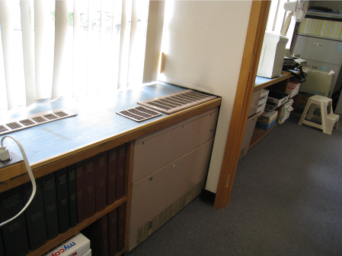

Univent, note dividing wall makes access to main cabinet and filter difficult

Picture 2

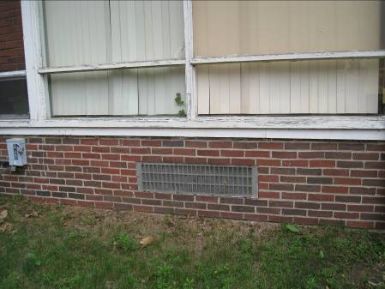

Univent fresh air intake

Picture 3

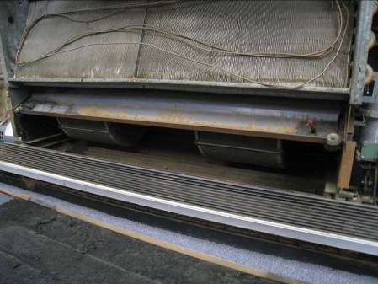

Main interior compartment of univent, note dust and lack of filter

Picture 4

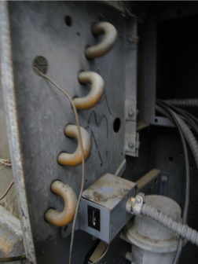

Spaces/breaches in the univent side cabinet

Picture 5

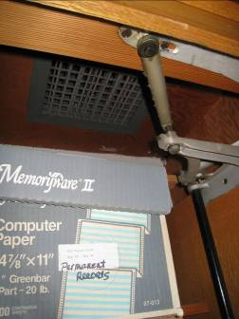

Exhaust vent in closet

Picture 6

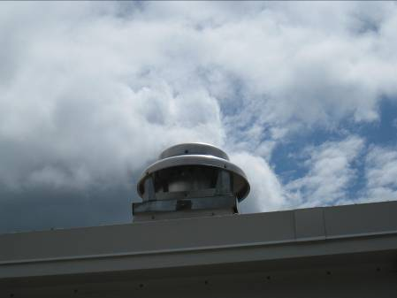

Rooftop exhaust fan

Picture 7

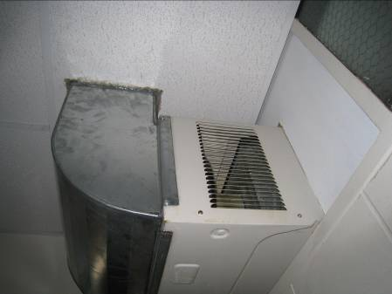

Air-conditioner installed through wall and ducted to hallway ceiling plenum

Picture 8

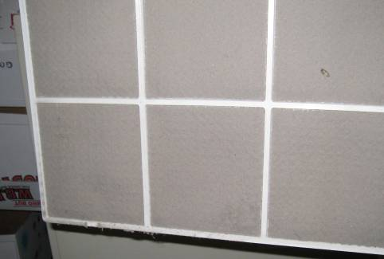

Air-conditioner filter occluded with dust

Picture 9

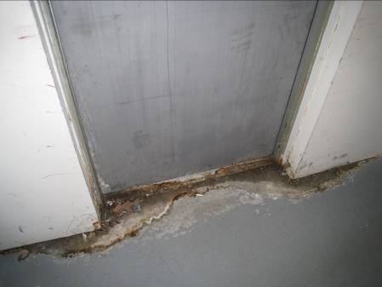

Evidence of water intrusion through door,

Picture 10

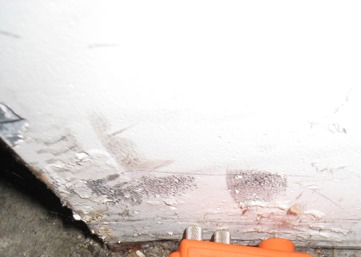

Discoloration/black staining and damaged paint indicated water damage to wall

Picture 11

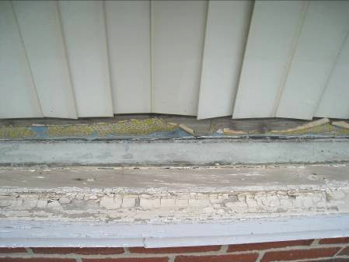

Water-damaged window, note damaged pane and wood in interior

Picture 12

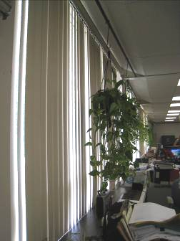

Hanging plants, note univent and radiator vents below

Picture 13

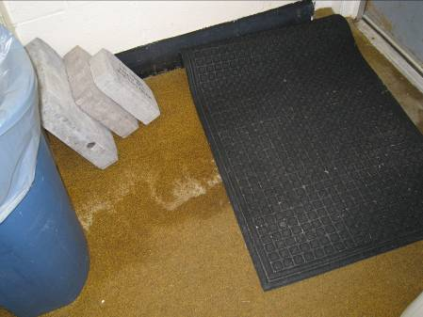

Water-damaged carpet

Picture 14

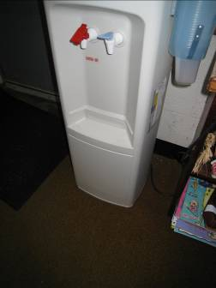

Water dispenser on water-stained carpet

Picture 15

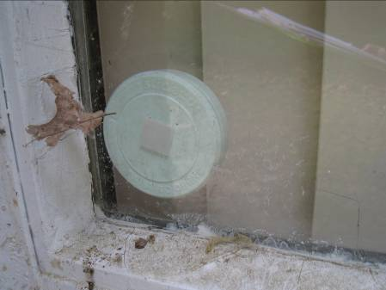

Air freshener on window

Picture 16

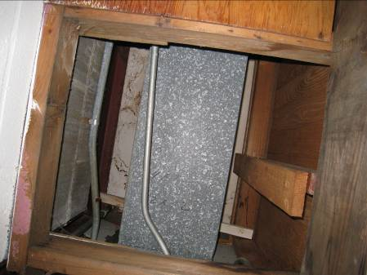

Missing panel in closet exposing ductwork
Location | Carbon  Dioxide  (ppm) | Carbon Monoxide  (ppm) | Temp  (°F) | Relative  Humidity  (%) | PM2.5  (µg/m3) | TVOC  (ppm) | Occupants  in Room | Windows  Openable | Ventilation |  | Remarks
 |  |  |  |  |  |  |  |  | Supply | Exhaust | Remarks
Background | 321 | ND | 76 | 54 | 10 | ND
Boiler room/office | 390 | ND | 74 | 60 | 8 | ND | 0 | Y  1/3 open | N | N | PF
Large meeting room/gym | 404 | ND | 75 | 59 | 4 | ND | 0 | Y | N | N | Stove, microwave, termite problem
Lunch room | 424 | ND | 75 | 58 | 4 | ND | 0 | Y | N | N | DO, WAC
Treasurer/  Assessing | 547 | ND | 76 | 55 | 5 | ND | 2 | Y | N | N | WD-CT, PF, plants, WAC
Assessor’s office | 579 | ND | 76 | 59 | 3 | ND | 1 | N | N | Y  Closet | CF. WAC
Assessor’s | 631 | ND | 77 | 58 | 4 | ND | 2 | Y | N | N | WD-vault wall, plants, WD bookcase, WAC
Treasurer’s | 561 | ND | 78 | 56 | 5 | ND | 3 | N | N | N | WAC, DO, plants, PF
Chief accountant | 697 | ND | 80 | 53 | 4 | ND | 1 | N | N | N | CF, WAC, fridge on carpet, toaster
Accountant/finance | 835 | ND | 79 | 53 | 5 | ND | 2 | Y | N | N | WAC, WD-carpet/musty
Parks & Recreation | 852 | ND | 82 | 53 | 3 | ND | 3 | Y | Y | N | Water dispenser on carpet, plants, PC, carpet, AD, WD-carpet, DO
Veteran’s Affairs | 728 | ND | 81 | 53 | 3 | ND | 2 | N | N | N | AD, WAC, DO
IT | 574 | ND | 77 | 42 | 3 | ND | 1 | N | N | N | Servers, 2 WAC, clutter
Meeting room | 681 | ND | 77 | 56 | 4 | ND | 0 | Y | N | Y | WAC, DEM, DO
Town Clerk | 568 | ND | 79 | 54 | 5 | ND | 2 | Y | N | Y | PF, CF, WAC, plants, AP
Town Clerk Office | 540 | ND | 80 | 52 | 4 | ND | 1 | Y | N | N | DO, PF
Community Planning | 516 | ND | 78 | 51 | 4 | ND | 0 | Y | N | N | WAC
Conf. Rm/Youth Services | 484 | ND | 76 | 55 | 3 | ND | 0 | Y | N | Y | WAC, WD-CT, MT, CF
Youth Services Office | 520 | ND | 77 | 54 | 4 | ND | 0 | N | N | N
Town Engineer | 462 | ND | 75 | 56 | 3 | ND | 0 | Y | N | N | WAC
Water Department | 491 | ND | 75 | 57 | 4 | ND | 1 | Y | N | N | Plants, WAC
DPW File Room | 475 | ND | 75 | 58 | 7 | ND | 0 | Y | N | N | Musty odor, WAC, DO
Health | 463 | ND | 75 | 58 | 4 | ND | 0 | Y | N | N | Original ceiling/debris, DO, WAC
Town Administration Secretary | 796 | ND | 76 | 58 | 4 | ND | 0 | Y | N | N | WAC
Copy Room | 471 | ND | 77 | 54 | 5 | ND | 0 | N | N | N | WAC
DPW director | 579 | ND | 77 | 55 | 4 | ND | 1 | Y | N | N | WAC
DPW secretary | 552 | ND | 78 | 55 | 5 | ND | 0 | N | N | N | WAC, DO
Board of Appeals | 624 | ND | 78 | 55 | 6 | ND | 3 | Y 1/3 | N | Y | CF, plants, WAC, PC
Al’s Office | 528 | ND | 78 | 54 | 5 | ND | 0 | Y | N | Y | DO
Building Commissioner | 563 | ND | 77 | 51 | 6 | ND | 1 | Y | N | N | CF, WAC, DO
Superintendant of Buildings | 526 | ND | 77 | 53 | 6 | ND | 0 | N | N | N | DO
Community Planning B | 522 | ND | 77 | 53 | 3 | ND | 2 | Y | N | Y | Musty smell, WD-CT, WAC, closet breaches.
Town Administrator | 634 | ND | 76 | 59 | 4 | ND | 1 | Y | Y | N | UV - on; DO, plants, WAC
Selectpersons’ conference room | 522 | ND | 75 | 58 | 3 | ND | 1 | Y | Y | N | UV-on, WAC
Selectpersons’ secretary | 556 | ND | 75 | 60 | 7 | ND | 1 | Y | Y  Off | N | AD, PF
HR | 668 | ND | 76 | 60 | 3 | ND | 2 | Y | N | N | WAC, PF, CPs

An Information Booklet Addressing PCB-Containing Materials in the Indoor Environment of Schools
and Other Public Buildings



Prepared by

Bureau of Environmental Health
Massachusetts Department of Public Health
December 2009
INTRODUCTION
The purpose of this information booklet is to provide assistance to school and public building officials and the general public in assessing potential health concerns associated with polychlorinated biphenyl (PCB) compounds in building materials used in Massachusetts and elsewhere. Recently, the U.S. Environmental Protection Agency (EPA) provided broad guidance relative to the presence of PCBs in building materials, notably PCBs in caulking materials. The most common building materials that may contain PCBs in facilities constructed or significantly renovated during the 1950s through the 1970s are fluorescent light ballasts, caulking, and mastic used in tile/carpet as well as other adhesives and paints.
This information booklet, developed by the Massachusetts Department of Public Health’s Bureau of Environmental Health (MDPH/BEH), is designed to supplement guidance offered by EPA relative to potential health impacts and environmental testing. It also addresses managing building materials, such as light ballasts and caulking, containing PCBs that are likely to be present in many schools and public buildings across the Commonwealth. This is because the Northeastern part of the country, and notably Massachusetts, has a higher proportion of schools and public buildings built during the 1950s through 1970s than many other parts of the U.S. according to a 2002 U.S. General Accounting Office report. The Massachusetts School Building Authority noted in a 2006 report that 53 percent of over 1,800 Massachusetts school buildings surveyed were built during the 1950s through 1970s. This information booklet contains important questions and answers relative to PCBs in the indoor environment and is based on the available scientific literature and MDPH/BEH’s experience evaluating the indoor environment of schools and public buildings for a range of variables, including for PCBs as well as environmental data reviewed from a variety of sources.
1. What are PCBs?
Polychlorinated biphenyl (PCB) compounds are stable organic chemicals used in products from the 1930s through the late 1970s. Their popularity and wide-spread use were related to several factors, including desirable features such as non-flammability and electrical insulating properties. Although the original use of PCBs was exclusive to closed system electrical applications for transformers and capacitors (e.g., fluorescent light ballasts), their use in other applications, such as using PCB oils to control road dust or caulking in buildings, began in the 1950s.
2. When were PCBs banned from production?
Pursuant to the Toxic Substance Control Act (TSCA) of 1976 (effective in 1979), manufacturing, processing, and distribution of PCBs was banned. While the ban prevented production of PCB-containing products, it did not prohibit the use of products already manufactured that contained PCBs, such as building materials or electrical transformers.
3. Are PCBs still found in building materials today?
Yes. Products made with PCBs prior to the ban may still be present today in older buildings. In buildings constructed during the 1950s through 1970s, PCBs may be present in caulking, floor mastic, and in fluorescent light ballasts. Available data reviewed by MDPH suggests that caulking manufactured in the 1950s through 1970s will likely contain some levels of PCBs. Without testing it is unclear whether caulking in a given building may exceed EPA’s definition of PCB bulk product waste of 50 parts per million (ppm) or greater. If it does, removal and disposal of the caulk is required in accordance with EPA’s TSCA regulations (40 CFR § 761).
4. Are health concerns associated with PCB exposure opportunities?
Although the epidemiological evidence is sometimes conflicting, most health agencies have concluded that PCBs may reasonably be anticipated to be a carcinogen, i.e., to cause cancer.
PCBs can have a number of non-cancer effects, including those on the immune, reproductive, neurological and endocrine systems. Exposure to high levels of PCB can have effects on the liver, which may result in damage to the liver. Acne and rashes are symptoms typical in those that are exposed to high PCB levels for a short period of time (e.g., in industry / occupational settings).
5. If PCBs are present in caulking material, does that mean exposure and health impacts are likely?
No. MDPH/BEH’s review of available data suggests that if caulking is intact, no appreciable exposures to PCBs are likely and hence health effects would not be expected. MDPH has conducted indoor tests and reviewed available data generated through the efforts of many others in forming this opinion.
6. How can I tell if caulking or light ballasts in my building may contain PCBs?
If the building was built sometime during the 1950s through 1970s, then it is likely that the caulking in the building and/or light ballasts may contain some level of PCBs. Light ballasts manufactured after 1980 have the words “No PCBs” printed on them. If the light ballast does not have this wording or was manufactured before 1980, it should be assumed that it contains PCBs.
7. What are light ballasts?
A light ballast is a piece of equipment that controls the starting and operating voltages of fluorescent lights. A small capacitor within older ballasts contains about one ounce of PCB oil. If light bulbs are not changed soon after they go out, the ballast will continue to heat up and eventually result in the release of low levels of PCBs into the indoor air.
8. Does the presence of properly functioning fluorescent light ballasts in a building present an environmental exposure concern?
No appreciable exposure to PCBs is expected if fluorescent light ballasts that contain PCBs are intact and not leaking or damaged (i.e., no visible staining of the light lenses), and do not have burned-out bulbs in them.

9. Should I be concerned about health effects associated with exposure to PCBs as a result of PCB-containing light ballasts?
While MDPH has found higher PCB levels in indoor air where light bulbs have burned-out, the levels are still relatively low and don’t present imminent health threats. A risk assessment conducted recently at one school did not suggest unusual cancer risks when considering a worst case exposure period of 35 years for teachers in that school. Having said this, MDPH believes that facility operators and building occupants should take prompt action to replace bulbs and/or ballasts as indicated to reduce/eliminate any opportunities for exposure to PCBs associated with PCB-containing light ballasts.
10. When should PCB-containing light ballasts be replaced?
If ballasts appear to be in disrepair, they should be replaced immediately and disposed of in accordance with environmental regulatory guidelines and requirements. However, if light bulbs burn out, the best remedy is to change them as soon as possible. If light bulbs are not changed soon after they go out, the ballast will continue to heat up and eventually result in the release of low levels of PCBs into the indoor air. Thus, burned-out bulbs should be replaced promptly to reduce overheating and stress on the ballast. As mentioned, ballasts that are leaking or in any state of disrepair should be replaced as soon as possible.
It should be noted that although older light ballasts may still be in use today, the manufacturers’ intended lifespan of these ballasts was 12 years. Thus, to the extent feasible or in connection with repair/renovation projects, the older light ballasts should be replaced consistent with the intended lifespan specified by the manufacturers.
11. Does MDPH recommend testing of caulking in buildings built during the 1950s -1980?
Caulking that is intact should not be disturbed. If caulking is deteriorating or damaged, conducting air and surface wipe testing in close proximity to the deteriorating caulking will help to determine if indoor air levels of PCBs are a concern as well as determining the need for more aggressive cleaning. Results should be compared with similar testing done in an area without deteriorating caulking. In this way, a determination can be made regarding the relative contribution of caulking materials to PCBs in the general indoor environment.
12. What if we determine that caulking in our building is intact and not deteriorating?
Based on a review of available data collected by MDPH and others, the MDPH does not believe that intact caulking presents appreciable exposure opportunities and hence should not be disturbed for testing. As with any building, regular operations and maintenance should include a routine evaluation of the integrity of caulking material. If its condition deteriorates then the steps noted above should be followed. Consistent with EPA advice, if buildings may have materials that contain PCBs, facility operators should ensure thorough cleaning is routinely conducted.
13. Should building facilities managers include information about PCB-containing building materials in their Operations and Maintenance (O&M) plans?
Yes. All buildings should have an O&M plan that includes regular inspection and maintenance of PCB building materials, as well as thorough cleaning of surfaces not routinely used. Other measures to prevent potential exposure to PCBs include increasing ventilation, use of HEPA filter vacuums, and wet wiping. These O&M plans should be available to interested parties.
14. Are there other sources of PCBs in the environment?
Yes. The most common exposure source of PCBs is through consumption of foods, particularly contaminated fish. Because PCBs are persistent in the environment, most residents of the U.S. have some level of PCBs in their bodies.
15. Where can I obtain more information?
For guidance on replacing and disposing of PCB building materials, visit the US EPA website: http://www.epa.gov/pcbsincaulk/. For information on health concerns related to PCBs in building materials, please contact MDPH/BEH at 617-624-5757.

Itchy, Runny or Watery Eyes |  |  |  | Stuffy or Runny Nose and Sinus congestion not related to an Infection
Response | Number | Percent |  | Response | Number | Percent
Yes | 7 | 88% |  | Yes | 5 | 63%
No | 1 | 13% |  | No | 3 | 38%
Total | 8 | 100% |  | Total | 8 | 100%
Skin Irritation, Dryness, Redness or Rashes |  |  |  | Pain or Stiffness in your Neck, Shoulders or Back
Response | Number | Percent |  | Response | Number | Percent
Yes | 4 | 50% |  | Yes | 4 | 50%
No | 4 | 50% |  | No | 4 | 50%
Total | 8 | 100% |  | Total | 8 | 100%
Sore, Hoarse or Dry Throat |  |  |  | Coughing
Response | Number | Percent |  | Response | Number | Percent
Yes | 4 | 50% |  | Yes | 3 | 38%
No | 4 | 50% |  | No | 5 | 63%
Total | 8 | 100% |  | Total | 8 | 100%
Difficulty Remembering Things or Concentrating |  |  |  | Headaches
Response | Number | Percent |  | Response | Number | Percent
Yes | 3 | 38% |  | Yes | 2 | 25%
No | 5 | 63% |  | No | 6 | 75%
Total | 8 | 100% |  | Total | 8 | 100%
Dizziness, Lightheadedness, or Loss of Balance |  |  |  | Breathing Problems when you did not have a Cold or the Flu
Response | Number | Percent |  | Response | Number | Percent
Yes | 2 | 25% |  | Yes | 2 | 25%
No | 6 | 75% |  | No | 6 | 75%
Total | 8 | 100% |  | Total | 8 | 100%

Nausea or Upset Stomach |  |  |  | Unusual Tiredness, Fatigue or Drowsiness
Response | Number | Percent |  | Response | Number | Percent
Yes | 2 | 25% |  | Yes | 2 | 25%
No | 6 | 75% |  | No | 6 | 75%
Total | 8 | 100% |  | Total | 8 | 100%
Wheezing in your Chest |  |  |  | Sneezing
Response | Number | Percent |  | Response | Number | Percent
Yes | 2 | 25% |  | Yes | 2 | 25%
No | 6 | 75% |  | No | 6 | 75%
Total | 8 | 100% |  | Total | 8 | 100%
Tightness in your Chest |  |  |  | Tingling in the Hands and Feet
Response | Number | Percent |  | Response | Number | Percent
Yes | 1 | 13% |  | Yes | 0 | 0%
No | 7 | 88% |  | No | 8 | 100%
Total | 8 | 100% |  | Total | 8 | 100%

The service life is the median time during which a particular system or component of …[an HVAC]… system remains in its original service application and then is replaced. Replacement may occur for any reason, including, but not limited to, failure, general obsolescence, reduced reliability, excessive maintenance cost, and changed system requirements due to such influences as building characteristics or energy prices (ASHRAE, 1991).
The ceiling plenum is the space between the dropped ceiling tile system and the roof decking above.

