INDOOR AIR QUALITY REASSESSMENT

North Shore Community College
Admission Office/Financial Aid
Thomas W. McGee Building
300 Broad Street
Lynn, Massachusetts 01901



Prepared by:
Massachusetts Department of Public Health
Bureau of Environmental Health
Indoor Air Quality Program
May 2009

Background/Introduction
At the request of George Neunaber, Facilities Engineer for North Shore Community College (NSCC), the Massachusetts Department of Public Health (MDPH), Bureau of Environmental Health (BEH) provided assistance and consultation regarding indoor air quality concerns at the administration/financial aid offices, located on the Lynn campus of the NSCC, 300 Broad Street, Lynn, Massachusetts. The building was previously visited in January 2007. A report detailing conditions observed at the time of the visit with recommendations for improving indoor air quality was issued (MDPH, 2007).
A follow-up visit to conduct an indoor air quality re-assessment was made to the administration/financial aid offices by Cory Holmes, Environmental Analyst/Inspector in BEH’s Indoor Air Quality (IAQ) Program on March 6, 2009. The assessment was prompted by reports of on-going respiratory irritation and exacerbation of allergies by occupants. Lingering odors/fumes from interior renovations are attributed by some building occupants to reported symptoms. Renovations including carpet square installation that occurred several years prior to the BEH initial assessment in 2007.
The administration/financial aid offices occupy space located on the ground floor of the Thomas W. McGee Building. The McGee Building is a three-story red brick building that was constructed in the mid 1980s. Interior renovations reportedly occurred during July-August 2006, that included the removal of partitions, the construction of walls to create office space, painting and the installation of carpet squares and base coving throughout the area. Windows are openable.

Actions on Previous MDPH Recommendations
As mentioned, MDPH staff had previously visited the building and issued a report with recommendations to improve indoor air quality (MDPH, 2007). A summary of actions taken on previous recommendations is included as Appendix A.

Methods
Air tests for carbon monoxide, carbon dioxide, temperature and relative humidity were conducted with the TSI, Q-Trak, IAQ Monitor, Model 8554. Air tests for airborne particle matter with a diameter less than 2.5 micrometers were taken with the TSI, DUSTTRAK™ Aerosol Monitor Model 8520. Screening for total volatile organic compounds (TVOCs) was conducted using a Thermo Environmental Instruments Inc., Model 580 Series Photo Ionization Detector (PID). MDPH staff also performed visual inspection of building materials for water damage and/or microbial growth.

Results
The administration/financial aid offices have an employee population of approximately 10 to 15 and are visited by numerous students and faculty throughout the day. The tests were taken during normal operations. Test results appear in Table 1.

Discussion

Ventilation
It can be seen from Table 1 that carbon dioxide levels were all below 800 parts per million (ppm), indicating adequate air exchange in the areas evaluated. The heating, ventilating and air conditioning (HVAC) system consists of air handling units (AHUs) located in a mechanical room on the top floor (Picture 1). Air is drawn in through fresh air intakes on the exterior of the building and passes through a bank of pleated air filters (Pictures 2 through 4). Conditioned air is distributed through ducted ceiling vents (Pictures 5) and drawn into the ceiling plenum via grated vents and ducted back to the AHUs (Picture 6). This system was operating during the assessment.
To maximize air exchange, the MDPH recommends that both supply and exhaust ventilation operate continuously during periods of occupancy. In order to have proper ventilation with a mechanical ventilation system, the systems must be balanced subsequent to installation to provide an adequate amount of fresh air to the interior of a room while removing stale air from the room. It is recommended that HVAC systems be re-balanced every five years to ensure adequate air systems function (SMACNA, 1994). No information was available concerning the date of the last HVAC system balancing.
The Massachusetts Building Code requires that each room have a minimum ventilation rate of 20 cubic feet per minute (cfm) per occupant of fresh outside air or openable windows (SBBRS, 1997; BOCA, 1993). The ventilation must be on at all times that the room is occupied. Providing adequate fresh air ventilation with open windows and maintaining the temperature in the comfort range during the cold weather season is impractical. Mechanical ventilation is usually required to provide adequate fresh air ventilation.
Carbon dioxide is not a problem in and of itself. It is used as an indicator of the adequacy of the fresh air ventilation. As carbon dioxide levels rise, it indicates that the ventilating system is malfunctioning or the design occupancy of the room is being exceeded. When this happens, a buildup of common indoor air pollutants can occur, leading to discomfort or health complaints. The Occupational Safety and Health Administration (OSHA) standard for carbon dioxide is 5,000 parts per million parts of air (ppm). Workers may be exposed to this level for 40 hours/week, based on a time-weighted average (OSHA, 1997).
The MDPH uses a guideline of 800 ppm for publicly occupied buildings. A guideline of 600 ppm or less is preferred in schools due to the fact that the majority of occupants are young and considered to be a more sensitive population in the evaluation of environmental health status. Inadequate ventilation and/or elevated temperatures are major causes of complaints such as respiratory, eye, nose and throat irritation, lethargy and headaches. For more information concerning carbon dioxide, please see Appendix B.
Temperature readings ranged from 69º F to 72 º F the day of the assessment, which were within the MDPH recommended comfort guidelines. The MDPH recommends that indoor air temperatures be maintained in a range of 70 º F to 78 º F in order to provide for the comfort of building occupants. In many cases concerning indoor air quality, fluctuations of temperature in occupied spaces are typically experienced, even in a building with an adequate fresh air supply.
The relative humidity measurements in the building ranged from 23 to 32 percent, which were below the MDPH recommended comfort range during the assessment. The MDPH recommends a comfort range of 40 to 60 percent for indoor air relative humidity. Relative humidity levels in the building would be expected to drop during the winter months due to heating. The sensation of dryness and irritation is common in a low relative humidity environment. Low relative humidity is a very common problem during the heating season in the northeast part of the United States.

Microbial/Moisture Concerns
Plants were observed in several areas. Plants, soil and drip pans can serve as sources of mold growth, and thus should be properly maintained. Over-watering of plants should be avoided and drip pans should be inspected periodically for mold growth (Picture 7).

Other IAQ Evaluations
Indoor air quality can be negatively influenced by the presence of respiratory irritants, such as products of combustion. The process of combustion produces a number of pollutants. Common combustion emissions include carbon monoxide, carbon dioxide, water vapor and smoke (fine airborne particle material). Of these materials, exposure to carbon monoxide and particulate matter with a diameter of 2.5 micrometers (μm) or less (PM2.5) can produce immediate, acute health effects upon exposure. To determine whether combustion products were present in the school environment, BEH staff obtained measurements for carbon monoxide and PM2.5.

Carbon Monoxide
Carbon monoxide is a by-product of incomplete combustion of organic matter (e.g., gasoline, wood and tobacco). Exposure to carbon monoxide can produce immediate and acute health affects. Several air quality standards have been established to address carbon monoxide and prevent symptoms from exposure to these substances. The MDPH established a corrective action level concerning carbon monoxide in ice skating rinks that use fossil-fueled ice resurfacing equipment. If an operator of an indoor ice rink measures a carbon monoxide level over 30 ppm, taken 20 minutes after resurfacing within a rink, that operator must take actions to reduce carbon monoxide levels (MDPH, 1997).
The American Society of Heating Refrigeration and Air-Conditioning Engineers (ASHRAE) has adopted the National Ambient Air Quality Standards (NAAQS) as one set of criteria for assessing indoor air quality and monitoring of fresh air introduced by HVAC systems (ASHRAE, 1989). The NAAQS are standards established by the US EPA to protect the public health from six criteria pollutants, including carbon monoxide and particulate matter (US EPA, 2006). As recommended by ASHRAE, pollutant levels of fresh air introduced to a building should not exceed the NAAQS levels (ASHRAE, 1989). The NAAQS were adopted by reference in the Building Officials & Code Administrators (BOCA) National Mechanical Code of 1993 (BOCA, 1993), which is now an HVAC standard included in the Massachusetts State Building Code (SBBRS, 1997). According to the NAAQS, carbon monoxide levels in outdoor air should not exceed 9 ppm in an eight-hour average (US EPA, 2006).
Carbon monoxide should not be present in a typical, indoor environment. If it is present, indoor carbon monoxide levels should be less than or equal to outdoor levels. Outdoor carbon monoxide concentrations were non-detect or ND. Carbon monoxide levels measured in the building were also ND (Table 1).

Particulate Matter (PM2.5)
The US EPA has established NAAQS limits for exposure to particulate matter. Particulate matter is airborne solids that can be irritating to the eyes, nose and throat. The NAAQS originally established exposure limits to particulate matter with a diameter of 10 μm or less (PM10). According to the NAAQS, PM10 levels should not exceed 150 microgram per cubic meter (μg/m³) in a 24-hour average (US EPA, 2006). These standards were adopted by both ASHRAE and BOCA. Since the issuance of the ASHRAE standard and BOCA Code, US EPA established a more protective standard for fine airborne particles. This more stringent PM2.5 standard requires outdoor air particle levels be maintained below 35 μg/m³ over a 24-hour average (US EPA, 2006). Although both the ASHRAE standard and BOCA Code adopted the PM10 standard for evaluating air quality, MDPH uses the more protective PM2.5 standard for evaluating airborne particulate matter concentrations in the indoor environment.
Outdoor PM2.5 concentrations were measured at 15 μg/m³ (Table 1). Indoor PM2.5 levels ranged from 6 to 8 μg/m³ (Table 1), which were below the NAAQS PM2.5 level of 35 μg/m³. Frequently, indoor air levels of particulates (including PM2.5) can be at higher levels than those measured outdoors. A number of mechanical devices and/or activities that occur in schools/offices can generate particulate during normal operations. Sources of indoor airborne particulates may include but are not limited to particles generated during the operation of fan belts in the HVAC system, cooking in the cafeteria stoves and microwave ovens; use of photocopiers, fax machines and computer printing devices; operation of an ordinary vacuum cleaner and heavy foot traffic indoors.

Total Volatile Organic Compounds (TVOCs)
As previously mentioned, occupants are concerned their current symptoms may be related to the possibility of lingering odors/fumes from previous renovations that occurred approximately three years ago, particulary the installation of carpet squares. In order to determine if any lingering materials were present, BEH staff conducted screening for volatile organic compounds (VOCs), with particular focus on carpeting.
Indoor air quality can be impacted by the presence of materials containing VOCs. VOCs are substances that have the ability to evaporate at room temperature. Frequently, exposure to low levels of total VOCs (TVOCs) may produce eye, nose, throat and/or respiratory irritation in some sensitive individuals. For example, chemicals evaporating from a paint can stored at room temperature would most likely contain VOCs. In an effort to determine whether VOCs were present in the building, air monitoring for TVOCs was conducted. Outdoor air samples were taken for comparison. Outdoor TVOC concentrations were ND. Indoor TVOC measurements throughout the area were also ND (Table 1). In addition, no lingering odors were detected by BEH staff nor were any such odors reported during the assessment. Given the significant amount of time that has passed since the renovations it is unlikely that residual odors would be related to health impacts.
Please note, TVOC air measurements are only reflective of the indoor air concentrations present at the time of sampling. Indoor air concentrations can be greatly impacted by the use of TVOC-containing products. While no measurable TVOC levels were detected in the indoor environment at the time of the assessment, VOC-containing materials were noted. The area contained dry erase boards and dry erase board markers. Materials such as dry erase markers and dry erase board cleaners may contain VOCs, such as methyl isobutyl ketone, n-butyl acetate and butyl-cellusolve (Sanford, 1999), which can be irritating to the eyes, nose and throat.

Other Conditions
In response to occupant reports of exacerbation of allergies, BEH staff conducted an inspection of AHUs and filters for potential respiratory irritants as well as measurement of airborne particulate matter. The general condition of the AHUs and filters were found to be relatively clean/recently changed with no obvious sources of respiratory irritants (Picture 4).
Finally, a damaged ceiling tile was observed in office 158 (Picture 8), which can provide a pathway for the movement of drafts, dusts, odors and particulate matter into occupied areas. In addition, missing/damaged ceiling tiles result in the degradation of the function of the exhaust vent plenum system, since this system is designed to operate with the suspended ceiling intact.

Conclusions/Recommendations
In view of the findings at the time of the visit, the following recommendations are made:
- Replace moldy/damaged potted plant drip pans, avoid over watering. Examine drip pans periodically, clean as needed.
- Replace damaged ceiling tile in room 158.
- Supplement airflow by using openable windows to control for comfort (with the exception of periods of high outdoor relative humidity to avoid condensation problems). Care should be taken to ensure windows are properly closed at night and weekends to avoid the freezing of pipes and potential flooding (during winter months).
- Consider balancing mechanical ventilation systems every 5 years, as recommended by ventilation industrial standards (SMACNA, 1994).
- For buildings in New England, periods of low relative humidity during the winter are often unavoidable. Therefore, scrupulous cleaning practices should be adopted to minimize common indoor air contaminants whose irritant effects can be enhanced when the relative humidity is low. To control for dusts, a high efficiency particulate arrestance (HEPA) filter equipped vacuum cleaner in conjunction with wet wiping of all surfaces is recommended. Drinking water during the day can help ease some symptoms associated with a dry environment (e.g., throat and sinus irritations).
- Refer to resource manuals and other related indoor air quality documents for further building-wide evaluations and advice on maintaining public buildings. Copies of these materials are located on the MDPH’s website: http://mass.gov/dph/indoor_air

References
ASHRAE. 1989. Ventilation for Acceptable Indoor Air Quality. American Society of Heating, Refrigeration and Air Conditioning Engineers. ANSI/ASHRAE 62-1989
BOCA. 1993. The BOCA National Mechanical Code/1993. 8th ed. Building Officials & Code Administrators International, Inc., Country Club Hills, IL.
MDPH. 1997. Requirements to Maintain Air Quality in Indoor Skating Rinks (State Sanitary Code, Chapter XI). 105 CMR 675.000. Massachusetts Department of Public Health, Boston, MA.
MDPH. 2007. Indoor Air Quality Assessment. North Shore Community College, McGee Building, Admissions/Financial Aid Offices. Massachusetts Department of Public Health, Executive Office of Human Services, Boston, MA. February 2007.

OSHA. 1997. Limits for Air Contaminants. Occupational Safety and Health Administration. Code of Federal Regulations. 29 C.F.R 1910.1000 Table Z-1-A.
Sanford. 1999. Material Safety Data Sheet (MSDS No: 198-17). Expo® Dry Erase Markers Bullet, Chisel, and Ultra Fine Tip. Sanford Corporation, Bellwood, IL.
SBBRS. 1997. Mechanical Ventilation. State Board of Building Regulations and Standards. Code of Massachusetts Regulations. 780 CMR 1209.0.
SMACNA. 1994. HVAC Systems Commissioning Manual. 1st ed. Sheet Metal and Air Conditioning Contractors’ National Association, Inc., Chantilly, VA.
US EPA. 2006. National Ambient Air Quality Standards (NAAQS). . US Environmental Protection Agency, Office of Air Quality Planning and Standards, Washington, DC. http://www.epa.gov/air/criteria.html.
Picture 1

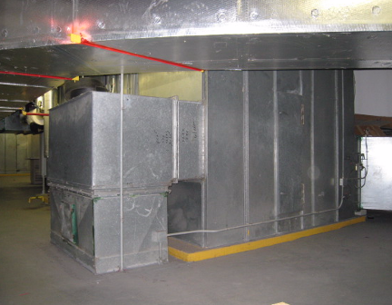

AHU for HVAC System in Mechanical Room

Picture 2



Fresh Air Intake Vents

Picture 3

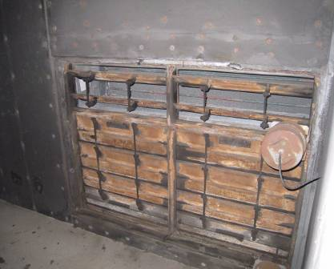

Fresh Air Intakes Louvers for AHU

Picture 4

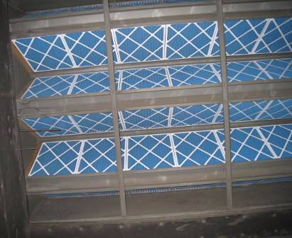

Bank of High Efficiency Pleated Air Filters

Picture 5

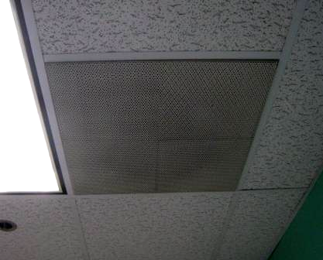

Ceiling-Mounted Air Diffuser

Picture 6

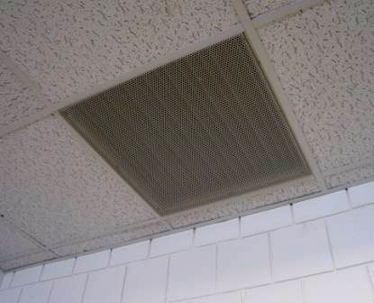

Ceiling-Mounted Return Vent

Picture 7

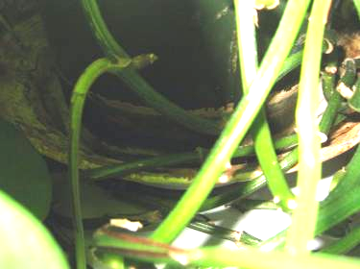

Moldy Drip Pan under Plant

Picture 8

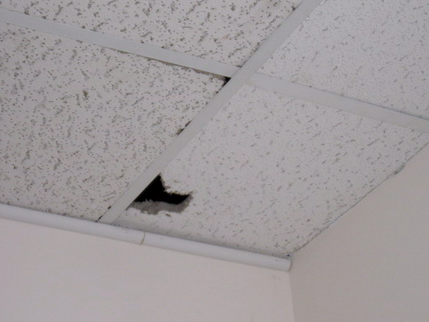

Broken Ceiling Tile in Office 158
Location/ Room | Occupants  in Room | Temp  (°F) | Relative  Humidity  (%) | Carbon  Dioxide  (ppm) | Carbon Monoxide  (ppm) | PM2.5  (µg/m³) | TVOCs  (ppm) | Windows  Openable | Ventilation |  | Remarks
 |  |  |  |  |  |  |  |  | Supply | Exhaust | Remarks
Background |  | 50 | 45 | 342 | ND | 15 | ND |  |  |  | Cool, overcast/cloudy
151 | 0 | 72 | 32 | 748 | ND | 6 | ND | Y | Y | Y
154 | 6 | 70 | 30 | 673 | ND | 7 | ND | Y | Y | Y
155 | 4 | 69 | 28 | 792 | ND | 7 | ND | Y | Y | Y | Plants, DEM
155-A | 0 | 70 | 24 | 680 | ND | 6 | ND | N | Y | Y | Open partitions near ceiling for airflow
157 | 1 | 72 | 24 | 664 | ND | 6 | ND | N | Y | Y
158 | 0 | 70 | 23 | 647 | ND | 6 | ND | Y | Y | N | Broken CT, plant-mold on drip pan/stained cabinet from WD
159 | 1 | 71 | 24 | 719 | ND | 6 | ND | Y | Y | N
160 | 1 | 70 | 23 | 670 | ND | 7 | ND | Y | Y | N | Plants
161 | 1 | 71 | 23 | 695 | ND | 8 | ND | Y | Y | Y | Plants
Second Round of Testing
151 | 0 | 71 | 24 | 696 | ND | 8 | ND | Y | Y | Y
154 | 6 | 70 | 25 | 769 | ND | 7 | ND | Y | Y | Y | Plants-moldy wicker basket/drip pans
155 | 4 | 71 | 25 | 770 | ND | 8 | ND | Y | Y | Y | DEM
155-A | 0 | 72 | 24 | 717 | ND | 7 | ND | N | Y | Y
157 | 3 | 71 | 23 | 702 | ND | 7 | ND | N | Y | Y
158 | 0 | 70 | 23 | 674 | ND | 8 | ND | Y | Y | N
159 | 1 | 71 | 23 | 699 | ND | 7 | ND | Y | Y | N | DO
160 | 0 | 71 | 23 | 713 | ND | 8 | ND | Y | Y | N | DO, plants
161 | 1 | 70 | 23 | 670 | ND | 8 | ND | Y | Y | Y | DO, plants

Actions on Previous MDPH Recommendations

The following is a status report of action(s) taken on MDPH recommendations (in bold) based on reports from NSCC officials, maintenance personnel and BEH staff observations.

- Replace damaged ceiling tile. Ensure ceiling tile system is intact as designed to facilitate exhaust ventilation.
Action: Damaged ceiling tiles identified in the previous report were replaced; another was discovered in office 158.
- Discard water damaged box in area 158.
Action: Water damaged box had been discarded.
- Ensure plants have drip pans and avoid over-watering. Examine drip pans periodically for mold growth and disinfect with an appropriate antimicrobial where necessary.
Action: Plants all had drip pans but several of them appeared to be over-watered and/or growing mold.
- Relocate or place tile or rubber matting underneath water coolers in carpeted areas.
Action: Rubber matting was installed beneath water cooler to prevent damage to carpeting.
- Clean supply and return vents periodically of accumulated dust.
Action: Vents were reportedly cleaned and did not appear to have excess accumulated dust at the time of the assessment.

