Background/Introduction

INDOOR AIR QUALITY ASSESSMENT

North Shore Community College
Health Professions Building
Danvers Campus
1 Ferncroft Road
Danvers, Massachusetts

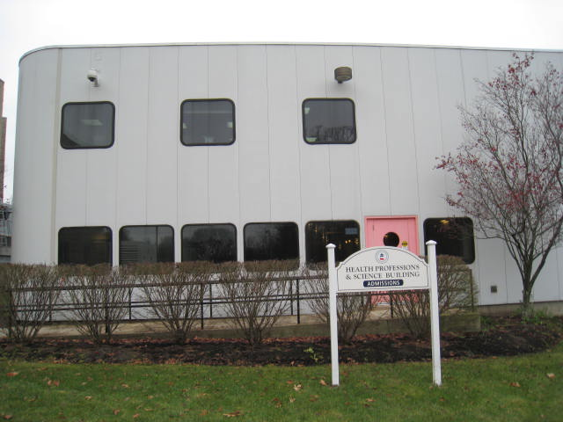

Prepared by:
Massachusetts Department of Public Health
Bureau of Environmental Health
Indoor Air Quality Program
February 2010
In response to a request from George Neunaber, Facilities Engineer, North Shore Community College (NSCC), the Massachusetts Department of Public Health (MDPH), Bureau of Environmental Health (BEH) provided assistance and consultation regarding indoor air quality (IAQ) concerns at the Health Professions Building (HPB) on NSCC’s Danvers Campus. Concerns about reports of musty odors on the first floor in suite 124 prompted this assessment.
On November 19, 2009, a visit to conduct an assessment of the HPB was made by Sharon Lee, an Environmental Analyst/IAQ Inspector in BEH’s IAQ Program. Ms. Lee was accompanied by Mr. Neunaber for the duration of the assessment.
The HPB is a multi-story steel-frame building on cement slab. The HPB currently houses classrooms, common areas and office space for administrative staff. Suite 124 consists of offices and a physical therapy (PT) room. The offices and PT room can be access through a common area. A new roof was installed in 2007. Windows throughout the building are not openable.

Methods
Air tests for carbon dioxide, carbon monoxide, temperature and relative humidity were taken with the TSI, Q-Trak, IAQ Monitor. MDPH staff also performed a visual inspection of building materials for water damage and/or microbial growth. Moisture content of porous building materials was measured with a Tramex Encounter Plus, Non-Destructive Moisture Meter.

Results
The HPB has a staff of approximately 150 and can be visited by hundreds of NSCC staff and students on a daily basis. Tests were taken under normal operating conditions. Test results appear in Table 1.

Discussion

Ventilation
It can be seen from Table 1 that carbon dioxide levels were below 800 parts per million (ppm) in all but one area surveyed, which is generally indicative of adequate air exchange. Fresh air for the offices within suite 124 is provided by ceiling-mounted unit ventilators (univents; Picture 1). Outdoor air is supplied to the univent and returned through an intake located at the base of the unit. Fresh and return air is mixed, filtered, heat/cooled and provided through an air diffuser located on the front of the unit. All univents were operating at the time of assessment.
No dedicated exhaust is provided to individual offices. Positive pressure created by the operating univents pushes air into the common area via undercut doors. Exhaust ventilation is provided by an exhaust vent in the common area (Picture 2). The exhaust vent is ducted to a rooftop fan, which removes air from the suite. BEH staff observed that some doors were undercut less than half an inch. Consideration should be given to increasing the space between the door and floor to allow for increased air movement out of offices and into the common area.
A wall-mounted thermostat in the common room of the suite controls the HVAC system for the entire suite. The thermostat activates the HVAC system at a preset temperature. Once the preset temperature is reached, the HVAC system is deactivated. Therefore, no mechanical ventilation is provided until the thermostat re-activates the system.
Please note, the door from the common area to the hallways was open on the day of the assessment. This hallway provides access to a door that leads to the exterior of the building. When both the exterior door in the hallway and the door to the common area for suite 124 are open, cold drafts can penetrate the common area of the suite. Cold air can activate the thermostat, which can call for the univent to close fresh air dampers for the purpose of providing tempered, recycled air. When univent fresh air dampers are closed, normally occurring pollutants can accumulate. Without a continuous source of fresh outside air and removal via the exhaust/return system, indoor environmental pollutants can accumulate and lead to indoor air quality/comfort complaints. Lack of air exchange can also lead to stale/musty odors, particularly during periods of high relative humidity (i.e., > 70%).
To maximize air exchange, the MDPH recommends that both supply and exhaust ventilation operate continuously during periods of occupancy. In order to have proper ventilation with a mechanical supply and exhaust system, the systems must be balanced to provide an adequate amount of fresh air to the interior of a room while removing stale air from the room. It is recommended that HVAC systems be re-balanced every five years to ensure adequate air systems function (SMACNA, 1994). The date of the last balancing of these systems was not available at the time of the assessment.
The Massachusetts Building Code requires that each room have a minimum ventilation rate of 20 cubic feet per minute (cfm) per occupant of fresh outside air or openable windows (SBBRS, 1997; BOCA, 1993). The ventilation must be on at all times that the room is occupied. Providing adequate fresh air ventilation with open windows and maintaining the temperature in the comfort range during the cold weather season is impractical. Mechanical ventilation is usually required to provide adequate fresh air ventilation.
Carbon dioxide is not a problem in and of itself. It is used as an indicator of the adequacy of the fresh air ventilation. As carbon dioxide levels rise, it indicates that the ventilating system is malfunctioning or the design occupancy of the room is being exceeded. When this happens, a buildup of common indoor air pollutants can occur, leading to discomfort or health complaints. The Occupational Safety and Health Administration (OSHA) standard for carbon dioxide is 5,000 parts per million parts of air (ppm). Workers may be exposed to this level for 40 hours/week, based on a time-weighted average (OSHA, 1997).
The MDPH uses a guideline of 800 ppm for publicly occupied buildings. A guideline of 600 ppm or less is preferred in schools due to the fact that the majority of occupants are young and considered to be a more sensitive population in the evaluation of environmental health status. Inadequate ventilation and/or elevated temperatures are major causes of complaints such as respiratory, eye, nose and throat irritation, lethargy and headaches. For more information concerning carbon dioxide, please see Appendix A.
Temperature measurements ranged from 74º F to 76º F, which were within the MDPH recommended comfort range in all areas. The MDPH recommends that indoor air temperatures be maintained in a range of 70º F to 78º F in order to provide for the comfort of building occupants. In many cases concerning indoor air quality, fluctuations of temperature in occupied spaces are typically experienced, even in a building with an adequate fresh air supply.
The relative humidity during the assessment ranged from 25 to 29 percent, which was below the MDPH recommended comfort range in all areas surveyed. The MDPH recommends a comfort range of 40 to 60 percent for indoor air relative humidity. Relative humidity levels would be expected to drop during the winter months due to heating and decreased outdoor relative humidity concentrations. The sensation of dryness and irritation is common in a low relative humidity environment. Low relative humidity is a very common problem during the heating season in the northeast part of the United States.

Microbial/Moisture Concerns
The primary purpose of this assessment was to investigate reports of musty odors related to a univent pipe leak in suite 124 and specifically office 124F (Picture 3). The pipe leak was reportedly discovered in August 2009. Water-damaged carpet was removed and replaced soon after the leak (Picture 4). NSCC facilities staff reportedly examined the gypsum wallboard (GW) and wall cavity for mold growth; reportedly no growth was observed on the GW or in the wall cavity. At the time of the BEH assessment, no odors were detected in office 124F or in the common area of the suite. BEH staff did not observe any mold growth or water damage on the surface of GW walls in office 124F. Moisture testing of these walls indicated that moisture levels were normal (i.e., dry). It is important to note that moisture content of materials measured is a real-time measurement of the conditions in the building at the time of the assessment.
Evidence of a window leak was observed in office 124D (Picture 5). Rags and other absorbent materials were observed on the windowsill; bubbling paint was also observed on the walls. Staff in adjoining offices had indicated the window had been leaking for some time; however, no reports of window leaks were made to the facilities department. At the time of assessment, the wall, windowsill and carpeting all had normal moisture levels. Mr. Neunaber indicated that facilities staff would examine and repair the window leak during the following weekend. In correspondence subsequent to the BEH assessment, Mr. Neunaber reported that the rubber window seals in that area of the building were re-caulked with silicone. NSCC staff also reported that no dampness appeared to be present in the wall areas around the repaired window.
Materials such as papers, folders and books were on the windowsill in office 124D (Picture 6). These items should be examined to ensure that exposure to moisture has not resulted in mold growth. Water damaged paper products can serve as a source of mold growth and should be removed and discarded to prevent a source of respiratory irritation.
The US Environmental Protection Agency (US EPA) and the American Conference of Governmental Industrial Hygienists (ACGIH) recommends that porous materials be dried with fans and heating within 24 to 48 hours of becoming wet (US EPA, 2001; ACGIH, 1989). If porous materials are not dried within this time frame, mold growth may occur. Water-damaged porous materials cannot be adequately cleaned to remove mold growth. The application of a mildewcide to moldy porous materials is not recommended.

Other IAQ Evaluations
Indoor air quality can be negatively influenced by the presence of respiratory irritants, such as products of combustion. The process of combustion produces a number of pollutants. Common combustion emissions include carbon monoxide, carbon dioxide, water vapor and smoke (fine airborne particle material). Of these materials, exposure to carbon monoxide can produce immediate, acute health effects upon exposure. To determine whether combustion products were present in the indoor environment, BEH staff obtained measurements for carbon monoxide.

Carbon Monoxide
Carbon monoxide is a by-product of incomplete combustion of organic matter (e.g., gasoline, wood and tobacco). Exposure to carbon monoxide can produce immediate and acute health effects. Several air quality standards have been established to address carbon monoxide and prevent symptoms from exposure to these substances. The MDPH established a corrective action level concerning carbon monoxide in ice skating rinks that use fossil-fueled ice resurfacing equipment. If an operator of an indoor ice rink measures a carbon monoxide level over 30 ppm, taken 20 minutes after resurfacing within a rink, that operator must take actions to reduce carbon monoxide levels (MDPH, 1997).
The American Society of Heating Refrigeration and Air-Conditioning Engineers (ASHRAE) has adopted the National Ambient Air Quality Standards (NAAQS) as one set of criteria for assessing indoor air quality and monitoring of fresh air introduced by HVAC systems (ASHRAE, 1989). The NAAQS are standards established by the US EPA to protect the public health from six criteria pollutants, including carbon monoxide and particulate matter (US EPA, 2006). As recommended by ASHRAE, pollutant levels of fresh air introduced to a building should not exceed the NAAQS levels (ASHRAE, 1989). The NAAQS were adopted by reference in the Building Officials & Code Administrators (BOCA) National Mechanical Code of 1993 (BOCA, 1993), which is now an HVAC standard included in the Massachusetts State Building Code (SBBRS, 1997). According to the NAAQS, carbon monoxide levels in outdoor air should not exceed 9 ppm in an eight-hour average (US EPA, 2006).
Carbon monoxide should not be present in a typical, indoor environment. If it is present, indoor carbon monoxide levels should be less than or equal to outdoor levels. On the day of the assessment, outdoor carbon monoxide concentrations were non detect (ND) (Table 1). No measurable levels of carbon monoxide were detected in the building.

Other Concerns
As discussed previously, staff reported musty odors when entering the common area in suite 124. At the time of assessment, BEH staff did not observe such odors in the common area. The odors described by the staff likely dissipated since the door in the common area that leads to the hallway was open. However, BEH staff did detect a strong, stale odor when entering office 124G. The source of the odor appeared to be a number of paper coffee cups and mugs partially filled with old coffee and water were found on the desk and other flat surfaces in this office. Open containers of liquids can be a source of odors and serve as a substrate for mold growth. As discussed previously, univents located in the offices create positive pressure to force air out through undercut doors and into the common area, where an exhaust vent is located. The positive pressure created by the univent can force such odors into the common area. The common area has exhaust ventilation, however, it lacks a source of fresh air supply to dilute odors and over time, odors can accumulate. Old containers should be removed and discarded to prevent odor accumulation and/or mold growth.
Additionally, accumulated items were observed on the floor, windowsills, tabletops, counters, bookcases and desks in office 124G (Picture 7). The large number of items stored in this office also provides a source for dusts to accumulate. These items (e.g., papers, folders, boxes) make it difficult for custodial staff to clean. Items should be relocated and/or be cleaned periodically to avoid excessive dust build up.
Utility holes were observed around pipes in the offices (Picture 8). Such spaces can allow movement of dust and other particles from the wall cavity into occupied spaces. These holes should be sealed to prevent such movement.

Conclusions/Recommendations
In view of the findings at the time of the assessment, the following recommendations are made to improve indoor air quality.
- Operate ventilation systems continuously. Set thermostat controls to the fan “on” position to provide constant supply and exhaust ventilation during periods of occupancy.
- Increase the introduction of fresh air/circulation in areas equipped with univents by operating fans in medium or high setting.
- Ensure the door between the suite common area and hallway is closed to regulate/maintain temperature control/comfort.
- Remove old food/drink containers to prevent odors/mold growth.
- Consider further undercutting office doors to increase airflow out of offices.
- Continue monitoring for leaks to ensure proper actions are taken to prevent mold growth. Office staff should report all leaks to the facilities department as soon as a leak is discovered for prompt remediation.
- Examine items in room 124D to ensure that moisture has not resulted in mold growth.
- Seal utility holes to prevent movement of dusts and particulates between areas.
- For buildings in New England, periods of low relative humidity during the winter are often unavoidable. Therefore, scrupulous cleaning practices should be adopted to minimize common indoor air contaminants whose irritant effects can be enhanced when the relative humidity is low. To control for dusts, a HEPA filter equipped vacuum cleaner in conjunction with wet wiping of all surfaces is recommended. Drinking water during the day can help ease some symptoms associated with a dry environment (throat and sinus irritations).
- Refer to resource manuals and other related indoor air quality documents for further building-wide evaluations and advice on maintaining public buildings. Copies of these materials are located on the MDPH’s website: http://mass.gov/dph/iaq.

References
ACGIH. 1989. Guidelines for the Assessment of Bioaerosols in the Indoor Environment. American Conference of Governmental Industrial Hygienists, Cincinnati, OH.
ASHRAE. 1989. Ventilation for Acceptable Indoor Air Quality. American Society of Heating, Refrigeration and Air Conditioning Engineers. ANSI/ASHRAE 62-1989
BOCA. 1993. The BOCA National Mechanical Code-1993. 8th ed. Building Officials & Code Administrators International, Inc., Country Club Hills, IL. M-308.1
OSHA. 1997. Limits for Air Contaminants. Occupational Safety and Health Administration. Code of Federal Regulations. 29 C.F.R. 1910.1000 Table Z-1-A.
SBBRS. 1997. Mechanical Ventilation. State Board of Building Regulations and Standards. Code of Massachusetts Regulations. 780 CMR 1209.0
SMACNA. 1994. HVAC Systems Commissioning Manual. 1st ed. Sheet Metal and Air Conditioning Contractors’ National Association, Inc., Chantilly, VA.
US EPA. 2001. Mold Remediation in Schools and Commercial Buildings. US Environmental Protection Agency, Office of Air and Radiation, Indoor Environments Division, Washington, DC. EPA 402-K-01-001. March 2001.
US EPA. 2006. National Ambient Air Quality Standards (NAAQS). US Environmental Protection Agency, Office of Air Quality Planning and Standards, Washington, DC. http://www.epa.gov/air/criteria.html.
Picture 1

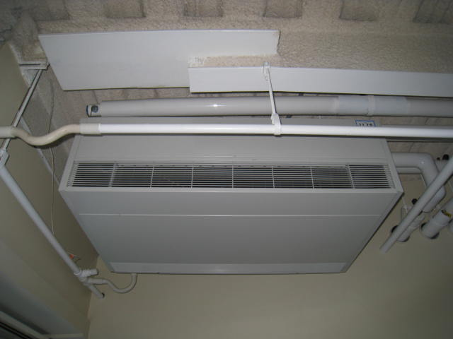

Univent in office

Picture 2

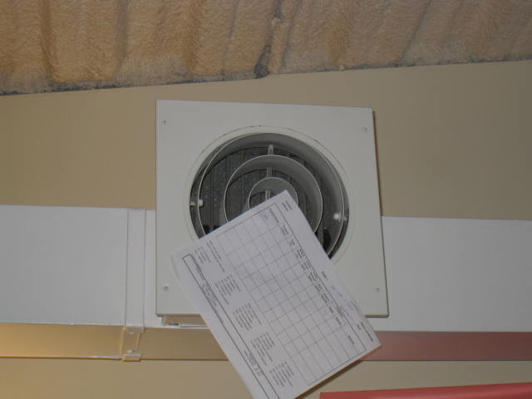

Exhaust fan in common area, note paper shows draw of air into vent

Picture 3

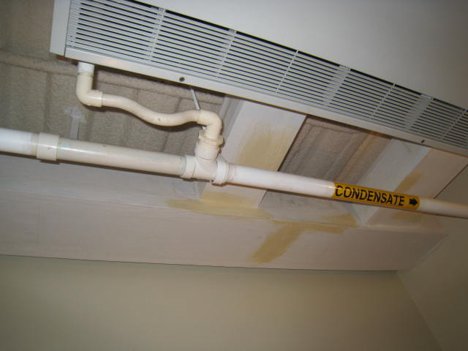
Section of piping that reportedly leaked

Univent in office 124F

Picture 4

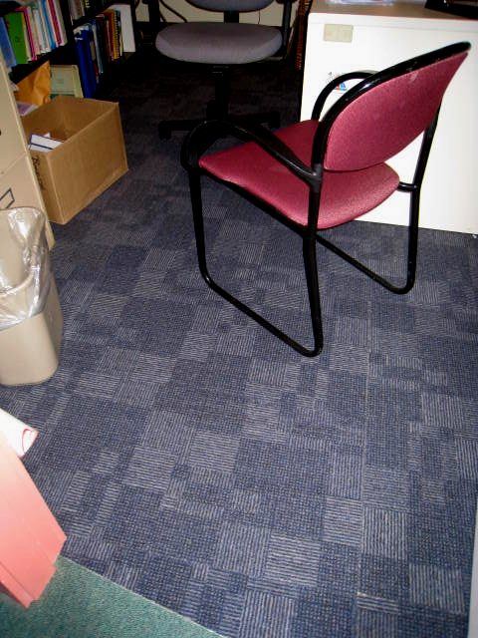

New carpet tiles in office 124F

Picture 5

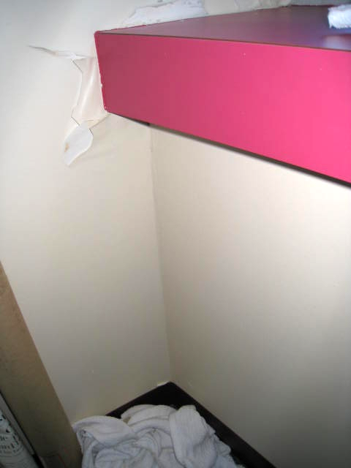

Leaking window in office 124D, note peeling paint and presence of rags

Picture 6

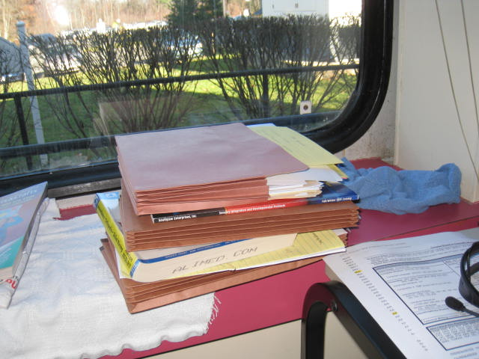

Paper products placed on rag near leaking window in Office 124D

Picture 7

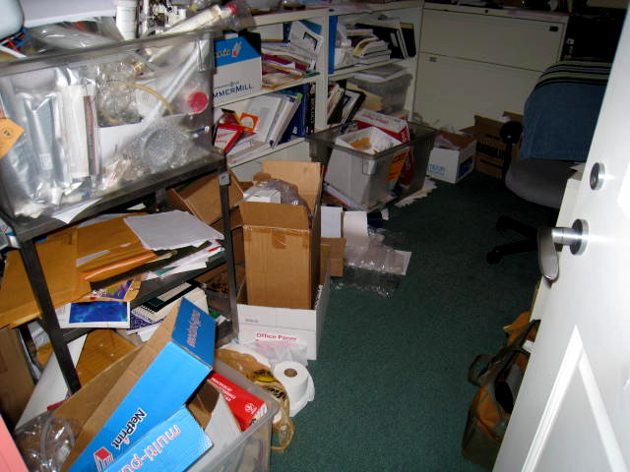

Accumulated items in office 124G

Picture 8

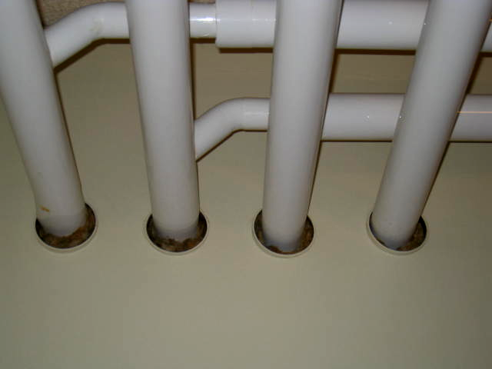

Open utility holes
Location | Occupants  in Room | Temp  (°F) | Relative  Humidity  (%) | Carbon  Dioxide  (ppm) | Carbon Monoxide  (ppm) | Windows  Openable | Ventilation |  | Remarks
 |  |  |  |  |  |  | Supply | Exhaust | Remarks
Background |  | 65 | 37 | 437 | ND |  |  |  | Sunny
124 common area | 2 | 75 | 28 | 613 | ND | N | Y | Y | DO
124D | 2 | 74 | 28 | 851 | ND | N | Y | N | DO, leaking window, items on windowsill
124E | 0 | 74 | 27 | 721 | ND | N | Y | N | DO
124F | 0 | 76 | 27 | 654 | ND | N | Y | N | DO, new carpeting
124G | 0 | 76 | 25 | 690 | ND | N | Y | N | Excessive items, strong stale coffee odor, assortment of used cups/mugs
124H | 1 | 76 | 28 | 790 | ND | N | Y | N | Strong perfume odor
124 (PT room) | 8 | 75 | 29 | 703 | ND | N | Y | N

