Background/Introduction

INDOOR AIR QUALITY ASSESSMENT
ODOR INVESTIGATION

North Shore Community College
Health Professions Building
Danvers Campus
1 Ferncroft Road
Danvers, Massachusetts

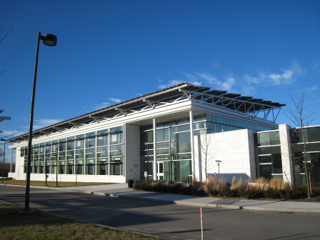

Prepared by:
Massachusetts Department of Public Health
Bureau of Environmental Health
Indoor Air Quality Program
June 2013
In response to a request from George Neunaber, Facilities Engineer, North Shore Community College (NSCC), the Massachusetts Department of Public Health (MDPH), Bureau of Environmental Health (BEH) provided assistance and consultation regarding indoor air quality (IAQ) concerns at the new Health Professions and Student Services Building (HPSSB) on NSCC’s Danvers Campus. Concerns about reports of musty odors in a suite of third floor offices prompted the request. On January 16, 2013, a visit to conduct an assessment of the HPSSB was made by Sharon Lee, an Environmental Analyst within BEH’s IAQ Program.
The HPSSB is a newly constructed multi-story building. Completed in 2011, the HPSSB is a zero net energy building, representative of NSCC sustainability efforts. This three-story building contains five general academic instruction spaces, as well as classrooms for nursing, physical and occupational therapy, radiology, respiratory and surgical care, and animal sciences.

Methods
BEH staff performed a visual inspection of building materials for water damage and mold growth. Moisture content of porous building materials [e.g., carpeting, gypsum wallboard (GW)] was measured with a Delmhorst, BD-2000 Model, Moisture Detector equipped with a Delmhorst Standard Probe. Temperature and relative humidity measurements were taken with a TSI, Q-Trak, IAQ Monitor, Model 7565. Air tests for airborne particle matter with a diameter less than 2.5 micrometers were taken with the TSI, Dust-Trak™ Aerosol Monitor Model 8520.

Background/Introduction
In response to a request from George Neunaber, Facilities Engineer for North Shore Community College (NSCC), the Massachusetts Department of Public Health (MDPH), Bureau of Environmental Health (BEH) provided assistance and consultation regarding indoor air quality (IAQ) concerns at the new Health Professions and Student Services Building (HPSSB) on NSCC’s Danvers Campus located at One Ferncroft Road. Concerns about reports of musty odors in a suite of third floor offices prompted the request. On January 14, 2013, a visit to conduct an assessment of the HPSSB was made by Sharon Lee, an Environmental Analyst within BEH’s IAQ Program.
The HPSSB is a newly-constructed multi-story building. Completed in 2011, the HPSSB is a zero net energy building, representative of NSCC sustainability efforts. This three-story building contains five general academic instruction spaces, as well as classrooms for nursing, physical and occupational therapy, radiology, respiratory and surgical care, and animal sciences.

Methods
BEH staff performed a visual inspection of building materials for water damage and mold growth. Moisture content of porous building materials [e.g., carpeting, gypsum wallboard (GW)] was measured with a Delmhorst, BD-2000 Model, Moisture Detector equipped with a Delmhorst Standard Probe. Temperature and relative humidity measurements were taken with a TSI, Q-Trak™ IAQ Monitor, Model 7565. Air tests for airborne particle matter with a diameter less than 2.5 micrometers were taken with the TSI, Dust-Trak™ Aerosol Monitor Model 8520.

Results
The HPSSB has a staff of approximately 150 and can be visited by hundreds of NSCC staff and students on a daily basis. Tests were taken under normal operating conditions. Test results appear in Table 1.

Discussion

Temperature and Relative Humidity
Temperature measurements ranged from 71° F to 72° F, which were within the MDPH recommended comfort range in all areas. The MDPH recommends that indoor air temperatures be maintained in a range of 70° F to 78° F in order to provide for the comfort of building occupants. In many cases concerning indoor air quality, fluctuations of temperature in occupied spaces are typically experienced, even in a building with an adequate fresh air supply.
At the time of the assessment, relative humidity was 41 percent in the areas tested, which was at the lower end of the MDPH recommended comfort range. The MDPH recommends a comfort range of 40 to 60 percent for indoor air relative humidity. Relative humidity levels would be expected to drop during the winter months due to heating and decreased outdoor relative humidity. The sensation of dryness and irritation is common in a low relative humidity environment. Low relative humidity is a very common problem during the heating season in the northeast part of the United States.

Microbial/Moisture Concerns
As mentioned, the assessment was prompted by musty odors in a third floor office suite. As reported by NSCC staff, a leak was experienced in room 338 in the spring of 2011. At that time, repairs were made. No leaks have been reported by staff or observed by maintenance since repairs were completed.
At the time of the BEH/IAQ assessment, room 338 was unoccupied due to the winter semester break. Upon entering the room, a strong new carpet odor was noted. These odors likely accumulated in this room because the office door was closed. In contrast, only faint carpet odors were noted in adjacent offices, since doors to these areas were open.
No water-damaged ceiling tiles or other building materials were observed. BEH/IAQ staff examined conditions above the ceiling tile (Pictures 1 and 2). No signs of recent water penetration were evident, and materials near the reported leak were dry at the time of assessment.
In order for building materials to support mold growth, a source of water exposure is necessary. Identification and elimination of the source of water moistening building materials is necessary to control mold growth. The US Environmental Protection Agency (US EPA) and the American Conference of Governmental Industrial Hygienists (ACGIH) recommends that porous materials be dried with fans and heating within 24 to 48 hours of becoming wet (US EPA, 2001; ACGIH, 1989). If porous materials are not dried within this time frame, mold growth may occur. Cleaning cannot adequately remove mold growth from water-damaged porous materials. The application of a mildewcide to mold-contaminated porous materials is not generally effective.
Please note, plants were observed by the window (Picture 3; Table 1). Plants should be properly maintained and equipped with drip pans. Plants should also be located away from ventilation sources to prevent aerosolization of dirt, pollen, or mold. Plants should not be placed on porous materials, since water damage to porous materials may lead to microbial growth.
An uncovered water jug containing discolored water was also observed in office 338 (Picture 4). The container was placed directly on carpet. While no odors were observed from the jug, stagnant water can be a source of odors and bacterial growth.

Particulate Matter
The US EPA has established National Ambient Air Quality Standards (NAAQS) limits for exposure to particulate matter (PM). Particulate matter includes airborne solids that can be irritating to the eyes, nose and throat. The NAAQS originally established exposure limits to PM with a diameter of 10 μm or less (PM10). In 1997, US EPA established a more protective standard for fine airborne particulate matter with a diameter of 2.5 μm or less (PM2.5). The NAAQS has subsequently been revised, and PM2.5 levels were reduced. This more stringent PM2.5 standard requires outdoor air particle levels be maintained below 35 μg/m³ over a 24-hour average (US EPA, 2006). Although both the American Society of Heating, Refrigeration and Air Conditioning Engineers (ASHRAE) Standard and the Building Officials and Code Administrators (BOCA) Code adopted the PM10 standard for evaluating air quality (ASHRAE, 1989; BOCA 1993), MDPH uses the more protective PM2.5 standard for evaluating airborne PM concentrations in the indoor environment.
Outdoor PM2.5 concentrations the day of the assessment were measured at 18 μg/m³. PM2.5 levels were measured in occupied areas to be 5 μg/m³ (Table 1). Indoor PM 2.5 levels were below the NAAQS PM2.5 level of 35 μg/m³ in all areas surveyed at the time of assessment.

Other Conditions
Staff reported odors in the lobby of the second floor entry. The lobby area provides entry to the Student Center and restrooms. Odors reportedly are noticable periodically and sporadically, although more likely to occur earlier in the day. The toilets in this building reportedly use collected rainwater from the green roofs for flushing. The rainwater collection system uses water that has been recovered, filtered, and piped from the roof to storage tanks at the ground level. The filtration system can remove large particles, but not dissolved particles. Over time, these dissolved materials can decompose and create odors. Measures should be taken to flush toilets when the building is opened in the morning to prevent these odors. Exhaust fans for the restroom areas should also be programmed to operate a few hours prior to the start of the work day to remove any lingering odors that may accumulate from stagnant water. Other sources of odors include floor drains, which can produce odors when drain traps become dry.

Conclusions/Recommendations
In view of the findings at the time of the assessment, the following recommendations are made to improve indoor air quality.
- Continue monitoring for leaks to ensure proper actions are taken to prevent mold growth. Office staff should report all leaks to the facilities department as soon as a leak is discovered for prompt remediation.
- Remove standing water (i.e. open water containers) that can be a source for odors.
- Ensure plants are appropriately maintained to prevent mold growth and standing water.
- Maintain floor drain traps by filling drains with water routinely.
- Consider activating bathroom exhausts a few hours prior to occupancy to allow for removal of water vapor and odors.
- Consider flushing toilets during the weekend or a few hours prior to occupancy to prevent odor build up from water stagnation.
- Increase ventilation to remove the odors from new carpeting or other furnishings.
- For buildings in New England, periods of low relative humidity during the winter are often unavoidable. Therefore, scrupulous cleaning practices should be adopted to minimize common indoor air contaminants whose irritant effects can be enhanced when the relative humidity is low. To control for dusts, a HEPA filter equipped vacuum cleaner in conjunction with wet wiping of all surfaces is recommended. Drinking water during the day can help ease some symptoms associated with a dry environment (throat and sinus irritations).
- Refer to resource manuals and other related indoor air quality documents for further building-wide evaluations and advice on maintaining public buildings. Copies of these materials are located on the MDPH’s website: http://mass.gov/dph/iaq.

References
ACGIH. 1989. Guidelines for the Assessment of Bioaerosols in the Indoor Environment. American Conference of Governmental Industrial Hygienists, Cincinnati, OH.
ASHRAE. 1989. Ventilation for Acceptable Indoor Air Quality. American Society of Heating, Refrigeration and Air Conditioning Engineers. ANSI/ASHRAE 62-1989
BOCA. 1993. The BOCA National Mechanical Code-1993. 8th ed. Building Officials & Code Administrators International, Inc., Country Club Hills, IL. M-308.1
US EPA. 2001. Mold Remediation in Schools and Commercial Buildings. US Environmental Protection Agency, Office of Air and Radiation, Indoor Environments Division, Washington, DC. EPA 402-K-01-001. March 2001.
US EPA. 2006. National Ambient Air Quality Standards (NAAQS). US Environmental Protection Agency, Office of Air Quality Planning and Standards, Washington, DC. http://www.epa.gov/air/criteria.htm

Picture 1

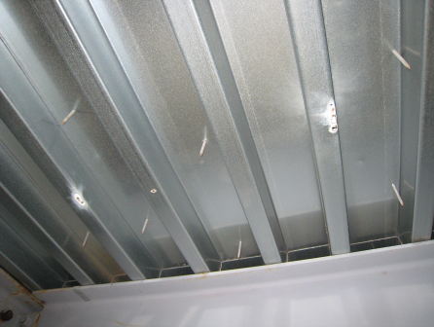

Roof decking near area of reported leak

Picture 2

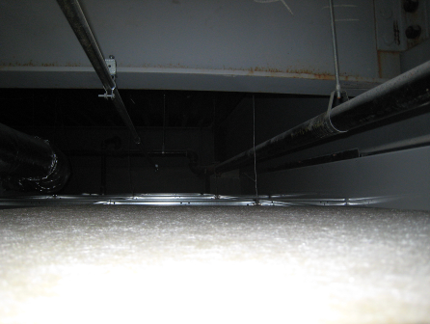

Plenum of area of reported leak

Picture 3

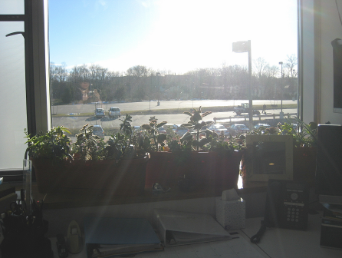

Plants in office

Picture 4

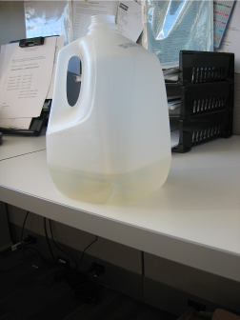

Container of discolored water

Location | Temp  (°F) | Relative  Humidity  (%) | PM2.5  (µg/m³) | Occupants  in Room | Windows  Openable | Ventilation |  | Remarks
Background | 48 | 33 | 18 |  |  |  |  | Sunny, clear, light wind
338 | 72 | 41 | 5 | 0 |  | Y | Y | Strong carpet odors, plants on windowsill, discolored water in container, reports of previous ceiling leak
337 | 72 | 41 | 5 | 3 |  | Y | Y | DO, slight carpet odor
335 | 72 | 41 | 5 | 1 |  | Y | Y | DO, strong sweet smell from candy

