# Background/Introduction

**INDOOR AIR QUALITY ASSESSMENT**

**ODOR INVESTIGATION**

**North Shore Community College**

**Health Professions Building**

**Danvers Campus**

**1 Ferncroft Road**

**Danvers, Massachusetts**

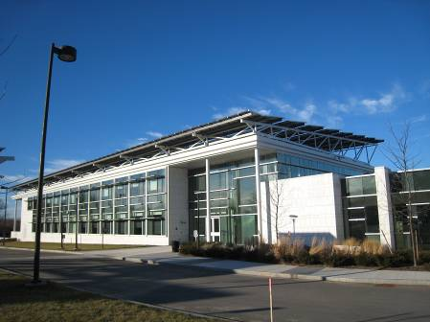

Prepared by:

Massachusetts Department of Public Health

Bureau of Environmental Health

Indoor Air Quality Program

May 2015

In response to a request from George Neunaber, Facilities Engineer, North Shore Community College (NSCC), the Massachusetts Department of Public Health (MDPH), Bureau of Environmental Health (BEH) provided assistance and consultation regarding indoor air quality (IAQ) concerns at the new Health Professions and Student Services Building (HPSSB) on NSCC’s Danvers Campus. Concerns about reports of musty odors in a suite of third floor offices prompted the request. On January 16, 2013, a visit to conduct an assessment of the HPSSB was made by Sharon Lee, an Environmental Analyst within BEH’s IAQ Program.

The HPSSB is a newly constructed multi-story building. Completed in 2011, the HPSSB is a zero net energy building, representative of NSCC sustainability efforts. This three-story building contains five general academic instruction spaces, as well as classrooms for nursing, physical and occupational therapy, radiology, respiratory and surgical care, and animal sciences.

# Methods

BEH staff performed a visual inspection of building materials for water damage and mold growth. Moisture content of porous building materials [e.g., carpeting, gypsum wallboard (GW)] was measured with a Delmhorst, BD-2000 Model, Moisture Detector equipped with a Delmhorst Standard Probe. Temperature and relative humidity measurements were taken with a TSI, Q-Trak, IAQ Monitor, Model 7565. Air tests for airborne particle matter with a diameter less than 2.5 micrometers were taken with the TSI, Dust-Trak™ Aerosol Monitor Model 8520.

# Background/Introduction

In response to a request from George Neunaber, Facilities Engineer for North Shore Community College (NSCC), the Massachusetts Department of Public Health (MDPH), Bureau of Environmental Health (BEH) provided assistance and consultation regarding indoor air quality (IAQ) concerns at the Health Professions and Student Services Building (HPSSB) on NSCC’s Danvers Campus located at One Ferncroft Road. Reports of musty odors in a suite of third floor offices prompted the request. On January 6, 2015, a visit to conduct an assessment of the HPSSB was made by Jason Dustin, an Environmental Analyst within BEH’s IAQ Program. A follow-up visit was later conducted on January 20, 2015 by Mike Feeney, Director of BEH’s IAQ Program accompanied by Mr. Dustin. Since the concerns of musty odors were in specific areas of the third floor office suite, this report focuses on those areas. A previous visit to investigate similar concerns was made on January 11, 2013. A summary of actions taken following that visit is included as [Appendix A](http://www.mass.gov/eohhs/docs/dph/environmental/iaq/appendices/carbon-dioxide.doc).

The HPSSB is a multi-story building that was completed in 2011. The HPSSB was designed as a zero net energy building. This three-story building contains five general academic instruction spaces, as well as classrooms for nursing, physical and occupational therapy, radiology, respiratory and surgical care, and animal sciences. Administrative offices are located on the third floor.

# Methods

BEH staff performed a visual inspection of building materials for water damage and mold growth. Moisture content of porous building materials [e.g., carpeting, gypsum wallboard (GW)] was measured with a Delmhorst, BD-2000 Model, Moisture Detector equipped with a Delmhorst Standard Probe. Air tests for carbon monoxide, carbon dioxide, temperature, and relative humidity were conducted with the TSI, Q-Trak, IAQ Monitor, Model 7565. Air tests for airborne particle matter with a diameter less than 2.5 micrometers were taken with the TSI, DUSTTRAK™ Aerosol Monitor Model 8520. Screening for total volatile organic compounds (TVOCs) was conducted using a RAE Systems, MiniRAE 2000 Model, Photoionization Detector.

# Results

The HPSSB has a staff of approximately 150 and can be visited by several hundred of NSCC students and visitors on a daily basis. Tests were taken while most students were still on winter break, however, the administration areas of the third floor office suite were experiencing typical occupancy. Test results appear in Table 1.

# Discussion

## Ventilation

It can be seen from Table 1 that carbon dioxide levels were below 800 parts per million (ppm) in all areas tested indicating adequate air exchange at the time of the assessment. Fresh air for the third floor of the HPSSB building is provided by an air handling unit (AHU) via ducted vents connected to active chilled beam units throughout the space. Active chilled beam units have an internal water coil over which supply and room air passes to further condition the air within a space. Supply air is ejected through nozzles and out of the side chamber vents thereby creating low pressure which draws in mixed room air through the coil/heat exchanger (Figure 1, Pictures 1 to 3).

Exhaust air is drawn into ducted vents in the ceiling (Picture 4) and reportedly directed outside of the building. It is important to note that HPSSB reportedly uses the main exhaust system (return system) of each floor’s AHU for bathrooms and kitchen areas as well. These areas normally require separate local exhaust ventilation directed immediately outside of the building. NSCC facilities staff reported that the ventilation system involves 100% fresh air intake and that no exhaust air is exchanged with fresh air supply. However, since the HVAC system utilizes a heat recovery/desiccant wheel to retain heat/cooling energy of exhaust air and reduce humidity levels of incoming fresh air, this configuration presents several possible moisture and microbial concerns. These concerns are discussed in the “Microbial/Moisture Concerns” section of this report. Although brush seals and purge sections are helpful in reducing the exchange of supply and exhaust air streams, in general heat recovery/desiccant wheels are not recommended where total separation of the air streams are required.

To maximize air exchange, the MDPH recommends that both supply and exhaust ventilation operate continuously during periods of occupancy. In order to have proper ventilation with a mechanical supply and exhaust system, the systems must be balanced to provide an adequate amount of fresh air to the interior of a room while removing stale air from the room. It is recommended that HVAC systems be re-balanced every five years to ensure adequate air systems function (SMACNA, 1994). It was reported by NSCC facilities staff that balancing the HVAC system has been an ongoing process as there have been continuous issues with the system since it was installed.

Minimum design ventilation rates are mandated by the Massachusetts State Building Code (MSBC). Until 2011, the minimum ventilation rate in Massachusetts was higher for both occupied office spaces and general classrooms, with similar requirements for other occupied spaces (BOCA, 1993). The current version of the MSBC, promulgated in 2011 by the State Board of Building Regulations and Standards (SBBRS), adopted the 2009 International Mechanical Code (IMC) to set minimum ventilation rates. **Please note that the MSBC is a minimum standard that is not health-based**. At lower rates of cubic feet per minute (cfm) per occupant of fresh air, carbon dioxide levels would be expected to rise significantly. A ventilation rate of 20 cfm per occupant of fresh air provides optimal air exchange resulting in carbon dioxide levels at or below 800 ppm in the indoor environment in each area measured. MDPH recommends that carbon dioxide levels be maintained at 800 ppm or below. This is because most environmental and occupational health scientists involved with research on IAQ and health effects have documented significant increases in indoor air quality complaints and/or health effects when carbon dioxide levels rise above the MDPH guidelines of 800 ppm for schools, office buildings and other occupied spaces (Sundell et al., 2011). The ventilation must be on at all times that the room is occupied. Providing adequate fresh air ventilation with open windows and maintaining the temperature in the comfort range during the cold weather season is impractical. Mechanical ventilation is usually required to provide adequate fresh air ventilation.

Carbon dioxide is not a problem in and of itself. It is used as an indicator of the adequacy of the fresh air ventilation. As carbon dioxide levels rise, it indicates that the ventilating system is malfunctioning or the design occupancy of the room is being exceeded. When this happens, a buildup of common indoor air pollutants can occur, leading to discomfort or health complaints. The Occupational Safety and Health Administration (OSHA) standard for carbon dioxide is 5,000 parts per million parts of air (ppm). Workers may be exposed to this level for 40 hours/week, based on a time-weighted average (OSHA, 1997).

The MDPH uses a guideline of 800 ppm for publicly occupied buildings. A guideline of 600 ppm or less is preferred in schools due to the fact that the majority of occupants are young and considered to be a more sensitive population in the evaluation of environmental health status. Inadequate ventilation and/or elevated temperatures are major causes of complaints such as respiratory, eye, nose and throat irritation, lethargy and headaches. For more information concerning carbon dioxide, please see Appendix B.

## Temperature and Relative Humidity

Temperature measurements ranged from 67° F to 74° F, which were within the MDPH recommended comfort range in most areas. The MDPH recommends that indoor air temperatures be maintained in a range of 70° F to 78° F in order to provide for the comfort of building occupants. In many cases concerning indoor air quality, fluctuations of temperature in occupied spaces are typically experienced, even in a building with an adequate fresh air supply.

At the time of the assessment, relative humidity ranged from 7 to 12 percent in the areas tested, which was below the MDPH recommended comfort range. The MDPH recommends a comfort range of 40 to 60 percent for indoor air relative humidity. Relative humidity levels would be expected to drop during the winter months due to heating and decreased outdoor relative humidity. The sensation of dryness and irritation is common in a low relative humidity environment. Low relative humidity is a very common problem during the heating season in the northeast part of the United States.

## Microbial/Moisture Concerns

As mentioned, the assessment was prompted by musty odors in a third floor office suite. Upon entering the reception area of the third floor office suite, BEH/IAQ staff detected a slight musty odor. There was a large plant in this area that appeared to be improperly maintained (Picture 5). Plants should be properly maintained and equipped with drip pans. Plants should also be located away from ventilation sources to prevent aerosolization of dirt, pollen, or mold. Overwatering and lack of drip pan cleaning/maintenance can promote microbial growth and associated odors. These odors can be distributed through the office space via pressure differentials. It is strongly recommended that this plant be removed from the office suite to prevent exacerbating any unrelated musty odors in the space.

In addition to the reception area, BEH/IAQ staff noted a musty odor in room #337 and a slight musty odor in room #338. No water-damaged ceiling tiles or other building materials were observed in these areas. BEH/IAQ staff examined conditions above the ceiling tiles in areas of the odor complaints. No signs of recent water penetration were evident in these areas (Picture 6). More invasive techniques such as lifting carpet tiles and cutting inspection holes in wallboard were not conducted at the time of the assessment; these actions could be used to rule out any minor leaks/condensation behind building materials. Since no obvious signs of leaks or water penetration were evident at the time of the assessment another source likely exists for the musty odors.

One potential source of musty odors is chronic condensation on porous materials or debris. According to the manufacturer of the active chilled beams used in the HPSSB, maintenance and vacuuming/cleaning of the ducts and coil area should be carefully performed at least twice per year to remove any accumulated dust and debris (Barcolair, 2011). This is an important maintenance requirement since most of the air that passes through the coil is unfiltered secondary air from the room containing both dust and occupant-induced water vapor. The MDPH typically recommends using a HEPA vacuum when cleaning to avoid re-aerosolizing any particulate matter. Also contributing to any debris in the chilled beams from induced room air is the use of inadequate air filters in the AHU for supply air (Picture 7). Higher efficiency air filters of the proper manufacturer-specified MERV rating should be used to reduce dust and debris in the coil areas of these units. Even slight chronic condensation in the heat exchanger/coil area of both the chilled beam units and the AHU can allow mold to colonize in the accumulated debris and contribute to musty odors throughout the space. BEH/IAQ staff asked Mr. Neunaber for permission to open one of the chilled beam units for inspection but a NSCC facilities staff member familiar with the new technology was not readily available for assistance at that time. Performing the required maintenance may verify the presence of this accumulated debris.

Dew point/humidity control is very important when utilizing active chilled beams to avoid chronic condensation issues. If the temperature of the incoming coil supply water is not kept at least two degrees above the room’s dew point, condensation will occur (ASHRAE, 2011). With the supply water coming into the AHU below the dew point of the room, especially during humid weather, it is crucial to have complete dew point/humidity control in the AHU before the supply water enters the chilled beam units to avoid condensation. NSCC staff reported that other areas in the HPSSB have experienced problems where condensation had caused it to “rain” beneath the units. According to NSCC staff, it has been an ongoing issue working with the HVAC design contractor in addressing ventilation, comfort and dew point issues throughout other areas of the building. According to the chilled beam manufacturer, dehumidification should be performed even during unoccupied hours (Barcolair, 2011) to reduce the likelihood of any condensation on the chilled beam coils.

As previously mentioned, exhaust air from high humidity sources such as bathrooms and kitchen areas may undermine the ability of the AHU to control humidity in occupied spaces since this humid air is used in a heat recovery/desiccant wheel where supply air is also introduced. This configuration could contribute to condensation issues and associated odors at the chilled beam units. A heat recovery/desiccant wheel is designed to remove moisture from incoming humid outside air and recover heat or cooling energy from exhausted air (Figure 2). According to the manufacturer of the heat recovery/desiccant wheel, when the exhaust air stream is more humid than the supply air stream, the wheel may transfer that moisture to the supply side of the air stream. The manufacturer also states that routine maintenance, inspection, and cleaning of the wheel are required. This maintenance should include inspecting the seals on the wheel especially where they divide the supply air from the exhaust air streams to minimize water vapor intrusion (Rotorsource, 2005). It may also be prudent to inspect the main supply side air ducts for any debris and signs of chronic moisture which could foster the growth of mold in the ducts. The inspection of the exhaust air connectivity to the AHU should be performed by a qualified third party HVAC contractor with proven experience in this technology to ensure proper configuration and settings.

After passing through the heat recovery/desiccant wheel, the supply air flows through heat exchanger coils within the AHU to condition the air before it travels to the individual chilled beam units. It is common for AHU heat exchanger coils to become fouled due to moisture, debris and sometimes mold. A humid supply air stream, combined with excess debris due to inefficient filters, would most likely intensify this fouling. These components require regular cleaning/maintenance to increase effectiveness, decrease energy use and eliminate odors and microbial growth. It is typical for microbial growth to occur during the cooling season and odors to become more intense at the start of the heating season. The timing of reported complaints seems to verify this pattern of occurrence in the space. The HPSSB reportedly does not have any ongoing cleaning/maintenance contracts in place for either the AHU components or chilled beam units.

Infiltration of water vapor from outside could be a further issue resulting in condensation at the chilled beam coils if the office space is not kept at a slight positive pressure as recommended when utilizing chilled beam technology (ASHRAE, 2011). This demonstrates the importance of balancing the ventilation system properly utilizing a qualified HVAC contractor familiar with these technologies.

Some offices in the third floor office suite had openable windows (Table 1). It is especially important to instruct all HPSSB employees to leave windows closed during the cooling cycle to avoid condensation issues and complicating the difficult task of dew point/humidity control with chilled beam technologies.

## Other IAQ Evaluations

Indoor air quality can be negatively influenced by the presence of respiratory irritants, such as products of combustion. The process of combustion produces a number of pollutants. Common combustion emissions include carbon monoxide, carbon dioxide, water vapor and smoke (fine airborne particle material). Of these materials, exposure to carbon monoxide and particulate matter with a diameter of 2.5 micrometers (μm) or less (PM2.5) can produce immediate, acute health effects upon exposure. To determine whether combustion products were present in the indoor environment, BEH/IAQ staff obtained measurements for carbon monoxide and PM2.5.

### Carbon Monoxide

Carbon monoxide is a by-product of incomplete combustion of organic matter (e.g., gasoline, wood and tobacco). Exposure to carbon monoxide can produce immediate and acute health effects. Several air quality standards have been established to address carbon monoxide and prevent symptoms from exposure to these substances. The MDPH established a corrective action level concerning carbon monoxide in ice skating rinks that use fossil-fueled ice resurfacing equipment. If an operator of an indoor ice rink measures a carbon monoxide level over 30 ppm, taken 20 minutes after resurfacing within a rink, that operator must take actions to reduce carbon monoxide levels (MDPH, 1997).

The American Society of Heating Refrigeration and Air-Conditioning Engineers (ASHRAE) has adopted the National Ambient Air Quality Standards (NAAQS) as one set of criteria for assessing indoor air quality and monitoring of fresh air introduced by HVAC systems (ASHRAE, 1989). The NAAQS are standards established by the US EPA to protect the public health from six criteria pollutants, including carbon monoxide and particulate matter (US EPA, 2006). As recommended by ASHRAE, pollutant levels of fresh air introduced to a building should not exceed the NAAQS levels (ASHRAE, 1989). The NAAQS were adopted by reference in the Building Officials & Code Administrators (BOCA) National Mechanical Code of 1993 (BOCA, 1993), which is now an HVAC standard included in the Massachusetts State Building Code (SBBRS, 2011). According to the NAAQS, carbon monoxide levels in outdoor air should not exceed 9 ppm in an eight-hour average (US EPA, 2006).

*Carbon monoxide should not be present in a typical, indoor environment*. If it *is* present, indoor carbon monoxide levels should be less than or equal to outdoor levels. On the day of the assessment, outdoor carbon monoxide concentration was non-detectable (Table 1). All indoor carbon monoxide measurements were non-detectable.

### Particulate Matter

The US EPA has established National Ambient Air Quality Standards (NAAQS) limits for exposure to particulate matter (PM). Particulate matter includes airborne solids that can be irritating to the eyes, nose and throat. The NAAQS originally established exposure limits to PM with a diameter of 10 μm or less (PM10). In 1997, US EPA established a more protective standard for fine airborne particulate matter with a diameter of 2.5 μm or less (PM2.5). The NAAQS has subsequently been revised, and PM2.5 levels were reduced. This more stringent PM2.5 standard requires outdoor air particle levels be maintained below 35 μg/m3 over a 24-hour average (US EPA, 2006). Although both the American Society of Heating, Refrigeration and Air Conditioning Engineers (ASHRAE) Standard and the Building Officials and Code Administrators (BOCA) Code adopted the PM10 standard for evaluating air quality (ASHRAE, 1989; BOCA 1993), MDPH uses the more protective PM2.5 standard for evaluating airborne PM concentrations in the indoor environment.

Outdoor PM2.5 concentrations the day of the assessment were measured at 6 μg/m3. PM2.5 levels measured in occupied areas ranged from 2 μg/m3 to 3 μg/m3 (Table 1). Indoor PM 2.5 levels were below the NAAQS PM2.5 level of 35 μg/m3 in all areas surveyed at the time of assessment (Table 1).

*Volatile Organic Compounds*

Indoor air concentrations can be greatly impacted by the use of products containing volatile organic compounds (VOCs). VOCs are carbon-containing substances that have the ability to evaporate at room temperature. Frequently, exposure to low levels of total VOCs (TVOCs) may produce eye, nose, throat and/or respiratory irritation in some sensitive individuals. For example, chemicals evaporating from a paint can stored at room temperature would most likely contain VOCs. In an effort to identify materials that can potentially increase indoor VOC concentrations, BEH/IAQ staff examined rooms for products containing these respiratory irritants. BEH/IAQ staff did not note any chemical odors or specific VOC issues at the time of the assessment. VOC measurements of both background and interior spaces within the third floor office suite were non-detectable (Table 1).

# Conclusions/Recommendations

In view of the findings at the time of the assessment, the following recommendations are made to improve indoor air quality.

1. Consider contracting with an outside third party HVAC contractor with proven experience in the technologies utilized at HPSSB (preferably unaffiliated with the HVAC design contractor) to objectively inspect and evaluate the HVAC system paying particular attention to:
   1. Performance testing of the AHU.
   2. Ensuring proper dew point/humidity control settings to avoid condensation at the chilled beam units.
   3. Ensuring proper heat recovery/desiccant wheel settings and dry cycles.
   4. Verifying that high-humidity point sources of exhaust ventilation are not interfering with the humidity control of the AHU in their current configuration. To alleviate health concerns, plans should be considered to directly exhaust these sources (restrooms, kitchens, scrub sinks, etc.) if they are contributing to water vapor intrusion into the supply side ducts. Building/plumbing codes may also require direct venting of these areas.
   5. Verifying correct settings for dehumidification of interior spaces during unoccupied hours.
   6. Verifying positive pressure in spaces utilizing chilled beam units.
   7. Ensuring adequate cfm/person of fresh air is being supplied to occupied areas (MDPH recommends 20 cfm/person).
   8. Inspect condition of AHU heat exchangers and chilled beam coils for fouling and mold growth which can restrict air flow and cause odors/health concerns.
2. Contract with an experienced (technology-specific) HVAC contractor to ensure that regular cleaning/maintenance of the system is being carried out by qualified personnel; this may include:
   1. Installing manufacturer recommended air filters of proper efficiency and changing at correct frequency.
   2. Cleaning AHU heat exchanger coils and drip pans regularly.
   3. Adjusting AHU settings to ensure proper functioning.
   4. Inspecting and cleaning/maintaining heat recovery/desiccant wheel.
   5. Cleaning/adjusting chilled beam units and other maintenance.
3. Remove the unmaintained large plant in the reception area to avoid contributing to the musty odors experienced in the third floor office suite.
4. Should the inspection of the AHU heat exchanger coils show signs of fouling and mold growth, these components should be cleaned promptly according to manufacturer recommendations.
5. Following manufacturer instructions, carefully vacuum/clean any dust and debris from the chambers and coil units of all chilled beam units at least twice per year. Priority should be placed on cleaning units with odor complaints first.
6. Continue monitoring for any leaks/condensation to ensure proper actions are taken to prevent mold growth. Office staff should report all leaks to the facilities department as soon as a leak is discovered for prompt remediation.
7. Consider having the main supply side air ducts inspected for signs of chronic water vapor intrusion. Chronic water vapor intrusion from humid exhaust sources coupled with accumulated debris due to the inefficient AHU filters could serve as a substrate for mold growth within the ducts.
8. Instruct all HPSSB employees to leave windows closed during the cooling cycle to avoid condensation issues and jeopardizing the difficult task of dew point/humidity control with chilled beam technologies.
9. Consider more invasive inspection techniques should odors persist following the cleaning of debris from chilled beam units and AHU heat exchanger coils. This may include lifting carpet tiles and cutting small inspection holes in wallboard to find any mold colonization under/behind porous building materials in the areas of musty odors.
10. For buildings in New England, periods of low relative humidity during the winter are often unavoidable. Therefore, scrupulous cleaning practices should be adopted to minimize common indoor air contaminants whose irritant effects can be enhanced when the relative humidity is low. To control for dusts, a HEPA filter equipped vacuum cleaner in conjunction with wet wiping of all surfaces is recommended. Drinking water during the day can help ease some symptoms associated with a dry environment (throat and sinus irritations).
11. Refer to resource manuals and other related indoor air quality documents for further building-wide evaluations and advice on maintaining public buildings. Copies of these materials are located on the MDPH’s website: <http://mass.gov/dph/iaq>.

# References

ASHRAE. 1989. Ventilation for Acceptable Indoor Air Quality. American Society of Heating, Refrigeration and Air Conditioning Engineers. ANSI/ASHRAE 62-1989

ASHRAE. 2011. Application Issues for Chilled Beam Technologies. American Society of Heating, Refrigeration and Air Conditioning Engineers. ASHRAE 2011

Barcolair. 2011. *Barcol-air* Active Chilled Beam *Optimair HF*. November 2011. Oxford, CT. [www.barcolairusa.com](http://www.barcolairusa.com)

BOCA. 1993. The BOCA National Mechanical Code-1993. 8th ed. Building Officials & Code Administrators International, Inc., Country Club Hills, IL. M-308.1

MDPH. 1997. Requirements to Maintain Air Quality in Indoor Skating Rinks (State Sanitary Code, Chapter XI). 105 CMR 675.000. Massachusetts Department of Public Health, Boston, MA.

OSHA. 1997. Limits for Air Contaminants. Occupational Safety and Health Administration. Code of Federal Regulations. 29 C.F.R 1910.1000 Table Z-1-A.

Rotorsource. 2005. Rotorsource Energy Recovery Cassette Operation-Maintenance-Repair. Baton Rouge, LA. [www.rotorsource.com](http://www.rotorsource.com)

SBBRS. 2011. Mechanical Ventilation. State Board of Building Regulations and Standards. Code of Massachusetts Regulations, 8th edition. 780 CMR 1209.0

SMACNA. 1994. HVAC Systems Commissioning Manual. 1st ed. Sheet Metal and Air Conditioning Contractors’ National Association, Inc., Chantilly, VA.

Sundell. 2011. Sundell, J., H. Levin, W. W. Nazaroff, W. S. Cain, W. J. Fisk, D. T. Grimsrud, F. Gyntelberg, Y. Li, A. K. Persily, A. C. Pickering, J. M. Samet, J. D. Spengler, S. T. Taylor, and C. J. Weschler. 2011. Ventilation rates and health: multidisciplinary review of the scientific literature. *Indoor Air*, Volume 21: pp 191–204.

US EPA. 2006. National Ambient Air Quality Standards (NAAQS). US Environmental Protection Agency, Office of Air Quality Planning and Standards, Washington, DC. <http://www.epa.gov/air/criteria.html>.

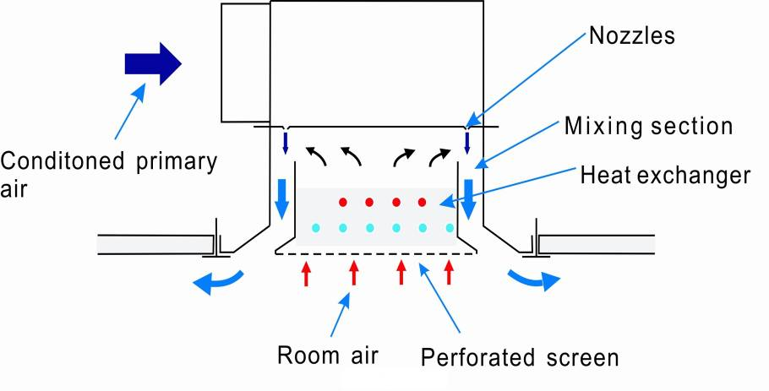

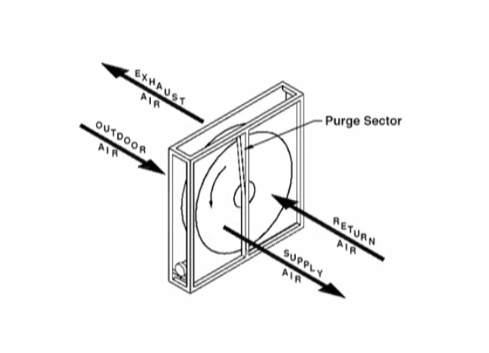

**Picture 1**

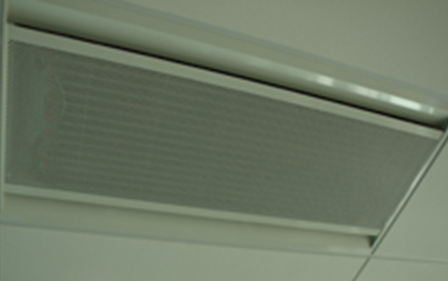

**Chilled beam unit in ceiling tile system**

**Picture 2**

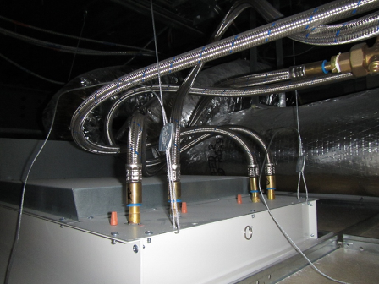

**Chilled beam unit showing supply and return connections for heat and cooling coils**

**Picture 3**

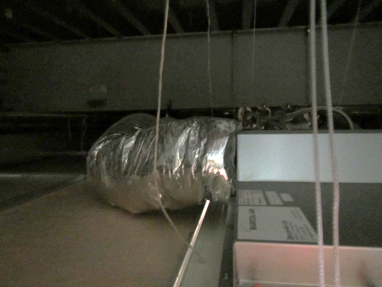

**Chilled beam unit with ducted supply air from AHU attached**

**Picture 4**

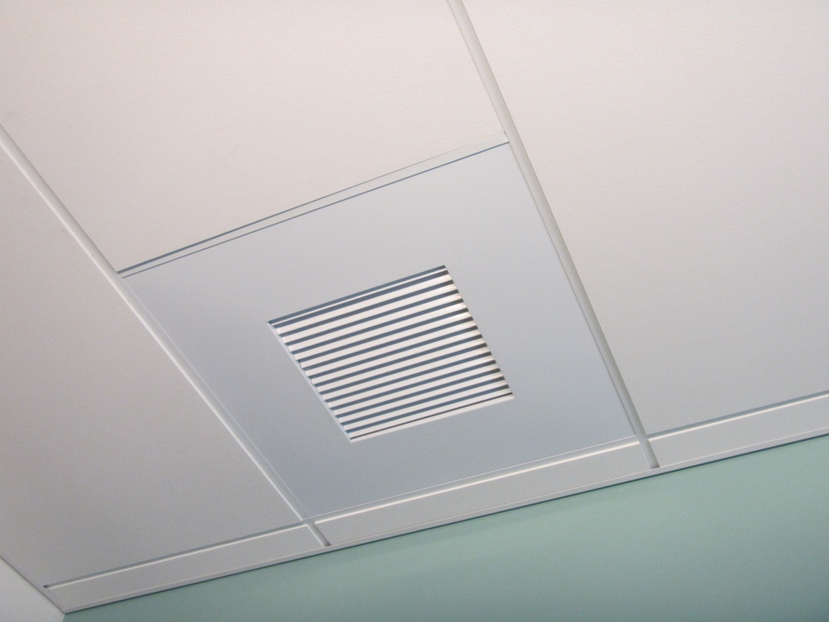

**Ducted exhaust vent**

**Picture 5**

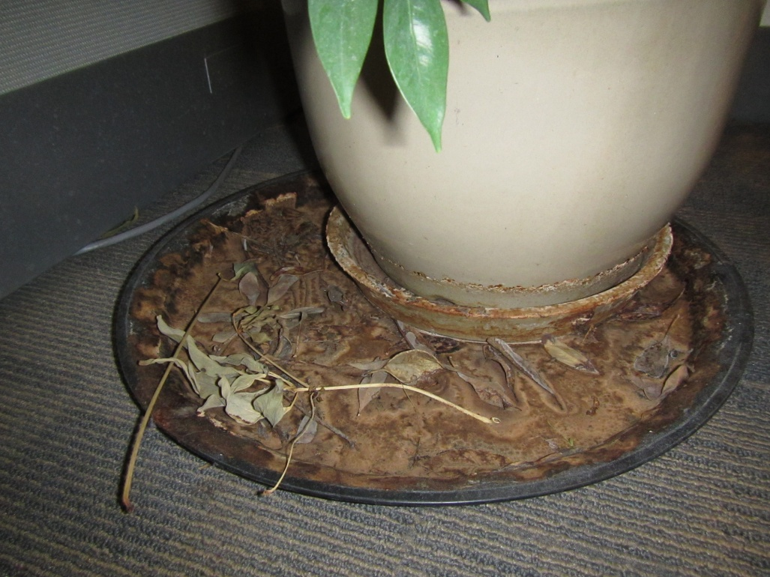

**Unmaintained plant/drip pan in reception area**

**Picture 6**

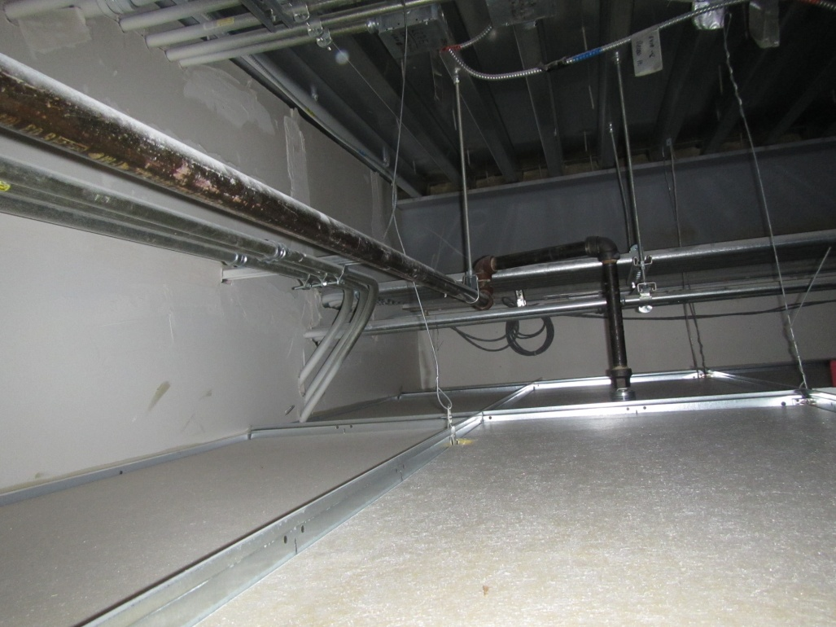

**No signs of water damage above ceiling tile system**

**Picture 7**

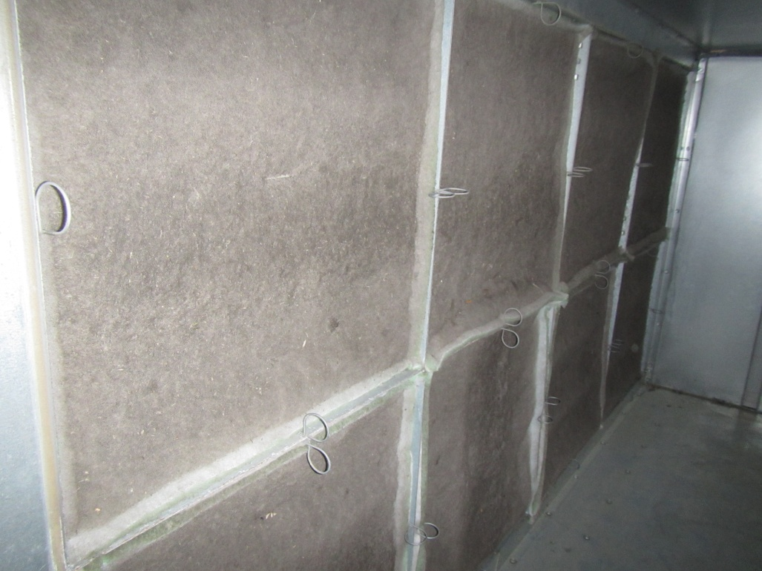

**Dirty filters in third floor AHU appear to be not of proper MERV rating**

| **Location** | **Carbon**  **Dioxide**  **(ppm)** | **Carbon Monoxide**  **(ppm)** | **Temp**  **(°F)** | **Relative**  **Humidity**  **(%)** | **TVOCs**  **(ppm)** | **PM2.5**  **(µg/m3)** | **Occupants**  **in Room** | **Windows**  **Openable** | **Ventilation** | | | **Remarks** |
| --- | --- | --- | --- | --- | --- | --- | --- | --- | --- | --- | --- | --- |
| **Supply** | **Exhaust** | |
| Background | 366 | ND | 29 | 33 | ND | 6 |  |  |  | |  | Light snow |
| Health Professions Building |  |  |  |  |  |  |  |  |  | |  |  |
| Reception area | 641 | ND | 67 | 12 | ND | 2 | 3 | N | Y | | N | Large plant, mildew odor, interior space |
| Faculty lounge  334 | 743 | ND | 74 | 9 | ND | 3 | 2 | Y | Y | | Y | No local exhaust for kitchen |
| 337 | 586 | ND | 74 | 8 | ND | 3 | 3 | Y | Y | | Y | Moderate mildew odor, southern exterior wall |
| 338 | 580 | ND | 73 | 7 | ND | 3 | 3 | Y | Y | | Y |  |
| 339 | 560 | ND | 72 | 8 | ND | 3 | 2 | Y | Y | | Y | Slight mildew odor, southern exterior wall |

ppm = parts per million ND = non detect ug/m3 = micrograms per cubic meter

**Actions on MDPH Recommendations at**

**North Shore Community College, Health Professions Building**

The following is a status report of action(s) taken on MDPH recommendations (specific short-term recommendations only) made following the January 14, 2013 MDPH visit (**in bold**) based on reports from NSCC Facilities staff, documents, photographs and MDPH staff observations taken during the January 6, 2015 and January 20, 2015 reassessments.

**Short-Term Recommendations**

* **Continue monitoring for leaks to ensure proper actions are taken to prevent mold growth. Office staff should report all leaks to the facilities department as soon as a leak is discovered for prompt remediation.**
* **Action:** It was reported that NSCC has a system in place where leaks are reported directly to the Facilities Department for prompt remediation.
* **Remove standing water (i.e. open water containers) that can be a source for odors.**
* **Action:** Complete. No open containers of standing water were found during follow-up assessments.
* **Ensure plants are appropriately maintained to prevent mold growth and standing water.**
* **Action:** Most plants were removed from the office suite with the exception of one large plant in the reception area. This plant is poorly maintained and should be removed.
* **Maintain floor drain traps by filling drains with water routinely.**
* **Action:**  NSCC Facilities personnel reported that this is conducted on occasion.
* **Consider activating bathroom exhausts a few hours prior to occupancy to allow for removal of water vapor and odors**
* **Action:** Complete. NSCC Facilities staff reported that the HVAC set times have been adjusted to allow for extra ventilation (supply and exhaust) prior to start of work.
* **Consider flushing toilets during the weekend or a few hours prior to occupancy to prevent odor build up from water stagnation.**
* **Action:**  Complete and ongoing.
* **Increase ventilation to remove the odors from new carpeting or furnishings.**
* **Action:** NSCC Facilities has been working with the HVAC design engineer to address ongoing ventilation issues. New carpeting/furnishing odors were not detected during follow-up visits.