Background/Introduction

INDOOR AIR QUALITY ASSESSMENT

North Shore Community College
Math and Sciences Building
Danvers Campus, 1 Ferncroft Road
Danvers, Massachusetts

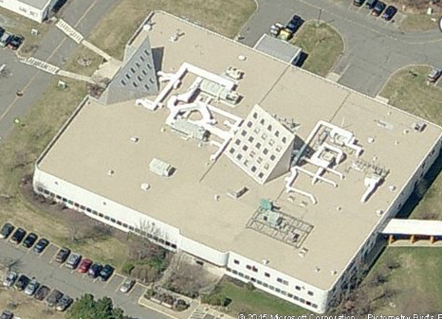

Prepared by:
Massachusetts Department of Public Health
Bureau of Environmental Health
Indoor Air Quality Program
May 2015
In response to a request from George Neunaber, Facilities Engineer, North Shore Community College (NSCC), the Massachusetts Department of Public Health (MDPH), Bureau of Environmental Health (BEH) provided assistance and consultation regarding indoor air quality (IAQ) concerns at the new Health Professions and Student Services Building (HPSSB) on NSCC’s Danvers Campus. Concerns about reports of musty odors in a suite of third floor offices prompted the request. On January 16, 2013, a visit to conduct an assessment of the HPSSB was made by Sharon Lee, an Environmental Analyst within BEH’s IAQ Program.
The HPSSB is a newly constructed multi-story building. Completed in 2011, the HPSSB is a zero net energy building, representative of NSCC sustainability efforts. This three-story building contains five general academic instruction spaces, as well as classrooms for nursing, physical and occupational therapy, radiology, respiratory and surgical care, and animal sciences.

Methods
BEH staff performed a visual inspection of building materials for water damage and mold growth. Moisture content of porous building materials [e.g., carpeting, gypsum wallboard (GW)] was measured with a Delmhorst, BD-2000 Model, Moisture Detector equipped with a Delmhorst Standard Probe. Temperature and relative humidity measurements were taken with a TSI, Q-Trak, IAQ Monitor, Model 7565. Air tests for airborne particle matter with a diameter less than 2.5 micrometers were taken with the TSI, Dust-Trak™ Aerosol Monitor Model 8520.

Background/Introduction
In response to a request from George Neunaber, Facilities Engineer for North Shore Community College (NSCC), the Massachusetts Department of Public Health (MDPH), Bureau of Environmental Health (BEH) provided assistance and consultation regarding indoor air quality (IAQ) concerns at the Math and Science Building (MSB) on NSCC’s Danvers Campus located at One Ferncroft Road, Danvers, MA. Reports of general IAQ complaints prompted the request. On January 20, 2015, a visit to conduct an assessment of the MSB was made by Mike Feeney, Director of BEH’s IAQ Program. Mr. Feeney was accompanied by Jason Dustin, Environmental Analyst within BEH’s IAQ Program. Since the reported health concerns were isolated to room 205A, this report focuses on that specific location. Room 205A is a small private office located inside of a larger office labeled room 205.
The MSB was purchased from the Varian Company in 1990. The building envelope is steel frame, clad on three sides with insulated metal panel siding. The fourth side of the building is concrete block. The building was renovated in 1994 and 2013. Windows do not open.

Methods
BEH/IAQ staff performed a visual inspection of building materials for water damage and mold growth. Air tests for carbon monoxide, carbon dioxide, temperature and relative humidity were conducted with the TSI, Q-Trak, IAQ Monitor, Model 7565. Air tests for airborne particle matter with a diameter less than 2.5 micrometers were taken with the TSI, DUSTTRAK™ Aerosol Monitor Model 8520.

Results
The MSB can be visited by hundreds of NSCC students and staff on a daily basis. Tests were taken during normal occupancy. Test results appear in Table 1.

Discussion

Ventilation
It can be seen from Table 1 that carbon dioxide levels were below 800 parts per million (ppm) in both rooms 205 and 205A, indicating adequate air exchange at the time of the assessment. Fresh air is supplied to the space by a unit ventilator (univent). The univent draws outdoor air through an air intake duct located on the roof of the building. Air from the room is returned to the unit through an air intake located at the base of the univent (Figure 1). Fresh and return air are mixed, filtered, heated and then delivered to the room through an air diffuser located in the top/front of the unit (Picture 1). No exhaust vent exists in room 205A, however there was an exhaust vent located in room 205 (Picture 2).
Minimum design ventilation rates are mandated by the Massachusetts State Building Code (MSBC). Until 2011, the minimum ventilation rate in Massachusetts was higher for both occupied office spaces and general classrooms, with similar requirements for other occupied spaces (BOCA, 1993). The current version of the MSBC, promulgated in 2011 by the State Board of Building Regulations and Standards (SBBRS), adopted the 2009 International Mechanical Code (IMC) to set minimum ventilation rates. Please note that the MSBC is a minimum standard that is not health-based. At lower rates of cubic feet per minute (cfm) per occupant of fresh air, carbon dioxide levels would be expected to rise significantly. A ventilation rate of 20 cfm per occupant of fresh air provides optimal air exchange resulting in carbon dioxide levels at or below 800 ppm in the indoor environment in each area measured. MDPH recommends that carbon dioxide levels be maintained at 800 ppm or below. This is because most environmental and occupational health scientists involved with research on IAQ and health effects have documented significant increases in indoor air quality complaints and/or health effects when carbon dioxide levels rise above the MDPH guidelines of 800 ppm for schools, office buildings and other occupied spaces (Sundell et al., 2011). The ventilation must be on at all times that the room is occupied. Providing adequate fresh air ventilation with open windows and maintaining the temperature in the comfort range during the cold weather season is impractical. Mechanical ventilation is usually required to provide adequate fresh air ventilation.
Carbon dioxide is not a problem in and of itself. It is used as an indicator of the adequacy of the fresh air ventilation. As carbon dioxide levels rise, it indicates that the ventilating system is malfunctioning or the design occupancy of the room is being exceeded. When this happens, a buildup of common indoor air pollutants can occur, leading to discomfort or health complaints. The Occupational Safety and Health Administration (OSHA) standard for carbon dioxide is 5,000 parts per million parts of air (ppm). Workers may be exposed to this level for 40 hours/week, based on a time-weighted average (OSHA, 1997).
The MDPH uses a guideline of 800 ppm for publicly occupied buildings. A guideline of 600 ppm or less is preferred in schools due to the fact that the majority of occupants are young and considered to be a more sensitive population in the evaluation of environmental health status. Inadequate ventilation and/or elevated temperatures are major causes of complaints such as respiratory, eye, nose and throat irritation, lethargy and headaches. For more information concerning carbon dioxide, please see Appendix A.
The temperature of both 205 and 205A at the time of the assessment was measured at 71° F, which was within the MDPH recommended comfort range. The MDPH recommends that indoor air temperatures be maintained in a range of 70° F to 78° F in order to provide for the comfort of building occupants. In many cases concerning indoor air quality, fluctuations of temperature in occupied spaces are typically experienced, even in a building with an adequate fresh air supply.
The relative humidity of both offices during the assessment was measured at 15 percent, which was below the MDPH recommended comfort range. The MDPH recommends a comfort range of 40 to 60 percent for indoor air relative humidity. Relative humidity levels would be expected to drop during the winter months due to heating and decreased outdoor relative humidity. The sensation of dryness and irritation is common in a low relative humidity environment. Low relative humidity is a very common problem during the heating season in the northeast part of the United States.

Microbial/Moisture Concerns
In order for building materials to support mold growth, a source of water exposure is necessary. Identification and elimination of the source of water-moistened building materials is necessary to control mold growth.
Bowed ceiling tiles were observed throughout room 205A indicating the likelihood of inadequate water vapor removal by the univent and a lack of an exhaust vent to the office. Since unconditioned fresh air is supplied directly to the univent, hot/moist air is drawn into the univent during humid weather. It is likely that the univent does not have the capacity to sufficiently remove humidity from the outdoor air flow. As the moist air is introduced to the room, it rises and condenses on the cooler ceiling tiles that are below the dew point temperature. Water-damaged ceiling tiles can provide a source of mold and should be replaced after the source of the water vapor intrusion is remedied.
BEH/IAQ staff observed a leak from a pipe joint/valve connected to the univent coil (Picture 3). Drops of liquid were observed collecting on the pipe joint/valve which then dripped onto insulation inside the univent. The liquid appeared to have an amber color and reportedly contained a glycol solution to prevent freezing of the coils, which had been an issue in this building in cold weather. The occupant of this office had previously reported a burning odor emanating from the univent. Leaking fluid in contact with the insulation is most likely the source of the odor. Water-damaged insulation and building materials should be removed and replaced once the leak is repaired to avoid mold colonization.
A refrigerator was located directly on carpeting (Picture 4) in room 205. Spills and leaks from these appliances may moisten the carpeting. Carpeting that is chronically moistened may develop odors and mold. It is recommended that a water resistant mat be placed beneath the carpeting to protect the carpeting from leaks and spills.
The US Environmental Protection Agency (US EPA) and the American Conference of Governmental Industrial Hygienists (ACGIH) recommend that porous materials be dried with fans and heating within 24 to 48 hours of becoming wet (US EPA, 2001; ACGIH, 1989). If not dried within this time frame, mold growth may occur. Once mold has colonized porous materials, they are difficult to clean and should be removed/discarded.

Other IAQ Evaluations
Indoor air quality can be negatively influenced by the presence of respiratory irritants, such as products of combustion. The process of combustion produces a number of pollutants. Common combustion emissions include carbon monoxide, carbon dioxide, water vapor and smoke (fine airborne particle material). Of these materials, exposure to carbon monoxide and particulate matter with a diameter of 2.5 micrometers (μm) or less (PM2.5) can produce immediate, acute health effects upon exposure. To determine whether combustion products were present in the indoor environment, BEH/IAQ staff obtained measurements for carbon monoxide and PM2.5.

Carbon Monoxide
Carbon monoxide is a by-product of incomplete combustion of organic matter (e.g., gasoline, wood and tobacco). Exposure to carbon monoxide can produce immediate and acute health effects. Several air quality standards have been established to address carbon monoxide and prevent symptoms from exposure to these substances. The MDPH established a corrective action level concerning carbon monoxide in ice skating rinks that use fossil-fueled ice resurfacing equipment. If an operator of an indoor ice rink measures a carbon monoxide level over 30 ppm, taken 20 minutes after resurfacing within a rink, that operator must take actions to reduce carbon monoxide levels (MDPH, 1997).
The American Society of Heating Refrigeration and Air-Conditioning Engineers (ASHRAE) has adopted the National Ambient Air Quality Standards (NAAQS) as one set of criteria for assessing indoor air quality and monitoring of fresh air introduced by HVAC systems (ASHRAE, 1989). The NAAQS are standards established by the US EPA to protect the public health from six criteria pollutants, including carbon monoxide and particulate matter (US EPA, 2006). As recommended by ASHRAE, pollutant levels of fresh air introduced to a building should not exceed the NAAQS levels (ASHRAE, 1989). The NAAQS were adopted by reference in the Building Officials & Code Administrators (BOCA) National Mechanical Code of 1993 (BOCA, 1993), which is now an HVAC standard included in the Massachusetts State Building Code (SBBRS, 2011). According to the NAAQS, carbon monoxide levels in outdoor air should not exceed 9 ppm in an eight-hour average (US EPA, 2006).
Carbon monoxide should not be present in a typical, indoor environment. If it is present, indoor carbon monoxide levels should be less than or equal to outdoor levels. On the day of the assessment, outdoor carbon monoxide concentrations were non-detect (ND) (Table 1). No measurable levels of carbon monoxide were detected inside rooms 205 and 205A (Table 1).

Particulate Matter
The US EPA has established National Ambient Air Quality Standards (NAAQS) limits for exposure to particulate matter (PM). Particulate matter includes airborne solids that can be irritating to the eyes, nose and throat. The NAAQS originally established exposure limits to PM with a diameter of 10 μm or less (PM10). In 1997, US EPA established a more protective standard for fine airborne particulate matter with a diameter of 2.5 μm or less (PM2.5). The NAAQS has subsequently been revised, and PM2.5 levels were reduced. This more stringent PM2.5 standard requires outdoor air particle levels be maintained below 35 μg/m³ over a 24-hour average (US EPA, 2006). Although both the American Society of Heating, Refrigeration and Air Conditioning Engineers (ASHRAE) Standard and the Building Officials and Code Administrators (BOCA) Code adopted the PM10 standard for evaluating air quality (ASHRAE, 1989; BOCA 1993), MDPH uses the more protective PM2.5 standard for evaluating airborne PM concentrations in the indoor environment.
Outdoor PM2.5 concentration the day of the assessment was measured at 8 μg/m³. PM2.5 levels measured in rooms 205 and 205A ranged from 7 to 11 μg/m³ (Table 1), which were below the NAAQS PM2.5 level of 35 μg/m³. Although PM2.5 levels were measured below recommended guidelines, it is recommended that higher efficiency air filters be considered for installation in the unit ventilators to provide for better fine particulate matter filtration. The current filters in the unit did not appear to be rated for adequate filtration efficiency (Picture 5).
The feasibility of installing disposable filters with an increased dust spot efficiency should be determined. The dust spot efficiency is the ability of a filter to remove particulates of a certain diameter from air passing through the filter. Filters that have been determined by ASHRAE to meet its standard for a dust spot efficiency of a minimum of 40 percent would be sufficient to reduce many airborne particulates (Thornburg, 2000; MEHRC, 1997; ASHRAE, 1992). Pleated filters with a Minimum Efficiency Reporting Value dust-spot efficiency of 9 or higher are recommended. Note that increasing filtration can reduce airflow (called pressure drop), which can subsequently reduce the efficiency of the unit due to increased resistance. Prior to any increase of filtration, each univent should be evaluated by a ventilation engineer to ascertain whether it can maintain function with more efficient filters.
Frequently, indoor air levels of particulates (including PM2.5) can be at higher levels than those measured outdoors. A number of activities that occur indoors and/or mechanical devices can generate particulate matter during normal operations. Sources of indoor airborne particulates may include but are not limited to particles generated during the operation of fan belts in the HVAC system, use of stoves and/or microwave ovens in kitchen areas; use of photocopiers, fax machines and computer printing devices; operation of an ordinary vacuum cleaner and heavy foot traffic indoors.

Conclusions/Recommendations
In view of the findings at the time of the assessment, the following recommendations are made to improve indoor air quality.
- Repair the leak inside the univent in room 205A.
- Remove any water-damaged building materials/insulation within or surrounding the univent and replace with new materials.
- Consider replacing univent filters with higher efficiency filters, while following manufacturer guidelines for pressure drop.
- Work with building engineer to prevent water vapor intrusion/condensation (adding exhaust ventilation in room 205A, widening doorway of room 205A to room 205, which has exhaust ventilation or conditioning air with rooftop air handling units prior to introducing to univents).
- Replace water-damaged (bowed) ceiling tiles in room 205A.
- Continue monitoring for any leaks/condensation to ensure proper actions are taken to prevent mold growth. Office staff should report all leaks to the facilities department as soon as discovered for prompt remediation.
- For buildings in New England, periods of low relative humidity during the winter are often unavoidable. Therefore, scrupulous cleaning practices should be adopted to minimize common indoor air contaminants whose irritant effects can be enhanced when the relative humidity is low. To control for dusts, a HEPA filter equipped vacuum cleaner in conjunction with wet wiping of all surfaces is recommended. Drinking water during the day can help ease some symptoms associated with a dry environment (throat and sinus irritations).
- To protect carpeting from spills and leaks, consider placing a water resistant mat under the refrigerator located in room 205.
- Refer to resource manuals and other related indoor air quality documents for further building-wide evaluations and advice on maintaining public buildings. Copies of these materials are located on the MDPH’s website: http://mass.gov/dph/iaq.

References
ACGIH. 1989. Guidelines for the Assessment of Bioaerosols in the Indoor Environment. American Conference of Governmental Industrial Hygienists, Cincinnati, OH.
ASHRAE. 1989. Ventilation for Acceptable Indoor Air Quality. American Society of Heating, Refrigeration and Air Conditioning Engineers. ANSI/ASHRAE 62-1989
ASHRAE. 1992. Gravimetric and Dust-Spot Procedures for Testing Air-Cleaning Devices Used in General Ventilation for Removing Particulate Matter. American Society of Heating, Refrigeration and Air Conditioning Engineers. ANSI/ASHRAE 52.1-1992.
BOCA. 1993. The BOCA National Mechanical Code-1993. 8th ed. Building Officials & Code Administrators International, Inc., Country Club Hills, IL. M-308.1
OSHA. 1997. Limits for Air Contaminants. Occupational Safety and Health Administration. Code of Federal Regulations. 29 C.F.R 1910.1000 Table Z-1-A.
MDPH. 1997. Requirements to Maintain Air Quality in Indoor Skating Rinks (State Sanitary Code, Chapter XI). 105 CMR 675.000. Massachusetts Department of Public Health, Boston, MA.
MEHRC. 1997. Indoor Air Quality for HVAC Operators & Contractors Workbook. MidAtlantic Environmental Hygiene Resource Center, Philadelphia, PA.
SBBRS. 2011. Mechanical Ventilation. State Board of Building Regulations and Standards. Code of Massachusetts Regulations, 8th edition. 780 CMR 1209.0
Sundell. 2011. Sundell, J., H. Levin, W. W. Nazaroff, W. S. Cain, W. J. Fisk, D. T. Grimsrud, F. Gyntelberg, Y. Li, A. K. Persily, A. C. Pickering, J. M. Samet, J. D. Spengler, S. T. Taylor, and C. J. Weschler. 2011. Ventilation rates and health: multidisciplinary review of the scientific literature. Indoor Air, Volume 21: pp 191–204.
Thornburg, D. 2000. Filter Selection: a Standard Solution. Engineering Systems 17:6 pp. 74-80.
US EPA. 2001. Mold Remediation in Schools and Commercial Buildings. US Environmental Protection Agency, Office of Air and Radiation, Indoor Environments Division, Washington, DC. EPA 402-K-01-001. March 2001.
US EPA. 2006. National Ambient Air Quality Standards (NAAQS). US Environmental Protection Agency, Office of Air Quality Planning and Standards, Washington, DC. http://www.epa.gov/air/criteria.html

Picture 1
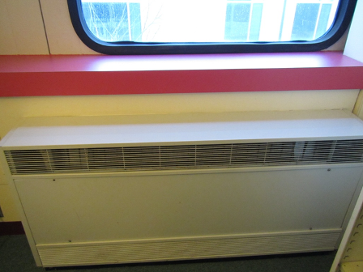
Unit ventilator
Picture 2
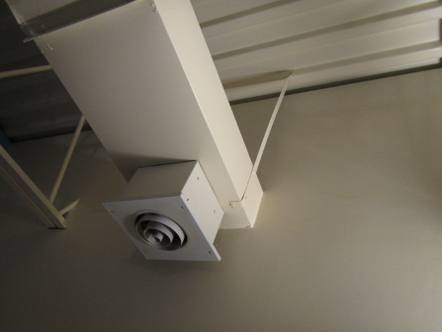
Exhaust vent located in room 205
Picture 3
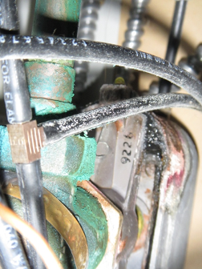
Leak inside univent in room 205A

Picture 4
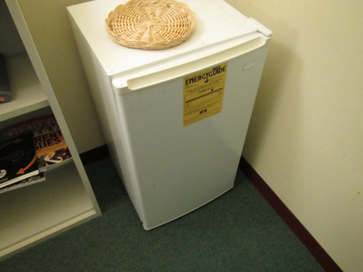
Refrigerator located on carpeting in room 205
Picture 5
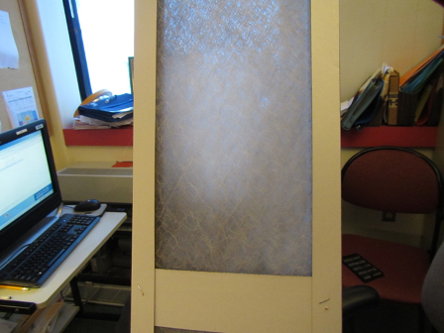
Inefficient univent filter

Location | Carbon  Dioxide  (ppm) | Carbon Monoxide  (ppm) | Temp  (°F) | Relative  Humidity  (%) | PM2.5  (µg/m³) | Occupants  in Room | Windows  Openable | Ventilation |  |  | Remarks
 |  |  |  |  |  |  |  | Supply | Exhaust
Background | 375 | ND | 28 | 22 | 8
Math & Sciences Building
205 | 724 | ND | 71 | 15 | 7 | 1 | N | Y |  | Y | Refrigerator on carpet, univent
205A | 715 | ND | 71 | 15 | 11 | 1 | N | Y |  | N | Bowed ceiling tiles, leak in univent pipe, inefficient filters

ppm = parts per million ND = non detect ug/m³ = micrograms per cubic meter

