WATER DAMAGE ASSESSMENT

North Shore Community College
Lynn College Campus
MBTA Parking Garage Classrooms
325 Broad St.
Lynn, Massachusetts

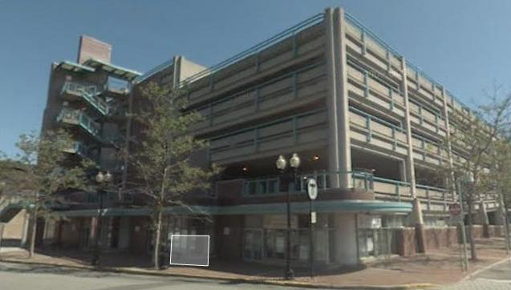

Prepared by:
Massachusetts Department of Public Health
Bureau of Environmental Health
Indoor Air Quality Program
September 2015

Background
Building: | North Shore Community College (NSCC), Lynn College Campus  Massachusetts Bay Transit Authority (MBTA) Parking Garage classrooms
Address: | MBTA Parking Garage, 325 Broad St. Lynn, MA
Assessment Requested by: | George M. Doherty Jr. R.A.  MBTA Project Manager A
Date of Assessment: | August 28 2015
BEH/IAQ Staff Conducting Assessment: | Michael Feeney, Director
Date of Building Construction: | 1990s
Reason for Request: | Mold concerns in gypsum wallboard

Building Description
NSCC occupies several portions of the ground floor of the MBTA parking garage that are physically separated by a walkway, garage stairs and elevators.

Methods
BEH/IAQ staff performed a visual inspection of building materials for water damage and/or microbial growth.

Results and Discussion
Water-damaged gypsum wallboard (GW) and insulation was found in the interior of the classrooms (Pictures 1 and 2). These damaged materials are the result of a chronic water leak from drains in the ceiling that service the second floor parking garage and/or damage as a result of the severe winter experience in 2015.
The US Environmental Protection Agency (US EPA) and the American Conference of Governmental Industrial Hygienists (ACGIH) recommend that porous materials be dried with fans and heating within 24 to 48 hours of becoming wet (US EPA, 2001; ACGIH, 1989). If porous materials are not dried within this time frame, mold growth may occur. Water-damaged porous materials cannot be adequately cleaned to remove mold growth. The application of a mildewcide to moldy porous materials is not recommended.

Conclusions/Recommendations
In view of the findings at the time of the visit, the following recommendations are made:
- Remove any water-damaged GW and wall insulation in a manner consistent with recommendations found in “Mold Remediation in Schools and Commercial Buildings” published by the US Environmental Protection Agency (US EPA, 2001).
- During remediation, the following steps should be taken to reduce exposure to remediation debris, odors, and/or airborne particulate matter:
- Remediation work should be done during unoccupied periods;
- Place water-damaged/mold-colonized materials in plastic bags for transport;
- Ensure air handling units are deactivated and/or seal vents temporarily in remediation areas during removal/remediation;
- Once removal/remediation is complete, clean areas/surfaces in remediation areas with a high efficiency particulate arrestance (HEPA) filter-equipped vacuum cleaner in conjunction with wet wiping of all non-porous surfaces.
- Once water-damaged materials are removed, continue with plans to install new GW as a temporary measure.
- Repair drains as needed.
- Consideration should be given to remodeling the walls with chronic water damage in the following manner:
- Install rigid, waterproof insulation between the wall studs and cement exterior that are exposed outdoors;
- Once completed, replace GW with cement board along exterior walls.

References
ACGIH. 1989. Guidelines for the Assessment of Bioaerosols in the Indoor Environment. American Conference of Governmental Industrial Hygienists, Cincinnati, OH.
US EPA. 2001. Mold Remediation in Schools and Commercial Buildings. US Environmental Protection Agency, Office of Air and Radiation, Indoor Environments Division, Washington, D.C. EPA 402-K-01-001. http://www.epa.gov/mold/mold_remediation.html
Picture 1
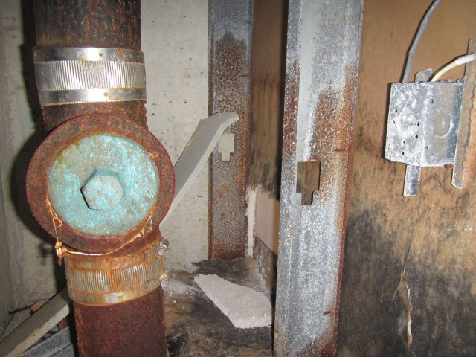
Mold-colonized GW

Picture 2
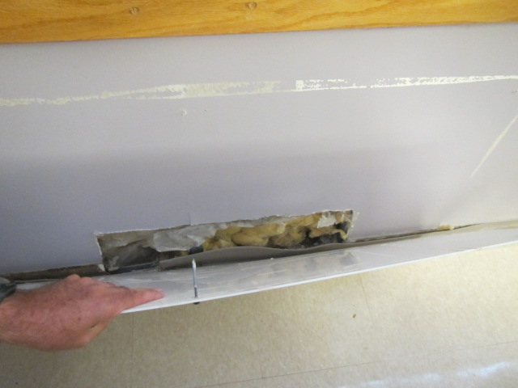
Insulation inside of wall cavity with water-damaged GW

