INDOOR AIR QUALITY ASSESSMENT

North Shore Community College
McGee Building
300 Broad Street
Lynn, Massachusetts

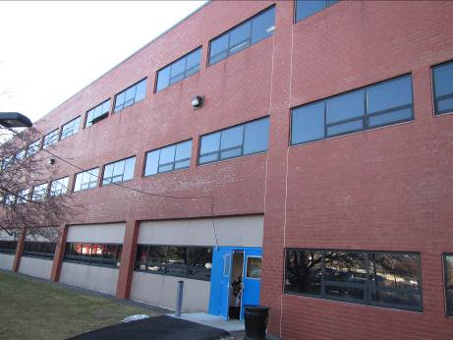

Prepared by:
Massachusetts Department of Public Health
Bureau of Environmental Health
Indoor Air Quality Program
March 2016

BACKGROUND
Building: | North Shore Community College (NSCC)- McGee Building
Address: | 300 Broad Street Lynn, MA
Assessment Requested by: | Vedad Konjic, Director of Building Services & Operations, NSCC
Reason for Request: | Employee concerns
Date of Assessment: | March 1, 2016
Massachusetts Department of Public Health/Bureau of Environmental Health (MDPH/BEH) Staff Conducting Assessment: | Jason Dustin, Environmental Analyst/Inspector, Indoor Air Quality (IAQ) Program
Date of Building Construction: | 1985
Building/Site Description: | The McGee building is a three story steel and concrete, brick-faced building with classrooms and administrative offices
Windows: | Openable

Executive Summary:
No significant public health concerns were identified during this visit. Some occupants expressed concern over the use of the antimicrobial agent, Concrobium. The Safety Data Sheet (SDS) for this product demonstrates it to be non-hazardous with slight irritant effects if handled with direct contact. The general IAQ assessment for the building revealed no major concerns. Fresh air ventilation should be increased by setting fan controls to continuous during occupied hours.

METHODS
BEH/IAQ staff performed general IAQ testing as well as a visual inspection of building materials for water damage and/or microbial growth. Moisture content of porous building materials was measured using a Delmhorst, BD-2000 Model Moisture Detector. Please refer to the IAQ Manual and appendices for methods, sampling procedures, and interpretation of results (MDPH, 2015).

RESULTS and DISCUSSION
The following is a summary of indoor air testing results (Table 1).
- Carbon dioxide levels were above 800 parts per million (ppm) in about 75% of areas surveyed, indicating a lack of air exchange at the time of assessment. This is likely the result of fresh air ventilation fans being set to intermittent (“auto”) function rather than the continuous (“on”) setting.
- Temperature was within or just below the MDPH recommended range of 70°F to 78°F in most areas.
- Relative humidity was below the MDPH recommended range of 40 to 60% in all areas as is typical during the heating season in the Northeast.
- Carbon monoxide levels were non-detect (ND) throughout all areas surveyed.
- Particulate matter (PM2.5) concentrations ranged from 1 to 5 μg/m³ throughout most areas. All of the readings were below the National Ambient Air Quality (NAAQS) guideline of 35 μg/m³ with the exception of room W169 which had a reading of 75 μg/m³ due to the lighting of birthday candles.
- Total Volatile Organic Compounds (TVOCs) levels were ND throughout the building.

This sampling indicates that the ventilation system should be set to the continuous or “on” setting to provide for increased fresh air circulation. Overall, all other IAQ parameters were within normal guidelines.
Ventilation
It can be seen from Table 1 that carbon dioxide levels were above 800 ppm in about 75% of areas surveyed. Fresh air is provided by air-handling units (AHUs) located in a mechanical room on the first floor. Fresh air is ducted to supply air diffusers located throughout the space. Air is returned to the AHUs via ceiling exhaust vents.
NSCC staff reported thermal comfort concerns, particularly in areas adjacent to windows. AHUs are regulated by a centrally controlled system, which staff reportedly do not have access. At the time of assessment, the HVAC fan setting for most occupied spaces appeared to be set to the intermittent function or “auto” setting. The BEH/IAQ program recommends that thermostats/central controls be set to the fan “on” setting during occupied periods to provide continuous air circulation and filtration. This setting typically reduces the incidence of IAQ complaints due to the dilution and removal of common indoor air pollutants.

Microbial/Moisture Concerns
In order for building materials to support mold growth, a source of water exposure is necessary.
- As discussed in the previous report (MDPH, 2016), the McGee building experienced flooding due to the failure of a sprinkler pipe during extreme cold weather.
- Flood remediation contractor, ServPro, used fans and dehumidifiers to begin drying porous building materials within hours of the event.
- In several areas, gypsum wallboard (GW) was removed on one side of wall to expedite drying.
- The antimicrobial agent, Concrobium, was applied to the wall cavity as well as carpeting to inhibit the growth of mold in porous materials after drying.
- The removed GW was then replaced and painted. Most GW was replaced to allow about a half inch space at the bottom to prevent water wicking in the future (Pictures 1 to 3).
- One water-damaged ceiling tile was observed in the W171 office suite (Picture 4). This water damage appeared to be historic and unrelated to the recent flooding. The source of this leak should be investigated and repaired if necessary. Any porous materials (e.g., ceiling tile) not dried within 48 hours should be discarded and replaced.
- No further signs of water damage were observed during the most recent site visit.
- The window gasket in office W117 appeared to require repair (Picture 5). Water intrusion may damage porous building materials.
- Plants were noted in several areas (Picture 6). Plants can be a source of pollen and mold, which can be respiratory irritants to some individuals. Plants should be properly maintained and equipped with drip pans and should be located away from air diffusers to prevent the aerosolization of dirt, pollen and mold.

Other IAQ Evaluations
- Some NSCC staff members reported that occupants were responsible for uncovering their personal effects as well as cleaning up around their items and surfaces following the Concrobium antimicrobial treatment. It is possible that in cleaning any remaining residue from the Concrobium, the occupants may have made direct contact with the agent. According to the SDS, “This product contains no substances which at given concentration, are considered to be hazardous to health” (Concrobium, 2015). The SDS does list the possibility of “mild skin irritation” and “slight eye irritation” if handled inappropriately. MDPH typically recommends thorough wet-wiping of surfaces and high efficiency particulate arrestance (HEPA) filter equipped vacuuming prior to allowing occupants to return to work spaces.
- IAQ staff noted air fresheners, scented hand sanitizers, cleaners, and dry erase materials in use (Table 1, Picture 7). All of these products have the potential to be irritants to the eyes, nose, throat, and respiratory system of sensitive individuals and their use should be minimized.
- Supply and exhaust vents were noted to be dusty in several areas throughout the first floor (Picture 8). These vents should be cleaned regularly to avoid aerosolizing accumulated particulate matter.
- NSCC staff reported that there is no regular cleaning schedule in place for carpeting. Carpets should be regularly vacuumed with HEPA filtered vacuum cleaners as well as cleaned annually to prevent them from becoming a source of suspended particulates.
- In several areas, items were observed on the floor, windowsills, tabletops, counters, bookcases, and desks (Picture 9). The large number of stored items provides a source for dusts to accumulate. These items (e.g., papers, folders, boxes) make it difficult for custodial staff to clean. Once aerosolized, they can act as irritants to eyes and respiratory system. Items should be relocated and/or be cleaned periodically to avoid excessive dust build up.

CONCLUSION AND RECOMMENDATIONS
In view of the findings at the time of the visit, the following recommendations are made:
- Continue with plans for wet-wiping of surfaces and HEPA vacuuming of carpets to remove any remaining residue from the antimicrobial agent.
- Ensure thermostats/central controls are set to the fan “on” setting during occupied periods to provide continuous air circulation and filtration. This setting typically reduces the incidence of IAQ complaints due to the dilution and removal of common indoor air pollutants. Increase fresh air supply to the AHU units if necessary.
- Investigate the source of the water-damaged ceiling tile in office suite W171 and repair if necessary. Any porous materials (e.g., ceiling tile) not dried within 48 hours should be discarded and replaced.
- Repair window gasket in office W117 to prevent water intrusion.
- Supply and exhaust vents should be cleaned regularly to avoid aerosolizing accumulated particulate matter.
- Carpets should be regularly vacuumed with HEPA-filtered vacuum cleaners as well as cleaned annually to prevent them from becoming a source of suspended particulate matter.
- The large number of stored items (e.g., papers, folders, boxes) make it difficult for custodial staff to clean. Items should be relocated and/or be cleaned periodically to avoid excessive dust build up.
- Minimize the use of air fresheners, scented hand sanitizers, cleaners, and dry erase materials within the building. These products have the potential to be irritants to the eyes, nose, throat, and respiratory system of sensitive individuals.
- Plants should be properly maintained and equipped with drip pans and should be located away from air diffusers to prevent the aerosolization of dirt, pollen and mold.
- To avoid temperature complaints, adjust or change supply diffusers to avoid drafts. Use of adjustable blinds and shades and/or the application of tinted window film should help to prevent heat complaints due to solar gain.
- For buildings in New England, periods of low relative humidity during the winter are often unavoidable. Therefore, scrupulous cleaning practices should be adopted to minimize common indoor air contaminants whose irritant effects can be enhanced when the relative humidity is low. To control for dusts, a HEPA filter equipped vacuum cleaner in conjunction with wet wiping of all surfaces is recommended. Avoid the use of feather dusters. Drinking water during the day can help ease some symptoms associated with a dry environment (throat and sinus irritation).
- Refer to resource manual and other related indoor air quality documents located on the MDPH’s website for further building-wide evaluations and advice on maintaining public buildings. These documents are available at http://mass.gov/dph/iaq.

REFERENCES
Concrobium. 2015. Safety Data Sheet, Concrobium Mold Control. March 28, 2015. Siamons International Inc. Toronto, Ontario Canada. http://www.concrobium.com/wp-content/uploads/2012/05/Concrobium-Mold-Control-SDS-May-2015.pdf
Massachusetts Department of Public Health (MDPH). 2015. Indoor Air Quality Manual: Chapters I-III. Available at: http://www.mass.gov/eohhs/gov/departments/dph/programs/environmental-health/exposure-topics/iaq/iaq-manual/.
Massachusetts Department of Public Health (MDPH). 2016. Water Damage Investigation. North Shore Community College. March 2016.
Picture 1
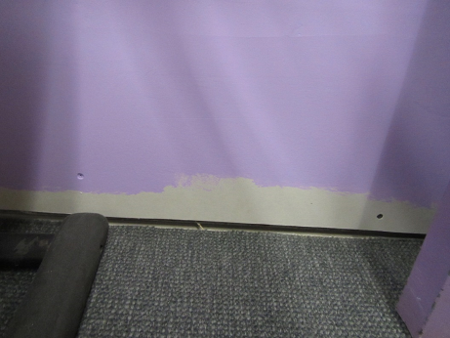
Area of replaced GW (note space at bottom to prevent wicking)
Picture 2
Area of replaced GW
Picture 3
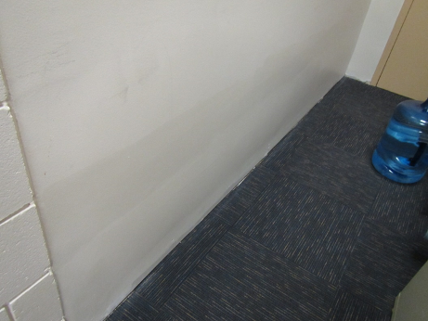
Area of replaced and repainted GW
Picture 4
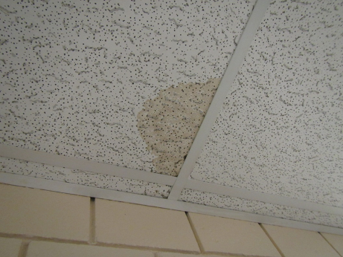
Water-damaged ceiling tile in suite W171
Picture 5
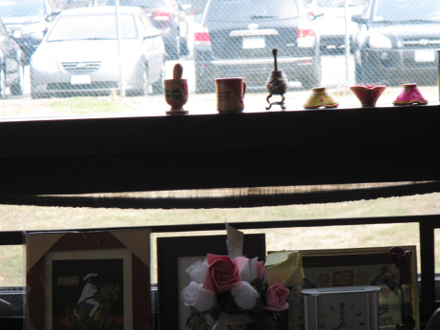
Loose window gasket in office W117
Picture 6
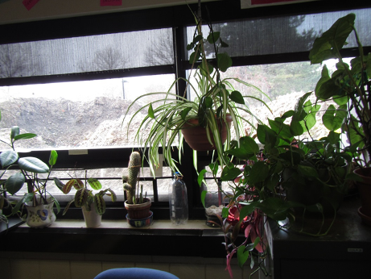
Plants in occupied area
Picture 7
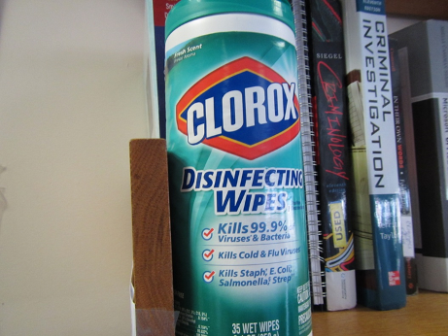
Scented cleaning wipes
Picture 8
Dust/debris on ceiling vent
Picture 9
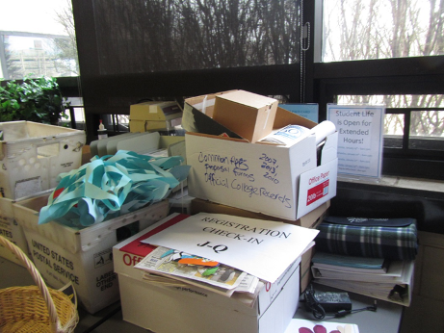
Accumulated items on surfaces

Location | Carbon  Dioxide  (ppm) | Carbon Monoxide  (ppm) | Temp  (°F) | Relative  Humidity  (%) | TVOCs  (ppm) | PM2.5  (µg/m³) | Occupants  in Room | Windows  Openable | Ventilation |  |  | Remarks
 |  |  |  |  |  |  |  |  | Intake | Exhaust
Background (outside) | 407 | ND | 45 | 39 | ND | 12
W171 | 733 | ND | 69 | 19 | ND | 1 | 3 | N | Y |  | N | HS, scented products, 1 water-damaged ceiling tile
W173 | 798 | ND | 69 | 19 | ND | 1 | 0 | Y | Y |  | Y | Photocopier, helium tank
W172 | 872 | ND | 69 | 20 | ND | 2 | 3 | Y | Y |  | Y
W168 | 750 | ND | 70 | 18 | ND | 1 | 0 | N | Y |  | Y | HS, plant in water
W167 | 748 | ND | 70 | 25 | ND | 1 | 0 | N | Y |  | Y
W166 | 781 | ND | 70 | 26 | ND | 3 | 0 | N | Y |  | Y | Fridge on carpet
W169 | 798 | ND | 70 | 25 | ND | 75 | 2 | N | Y |  | Y | Birthday candles burning
W165 | 1016 | ND | 70 | 29 | ND | 2 | 4 | Y | Y |  | Y | Plants, scented HS
W164 | 910 | ND | 70 | 27 | ND | 2 | 1 | Y | Y |  | Y | Scented creams, AI, plush dolls
W157 | 1055 | ND | 70 | 27 | ND | 3 | 4 | N | Y |  | Y | Water cooler on carpet
W160 | 1037 | ND | 71 | 28 | ND | 3 | 1 | Y | Y |  | Y
W158 | 992 | ND | 71 | 27 | ND | 3 | 0 | Y | Y |  | N | HS, plant, CP, AD
W155 | 935 | ND | 71 | 27 | ND | 2 | 3 | Y | Y |  | Y | Photocopier, DEM, plants
W121 | 853 | ND | 71 | 27 | ND | 4 | 3 | N | Y |  | Y | Plant
W117 | 851 | ND | 71 | 27 | ND | 4 | 2 | Y | Y |  | Y | Water-damaged papers, CP, HS, loose window gasket
W113 | 870 | ND | 71 | 18 | ND | 4 | 1 | Y | Y |  | Y | HS, AD, CP, plants
W119 | 798 | ND | 71 | 25 | ND | 3 | 0 | Y | Y |  | Y | Scented HS
W126 | 847 | ND | 72 | 27 | ND | 4 | 2 | N | Y |  | N | HS, Photocopier
W130 | 853 | ND | 72 | 28 | ND | 3 | 2 | Y | Y |  | N | HS, plant
W123 | 854 | ND | 72 | 27 | ND | 4 | 0 | N | Y |  | Y | Bed/blanket, exhaust in adjoining bath
W122 | 933 | ND | 72 | 28 | ND | 3 | 2 | N | Y |  | Y | Plants
W109 | 813 | ND | 72 | 24 | ND | 4 | 0 | Y | Y |  | Y | Plants
W110 | 788 | ND | 72 | 24 | ND | 3 | 0 | Y | Y |  | Y | HS, plants
W112 | 805 | ND | 71 | 25 | ND | 3 | 2 | Y | Y |  | Y | HS, plants
W114 | 837 | ND | 71 | 25 | ND | 4 | 3 | N | Y |  | Y | HS, plants
W126 | 857 | ND | 71 | 26 | ND | 3 | 2 | N | Y |  | Y | HS
Hallway near Trio | 876 | ND | 71 | 26 | ND | 5 | 12 | N | Y |  | Y
W102 | 853 | ND | 69 | 20 | ND | 3 | 0 | Y | Y |  | Y
W102-104 | 884 | ND | 69 | 20 | ND | 3 | 1 | N | Y |  | Y
W103 | 887 | ND | 69 | 19 | ND | 4 | 0 | N | Y |  | N | Photocopier
W104 | 857 | ND | 69 | 20 | ND | 4 | 1 | Y | Y |  | Y
W106-108 | 934 | ND | 71 | 19 | ND | 3 | 0 | N | Y |  | Y
W106 | 828 | ND | 71 | 17 | ND | 4 | 0 | N | Y |  | Y
W107 | 828 | ND | 71 | 19 | ND | 4 | 0 | N | Y |  | Y

