WATER DAMAGE INVESTIGATION

North Shore Community College
McGee Building
300 Broad Street
Lynn, Massachusetts

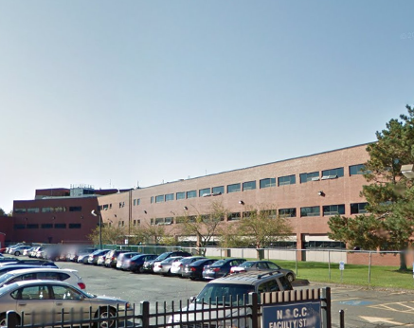

Prepared by:
Massachusetts Department of Public Health
Bureau of Environmental Health
Indoor Air Quality Program
March 2016

BACKGROUND
Building: | North Shore Community College (NSCC)- McGee Building
Address: | 300 Broad Street Lynn, MA
Assessment Requested by: | Vedad Konjic, Director of Building Services & Operations, NSCC
Reason for Request: | Water Damage
Date of Assessment: | February 18, 2016
Massachusetts Department of Public Health/Bureau of Environmental Health (MDPH/BEH) Staff Conducting Assessment: | Jason Dustin, Environmental Analyst/Inspector, Indoor Air Quality (IAQ) Program
Date of Building Construction: | 1985
Building/Site Description: | The McGee building is a three story steel and concrete, brick-faced building with classrooms and administrative offices
Windows: | Openable

Executive Summary:
No visible signs of mold-contaminated materials were identified during this visit. Moisture testing of porous building materials (e.g., carpeting, wallboard) revealed that a large number of areas had gypsum wallboard (GW) that was still moist after over 3 days of drying with fans and dehumidifiers. It was recommended to NSCC staff that any porous building materials not dried within 48 hours should be removed/discarded.

METHODS
BEH/IAQ staff performed a visual inspection of building materials for water damage and/or microbial growth. Moisture content of porous building materials was measured using a Delmhorst, BD-2000 Model Moisture Detector. Please refer to the IAQ Manual and appendices for methods, sampling procedures, and interpretation of results (MDPH, 2015).

RESULTS AND DISCUSSION
Due to the severely cold weather experienced on the evening of February 14, 2016, a sprinkler pipe in the ceiling of the first floor of the McGee building failed and flooded most of the first floor (Picture 1). The flooding affected gypsum wallboard (GW), insulation, carpet, and some ceiling tiles.
The facilities personnel for the building responded within the hour of the incident. Flood remediation contractor, ServPro extracted all standing water from the space within the first several hours and began drying areas with fans and dehumidifiers (Pictures 2 to 5). Indoor temperature was between 69°F and 71°F and relative humidity was between 19 and 22% during the assessment.
In some areas of the NSCC, the GW was cut away on one side of the wall to dry the wall cavity as well as remove any accumulated water that may have been standing in the metal framing members (Pictures 5 to 7). In other areas, GW remained with vinyl base coving intact (Picture 8), which can hinder drying. Using the moisture meter, BEH/IAQ staff found many areas throughout the NSCC to have elevated moisture levels in the GW despite more than 72 hours of drying time (Pictures 9 and 10). The height of moistened GW in most areas was between the floor and one foot above. The BEH IAQ program recommends that GW that is not dried within 48 hours should be removed, plus an additional 12 inches from the level where it was moistened to prevent the occurrence of mold growth. Carpeting tested with the moisture meter appeared dry in most areas tested.
The US Environmental Protection Agency (US EPA) and the American Conference of Governmental Industrial Hygienists (ACGIH) recommends that porous materials (e.g., wallboard, carpeting) be dried with fans and heating within 24 to 48 hours of becoming wet (US EPA, 2001; ACGIH, 1989). If porous materials are not dried within this time frame, mold growth may occur.

CONCLUSIONS AND RECOMMENDATIONS
The following recommendations were made at the time of the assessment and are reiterated below:

- If possible, continue to keep affected staff relocated until remediation is complete.
- Continue to work with remediation contractor to identify all porous building materials that were not dried within 48 hours. These water-damaged materials should be removed. Typically, the lower portion of GW is removed from a height of flood level plus 12 inches. Consider replacing any removed carpeting with carpet tiles.
- Water-damaged carpeting, ceiling tiles, GW and insulation should be removed in a manner consistent with recommendations found in “Mold Remediation in Schools and Commercial Buildings” published by the US Environmental Protection Agency (US EPA, 2001).
- During remediation the following steps should be taken to reduce exposure to remediation debris, odors and/or airborne particulate matter:
- Remediation work should be done while area is unoccupied;
- Remove furniture and personal items or cover employee workstations in areas of remediation to protect items and facilitate cleanup;
- Place water-damaged materials in plastic bags for transport;
- Ensure air handling units are deactivated and/or seal vents temporarily in remediation areas during removal/remediation;
- Once removal/remediation is complete, clean areas/surfaces in remediation area with a high efficiency particulate arrestance (HEPA) filter equipped vacuum cleaner in conjunction with wet wiping of all non-porous surfaces.
- Consult MDPH guideline “Methods Used to Reduce/Prevent Exposure to Construction/Renovation Generated Pollutants in Occupied Buildings” (MDPH, 2006).
- Ensure that thermostats are set to “fan on” during occupied periods for continuous air exchange.

REFERENCES

ACGIH. 1989. Guidelines for the Assessment of Bioaerosols in the Indoor Environment. American Conference of Governmental Industrial Hygienists, Cincinnati, OH.
MDPH. 2015. Massachusetts Department of Public Health. Indoor Air Quality Manual: Chapters I-III. Available at: http://www.mass.gov/eohhs/gov/departments/dph/programs/environmental-health/exposure-topics/iaq/iaq-manual/.
MDPH. 2006. Methods Used to Reduce/Prevent Exposure to Construction/Renovation Generated Pollutants in Occupied Buildings. Available at: http://www.mass.gov/eohhs/gov/departments/dph/programs/environmental-health/exposure-topics/iaq/pollution/renovate/constructionrenovation-pollutants-prevention.html
US EPA. 2001. Mold Remediation in Schools and Commercial Buildings. US Environmental Protection Agency, Office of Air and Radiation, Indoor Environments Division, Washington, D.C. EPA 402-K-01-001. http://www.epa.gov/mold/mold-remediation-schools-and-commercial-buildings-guide
Picture 1
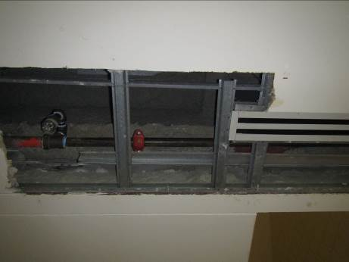

Sprinkler pipe that failed in ceiling above the first floor
Picture 2
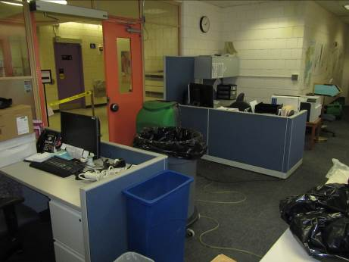

Dehumidifier and fans (arrows) being used to facilitate drying
Picture 3
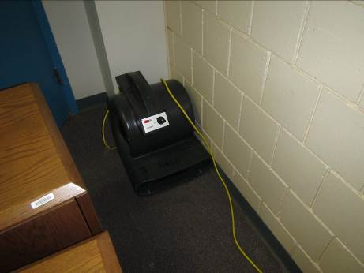

Office furniture moved to assist in drying of carpet with fan
Picture 4
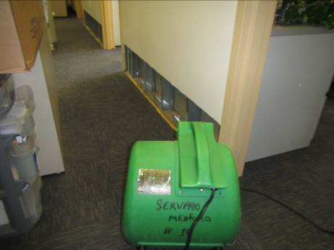
Fan drying inner hall of office space
Picture 5
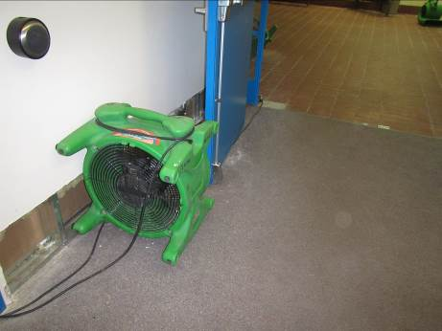
Fans located near foyer where sprinkler failed
Picture 6
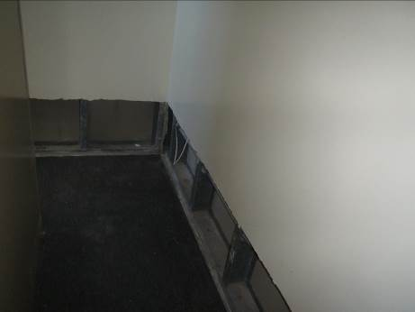
One side of GW wall removed to dry wall cavity
Picture 7
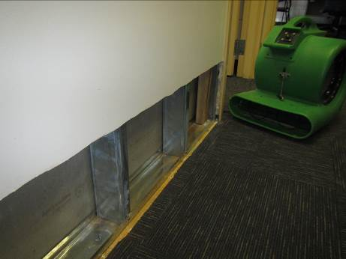
Fan drying wall cavity and back side of GW on opposing wall
Picture 8
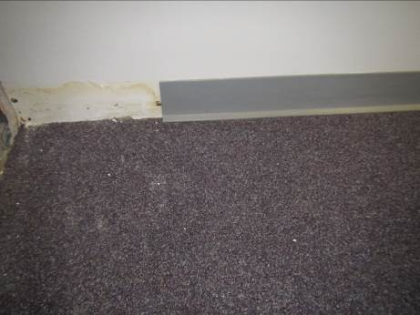
GW with vinyl coving left intact
Picture 9
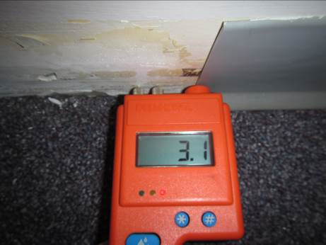
Moisture meter showing elevated moisture in GW
Picture 10
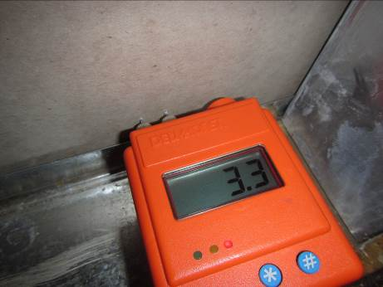
Moisture meter showing elevated moisture in GW

