INDOOR AIR QUALITY ASSESSMENT
MOLD INVESTIGATION

North Shore Community College
Lynn Campus, 300 Broad Street
Lynn, Massachusetts



Prepared by:
Massachusetts Department of Public Health
Bureau of Environmental Health
Indoor Air Quality Program
April 2012

Background/Introduction
At the request of George Neunaber, an Engineer within the Facilities Management Department, North Shore Community College (NSCC), the Massachusetts Department of Public Health (MDPH), Bureau of Environmental Health (BEH) provided assistance and consultation regarding indoor air quality (IAQ) concerns in a storage unit located at the NSCC Lynn Campus located at 300 Broad Street, Lynn, Massachusetts. On March 19, 2012, a site visit was made by Sharon Lee, an Environmental Analyst within BEH’s IAQ Program. Concerns about mold growth and respiratory irritation among IT staff who intermittently visit the storage unit prompted the request.
The storage unit is an un-insulated metal container that is currently located in a parking lot behind the main school building (Picture 1). Its primary function is for housing older, unused computer equipment. Most recently, IT staff have been accessing the storage unit for inventory purposes.

Methods
BEH staff performed visual inspection of building materials for water damage and microbial growth.

Discussion

Microbial/Moisture Concerns
As mentioned, concerns regarding respiratory irritation and allergic symptoms believed to be associated with mold growth in the storage unit prompted this assessment. At the time of the assessment, the unit was locked up, and access to it had been restricted. Upon gaining access, BEH staff detected a strong musty odor within the unit, which contained a number of cardboard boxes, approximately 10 older laptop units, and an assortment of IT-related equipment (Picture 2). A fine, white growth was observed on a number of flat surfaces (Picture 3 and 4), as well as the wooden floor (Picture 5). Some items also appeared water-damaged (Picture 6).
Since the trailer is not insulated, it is very susceptible to temperature changes. On sunny days, the interior temperature of the storage unit rises significantly due to solar gain. During evenings, particularly during winter months, the interior temperatures are reduced. Because the trailer is not airtight, it is susceptible to humidity/moisture infiltration; dust and other particulates can also penetrate through openings and breaches in the unit. The combination of temperature changes and moisture penetration into the unit creates conditions allowing moisture to dampen porous materials or condense on cool surfaces. Over time, moistened materials and/or dust/debris can become a source for mold growth. Without proper ventilation and/or moisture control, the potential for exposure to mold growth/spores exists when the unit is entered.

Conclusions/Recommendations
In view of the findings at the time of the visit, several recommendations are offered. These recommendations were communicated at the time of the assessment and are reiterated here:
- Discontinue use of this storage unit for porous materials and/or consider alternative storage methods.
- Discard porous materials (i.e., paper, cardboard) and any other materials that cannot be readily cleaned sufficiently to remove mold growth.
- Clean/scrub non-porous surfaces with an appropriate disinfectant.
- Consider opening doors and operating fans to increase ventilation in the storage unit at least one hour prior to any entry.
- Consider using appropriate personal protective equipment, such as skin, eye and respiratory protection as recommended by the US EPA (2001) when accessing materials in the storage unit, since movement of stored materials can aerosolize mold and other irritants.

References
US EPA. 2001. Mold Remediation in Schools and Commercial Buildings. US Environmental Protection Agency, Office of Air and Radiation, Indoor Environments Division, Washington, D.C. EPA 402-K-01-001. March 2001.
Picture 1

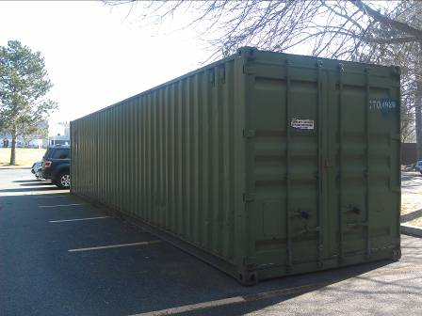

Storage unit

Picture 2

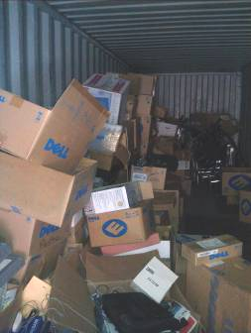

Items stored inside storage unit

Picture 3

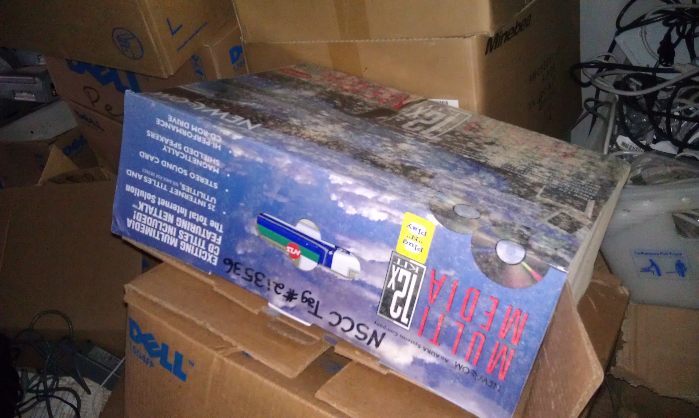

Mold growth on cardboard box

Picture 4

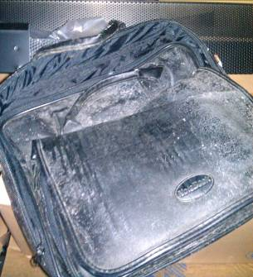

Mold growth on laptop case

Picture 5

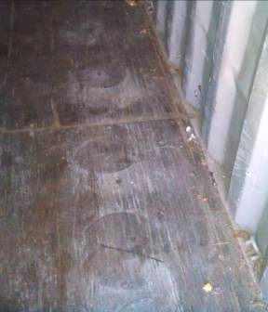

Mold growth on wooden floor

Picture 6

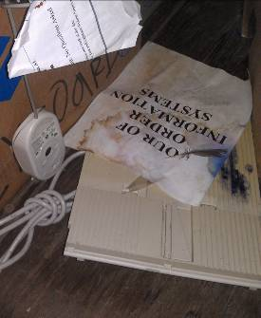

Water-damaged paper

