INDOOR AIR QUALITY ASSESSMENT

North Shore Technical High School
30 Log Bridge Rd
Middleton, MA

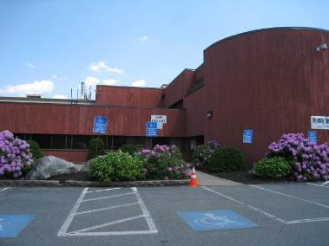

Prepared by:
Massachusetts Department of Public Health
Bureau of Environmental Health
Indoor Air Quality Program
November 2014

Background/Introduction
At the request of Derek Fullerton, Director of Public Health for the town of Middleton, the Massachusetts Department of Public Health (MDPH), Bureau of Environmental Health conducted an evaluation of indoor environmental conditions at the North Shore Technical High School (NSTHS), 30 Log Bridge Road, Middleton, MA. On May 31, 2013, a visit was made to the campus by Michael Feeney, Director, BEH’s Indoor Air Quality (IAQ) Program. Mr. Feeney was accompanied by Ruth Alfasso, an Environmental Engineer/Inspector for BEH’s IAQ Program. This indoor environmental assessment is part of a larger MDPH/BEH investigation of concerns associated with environmental factors and vocal tics among students at the NSTHS and Essex Agricultural and Technical School (EATS) in Danvers, Massachusetts. The IAQ Program conducted air-sampling for carbon monoxide, volatile organic compounds (VOCs) and mercury vapor; conditions that contribute to heath of the indoor environment were also observed. In addition, in response to concerns expressed by some parents, this assessment includes evaluations of the drinking water and athletic fields utilized by students from both schools during merged athletic programs.
The NSTHS has been housed at a two-story 1970’s building since 1992. The building is concrete and metal, with a decorative wood facing. Most areas in the building have openable windows. The NSTHS also has several outbuildings, including a gymnasium.

Methods
Air tests for carbon dioxide, carbon monoxide, temperature, and relative humidity were conducted with the TSI, Q-Trak, IAQ Monitor, Model 7565. Air tests for airborne particle matter with a diameter less than 2.5 micrometers were taken with the TSI, DUSTTRAK™ Aerosol Monitor Model 8520. Air testing for total volatile organic compounds (TVOCs) was conducted using a MiniRAE 2000 photo ionization detector (PID). Air tests for mercury vapor was conducted using a Lumex Mercury analyzer RA-915+. BEH/IAQ staff also performed a visual inspection of building materials for water damage and/or microbial growth.

Results
The school serves approximately 500 high school-age students and has approximately 50 staff members. Tests were taken during normal operations, and results appear in Table 1.

Discussion

Ventilation
It can be seen from Table 1 that carbon dioxide levels were above 800 parts per million (ppm) in nine of 52 areas of the main building, indicating adequate fresh air in most areas at the time of assessment. Carbon dioxide levels in the gymnasium, which is in a separate building, were below 800 ppm. It is important to note that some areas of the main building were sparsely populated or had doors or windows open to the outside, which can greatly reduce carbon dioxide levels. Carbon dioxide levels would be expected to increase with higher occupancy and closed windows and doors.
Fresh air to the main building and the gymnasium is supplied by rooftop air-handling units (AHUs) ducted to ceiling-mounted supply vents (Pictures 1 and 2). The AHUs for the main building supplies both heating and cooling. It was reported to BEH/IAQ staff that cooling for some portions of the building was not operational during the day of assessment.
Exhaust ventilation in the main building is provided by ceiling-mounted exhaust vents (Picture 3). In workshop/technical areas, there is also additional exhaust equipment, such as hoods in the kitchen areas and a dedicated exhaust system for the carpentry area (Picture 4). Both supply and exhaust ventilation must be free of blockages and allowed to operate while the building is occupied. Dedicated exhaust equipment should be used when this equipment is in operation; use of specialized exhaust equipment should continue for some time afterward to ensure materials/odors are removed.
BEH/IAQ staff observed an exhaust hood in the storage/mixing area of the cosmetology classroom, but no means for activating the unit could be identified. The hood unit appeared to be blocked from the inside (Picture 5). School staff could not confirm if the unit had ever been operational. Dedicated exhaust ventilation would facilitate removal of pollutants and odors generated from cosmetic chemicals.
To maximize air exchange, the MDPH recommends that both supply and exhaust ventilation operate continuously during periods of occupancy. In order to have proper ventilation with a mechanical supply and exhaust system, the systems must be balanced to provide an adequate amount of fresh air to the interior of a room while removing stale air from the room. It is recommended HVAC systems be re-balanced every five years to ensure adequate air systems function (SMACNA, 1994). The date of the last balancing of mechanical ventilation systems was not available at the time of the assessment.
Minimum design ventilation rates are mandated by the Massachusetts State Building Code (MSBC). Until 2011, the minimum ventilation rate in Massachusetts was higher for both occupied office spaces and general classrooms, with similar requirements for other occupied spaces (BOCA, 1993). The current version of the MSBC, promulgated in 2011 by the State Board of Building Regulations and Standards (SBBRS), adopted the 2009 International Mechanical Code (IMC) to set minimum ventilation rates. Please note that the MSBC is a minimum standard that is not health-based. At lower rates of cubic feet per minute (cfm) per occupant of fresh air, carbon dioxide levels would be expected to rise significantly. A ventilation rate of 20 cfm per occupant of fresh air provides optimal air exchange resulting in carbon dioxide levels at or below 800 ppm in the indoor environment in each area measured. MDPH recommends that carbon dioxide levels be maintained at 800 ppm or below. This is because most environmental and occupational health scientists involved with research on IAQ and health effects have documented significant increases in indoor air quality complaints and/or health effects when carbon dioxide levels rise above the MDPH guidelines of 800 ppm for schools, office buildings and other occupied spaces (Sundell et al., 2011). The ventilation must be on at all times that the room is occupied. Providing adequate fresh air ventilation with open windows and maintaining the temperature in the comfort range during the cold weather season is impractical. Mechanical ventilation is usually required to provide adequate fresh air ventilation.
Carbon dioxide is not a problem in and of itself. It is used as an indicator of the adequacy of the fresh air ventilation. As carbon dioxide levels rise, it indicates that the ventilating system is malfunctioning or the design occupancy of the room is being exceeded. When this happens, a buildup of common indoor air pollutants can occur, leading to discomfort or health complaints. The Occupational Safety and Health Administration (OSHA) standard for carbon dioxide is 5,000 parts per million parts of air (ppm). Workers may be exposed to this level for 40 hours/week, based on a time-weighted average (OSHA, 1997).
The MDPH uses a guideline of 800 ppm for publicly occupied buildings. A guideline of 600 ppm or less is preferred in schools due to the fact that the majority of occupants are young and considered to be a more sensitive population in the evaluation of environmental health status. Inadequate ventilation and/or elevated temperatures are major causes of complaints such as respiratory, eye, nose and throat irritation, lethargy and headaches. For more information concerning carbon dioxide, consult Appendix A.
Temperatures ranged from 69°F to 81°F in the main building and 86°F to 90°F in the gymnasium (Table 1). Temperatures in the main building were mostly within the MDPH recommended comfort range, with one reading above the range and one slightly below (Table 1). Temperatures in the gymnasium, which lacks any form of air-conditioning, were all above the recommended comfort range. The MDPH recommends that indoor air temperature be maintained in a range of 70°F to 78°F in order to provide for the comfort of building occupants. In many cases concerning indoor air quality, fluctuations of temperature in occupied spaces are typically experienced, even in a building with an adequate fresh air supply. As mentioned previously, some of the air conditioning systems in the building were reportedly not functioning at the time of the assessment. Outdoor temperatures at the time of the assessment were in the upper 80s, so elevated indoor temperatures are largely reflective of outdoor conditions.
Nearly 80 percent of areas assessed had relative humidity measurements within the MDPH comfort range. Relative humidity measurements ranged from 31 to 73 percent (Table 1). The MDPH recommends a comfort range of 40 to 60 percent for indoor air relative humidity. The outdoor relative humidity level was 57 percent at the time of assessment. Relative humidity in some areas was influenced by moisture sources related to specific school activities (e.g., cosmetology, culinary arts). Relative humidity measurements above background may also indicate that the ventilation system is not operating effectively to remove occupant-generated moisture from the building, such as might occur with a malfunctioning air-conditioning system. Moisture removal is important since the combination of relative humidity and temperature elevated above the MDPH recommended ranges reduces the ability of the body to cool itself by sweating. At a given indoor temperature, the addition of humid air increases occupant discomfort and may generate heat complaints. If moisture/humidity levels are decreased, the comfort of the individuals increases.
Relative humidity levels in the buildings would be expected to drop during the winter months due to heating. The sensation of dryness and irritation is common in a low relative humidity environment. Low relative humidity is a very common problem during the heating season in the northeast part of the United States.

Microbial/Moisture Concerns
Water-stained ceiling tiles were observed in a few areas (Picture 6; Table 1). Water-damaged ceiling tiles indicate leaks from the building envelope or plumbing and can provide a source for mold. Stand and damaged materials should be replaced after the source of moisture has been addressed.
Plants were observed in some classrooms and offices (Table 1). Plants should be properly maintained and equipped with drip pans. Plants should also be located away from ventilation sources to prevent aerosolization of dirt, pollen, or mold. Plants should not be placed on porous materials, since water damage to porous materials can lead to microbial growth.
Small refrigerators were observed on top of carpeting (Picture 7). These appliances can leak or spill and moisten the carpet, which can lead to microbial growth; they should be placed on a non-porous surface when possible.
During an examination of the exterior of the building, BEH/IAQ staff observed plants and shrubs in close proximity to the building in some areas (Picture 8). Shrubs/trees in close proximity to the building hold moisture against the building exterior and prevent drying. The growth of roots against exterior walls can bring moisture in contact with the foundation. Plant roots can eventually penetrate the wall, leading to cracks and/or fissures in the sublevel foundation. Over time, these conditions can undermine the integrity of the building envelope and provide a means of water entry into the building via capillary action through exterior walls, foundation concrete, and masonry (Lstiburek & Brennan, 2001). The freezing and thawing action of water during the winter months can create cracks and fissures in the foundation that can result in additional penetration points for both water and pests. Trees and shrubs can also be a source of pollen, debris, and mold into univents and windows. Consideration should be given to removing landscaping in close proximity to the building so as to maintain a space of 5 feet between shrubbery and the building.
Several holes/penetrations were noted along the exterior of the building, including what appeared to be damaged vents for items such as laundry dryers (Picture 9). If these vents are still in use, the damage observed in the vent could prevent the exhaust from being efficiently vented, which may prevent the attached appliance from working properly or cause moisture and gases to be pushed back into occupied areas. If the vent is no longer in use, it should be properly sealed with an applicable water/air resistant material to prevent the ingress of unconditioned air, dust/debris, moisture, and pests. Other penetrations to the wall, such as holes resulting from missing vents should be also sealed similarly (e.g., Picture 10).
Finally, a birdbath was observed outside the building. Standing, stagnant water, as may be present in a birdbath, can be a place for mosquitoes to breed. Standing water should be eliminated to the greatest extent possible to prevent the breeding of mosquitoes.

Other IAQ Evaluations
Indoor air quality can be negatively influenced by the presence of respiratory irritants, such as products of combustion. The process of combustion produces a number of pollutants. Common combustion emissions include carbon monoxide, carbon dioxide, water vapor, and smoke (fine airborne particle material). Of these materials, exposure to carbon monoxide and particulate matter with a diameter of 2.5 micrometers (μm) or less (PM2.5) can produce immediate, acute health effects upon exposure. To determine whether combustion products were present in the indoor environment, BEH/IAQ staff obtained measurements for carbon monoxide and PM2.5.

Carbon Monoxide
Carbon monoxide is a by-product of incomplete combustion of organic matter (e.g., gasoline, wood, tobacco). Exposure to carbon monoxide can produce immediate and acute health affects. Several air quality standards have been established to address carbon monoxide and prevent symptoms from exposure to these substances. The MDPH established a corrective action level concerning carbon monoxide in ice skating rinks that use fossil-fueled ice resurfacing equipment. If an operator of an indoor ice rink measures a carbon monoxide level over 30 ppm, taken 20 minutes after resurfacing within a rink, that operator must take actions to reduce carbon monoxide levels (MDPH, 1997).
The American Society of Heating Refrigeration and Air-Conditioning Engineers (ASHRAE) has adopted the National Ambient Air Quality Standards (NAAQS) as one set of criteria for assessing indoor air quality and monitoring of fresh air introduced by HVAC systems (ASHRAE, 1989). The NAAQS are standards established by the United States Environmental Protection Agency (US EPA) to protect the public health from six criteria pollutants, including carbon monoxide and particulate matter (US EPA, 2006). As recommended by ASHRAE, pollutant levels of fresh air introduced to a building should not exceed the NAAQS levels (ASHRAE, 1989). The NAAQS were adopted by reference in the Building Officials & Code Administrators (BOCA) National Mechanical Code of 1993 (BOCA, 1993), which is now an HVAC standard included in the MSBC (SBBRS, 2011). According to the NAAQS, carbon monoxide levels in outdoor air should not exceed 9 ppm in an eight-hour average (US EPA, 2006).
Carbon monoxide should not be present in a typical, indoor environment. If it is present, indoor carbon monoxide levels should be less than or equal to outdoor levels. Outdoor carbon monoxide concentrations were non-detect (ND) at the time of the assessment (Table 1). Most carbon monoxide readings inside the building were ND; however, low levels of carbon monoxide ranging from 0.4 to 2.4 ppm were detected in the gym, graphic arts, and automotive areas (Table 1). While these levels are significantly below the action levels, additional ventilation will reduce these levels to background (i.e. outdoor levels).
Carbon monoxide measured in some areas of the NSTHS is likely a result of vocational education related activities, such as operation of vehicle engines in the automotive areas. Carbon monoxide may also include outdoor sources. At the time of assessment, fossil fuel-fired maintenance/lawn care equipment was being operated. Odors and materials from this equipment, including carbon monoxide can enter the gymnasium through an open door. Installation of carbon monoxide detectors in these areas can be helpful in identifying potential elevated carbon monoxide levels and prevent occupant exposure to hazardous conditions.
Vehicle idling can also contribute to measureable carbon monoxide levels within the building. The NSTHS has students from around the region and thus has a large number of school buses serving its population. A Massachusetts state law exists that restricts idling of vehicles to no more than five minutes unless absolutely necessary (MGL, 1986).

Particulate Matter
The US EPA has established NAAQS limits for exposure to particulate matter. Particulate matter includes airborne solids that can be irritating to the eyes, nose, and throat. The NAAQS originally established exposure limits to PM with a diameter of 10 μm or less (PM10). In 1997, US EPA established a more protective standard for fine airborne particulate matter with a diameter of 2.5 μm or less (PM2.5). The NAAQS has subsequently been revised, and PM2.5 levels were reduced. This more stringent PM2.5 standard requires outdoor air particle levels be maintained below 35 μg/m³ over a 24-hour average (US EPA, 2006). Although both the ASHRAE standard and BOCA Code adopted the PM10 standard for evaluating air quality, MDPH uses the more protective PM2.5 standard for evaluating airborne PM concentrations in the indoor environment.
Outdoor PM2.5 concentrations the day of the assessment were measured at 42 μg/m³. PM2.5 levels measured inside all building ranged from 21 to 76 μg/m³ (Table 1). Outdoor measurements and most readings indoors were above the NAAQS PM2.5 level of 35 μg/m³. Frequently, indoor air levels of particulates (including PM2.5) can be at higher levels than those measured outdoors. A number of activities that occur indoors and/or mechanical devices can generate particulate during normal operations. Sources of indoor airborne particulates in classroom and office areas may include but are not limited to particles generated during the operation of fan belts in the HVAC system, use of stoves and/or microwave ovens in kitchen areas; use of photocopiers, fax machines and computer printing devices; operation of an ordinary vacuum cleaner and heavy foot traffic.
Several likely sources of increased particulates are present inside the building. Some activities conducted at the NSTHS (e.g. masonry, the woodworking, and automotive and machine equipment operation) generate dusts. If general and/or dedicated exhaust ventilation are not functioning effectively to draw pollutants out of work areas, particulate matter and odors can remain in workshops or subsequently pressurized into hallways and adjacent classrooms. Further, dedicated exhaust ventilation equipment designed to capture large amounts of particulate matter need to be cleaned and maintained frequently in order to ensure effectiveness.
Note that particulate levels outdoors on the day of the assessment were elevated statewide due to the hot, humid weather conditions; according to AirNow (http://www.airnow.gov), a website run by the U.S. EPA, PM2.5 levels statewide were within the “moderate” category, as defined by PM2.5 levels of between 50 and 100 μg/m³. Elevated outdoor levels can contribute to indoor particulate load as air moves into the building through open windows.
Elevated levels of particulates inside non-workshop areas may also indicate that there is poor filtration on the AHUs. Filters with an appropriate dust spot efficiency can be installed in air-handling equipment. The dust spot efficiency is the ability of a filter to remove particulate matter of a certain diameter from air passing through the filter. Filters that have been determined by ASHRAE to meet its standard for a dust spot efficiency of a minimum of 40 percent would be sufficient to reduce many airborne particulates (Thornburg, 2000; MEHRC, 1997; ASHRAE, 1992). Pleated filters with a Minimum Efficiency Reporting Value dust-spot efficiency of 9 or higher are recommended. Note that increasing filtration can reduce airflow (called pressure drop), which can subsequently reduce the efficiency of the unit due to increased resistance. Prior to any increase of filtration, each AHU should be evaluated by a ventilation engineer to ascertain whether it can maintain function with more efficient filters.
In some classrooms and offices, items were observed on windowsills, tabletops, counters, bookcases and desks (Table 1). The large number of items stored in classrooms provides a source for dusts to accumulate. These items (e.g., papers, folders, boxes) make it difficult for custodial staff to clean. Items should be relocated and/or be cleaned periodically to avoid excessive dust build up. In addition, these materials can accumulate on flat surfaces (e.g., desktops, shelving and carpets) in occupied areas and subsequently be re-aerosolized causing further irritation. Items were also observed hanging from ceiling tiles in the cafeteria; these items can become a source of dust. In addition, the process of hanging items from the ceiling can disturb the ceiling tiles and cause them to release fibers/dust.
Supply vents, exhaust vents, and personal fans were found to be dusty (Table 1). Re-activated supply vents/fans can aerosolize dust accumulated on fan blades/housing. If exhaust vents are not functioning, backdrafting can occur, which can re-aerosolize dust particles.

Volatile Organic Compounds
Indoor air concentrations can be greatly impacted by the use of products containing volatile organic compounds (VOCs). VOCs are carbon-containing substances that have the ability to evaporate at room temperature. Frequently, exposure to low levels of total VOCs (TVOCs) may produce eye, nose, throat and/or respiratory irritation in some sensitive individuals and are associated with various neurological symptoms, such as headache, numbness and lethargy. For example, chemicals evaporating from a paint can stored at room temperature would most likely contain VOCs. In order to determine if VOCs were present, testing for TVOCs was conducted. Background levels of TVOCs were measured at 0.2 ppm (Table 1).
TVOCs were non-detect in most areas tested; levels of 1-1.7 ppm were detected in the cosmetology area and part of the automotive area. These low levels of VOCs are likely from the use of VOC-containing products such as nail polish remover (Picture 11 and 12) and barbicide (Picture 13) in the cosmetology area, and fuels/oils in the automotive area. Barbicide contains isopropyl alcohol, and nail polish remover contains acetone. Isopropyl alcohol and acetone are compounds likely to be suspended in the air. Other potential sources of VOCs exist in the cosmetology area, including nail resins, hair straightening/perm solutions, hairspray, cleaners, and products containing fragrances/perfumes. Current Materials Safety Data Sheets (MSDSs) for all products used in this area must be available in case of an accident or spill. In addition, containers of products that may emit VOCs should be kept tightly closed whenever not in use.
BEH/IAQ staff also noted that there were a number of vented manicure tables in the cosmetology room (Picture 14). These tables are frequently used in nail salons to reduce exposure to VOCs. The tables are equipped with a small exhaust vent at the top near the work surface and fan/blower to remove VOCs from the area of active use of (e.g. where nail lacquer, nail polish removers, and glues are applied). The BEH/IAQ Program recommends the use of these tables to prevent exposure to VOCs. Measures should be taken to ensure exhaust from these tables is properly directed outside, and that the mechanical equipment maintained and serviced regularly for optimal function.
Additional sources of TVOCs were noted throughout the building, including a container of oily rags in the graphic arts room, paints in the graphic arts rooms, large graphic arts printers, and containers of oils and lubricants in automotive and machine shop areas. The container of rags was found to be tightly sealed, so that TVOCs could only be detected with the lid opened (Picture 15). All chemicals should be kept in tightly sealed and properly labeled containers with applicable MSDSs available. Note that BEH/IAQ staff observed glue in a repurposed food container (Picture 16). Food containers should generally not be reused since food residues may serve as an attractant for pests. Such containers should never be reused for potentially hazardous chemicals such as glue to prevent mishandling and potential ingestion.
In non-workshop areas, other potential sources of TVOCs were also noted. There are several photocopiers in the school (Table 1). Photocopiers can be sources of pollutants such as VOCs, ozone, heat and odors, particularly if the equipment is older and in frequent use. Both VOCs and ozone are respiratory irritants (Schmidt Etkin, 1992). Photocopiers should be located in well-ventilated rooms, and should be located near windows or exhaust vents.
Many classrooms contained dry erase boards and related materials. In some areas, dry erase debris was collected on the marker tray. Materials such as dry erase markers and dry erase board cleaners may contain VOCs, such as methyl isobutyl ketone, n-butyl acetate and butyl-cellusolve (Sanford, 1999), which can be irritating to the eyes, nose and throat.
Cleaning products were observed in some areas. Cleaning products contain chemicals that can be irritating to the eyes, nose and throat of sensitive individuals. These products should be properly labeled and stored. Additionally, a Material Safety Data Sheet (MSDS) should be available at a central location for each product in the event of an emergency. Consideration should be given to providing teaching staff with school-issued cleaning products and supplies to prevent any potential for adverse chemical interactions between residues left from cleaners used by the schools facilities staff and those left by cleaners brought in by others.

Mercury Vapor
Mercury (Hg) is a naturally occurring metal that has several forms. Elemental mercury (also known as metallic mercury) is a shiny, silver-white, odorless liquid at room temperature. If heated, it is a colorless, odorless vapor. When elemental mercury is spilled or a device containing mercury breaks, the spilled mercury can vaporize and become an invisible, odorless, toxic vapor. Exposure to elemental mercury primarily occurs by inhaling mercury vapors that are released into air. Although elemental mercury is not readily absorbed by the skin or stomach, people can also be exposed to elemental mercury vapors when mercury is handled. Sources of mercury in buildings can typically include exhaust from vehicles/furnaces; broken fluorescent light bulbs, thermometers, thermostats, barometers and sphygmomanometers (blood pressure cuffs). MDPH has also responded to spills of science chemicals or materials mentioned above. These types of materials can be found in classrooms/schools and public buildings across the state.
Mercury also occurs naturally in the environment and can be found at low levels in air. Mercury levels have been measured at levels between 0.010 and 0.020 µg/m³ in outdoor, urban settings and 0.006 µg/m3 in ambient, non-urban settings (ATSDR, 1999). Background levels of mercury outside the NSTHS were measured at .009 µg/m³. Indoor mercury levels ranged from 0.008 to 0.028µg/ m³. Factors that may contribute to these background mercury levels include the fossil-fueled lawn and field care equipment and traffic nearby the NSTHS.
The U.S. Agency for Toxic Substances and Disease Registry (ATSDR) has also established suggested action levels for mercury indoors (Appendix B). The MDPH recommends that buildings with mercury spills indoors be remediated/cleaned to where mercury air vapor levels are below 1 µg/m³ within the relevant breathing zone of occupants based upon ATSDR guidance. Mercury levels in all areas sampled were in a range of 0.008 to 0.028 µg /m³, well below the ATSDR suggested action level of 1 µg/m³.
Short-term exposure to high levels of elemental mercury vapors may cause effects including, but not limited to: nausea, vomiting, diarrhea, increases in blood pressure or heart rate, skin rashes, eye irritation, metallic taste in the mouth, and irritant effects to the respiratory system and lung (such as coughing and sore throat). Longer-term health effects depend on the amount and length of time of exposure to elemental mercury. Higher exposures to mercury can result in a range of health effects, including effects to the central nervous system and liver and kidney damage.

Other Conditions
The chemistry storage areas were also briefly assessed. General storage of chemicals and items in the chemistry storage area should be reviewed and revised. Appendix C contains guidance on chemical storage and use in schools.

Drinking Water Evaluation
At a 2013 meeting with parents regarding concerns about vocal tics and chronic hiccups, drinking water provided during athletic events at NSTHS was identified as a common factor among some of the students who were reported as having these symptoms. In response to these specific concerns, MDPH spoke with school officials responsible for managing drinking water provided for athletic activities and learned there are approximately 25 large team water cooler containers that are cleaned, filled, and rotated on a regular basis for sporting events. All team water cooler containers are filled from the same water tap, which is supplied by municipal water, and none of the water cooler containers are specifically assigned to one particular team.
MDPH collected two water samples in June 2013. One was collected from a large filled team water cooler container and another was collected from the supply tap where the team water cooler containers are routinely filled. Both water samples were delivered to a private analytical lab where they were analyzed for a suite of regulated drinking water contaminants including metals, volatile organic compounds, and semi-volatile organic compounds (e.g. pesticides). No drinking water contaminants were detected in either of the water samples.

Athletic Field Investigation
Several parents who have raised concerns about vocal tics and chronic hiccups among students who attend EATS or NSTHS have noted that some students exhibiting these symptoms play on merged sports teams that spend time practicing on the athletic fields located at North Shore Technical High School. To help address concerns associated with use of these fields, MDPH spoke with school officials to learn more about the overall use of athletic fields at the school and obtained field maintenance information including the use of pesticides or other products applied to the fields.
The NSTHS fields are used for a variety of student sporting activities, team practices, and game events that include physical education classes and sports programs such as soccer, baseball, softball, and football. During the school day, physical education classes are attended by NSTHS students. Team sports programs occur during the afternoon and evenings and include students from both NSTHS and Essex Agricultural and Technical High School. Football games take place on Saturdays.
According to Richard Levesque, NSTHS Facilities Coordinator and coordinator of the school’s outdoor Integrated Pest Management (IPM) plan, only fertilizers are applied to the athletic fields during the school year. Historically, no pesticides have been applied on the fields during the academic year and any necessary chemical applications to the fields typically occur in mid to late July by a licensed pesticide applicator.
State regulations (333 CMR: 14.00) require all schools in the Commonwealth to develop and maintain an IPM Plan. IPM plans are designed to achieve pest control in an environmentally responsible manner through a combination of multiple pest control measures that minimize the reliance on chemical pesticides. When pesticide applications are necessary, the plan is written to ensure that the selected pesticide products pose the least amount of risk. State regulations also require that pesticides not be applied to outdoor school properties when students are present, that signage be posted at conspicuous access points, and that the school ensures students remain off the treated area(s) for at least eight hours.
In July 2012 and 2013, two pesticide products were applied on outdoor school grounds at NSTHS to address weeds, and another product was applied for grub control. All three products are pesticides with active ingredients (i.e. imidachloprid, glyphosate, dimethylamine salt of 2,4-dichlorophenoxyacetic acid, quinclorac, Dicamba) that are also commonly used throughout Massachusetts and the U.S. for athletic fields and for many other commercial and private residential lawn settings. These pesticide products are designed to be absorbed by the plant material and upper soil within a short period of time and little to no residue is expected shortly after they are applied.
Although not applied directly to the grass of the playing fields, ground spray pesticide applications have been conducted periodically in the area of NSTHS and throughout the region by the mosquito control district to reduce the risk of mosquito-borne illnesses (i.e. West Nile Virus and Eastern Equine Encephalitis). The pesticide products associated with mosquito control applications are also listed in the NSTHS IPM plan (and subject to the plan’s notification requirements). Ground spraying activities are conducted with truck-mounted sprayers and typically occur close to the roads and outside fences. In 2012, ground spraying in the vicinity of NSTHS consisted of two applications of the pesticide Duet (containing active ingredients sumithrin, prallethrin, and piperonyl butoxide) in August and September. In 2013, ground spraying of Duet in the vicinity of NSTHS occurred in August, but not in September due to ambient temperatures being too low.
Although it has been reported that some students with vocal tic and repetitive hiccup symptoms have spent significant time on NSTHS fields, many other students have also regularly used these fields with no similar symptoms being reported. Implementation of the IPM plan at NSTHS helps to reduce the need for chemical pesticide use. Thus, based on the available information reviewed, it is unlikely that health effects such as vocal tic symptoms, would result from pesticide use at these fields based on time of application (when fields are not in use) and minimal if any residues following application. In addition, field maintenance practices at NSTHS are typical of what occurs at other schools throughout Massachusetts.

Conclusions/Recommendations
Based on the observations and air measurements taken during this visit, substances that more likely to have neurological effect (e.g., carbon monoxide, VOCs, or mercury) were not found at appreciable levels and importantly not at levels associated with health impacts based upon the scientific/medical literature. Other indoor environmental inspections, including air testing, conducted by the MDPH IAQ Program at the EAST campus on March 26, 2013 and May 22, 2013, also identified no significant environmental factors at the schools that would be expected to result in potential neurological effects. BEH/IAQ staff did identify various conditions that can affect the comfort of building occupants and suggests a number of recommendations to improve indoor environmental conditions.
It is important to note that a new building is being constructed. Recommendations provided in this report are designed to improve the indoor environmental conditions in the existing buildings while they are continuing to be used:
- Operate all ventilation systems throughout buildings continuously during periods of occupancy to maximize air exchange.
- Operate all dedicated exhaust systems when the activities/rooms they serve are in use and for a period of time afterwards to remove pollutants generated in those areas.
- Consider having the mechanical systems balanced as recommended by ventilation industrial standards (SMACNA, 1994).
- Examine the exhaust hood noted in the cosmetology storage area to see if this can be made usable. If so, ensure the unit is in use whenever materials that may release TVOCs are used in the storage area.
- If they are operable, use the vented manicure tables in the cosmetology area for manicure activities to prevent exposure to TVOCs. Ensure that the tables are vented outside and used and maintained in accordance with manufacturer’s instructions.
- When the air conditioning system is in operation, keep exterior doors and windows shut to prevent the ingress of unconditioned air, dusts, and pests. Use openable windows to supplement fresh air in the classrooms during occupancy only during periods when the air conditioning system is not in use. Ensure that all windows are closed at the end of the day.
- Consider increasing the dust spot efficiency of filters in AHUs. Prior to any increase of filtration, each AHU should be evaluated by a ventilation engineer to ascertain whether it can maintain function with filters that are more efficient.
- For buildings in New England, periods of low relative humidity during the winter are often unavoidable. Therefore, scrupulous cleaning practices should be adopted to minimize common indoor air contaminants whose irritant effects can be enhanced when the relative humidity is low. To control dusts, a high efficiency particulate arrestance (HEPA) filter equipped vacuum cleaner in conjunction with wet wiping of all surfaces is recommended. Avoid the use of feather dusters. Drinking water during the day can help ease some symptoms associated with a dry environment (throat and sinus irritations).
- Examine areas of leakage and ensure any water-damaged ceiling tiles and wall materials are repaired and/or replaced. Examine the area above ceiling tiles for mold growth. Disinfect areas of water leaks with an appropriate antimicrobial, as needed.
- Ensure indoor plants are equipped with drip pans. Examine drip pans periodically for mold growth and disinfect with an appropriate antimicrobial, as needed. Move plants away from the air stream of mechanical ventilation equipment.
- Consider moving refrigerators to areas with non-porous flooring or using a non-porous mat to collect spills.
- Trim back shrubbery from the foundation of the building.
- Seal holes/penetrations in the building envelope. Examine vent holes in the side of the building to determine if they are functional vents that should be repaired or disused vents that should be sealed.
- Ensure that birdbaths and other sources of potentially stagnant water outside are emptied/cleaned regularly to prevent the breeding of mosquitoes.
- Regularly examine and clean out chemical storage areas to remove outdated and unneeded chemicals.
- Ensure that all chemicals in use in the building, whether in the science areas, workshop/vocational areas or for janitorial/cleaning purposes, are kept in clearly labeled, sealed containers and that MSDSs are available for all of them in case of spill or incident. Refrain from using food containers to store any chemicals. All cleaning products used at the facility should be approved by the school department with MSDS’ available at a central location.
- Consider installing carbon monoxide detectors in areas that use fuel-fired equipment to ensure the safety of occupants and assist in controlling the source of any indoor emissions of carbon monoxide.
- Limit idling of buses in accordance with Massachusetts state law.
- Consider reducing the amount of items that are stored in classrooms to assist with cleaning. Refrain from hanging materials from the ceiling tiles.
- Consider adopting the US EPA (2000) document, “Tools for Schools,” as an instrument for maintaining a good indoor air quality environment in the building. This document is available at: http://www.epa.gov/iaq/schools/index.html
- Refer to resource manual and other related indoor air quality documents located on the MDPH’s website for further building-wide evaluations and advice on maintaining public buildings. These documents are available at http://mass.gov/dph/iaq.

References
ASHRAE. 1989. Ventilation for Acceptable Indoor Air Quality. American Society of Heating, Refrigeration and Air Conditioning Engineers. ANSI/ASHRAE 62-1989.
ASHRAE. 1992. Gravimetric and Dust-Spot Procedures for Testing Air-Cleaning Devices Used in General Ventilation for Removing Particulate Matter. American Society of Heating, Refrigeration and Air Conditioning Engineers. ANSI/ASHRAE 52.1-1992.
ATSDR. 1999. Toxicological Profile For Mercury. Agency for Toxic Substances and Disease Registry, Atlanta, Georgia.
BOCA. 1993. The BOCA National Mechanical Code/1993. 8th ed. Building Officials & Code Administrators International, Inc., Country Club Hills, IL.
Lstiburek, J. & Brennan, T. 2001. Read This Before You Design, Build or Renovate. Building Science Corporation, Westford, MA. U.S. Department of Housing and Urban Development, Region I, Boston, MA.
MDPH. 1997. Requirements to Maintain Air Quality in Indoor Skating Rinks (State Sanitary Code, Chapter XI). 105 CMR 675.000. Massachusetts Department of Public Health, Boston, MA.
MEHRC. 1997. Indoor Air Quality for HVAC Operators & Contractors Workbook. MidAtlantic Environmental Hygiene Resource Center, Philadelphia, PA.
OSHA. 1997. Limits for Air Contaminants. Occupational Safety and Health Administration. Code of Federal Regulations. 29 C.F.R 1910.1000 Table Z-1-A.
Sanford. 1999. Material Safety Data Sheet (MSDS No: 198-17). Expo® Dry Erase Markers Bullet, Chisel, and Ultra Fine Tip. Sanford Corporation. Bellwood, IL.
SBBRS. 2011. Mechanical Ventilation. State Board of Building Regulations and Standards. Code of Massachusetts Regulations, 8th edition. 780 CMR 1209.0.
Schmidt Etkin, D. 1992. Office Furnishings/Equipment & IAQ Health Impacts, Prevention & Mitigation. Cutter Information Corporation, Indoor Air Quality Update, Arlington, MA.
SMACNA. 1994. HVAC Systems Commissioning Manual. 1st ed. Sheet Metal and Air Conditioning Contractors’ National Association, Inc., Chantilly, VA.
Sundell. 2011. Sundell, J., H. Levin, W. W. Nazaroff, W. S. Cain, W. J. Fisk, D. T. Grimsrud, F. Gyntelberg, Y. Li, A. K. Persily, A. C. Pickering, J. M. Samet, J. D. Spengler, S. T. Taylor, and C. J. Weschler. Ventilation rates and health: multidisciplinary review of the scientific literature. Indoor Air, Volume 21: pp 191–204.
Thornburg, D. 2000. Filter Selection: a Standard Solution. Engineering Systems 17:6 pp. 74-80.
US EPA. 2000. Tools for Schools. Office of Air and Radiation, Office of Radiation and Indoor Air, Indoor Environments Division (6609J). EPA 402-K-95-001, Second Edition. http://www.epa.gov/iaq/schools/actionkit.html
US EPA. 2006. National Ambient Air Quality Standards (NAAQS). US Environmental Protection Agency, Office of Air Quality Planning and Standards, Washington, DC. http://www.epa.gov/air/criteria.html
Picture 1

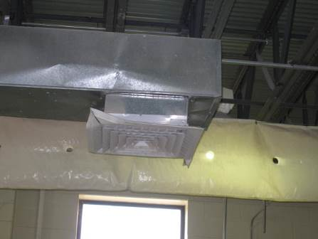

Supply vent in a workshop area

Picture 2

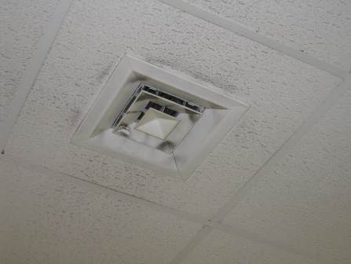

Supply vent in a classroom/office area, note dust on louvers

Picture 3

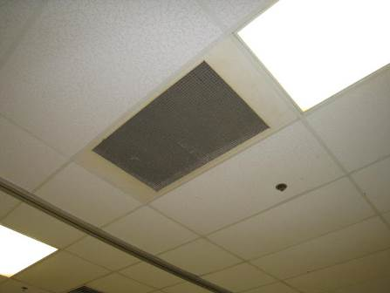

Ceiling-mounted exhaust vent

Picture 4

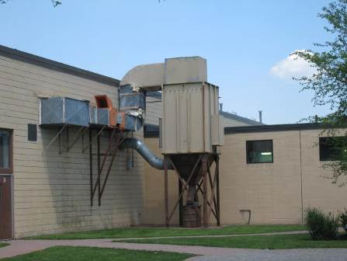

Exhaust system for carpentry area

Picture 5

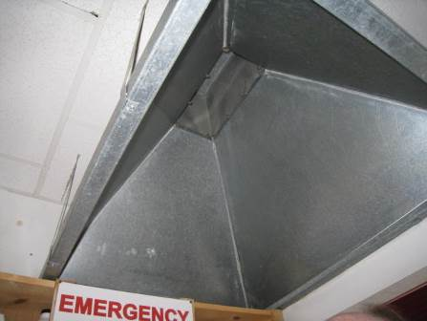

Exhaust hood structure in the cosmetology storage area

Picture 6

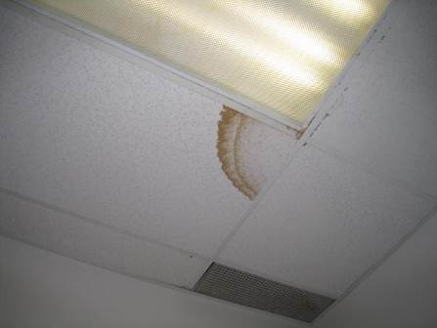

Water-stained ceiling tile

Picture 7

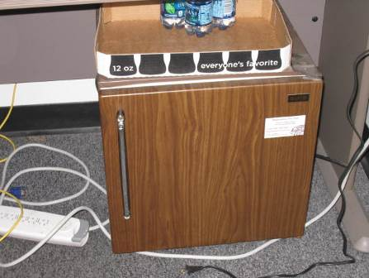

Refrigerator on carpet

Picture 8



Shrubs growing close to the exterior of the building

Picture 9

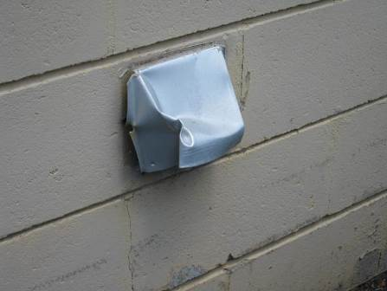

Damaged vent on exterior of building

Picture 10

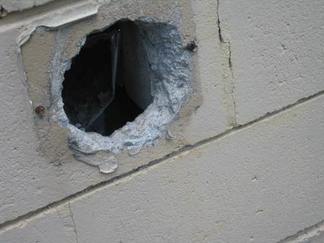

Missing vent cover/hole in exterior wall

Picture 11

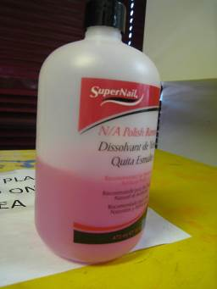

Nail polish remover used in the cosmetology area

Picture 12

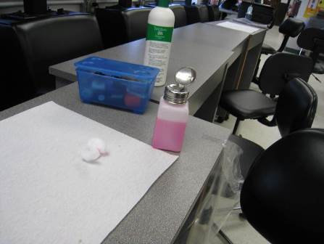

Open container of nail polish remover and moistened cotton ball

Picture 13

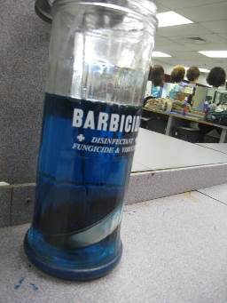

Barbicide container, note cover is ajar

Picture 14

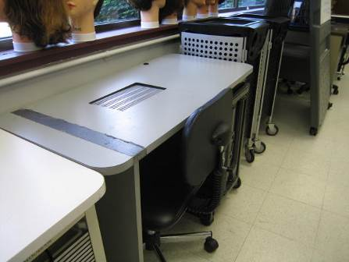

Mechanically-vented manicure table

Picture 15

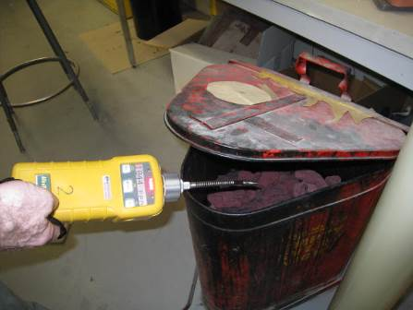

Oily rag storage container; unit was tightly sealed so VOCs could only be detected with the lid open

Picture 16

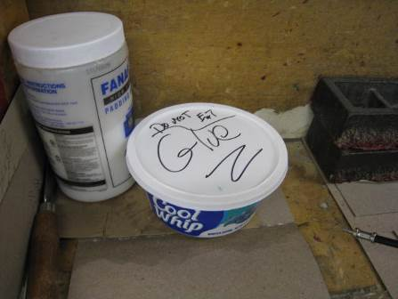

Food container reused for glue
Location | Carbon  Dioxide  (ppm) | Carbon Monoxide  (ppm) | Temp  (°F) | Relative  Humidity  (%) | PM2.5  (µg/m³) | Hg  (µg/m³) | TVOCs  (ppm) | Occupants  in Room | Windows  Openable | Ventilation |  |  | Remarks
 |  |  |  |  |  |  |  |  |  | Intake | Exhaust |  | Remarks
Background (outside) | 390 | ND | 86 | 57 | 42 | 0.009 | 0.2 |  |  |  |  |  | mostly sunny, hot
Gym | 423 | 1.1 | 90 | 46 | 43 | 0.010 | 0.6 | 10 | N | Y |  | Y | open doors to outside, wood floor, gym building rededicated 2011
Gym Weight Room | 408 | ND | 88 | 51 | 48 | 0.011 | 0.5 | 0 | N | Y |  | Y | DO, items, rubber mats and rubber/metal equipment
Gym Girls Locker | 410 | ND | 82 | 58 | 31 |  |  | 0 | N | Y |  | Y | weak exhaust flow
103 automotive | 407 | ND | 69 | 65 | 39 | 0.016 | 0.3 | 0 | N | Y |  | Y | door to outside (closed)
106 machine | 512 | ND | 70 | 64 | 58 | 0.014 | 0.6 | 3 | N | Y |  | Y | machine shop items, metal shavings on machines, oils, other machine shop items, Plimo vents
107 graphic arts | 594 | 1.8 | 73 | 57 | 50 | 0.019 | 0.5 | 4 | N | Y |  | Y | carpet, DO, PC, big printer
107 graphic arts rear | 627 | 0.4 | 74 | 58 | 51 | 0.024 | 0.5 | 5 | N | Y |  | Y | VOCs from oily rags storage (when open), bottles of inks, PF, other equipment
108 carpentry | 621 | ND | 73 | 58 | 53 | 0.010 | 0.5 | 1 | N | Y |  | Y | wood, wood items and equipment
110 H automotive classroom area | 417 | 2.4 | 73 | 60 | 53 | 0.014 | 0.9 | 4 | N | Y |  | Y
115 B culinary storage | 526 | ND | 76 | 62 | 41 | 0.016 | 0.5 | 0 | N | N |  | N | Food
116 Culinary | 586 | ND | 74 | 69 | 39 | 0.015 | 0.5 | 0 | N | Y |  | Y | commercial kitchen, including kitchen hoods, food, items
117 health technology | 650 | ND | 73 | 62 | 44 | 0.011 | 0.5 | 13 | N | Y |  | Y | NC
118 Log Bridge Inn | 596 | ND | 72 | 61 | 39 | 0.009 | 0.2 | 10 | N | Y |  | Y | NC, ceiling tiles in outside hallway ajar
119 cafeteria | 827 | ND | 72 | 61 | 40 | 0.009 | 0.2 | ~200 | N | Y |  | Y | items hanging from ceiling
126 Cosmetology | 483 | ND | 73 | 63 | 46 | 0.009 | 1.7 | 12 | N | Y |  | Y | NC, cosmetology items, people getting hair services, chemicals (barbicide, acetone, nail polish)
126 Cosmetology storage | 432 | ND | 72 | 67 | 62 |  |  | 0 | Y | N |  | Y | NC, exhaust hood vent not functioning/no switch, hairspray and other materials stored
126 Cosmetology, rear | 464 | ND | 72 | 61 | 47 | 0.008 | 0.5 | 0 | Y | Y |  | Y | NC, cosmetology items, people getting hair services, chemicals (barbicide, acetone, nail polish)
127 Nurse | 621 | ND | 74 | 57 | 36 | 0.012 | ND | 1 | Y | Y |  | Y | NC, DO, fridge, plants outside window
127A nurse’s restroom |  |  |  |  |  |  |  | 0 | N |  |  | Y | DO
127B nurse exam/laydown room | 537 | ND | 73 | 60 | 41 | 0.012 | ND | 0 | N | N |  | N | DO
132B | 561 | ND | 74 | 48 | 29 | 0.016 | 0.3 | 1 | N | Y |  | Y | NC, DEM, food, computers
133 Library conference 1 | 607 | ND | 75 | 51 | 28 | 0.024 | ND | 2 | N | Y |  | Y | Supply dusty, exhaust has ajar panel, carpet, pipe penetration
134 library conference 2 | 540 | ND | 74 | 54 | 29 |  | ND | 0 | N | Y |  | Y | 1 WD-CT, carpet
135 library read office area | 615 | ND | 73 | 53 | 29 | 0.022 | ND | 2 | N | Y |  | Y | DO, NC, sofa
136 library | 639 | ND | 73 | 56 | 31 | 0.028 | ND | 35 | N | Y |  | Y | Carpet, computers, books
137 computer | 567 | ND | 76 | 45 | 31 | 0.014 | 0.5 | 0 | N | Y |  | Y | Many computers, NC, DEM
137A computer | 602 | ND | 75 | 48 | 34 | 0.024 | 0.3 | 0 | N | Y |  | Y | many computers, NC
140 visual design | 566 | ND | 73 | 50 | 31 | 0.018 | 0.3 | 6 | N | Y |  | Y | DEM, computers, NC, items, food, large printers
141 teacher’s lounge | 629 | ND | 75 | 47 | 36 | 0.015 | 0.3 | 4 | N | Y |  | Y | fridge, computers, microwave, NC
142 | 559 | ND | 81 | 31 | 21 | 0.014 | 0.3 | 1 | N | Y |  | Y | DEM, NC, Velcro on supply vent (possibly for a cover)
145 | 988 | ND | 72 | 51 | 41 | 0.012 | ND | 12 | Y | Y |  | Y | NC
146 | 902 | ND | 72 | 51 | 45 | 0.012 | ND | 14 | Y | Y |  | Y | NC
147 | 767 | ND | 72 | 52 | 43 | 0.013 | ND | 1 | Y | Y |  | Y | NC, shades down
149 | 759 | ND | 72 | 51 | 51 | 0.013 | ND | 0 | Y | Y |  | Y | chalk, NC
149 | 647 | ND | 71 | 50 | 50 | 0.015 | ND | 2 | Y | Y |  | Y | NC
150 electrical shop | 648 | ND | 71 | 48 | 41 | 0.016 | ND | 5 | Y | Y |  | Y
151A | 628 | ND | 73 | 52 | 50 | 0.017 | ND | 4 | Y | Y |  | Y | DEM, NC
152 | 548 | ND | 73 | 59 | 44 | 0.021 | ND | 0 | Y | Y |  | Y | DEM, science chemicals
153 | 502 | ND | 73 | 58 | 44 | 0.013 | ND | 1 | Y | Y |  | Y | NC
154 main area | 716 | ND | 73 | 51 | 31 | 0.013 | ND | 1 | N | Y |  | Y | NC, plants
154 side office | 677 | ND | 73 | 52 | 33 | 0.011 | ND | 0 | N | Y |  | Y | NC, DEM
165 assistant principal | 762 | ND | 73 | 53 | 39 | 0.012 | ND | 0 | Y | Y |  | Y | Carpet, plans outside close to window
166 principal’s assistant | 734 | ND | 74 | 53 | 31 | 0.013 | ND | 1 | Y | Y |  | N | Carpet, plants, DO
168 | 618 | ND | 70 | 52 | 55 | 0.016 | 0.6 | 7 | Y | Y |  | Y | Door to outside
201 | 1212 | ND | 75 | 56 | 49 | 0.013 | ND | 19 | Y | Y |  | Y | NC, DEM
202 | 748 | ND | 75 | 51 | 50 | 0.012 | ND | 0 | Y | Y |  | Y | NC
203 | 811 | ND | 74 | 48 | 46 | 0.012 | ND | 17 | Y | Y |  | Y | NC, chalk
205A/B | 907 | ND | 75 | 53 | 50 | 0.012 | ND | 18 | N | Y |  | Y | Carpet
207 | 1055 | ND | 76 | 59 | 76 | 0.016 | ND | 8 | Y | Y |  | Y | NC, DO, shades down
208 | 1033 | ND | 76 | 58 | 44 | 0.013 | 0.4 | 22 | Y | Y |  | Y | NC, DO, supply weak
209 | 971 | ND | 77 | 54 | 50 | 0.014 | 0.2 | 15 | Y | Y |  | Y | NC, DEM, supply weak
210 | 648 | ND | 74 | 46 | 27 | 0.012 | ND | 0 | Y | Y |  | Y | NC, chemical storage
223 student services | 677 | ND | 75 | 46 | 26 | 0.012 | 0.2 | 2 | N | Y |  | Y | NC
230 | 700 | ND | 75 | 53 | 27 | 0.012 | 0.2 | 0 | N | Y |  | Y | NC
M109 masonry | 502 | ND | 73 | 73 | 58 | 0.013 | 0.2 | 5 | N (door) | Y |  | Y | door to outside, open
Main entry atrium | 735 | ND | 74 | 49 | 31 | 0.012 | ND | 1 | N (door) | Y |  | Y | NC

Carbon Dioxide and its Use in Evaluating Adequacy
of Ventilation in Buildings

The Bureau of Environmental Health’s (BEH) Indoor Air Quality (IAQ) Program examines indoor air quality conditions that may have an effect on building occupants. The status of the ventilation system, potential moisture problems/microbial growth and identification of respiratory irritants are examined in detail, which are described in the attached report. In order to examine the function of the ventilation system, measurements for carbon dioxide, temperature and relative humidity are taken. Carbon dioxide measurements are commonly used to assess the adequacy of ventilation within an indoor environment.
Carbon dioxide is an odorless, colorless gas. It is found naturally in the environment and is produced in the respiration process of living beings. Another source of carbon dioxide is the burning of fossil fuels. Carbon dioxide concentration in the atmosphere is approximately 250-600 ppm (Beard, 1982; NIOSH, 1987).
Carbon dioxide measurements within an occupied building are a standard method used to gauge the adequacy of ventilation systems. Carbon dioxide is used in this process for a number of reasons. Any occupied building will have normally occurring environmental pollutants in its interior. Human beings produce waste heat, moisture and carbon dioxide as by-products of the respiration process. Equipment, plants, cleaning products or supplies normally found in any building can produce gases, vapors, fumes or dusts when in use. If a building has an adequately operating mechanical ventilation system, these normally occurring environmental pollutants will be diluted and removed from the interior of the building. The introduction of fresh air both increases the comfort of the occupants and serves to dilute normally occurring environmental pollutants.
An operating exhaust ventilation system physically removes air from a room and thereby removes environmental pollutants. The operation of supply in conjunction with the exhaust ventilation system creates airflow through a room, which increases the comfort of the occupants. If all or part of the ventilation system becomes non-functional, a build up of normally occurring environmental pollutants may occur, resulting in an increase in the discomfort of occupants.
The MDPH approach to resolving indoor air quality problems in schools and public buildings is generally two-fold: 1) improving ventilation to dilute and remove environmental pollutants and 2) reducing or eliminating exposure opportunities from materials that may be adversely affecting indoor air quality. In the case of an odor complaint of unknown origin, it is common for BEH staff to receive several descriptions from building occupants. A description of odor is subjective, based on the individual’s life experiences and perception. Rather than test for a potential series of thousands of chemicals to identify the unknown material, carbon dioxide is used to judge the adequacy of airflow as it both dilutes and removes indoor air environmental pollutants.
As previously mentioned, carbon dioxide is used as a diagnostic tool to evaluate air exchange by building ventilation systems. The presence of increased levels of carbon dioxide in indoor air of buildings is attributed to occupancy. As individuals breathe, carbon dioxide is exhaled. The greater the number of occupants, the greater the amount of carbon dioxide produced. Carbon dioxide concentration build up in indoor environments is attributed to inefficient or non-functioning ventilation systems. The Occupational Safety and Health Administration (OSHA) standard for carbon dioxide is 5,000 parts per million parts of air (ppm). Workers may be exposed to this level for 40 hours/week, based on a time-weighted average (OSHA, 1997).
Carbon dioxide can be a hazard within enclosed areas with no air supply. These types of enclosed areas are known as confined spaces. Manholes, mines and sewer systems are examples of confined spaces. An ordinary building is not considered a confined space. Carbon dioxide air exposure limits for employees and the general public have been established by a number of governmental health and industrial safety groups. Each of these standards of air concentrations is expressed in parts per million (ppm). Table 1 is a listing of carbon dioxide air concentrations and related health effects and standards.
The MDPH uses a guideline of 800 ppm for publicly occupied buildings (Burge et al., 1990; Gold, 1992; Norback, 1990; OSHA, 1994; Redlich, 1997; Rosenstock, 1996; SMACNA, 1998). A guideline of 600 ppm or less is preferred in schools due to the fact that the majority of occupants are young and considered to be a more sensitive population in the evaluation of environmental health status. Several sources indicate that indoor air problems are significantly reduced at 600 ppm or less of carbon dioxide (ACGIH, 1998; Bright et al., 1992; Hill, 1992; NIOSH, 1987). Inadequate ventilation and/or elevated temperatures are major causes of complaints such as respiratory, eye, nose and throat irritation, lethargy and headaches.
Air levels for carbon dioxide that indicate that indoor air quality may be a problem have been established by the American Society of Heating, Refrigerating and Air-conditioning Engineers (ASHRAE). Above 1,000 ppm of carbon dioxide, ASHRAE recommends adjustment of the building’s ventilation system (ASHRAE, 1989). In 2001, ASHRAE modified their standard to indicate that no more than 700 ppm above the outdoor air concentration; however 800 ppm is the level where further investigation will occur.
Carbon dioxide itself has no acute (short-term) health effects associated with low level exposure (below 5,000 ppm). The main effect of carbon dioxide involves its ability to displace oxygen for the air in a confined space. As oxygen is inhaled, carbon dioxide levels build up in the confined space, with a decrease in oxygen content in the available air. This displacement of oxygen makes carbon dioxide a simple asphyxiant. At carbon dioxide levels of 30,000 ppm, severe headaches, diffuse sweating, and labored breathing have been reported. No chronic health effects are reported at air levels below 5,000 ppm.
Air testing is one method used to determine whether carbon dioxide levels exceed the comfort levels recommended. If carbon dioxide levels are over 800-1,000 ppm, the MDPH recommends adjustment of the building's ventilation system. The MDPH recommends that corrective measures be taken at levels above 800 ppm of carbon dioxide in office buildings or schools. (Please note that carbon dioxide levels measured below 800 ppm may not decrease indoor air quality complaints). Sources of environmental pollutants indoors can often induce symptoms in exposed individuals regardless of the adequacy of the ventilation system. As an example, an idling bus outside a building may have minimal effect on carbon dioxide levels, but can be a source of carbon monoxide, particulates and odors via the ventilation system.
Therefore, the MDPH strategy of adequate ventilation coupled with pollutant source reduction/removal serves to improve indoor air quality in a building. Please note that each table included in the IAQ assessment lists BEH comfort levels for carbon dioxide levels at the bottom (i.e. carbon dioxide levels between 600 ppm to 800 ppm are acceptable and <600 ppm is preferable). While carbon dioxide levels are important, focusing on these air measurements in isolation to all other recommendations is a misinterpretation of the recommendations made in these assessments.

Table 1: Carbon Dioxide Air Level Standards
Carbon Dioxide  Level | Health Effects | Standards or Use of Concentration | Reference
250-600 ppm | None | Concentrations in ambient air | Beard, R.R., 1982  NIOSH, 1987
600 ppm | None | Few indoor air complaints, used as reference for air exchange for protection of children | ACGIH, 1998; Bright et al., 1992; Hill, 1992; NIOSH 1987
800 ppm | None | Used as an indicator of ventilation adequacy in schools and public buildings, used as reference for air exchange for protection of children | Mendler, 2003  Bell, A. A., 2000; NCOSP, 1998;  SMACNA, 1998; EA, 1997;  Redlich, 1997; Rosenstock, 1996; OSHA, 1994; Gold, 1992;  Burge et al., 1990; Norback, 1990 ;  IDPH, Unknown
1000 ppm | None | Used as an indicator of ventilation inadequacy concerning removal of odors from the interior of building. | ASHRAE, 1989
950-1300 ppm* | None | Used as an indicator of ventilation inadequacy concerning removal of odors from the interior of building. | ASHRAE, 1999
700 ppm (over background) | None | Used as an indicator of ventilation inadequacy concerning removal of odors from the interior of building. | ASHRAE, 2001
5000 ppm | No acute (short term) or chronic (long-term) health effects | Permissible Exposure Limit/Threshold Limit Value | ACGIH, 1999  OSHA, 1997
30,000 ppm | Severe headaches, diffuse sweating, and labored breathing | Short-term Exposure Limit | ACGIH, 1999  ACGIH. 1986
* outdoor carbon dioxide measurement +700 ppm

References
ACGIH. 1986. Documentation of the Threshold Limit Values. American Conference of Governmental Industrial Hygienists. Cincinnati, OH.
ACGIH. 1998. Industrial Ventilation A Manual of Recommended Practice. 23rd Edition. American Conference of Governmental Industrial Hygienists. Cincinnati, OH.
ACGIH. 1999. Guide to Occupational Exposures-1999. American Conference of Governmental Industrial Hygienists, Cincinnati, OH.
ASHRAE. 1989. Ventilation for Acceptable Indoor Air Quality. American Society of Heating, Refrigeration and Air Conditioning Engineers. ANSI/ASHRAE 62-1989.
ASHRAE. 1999. Ventilation for Acceptable Indoor Air Quality. American Society of Heating, Refrigeration and Air Conditioning Engineers. ANSI/ASHRAE 62-1999.
ASHRAE. 2001. Ventilation for Acceptable Indoor Air Quality. American Society of Heating, Refrigeration and Air Conditioning Engineers. ANSI/ASHRAE 62-2001.
Beard, R.R. 1982. Chapter Fifty-two, Inorganic Compounds of Oxygen, Nitrogen, and Carbon. Patty’s Industrial Hygiene and Toxicology, Vol. IIc. 3rd ed. Clayton, G. D. & Clayton, F. E., eds. John Wiley & Sons, New York, NY.
Bright, P.; Mader, M.; Carpenter, D.; and Hermon-Cruz, I.Z. 1992. Guideline for Indoor Air Surveys. Brooks Air Force Base, TX. Armstrong Laboratory, Occupational and Environmental Health Directorate. NTIS AL-TR-1992-0016.
Burge, H. and Hoyer, M. 1990. Focus On … Indoor Air Quality. Appl. Occup. Environ. Hyg. 5(2):88.
EA. 1997. Indoor Air Quality. Environment Australia, Department of the Environment, Sport and Territories, Canberra, Australia. www.environment.gov.au/soe/1996/publications/technical/pubs/12indora.pdf
Gold, D. 1992. Indoor Air Pollution. Clinics in Chest Medicine. 13(2):224-225.
Hill, B.; Craft, B.; and Burkart, J. 1992. Carbon Dioxide, Particulates and Subjective Human Responses in Office Buildings without Histories of Indoor Air Quality Problems. Appl. Occup. Environ. Hyg. 7(2): 101-111.
IDPH. Unknown. Illinois Department of Public Health Guidelines for Indoor Air Quality. Illinois Department of Public Health, Springfield, Il. http://www.idph.state.il.us/envhealth/factsheets/indoorairqualityguide_fs.htm
Mendler, S. and Odell, W. 2003. Indoor Air Quality for the EPA. ArchitectureWeek. April 16, 2003. http://www.architectureweek.com/2003/0416/environment_1-2.html
NCOSP. 1998. Workplace Requirements for Safety & Health, Indoor Air Quality 3.3.3. NC Office of State Personnel, Raleigh, NC. www.osp.state.nc.us/emprsk/safety/handbook/5-9.pdf
NIOSH. 1987. Guidance for Indoor Air Quality Investigations. Cincinnati, OH. National Institute for Occupational Safety and Health, Hazards Evaluations and Technical Assistance Branch, Division of Surveillance, Hazard Evaluation and Field Studies.
Norback, D.; Torgen, M.; and Edling, C. 1990. Volatile Organic Compounds, Respirable Dust, and Personal Factors Related to Prevalence and Incidence of Sick Building Syndrome in Primary Schools. British Journal of Industrial Medicine. 47:740.
OSHA. 1994. Occupational Safety and Health Administration. Indoor Air Quality (Proposed Regulation), Federal Register 59:15968-16039, (1994) Appendix A.
OSHA. 1997. Limits for Air Contaminants. Occupational Safety and Health Administration. Code of Federal Regulations. 29 C.F.R 1910.1000 Table Z-1-A.
Redlich, C.; Sparer, J.; and Cullen, M. 1997. Sick-building Syndrome. Lancet. 349:1016.
Rosenstock, L. 1996. NIOSH Testimony to the U.S. Department of Labor on Air Quality, Appl. Occup. Environ. Hyg. 11(12):1368.
SMACNA. 1998. Indoor Air Quality: A Systems Approach. 3rd ed. Sheet Metal and Air Conditioning Contractors’ National Association, Inc, Chantilly, VA. National Association, Inc.

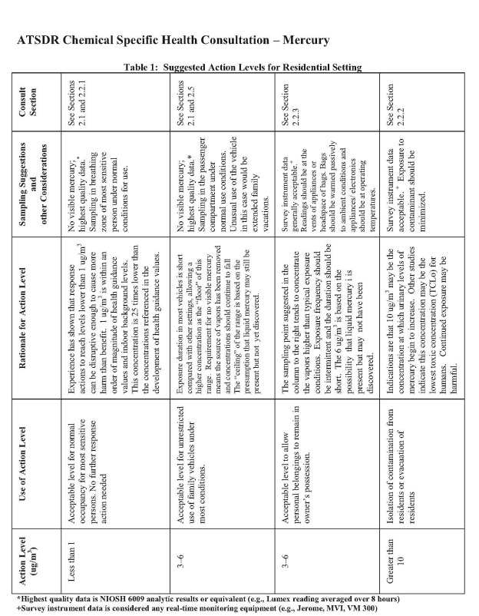
Source: http://www.atsdr.cdc.gov/emergency_response/Action_Levels_for_Elemental_Mercury_Spills_2012.pdf

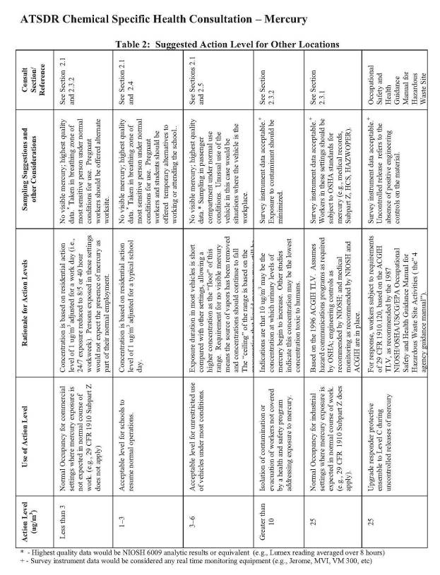
Source: http://www.atsdr.cdc.gov/emergency_response/Action_Levels_for_Elemental_Mercury_Spills_2012.pdf

BUREAU OF ENVIRONMENTAL HEALTH
Indoor Air Quality Program

Guidance Concerning Proper Use and Storage of Chemicals in Schools to Protect Public Health

November 2006

The improper use and storage of chemicals in schools can lead to irritant symptoms related to indoor air quality, particularly in buildings with poor exhaust ventilation. The safety of students, faculty and school staff as well as emergency responders can all be adversely affected by the improper use and storage of chemicals. Due to the inherent danger from chemicals used in science curriculum and the variety of materials used by custodial staff, appropriate measures for proper use and storage of these materials are needed to prevent/reduce exposure. The municipal fire department in each municipality in Massachusetts has the exclusive authority to regulate the storage of flammable materials (527 CMR 14.00). The fire safety office of your municipal fire department should be consulted for assistance in compliance with these regulations.

The following guidelines are intended to serve as recommendations for the proper use and storage of these hazardous materials.

Chemical Identification
Container Labeling
Each container must be labeled with the chemical name of the material stored within (not chemical formula solely). Chemical names must be consistent with M.G.L. c. 111F (Hazardous Substances Disclosure By Employers, also known as the Massachusetts Right-To-Know Law) in order to facilitate the identification of the chemical(s) in case of a spill.

Material Safety Data Sheets (MSDS)
An appropriate MSDS for custodial supplies and chemicals used in science, art, photography and other programs should be obtained from the chemical supplier/manufacturer and kept in an area that is accessible to all individuals during periods of building operations in conformance with M.G.L. c. 111F. If no MSDS is available for a product because 1) the manufacturer no longer exists; 2) the manufacturer cannot be identified from the label or 3) the chemical was obtained prior to the promulgation of M.G.L. c. 111F, that material should be considered hazardous waste and disposed of in a manner consistent with Massachusetts hazardous waste regulations.

Proper Chemical Storage and Handling
Storage Cabinets
Flammable materials
All cabinets for storage of flammable materials must be in compliance with Massachusetts statutes, regulations and local ordinances promulgated pursuant to M.G.L. c. 148, § 13. In addition, all flameproof cabinets must meet the design and installation criteria set forth in the National Fire Prevention Association’s (NFPA) latest version of NFPA 30: Flammable and Combustible Liquids Code.

Acids
Acids must be stored in a cabinet that is constructed from corrosion-resistant materials. Each acid cabinet should be vented to reduce acid vapor build up.

Chemical Storeroom Ventilation
Rooms that are designated for use as chemical storage areas must have a functioning exhaust ventilation system that operates continuously to remove fugitive chemical vapors. The local exhaust system should be ducted to the outdoors independent of the general ventilation system. Each room must also have an appropriate source of transfer (or make-up) air allowing for exhaust vents to operate efficiently. Such chemical storage ventilation systems must be in conformance with the applicable fire and building codes. Chemical storeroom exhaust vents must be inspected annually by appropriately trained individuals to ensure proper function.

Shelving
If chemicals are stored on shelving:
- Shelving must be constructed of appropriate materials that will resist corrosion resulting from leaking materials stored on or around the shelves. For example, chemicals that are oxidizers should not be stored on wood and acids should not be stored on or near steel.
- The shelving must be able to support the weight of stored materials.
- Guardrails should be installed along the edge of shelving to prevent accidental slippage.
Chemical Hoods
Chemical hoods used in science programs as part of experiment preparation must be maintained in an appropriate manner in accordance with manufacturers’ recommendations. Chemical hoods must be recalibrated annually by appropriately trained individuals to ensure proper function. Documentation of annual recalibration should be assessable to all building occupants. If an area is designed so the chemical hood is the sole exhaust vent for an area, the chemical hood must operate continuously during occupied hours. Chemical hoods should not be used to store unattended chemicals.
Prohibited Activities
The following chemical storage/handling practices should be prohibited to provide for the health and safety of school occupants.
- No shock sensitive material should be present in the school and should only be removed after consultation with the local fire safety office.
- No flammable materials should be stored outside flameproof cabinets.
- No non-flammable materials should be stored inside flameproof cabinets.
- Chemically incompatible materials must be separated and stored in an appropriate manner according to the manufacturer’s recommendations.
- No flameproof cabinet should be vented in a manner to allow for backflow of air into the cabinet.
- No cabinet should share venting with the chemical hood.
- Acids should not be stored in cabinets made of or shelves supported by materials made of steel.
- Carpeting should not be used as floor covering in laboratories.
- Schools should not store more flammables or other liquid chemicals than are necessary to meet curriculum needs, and in no event more than a two year supply.
- No water reactive materials should be stored within 10 feet of a water source.
- Chemicals must not be stored in recycled food storage containers.
Chemical Spill Response Plan
Schools should have a chemical inventory and emergency response plan to ensure the safety of building occupants and emergency responders. The elements of an emergency response plan should include the following topics:
- Procedures for evacuation of the building in the case of a spill that may to result in exposure to building occupants.
- Contact number (911) for emergency response to a chemical spill.
- Emergency procedures to contain the material in the location of the spill.
- Closing of doors
- Deactivation of the ventilation system
- Routing of evacuation away from the spill location
- Contact information for remediation services
- Procedures for proper disposal of hazardous material in compliance with Massachusetts hazardous waste disposal laws.

Questions
If you have any questions concerning these guidelines, please contact:

Massachusetts Department of Public Health
Bureau of Environmental Health
Indoor Air Quality Program
250 Washington Street, 7th Floor
Boston, MA 02108

Phone: (617) 624-5757 Fax: (617) 624-5777

Document Reviewed: August 2008

“Heat index” is a measurement accounts for the combined impact of heat and humidity, providing an estimate of the felt temperature.

