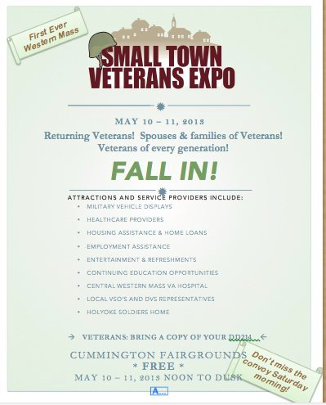

Central Hampshire Veterans Services

FINAL REPORT: COMMUNITY INNOVATION CHALLENGE GRANT



**Central Hampshire Veteran's Services**

Steven James Connor, Director

240 Main Street, Suite #4

Northampton, MA 01060

1April, 2014

Massachusetts provides the most comprehensive benefits to veterans of any state in the country. The establishment of these benefits and services for Veterans and their dependents began with the passage of MGL Chapter 115 in 1861 in the midst of the Civil War. It was considered an honor and an obligation to provide for those veterans “who shall have borne the battle, and for his widow, and his orphan.” Of course, Massachusetts has a long history of providing veterans benefits beginning with the original patriots of the American Revolution. The Daniel Shays Rebellion occurred in Northampton and catalyzed this country to recognize that those who fought for freedom should be treated with all the respect and assistance that we can offer. Here at Central Hampshire Veterans Services District, we are very proud of that history and we take very seriously our commitment to its legacy.

When I began working as the Veterans Service Officer for the city of Northampton in 2004, the office was providing benefits for 12 veterans or surviving spouses. After intensive and deliberate outreach, that number grew steadily. In the most recent 6 month period, we provided benefits for 257 individuals, ranging from very elderly World War II veterans to young adults returning from Iraq and Afghanistan.

In Fiscal Year 2009, we embarked on an experiment to share resources between Northampton and some of our neighboring communities, including the Towns of Amherst, Pelham, Williamsburg, Chesterfield and Cummington. In Fiscal Year 2011, the towns of Goshen and Worthington also joined. The benefits of creating a regional veterans services district include the ability to hire additional staff professionally trained to serve the needs of increasing numbers of veterans, and the ability for veterans in small towns to have access to their VSO on a full time basis. Previously, the smallest communities had such part time Veterans’ Services Officers (VSO)’s that a veteran’s access to services was limited to a very small number of hours each week. In every community we served through the Central Hampshire Veterans Services District (CHVSD), we have seen the numbers of veterans whose needs had been previously unserved now getting the benefits they have earned.

More important to us than the numbers are the stories behind them which includes stories of suffering relieved and opportunities lifting people up. We knew that we could bring transformational stories like these to our neighbors in Hadley and Middlefield as well and indeed, we found that to be true. Stories like:

* A 92­year­old Army nurse, living in a neighboring town and struggling to survive on $1,050 a month in public housing on Social Security was helped because there had been outreach to determine if she was eligible for Chapter 115 benefits. She now receives supplemental income for housing and food, and Medicare to cover medical expenses. She says, "This is wonderful. I've been looking for help for a few years now."
* The Surviving spouse of a WWII Vet who received $873.90 from Social Security, with rent of $725.00. CHVSD determined she was entitled to Ch. 115 benefits, thanks to our staff’s level of experience and training.
* A returning Operation Iraqi Freedom Marine veteran wanted to complete his college education but didn’t think he could afford to support his pregnant partner and their first child because the GI Bill did not provide support during the times they are not in school. Our VSO told him that he could work up to 25 hours as a work-study student in a local Veterans Service office to make ends meet between semesters. That Marine is now serving in one of my offices with enough extra income to support his young family, and is finishing his degree at Springfield Technical Community College and on to UMass.

Hadley and Middlefield’s town governments were interested in joining, but unable to budget for the additional costs. The Community Innovation Challenge (CIC) Grant allowed this to happen. I am grateful to our municipal partners, Northampton Mayor David Narkewicz, Amherst Town Manager John Musante, Williamsburg Town Manager Charlene Nardi, and their respective staffs. They have not only helped launch this effort and been major participants in central Hampshire veterans services, but they have generally been at the forefront of efforts to include our new towns of Hadley and Middlefield.

Finally, it is absolutely essential for us to thank the Patrick Administration and the Executive

Office of Administration and Finance for their financial support for this work, and for their

commitment to veterans services at both the state and municipal levels. Already, our expanded collaboration has begun changing lives for the better. We consider the investment of this Community Innovation Grant to be just the next chapter in the long story of support the Commonwealth of Massachusetts has always extended to its veterans and their families.

Sincerely,

Steven James Connor, Director

Central Hampshire Veterans Services District.

**Table of Contents**

**EXECUTIVE SUMMARY** 1

**COMMUNITY PARTNERS** 3

**BUDGET** 4

**IMPLEMENTATION PLAN** 6

**OUTCOMES** 12

**CONTACT INFORMATION** 13

# **EXECUTIVE SUMMARY**

### In 2012, the Central Hampshire Veterans Services District (CHVSD), a regional collaboration between eight communities and based in the City of Northampton’s Veterans Services Department, began conversations with the towns of Hadley and Middlefield to join our collaboration. CHVSD has been organized under an Inter-Municipal Agreement since 2009. The Town of Hadley was particularly significant for us, as it would provide us the opportunity to organize under MGL Chapter 115 as a Veterans Services District, being the town that would make our district geographically contiguous.

In order to begin serving additional towns, we knew that we would need to add some additional staff hours, and as importantly to add to our available technology. Many of the veterans we serve cannot easily come to our office hours, and we take a significant number of applications online in the person’s home, hospital, or rehab facility. Hadley and Middlefield officials were very interested and their town Select Boards were cautiously interested, but concerned about budgetary implications. We applied for a $35,000 Community Innovation Challenge Grant to help subsidize the first year’s membership in CHVSD for those communities and to allow us to ramp up our staffing and technology to meet the needs.

What makes this project innovative is rooted in our belief that we are better together. Under MGL Chapter 115, every community in the Commonwealth must have at least a part time Veterans Service Officer, depending on the size of the community. In practical terms what this has meant for small towns is that their citizens have access to their veterans services office only on limited days and for limited hours each week or month – and sometimes that means that the veteran has effectively no access, if they cannot make it to those office hours. By joining neighboring communities together, we are better able to provide needed services at the convenience of our veterans, who have access to a full and professional Veterans Services Office all week long. What we also know is that veterans services is much more complicated today than it has been in the past. We routinely deal with World War II vets who are facing the challenges of aging and intensification of service-connected disabilities. Korean War and VietNam War veterans are also aging and the latter group is still grappling with Agent Orange and other service-connected issues unique to that conflict. We see the veterans of today’s conflicts who are becoming homeless at a remarkably rapid rate, dealing with traumatic brain injuries, and trying to navigate the new GI bill to get back to school. We deal with veterans of all ages and genders struggling with post traumatic stress and the lasting impact of military sexual trauma. It’s an incredibly complicated landscape, and VSO’s must be well trained to know how to respond to all of these critical issues. In additions, more and more state and federal agencies require us to submit applications online only. In small towns, very part time VSO’s often do not have the time or the professional development resources to became familiar with these online platforms, much less to attend the day long or multi-day trainings they need to keep up with best practices. Our innovative approach makes highly trained and skilled Veterans Service Officers available to every citizen of our member communities on a full time basis. We continue to hold in person office hours in each town, but on any day of the week, your phone call or email will be answered.

On April 4th, 2014, the governor signed Valor Act II legislation, which among many things requires a Veterans Services Officer to be trained, tested and certified in the professionalism of our services. I believe this new law will encourage most small town communities to do as we have done, and form a district. We hope this CIC grant that we have just concluded can serve as a model for others to do the same here in Massachusetts.

This radically expansive approach to providing veterans services has been incredibly successful in connecting our neighbors who are veterans with the benefits they have earned. We are so grateful that we have been able to extend our reach to our neighbors in Hadley and Middlefield this year. In the process we have learned important lessons about appropriate staffing levels to serve our member communities. CHVSD is well positioned to continue to provide the high level of services to which we are committed and which our Commonwealth’s veterans deserve.

# **COMMUNITY PARTNERS**

Since 2009, six municipalities in Western Massachusetts made up the Central Hampshire Veterans’ Services District. The initial idea came from the City of Northampton offering services to the neighboring town of Williamsburg when the VSO serving in the town at that time did not know how to administer needed benefits to a veteran living there. The town of Northampton offered to provide services for an annual stipend. It did not take long to realize the benefits of providing full time service to Williamsburg. The number number of veterans and their families receiving benefits quickly increased, and word spread to the towns of Chestrefield and Cummington. Soon conversations took place with the governing authorities of Northampton and Amherst, and a proposal was developed to create a district in our region with the City of Northampton serving as the fiscal agent. Our partners now include the Towns of Amherst, Pelham, Williamsburg, Chesterfield, and Cummington. Through Fiscal Year 2013 funding, the Towns of Hadley and Middlefield joined the district. The towns of Hatfield, Westhampton and Southampton were also invited to join, but decided to continue with their current part time VSO We believe that we could serve those communities as well, but the total number of communities that could be served by this model is well described in A Guide For Establishing A Veterans Services District Under Chapter 115, published by the Massachusetts Department of Veterans Services.

**GOALS**

Expansion of the veterans’ services district met two key goals regarding service to veterans in Western Massachusetts:

1. Development of an official veterans’ services district. Under the guidelines of Chapter 115 of the Massachusetts General Laws, municipalities in a veterans’ services district must be contiguous. Before the filing of the grant application, the district operated with a waiver from the Division of Veterans’ Services (DVS) and under an intermunicipal agreement through Massachusetts General Laws Chapter 40, Section 4a. The inclusion of the Town of Hadley would bring the district compliant with regulations under Chapter 115.
2. Improve outreach to veterans- In addition to developing a district under Chapter 115, the grant provided an opportunity for the district to provide outreach and services to veterans in the Towns of Hadley and Middlefield. This goal comes from the belief that more veterans in need were living in those communities and not receiving the benefits they earned.

# **BUDGET**

Original Budget:

|  |  |
| --- | --- |
| **ITEM** | **TOTAL COST** |
| Town of Hadley first year assessment | $17,944 |
| Town of Middlefield first year assessment | $1,781 |
| Additional clerical staff | $7,359 |
| Computer and desk for new clerical | $2,000 |
| Computer to replace privately owner laptop | $2,000 |
| Additional travel | $4,000 |

Note: Chapter 115, Section 11 reads: “Said board may determine the expenses of said director and deputy or assistant and of the department under the charge of said Director, and may apportion said expenses among the several municipalities comprising said District on the basis of the taxable valuation of said municipalities as last established by the General Court as a basis of apportionment for State and County taxes, or on the basis of the population of each municipality in such District based on the most recent Federal Census, or by any other means determined by a unanimous vote of said board to be fair and equitable to each community.” Our board concluded that making assessments to member communities on the basis of population was most equitable in our circumstance.

Final Budget:

|  |  |
| --- | --- |
| **ITEM** | **TOTAL COST** |
| Hadley first year assessment | $17,944 |
| Middlefield first year assessment | $1,781 |
| Additional clerical staff | $7,359 |
| Computer and desk for new clerical | $1,860 |
| Computer to replace privately owned laptop | $1,800 |
| Additional travel | $3,600 |
| Small Town Vet Expo | $8,000 |

**Ongoing Additional Annual Costs (estimated at approximately $20,000 if you include office space):**

Annual Audit

Bond for Treasurer

Workers Compensation Insurance

General Liability Insurance

Banking Services

District Treasurer

Office Space

Main Office Phone

Copier

**One-Time Costs:  (estimated at approximately $8,000)**

Buy-in to Hampshire County Health Insurance Trust

Computer and Software for District Treasurer

With all of this in mind the CHVSD board decided it was more appropriate to spend our resources on the delivery of services rather than these outlined expenses. It is important to note that the secretary of Massachusetts Department of veterans services has given approval to our district under this contractual agreement because we continue to meet the requirements the secretary office had laid out in A Guide for Establishing Veterans' Services Districts under Chapter 115. Although we do not meet all that is required under chapter 115, we essentially meet the spirit of the law. In other words, we continue to meet the staffing levels for populations, and we surpass the service levels in both the types of services and the number of veterans that we serve. It is estimated that one out of every 1,000 citizens in any city or town in Massachusetts should be receiving veterans benefits under chapter 115. In every one of our communities we either meet or exceed those expected numbers. It may be that the issue of formation under Mass General law chapter 115 may still need to be addressed in the future if the Central Hampshire Veterans Services District grows in any significant way, but as it stands now we believe our limited resources should focus on the veterans in our communities who need our assistance.

# **IMPLEMENTATION PLAN**

The project goal for our community innovation challenge grant seemed simple enough with the task to expand veterans services to two new towns and to become an official veterans services district under chapter 115, however, as we’ve learned over the year, simple is not always easy.

March, 2013: Evaluated needs of an expanded district

We began our project in March 2013 understanding that there would be the need for an increase in staffing and a need for more office equipment and up-to-date technology, especially mobile technology as often we need to meet veterans, often senior veterans, in their homes throughout our district.

May, 2013- Outreach to veterans

Beyond that we had the greater challenge of doing the outreach to inform the communities’ veterans and their families about the benefits and services available to them. We amended our contract just prior to its beginning in order to move additional money for the biggest outreach event in our small part of the state. We called it the Small Town Veterans’ Expo and it took place on May 9 and 10th of 2013 at the Cummington Fairgrounds. This event was a joint effort of the central Western Mass VA healthcare systems and Central Hampshire Veterans’ Services, along with dozens of wonderful volunteers. There were over 40 providers covering such things as homebuying to homelessness services, training and educational institutions, many departments of the VA hospital and nonprofit and for-profit providers of services to our veterans. There was considerable advertising on both radio and appearances on local television programs. There were also professionally designed flyers, posters, and yard signs dispersed throughout the towns of the upper Berkshires and Western Franklin Hampshire County.

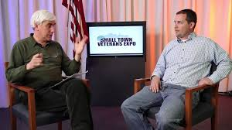

The funding for the advertising and marketing of this event came from a grant from the Central Western Mass VA Health Systems and from this grant. Unfortunately, we faced some of the most inclement weather of the spring with rain on both days and intermittent downpours that made us think we may have to call for a Naval rescue.

*Photo from the Daily Hampshire Gazette* 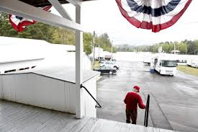

However, we did have some local veterans from the Berkshire towns who attended and they were amazed at all of the benefits and services that were potentially out there for them if and when needed. It also was an opportunity for all the providers there to network and learn all the things that their colleagues were doing. There were many, many people we met either at this event or during the following months who were thrilled that we were putting on such a significant and comprehensive event in the small towns of our district and asked us to try and bring it back again next year. As of the writing of this report there are preliminary plans of having another Small Town Veterans Expo in one of the small towns of our district in early autumn of 2014. Although this grand event did much to let the small towns in our district know we were there to serve them, more direct outreach was going to be necessary for our new towns of Hadley and Middlefield.

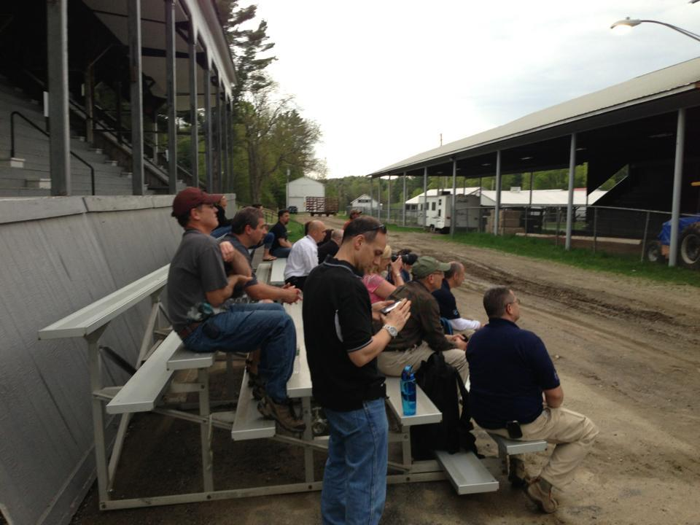

*enjoying music at small town veterans expo*

March, 2013- Present: Development of luncheon speaking schedule

Early on we worked with the senior center staff from the Hadley and Middlefield Councils on Aging and arranged to be speakers at the regular scheduled luncheons. Many of the questions were around eligibility and enrollment for VA health care and the Holyoke Soldiers Home, as well as questions about the Veteran Cemetery in Agawam. However, it did stir up enough interest that in the following months people would come to our office hours and more focused and relevant conversations would ensue about the whole array of benefits these veterans and their dependents would be eligible for.

In the town of Hadley we also had the opportunity to go to a private housing complex for seniors over the age of 60 and give a presentation on all of our services. This event was also well attended and there were several follow-up conversations. In the town of Middlefield, the smallest of all our communities at just over 600 citizens, there haven’t been that many opportunities other than our Small Town Veterans Expo and the Council on Aging to get the word out. However, we believe that in our outreach efforts and our regular office hours at the Townhall the citizens of Middlefield know of our services and will come to us when needed. We even have had veterans from two neighboring communities that are not part of our district seek information and services from us during regular office hours, which is evidence that our Small Town Veterans Expo was a successful outreach strategy.

**SUCCESSES AND CHALLENGES**

The intention of all of these outreach efforts especially in the towns of Hadley and Middlefield was to increase the numbers of veterans and their dependents in the community to receive the benefits and services they earned. In the Town of Hadley since we took over providing veterans services we have seen a significant increase in those receiving veterans benefits under chapter 115 from one veteran at the beginning, to currently 18 veterans or their surviving spouses. Many of these cases came from the initial outreach events mentioned previously.

We began assisting an array of citizens from a 92-year-old World War II nurse veteran, to returning veterans from the war in Iraq and the war in Afghanistan. The returning younger veterans only needed our assistance for short periods of time, while others living on very small fixed incomes are going to need our supports long into the future. There are also those veterans who came to us inquiring about our local benefits who learned that they may be eligible for benefits through the federal VA system. In fact, we have filed for service related compensation claims, and three of those claims were awarded with the other one still pending appeal. Many of the senior veterans that we have provided services for have asked us where we’ve been all this time, another confirmation that our outreach efforts had come to fruition. Beyond the claims for benefits, we have also assisted several veterans in preparing applications for the state Veteran Cemetery in Agawam and the National Cemetery in Bourne, as well as ] applications for admittance into the Holyoke Soldiers Home long-term care facility. We have even assisted a couple of veterans in getting their American Legion magazine to be sent to the right address.

In the town of Middlefield we have yet to enroll anyone into our state benefit system. However we have assisted several veterans in getting their military records and documents from the VA in order to receive tax abatements and other benefits they are entitled to. We were working with a senior disabled veteran in the community to get sections of his house adapted with specialized equipment due to his disabilities and advanced age, however the process was never completed due to the passing of this proud American veteran.

One of the truly surprising issues we faced during this year of the grant involved staffing. The staffing make up that we looked to have in place due to the inclusion of the new towns of two full-time and three part-time staff has been modified out of necessity to a three full-time plus staff at the end of this period of the grant. The original plan of having two part time veteran service officers with one concentrating on the hilltowns of western Hampshire County that are part of our district, and the other officer concentrating on the communities of the lower Valley, could not be sustained. One of the positions was 25 hours a week and the other was 18 hours a week. In July 2013 our veteran service officer of the lower valley gave notice and moved to a full-time position with the VA health care system.

This part time position proved to be very difficult to fill at only 18 hours a week. Twice - once in August and again in October - it looked like we had found a qualified candidate for the position who would be willing and able to work the part-time hours. Unfortunately, the candidates rejected the position shortly before they were to begin. Because of the increased workload and demands of the job, there was very little time to spend on recruitment for a new veteran service officer. The other veteran service officer with the responsibility of the hilltown communities had given notice over a year ago that his intention was to retire in December 2013. Although we had plenty of notice we had to request him to stay on with us until we could find not only a replacement for him but for the other position that still lay vacant.

In addition to all of the issues of the two part-time veterans agents, we also had difficulties with the part-time administrative position. Initially, we requested funding from the grant for a 10 hour administrative support staff to assist in the additional duties that came with the addition of our two new towns. Although we were fortunate enough to find a very capable person to fill that position, it became very obvious that training someone in our system was going to be very challenging at only 10 hours a week. Also, when the new staff understood that there may not be any increase in their hours on the horizon they continued to look for full-time work and were successful in finding another position and left us at the end of September 2013.

In November of this past year I met with members of the district board and discussed how to solve this very difficult staffing problem. After much consultation we presented to the district board that we would need to dramatically change our staffing pattern. Rather than having two part-time veteran service officers to cover office hours in all our communities we decided to make it a full-time 35 hours a week position, which in turn, would be increased to a 40 hour position for fiscal year 2015. This new position was posted in January 2014 and we saw a significant increase in the number of applicants wishing to secure employment. Fortunately in March we were able to hire a veteran of the Iraq war and long time National Guardsmen to fill the position. He is now working in every community within our district, meeting many of the people that we serve and is eager to learn all there is to know to be an effective veteran service officer. The part-time 10 hour administrative staff position has been eliminated and the director’s position has gone from 35 hours to 40 hours a week in order to ensure a smooth running administration of benefits under chapter 115 of the Mass. General Laws. It should be noted that although our part-time veterans agent planned to retire fully, we have managed to save enough money in our budget to keep him on at five hours a week in order to continue our very important work with the District Attorney’s Office, local courts and the Hampshire County House of Correction, assisting veterans who have found themselves in trouble with the law.

At the beginning of the grant period we had designed a five person staff team at 128 hours a week, and now as we make our final report on the grant we are a staff team of four at 125 hours per week. We really believe that we have found the necessary staffing pattern that will ensure a continuation of highly competent and professional service to veterans and their families that we serve in our new expanded district.

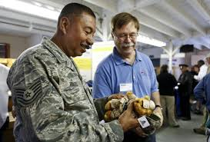 *Photo from the Daily Hampshire Gazette*

One of the goals that we had set for our project was to form our district under the confines of chapter 115 rather than the current contractual agreement pursuant to c. 40, sec. 4A. The intention for this goal was to make it a more streamlined process to operate each fiscal year without the need to secure votes from multiple select boards and city councils to approve the contract every year. This seemed at the time like a simple enough objective and we began to move forward with the process with the intention of having it completed for fiscal year 2015. (It should be noted that with the inclusion of Hadley into our district it met one of the requirements under Mass General law chapter 115 that we previously could not meet, that all towns in a district need to be contiguous to one another.)

However, as we researched the process, we learned that what this was going to entail was not only creating our own government entity with our own legal name and tax ID, but we were going to need to hire our own treasurer to handle the payroll and benefits of our staff. These are functions that are currently provided by the City of Northampton at no charge to the District. In our analysis of remaining under the inter-municipal agreement format versus the c.115 design, the cost increase was going to be significant because a c.115 district would become responsible for the following additional costs:

# **OUTCOMES**

As part of our project agreement under the Community Innovation Challenge grant, we developed a brief survey to learn what the community of Hadley and Middlefield feel about getting their veterans services from CHVSD. It has been difficult to get veterans to complete the surveys due to the rural nature of our communities, the lack of high-speed Internet access in the Berkshires, and the very busy lives of other municipal employees whom we asked for assistance. We were able to get some survey results and they have been quite positive. However, the real measure of our success in providing services is the significant increase in both the number of people we have served and the significant increase in financial benefits provided through our district. As we have seen in every community that we have entered into an agreement with to provide services the amount of citizens in the amount of benefits provided have gone up notably in the first year.

|  |  |  |  |  |  |  |  |  |  |
| --- | --- | --- | --- | --- | --- | --- | --- | --- | --- |
| GOAL | MEASURE | | CURRENT PERIOD | PRIOR PERIOD | TREND | TARGET | STATUS | COMMENTS | |
|  | # of veterans served in Hadley and Middlefield | | 33 | 2 |  |  | Green dot | This includes for state and federal filings | |
| # of benefits provided to veterans served in Hadley and Middlefield | | $8,009.86 last month of grant | $137.37month before we took over |  |  | Green dot | This is for ch. 115 benefits only | |
| % of municipal officials satisfied with the provision of veterans services, as evidenced through a survey | | 8 officials filled out survey. 100% |  |  | 80% satisfaction | Green dot |  | |
| % of veterans that state the quality of services provided has improved, based on a survey of participating veterans | | 12 veterans filled out survey  91.66% |  |  | 80% satisfaction | Green dot | One respondent did not know what our office did. We need to continue outreach. | |
| **STATUS LEGEND** | **OFF TARGET:** | Red square showing that a measure is off topic | **CLOSE TO TARGET** | Yellow triangle showing that the data collected towards a measure is approaching the target | **ON TARGET:** | Green circle showing that the data collected towards a measure is on target | **NOT APPLICABLE:** | | Straight line showing that a particular category is not applicable to a particular measure |

# **CONTACT INFORMATION**

Steven James Connor, Director of CHVS

[sconnor@northamptonma.gov](mailto:sconnor@northamptonma.gov), 413-218-0814

David Nixon, Hadley Town Manager

admin@hadleyma.org , 413-586-0221

REFERENCES

[Mass General Laws, Chapter 115, Veterans Benefits](https://malegislature.gov/Laws/GeneralLaws/PartI/TitleXVII/Chapter115)

[DVS District formation guide](http://www.mass.gov/veterans/docs/district-formation-guide-2011.pdf)

RESOURCES

Sample Intermunicipal Agreement:

VETERANS’ SERVICES INTER-MUNICIPAL AGREEMENT

**Between the City of Northampton**

**and the Towns of**

**Amherst, Chesterfield, Cummington, Hadley, Pelham, Middlefield, Williamsburg, Goshen and Worthington**

**Fiscal Year 2015**

Pursuant to c. 40, sec. 4A, this Agreement, approved by the Northampton City Council and the Selectboards of the participating Towns, is hereby entered into and is effective from this __first_____ day of July, 2014 by and between the City of Northampton and the Towns of Amherst, Chesterfield, Cummington, Hadley, Middlefield, Pelham, Williamsburg, Goshen and Worthington. This agreement contractually enables the Director of Northampton’s Veterans Services Office (hereafter “the Northampton Office”), and such other Veterans Service Officers as shall be on staff of such office, to perform the duties of such office for all of the towns which are party to this agreement. The term of this contract shall be for Fiscal Year 2015: July 1, 2014 through June 30, 2015.

1. Such duties will be performed in the Northampton office of the City’s Veterans’ Services Officer during regularly scheduled business hours or in the member towns during weekly office hours there.
2. It is understood and agreed that the distribution of benefits payable to Veterans in the member towns under the provisions of Chapter 115 of the Massachusetts General Laws shall be paid by the Treasurer of the member Town in which that Veteran resides.
3. It is understood and agreed that the seventy-five percent (75%) reimbursement of Veterans’ benefits from the Commonwealth of Massachusetts will be credited to the member Town in which that Veteran resides.
4. The Veterans’ Service Officer of Northampton shall serve as the Director of the Northampton Office and will supervise all Staff in their duties as related to the Office in the various Towns.
5. A Member Board shall be created on acceptance of this agreement with one representative from each member community. Each community shall have one vote in matters that come before the Board. The Board shall meet no less than twice a year.
6. The Northampton Office shall work with local Veterans Councils from the member communities to assist the Councils in coordinating all ceremonies and parades in all member communities.
7. The Northampton Office shall comply with the DVS Directive, dated June 8, 2009, to move to a paperless Web-VSMIS system in August of 2009. In anticipation of this transition to paperless benefits, member communities shall make available to the Veterans’ Services Officer such technology as may be required to comply with the paperless directive, or will make appropriate arrangements with the Director as needed.
8. Beginning in FY 2011, each member town will contribute 25% of the cost of procuring flags for their community to the Northampton Office and the Northampton Office shall procure and distribute all flags in FY 2012.
9. Assessments to the District shall be made payable to the City of Northampton, and mailed to the Central Hampshire Veterans’ Services District Office, 240 Main Street, Northampton, MA 01060 no later than September 30, 2013. For Fiscal Year 2014, assessments are made based on population. The Assessments for Fiscal Year 2015 shall be as follows:
   1. Amherst………. $82,310
   2. Chesterfield…... $ 4,521
   3. Cummington….. $ 3,226
   4. Pelham………... $ 4,887
   5. Williamsburg…. $ 9,182
   6. Worthington…. $ 4,276
   7. Northampton… $96,068
   8. Goshen………. $ 3,899
   9. Hadley………. $19,422
   10. Middlefield….. $ 1,927

All remaining costs associated with the operation of the Central Hampshire Veterans Services Office shall be paid by the City of Northampton.

If additional towns opt to join the Inter-Municipal Veterans’ Services Agreement in FY 2015, it is understood that the annual assessments will change.

This agreement may be renewed on an annual basis by mutual written agreement of all the parties.

**City of Northampton:**

_________________________________ ________________________

Mayor David J. Narkewicz date

**Town of Amherst:**

_________________________________ _________________________

John Musante, Town Manager date

**Town of Chesterfield:**

_________________________________ __________________________

David Kielson, Select Board Chair date

**Town of Cummington:**

_________________________________ ___________________________

Russell L. Sears III, Select Board Chair date

**Town of Pelham:**

_________________________________ ___________________________

Linda Michaud, Select Board Chair date

**Town of Williamsburg:**

________________________________ ___________________________

David Mathers, Select Board Chair date

**Town of Worthington:**

________________________________ ___________________________

Richard Wagner, Select Board Chair date

**Town of Goshen:**

________________________________ ___________________________

John D. Stellberger, Select Board Chair date

**Town of Middlefield:**

**________________________________ ____________________________**

Alan Vint, Select Board Chair date

**Town of Hadley:**

________________________________ _____________________________

Daniel J. Dudkiewicz, Select Board Chair date