**Department of Developmental Services Self-Direction Area Office Liaison Contact information**

**Northeast Region**

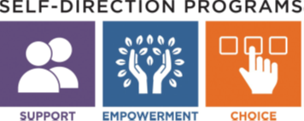

A DDS Self-Directed Support liaison is available for each DDS Area Office to help individuals and their families learn about **Agency with Choice** and the **Participant Directed Program.**

Not sure which area office serves you? Click here: [DDS area office locator](https://areaofficelocator.dds.state.ma.us/Home/LookupByCity)

**Metro North**

Missy Cohen

978-880-4877

[melissa.k.cohen@mass.gov](mailto:melissa.k.cohen@mass.gov)

Erin DiSanza

978-880-4693

[erin.disanza@mass.gov](mailto:erin.disanza@mass.gov)

**Merrimac Valley**

Ann Lorenzo

978-621-3130

[ann.lorenzo@mass.gov](mailto:ann.lorenzo@mass.gov)

**Central Middlesex**

Gail Bartlett

978-880-4611

[gail.bartlett@mass.gov](mailto:gail.bartlett@mass.gov)

**North Shore**

Joe Allouise

978-927-2727 x 1114

[joseph.allouise@mass.gov](mailto:joseph.allouise@mass.gov)

**Lowell**

Natalie Mersha

978-880-5934

[natalie.mersha@mass.gov](mailto:natalie.mersha@mass.gov)