INDOOR AIR QUALITY ASSESSMENT

**Norwell High School**

18 South Street

Norwell, Massachusetts

**April 2024**

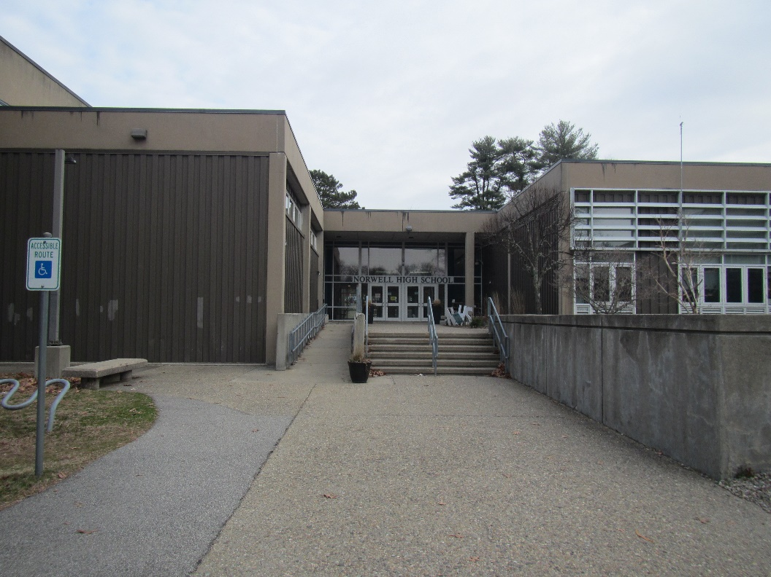

Prepared by:

Massachusetts Department of Public Health

Bureau of Climate and Environmental Health

Indoor Air Quality Program

Contents

EXECUTIVE SUMMARY 3

BACKGROUND 5

RESULTS AND DISCUSSION 5

Ventilation 6

HVAC System Maintenance 6

HVAC Types and Specific Conditions 7

Water Damage and Moisture Concerns 8

Sources of Respiratory Irritants/Possible Asthma Triggers 9

Other IAQ Issues 11

CONCLUSIONS AND RECOMMENDATIONS 12

REFERENCES 17

FIGURES 19

PICTURES 20

Table 1 29

Table 2A 29

Table 2B 30

Table 2C 31

Table 3 32

Table 4 34

# R an EXECUTIVE SUMMARY

The Massachusetts Department of Public Health’s Indoor Air Quality Program (MADPH IAQ) conducted an IAQ assessment of the Norwell High School located at 18 South Street on March 20, 2024. This assessment was requested by the Norwell School Department and Health Department.

Any building can have IAQ issues. These issues can be made worse through conditions common to marginalized communities (Environmental Justice communities or EJ) such as inequitable exposure to outdoor air pollution and a greater likelihood of poor building conditions leading to deterioration of IAQ resulting in higher asthma rates. The Norwell High School is not within an EJ community. The pediatric asthma rate for the town of Norwell as of 2018 is 6.1% compared to the statewide pediatric prevalence rate of 11.8%.

The assessment was conducted by evaluating several key elements within the school; a visual inspection of the heating, cooling, and ventilating (HVAC) systems, water/microbial damage, cleanliness, point sources of respiratory irritants such as chemicals, and electronic measurement of carbon dioxide (CO2), carbon monoxide (CO), temperature, relative humidity (RH), and small particulate matter (PM2.5) all taken with a Qtrak XP monitor. Data is collected in this manner to identify potential asthma triggers, allergens, and other environmental factors that can cause indoor air quality symptoms. Please refer to the [Indoor Air Quality Manual](https://www.mass.gov/lists/indoor-air-quality-manual-and-appendices#indoor-air-quality-manual-) on the MDPH website for methods, sampling procedures, and interpretation of results.

As a result of this assessment, there are several findings: conditions in this school are typical of high schools of this age and type, univents and other heating, ventilation, and air conditioning (HVAC) components are reaching their lifespan, some water-stained ceiling tiles were observed due to roof leaks, and there are occupant induced issues such as storage and handling of science chemicals, and clutter. (Results and Discussion)

Upon review of these findings, a number of recommendations are made to optimize existing HVAC systems and improve air exchange. However, the age of univents and other HVAC components will make maintenance increasingly difficult. Issues regarding the presence of point sources of irritation such as science storage and clutter can be addressed to reduce dust and odors. (Conclusions)

Based on the results of the assessment, the following primary recommendations are made:

* Operate supply and exhaust ventilation *continuously* when the building is occupied.

* Educate teachers and staff on the operation of univents and exhaust vents so they can avoid blocking units and can report off or inoperable units to facility staff.
* Reduce clutter, outdated chemicals, and other potential hazards in science preparation rooms.
* Consider reducing the number of items stored in rooms to make cleaning easier.

(Conclusions and Recommendations)

Please note: this report contains a series of recommendations that should serve as Best Practices that apply to most public-school buildings across the Commonwealth and should be shared amongst other buildings in the school district.

# R an BACKGROUND

|  |  |
| --- | --- |
| Building: | Norwell High School |
| Address: | 18 South Street  Norwell, Massachusetts |
| Assessment Requested by: | John Maurice, Facilities Manager,  Norwell Public Schools, and R. Benjamin Margro, Health Agent, Board of Health, Town of Norwell |
| Reason for Request: | General IAQ |
| Date of Assessment: | March 20, 2024 |
| Massachusetts Department of Public Health/Bureau of Climate and Environmental Health (MDPH/BCEH) Staff Conducting Assessment: | Ruth Alfasso, Inspector, IAQ Program |
| Building Description: | The Norwell High School is a concrete and metal building originally built in the 1970s. Renovations to heating, ventilating, and air conditioning systems (HVAC), windows, and interior finishes were completed in 2003. Additional upgrades to the HVAC system were conducted over the last few years. The building has two floors and multiple wings in a complex shape. It contains classrooms, offices, art and shop classrooms, and other accessory rooms, along with a gym, cafeteria, and auditorium. |
| Windows: | Most windows in the building are openable. |

# R an RESULTS AND DISCUSSION

The following is a summary of indoor air testing results (Table 1)

|  |  |  |
| --- | --- | --- |
| * ***Carbon dioxide (CO2)*** | *a measure of the adequacy of ventilation* | Levels were below the MDPH guideline of 800 parts per million (ppm) in most of the areas surveyed. A few areas had levels above 800 ppm, typically rooms with high occupancy. |
| * ***Temperature*** | *a measure of comfort* | Was within or slightly below the MDPH recommended range of 70°F to 78°F in occupied areas. In some cases, such as the gym or science labs, this may be intentional. |
| * ***Relative humidity*** | *a measure of comfort and, when in excess for an extended period, a way to reflect the potential for mold and fungal growth* | Was below the MDPH recommended range of 40 to 60% in all areas tested. Low relative humidity is typical with cold outdoor temperatures and indoor heating. |
| * ***Carbon monoxide***   ***(CO)*** | *a product of combustion that can result in acute and long term cardiovascular, respiratory, and neurological symptoms* | Levels were non-detectible in all areas assessed. |
| * ***Particulate matter (PM2.5)*** | *a way to measure inhalable particle distribution in the air* | Concentrations were below the National Ambient Air Quality Standard (NAAQS) of 35 micrograms per cubic meter (μg/m3) in all areas tested. Most measurements were non-detect (ND). |

## Ventilation

Ventilation refers to both the supply of fresh air and the removal of stale air from a room. The introduction of fresh air into an occupied space will dilute normally occurring pollutants that are generated by occupancy and other activities. In addition, an HVAC system will remove pollutants from a building if operating appropriately. All ventilation systems throughout the building should operate continuously during periods of occupancy.

Norwell High School has a combination of unit ventilators (univents), both mounted next to the exterior wall (Picture 1) and mounted on the ceiling (Picture 2), and rooftop air handing units. Univents bring in fresh air from a vent on the outside of the building (Picture 3), filter it, heat it, and supply the air through a vent. Some room air is recirculated along with the fresh air through a vent at the bottom (Figure 1). The air handling units bring in fresh air from the roof, filter it, heat it, and bring it into classrooms and offices through ceiling-mounted supply vents (Pictures 4 and 5). Classrooms are also equipped with exhaust vents that remove stale air from rooms. These are located on classroom walls or ceilings (Picture 6). Controls for the univents include carbon dioxide sensors (Picture 6) which are intended to supply more fresh air when carbon dioxide levels rise. These sensors were typically located near the classroom exhaust vent (Table 2B).

The various types of ventilation components as well as devices that can move/redirect airflow are listed in Table 2A, Table 2B and Table 2C.

### HVAC System Maintenance

* Univents date from the 2003 renovation, and are reaching or are beyond their service life According to the American Society of Heating, Refrigeration, and Air-Conditioning Engineering (ASHRAE), the service life of this type of unit is 15-20 years, assuming routine maintenance of the equipment (ASHRAE, 1991).
* Filters for univents and other AHU are changed twice a year.

### HVAC Types and Specific Conditions

**Balancing**

To have proper ventilation with a mechanical supply and exhaust system, a system must be balanced to provide an adequate amount of fresh air to the interior of a room while also removing stale air from the room.

It is recommended that HVAC systems be re-balanced every five years to ensure adequate air systems function (SMACNA, 1994).

(see HVAC pictures)

**Classroom Unit ventilators**:

* **Some univents were blocked with furniture or** **items** (Table 1).
* **Some univents were turned off by occupants**, due to noise or drafts (Table 1).
* Neither univent nor AHU filters could be examined**. The DPH IAQ Program recommends that ventilation equipment use the highest quality filters that can be used without compromising airflow in existing equipment**. A minimum MERV (minimum efficiency rating value) rating of 8 is recommended to filter out pollen and mold spores.

**Classroom Exhaust vents**:

* **All of the exhaust vents that were tested for air draw during the assessment were found to be working.** Broken or turned-off exhaust vents are a common finding in school classrooms.

**Additional HVAC Conditions:**

* **Most classrooms have openable windows (Table 1)**. These can be used for additional fresh air during temperate weather. Windows should be kept closed during wet weather, when air conditioning is operating in the room to prevent condensation and mold growth during elevated relative humidity, and at the end of the school day to prevent frozen pipes during the winter.
* **Some science classrooms and science prep rooms were equipped with lab hoods (Picture 7).** While these units are reportedly calibrated annually in accordance with regulations, it is not known if any of them are used. Several of them appeared to have chemicals and items stored inside. Lab hoods should not be used for storage.
* **The art room kiln is equipped with a large exhaust hood (Picture 8).** This unit should be used every time the kiln is operated until it has cooled down.
* **The wood and metal shop areas have task-based exhaust equipment and dust collection equipment (Picture 9).** These should be used whenever the associated equipment is used to remove dust, fumes, and odors from the breathing zone of occupants, including the equipment user. Dust collection equipment needs to be emptied and cleaned regularly.

## Water Damage and Moisture Concerns

Please note that the IAQ Program does not recommend conducting mold testing in a typical water damage remediation. For details, please consult [Guidance Regarding Testing for Mold in Water-Damaged Public Buildings](https://www.mass.gov/info-details/guidance-regarding-testing-for-mold-in-water-damaged-public-buildings) | Mass.gov

The application of a mildewcide to moldy porous materials is not recommended.

Molds are found naturally in our environment both indoors and outdoors. Inside, mold growth may occur when items, particularly porous products such as paper or gypsum wallboard, are exposed to moisture. Typical water sources include leaks, floods, and condensation. To avoid mold growth, dry all water-damaged items and affected areas within 24-48 hours and reduce indoor humidity. Some people with chronic respiratory conditions, such as asthma, are more likely to experience health symptoms associated with molds, including allergic reactions and respiratory irritation. Controlling moisture is the key to preventing mold growth and potential health symptoms.

Hot humid summers are becoming more frequent due to climate change. Massachusetts has experienced hot, humid, and rainy summers in 2018, 2021, and 2023. July of 2021 was the wettest ever recorded in Massachusetts, and the three-month period from June through August, known as the meteorological summer, was the fourth wettest on record, according to the National Oceanic and Atmospheric Administration’s (NOAA) Centers for Environmental Information (NOAA, 2021). The summer of 2023 was also hot, and wet, being measured as the second rainiest on record (WBUR, 2023). These conditions are challenging for buildings, particularly those without air conditioning.

During these hot and wet summers, extended periods of outdoor relative humidity above 70% occurred. Under these weather periods, public buildings experienced extended periods of water vapor exposure from high relative humidity. When exposed to these conditions, porous materials such as gypsum wallboard, cardboard, and other materials may become prone to developing mold colonization, particularly if located in areas that are prone to developing condensation on floors and walls (e.g., below grade space).

* **Water-damaged ceiling tiles were found in a few locations (Picture 11; Table 1),** which can indicate current/historic roof/plumbing leaks or other water infiltration. Water-damaged ceiling tiles can provide a source of mold and should be replaced after a water leak is discovered and repaired. The roof of the NHS is known to leak in some areas and plans for a new roof are in process.
* **Bowed or sagging ceiling tiles were noted in some areas (Table 1).** This is an indication that these rooms have been subject to an extended period of high humidity.
* **Plants were noted in some classrooms and offices (Picture 12).** Plants can be a source of pollen or mold especially if overwatered or not well maintained. They should also be kept away from sources of air movement.
* **Light mold staining was noted on the gasket of the refrigerator in the life skills room (Picture 13).** The mold and any associated debris should be removed using an antimicrobial cleaner. If the gasket is unable to be cleaned, it can be replaced.
* There are sinks in some classrooms including science classrooms. **If sinks are not used regularly, the drain trap may dry out and allow sewer gas into the room.**
* **Science classrooms are equipped with emergency showers and eyewash stations.** These are reportedly tested each summer as required. In addition, the area around each shower should be kept clear of porous items and other items that could be damaged by exposure to water.
* **The NHS is located in a heavily wooded area (Picture 14),** althoughthere are no trees directly adjacent to the building, Trees can be a source of debris which can clog roof drains and lead to water infiltration. In addition, during severe weather, trees may fall on the building.
* **Damage was noted on metal siding in a few areas of the building exterior (Picture 15).** Picture 15 also shows staining due to moss, which indicates that this area of the building does not fully dry.

A list of water damage issues identified inside and outside the building were identified which can contribute to water issues, is included as Table 3.

(see Water Damage and Moisture Concern Pictures)

**Mold Growth**

Porous materials (e.g., gypsum wallboard, ceiling tiles and carpeting) can be dried with fans and heating within 24 to 48 hours of becoming wet (US EPA, 2008).

If porous materials are not dried within this time frame, mold growth may occur.

## Sources of Respiratory Irritants/Possible Asthma Triggers

Asthma is a lung disease that can make breathing difficult. Without careful management of asthma, some people can have symptoms, like a tight feeling in the chest, shortness of breath, coughing, or wheezing. Although there is no cure for asthma, people with asthma can live healthy, active lives. A safe and healthy environment helps to reduce asthma symptoms.

**Comparison of Local and State-wide Asthma Rates**

6.1% of children

have asthma

**Norwell**

11.8% of children

have asthma

**Massachusetts**

Asthma data is submitted to the state for grades K-8 only

**Norwell High School**

* **Sometimes, learning tools and personal items in a classroom can be a source of irritants.** For example, a bird or insect nest is a great learning tool for students but may harbor microbes and allergens. Similarly, food-based projects can attract pests that carry disease or trigger allergies.
* **Personal products, particularly those with volatile organic compounds (VOCs) including scents, can also be a source of respiratory irritation.** VOCs are carbon-containing substances that have the ability to evaporate at room temperature. Frequently, exposure to low levels of total VOCs (TVOCs) may produce eye, nose, throat and/or respiratory irritation in some sensitive individuals.
* **Dust, a common respiratory and eye irritant, can collect on surfaces and items.** Although janitorial and maintenance staff perform routine cleaning in classrooms, they may not be able to clean as effectively if classroom items are not picked up or surfaces are cluttered.
* Even with a properly functioning ventilation system, it is necessary to either eliminate or reduce the use of materials that can be a source of respiratory irritants to prevent symptoms in individuals who have sensitivity to such pollutants.

For guidance on maintaining an asthma-friendly healthy school environment, please consult the MDPH Asthma Prevention and Control Program’s [Clearing the Air: An Asthma Toolkit for Healthy Schools](https://www.maasthma.org/schooltoolkit).

Possible asthma triggers and/or airborne pollutants exist in the building. These are listed below as well as in (Table 4).

(see Sources of Respiratory Irritant Pictures)

* **Exposure to low levels of total volatile organic compounds (TVOCs) may produce eye, nose, throat, and/or respiratory irritation in some sensitive individuals.** BCEH/IAQ staff noted products containing VOCs such as hand sanitizers, cleaners, dry erase materials, and a variety of scented products/air fresheners (Picture 16; Table 1) in use within the building. These products have the potential to be irritants to the eyes, nose, throat, and respiratory system of sensitive individuals. Consult “[Clean Air Is Odor Free](https://www.mass.gov/doc/clean-air-is-odor-free-removing-fragrances-to-improve-indoor-air-quality-in-schools-and-offices-0/download)” for more information on fragrances in schools and other building. Note that one room with a scent diffuser also had elevated levels of PM2.5.
* **Tennis balls had been sliced open and placed on table/chair footings to reduce noise in a few areas** **(Picture 17).** Tennis balls are made of a number of materials that are a source of respiratory irritants. Constant wearing of tennis balls can produce fibers and lead to off gassing of VOCs. Tennis balls are made with a natural rubber latex bladder, which becomes abraded when used as a chair leg pad. Use of tennis balls in this manner may introduce latex dust into the school environment. Some individuals are highly allergic to latex (e.g., spina bifida patients) (SBAA, 2001). It is recommended that the use of materials containing latex be limited in buildings to reduce the likelihood of symptoms in sensitive individuals (NIOSH, 1997).
* **Of particular concern is chemical storage found in several science preparation rooms.** As shown in Pictures 18-22, large amounts of materials are stored in science preparation rooms, including a variety of chemicals. While most chemicals found in these rooms are, or are similar to, common household products, there are also flammable, corrosive, and toxic materials stored. The following conditions were observed:
  + - **Chemicals stored in a disorganized manner (Pictures 18-20).** This may lead to unwanted chemical interactions, spills, and use of the wrong chemicals during experiments.
    - **Materials stored in the laboratory hood (Picture 19).** Nothing should be stored in laboratory hoods.
    - **Chemical bottles which appear to have dates from the 1970s and 1980s (Picture 21).** While some materials may remain in good condition for that long, most will not. This also suggests that any cleanouts of material in these storerooms have not been comprehensive.
    - **Other disorganized materials such as glassware (Picture 22)** which can lead to breakage and injury.
    - **Use of laboratory refrigerators for storing both food and chemistry items.** This is a hazardous condition.
    - **Flammable materials storage cabinets which are not vented.** This can allow fumes from flammable materials to build up.
* **The life skills room had (electric) stoves without direct-vented exhaust hoods (Picture 23**). They appear to have hoods which recirculate air only. Even with regular filter changes, these are less effective at removing particulates and odors from cooking.
* **A 3-D printer was located in a shop room (Picture 10).** These can be a source of odors and fumes from melting plastic. They should be used with good ventilation.
* **Some classrooms and storage rooms had an excess of items such as books, craft materials, papers, and other materials.** Items need to be stored neatly so that effective cleaning can be performed.
* **Some classrooms were equipped with area rugs (Table 1).** These need to be cleaned regularly to remove dust, debris, and odors. Area rugs should be stored off the floor in a climate-controlled area during the summer to prevent moistening by condensation. Used area rugs should not be brought into the school as they may harbor allergens such as pet dander. Used upholstered furniture should also not be used in classrooms (Picture 24).
* **Air purifiers were noted in some classrooms (Table 1).** These appear to be units which use high efficiency particulate arrestance (HEPA) filters, and, in some cases, an additional carbon filter. These are good choices for use in occupied areas. Air purifiers that may produce ozone should not be used (EPA, 2003) All air purifiers should be cleaned and maintained in accordance with manufacturer’s instructions.
* **In some areas supply/exhaust vents and personal fans were dusty (Table 1; Picture 25).** This dust can be aerosolized under certain conditions and can also be a medium for mold growth. Univent cabinets can also accumulate dust and debris.

## Other IAQ Issues

*Radon*

Radon is a naturally occurring radioactive gas that seeps into buildings from the surrounding soil and at elevated levels can increase the risk of lung cancer.

The Environmental Protection Agency (EPA) conducted a National School Radon Survey “in which it discovered nearly one in five schools has at least one schoolroom with a short-term radon level above the action level of 4pCi/L (picocuries per liter) – the level at which the EPA recommends that schools take action to reduce the level” (US EPA, 1993).

**The BCEH/IAQ Program therefore recommends that every school be tested for radon, and that this testing be conducted during the heating season while school is in session in a manner consistent with USEPA radon testing guidelines**. Radon measurement specialists and other information can be found at [www.nrsb.org](http://www.nrsb.org) and <http://aarst-nrpp.com/wp>, with additional information at: <https://www.mass.gov/radon>.

# R an CONCLUSIONS AND RECOMMENDATIONS

Please note: this report contains a series of recommendations that should serve as *Best Practices* that apply to most public-school buildings across the Commonwealth and should be shared amongst other buildings in the School District.

Issues typical to many schools were found in this building. The age of the univents will make controlling temperature and airflow more difficult as time goes on. Some water damage was observed due to roof leaks. Chemical and other material storage in the science preparation rooms is currently disorganized and inadequate. Other occupant-induced issues were observed such as clutter and the use of fragrances.

**Short-term recommendations** can be implemented as soon as practicable, however **long-term measures** are more complex and will require planning and resources to adequately address overall indoor air quality concerns within the building. Note that the Norwell School Department is beginning planning for a new High School which may limit the ability and the need to make capital repairs to this building.

|  |  |  |
| --- | --- | --- |
| **Short-term Recommendations** | | |
| **HVAC System** | | **Helpful Links** |
|  | Ensure all univents are on and operating *continuously* during occupied periods. If univent fan operation is linked to thermostat, work with HVAC vendor to operate independently as to not “cycle” off/on during the school day. |  |
|  | Remove blockages from AC units in classroom closets, exhaust vents, and the top/front of univents, including furniture and items. |  |
|  | Periodically check the function of all classroom and restroom exhaust vents and repair as needed. |  |
|  | Close classroom doors for improved exhaust vent function and air exchange. |  |
|  | Continue with regular filter changes for HVAC equipment using a minimum efficiency rating value (MERV) 8 or the best quality/highest MERV-rated filter that can be used without effecting airflow.  Ensure filters fit flush within their racks to prevent filter bypass. | [ANSI/ASHRAE Standard 52.2-2017](https://www.ashrae.org/File%20Library/Technical%20Resources/COVID-19/52_2_2017_COVID-19_20200401.pdf) |
|  | During filter changes, clean dust and debris from the inside of univent and HVAC system cabinets. |  |
|  | Have the carbon dioxide sensing system monitored, calibrated, or replaced as recommended by the manufacturer. |  |
|  | Use task-based exhaust and dust control equipment for shops, the kiln, and lab hoods, consistently. Clean and maintain these systems to ensure proper operation. |  |
|  | Use openable windows for additional fresh air during temperate weather. Tightly close windows at the end of the day and avoid opening windows when air conditioning is in use or during extreme cold to prevent freezing of pipes. |  |
| **Water Damage Sources** | | |
|  | Replace water-damaged ceiling tiles. Repeated water damage to ceiling tiles indicates leaks from the roof or plumbing/HVAC system which should be repaired. | <http://www.epa.gov/mold/mold-remediation-schools-and-commercial-buildings-guide> |
|  | Do not store cardboard or other porous items directly on floors to prevent mold growth due to condensation on cool surfaces, Elevate items with pallets or store on shelving. |  |
|  | Properly maintain plants to avoid mold and odors. Keep plants away from airflow of HVAC equipment. |  |
|  | Clean the gaskets of refrigerators to remove debris and mold. Replace gaskets that are worn or unable to be cleaned. |  |
|  | Pour water down drains that aren’t used regularly to avoid dry drain traps. |  |
|  | Avoid storing porous items and items sensitive to water near the safety showers. |  |
|  | Monitor the condition of trees near the exterior of the building and remove dead or damaged trees before they fall. |  |
|  | Monitor condition of building siding, and remove/clean moss from building exterior periodically. |  |
|  | Use these guidelines to control for moisture and increase comfort in a non-air-conditioned school especially during heatwaves. | * Mold Growth Prevention During Hot, Humid Weather <https://www.mass.gov/service-details/preventing-mold-growth-in-massachusetts-schools-during-hot-humid-weather> * Remediation and Prevention of Mold Growth and Water Damage in Public Schools <https://www.mass.gov/service-details/remediation-and-prevention-of-mold-growth-and-water-damage-in-public-schools-and> * Methods for Increasing Comfort in Non-air-conditioned Schools <https://www.mass.gov/doc/methods-for-increasing-comfort-in-non-air-conditioned-schools/download> |
|  | While bowed/sagging ceiling tiles are not a source of mold, this indicates extended exposure to high humidity. Therefore, care should be taken with storage of materials in these areas during hot, humid weather and over the summer. |  |
|  | During summer months, pull furniture away (1 to 2 inches) from walls to prevent mold growth due to lack of airflow and remove impermeable wall coverings that can trap moisture such as laminated posters. |  |
| **Respiratory Irritants/Possible Asthma Triggers** | | |
|  | Reduce use of products and equipment that create irritating volatile organic compounds (VOCs) and only use in well-ventilated areas. Minimize the use of air fresheners (e.g., plug-ins), deodorizers and scented products. | <https://www.mass.gov/cleaner-greener-healthier-schools> |
|  | Avoid using latex-containing tennis balls as chair or table glides. Replace with latex-free glides or other materials. | <https://www.cdc.gov/niosh/docs/97-135/default.html>  <https://www.spinabifidaassociation.org/wp-content/uploads/latex-in-the-home-and-community-eng.pdf> |
|  | Perform a thorough clean-out of all science preparation rooms to remove outdated chemicals and unnecessary items. Store remaining items neatly, with every chemical container clearly labeled. Only store compatible products together, Avoid using the same refrigerators for both chemistry items and food. | <https://www.mass.gov/info-details/improper-chemical-storage-or-usage> |
|  | Use care when operating stoves without exhaust ventilation to avoid burning food or creating irritating odors. Keep all kitchen equipment clean. |  |
|  | Operate 3-D printers in accordance with NIOSH recommendations. | <https://www.cdc.gov/niosh/research-rounds/resroundsv1n12.html> |
|  | Clean personal fans, supply, and exhaust/return vents periodically to remove dust and debris. |  |
|  | Clean area rugs frequently using a HEPA-equipped vacuum cleaner. Clean upholstered items regularly. Avoid bringing used area rugs, couches, and other items into the school. |  |
|  | Use only District-approved cleaning products. Keep spray bottles properly labeled and out of the reach of children. |  |
|  | Periodically sort classroom and stored items to remove unwanted items. Store remaining items neatly and off the floor. Where rooms have a history of moisture issues, consider storing items in waterproof totes |  |
|  | Clean and maintain air purifiers in accordance with manufacturer’s instructions. Avoid the use of air purifiers that may product ozone. | <https://www.epa.gov/indoor-air-quality-iaq/ozone-generators-are-sold-air-cleaners> |
| **Other Recommendations to Improve Air Quality Conditions** | | |
|  | * Test the school for radon by a certified radon measurement specialist during the heating season when school is in session. Radon measurement specialists and other information can be found at: | * [www.nrsb.org](http://www.nrsb.org) * <http://aarst-nrpp.com/wp> |
|  | * To learn more about radon, review the MDPH’s Radon in Schools and Child Care Programs factsheet, with additional information. | * <https://www.mass.gov/radon>. |
|  | * Utilize the US EPA’s (2000), “Tools for Schools”, as an instrument for maintaining a good IAQ environment in the building. | * <https://www.epa.gov/iaq-schools>. |
|  | * For guidance on maintaining an asthma-friendly healthy school environment, please consult the MDPH Asthma Prevention and Control Program’s *Clearing the Air: An Asthma Toolkit for Healthy Schools*. | * <https://www.maasthma.org/schooltoolkit> |
|  | * Include an IAQ component in the school’s Wellness Advisory Committee program. An IAQ plan should have an IAQ liaison/teacher representative, a member of maintenance/facilities and administration that conduct regular walk-throughs to identify on-going and/or potential environmental issues. |  |
| **Long-term Recommendations** | | |
|  | Since univents are reaching their service life, contact an HVAC engineering firm for advice regarding conditions noted, including a building-wide HVAC equipment assessment to determine:   * Whether the existing HVAC system can be balanced as recommended. * The operability and feasibility repairing the existing equipment. * If the equipment should be replaced due to age, physical deterioration, and availability of parts for ventilation components. | |
|  | Consider installing additional sensor technology in classrooms to provide continuous monitoring of the following indoor air parameters (particularly temperature and relative humidity). Sensors should be re-calibrated quarterly or according to manufacturer’s specifications and building management software updated as per manufactures instructions, industrial standards, and/or change in operating systems. For an example, the following link illustrates how this technology is serving Boston Public Schools to improve air quality [COVID-19 Health & Safety Information / Indoor Air Quality Sensor Dashboard (bostonpublicschools.org)](https://www.bostonpublicschools.org/Page/8810)   * + Temperature   + Relative Humidity   + Carbon monoxide, and   + Particulate matter (PM2.5) | |

# REFERENCES

ASHRAE. 1991. ASHRAE Applications Handbook, Chapter 33 “Owning and Operating Costs”. American Society of Heating, Refrigeration and Air Conditioning Engineers, Atlanta, GA.

ASHRAE. 2012. American Society of Heating, Refrigeration and Air Conditioning Engineers (ASHRAE) Standard 52.2-2012 -- Method of Testing General Ventilation Air-Cleaning Devices for Removal Efficiency by Particle Size (ANSI Approved).

MDPH. 2015. Massachusetts Department of Public Health. Indoor Air Quality Manual: Chapters I-III. Available at: <https://www.mass.gov/lists/indoor-air-quality-manual-and-appendices>.

NIOSH. 1997. NIOSH Alert Preventing Allergic Reactions to Natural Rubber latex in the Workplace. National Institute for Occupational Safety and Health, Atlanta, GA.

NOAA. 2021. Summer 2021 neck and neck with Dust Bowl summer for hottest on record. National Oceanic and Atmospheric Administration, 1401 Constitution Avenue NW, Room 5128, Washington, DC 20230 <https://www.noaa.gov/news/summer-2021-neck-and-neck-with-dust-bowl-summer-for-hottest-on-record>

SBAA. 2001. Latex In the Home And Community Updated Spring 2001. Spina Bifida Association of America, Washington, DC.

SMACNA. 1994. HVAC Systems Commissioning Manual. 1st ed. Sheet Metal and Air Conditioning Contractors’ National Association, Inc., Chantilly, VA.

US EPA. 1993. Radon Measurement in Schools, Revised Edition. Office of Air and Radiation, Office of Radiation and Indoor Air, Indoor Environments Division (6609J). EPA 402-R-92-014.

US EPA. 2000. Tools for Schools. Office of Air and Radiation, Office of Radiation and Indoor Air, Indoor Environments Division (6609J). EPA 402-K-95-001, Second Edition. <http://www.epa.gov/iaq/schools/index.html>.

US EPA. 2003. “Ozone Generators that are Sold as Air Cleaners: An Assessment of Effectiveness and Health Consequences”. United States Environmental Protection Agency, Office of Air and Radiation, Indoor Environments Division, Washington, DC. Last updated September, 2018. https://www.epa.gov/indoor-air-quality-iaq/ozone-generators-are-sold-air-cleaners

US EPA. 2008. Mold Remediation in Schools and Commercial Buildings. US Environmental Protection Agency, Office of Air and Radiation, Indoor Environments Division, Washington, D.C. EPA 402-K-01-001. <http://www.epa.gov/mold/mold-remediation-schools-and-commercial-buildings-guide>.

WBUR. 2023. “It's been a summer of rain and flooding misery in Mass.” WBUR local news. September 12, 2023. <https://www.wbur.org/news/2023/09/12/summer-flooding-rain-massachusetts>.

# R an FIGURES

**Figure 1**

**Unit Ventilator (Univent)**

Mixed Air

Air Diffuser

**Outdoors Indoors**

Fan

Heating/Cooling Coil

Air Mixing Plenum

Filter

Outdoor Return

Air Air

Air

Flow

Control

Louvers

**Air Flow**

= Fresh Air/Return Air

= Mixed Air

# 

# R an PICTURES

(Click to link back to report)

HVAC pictures

**Picture 1**

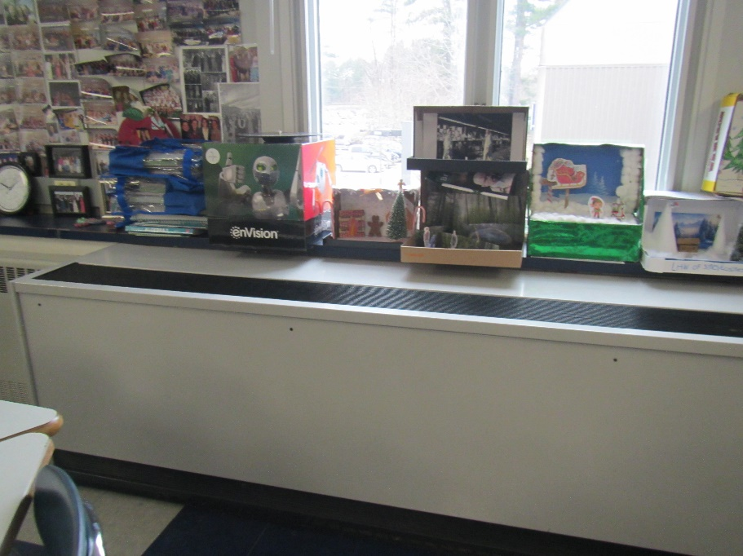

**Unit ventilator (univent) along exterior wall**

**Picture 2**

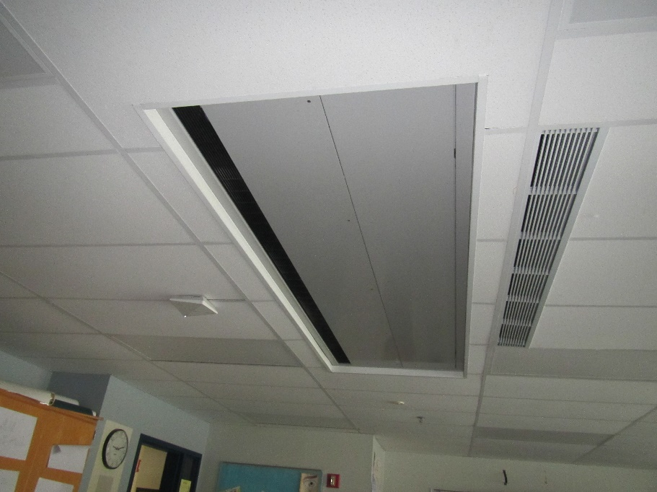

**Univent mounted on the ceiling**

**Picture 3**

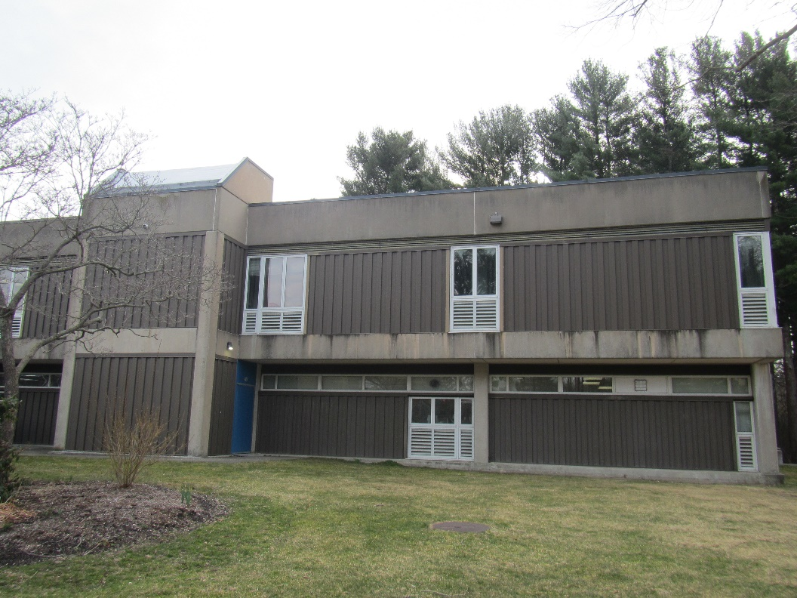

**Univent fresh air intakes on building exterior, under windows**

**Picture 4**

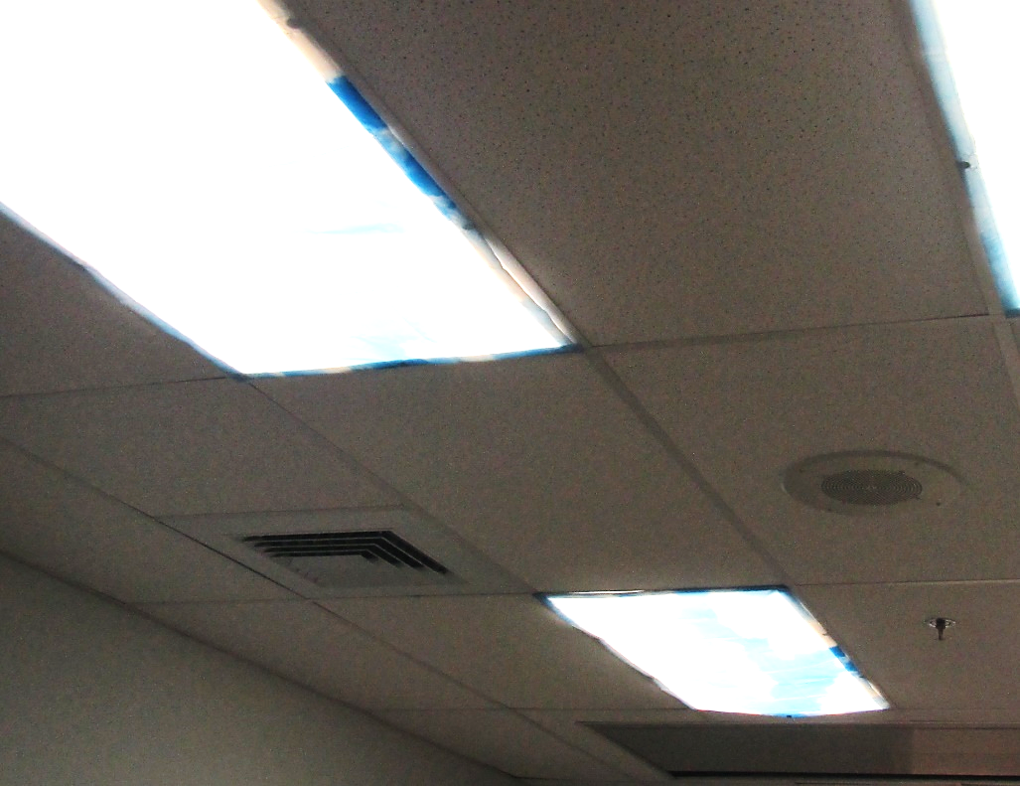

**Ceiling-mounted supply vent**

**Picture 5**

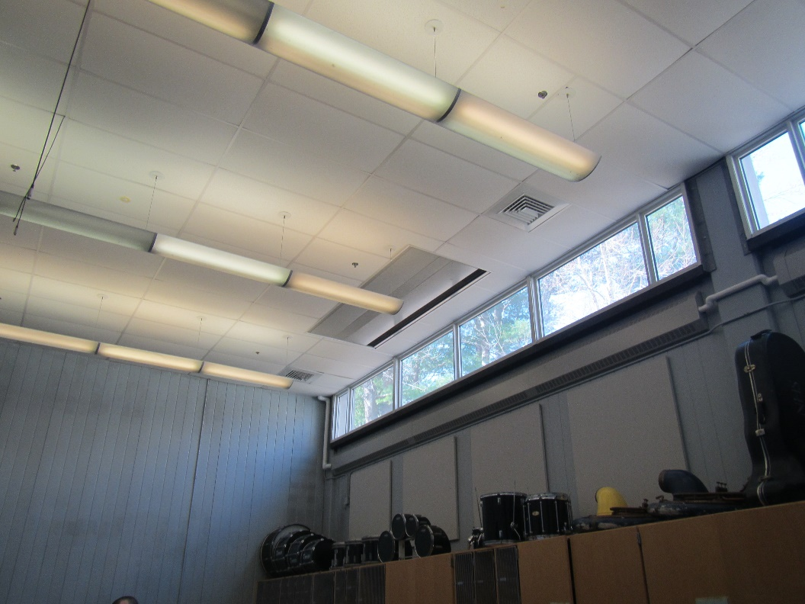

**Ceiling-mounted supply vent and ceiling-mounted univent in the music room**

**Picture 6**

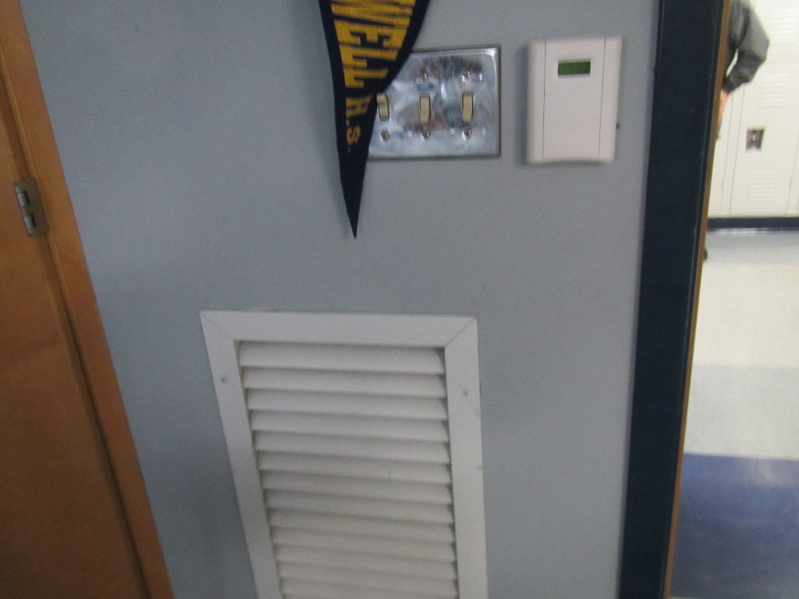

**Exhaust vent on classroom wall near door, note carbon dioxide sensor (white box in upper right)**

**Picture 7**

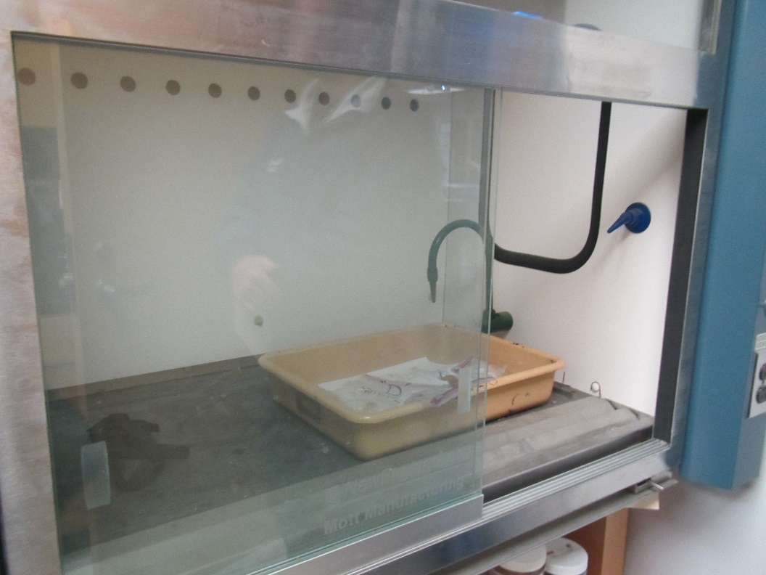

**Lab hood in science classroom**

**Picture 8**

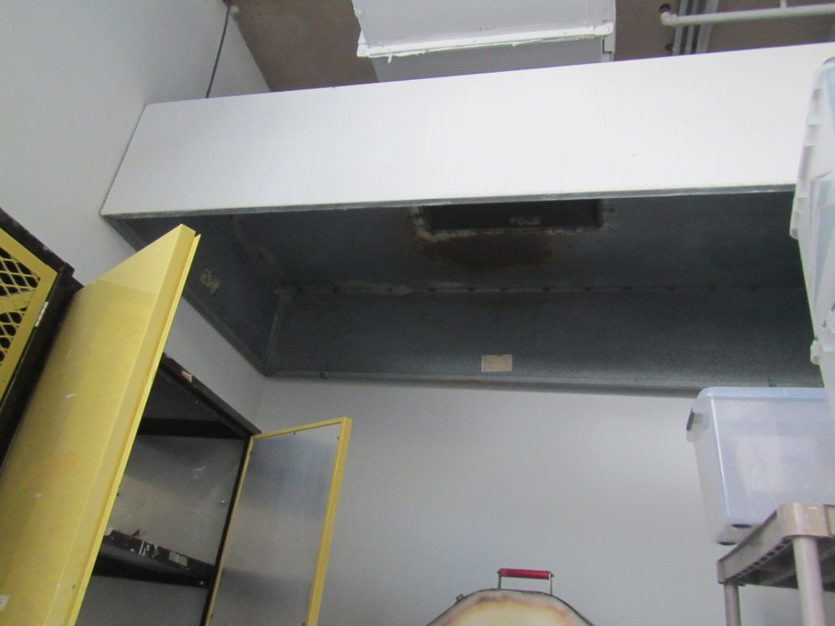

**Large overhead exhaust vent for the kiln**

**Picture 9**

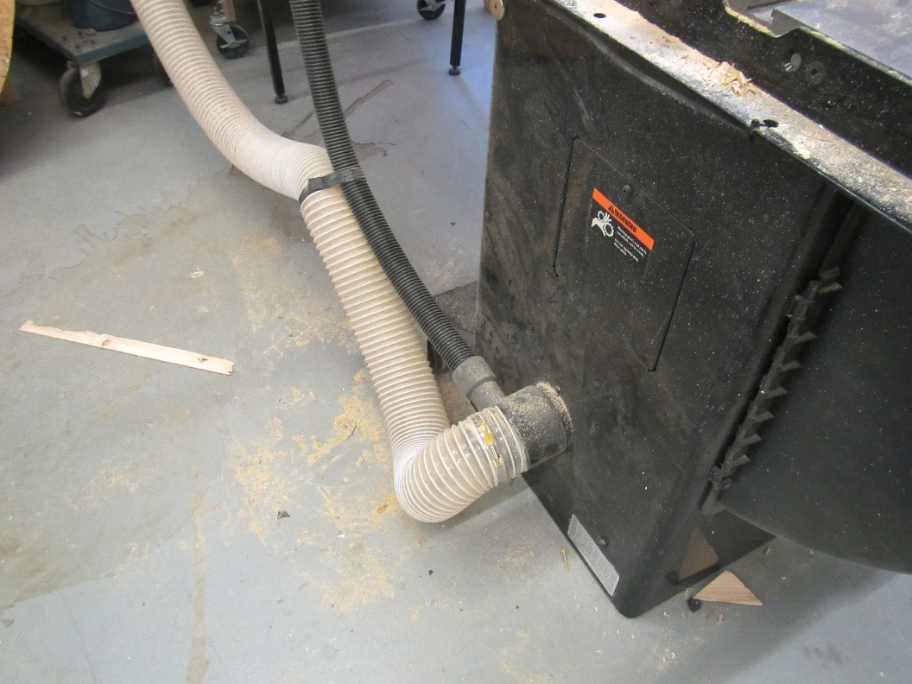

**Part of a dust collection system in the wood shop**

**Picture 10**

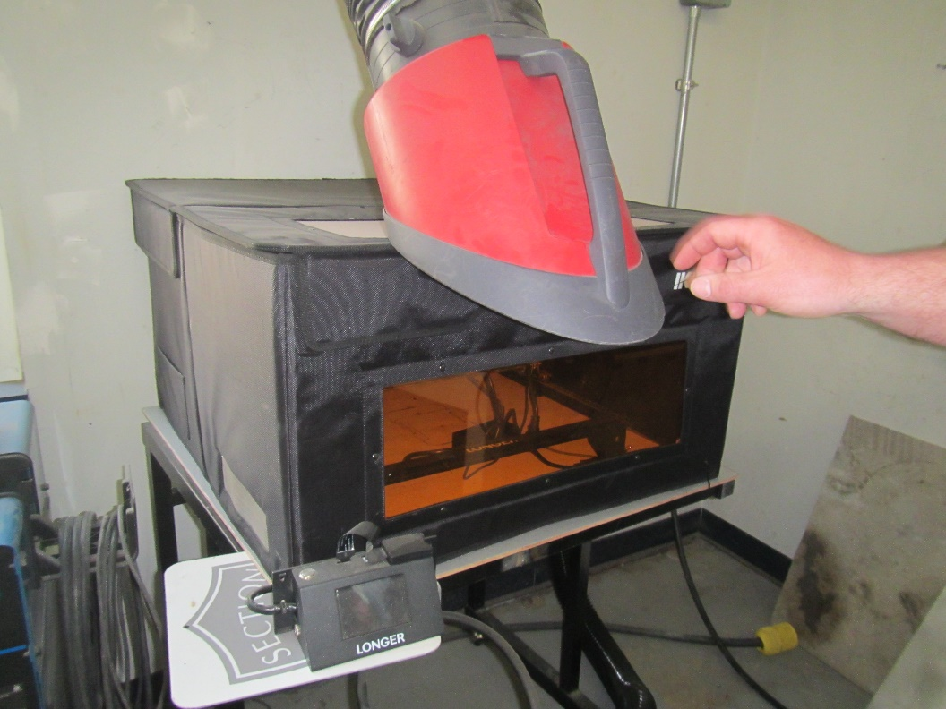

**Welding fume removal vent, and 3-D printer**

Water Damage and Moisture Concern Pictures

(click to link back to report)

**Picture 11**

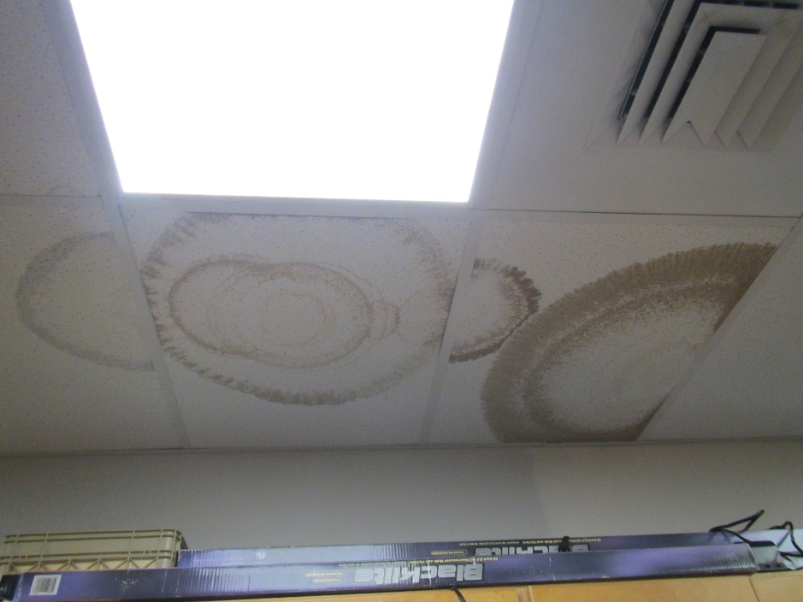

**Water-damaged ceiling tiles**

**Picture 12**

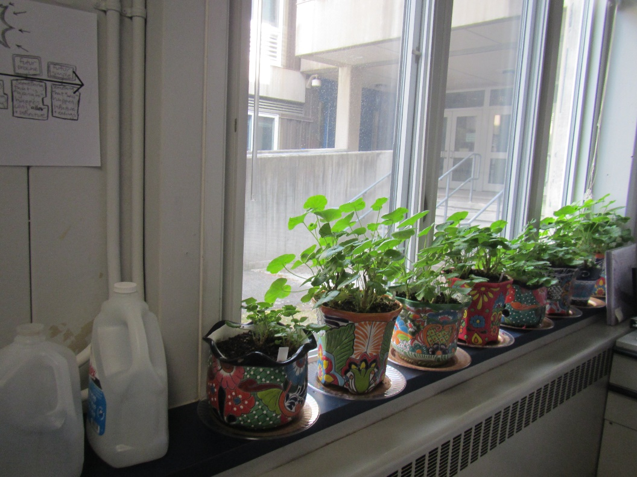

**Plants on a radiator**

**Picture 13**

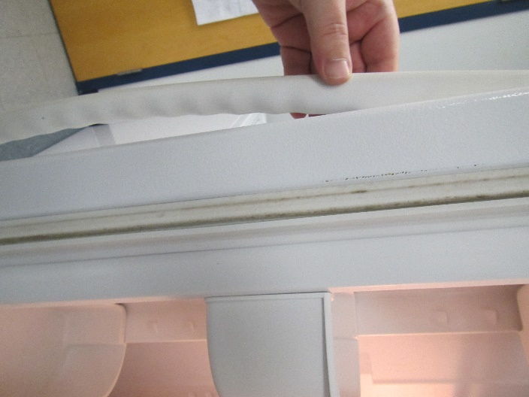

**Debris and mold on refrigerator gasket**

**Picture 14**

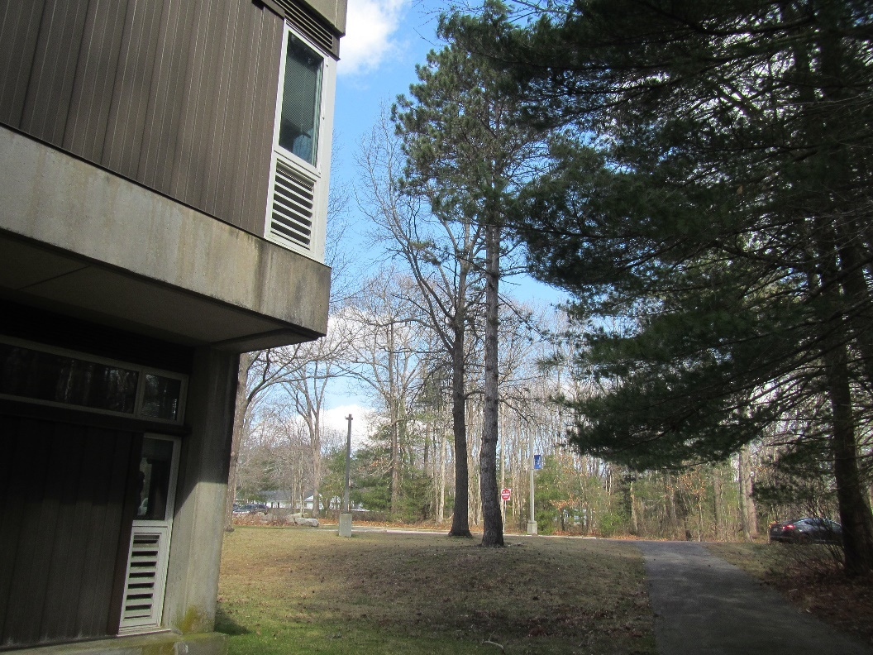

**Trees close enough to fall on the building during severe weather**

**Picture 15**

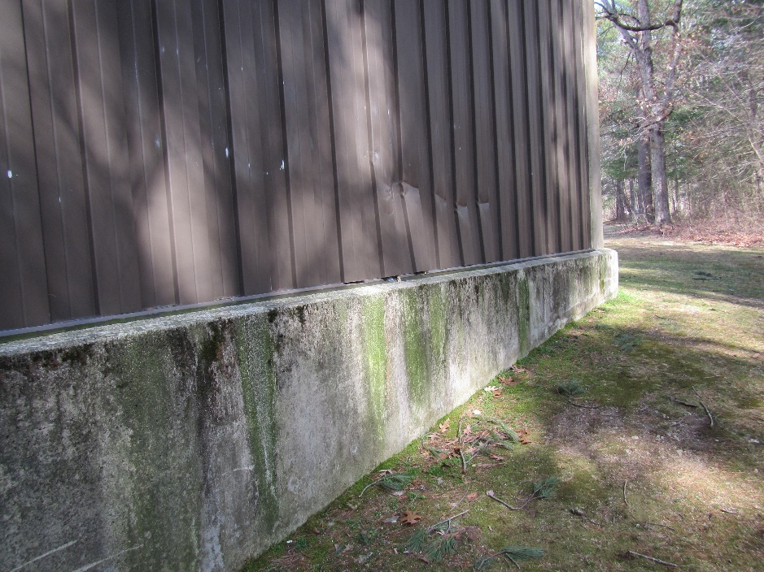

**Damage to metal siding of the building, and staining with moss**

Sources of Respiratory Irritant Pictures

(Click to link back to report)

**Picture 1****6**

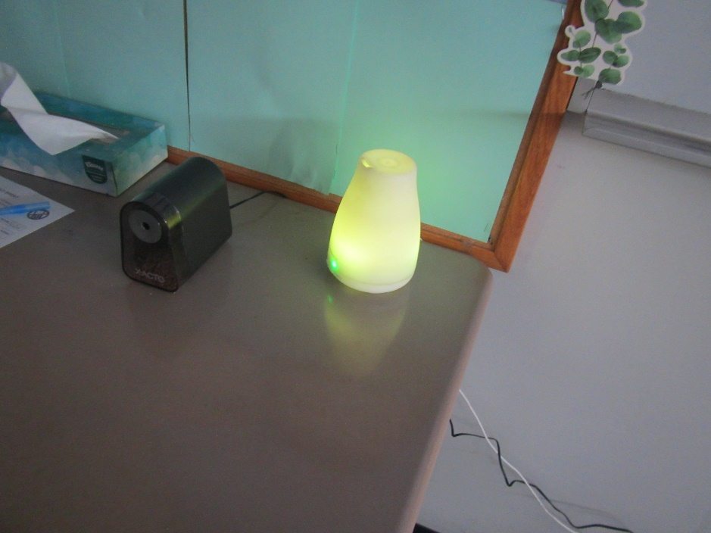

**Scent diffuser**

**Picture 17**

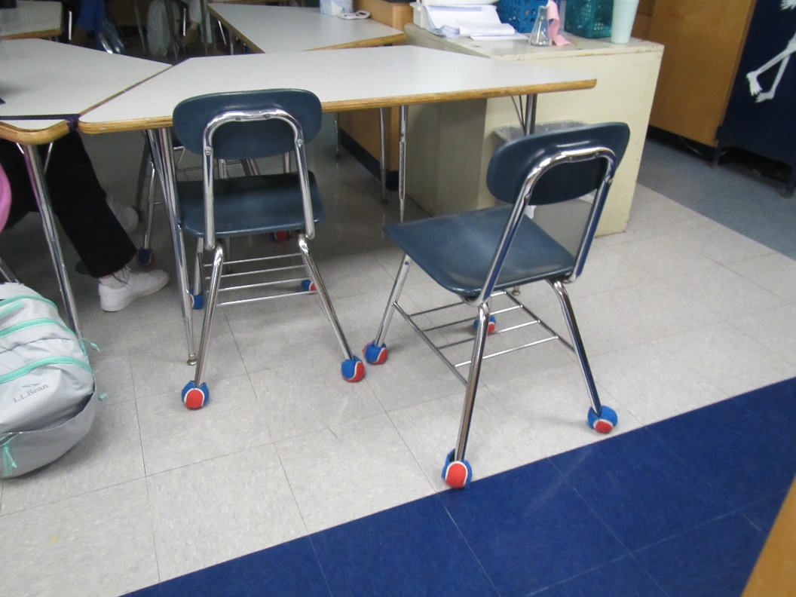

**Tennis balls used as chair glides**

**Picture 18**

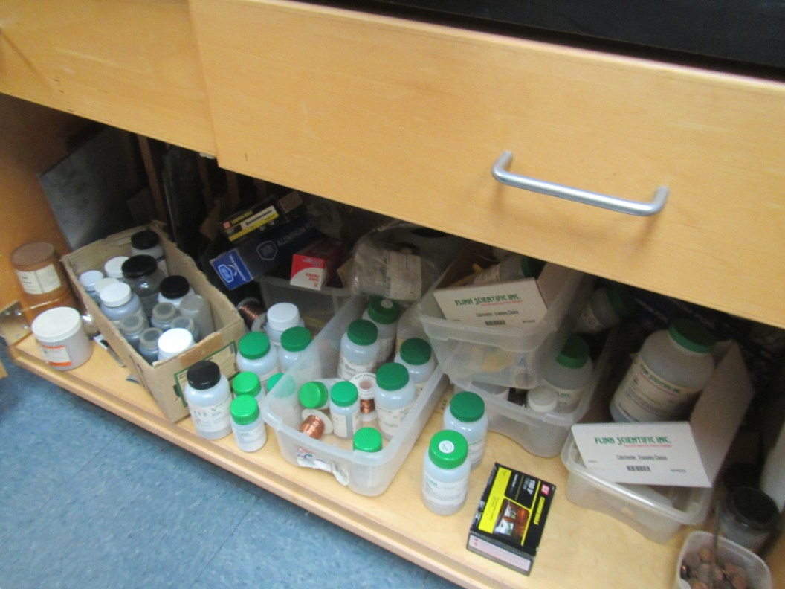

**Disorganized chemical storage**

**Picture 19**

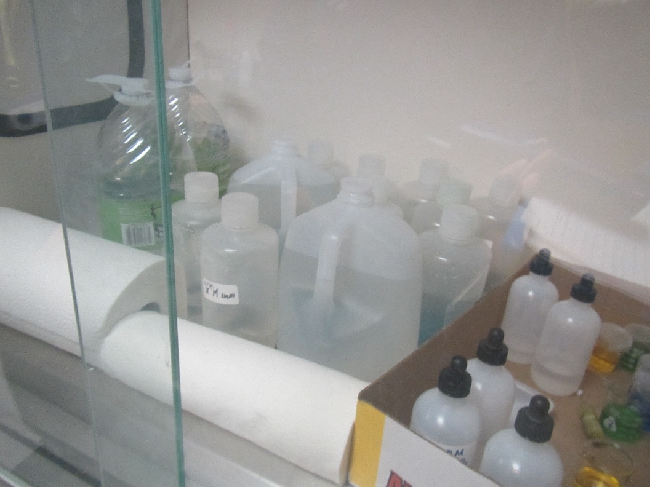

**Chemicals stored inside lab hood**

**Picture 20**

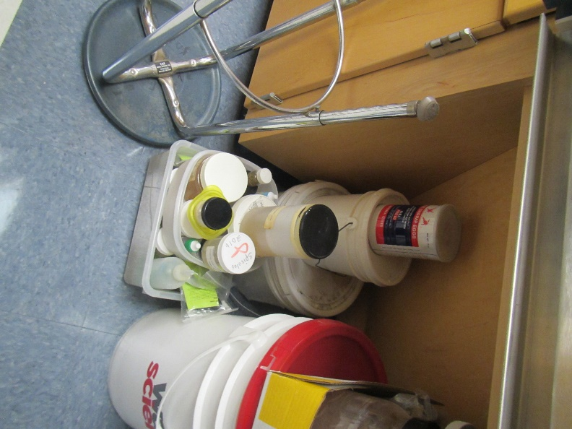

**Materials stored on the floor of a science preparation room**

**Picture 21**

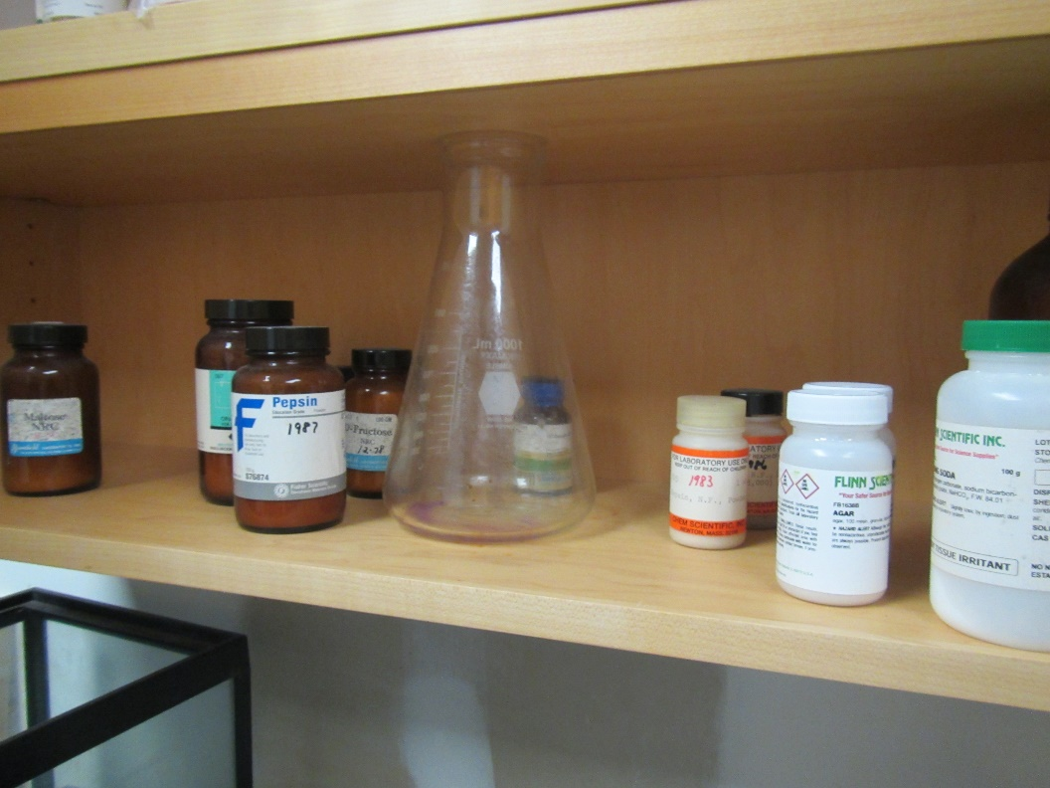

**Chemistry items which appear to have dates in the 1970s and 1980s**

**Picture 22**

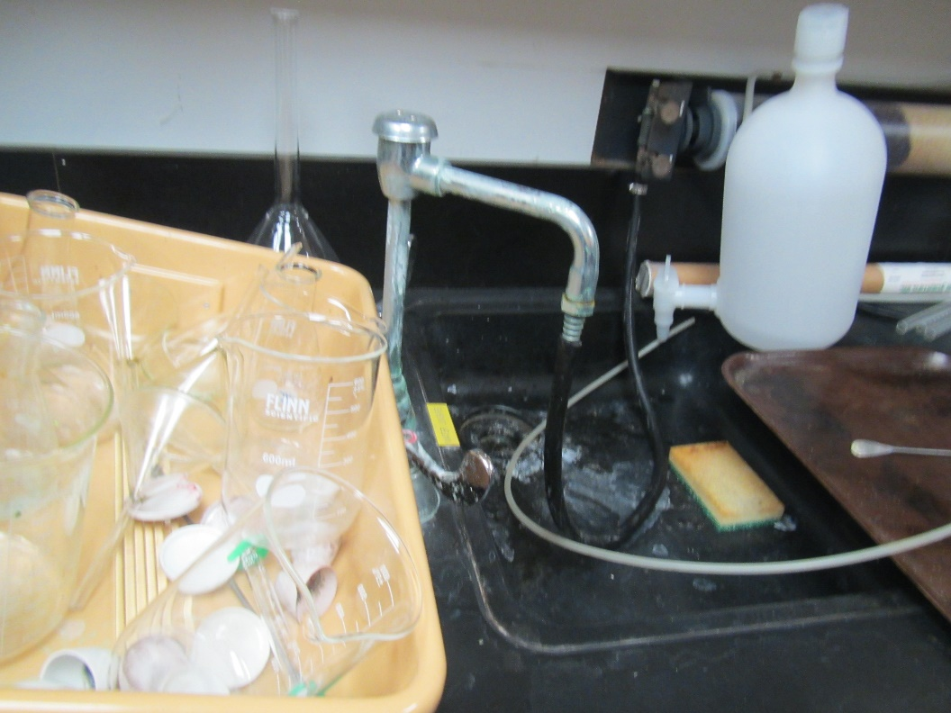

**Precariously-stored glassware in a science preparation room**

**Picture 23**

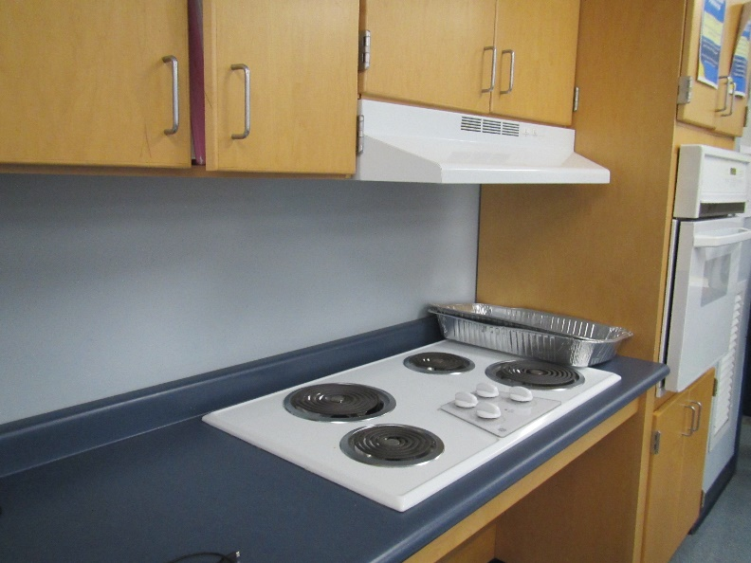

**Stove with recirculating hood**

**Picture 24**

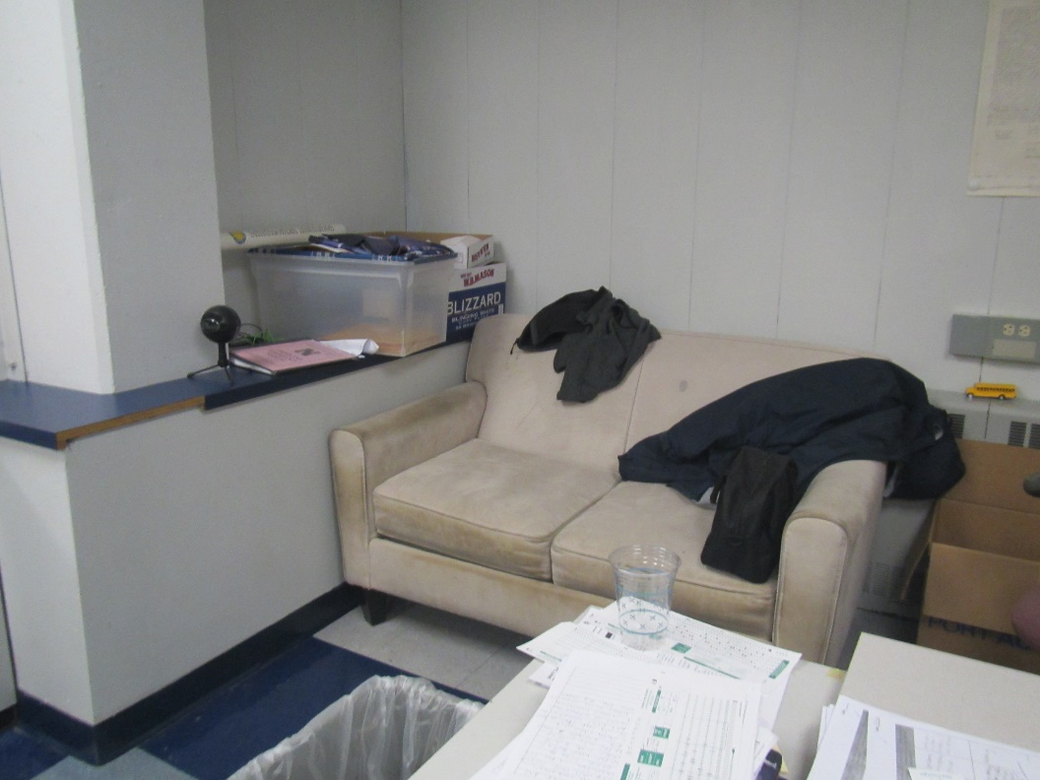

**Used couch**

**Picture 25**

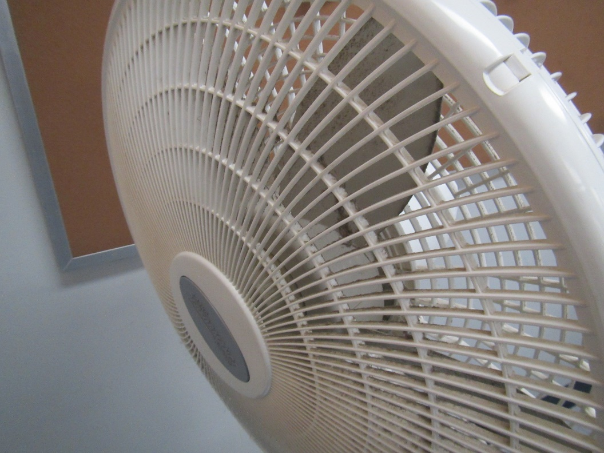

**Dusty fan**

Click to link back to report

| Table 1 **Location** | **Carbon**  **Dioxide**  **(ppm)** | **Carbon Monoxide**  **(ppm)** | **Temp**  **(°F)** | **Relative**  **Humidity**  **(%)** | **PM2.5**  **(µg/m3)** | **Occupants**  **in Room** | **Windows**  **Openable** | **Ventilation** | | **Remarks** |
| --- | --- | --- | --- | --- | --- | --- | --- | --- | --- | --- |
| **Supply** | **Exhaust** |
| Background (outside) | 403 | ND | 53 | 51 | 2 |  |  |  |  | Mostly sunny, windy |
| Upper gold wing | | | | | | | | | | |
| UC207 | 420 | ND | 70 | 34 | ND | 0 | Y | Y | Y on | Ceiling-mounted UV, DEM, NC |
| UC208 | 603 | ND | 69 | 35 | ND | 17 | Y | Y on | Y on | Area rug, wall UV |
| UC209 | 926 | ND | 71 | 35 | ND | 24 | Y | Y | Y | DEM, recycling |
| UC210 | 556 | ND | 71 | 51 | 1 | 0 | Y | Y UV on | Y | Carpet, WD CT |
| UC211 | 663 | ND | 71 | 33 | ND | 14 | Y | Y | Y | CM UV, science lab, sinks, DEM, eyewash and safety shower |
| UC202 | 631 | ND | 71 | 32 | ND | 1 | Y | Y | Y on | DEM, sink, eyewash and safety shower |
| UC203 | 685 | ND | 70 | 35 | ND | 17 | Y | Y | Y on | PS, PF, DEM |
| UC204 | 641 | ND | 70 | 35 | ND | 20 | Y | Y | Y on | DEM |
| UC205 | 689 | ND | 70 | 35 | ND | 21 | Y | Y | Y on |  |
| UC206 | 624 | ND | 70 | 35 | ND | 16 | Y | Y | Y on | Recycling, DEM, microwave |
| Upper blue wing | | | | | | | | | | WD CT in hallway |
| LD231 | 436 | ND | 68 | 35 | ND | 3 | N | Y | Y | Has CM UV and AHU vents |
| LD230 | 913 | ND | 68 | 36 | ND | 4 | Y 1 open | Y | Y | Plants on UV, DEM |
| LD229 | 448 | ND | 68 | 34 | ND | 3 | Y | Y | Y | DEM, HS, CP |
| LD228 | 398 | ND | 69 | 34 | ND | 0 | Y | Y | Y | DEM |
| LD227 | 538 | ND | 69 | 35 | ND | 12 | Y | Y | Y | Microwave |
| LD227 Science prep room |  |  |  |  |  | 0 | N | Y | Y | Has lab waste neutralizer in floor, WD CTs, sinks, TBs, lab hood |
| LD224 | 745 | ND | 71 | 35 | ND | 14 | Y | Y | Y | Science sinks, DEM |
| LD223 | 459 | ND | 70 | 33 | ND | 1 | Y | Y | Y | NC, DEM, heater |
| LD222 | 403 | ND | 71 | 33 | ND | 0 | Y | Y | Y | DEM, PF |
| LD221 | 425 | ND | 71 | 34 | ND | 0 | Y | Y | Y |  |
| LD220 | 422 | ND | 70 | 33 | ND | 0 | Y | Y | Y | PF, NC, plush chair, DEM, WD CT |
| Upper spine | | | | | | | | | | |
| SD212 | 424 | ND | 69 | 35 | ND | 11 | N | Y | Y | Occupants report past gas odor |
| SD214 | 570 | ND | 69 | 34 | ND | 11 | Y | Y | Y | Door to outside, painted CTs |
| SD216 | 537 | ND | 69 | 33 | ND | 0 | Y | Y | Y | WD CT, PS, DEM |
| SD201 library/media | 684 | ND | 69 | 32 | ND | 13 | Y | Y | Y | Previous leak repaired, carpet, books |
| Library computer lab | 731 | ND | 70 | 32 | ND | 15 | Y | Y | Y | Carpeted |
| C206 library workroom | 622 | ND | 70 | 29 | ND | 0 | N | Y | Y | Carpeted, DEM |
| C211 library lounge | 615 | ND | 71 | 30 | ND | 0 | N | Y | Y | DEM, sink |
| C210 | 624 | ND | 71 | 31 | ND | 0 | N | Y | N |  |
| Room with elevator | 683 | ND | 71 | 31 | ND | 4 | Y | Y | Y | WD CT, elevator access, carpet, plants |
| office | 717 | ND | 70 | 31 | ND | 1 | Y | Y | Y | WD CT, DEM, carpet |
| C208 conference | 672 | ND | 70 | 30 | ND | 0 | Y | Y | Y | Plug-in AF, DEM |
| Lower blue wing | | | | | | | | | | |
| Nurse (main area) | 491 | ND | 70 | 32 | ND | 0 | N | Y | Y |  |
| LD134 Nurse office | 481 | ND | 70 | 33 | ND | 1 | N | Y | Y | Carpet, water cooler on carpet |
| LD132 | 828 | ND | 70 | 36 | ND | 12 | Y | Y | Y | DEM |
| LD130 | 656 | ND | 69 | 36 | 26 | 5 | Y | Y | Y | Scent diffuser, DEM |
| LD129 | 603 | ND | 70 | 35 | 2 | 11 | Y | Y | Y | WD Ct, DEM, plants, PF, lab hood, sinks |
| B108 |  |  |  |  |  |  | N | Y | Y | Science prep/storage, chemical storage |
| LD126 | 731 | ND | 67 | 34 | ND | 12 | Y | Y | Y | Sinks, lab hood |
| LD125 | 646 | ND | 68 | 37 | ND | 10 | Y | Y | Y | DEM, MT |
| LD124 | 673 | ND | 69 | 37 | ND | 9 | Y | Y | Y |  |
| LD123 | 590 | ND | 70 | 36 | ND | 0 | Y | Y | Y | WD CT |
| LD120 | 586 | ND | 70 | 34 | ND | 2 | Y | Y | Y | Area rug, DEM |
| Chill room |  |  |  |  |  | 0 | Y | Y | Y | Area rug, items |
| B113 | 464 | ND | 69 | 34 | ND | 1 | Y | Y | Y | Area rug and carpet |
| Foreign Language Wing | | | | | | | | | | |
| FD117 | 601 | ND | 69 | 37 | ND | 13 | Y | Y | Y | DEM, plant |
| FD116 | 674 | ND | 70 | 36 | ND | 20 | Y | Y | Y | WD CTs |
| FD115 | 530 | ND | 71 | 34 | ND | 2 | Y | Y | Y | Plants, DEM |
| FD114 | 720 | ND | 71 | 35 | ND | 14 | Y | Y | Y | Rubber ball chairs, DEM |
| FD113 | 586 | ND | 71 | 35 | ND | 12 | N | Y | Y | Carpet, DEM, used to be computer room |
| FD112 | 501 | ND | 71 | 34 | ND | 0 | N | Y | Y | DEM |
| Lower gold wing | | | | | | | | | | |
| UC107 |  |  |  |  |  |  | N | Y | Y | Photography room, NC |
| UC106 | 552 | ND | 69 | 36 | ND | 3 | Y | Y | Y | Life skills room: stoves, sinks, refrigerator, microwave. Stoves have recirculating hood, room partly carpeted |
| UC105 | 580 | ND | 69 | 35 | ND | 0 | Y | Y | Y | DEM, old couch not school supplied |
| UC104 | 587 | ND | 70 | 36 | ND | 15 | Y | Y | Y | DEM |
| UC103 | 621 | ND | 70 | 34 | ND | 1 | Y | Y | Y | Dog and dog bedding, non-HEPA vacuum |
| UC102 | 625 | ND | 70 | 35 | ND | 15 | Y | Y | Y | Science classroom, TBs, WD CT, lab hood |
| US102 science prep |  |  |  |  |  |  | N | Y | Y | Flammable and corrosive cabinet, chemical storage |
| UC113 | 530 | ND | 71 | 35 | ND | 1 | Y | Y | Y | Biology and chemistry science classroom, eyewash and safety shower |
| UC112 | 530 | ND | 69 | 36 | ND | 0 | Y | Y | Y | DEM |
| UC111 | 542 | ND | 70 | 36 | ND | 15 | Y | Y | Y | DEM |
| UC110 | 540 | ND | 69 | 34 | ND | 1 | N | Y | Y | Loud AHU (VFD), DEM, wall to wall carpet |
| UC109 | 470 | ND | 70 | 34 | ND | 0 | N | Y | Y | Carpet, plush items, dusty PF, microwave and toaster, food |
| Lower-level accessory rooms | | | | | | | | | | |
| Art office | 467 | ND | 70 | 35 | ND | 2 | N | Y | Y | 2 WD CT |
| Art ceramics room | 466 | ND | 72 | 36 | ND | 0 | Y |  |  | Doors to outside are open, thermostat in wood shop means this room is usually too hot, electric kiln with overhead exhaust |
| Art classroom area | 557 | ND | 73 | 36 | ND | 10 | Y and door open | Y | Y | Sinks, items, PF |
| Wood shop | 460 | ND | 71 | 34 | ND | 0 | Y and door | Y | Y | Task exhausts and wood dust catchers |
| Welding/auto/metal shop | 468 | ND | 70 | 35 | ND | 0 | Y |  |  | Task based exhaust for welding, 3D printer |
| SC127 tech education | 456 | ND | 69 | 35 | 1 | 3 | Y | Y | Y | Computers |
| A101 | 450 | ND | 69 | 34 | ND | 2 | N | Y | Y | Carpet, shredder |
| A108 | 456 | ND | 69 | 34 | ND | 1 | N | Y | Y | DEM |
| Main office mailroom | 499 | ND | 70 | 33 | ND | 0 | N | Y | Y | Sink, fridge, microwave, toaster |
| A107 | 420 | ND | 71 | 33 | ND | 0 | Y | Y | Y | Carpet, small fridge on carpet, DEM, WD CT |
| A106 | 422 | ND | 71 | 32 | ND | 1 | Y | Y | Y | Plants, WD CT, DEM, carpet |
| Main office conference room | 425 | ND | 71 | 32 | ND | 0 | Y | Y | Y | Carpet |
| A105 Principal | 413 | ND | 71 | 32 | ND | 1 | Y and door | Y | Y | Carpet |
| A103 |  |  |  |  |  | 2 | N | Y | Y | Carpet, WD CT |
| A110 | 462 | ND |  |  |  | 0 | N | Y | Y | Carpet, WD CT |
| Faculty restroom |  |  |  |  |  | 0 | N | N | Y on | Scent, bowed CT |
| Music E112 | 480 | ND | 70 | 34 | ND | 2 | N | Y | Y | DEM |
| Music office | 481 | ND | 71 | 34 | ND | 0 | N | Y | Y | Rusty vents, fridge, area rug, carpet |
| Auditorium | 447 | ND | 69 | 33 | ND | 0 | N | Y | Y | Carpet |
| E110 drama | 438 | ND | 68 | 35 | ND | 1 | N | Y | Y | Carpet, DEM |
| E109 | 512 | ND | 70 | 34 | ND | 1 | N | Y | Y | Carpet, area rug |
| Practice rooms | 501 | ND | 68 | 30 | ND | 0 | N | Y | Y |  |
| Jazz | 548 | ND | 70 | 33 | ND | 0 | N | Y | Y | DEM, WD CT |
| G107 | 562 | ND | 70 | 34 | ND | 0 | N | Y | Y |  |
| G200 | 427 | ND | 69 | 33 | ND | 0 | N | Y | Y |  |
| Weight room | 437 | ND | 68 | 34 | ND | 0 | N | Y | Y | WD CT |
| C204 multi-use | 624 | ND |  |  |  |  | Y | Y | Y |  |
| Cafeteria | 542 | ND | 70 | 34 | ND | 100+ | Doors open | Y | Y | WD CT |

(Click to link back to report)

# Table 2A

|  |  |  |  |  |  |
| --- | --- | --- | --- | --- | --- |
| **Equipment Present in Building**  **(X = Yes)** | **Type of Heating/Cooling Ventilation**  **Equipment** | **Fresh**  **Air**  **Supply**  **(X = Yes)** | **Type of Location(s)** | **Air Filters Installed**  **MERV Rating**  **(1-15, U*)**  **(X = Yes)** | **Comments** |
| X | Univents | X | Classrooms | U |  |
| X | Rooftop Air Handling Units | X | Common areas | U |  |
|  | Outdoor, Ground-Installed Air Handling Units |  |  |  |  |
|  | Attic/Crawlspace Air Handling Units |  |  |  |  |
|  | Ceiling-Mounted Air Handling Units (including inside plenum) |  |  |  |  |
|  | Basement/Crawlspace-Installed Air Handling Units |  |  |  |  |
|  | Mechanical Room-installed Air Handling Units |  |  |  |  |
|  | Fan Coil Units |  |  |  |  |
|  | Window-Mounted Air Conditioners |  |  |  |  |
|  | Wall Louver-Controlled Gravity Air Supply |  |  |  |  |
| X | Windows |  |  |  |  |
|  | Fan in window (blowing in) |  |  |  |  |
|  | Built in wall fan (switched) |  |  |  |  |
|  | Heat recovery ventilator unit |  |  |  |  |
|  | Energy recovery ventilator unit |  |  |  |  |
|  | Chilled Beam |  |  |  |  |
|  | Passive combustion supply vent in basement/boiler room |  |  |  |  |

*U = Filter Rating underdetermined due to inaccessibility during building visit

(Click to link back to report)

# Table 2B

|  |  |  |  |  |
| --- | --- | --- | --- | --- |
| **Equipment Present in Building**  **(X = Yes)** | **Type of Exhaust Ventilation**  **Equipment** | **Ducted**  **To Outdoors**  **(X = Yes)** | **Type of Location(s)** | **Comments** |
| X | Rooftop Motors/Fans | X | Classrooms |  |
|  | Unit Exhaust |  |  |  |
| X | Ceiling Return Vent | X | Some common areas |  |
|  | Ceiling Return Vent, Plenum |  |  |  |
| X | Wall Return Vent | X | Some common areas (E.g. gym) |  |
| X | Kitchen Stove Hood | X | Kitchen, not examined |  |
| X | Restroom Exhaust Vent | X |  |  |
|  | Photocopier Exhaust Vent |  |  |  |
|  | Garage |  |  |  |
| X | Chemical Hood(s) | X | Science room and science prep rooms |  |
| X | Locker Rooms |  |  |  |
| X | Showers |  |  |  |
|  | Clothes Dryers |  |  |  |
|  | Gas Water Heaters |  |  |  |
|  | Furnace-Flue to Chimney |  |  |  |
|  | Furnace/Boiler direct vent or power vent (no combustion air supply) |  |  |  |
| X | Kiln, Pottery | X | Art room |  |
|  | Dark Room |  |  |  |
|  | Generator Room |  |  |  |
| X | Wood Shop Dust Collector | X | Wood shop |  |
|  | Spray Paint Booths |  |  |  |
|  | Fan in window (blowing out) |  |  |  |

# Table 2C

|  |  |  |  |
| --- | --- | --- | --- |
| **Equipment Present in Building**  **(X = Yes)** | **Type of Equipment** | **Type of Location(s)** | **Comments** |
|  | Floor Fans, pedestal |  |  |
|  | Floor Fans, portable |  |  |
| X | Air Purifier (HEPA, other) | A few classrooms and offices |  |
| X | Floor heaters, portable | A few classrooms and offices |  |
| X | Refrigerators, Cold Beverage Vending Machines |  |  |
| X | Radiator, wall-mounted | Some exterior areas |  |
|  | Radiator, floor-mounted |  |  |
|  | Passive Vents (Wall/Door) |  |  |

(Click to link back to report)

# Table 3

| **Found in Building**  **X = Yes** | **Water-Damaged Materials, Building Components or Stored Materials** | **Location** | **Visible Microbial Growth?**  **X = Yes** | **Musty odor detected?**  **X = Yes** | **Comments** |
| --- | --- | --- | --- | --- | --- |
|  | Books-other bound materials |  |  |  |  |
|  | Brick walls – broken, missing mortar |  |  |  |  |
|  | Brick walls – blocked weep holes |  |  |  |  |
|  | Cardboard boxes |  |  |  |  |
|  | Carpet tiles |  |  |  |  |
|  | Carpet - Area rugs |  |  |  |  |
|  | Carpet wall-to-wall |  |  |  |  |
|  | Ceiling tiles - affixed directly to ceiling surface |  |  |  |  |
| X | Ceiling tiles - bowing-in suspended ceiling |  |  |  |  |
|  | Ceiling tiles - water-stained in splined ceiling |  |  |  |  |
| X | Ceiling tiles - water-stained in suspended ceiling |  |  |  |  |
|  | Chairs - laminated |  |  |  |  |
|  | Cloth |  |  |  |  |
|  | Countertops (around sinks) |  |  |  |  |
|  | Curtains |  |  |  |  |
|  | Dust/debris within AHU, uninvent, HVAC, chilled beam units, etc. (WD through condensation, humidity, or leaks) |  |  |  |  |
|  | Efflorescence (i.e., mineral deposits) |  |  |  |  |
|  | Engineered woods - particleboard, plywood, Masonite |  |  |  |  |
|  | Flooring – loosened tiles |  |  |  |  |
|  | Flooring - wooden |  |  |  |  |
|  | Furniture - laminated |  |  |  |  |
|  | Furniture - upholstered |  |  |  |  |
|  | Gypsum wallboard - ceiling |  |  |  |  |
|  | Gypsum wallboard - restroom wall |  |  |  |  |
|  | Gypsum wallboard - interior wall |  |  |  |  |
|  | Gypsum wallboard – located on exterior wall |  |  |  |  |
|  | HVAC drain pan – lack of draining |  |  |  |  |
|  | HVAC filters |  |  |  |  |
|  | Insulation- attic (paper-backed) |  |  |  |  |
|  | Insulation - inside air handling unit |  |  |  |  |
|  | Insulation - on pipe(s) fiberglass |  |  |  |  |
|  | Insulation - on pipe(s) other/plaster-like material |  |  |  |  |
|  | Insulation - wall cavity |  |  |  |  |
|  | Insulation – ceiling plenum |  |  |  |  |
|  | Modular furniture – walls/cloth partitions |  |  |  |  |
|  | Musical instrument cases |  |  |  |  |
|  | Plaster ceilings |  |  |  |  |
|  | Records/files |  |  |  |  |
| X | Refrigerator - door gasket | Break room | X |  |  |
|  | Refrigerator - drip pan |  |  |  |  |
|  | Refrigerator - Interior surfaces |  |  |  |  |
|  | Room divider - ceiling-mounted, sliding |  |  |  |  |
|  | Sink backsplash |  |  |  |  |
|  | Tables – laminated |  |  |  |  |
|  | Wallpaper |  |  |  |  |
|  | Wood - attic/roof materials |  |  |  |  |
|  | Wood - floor joists in basement ceiling |  |  |  |  |
|  | Wood - wall framing |  |  |  |  |
|  | Wood - window sills |  |  |  |  |
|  | Wood - window-mounted air conditioner framing |  |  |  |  |
|  | OTHER |  |  |  |  |

WHAT ARE ENVIRONMENTAL ASTHMA TRIGGERS?

Asthma triggers are any chemical, pollutant, or allergen that can make your asthma worse. Asthma triggers can also be strong chemical smells, dust, or pets. Your asthma triggers may be different from those of other people. Not all asthma triggers affect people the same way. Environmental asthma triggers are found both indoors and outdoors. DPH link: [Asthma and Your Environment (mass.gov)](https://www.mass.gov/doc/asthma-and-your-environment-english/download)

(click to link back to report)

# Table 4

| **Condition Present**  **X = Yes** | **Possible asthma symptom-inducing environmental pollutant** | **Recommendation to reduce or eliminate the pollutant** |
| --- | --- | --- |
| X | Water Damage and/or Mold  (allergen) | Identify water source and repair to eliminate.  Clean non-porous materials.  Remove and replace porous materials susceptible to mold growth.  Perform regular water damage assessments as a tool to ensure timely mitigation as needed.  Use NIOSH water damage assessment protocol as a guide: [NIOSH water damage assessment guideline](https://www.cdc.gov/niosh/docs/2019-115/pdfs/2019-115.pdf?id=10.26616/NIOSHPUB2019115&inf_contact_key=241b5c2ed98c27d94b530dedc36f1623f651f238aa2edbb9c8b7cff03e0b16a0). |
|  | Moistening of building components during hot, humid weather (>2 days in length) (mold, allergen) | Remove materials not dried in <2 days in a manner consistent with [US EPA Mold Removal in Commercial Buildings guideline](https://www.epa.gov/mold/pdf-version-checklist-mold-remediation-mold-remediation-schools-and-commercial-buildings).  Use dehumidification in occupied basement areas and other areas with chronic dampness. |
|  | Vegetation against exterior of building (water damage-mold) | Remove all vegetation preventing building exterior drying.  Remove all vegetation capable of falling onto a building or depositing debris onto the roof. |
|  | Personal humidifiers (lack of proper maintenance)  (pollutant and allergen) | Clean and maintain properly.  Use distilled water to eliminate metal and water treatment odors.  Maintain hydration by increasing water consumption. |
| X | Drains: Floor drains, Sink drains (abandoned use)  Water bubblers (abandoned use) | If in use, pour water into drain at least twice a week.  If not in use, seal the drain with an appropriate material in accordance with Massachusetts Plumbing Code (248 CMR 10.00). |
|  | Live Animals (turtles, gerbils, birds, rabbits, etc.) | Ensure cleanliness or remove animals from the location. |
|  | Improperly maintained aquariums and terrariums (allergen) | Maintain such equipment properly to eliminate odor.  Discontinue use. |
| X | Plants and flowers  (allergen and mold) | Keep indoor plants well maintained and not overwatered. Monitor for signs of mold and pests.  Ensure water for cut flowers does not become stagnant.  Ensure dried plant material is free of odors, mold, and pests and handled carefully  If asthma risks are high, eliminate plants and flowers. |
|  | HVAC system moisture issues  (mold, allergen) | Consult ASHRAE’s minimum standards for HVAC maintenance and inspection of commercial HVAC systems (<https://www.ashrae.org/technical-resources/bookstore/standards-180-and-211>). |
|  | HVAC system contaminant issues (allergen) | Consult ASHRAE’s minimum standards for HVAC maintenance and inspection of commercial HVAC systems (<https://www.ashrae.org/technical-resources/bookstore/standards-180-and-211>). |
|  | Indoor swimming pool odors outside of swimming pool (mold, chemical) | Maintain and operate pool HVAC systems to vent odors from building.  Ensure locker room exhaust vents are operating during building hours.  All doors leading to pool should be rendered airtight and be closed. |
|  | Pollen (allergen) | Recommend installation of MERV 8 or better filters if HVAC engineer confirms HVAC system can be so equipped without adversely affecting function.  Cut grass after hours.  Cut grass in a pattern to direct clippings away from exterior wall.  Remove trees and shrubs from in front of windows and air intakes. |
| X | Dry air | Maintain hydration.  Avoid overheating of air. |
|  | Dust mites  (allergen) | Recommendation to remove non-official upholstered furniture, area rugs, pillows, cushions, etc.  Cleaning with use of HEPA-filtered vacuum cleaner.  Eliminating clutter, storing items in dust and moisture-proof containers, and regularly removing dust through wet wiping. |
|  | Pests, including rodents and cockroaches  (allergen) | Use of integrated pest management guidelines, including:   * Proper disposal of food containers * Proper storage of food products in airtight containers * Elimination of use of food as art projects * Remove pest harborages/clutter * Regular monitoring for pests   [EPA IPM guideline link](https://www.epa.gov/ipm/introduction-integrated-pest-management) |
| X | Latex-containing materials | Remove tennis balls from furniture legs. |
| X | Fragrances  (chemical) | Eliminate point sources, such as:   * Plug-in air fresheners * Aroma/oil reed diffusers * Scented sprays * Discontinue use of other scented materials * Consult DPH fragrance guideline: [*Clean air is odor-free*](https://www.mass.gov/doc/clean-air-is-odor-free-removing-fragrances-to-improve-indoor-air-quality-in-schools-and-0/download) |
|  | Strong smells from /use of Chemicals (such as cleaning products)  (chemical) | Use building-issued cleaning products.  Use products in accordance with manufacturer’s instructions including dilution, application, and ventilation.  Avoid using products that are stronger than needed for the situation. |
|  | Strong odors from new building materials (carpeting/furniture)  (chemical) | Use low VOC-emitting materials.  Air out materials (outside or in unoccupied area) prior to installation. |
|  | Tobacco smoke  Secondhand Smoke  (pollutant) | Eliminate tobacco smoking.  Seal all shared wall penetrations. |
| X | Products with a strong odor such as paint, perfume, hairspray, air fresheners, bug-spray, laminators, candles, wax melters, dry erase markers and other VOC-containing products  (chemical) | If essential:   * Provide proper exhaust ventilation to eject aerosolized product directly outdoors. * Avoid/reduce use during occupied hours.   If not necessary, remove and eliminate. |
|  | Vehicle exhaust  (pollutant) | Enforce anti-idling regulations and post signs to give notice.  Relocate vehicles away from fresh air intakes.  Require cars to park face-in at building walls.  [MA anti-idling law FAQs](https://www.mass.gov/files/documents/2018/02/20/idling-faq.pdf#:~:text=The%20Massachusetts%20Anti-Idling%20Law%20The%20goal%20of%20the,sometime%20wonder%20when%20idling%20might%20be%20considered%20necessary.) |
|  | Vapors and or fumes from gas, oil, or kerosene stoves  (pollutant) | Operate stove hood when stove in use.  Install stove hood if not present.  Ensure equipment is in good working order. |
|  | Ozone (pollutant) | Eliminate use of ozone generating equipment. |
|  | Window Air Conditioners (if not properly maintained) (allergen) | Equip with proper filter and clean periodically.  Clean drip pans.  Install in window with weathertight, non-mold-growth sustaining material. |
| X | Pottery (pollutant) | Do not operate kiln during occupied hours.  Operate kiln with exhaust system activated.  Seal all seams and holes in kiln vent.  Ensure kiln exhaust discharge terminates outdoors. |
|  | Carpeting (allergen) | Clean carpeting in a manner consistent with IICRC standards, including regular vacuuming with a high efficiency particulate air (HEPA) filtered vacuum in combination with annual cleaning or semi-annual cleaning in soiled high traffic areas. |
|  | Sweeping/dusting vs HEPA vacuuming/wet wiping  (allergen or pollutant) | Refrain from using feather dusters or brooms.  Utilize HEPA vacuums and wet wiping to minimize aerosolizing particulate matter. |
|  | Lack of adequate air exchange/mechanical ventilation | Make repairs as necessary and ensure all HVAC system components are operating continuously when building is occupied. |
|  | Lack of local exhaust at source of pollution (vocational shop activities, kitchen exhaust hood) (all) | Recommend installation of exhaust ventilation to direct pollutants directly outdoors. |
|  | Renovating buildings while occupied  (chemical) | Use all SMACNA guidelines for Renovation While Buildings Are Occupied. For information, visit <https://www.mass.gov/service-details/construction-and-renovation-generated-pollutants-in-occupied-buildings>. |
| X | Chemistry program chemical storage  (chemical) | Repair (if needed) and operate chemical storeroom vents appropriately.  Reduce or eliminate unneeded or overstocked chemicals.  Store all chemicals in a manner to separate incompatible chemicals.  Keep chemical storerooms clean. |
| X | Photocopiers/duplicating machines | All machines should have dedicated exhaust vents. |