October 7, 2024

**VIA EMAIL**

Stephen Davis, Director

Division of Health Care Facility Licensure and Certification

Department of Public Health

67 Forest Street

Marlborough, MA 01752

Re: Norwood Hospital – Notice of Hospital Closure

Dear Mr. Davis:

This letter is submitted on behalf of Steward Health Care System LLC regarding Norwood Hospital, located at 800 Washington Street, Norwood, MA 02062 (the “Hospital”). As you know, the Hospital has been out of service since June 2020 due to catastrophic flooding, although certain of its outpatient satellites have continued to operate. Pursuant to 105 CMR 130.122, the Hospital hereby informs the Department of Public Health (“Department”) that the Hospital intends to formally close on November 5, 2024 and will submit its notice of the proposed closure shortly. The proposed closure will include the following: 121 Medical/Surgical beds, 11 Intensive Care Unit beds, 3 Pediatric Service beds, all ambulatory care services at the Hospital, closure of the following satellite campuses: Foxboro, located at 70 Walnut Street, Foxborough, MA 02035; Norwood Hospital Cancer Care Center at Foxboro, located at 70 Walnut Street, 1st Floor, Foxborough, MA 02035; Guild Imaging Center of Norwood Hospital, located at 825 Washington Street, Suites #170 and #210, Norwood, MA 02062; and Norwood Performance Therapy, located at 1343 Providence Highway, Norwood, MA 02062.

Please note that in compliance with the Department’s regulations, the Hospital, through separate correspondence, is sending notice to each staff member of the Hospital and every labor organization that represents the Hospital’s workforce during the period of the essential services closure process. Notice is also being sent to members of the General Court, as well as appropriate local elected officials.

Thank you for your attention to this matter. If you have any questions, please do not hesitate to contact Octavio J. Diaz, MD, MPH, President North Region & System Chief Medical Officer of Steward Health Care System LLC at [octavio.diaz@steward.org](mailto:octavio.diaz@steward.org), or me.

Sincerely,

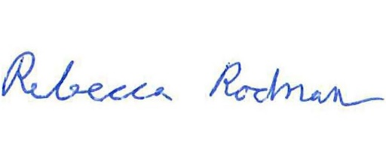

HUSCH BLACKWELL LLP

Rebecca Rodman

cc: Walter Mackie, DPH

Antonio Sousa, DPH

Judy Bernice, DPH

Beth McLaughlin, DPH

Torey McNamara, DPH

Octavio Diaz, MD, Steward