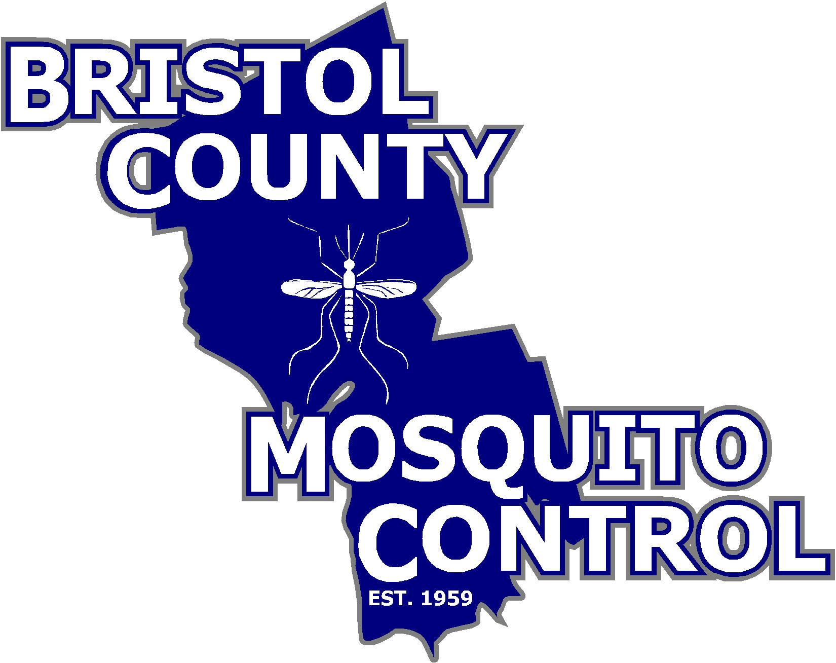
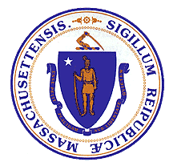
The Commonwealth of Massachusetts
State Reclamation and Mosquito Control Board

________________________________________

Bristol County Mosquito Control Project
38R Forest Street Attleboro, MA 02703
TEL: (508) 823-5253 FAX: (508) 828-1868

TO: Whom it may concern

FROM: Bristol County Mosquito Control Commission

DATE: December 7, 2018

RE: Meeting Agenda

The next full meeting of the Bristol County Mosquito Control Project Commission will be December 12, 2018 at 38R Forest Street Attleboro, Massachusetts at 7:00am.

1. Call to Order

2. Vote to approve the 11-15-18 meeting minutes

3. Commissioner Activities
- OVM Chargeback

4. Project Activities
- NMCA Meeting
- End of Season Update

5. New and Unfinished Business

6. Date of next Commission Meeting

7. Adjournment

