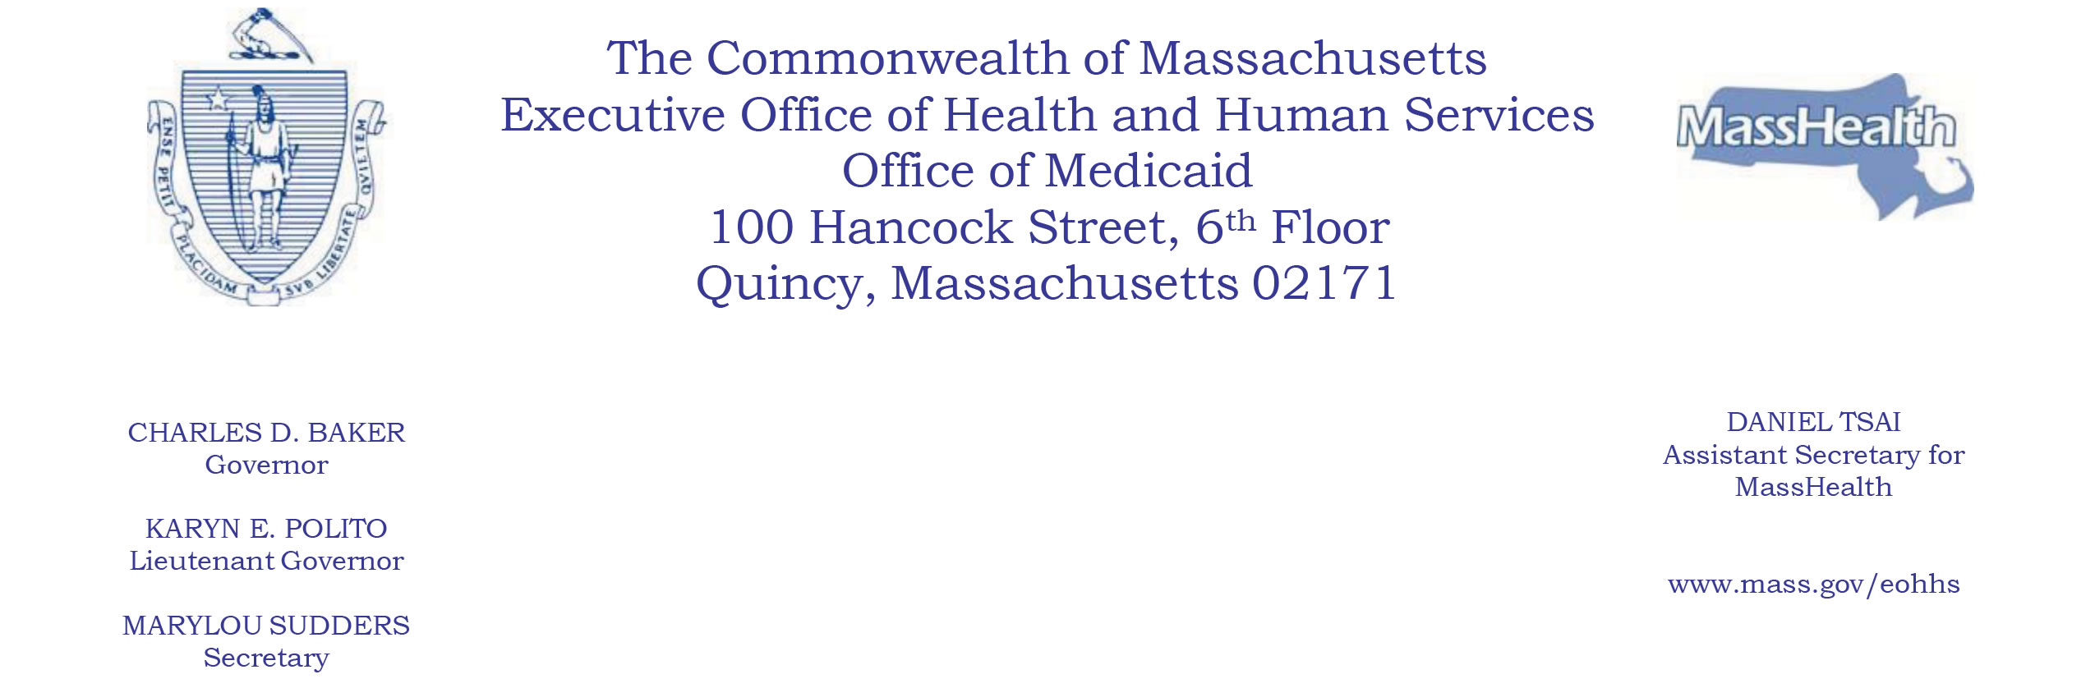

NOTICE OF AGENCY ACTION

SUBJECT: MassHealth: Amendment to the Standard and CarePlus Alternative Benefit Plan State Plans (Clinic Services)

AGENCY: Massachusetts Executive Office of Health and Human Services (EOHHS)

EOHHS has determined that certain conforming amendments to its Standard and CarePlus Alternative Benefit Plan (ABP) State Plans (ABP State Plans) are warranted. EOHHS plans to remove treatment limitations for case consultation at substance use disorder (SUD) outpatient counseling treatment clinics, acupuncture detoxification at SUD outpatient counseling treatment clinics, and counseling sessions at opioid treatment service centers in the Medicaid State Plan. As a result, EOHHS has determined to remove treatment limitations for case consultation at substance use disorder (SUD) outpatient counseling treatment clinics, acupuncture detoxification at SUD outpatient counseling treatment clinics, and counseling sessions at opioid treatment service centers from the ABP State Plans. These amendments do not represent a change in covered services, but do remove the treatment limitations for those services.

EPSDT and Tribal Consultation

The amendments will not affect how MassHealth provides Early and Periodic Screening, Diagnostic and Treatment (EPSDT) services. EOHHS has followed the tribal consultation noticing process established under the American Recovery and Reinvestment Act of 2009 and set forth in its approved state plan.

Public Comments

EOHHS will hold a public comment period until March 28, 2019, relative to these ABP State Plan Amendments. Individuals may submit written comments by emailing
ehs-regulations@state.ma.us.
Please submit electronic comments as an attached Word document or as text within the body of the email with the phrase “ABP SUD Clinic Services Treatment Limitations” in the subject line. All submissions must include the sender’s full name and email address.

Individuals who are unable to submit comments by email should submit written comments to
EOHHS, c/o Debby Briggs
100 Hancock Street, 6th Floor
Quincy, MA 02171
To be considered, written comments must be received by 5:00 p.m. on March 28, 2019.

Posted: March 21, 2019

