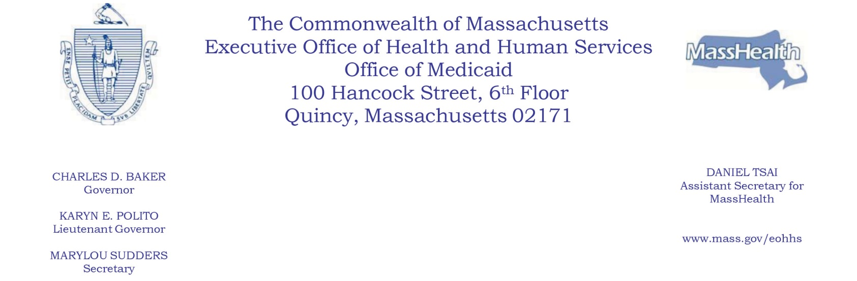
NOTICE OF AGENCY ACTION

SUBJECT: High Medicaid Volume Intellectual/Developmental Disability (IDD) Dental Provider Supplemental Payment

AGENCY: Massachusetts Executive Office of Health and Human Services (EOHHS)

Beginning with rate year 2019, EOHHS will make a High Medicaid Volume IDD Dental Provider Supplemental Payment to eligible MassHealth providers of dental services.

To qualify for this payment, a dental provider must (1) have provided at least 70% of all MassHealth Behavioral Management visits in State Fiscal Year 2018, and (2) must enter into a separate payment agreement with EOHHS. Based on these criteria, Tufts Dental Facilities is the only MassHealth dental provider eligible for this payment.

Such payment will be the difference, not to exceed $3 million, between (1) annual payments to the eligible dental provider made pursuant to the fee schedule as reported to the Medicaid Management Information System (MMIS), and (2) the annually calculated average private commercial rate, where the average private commercial rate is derived from commercial fee schedules applied to paid Medicaid claims as reported to the MMIS. Such payment will be made annually by the first quarter following the end of the preceding rate year.

EOHHS is making these changes to ensure continued access to dental services for MassHealth members with intellectual and developmental disabilities. The changes are projected to increase annual aggregate MassHealth expenditures by approximately $3 million.

Individuals may submit written comments by emailing ehs-regulations@state.ma.us. Please submit electronic comments as an attached Word document or as text within the body of the email with “High Medicaid Volume IDD Dental Provider Supplemental Payment” in the subject line. All submissions must include the sender’s full name and address. Individuals who are unable to submit comments by email should mail written comments to EOHHS, c/o D. Briggs, 100 Hancock Street, 6th Floor, Quincy, MA 02171. Copies of the proposed changes are available at EOHHS or may be viewed at EOHHS’s website at https://www.mass.gov/lists/special-notices#special-notices-for-dental-providers-.

Posted: March 30, 2019

