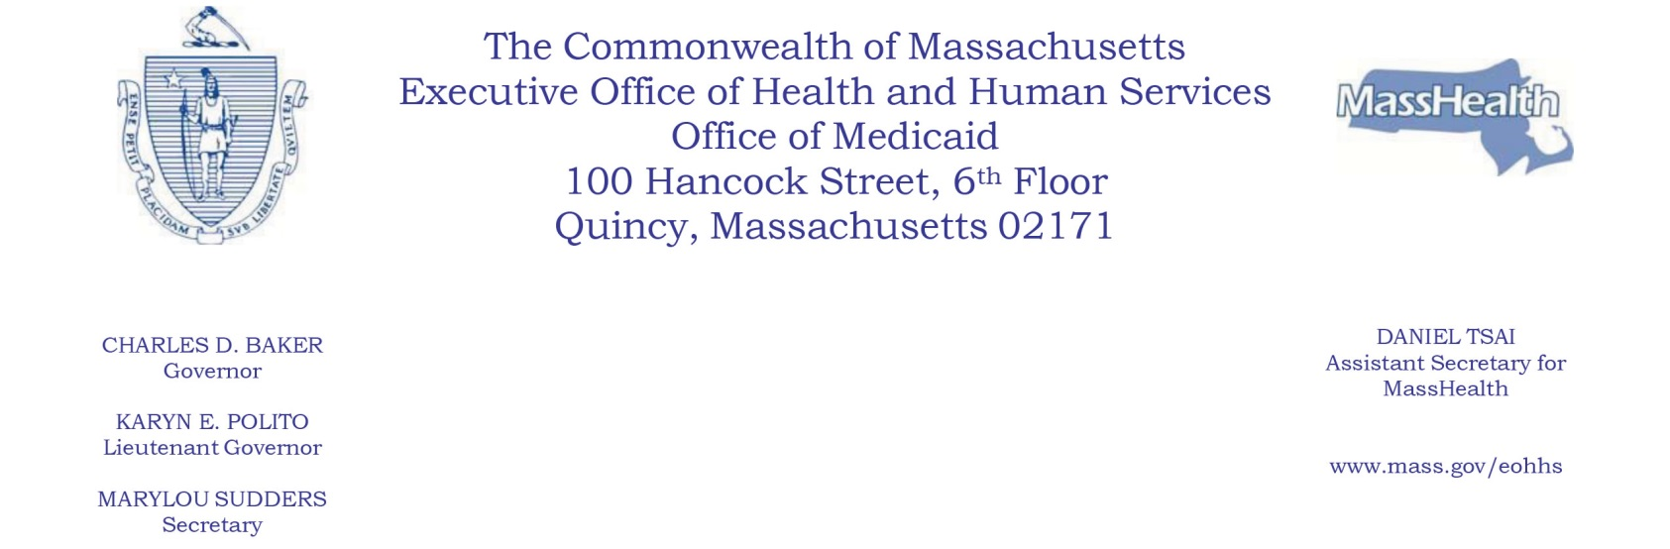

NOTICE OF AGENCY ACTION
SUBJECT: MassHealth: Amendment to the Standard and CarePlus Alternative Benefit Plan State
Plans (Medication-Assisted Treatment)
AGENCY: Massachusetts Executive Office of Health and Human Services (EOHHS)
EOHHS has determined that certain conforming amendments to its Standard and CarePlus Alternative
Benefit Plan (ABP) State Plans (ABP State Plans) are warranted. EOHHS is confirming its coverage of medication-assisted treatment (MAT) drugs and biological products and related counseling services and behavioral therapy in the Medicaid State Plan, as required by section 1006(b) of the Substance Use-Disorder Prevention that Promotes Opioid Recovery and Treatment (SUPPORT) for Patients and Communities Act. EOHHS is making conforming changes in the ABP State Plans to confirm coverage of MAT under these plans as well.

EPSDT and Tribal Consultation
The amendments will not affect how MassHealth provides Early and Periodic Screening, Diagnostic
and Treatment (EPSDT) services. EOHHS has followed the tribal consultation noticing process
established under the American Recovery and Reinvestment Act of 2009 and set forth in its approved
state plan.

Public Comments
EOHHS will hold a public comment period until March 29, 2021, relative to these ABP State Plan
Amendments. Individuals may submit written comments by emailing ehs-regulations@state.ma.us.
Please submit electronic comments as an attached Word document or as text within the body of the
email with the phrase “ABP Medication-Assisted Treatment” in the subject line. All submissions must
include the sender’s full name and email address.
Individuals who are unable to submit comments by email should submit written comments to
EOHHS, c/o Debby Briggs
100 Hancock Street, 6th Floor
Quincy, MA 02171
To be considered, written comments must be received by 5:00 p.m. on March 29, 2021.
Copies of the proposed changes are available at EOHHS or may be viewed at EOHHS’s website at www.mass.gov/lists/special-notices#special-notices-for-dental-providers-.
Posted: March 16, 2021

