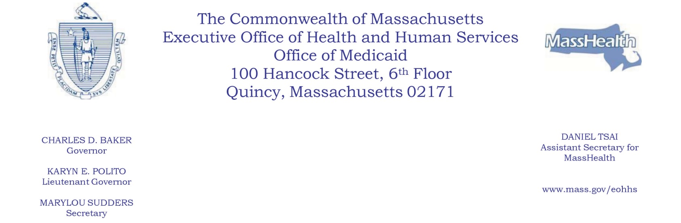
NOTICE OF AGENCY ACTION

SUBJECT: MassHealth Copayments for Smoking Cessation Products and Drugs

AGENCY: Massachusetts Executive Office of Health and Human Services (EOHHS)

Effective September 25, 2019, EOHHS is eliminating copayments for smoking cessation products and drugs for all MassHealth members.

EOHHS is making this change in order to eliminate potential barriers to the ability of MassHealth members to obtain medically necessary smoking cessation products and drugs as they seek to overcome nicotine addiction. Elimination of this copayment is projected to increase annual aggregate MassHealth expenditures by approximately $173,000.

Individuals may submit written comments by emailing masshealthpublicnotice@state.ma.us. Please submit electronic comments as an attached Word document or as text within the body of the email with “Copayments for Smoking Cessation Products and Drugs” in the subject line. All submissions must include the sender’s full name and address. Individuals who are unable to submit comments by email should mail written comments to EOHHS, c/o D. Briggs, 100 Hancock Street, 6th Floor, Quincy, MA 02171. Copies of the proposed changes are available at www.mass.gov/lists/special-notices#special-notices-for-copayments-.

Posted: September 24, 2019

