Charles D. Baker  Governor  Karyn E. Polito  Lieutenant Governor  Thomas A. Turco, III  Secretary of Public Safety and Security |  |  | Terrence Reidy  Undersecretary  Chief Robert J. Ferullo, Jr. ret.  Interim Executive Director

 | Commonwealth of Massachusetts  Municipal Police Training Committee  “Training for Today, Planning for the Future” | 6 Adams Street  Randolph, MA 02368  Phone: (781) 437-0300  Fax: (781) 963-0235 | 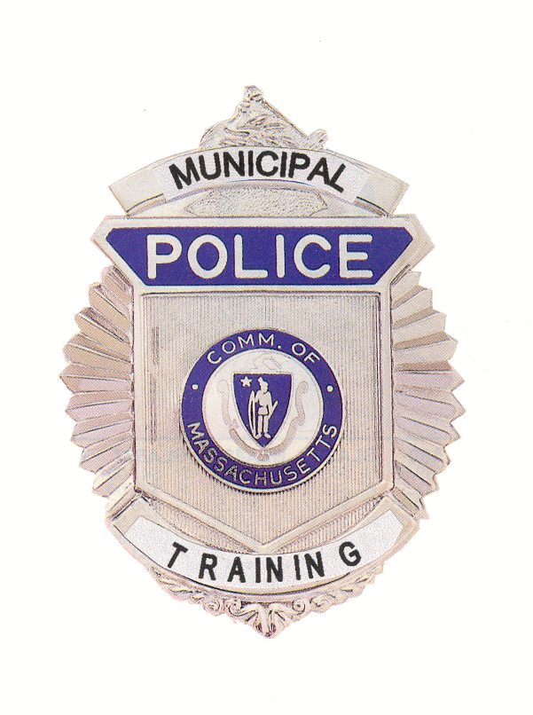
 | MEMORANDUM
TO: | Secretary of State (delivered via email to regs@sec.state.ma.us)  Department of Administration and Finance  (delivered via mail to melissa.andrade@state.ma.us)
FROM: | Chief Robert Ferullo, Interim Executive Director
DATE: | September 4, 2020
RE: | Continuation of Administrative Hearing

NOTICE OF CONTINUATION OF DISCIPLINARY HEARING
Under the provisions of G.L. c. 30A, the Police Standards Subcommittee of the Municipal Police Training Committee will conduct the continuation of a Disciplinary Hearing (initially started on July 14, 2020), virtually on Tuesday, September 8, 2020 at 9:00 am.

To view this meeting on computer, laptop, tablet or smartphone with speakers and microphone, use the link below at the above date and time:

Join Zoom Meeting:

https://zoom.us/j/92227420694?pwd=NytBVkxUeW0rbjh4dFp5bFcyaWtyZz09

Meeting ID: 922 2742 0694
Passcode: 208932
Dial in by your location
+1 312 626 6799 US

Agenda

Tuesday, Septeber 8, 2020

09:00 a.m. – Police Standards Subcommittee Meeting to consider the dismissal appeal of Mohammed Islam from the Cambridge Police Academy at Northeastern University.

